Experimental Study of DWT Compressed Word Embeddings for MCCNN Text Classification
Five-seed SST-2 Reproduction and Efficiency Evaluation
Author Tszhei Hon
Project dwt-textcnn-classification
Date 2026-10-11
Professional Technical Report

Executive Summary
This project independently implements the ordinary multichannel convolutional neural network MCCNN and evaluates how compressing 300-dimensional Google News Word2Vec vectors to 150 dimensions affects SST-2 sentiment classification and resource use. Original, one-level DWT approximation coefficients, DWT detail coefficients, and PCA are compared under identical data splits, a train-only vocabulary, one network architecture, one training protocol, and five fixed random seeds.
Across five seeds, Original achieves the highest test accuracy at 81.68% ± 0.90%. PCA is the strongest compressed representation at 81.33% ± 0.83%, only 0.35 percentage points below Original. DWT-cD and DWT-cA reach 81.04% and 80.65%, respectively. Every 150-dimensional method approximately halves the model parameters, embedding cache, and checkpoint size while reducing peak allocated CUDA memory by 40.12%.
The main conclusion is that compression yields substantial efficiency gains for a small accuracy cost, and PCA provides the best overall balance under this fixed protocol. DWT retains most classification performance but does not outperform PCA or Original. The Original mean is 6.42 percentage points below the 88.1% MCCNN result reported by the reference paper, a gap that should be interpreted in light of training and initialization details that were not fully specified.
Keywords text classification multichannel CNN discrete wavelet transform embedding compression PCA SST-2

Contents
1 Background and Objectives
2 Data and Experimental Design
3 Methods and Implementation
4 Formal Experimental Results
5 Time Memory and Storage
6 Discussion and Limitations
7 Conclusions and Recommendations
References
Appendix Five-seed Results

1 Background and Objectives
Convolutional neural networks extract local n-gram features and remain an important baseline for neural text classification. Xiao et al. introduced transformable convolution and pooling at IJCAI 2018 using an ordinary MCCNN as a baseline. That paper reports 88.1% accuracy on SST-2 for MCCNN. This project reproduces only the ordinary MCCNN, not TF-MCCNN or TF-DCNN, to establish a transparent and reproducible baseline for embedding compression.
Embedding dimensionality directly affects lookup-table size, convolution parameters, storage, and inference cost. Salama et al. studied discrete wavelet compression of word and sentence embeddings at Findings of ACL 2024. A one-level DWT separates a vector into low-frequency approximation coefficients cA and high-frequency detail coefficients cD. Following that idea, this project treats each 300-dimensional Word2Vec vector as a one-dimensional signal, retains either 150-dimensional cA or cD, and uses PCA as an equal-dimensional control.

1.1 Research Questions
- What performance does an independent ordinary MCCNN implementation achieve under a fixed SST-2 protocol?
- How much classification performance is lost when Word2Vec is compressed from 300 to 150 dimensions?
- How do DWT-cA, DWT-cD, and PCA differ at the same output dimension?
- Does compression reduce parameter count, storage, training time, inference latency, and GPU memory?
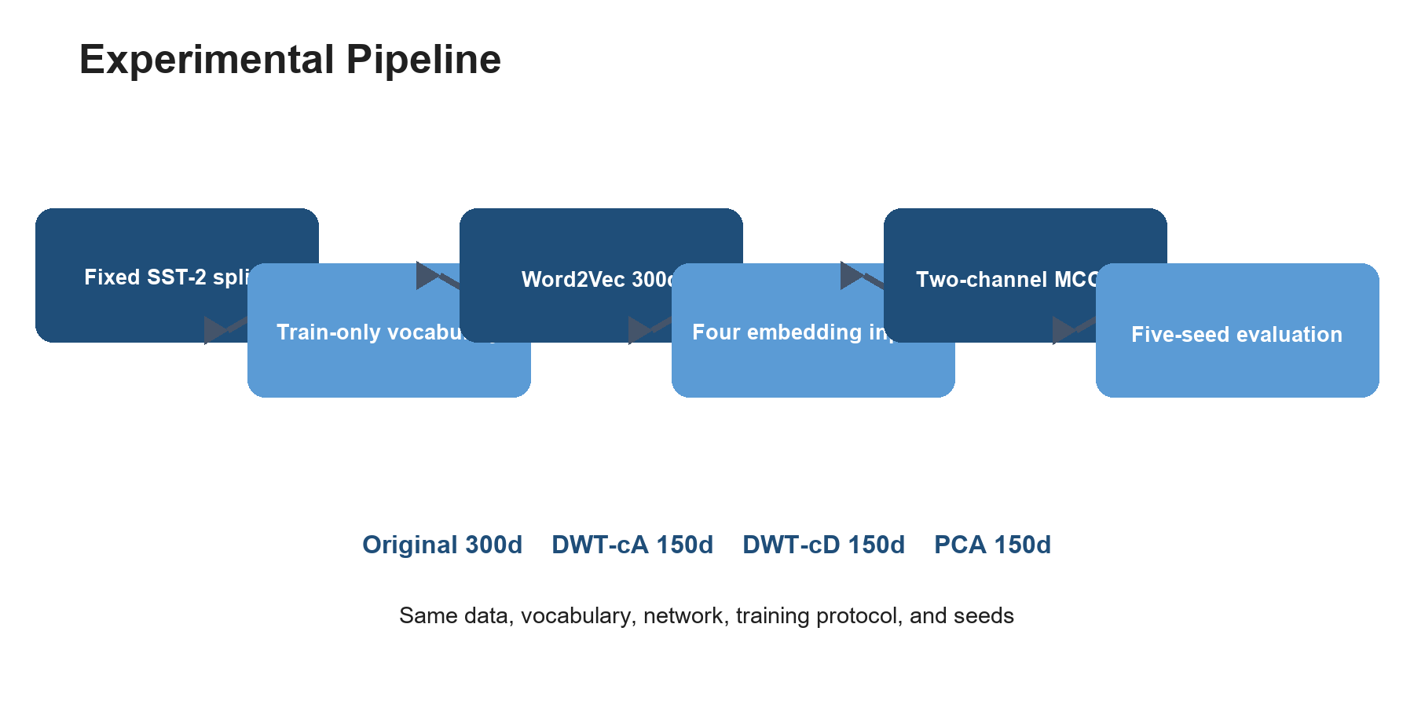
Figure 1 Project experimental pipeline

2 Data and Experimental Design
The dataset is Stanford NLP's original 2013 trainDevTestTrees PTB release. Only the root label and complete leaf sequence of each tree are used. Root labels 0 and 1 map to negative, labels 3 and 4 map to positive, and neutral label 2 is removed. The fixed binary splits contain 6,920 Train, 872 Dev, and 1,821 Test examples, matching the CNN reference paper.
The vocabulary is built exclusively from Train. It contains 16,282 lexical tokens plus <pad> and <unk>, for 16,284 entries. Dev and Test tokens absent from Train map to <unk>, preventing evaluation text from fitting the vocabulary or compression transform. Word2Vec exactly matches 14,505 lexical tokens; unmatched tokens use seed-controlled Uniform(-0.25, 0.25) vectors.
Item | Fixed setting
Source | Stanford 2013 SST PTB
Splits | 6,920 / 872 / 1,821
Vocabulary | Train-only, 16,284
Word2Vec | Google News 300d
Seeds | 13, 21, 42, 87, 100
Dev usage | Checkpoint selection only
Test usage | Final evaluation only

2.1 Fairness Constraints
- All methods share identical splits and token IDs.
- For each seed, every compressed cache derives from the same Original matrix.
- Network and training hyperparameters are fixed; only embedding dimension changes.
- Dev selects the checkpoint and Test is excluded from tuning.
- Conclusions use five-seed means and sample standard deviations, not the best seed.

3 Methods and Implementation

3.1 Embedding Representations
Method | Dim. | Definition
Original | 300 | Exact Google News Word2Vec matches remain at 300 dimensions; OOV tokens and <unk> use seed-controlled random initialization.
DWT-cA | 150 | PyWavelets applies coif1 at one level with periodization boundaries and retains 150 approximation coefficients.
DWT-cD | 150 | The same DWT configuration retains 150 detail coefficients.
PCA | 150 | scikit-learn full SVD without whitening is fitted only on the 14,505 Train tokens matched in Word2Vec.

3.2 MCCNN Architecture
The model contains two trainable lookup channels with the same dimensionality. The pretrained channel is initialized from the selected cache, while the random channel is initialized directly at the target dimension. Shared convolutions use widths 5, 6, and 7 with 100 filters each. Each channel independently applies convolution, bias, and ReLU before the feature maps are summed. Max-over-time pooling, concatenation, dropout 0.5, and a fully connected layer produce the binary prediction.
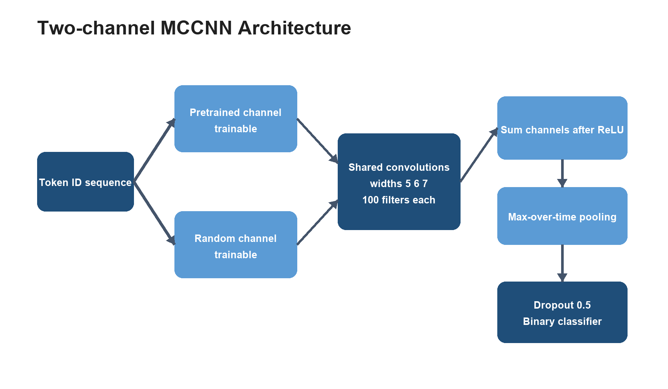
Figure 2 Two-channel MCCNN architecture

3.3 Training Protocol
Parameter | Setting
Batch size | 50
Maximum epochs | 30
Optimizer | Adadelta
Learning rate | 1.0
rho / eps | 0.95 / 1e-6
Early stopping | Dev Accuracy, patience 5
Initialization | Truncated normal, std 0.1
Determinism | PyTorch deterministic algorithms

4 Formal Experimental Results
Table 4 summarizes Test Accuracy and Macro-F1 across the five fixed seeds. Original has the highest mean accuracy at 81.68%. PCA is only 0.35 percentage points lower and retains the most performance among compressed methods. DWT-cD exceeds DWT-cA by 0.39 percentage points, but neither DWT variant exceeds PCA.
Method | Dim. | Test Accuracy | Macro-F1 | vs. Original
Original | 300 | 81.68% ± 0.90% | 81.66% ± 0.92% | —
DWT-cA | 150 | 80.65% ± 1.29% | 80.63% ± 1.31% | -1.03 pp
DWT-cD | 150 | 81.04% ± 1.46% | 81.01% ± 1.47% | -0.64 pp
PCA | 150 | 81.33% ± 0.83% | 81.25% ± 0.89% | -0.35 pp

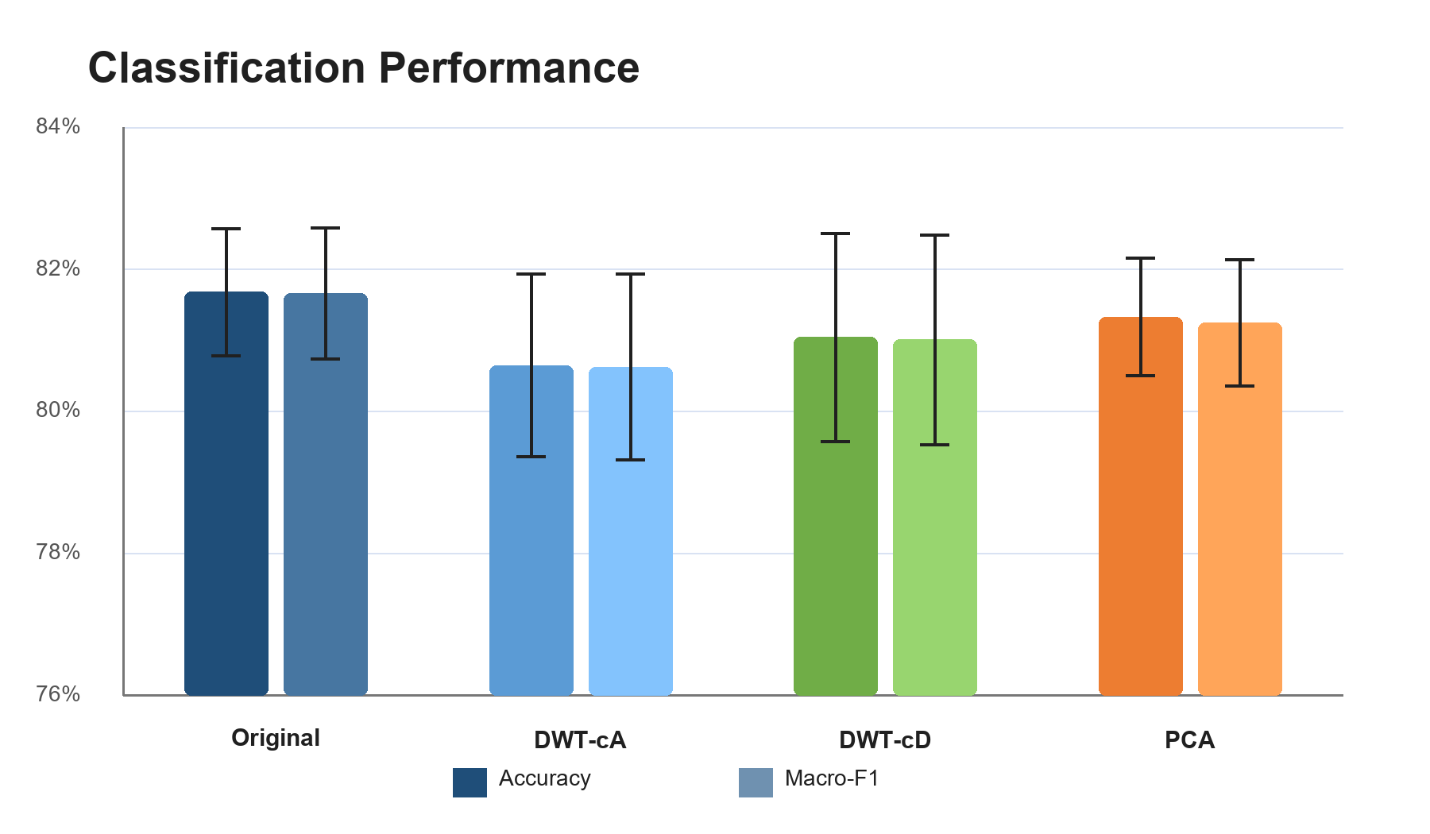
Figure 3 Five-seed classification performance with sample standard deviation
The Original mean of 81.68% is 6.42 percentage points below the reference paper's 88.1%. This value is the complete five-seed mean rather than a selected best run. Because the reference paper does not fully specify learning rate, training duration, stopping rules, and some initialization details, this project reports the gap as a reproduction limitation instead of tuning after observing Test results.

5 Time Memory and Storage

5.1 Parameters and File Size
Reducing embeddings from 300 to 150 dimensions halves both lookup channels and halves the Conv1d input dimensionality. Each compressed model has 5,156,102 parameters versus 10,311,302 for Original, a 50.00% reduction. The embedding cache falls to 9.77 MB and the checkpoint to 20.63 MB, both approximately half their Original size.
Method | Pretrained | Random | Conv. | Total | Cache | Checkpoint
Original | 4,885,200 | 4,885,200 | 540,300 | 10,311,302 | 19.54 MB | 41.25 MB
DWT-cA | 2,442,600 | 2,442,600 | 270,300 | 5,156,102 | 9.77 MB | 20.63 MB
DWT-cD | 2,442,600 | 2,442,600 | 270,300 | 5,156,102 | 9.77 MB | 20.63 MB
PCA | 2,442,600 | 2,442,600 | 270,300 | 5,156,102 | 9.77 MB | 20.63 MB

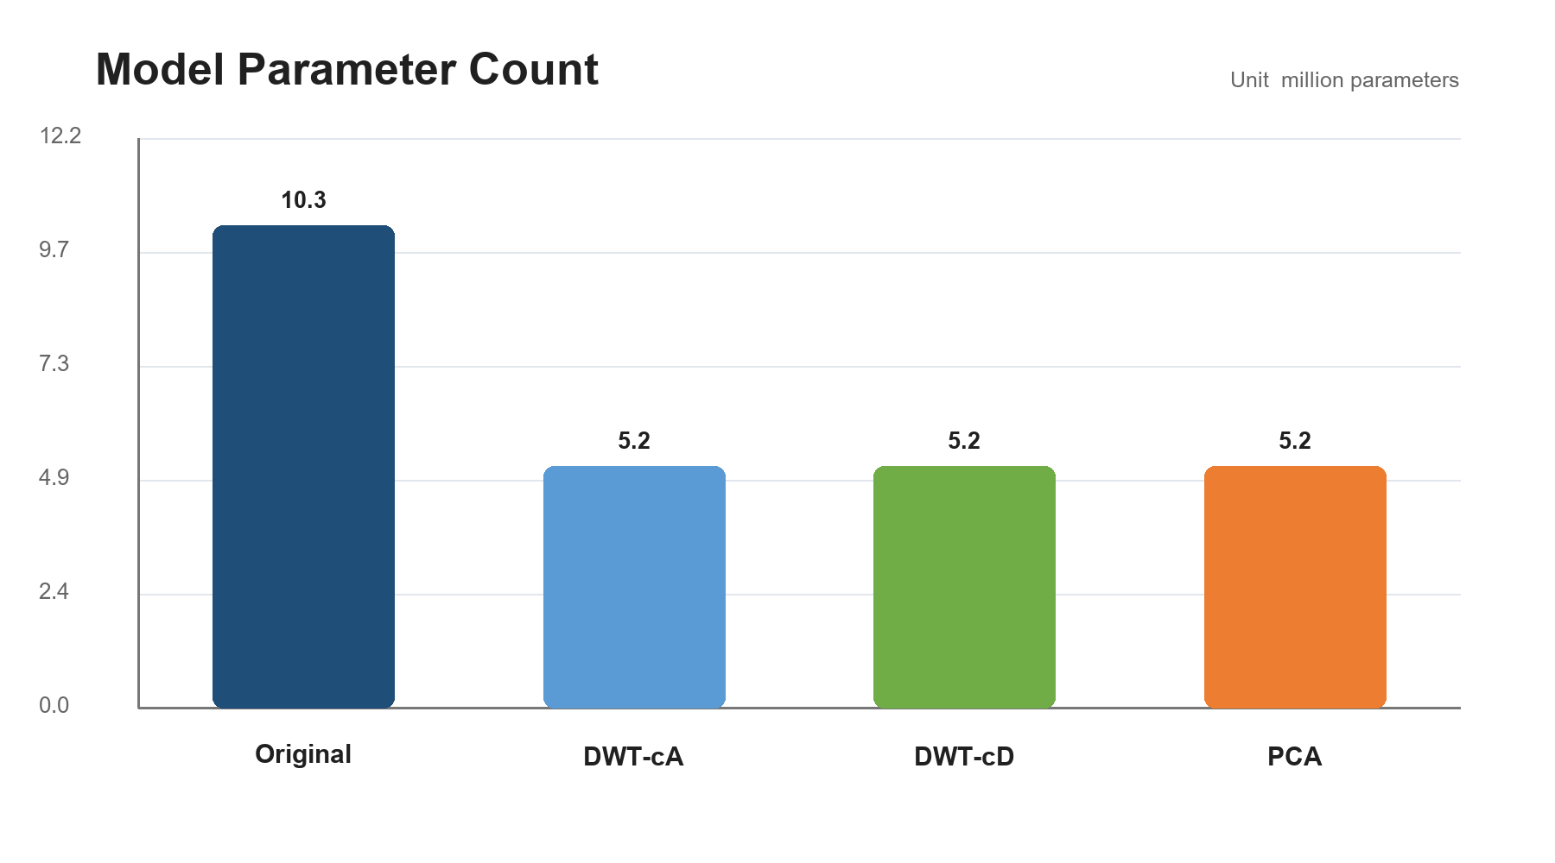
Figure 4 Total model parameter count

5.2 Training Efficiency
Mean total training time falls from 8.76 seconds for Original to 7.22 seconds for DWT-cA, 7.11 seconds for DWT-cD, and 6.38 seconds for PCA. Total duration depends on the number of epochs completed under early stopping, so mean epoch time is the cleaner compute measure: 0.778 seconds for Original and 0.643 seconds for PCA.
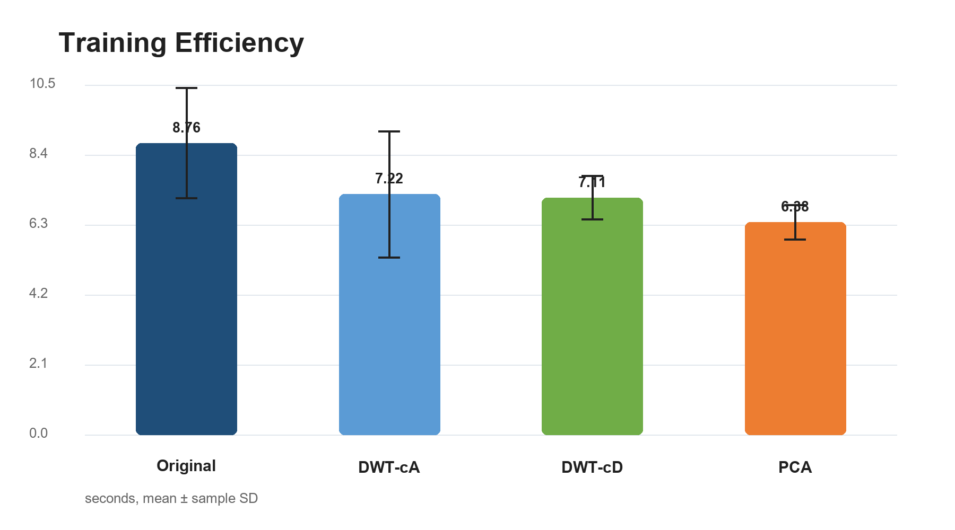
Figure 5 Total training time with sample standard deviation

5.3 Inference and Memory
Inference uses the first 50-example Test batch, 20 warm-up iterations, and 100 measured iterations with CUDA synchronization around timing. Original averages 1.247 ms per batch. Compressed methods range from 0.933 to 1.145 ms, but DWT-cD and PCA vary noticeably across seeds. The results support a general efficiency advantage for 150 dimensions, not a strong speed ranking among the three transforms.
Peak CUDA allocation is 60,389,888 bytes for Original and 36,159,488 bytes for every compressed method, a 40.12% reduction. Process RSS also includes Python, PyTorch, CUDA libraries, and memory-mapped artifacts. It does not fall with model size and must not be interpreted as model-only CPU memory.
Method | Per epoch | Batch latency | Throughput | CUDA peak
Original | 0.778 s | 1.247 ms | 40,177/s | 57.59 MiB
DWT-cA | 0.732 s | 0.933 ms | 53,643/s | 34.48 MiB
DWT-cD | 0.674 s | 1.145 ms | 45,224/s | 34.48 MiB
PCA | 0.643 s | 1.118 ms | 45,732/s | 34.48 MiB

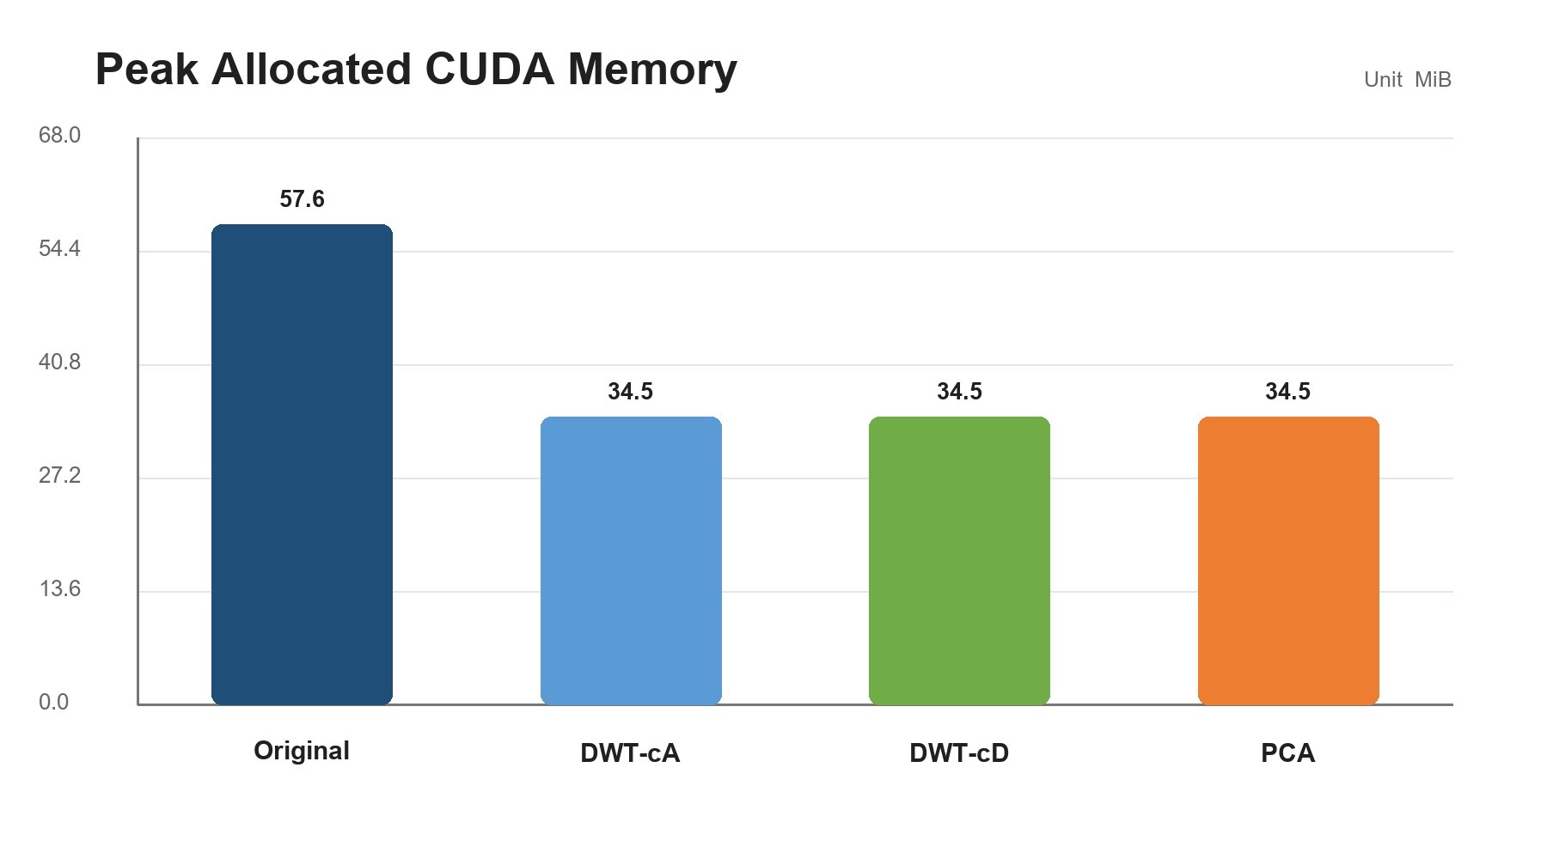
Figure 6 Peak allocated CUDA memory

6 Discussion and Limitations

6.1 Performance Efficiency Tradeoff
PCA is only 0.35 percentage points below Original while delivering approximately 50% parameter and storage reductions, making it the strongest overall choice in this experiment. DWT-cD exceeds DWT-cA, indicating that high-frequency variation contains useful information for this classification task. However, DWT-cD has a larger cross-seed standard deviation of 1.46%, compared with 0.83% for PCA.
DWT requires no labels, no fitting, and can process vectors independently. PCA must be fitted on training tokens, but its projection adapts to the observed embedding distribution. The present results indicate that this data-adaptive projection is more effective for SST-2 MCCNN.

6.2 Reproduction Gap
The reference paper's 88.1% exceeds the Original mean in this project. Dataset size and vocabulary scale are aligned, but the paper does not publish enough information to uniquely reconstruct every training decision. This project fixes Adadelta settings, initialization scale, early stopping, and a train-only vocabulary and records those assumptions. The experiment is internally fair and traceable, but it is not a bit-for-bit reconstruction of the authors' implementation.

6.3 Limitations
- Only SST-2 is evaluated, so conclusions may not transfer to other tasks.
- Only one-level coif1 is used; mother wavelet and level are not searched.
- Trainable embedding channels can move away from their initial compressed representation.
- Five seeds do not support broad significance claims.
- Short GPU benchmarks are sensitive to operating-system scheduling and power state.
- Process RSS is sampled at process level and is not isolated model memory.

7 Conclusions and Recommendations
The project completes a reproducible path from data and pretrained vectors through compression, MCCNN training, five-seed evaluation, and standardized efficiency measurement. Original has the highest mean accuracy. PCA approximately halves model and storage size for a 0.35 percentage-point accuracy cost and is the best overall compressed option. DWT-cD performs better than DWT-cA but does not exceed PCA.
Future work should be separated from the formal results and specified in advance. The first priority is a training-protocol sensitivity study to investigate the gap to the paper's 88.1%. The next priority is evaluation of alternative mother wavelets and decomposition levels. TF-MCCNN, trainable wavelets, and additional datasets should be considered only after the baseline is stable.

References
[1] Xiao, L., Zhang, H., Chen, W., Wang, Y., and Jin, Y. 2018. Transformable Convolutional Neural Network for Text Classification. Proceedings of IJCAI 2018, 4496–4503.
[2] Salama, R. A., Youssef, A., and Diab, M. 2024. Semantic Word and Sentence Embeddings Compression using Discrete Wavelet Transform. Findings of ACL 2024, 15963–15977.
[3] Socher, R., Perelygin, A., Wu, J., Chuang, J., Manning, C. D., Ng, A., and Potts, C. 2013. Recursive Deep Models for Semantic Compositionality Over a Sentiment Treebank. EMNLP 2013.
[4] Mikolov, T., Chen, K., Corrado, G., and Dean, J. 2013. Efficient Estimation of Word Representations in Vector Space. ICLR Workshop.
[5] Pedregosa, F. et al. 2011. Scikit-learn Machine Learning in Python. Journal of Machine Learning Research, 12, 2825–2830.
[6] Lee, G. et al. PyWavelets A Python Package for Wavelet Analysis. Journal of Open Source Software.

Appendix Five-seed Results
The table lists Test Accuracy for every method and formal seed. Reported means and standard deviations use all five runs.
Method | Seed 13 | Seed 21 | Seed 42 | Seed 87 | Seed 100
Original | 82.21% | 81.77% | 82.70% | 81.38% | 80.34%
DWT-cA | 81.71% | 80.72% | 81.66% | 80.62% | 78.53%
DWT-cD | 82.81% | 80.51% | 81.16% | 78.91% | 81.82%
PCA | 82.21% | 81.16% | 80.34% | 80.78% | 82.15%

Reproduction Entry Points
dwt-textcnn prepare-data
dwt-textcnn prepare-embeddings --config configs/<method>.yaml
dwt-textcnn train --config configs/<method>.yaml --seed <seed>
dwt-textcnn evaluate --run-dir <run-dir>
dwt-textcnn benchmark --run-dir <run-dir>
dwt-textcnn summarize --config configs/base.yaml --run-id formal-5seed

