**Introduction to Programming**

2. Find the description of the **System.Console** class in the standard .NET API documentation (MSDN Library).

**2**. **System.Console** class represents the standard input, output, and error streams for console applications. This class cannot be inherited.

3. Find the description of the **System.Console.WriteLine()** method and its different possible parameters in the MSDN Library.

**3**. **System.Console.WriteLine()** method writes the specified data, followed by the current line terminator, to the standard output stream.

**4.**

Console.WriteLine("Hello World!!");

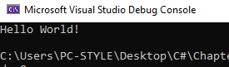

**5.**

Console.WriteLine("Good Day!");

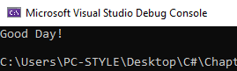

**6**.

System.Console.Write("Edison Hoxha");

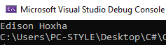

**7**.

Console.WriteLine("1");

Console.WriteLine("101");

Console.WriteLine("1001");

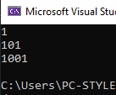

**8.**

Console.WriteLine(DateTime.Now);

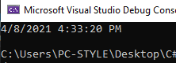

**9.**

Console.WriteLine("Rrenja katerore e numrit 123456 eshte: " + Math.Sqrt(123456));

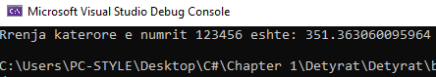

**10.**

for (int i = 2; i <= 100; i++)

{

if (i % 2 != 0)

{

Console.Write($"{-i}, ");

}

else

{

Console.Write($"{i}, ");

}

}

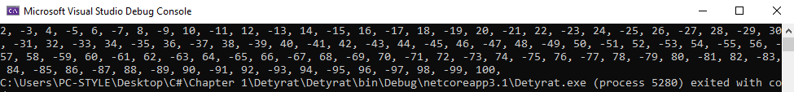

**11.**

Console.WriteLine("Mosha juaj aktuale eshte: ");

int moshaAktuale = Convert.ToInt32(Console.ReadLine());

Console.WriteLine("Mosha juaj pas 10 viteve do te jete: {0}", moshaAktuale + 10);

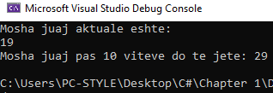

**12**. Describe the difference between **C#** and the **.NET Framework**.

12. C# is actually a programming language that was developed by Microsoft for .Net, whereas .Net is a framework built by Microsoft. In fact, .Net supports many programming languages, and defines the rules and associated libraries those languages will use.

**13**. Make a list of the **most popular programming** languages. How are they different from C#?

1. Python,

2. Javascript,

3. Java,

4. C#,

5. C++,

6. Go,

7. Swift,

8. PHP.

The difference between other programming languages and C# is that C# is a much more modern **programming language**, **C#** was designed to work with the current Microsoft . NET framework in both client and web-based applications. While C++ is an object-oriented **language**, **C#** is considered a component-oriented **programming language**.