**Primitive Types and Variables**

ushort n1 = 52130;

sbyte n2 = -115;

uint n3 = 4825932;

byte n4 = 97;

short n5 = -10000;

short n6 = 20000;

byte n7 = 224;

uint n8 = 970700000;

sbyte n9 = 112;

sbyte n10 = -44;

int n11 = -1000000;

ushort n12 = 1992;

long n13 = 123456789123456789;

Console.Write("{0},\n{1},\n{2},\n{3},\n{4},\n{5},\n{6},\n{7},\n{8},\n{9},\n{10},\n{11},\n{12}", n1, n2, n3, n4, n5, n6, n7, n8, n9, n10, n11, n12, n13);

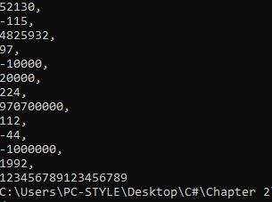

float n1 = 5f;

Console.WriteLine(n1);

float n2 = -5.01f;

Console.WriteLine(n2);

double n3 = 34.567839023;

Console.WriteLine(n3);

float n4 = 12.345f;

Console.WriteLine(n4);

double n5 = 8923.1234857;

Console.WriteLine(n5);

decimal n6 = 3456.091124875956542151256683467m;

Console.WriteLine(n6);

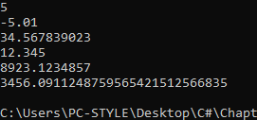

**3.**

double number1 = 10.000001;

double number2 = 10.000002;

Console.WriteLine(number1.Equals(number2));



**4.**

int number = 0x100;

Console.WriteLine(number);



**5.**

char unicode = '\u0072';

Console.WriteLine(unicode);

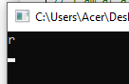

**6.**

bool isMale = true;

Console.WriteLine(isMale);



**7.**

string firstWord = "Hello ";

string secondWord = "World";

object greeting = firstWord += secondWord;

Console.WriteLine(greeting);



**8.**

string firstWord = "Hello";

string secondWord = "World";

object fullGreeting = firstWord + " " + secondWord;

string initilized = (string)fullGreeting;



**9.**

string value1 = "The \"use\" of quotations causes difficulties.";

string value2 = @"The ""use"" of quotations causes difficulties.";

Console.WriteLine(value1);

Console.WriteLine(value2);

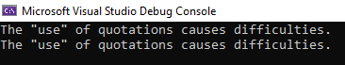

**10.**

Console.WriteLine(" 0 0 ");

Console.WriteLine("0 0 0 0");

Console.WriteLine(" 0 0 0 0");

Console.WriteLine(" 0 00 0");

Console.WriteLine(" 0 0 ");

Console.WriteLine(" 0 0 ");

Console.WriteLine(" 0 0 ");

Console.WriteLine(" 00 ");

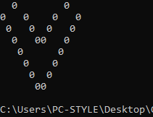

**11.**

Console.WriteLine(" ©");

Console.WriteLine(" © ©");

Console.WriteLine(" © ©");

Console.WriteLine(" © ©");

Console.WriteLine("©©©©©©©©©");

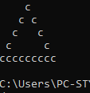

**12.**

string emri = "Bajram";

string mbiemri = "Kunushefci";

byte mosha = 18;

char gjinia = 'M';

uint id = 12345678;

Console.WriteLine("Emri: {0}", emri);

Console.WriteLine("Mbiemri: {0}", mbiemri);

Console.WriteLine("Mosha: {0}", mosha);

Console.WriteLine("Gjinia: {0}", gjinia);

Console.WriteLine("ID: {0}", id);

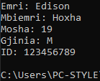

**13.**

int number1 = 5;

int number2 = 10;

int placeholder = number2;

number2 = number1;

number1 = placeholder;

Console.WriteLine(number1);

Console.WriteLine(number2);

