**Operators and Expressions**

**1.**

Console.WriteLine("Shkruaj nje numer:");

int number = Convert.ToInt32(Console.ReadLine());

bool even = number % 2 == 0 ? true : false;

Console.WriteLine("{0} is even? {1}", number, even);

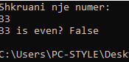 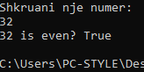

**2.**

Console.WriteLine("Shkruaj nje numer:");

int numri = Convert.ToInt32(Console.ReadLine());

bool pjestueshem = numri % 35 == 0 ? true : false;

Console.WriteLine("{0} is divisible by both 5 and 7? {1}", numri, pjestueshem);

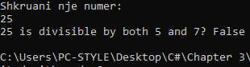

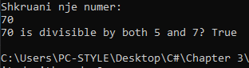

**3.**

Console.WriteLine("Shkruaj nje numer:");

int numri = Convert.ToInt32(Console.ReadLine());

bool numriItret = (numri / 100) % 10 == 7 ? true : false;

if (numriItret == true)

{

Console.WriteLine("Numri i tret i numrit {0} eshte 7", numri);

}

else

{

Console.WriteLine("Numri i tret i numrit {0} nuk eshte 7", numri);

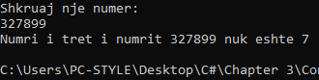

**4.**

Console.Write("Shkruaj nje numer: ");

int numri = int.Parse(Console.ReadLine());

Console.WriteLine("Biti i tret i {0} eshte 1? {1}", numri, ((numri >> 3) & 1) == 1);

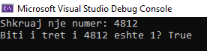

**5.**

float a = 2;

float b = 3;

float h = 4;

Console.WriteLine("S={0}", (a + b) * (h / 2));



**6.**

Console.WriteLine("Shkruaj brinjen a: ");

int a = Convert.ToInt32(Console.ReadLine());

Console.WriteLine("Shkruaj brinjen b: ");

int b = Convert.ToInt32(Console.ReadLine());

Console.WriteLine("S={0}, P={1}", (a * b), (a + b) * 2);

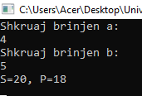

**7.**

Console.WriteLine("Shkruani peshen tuaj: ");

int pesha = Convert.ToInt32(Console.ReadLine());

Console.WriteLine("Ti do te peshosh ne hene {0} kg", pesha * 0.17);

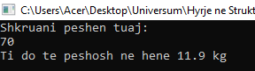

**8.**

Console.Write("Shkruaj x: ");

int x = int.Parse(Console.ReadLine());

Console.Write("Shkruaj y: ");

int y = int.Parse(Console.ReadLine());

bool eshteBrenda = (x * x + y * y <= 5) ? true : false;

Console.WriteLine("Pika O({0},{1}) eshte brenda K((0,0),5)?: {2}", x, y, eshteBrenda);

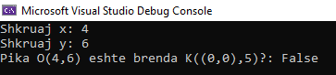

**9.**

Console.Write("Shkruaj x: ");

int x = int.Parse(Console.ReadLine());

Console.Write("Shkruaj y: ");

int y = int.Parse(Console.ReadLine());

bool eshteBrendaRrethit = (x * x + y * y <= 5) ? true : false;

bool eshteJashteDrejtkendeshit = (x < -1 && x > 5 && y < 1 && y > 5) ? true : false;

Console.WriteLine("The point O({0},{1}) is inside K((0,0),5)?: {2}", x, y, eshteBrendaRrethit);

Console.WriteLine("The point O({0},{1}) is outside rectangle ((-1, 1), (5, 5)?: {2}", x, y, eshteJashteDrejtkendeshit);

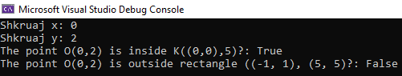

**10.**

Console.WriteLine("Shkruaj numrin: ");

int numri = Convert.ToInt32(Console.ReadLine());

int a = (numri / 1000) % 10;

int b = (numri / 100) % 10;

int c = (numri / 10) % 10;

int d = numri % 10;

Console.WriteLine("1. Sum of digits = {0}", a + b + c + d);

Console.WriteLine("2. Digits backwards = {3}{2}{1}{0}", a, b, c, d);

Console.WriteLine("3. Last digit on first place = {3}{0}{1}{2}", a, b, c, d);

Console.WriteLine("4. Replace third and second digit = {0}{2}{1}{3}", a, b, c, d);

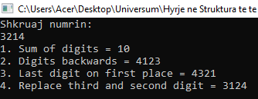

**11.**

int numberN = 35;

int positionP = 6;

int i = 1;

int mask = i << positionP;

Console.WriteLine((numberN & mask) != 0 ? "Biti i trete eshte 1" : "Biti i trete eshte 0");



**12.**

int integerV = 350;

int positionP = 150;

int mask = 1 << positionP;

bool isOne = (integerV & mask) != 0 ? true : false;

Console.WriteLine("Biti te pozicioni {0} i numrit {1} eshte 1? {2}", positionP, integerV, isOne);



**13.**

int n = 25;

int v = 1;

int p = 2;

n = (v == 0) ? n = n & (~(1 << p)) : n = n | (1 << p);

Console.WriteLine(n);



**14.**

Console.Write("Shkruaj nje numer: ");

int numri = int.Parse(Console.ReadLine());

bool isPrime = true;

if (numri > 2)

for (int i = 2; i <= Math.Ceiling(Math.Sqrt(numri)); ++i)

{

if (numri % i == 0) isPrime = false;

}

Console.WriteLine("{0} is prime?: {1}", numri, isPrime);

