**Console Input and Output**

**1.**

Console.WriteLine("Shkruaj 3 numra: ");

int numriIpare = int.Parse(Console.ReadLine());

int numriIdyte = int.Parse(Console.ReadLine());

int numriItret = int.Parse(Console.ReadLine());

Console.WriteLine("Shuma e 3 numrave eshte {0}", numriIpare + numriIdyte + numriItret);

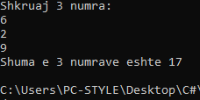

**2.**

Console.Write("Enter radius: ");

int r = int.Parse(Console.ReadLine());

Console.WriteLine("P is {0} and S is {1}", 2 * Math.PI * r, Math.PI * r * r);

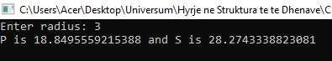

**3.**

Console.Write("Shkruaj emrin e kompanis: ");

string emriKompanis = Console.ReadLine();

Console.Write("Shkruaj adresen e kompanis: ");

string adresaKompanis = Console.ReadLine();

Console.Write("Shkruaj numrin e telefonit te kompanis: ");

string nrTel = Console.ReadLine();

Console.Write("Shkruaj websiten e kompanis: ");

string webIKompanis = Console.ReadLine();

Console.WriteLine("Emri i kompanis: {0},\nAdresa: {1},\nNr. Tel: {2},\nWebsite i kompanis: {3}.", emriKompanis, adresaKompanis, nrTel, webIKompanis);

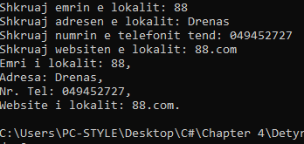

**5.**

Console.Write("Enter first number: ");

int a = Int32.Parse(Console.ReadLine());

Console.Write("Enter second number: ");

int b = Int32.Parse(Console.ReadLine());

for (int i = a; i <= b; i++)

{

if (i % 5 == 0) counter++;

}

Console.WriteLine("{0} numbers found.", counter);

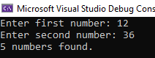

**6.**

Console.Write("Shkruaj numrin e pare: ");

int numriIpare = Convert.ToInt32(Console.ReadLine());

Console.Write("Shkruaj numrin e pare: ");

int numriIdyte = Convert.ToInt32(Console.ReadLine());

Console.WriteLine("{0} >= {1}", Math.Max(numriIpare, numriIdyte), Math.Min(numriIpare, numriIdyte));

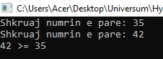

**7.** int a, b, c, d, e;

bool vazhdon = false;

do

{

Console.WriteLine("Shkruje numrin e pare: ");

vazhdon = int.TryParse(Console.ReadLine(), out a);

Console.WriteLine(vazhdon);

} while (!vazhdon);

do

{

Console.WriteLine("Shkruje numrin e dyte: ");

vazhdon = int.TryParse(Console.ReadLine(), out b);

Console.WriteLine(vazhdon);

} while (!vazhdon);

do

{

Console.WriteLine("Shkruje numrin e trete: ");

vazhdon = int.TryParse(Console.ReadLine(), out c);

Console.WriteLine(vazhdon);

} while (!vazhdon);

do

{

Console.WriteLine("Shkruje numrin e katert: ");

vazhdon = int.TryParse(Console.ReadLine(), out d);

Console.WriteLine(vazhdon);

} while (!vazhdon);

do

{

Console.WriteLine("Shkruje numrin e peste: ");

vazhdon = int.TryParse(Console.ReadLine(), out e);

Console.WriteLine(vazhdon);

} while (!vazhdon);

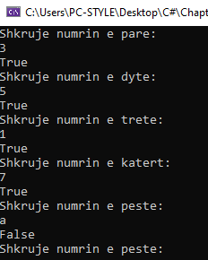

**8.**

Console.WriteLine("Shkruaj 5 numra: ");

int n1 = int.Parse(Console.ReadLine());

int n2 = int.Parse(Console.ReadLine());

int n3 = int.Parse(Console.ReadLine());

int n4 = int.Parse(Console.ReadLine());

int n5 = int.Parse(Console.ReadLine());

if (n2 > n1) n1 = n2;

if (n3 > n1) n1 = n3;

if (n4 > n1) n1 = n4;

if (n5 > n1) n1 = n5;

Console.WriteLine("Numri me i madh eshte numri {0}", n1);

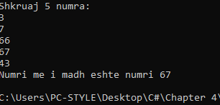

**9.**

int sum = 0;

Console.Write("Enter numbers count: ");

int length = Int32.Parse(Console.ReadLine());

for (int i = 0; i < length; i++)

{

Console.Write("Shkruaje numrin e {0}: ", i + 1);

sum += Int32.Parse(Console.ReadLine());

}

Console.WriteLine("Shuma e te gjithe numrave eshte {0}.", sum);

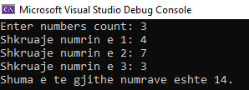

**10.**

int sum = 0;

Console.Write("Enter number: ");

int length = Int32.Parse(Console.ReadLine());

for (int i = 1; i <= length; i++)

{

Console.WriteLine(i);

}

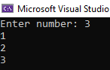

**11.** int num1 = 0;

int num2 = 1;

int sum = 1;

int count = 0;

Console.WriteLine(num1);

while (count < 100)

{

sum = num1 + num2;

num1 = num2;

num2 = sum;

Console.WriteLine(num2);

count++;

}

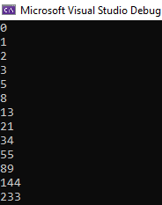

**12.**

Console.Write("Enter last number: ");

int length = Int32.Parse(Console.ReadLine());

double sum = 1.0;

for (int i = 2; i <= length; i++)

{

sum += (1.0 / i);

}

Console.WriteLine("{0:F3}", sum);

