**Loops**

**1.**

Console.Write("Enter a number: ");

int length = Int32.Parse(Console.ReadLine());

for (int i = 1; i < length; i++)

Console.WriteLine(i);

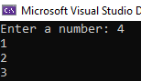

**2.**

Console.Write("Enter N: ");

int length = int.Parse(Console.ReadLine());

for (int i = 1; i < length; i++)

{

if (i % (3 * 7) != 0) Console.Write(i + ", ");

}

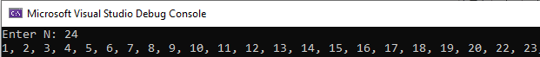

**3.**

int meivogli = 0;

int meimadhi = 0;

int input;

Console.Write("Shkruaj gjatesin e numrave: ");

int gjatesia = int.Parse(Console.ReadLine());

for (int i = 0; i < gjatesia; i++)

{

Console.Write("Shkruaje numrin: ");

input = int.Parse(Console.ReadLine());

if (i == 0) meivogli = meimadhi = input;

else

{

if (meivogli > input) meivogli = input;

if (meimadhi < input) meimadhi = input;

}

}

Console.WriteLine("Me i vogli - {0}, Me i madhi - {1}", meivogli, meimadhi);

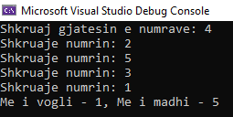

**4.**

for (int i = 0; i < 4; i++)

{

if (i != 0) Console.WriteLine();

for (int j = 0; j < 13; j++)

{

switch (i)

{

case 0: Console.Write("Hearts "); break;

case 1: Console.Write("Diamonds "); break;

case 2: Console.Write("Spades "); break;

case 3: Console.Write("Clubs "); break;

}

switch (j)

{

case 0: Console.WriteLine("2"); break;

case 1: Console.WriteLine("3"); break;

case 2: Console.WriteLine("4"); break;

case 3: Console.WriteLine("5"); break;

case 4: Console.WriteLine("6"); break;

case 5: Console.WriteLine("7"); break;

case 6: Console.WriteLine("8"); break;

case 7: Console.WriteLine("9"); break;

case 8: Console.WriteLine("10"); break;

case 9: Console.WriteLine("J"); break;

case 10: Console.WriteLine("Q"); break;

case 11: Console.WriteLine("K"); break;

case 12: Console.WriteLine("A"); break;

}

}

}

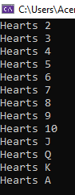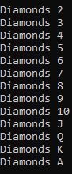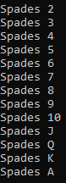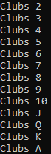

**5.**

int numri1 = 0, numri2 = 1, numri3 = 0;

Console.Write("Shkruaje numrin: ");

int gjatesia = int.Parse(Console.ReadLine());

Console.Write("0, 1,");

for (int i = 2; i < gjatesia; i++)

{

numri3 = numri1 + numri2;

Console.Write(" {0},", numri3);

numri1 = numri2;

numri2 = numri3;

}



**6.**

Console.Write("Enter N: (1<K<N) ");

int n = Int32.Parse(Console.ReadLine());

Console.Write("Enter K: (1<K<N) ");

int k = Int32.Parse(Console.ReadLine());

for (int i = n - 1; i > 0; i--)

{

n *= i;

}

for (int i = k - 1; i > 0; i--)

{

k *= i;

}

n /= k;

Console.WriteLine("Result is {0}", n);

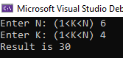

**7.**

Console.Write("Enter N: (1<K<N) ");

int n = Int32.Parse(Console.ReadLine());

Console.Write("Enter K: (1<K<N) ");

int k = Int32.Parse(Console.ReadLine());

int nMinusK = n - k;

for (int i = n - 1; i > 0; i--) n *= i;

for (int i = k - 1; i > 0; i--) k *= i;

for (int i = nMinusK - 1; i > 0; i--) nMinusK *= i;

Console.WriteLine("Result is {0}", n * k / nMinusK);

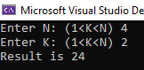

**8.**

Console.Write("Enter N: (N >=0 ) ");

int n = Int32.Parse(Console.ReadLine());

int fact2N = 2 * n, factNplus1 = n + 1;

for (int i = fact2N - 1; i > 0; i--) fact2N *= i;

for (int i = factNplus1 - 1; i > 0; i--) factNplus1 *= i;

for (int i = n - 1; i > 0; i--) n *= i;

Console.WriteLine("Result is {0}", fact2N / (factNplus1 * n));



**9.**

int sum = 1, temp = 1;

Console.Write("Enter n: ");

int n = Int32.Parse(Console.ReadLine());

Console.Write("Enter x: ");

int x = Int32.Parse(Console.ReadLine());

for (int i = 1; i <= n; i++)

{

temp *= i / x;

sum += temp;

}

Console.WriteLine("Result is {0}", sum);

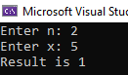

**11.**

Console.Write("Enter N: ");

decimal n = Int32.Parse(Console.ReadLine());

int zeroes = 0;

for (int i = (int)(n - 1); i > 0; i--)

n *= i;

Console.Write("N! is {0} and it ends ", n);

do

{

n /= 10;

zeroes++;

} while (n % 10 == 0);

Console.WriteLine("with {0} zeros.", zeroes);



**12.**

Console.Write("Enter number: ");

int n = Int32.Parse(Console.ReadLine());

string binary = Convert.ToString(n, 2);

Console.WriteLine("Result is {0}", binary);



**13.**

Console.Write("Enter the Binary Number : ");

int binaryNumber = int.Parse(Console.ReadLine());

int decimalValue = 0;

int base1 = 1;

while (binaryNumber > 0)

{

int reminder = binaryNumber % 10;

binaryNumber = binaryNumber / 10;

decimalValue += reminder * base1;

base1 = base1 * 2;

}

Console.Write($"Decimal Value : {decimalValue} ");



**14.**

using System;

class GFG

{

static void decToHexa(int n)

{

char[] hexaDeciNum = new char[100];

int i = 0;

while (n != 0)

{

int temp = 0;

temp = n % 16;

if (temp < 10)

{

hexaDeciNum[i] = (char)(temp + 48);

i++;

}

else

{

hexaDeciNum[i] = (char)(temp + 55);

i++;

}

n = n / 16;

}

for (int j = i - 1; j >= 0; j--)

Console.Write(hexaDeciNum[j]);

}

public static void Main(String[] args)

{

Console.Write("Shkruaj nje numer decimal: ");

int n = int.Parse(Console.ReadLine());

decToHexa(n);

}

}



**15.**

Console.WriteLine("Shkruaj nje numer hexadecimal: ");

string hexval = Convert.ToString(Console.ReadLine());

Console.WriteLine("Hexadecimal number: " + hexval);

int decValue = int.Parse(hexval, System.Globalization.NumberStyles.HexNumber);

Console.WriteLine("Convert to-");

Console.WriteLine("Decimal number: " + decValue);

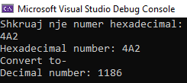

**16.**

Random rnd = new Random();

int temp, randomNumber;

Console.Write("Enter number: ");

int n = Int32.Parse(Console.ReadLine());

int[] arr = new int[n];

for (int i = 0; i < arr.Length; i++)

{

arr[i] = i;

}

foreach (int i in arr)

{

randomNumber = rnd.Next(0, n);

temp = arr[i];

arr[i] = arr[randomNumber];

arr[randomNumber] = temp;

}

foreach (int i in arr) Console.WriteLine(arr[i]);

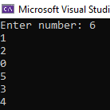

**17.**

Console.Write("Enter first number: ");

int a = Int32.Parse(Console.ReadLine());

Console.Write("Enter second number: ");

int b = Int32.Parse(Console.ReadLine());

while (a != 0 && b != 0)

{

if (a > b) a %= b;

else b %= a;

}

if (a == 0) Console.WriteLine(b);

else Console.WriteLine(a);

