Curriculum Vitae
Personal Information
English Name: | Edith | Chinese Name: | 屈怡婷 | 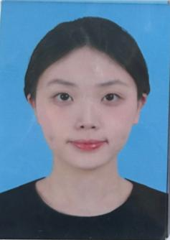
Gender: | Female | Date of Birth: | 02/10/2005
ID No.: | 430407200510020021 | Student ID No.: | dc328581
Major: | Computer Science | Year of Study: | 3
Telephone/  Mobile: | +86 13307476223  (Macau)66722740 | Email: | dc32858@um.edu.mo
Address: | Xiangjiang Waterfront New City, Zhengxiang District, Hengyang City, Hunan Province
Working/Training Experience
Internship:Sinotrans Air Transport Co., Ltd. Wuhan Branch
- Master the business logic and operation of customs declaration, human resources (recruitment/training/performance), and sales (inquiry/quotation) systems
- Using computer expertise to optimize system operation processes and improve business processing efficiency
- Ensure the stable operation of the system throughout the entire process and complete internship tasks with high quality
Project:NLP Lab Research Project
- Participate in cutting-edge research in the field of natural language processing, focusing on the medical field;
- Build an experimental environment using Python, PyTorch, and Hugging Face toolchain, responsible for developing data preprocessing and model training modules;
- Participate in weekly group meetings and academic seminars, assist in organizing experimental ideas, iterating optimization plans, and synchronously organizing experimental records and stage reports.
Activity Participation
RC Office
Manage the order of the academy
Organize documents, summarize information, etc
Hobby/Interest
Language: English; Chinese
Technical Skills: Python, C, C++, Java, Web Development, Algorithm Design, Digital Image Processing, WPS
Hobbies: Photography,Edit
Self-Introduction
Third-year Computer Science student at the University of Macau, with a solid grasp of foundational programming skills in Python, C/C++, and Java. Currently participating in NLP research in the medical domain, where I assist in building experimental environments and developing data preprocessing modules. During my internship, I leveraged my technical background to understand and optimize the operation of customs declaration, HR, and sales systems, improving daily processing efficiency. I am a proactive learner, eager to apply and expand my technical skills in practical scenarios.

