Assignment 4

I have modified the grid_mapper assignment to have 5cm resolution. I ran experiment on a simulated environment and the map perfectly fits the expected area. Following are some screen shots from the simulator data.

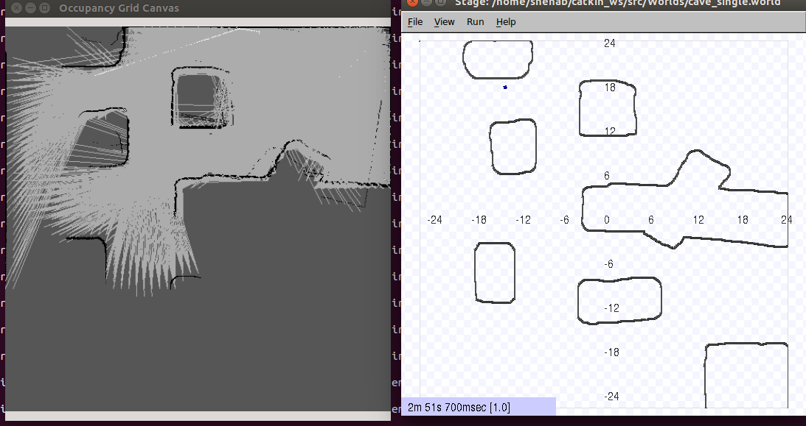

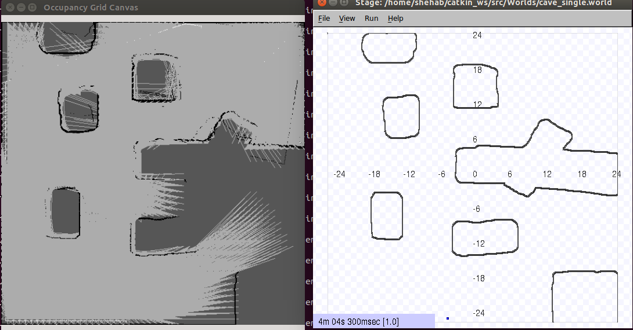

As the next part of the project I used my program to map a portion of 3rd floor hallway in swearingen and some part of my office. The map was roughly accurate. I have attached some screen shots of that experiment as well.

