Assignment 5

The individual part of this assignment was about implementing the propagation model of a particle filter. I did the particle filter experiment with two basic behavior from assignment 4 as mentioned in the description.

**My Implementation:**

I have implemented the particle filter propagation step assuming both the translation and rotation noise as a independent normal distribution with mean 0, and some suitable variance ( from general idea from previous experiments )

default_random_engine lgenerator(234254);

default_random_engine agenerator(412356);

normal_distribution<**double**> linearErrorModel(0.0,0.006) ; //(mean,var)

normal_distribution<**double**> angularErrorModel(0,0.0002);//(mean,var)

**Propagation:**

I initialized the experiment with 20 particles and propagated along the time stamps based on the velocity command which stored in a bag file. I want to mention that I did not implement the resampling part. The propagation was done just with vector rotation and translation.

**Experiment 1 ( translate 5 meter):**

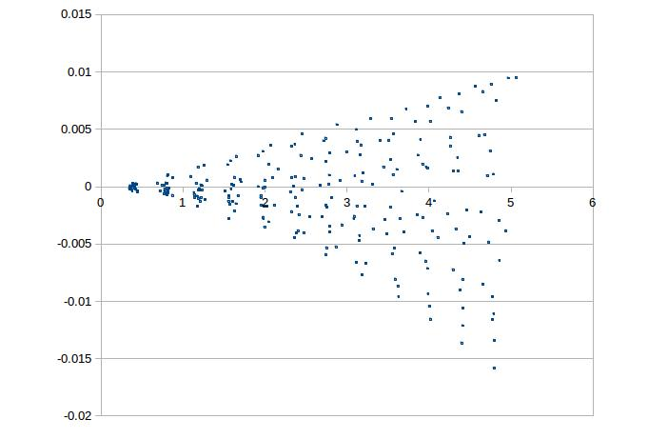

Fig: Particles in a 5 meter translation experiment

**Experiment 2 ( 1 square meter move ):**

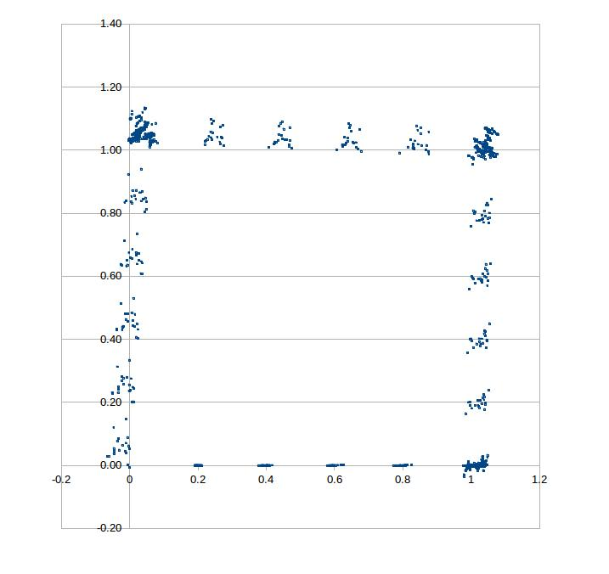

Fig: Particles in 1 square meter move experiment.

**Analysis:**

I pretty much got the results I expected. For the translation I kind of expected the banana shape, and I believe I did not get it because I have less number of particles and did not do the resampling.