**To Good To Go**

1. The project is a free mobile application that connects restaurants and stores that have unsold, surplus food, with customers who can then buy whatever food the outlet considers surplus to requirements (without the ability to choose) at a much lower price than normal.

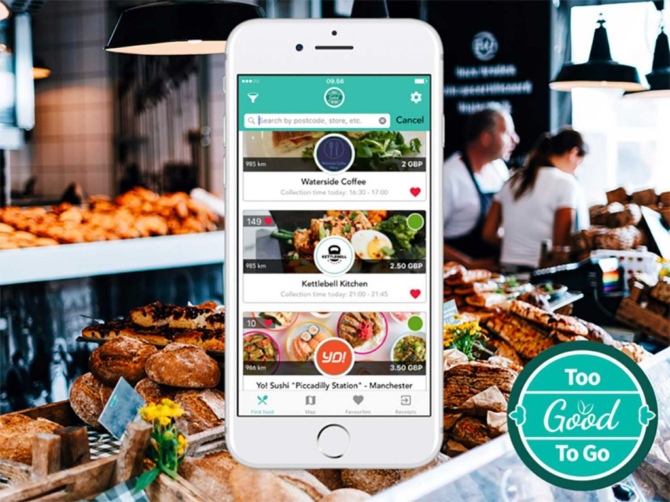

1. The application covers major European cities and started operations in North America.
2. A mobile phone running Android or iOS is required and must be taken to the seller.
3. The potential customer runs the TGTG app, which shows what outlets have what sort of food available within a certain radius and in a specified timeslot, usually of 30 minutes or more.
4. If any is selected the customer pays for it in a way compatible with the phone, and collects within the timeslot; the app's display confirming payment is shown, and the transaction is finalised by swiping the app to confirm collection.

**DamoGO**

1. 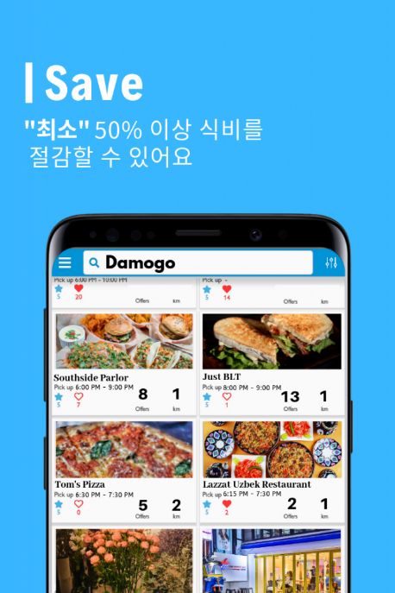DamoGo has 3 working business models:
2. Restaurants and other food retailers that upload the day’s perfectly good, unsold food for any customer to purchase instead of letting it go to waste
3. It works with farms that sell their “ugly” fruits and vegetables to households
4. Distribution of the “ugly” fruits and vegetables to other food businesses.
5. DamoGO app works is simple by downloading the app and receiving notifications about available discounted food in stores nearby. The purchase can be made on the app, and then food picked up from the store later.
6. It was launched in South Korea in the middle of 2019 and currently also operating in Indonesia since May 2020.
7. Users save on average 50% off the regular price and Damogo’s B2B partners save 20-40%. DamoGO keeps 20% of every purchase on the app (B2C) and sells imperfect produce at 30-40% gross margin on the app to stores and users (B2C + B2B).

**OLIO**

1. Olio is a [mobile app](https://en.wikipedia.org/wiki/Mobile_app) for food-sharing, aiming to reduce [food waste](https://en.wikipedia.org/wiki/Food_waste). It does this by connecting those with surplus food to those who need or wish to consume such food. The food must be edible; it can be raw or cooked, sealed or open.

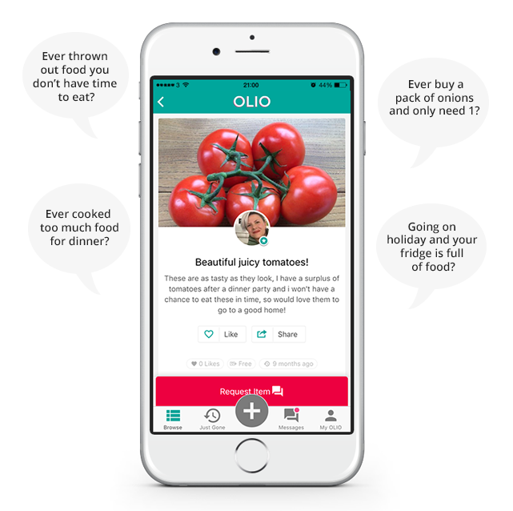

1. Those donating surplus food can be individuals or companies such as [food retailers](https://en.wikipedia.org/wiki/Grocery_store), [restaurants](https://en.wikipedia.org/wiki/Restaurant), [corporate canteens](https://en.wikipedia.org/wiki/Cafeteria), [food photographers](https://en.wikipedia.org/wiki/Food_photography) etc., and donations can take place on an ad-hoc or recurrent basis.
2. To make an item available, simply open the app, add a photo, description, and when and where the item is available for pick-up.
3. To access items, simply browse the listings available near you, request whatever takes your fancy and arrange a pick-up via private messaging.
4. The app wishes to be worldwide and can be downloaded from more than 40 countries. It is not really in the Asian market yet and available only in English and Spanish.