## ED KIIRU

**IPBC-BUILDING A CUBE**

## Building a Cube with Mortgage Data

Now that you have completed the Mortgage Project, it is time to learn how to build a cube out of the Dimension and Fact tables created in Story 6.

**Step 1: Prepare the Environment**

* **Install and configure SQL Server Analysis Services (SSAS) in Multidimensional Mode.**
* **Ensure your Fact_Financial and dimension tables (Dim_Borrower, Dim_Loan, Dim_Property) are correctly populated and available in your data warehouse.**

**Choose Impersonation Info (e.g., Windows Authentication).**

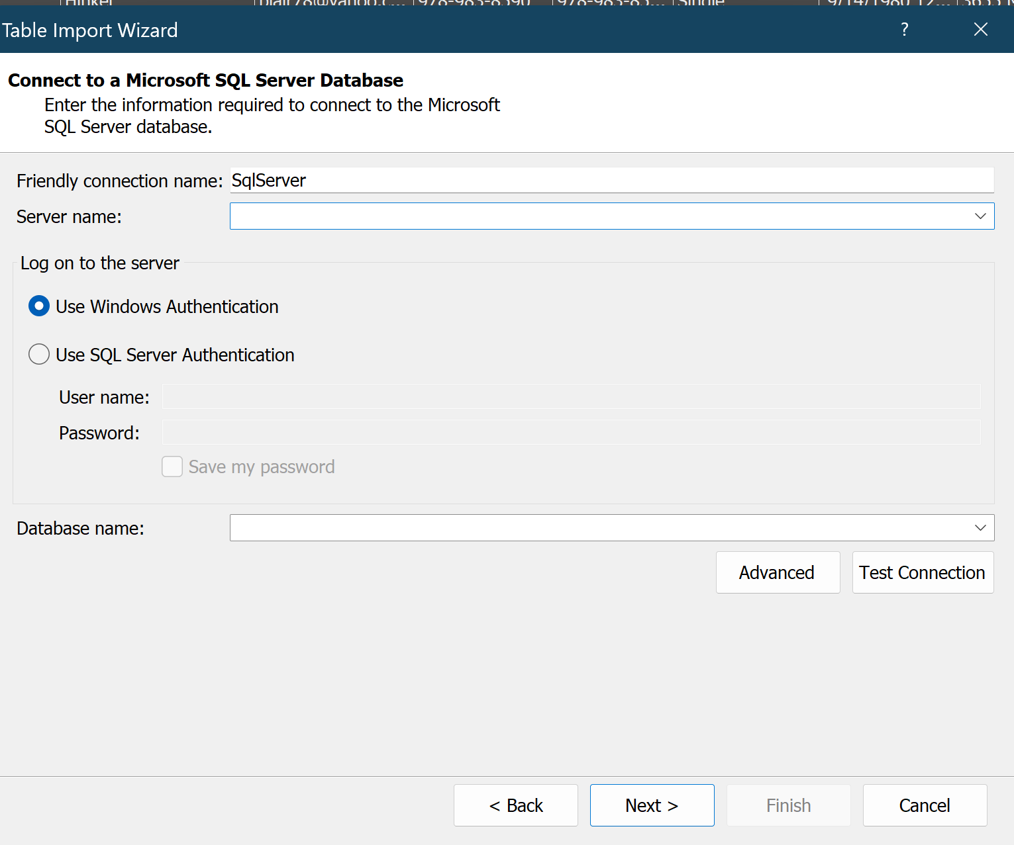

**• Open Visual Studio and select File → New Project.**

**• Choose Analysis Services Multidimensional and Data Mining Project.**

**• Name the project RGM_Datawarehouse.**

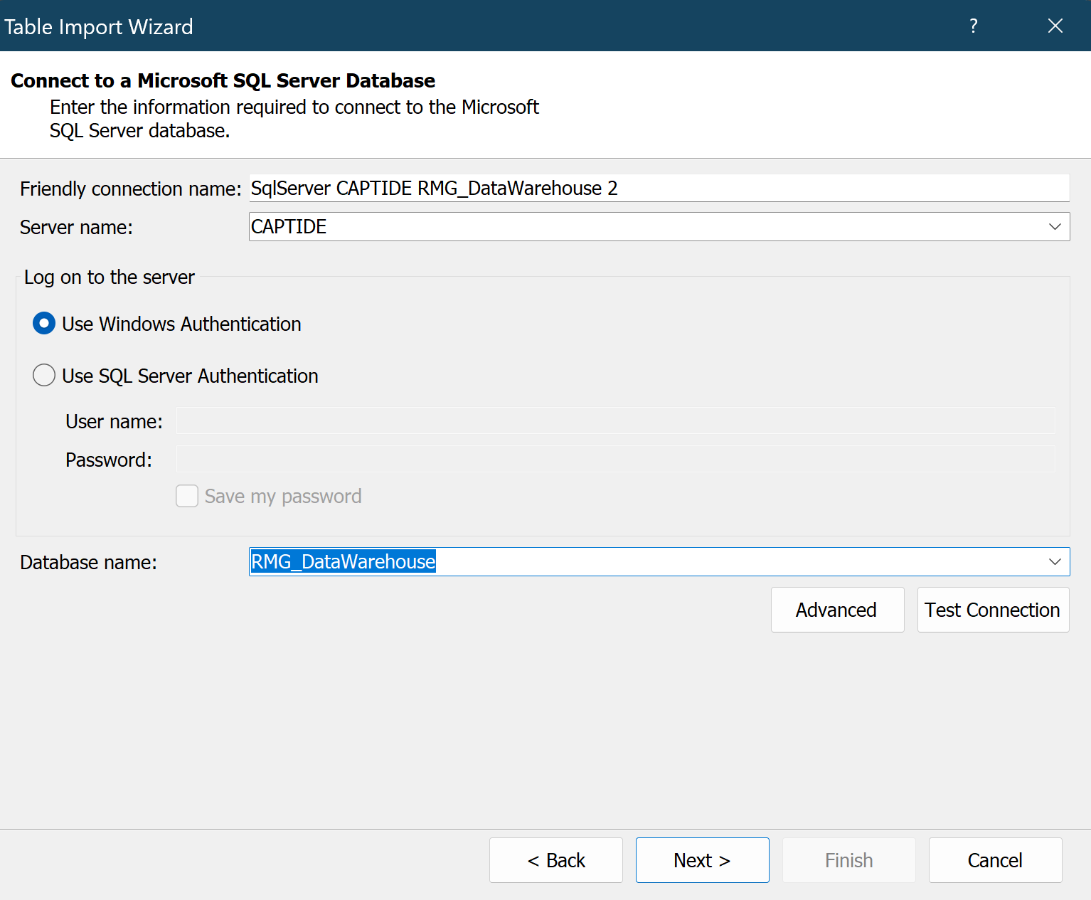

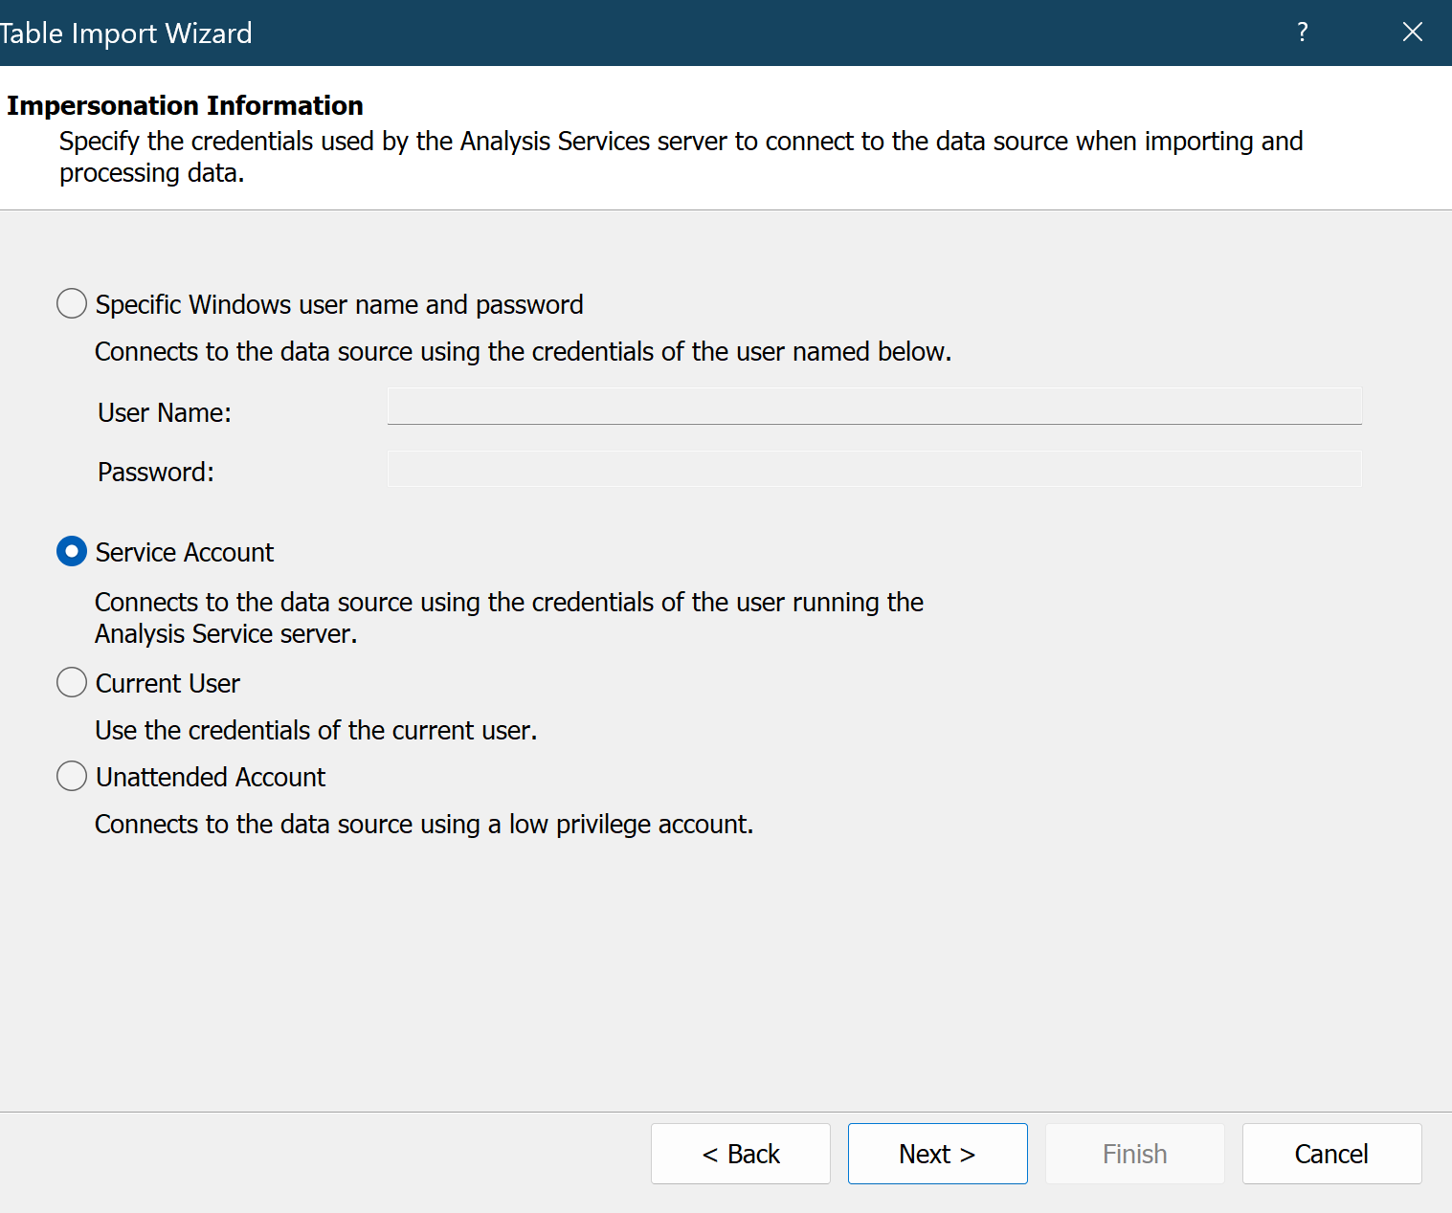

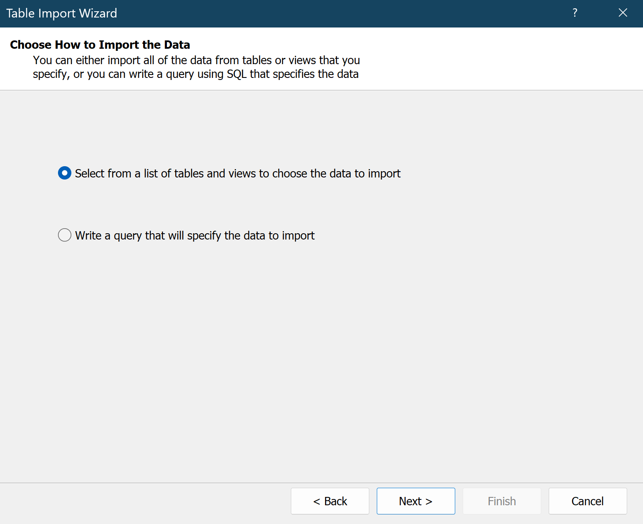

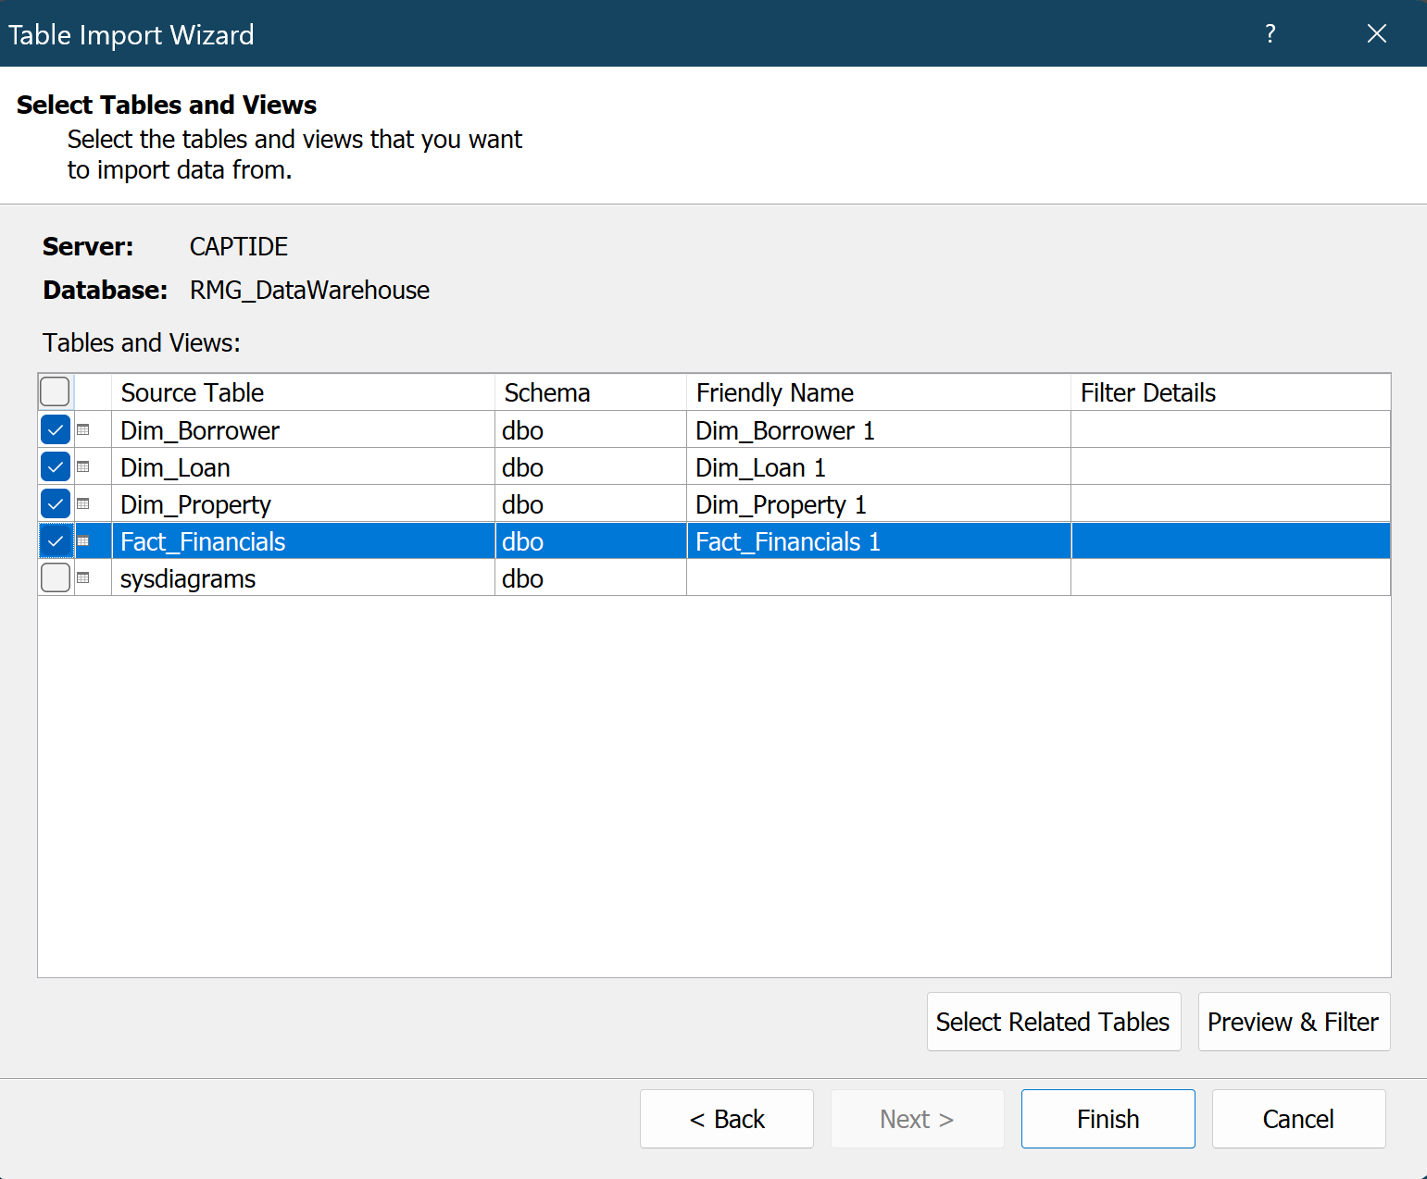

**Step 3: Create a Data Source**

1. **Right-click Data Sources → New Data Source.**
2. **Select the SQL Server Database where your fact and dimension tables reside.**
3. **Provide the connection details (server name, authentication, and database name).**
4. **Choose Impersonation Info (e.g., Windows Authentication).**

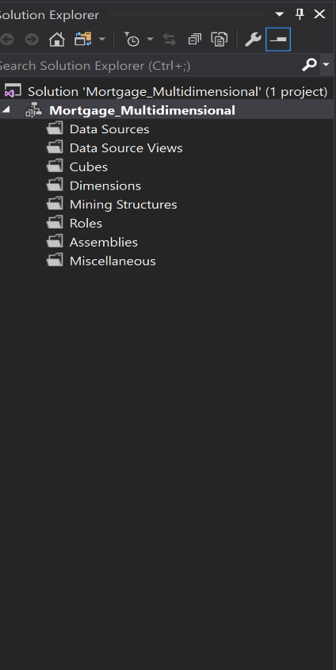

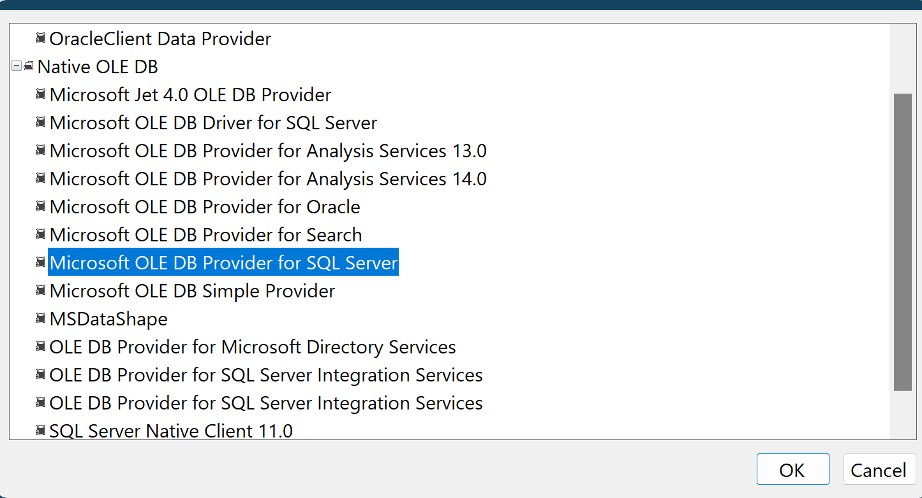

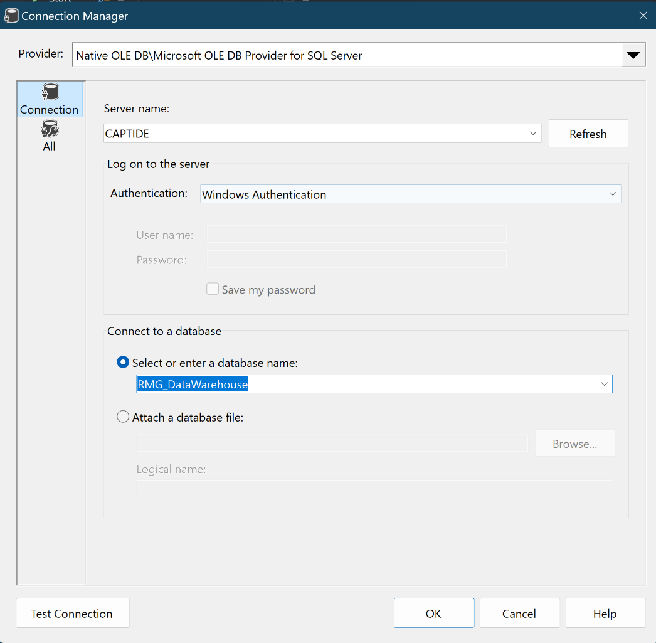

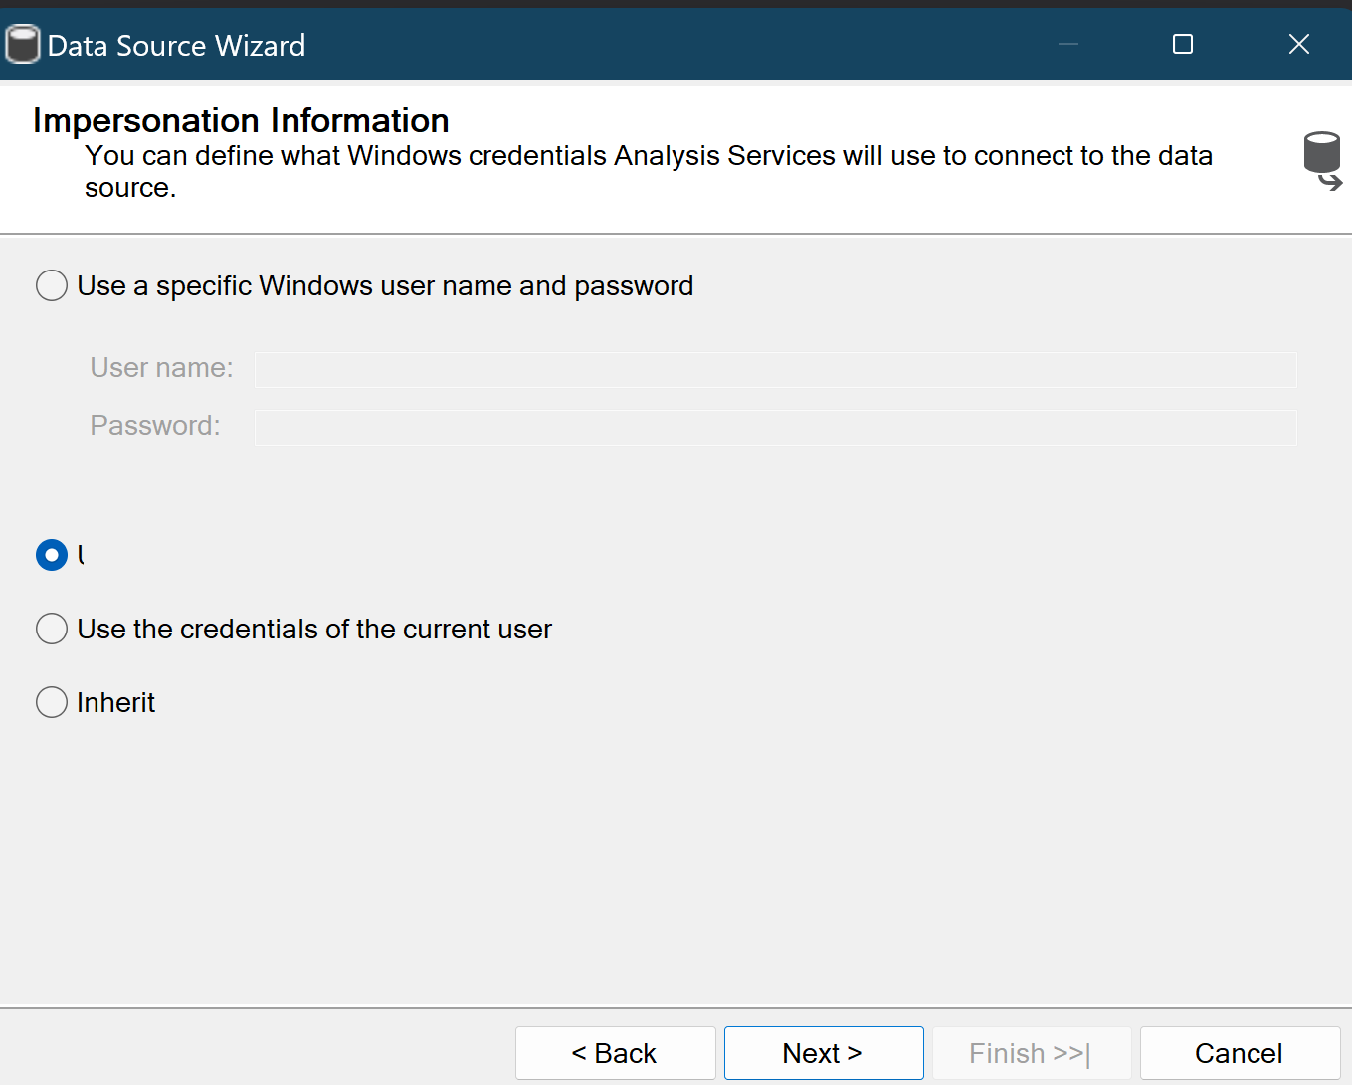

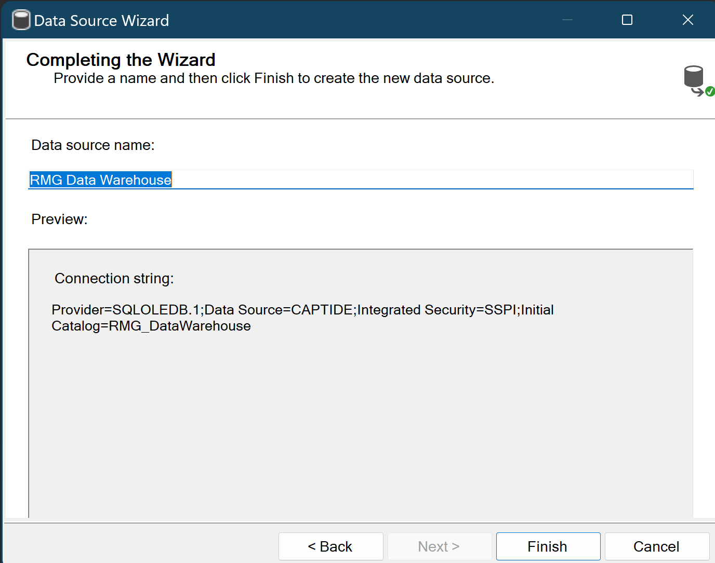

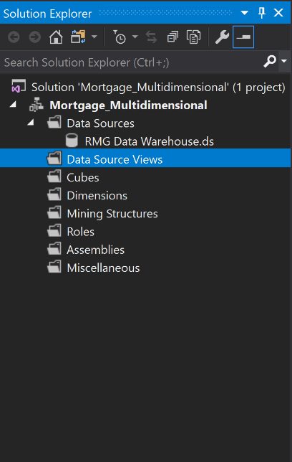

**Step 4: Create a Data Source View (DSV)**

1. **Right-click Data Source Views → New Data Source View.**
2. **Select the data source created in the previous step.**
3. **Add the following tables to the DSV:**
   * **Fact_Financial (fact table)**
   * **Dim_Borrower**
   * **Dim_Loan**
   * **Dim_Property**
4. **Confirm relationships between the fact table and dimension tables. If relationships are missing, add them manually in the DSV.**

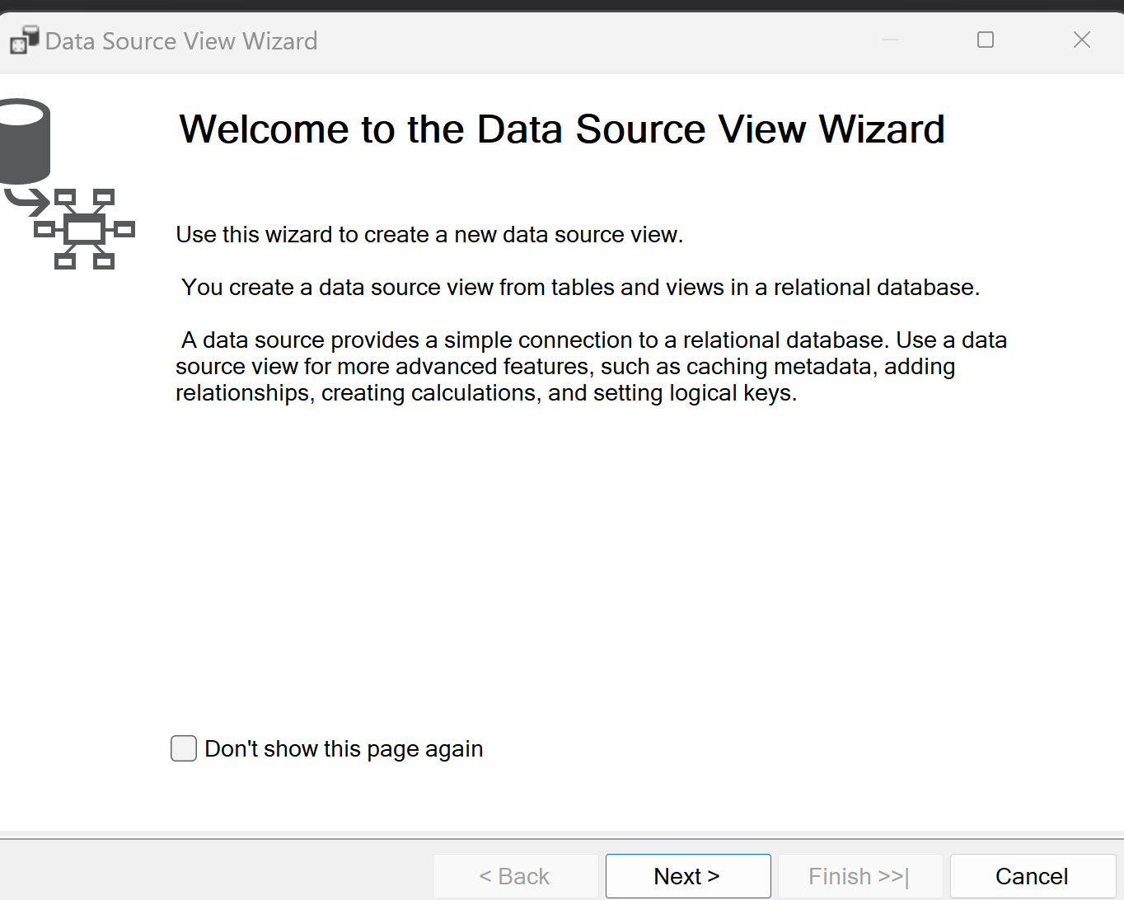

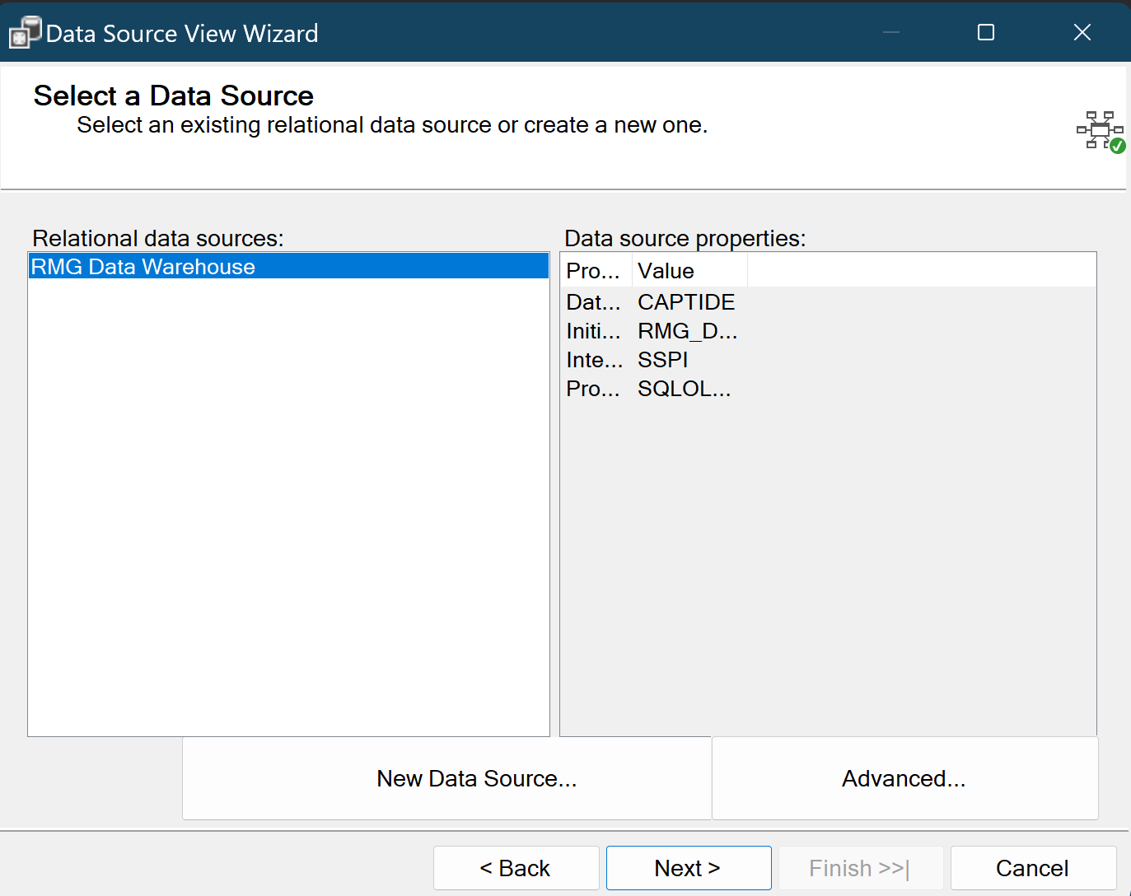

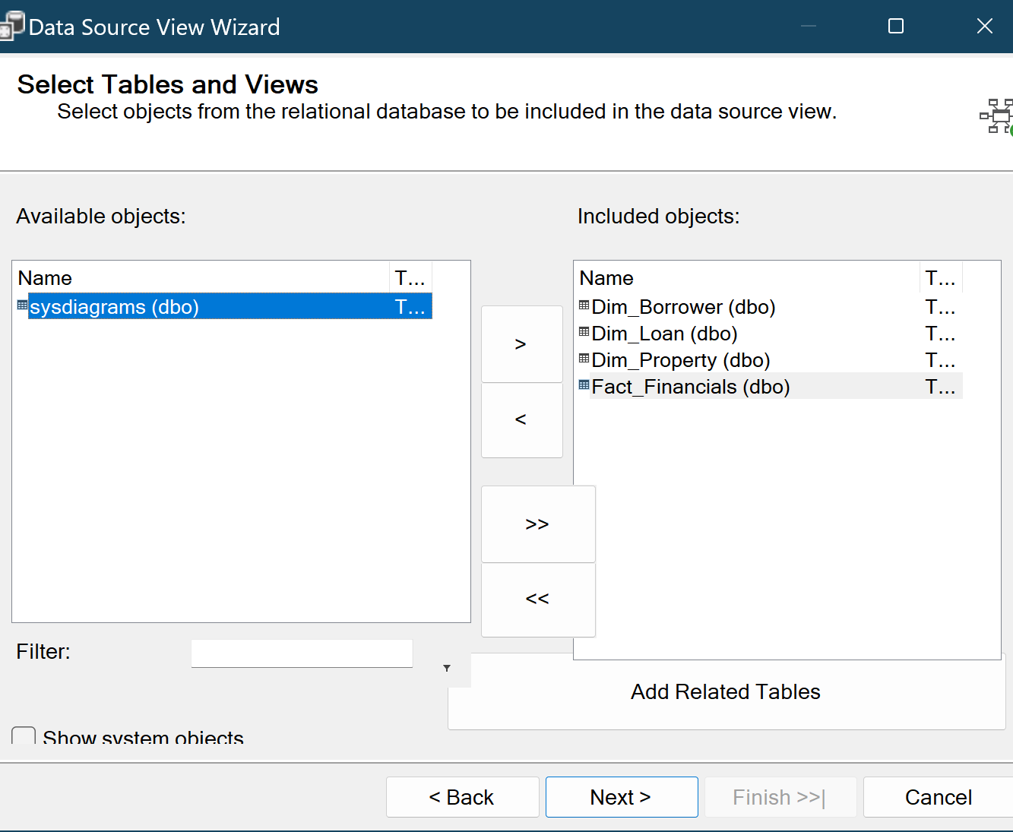

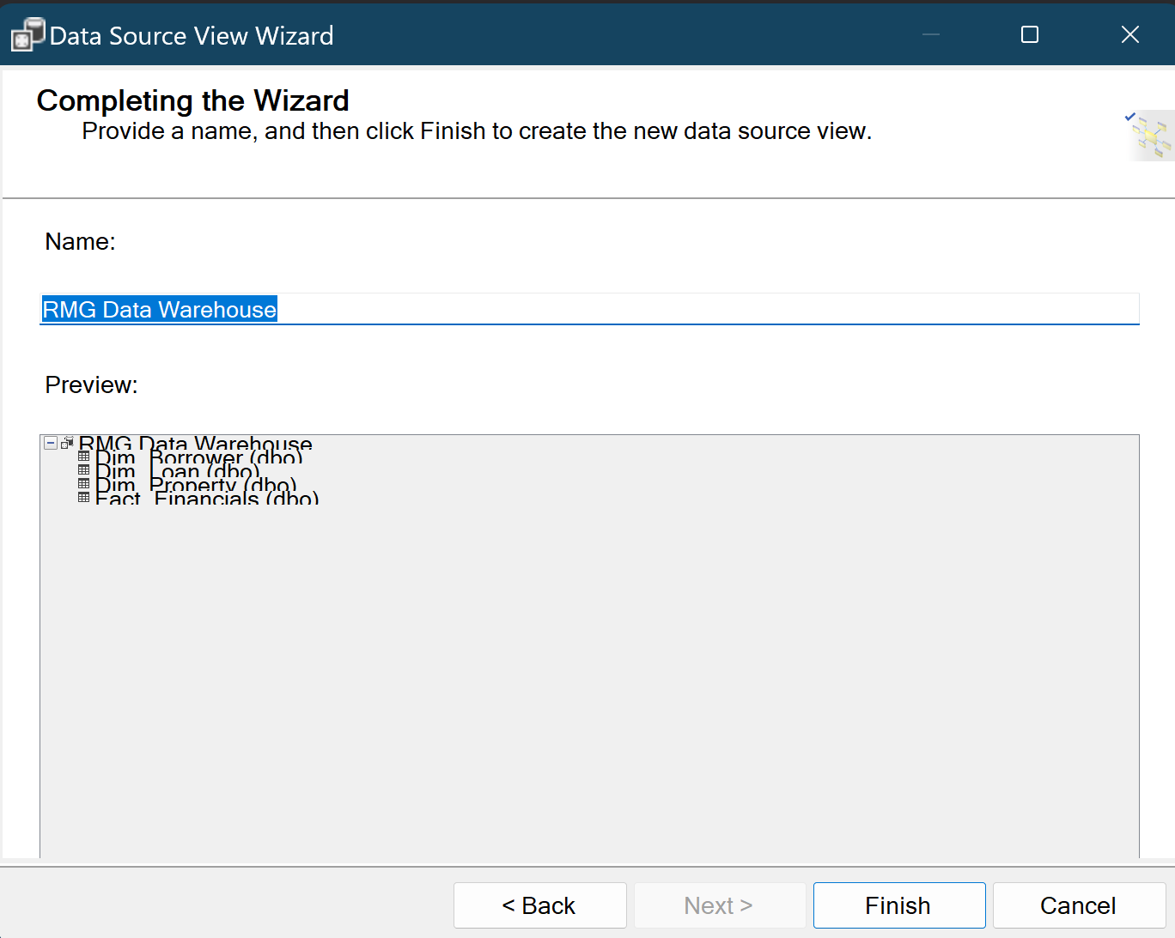

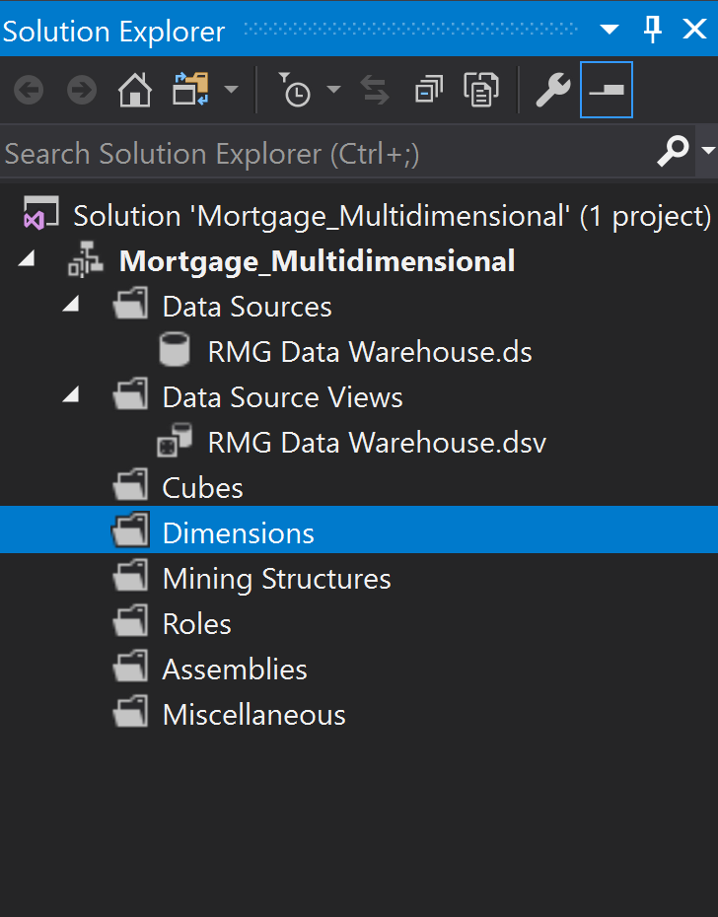

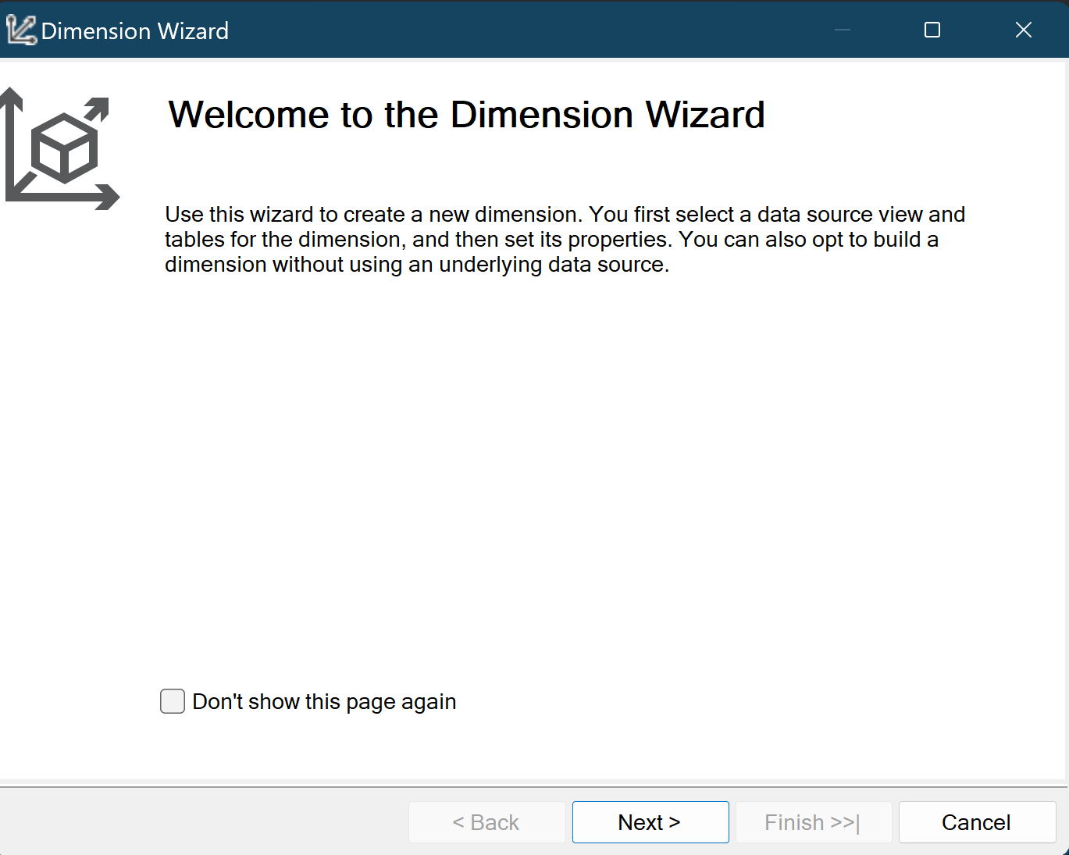

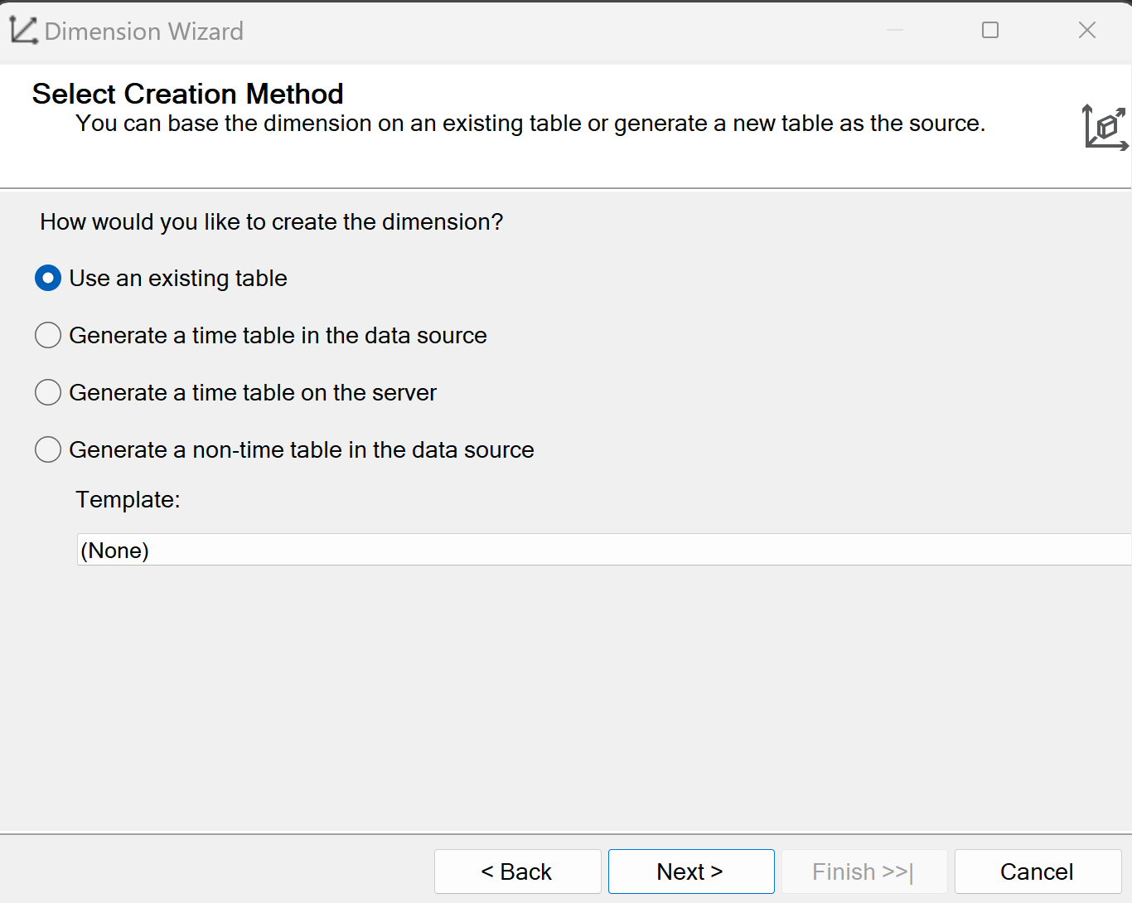

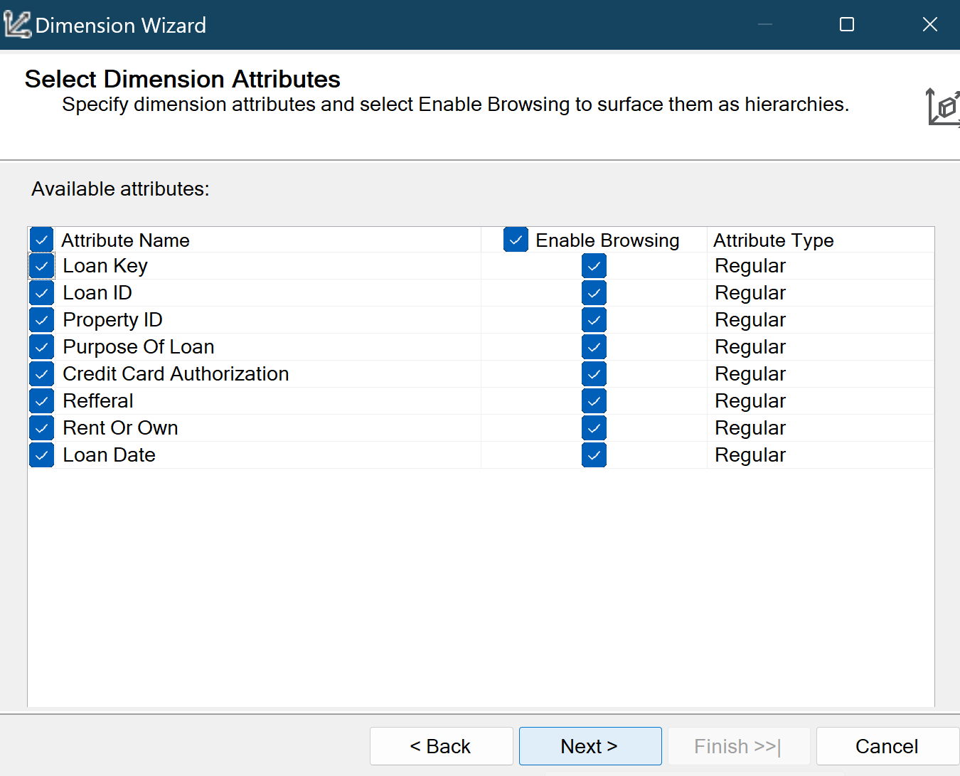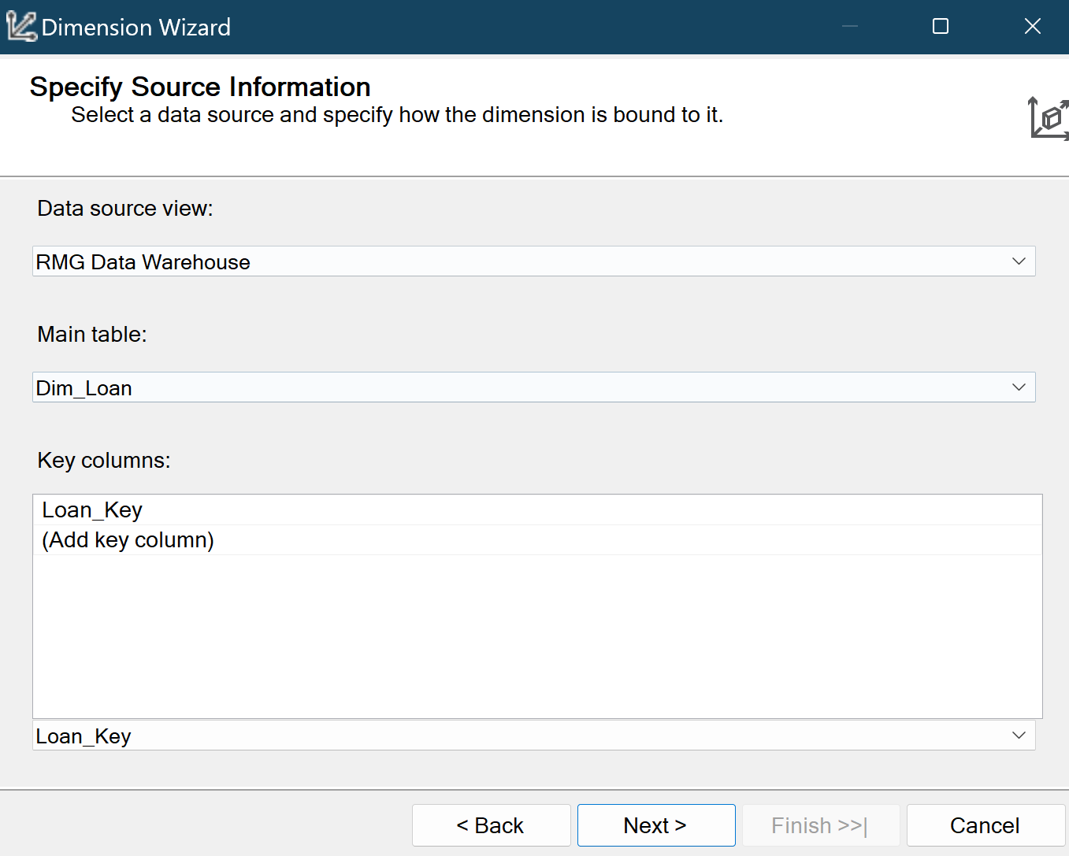

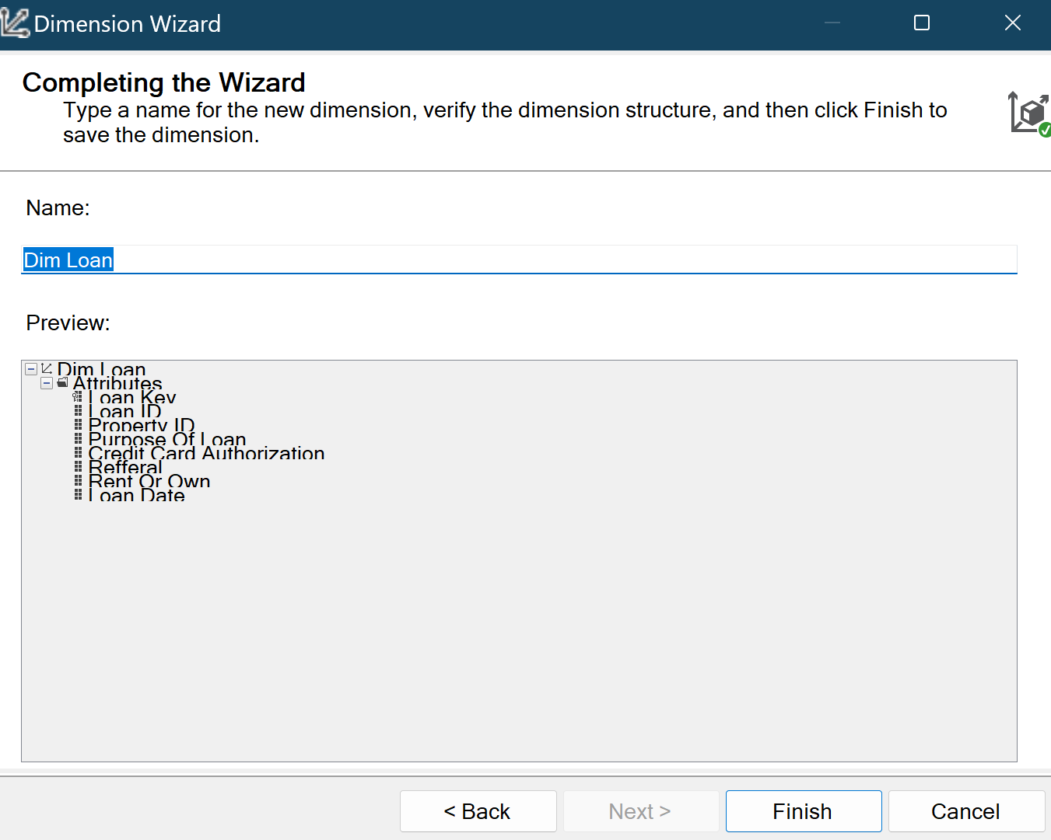

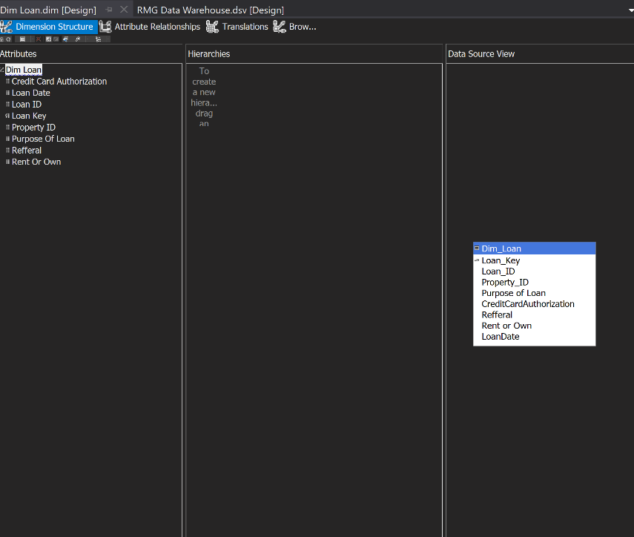

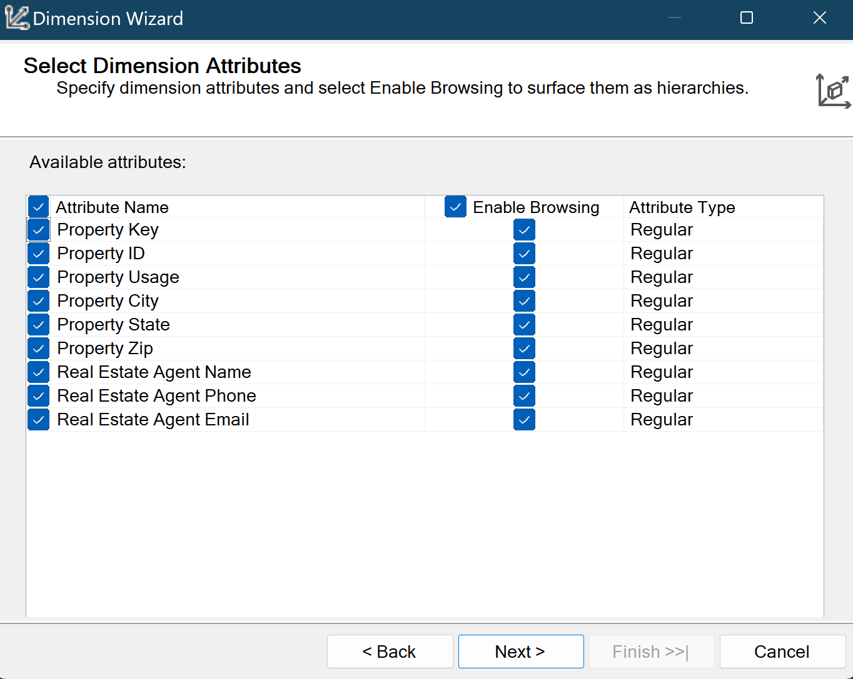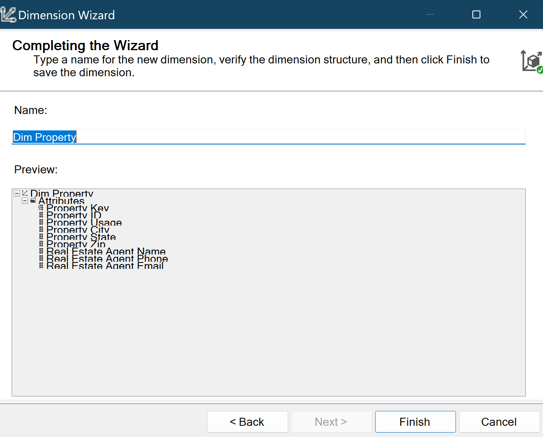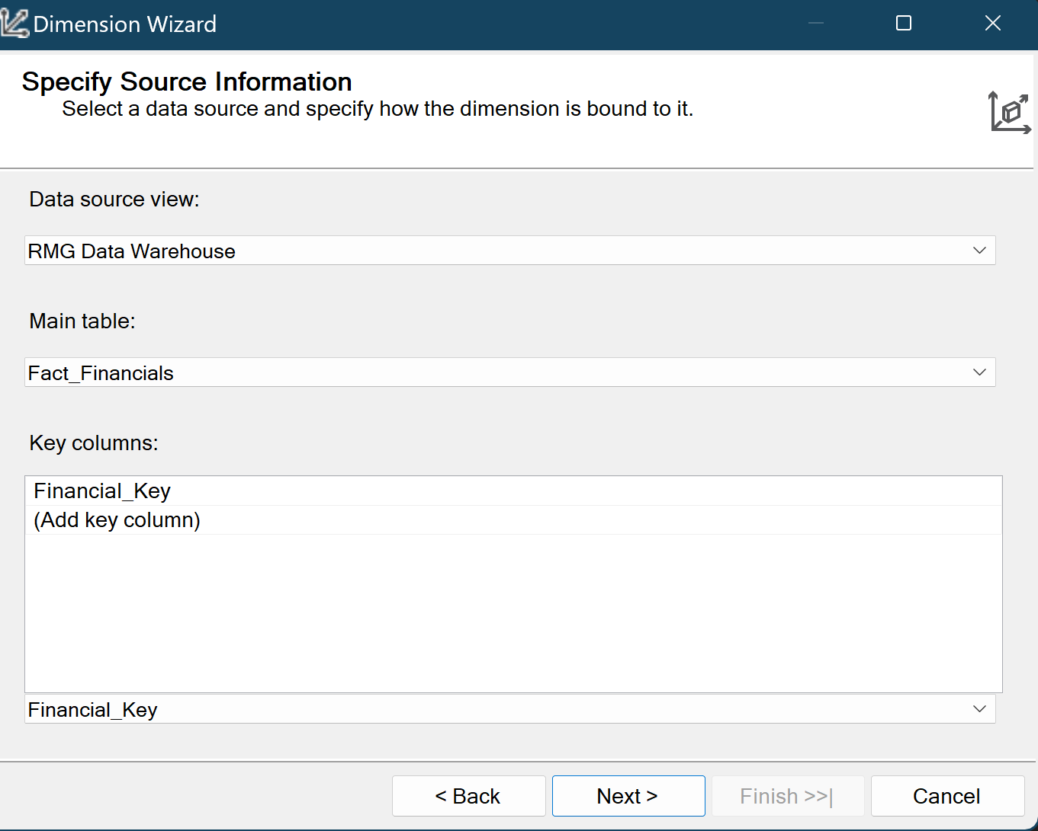

1. **Create a time dimension based on the Loan Date** (Link them with the Cube Attributes)

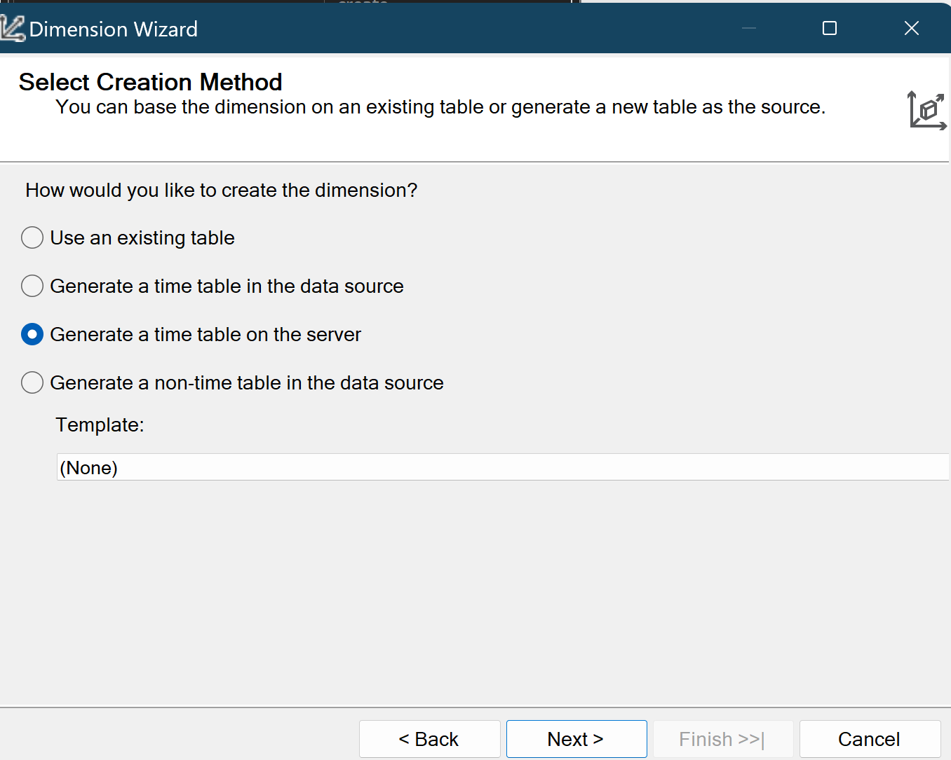

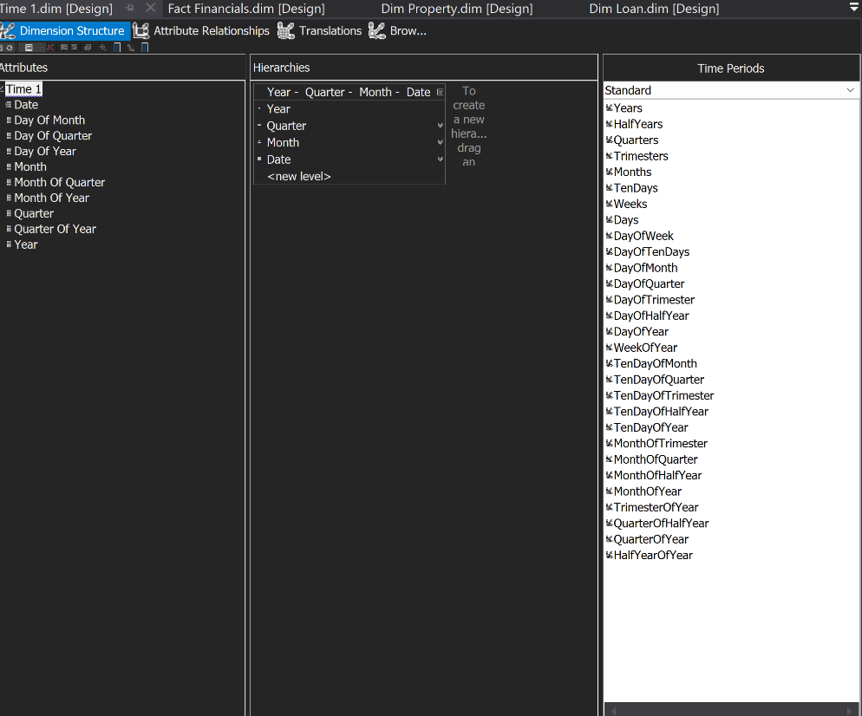

1. **Create a Hierarchy on the Time Dimension**

**

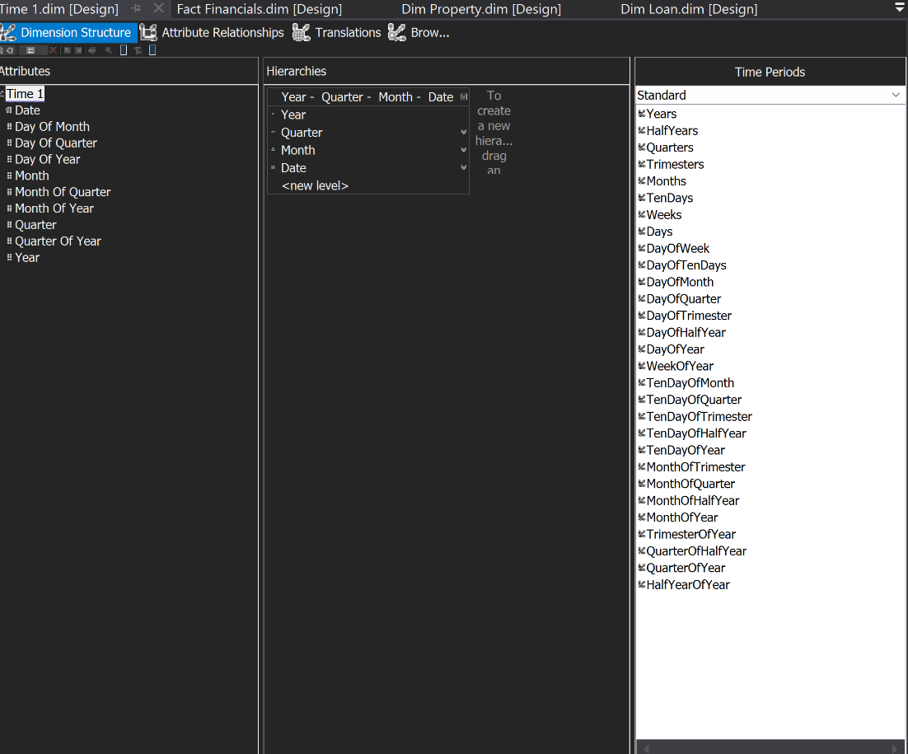

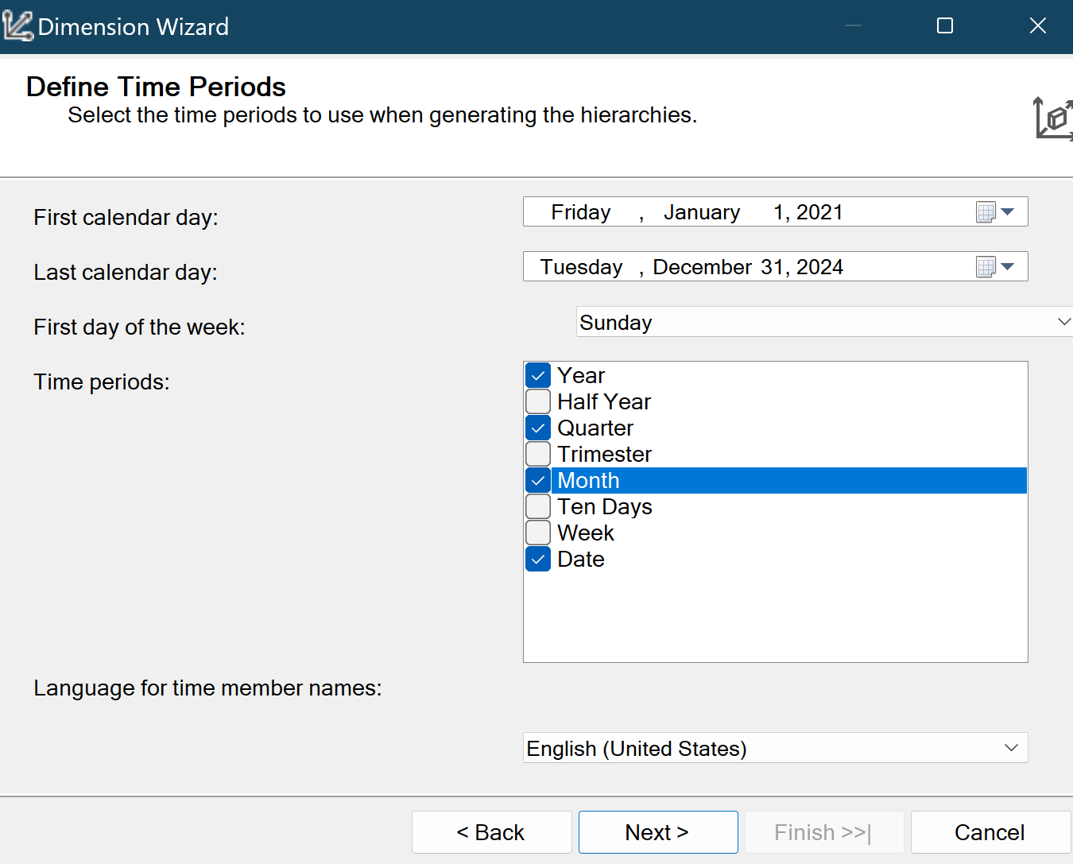

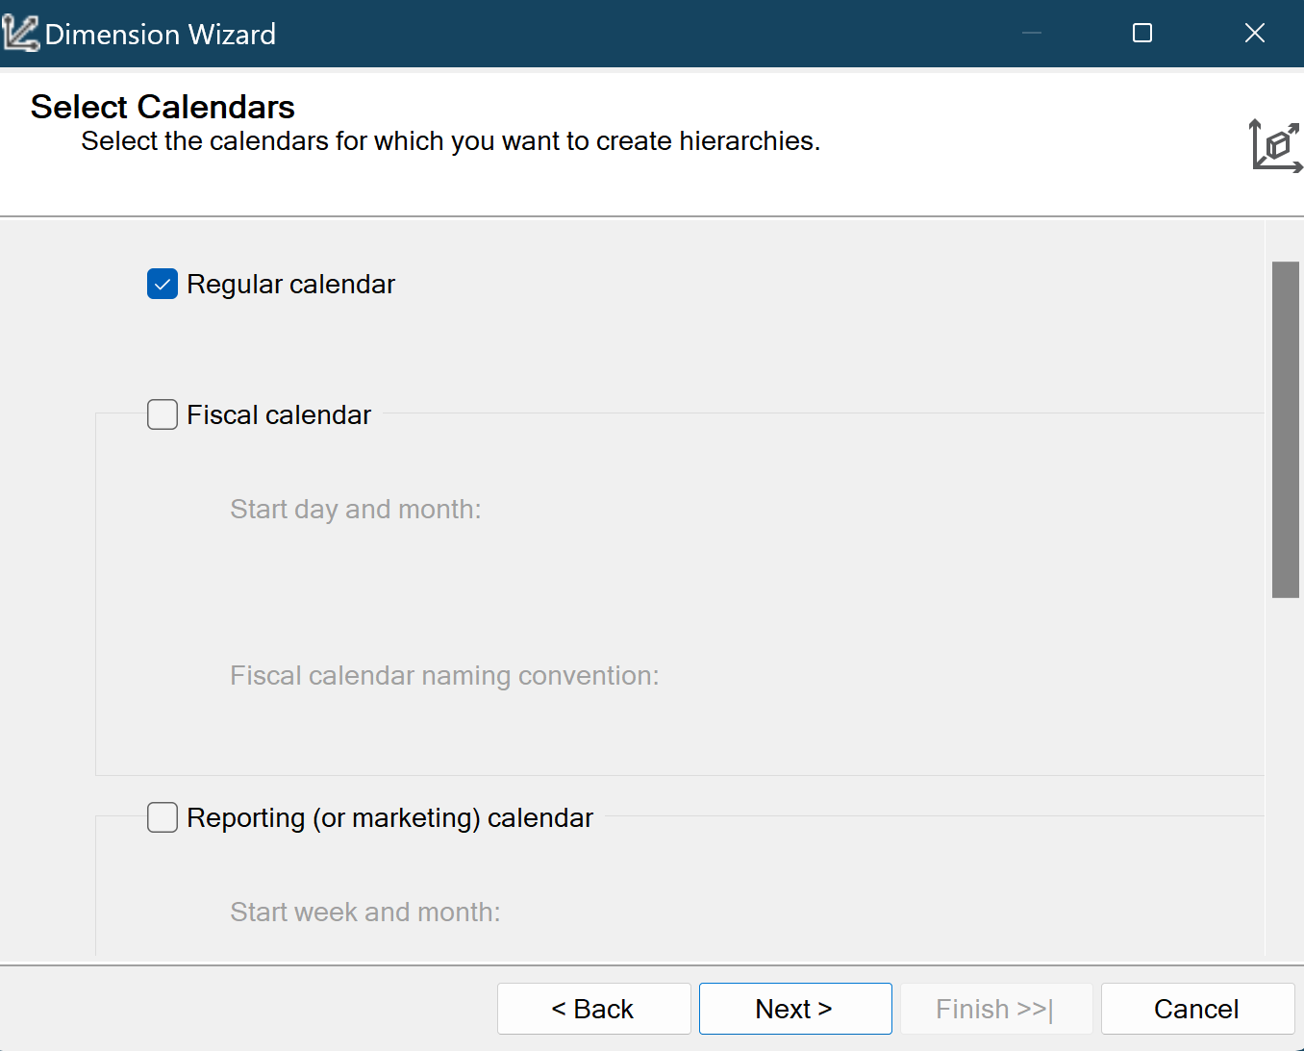

**Step 5: Create and process the Cube**

1. **Right-click Cubes → New Cube.**
2. **Choose Use Existing Tables and click Next.**
3. **Select Fact_Financial as the measure group (fact table).**
4. **Choose the appropriate aggregation measures (e.g., Sum, Count) from numeric columns in Fact_Financial.**
5. **Add the following dimensions:**
   * **Dim_Borrower**
   * **Dim_Loan**
   * **Dim_Property**

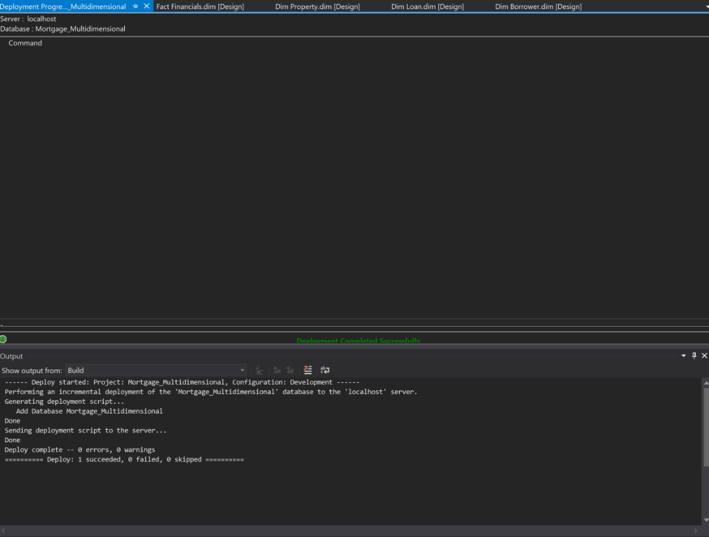

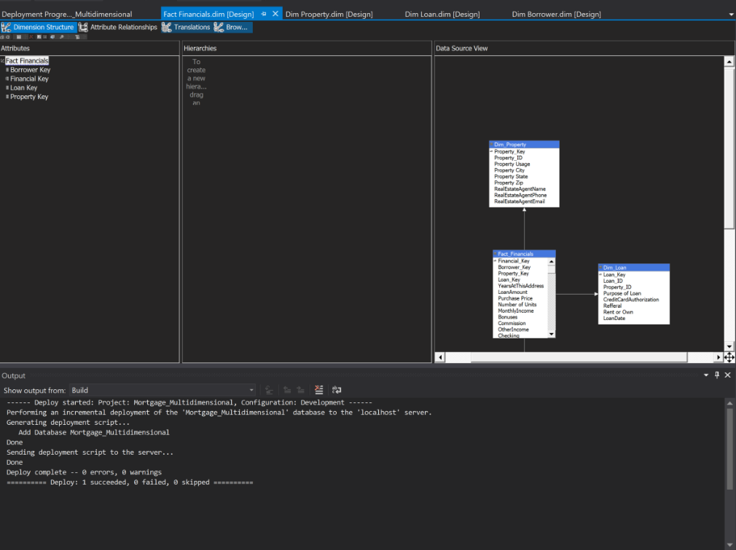

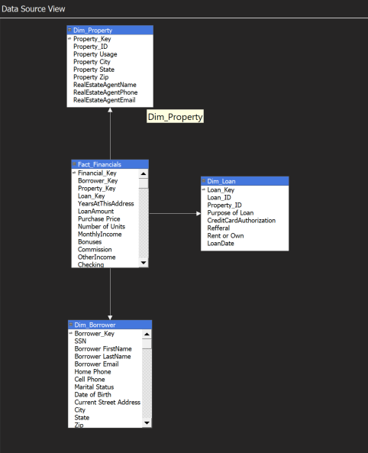

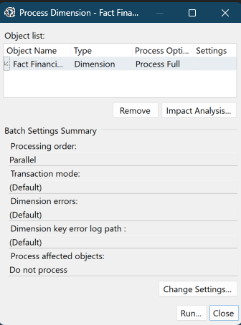

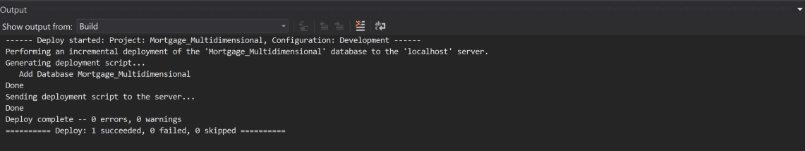

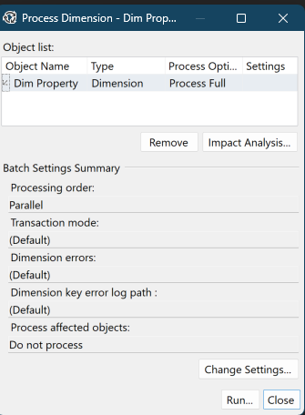

1. **Build an SSRS Report on the cube –** Be creative and build something visually appealing. Use the Time Dimension as a Parameter in your report.

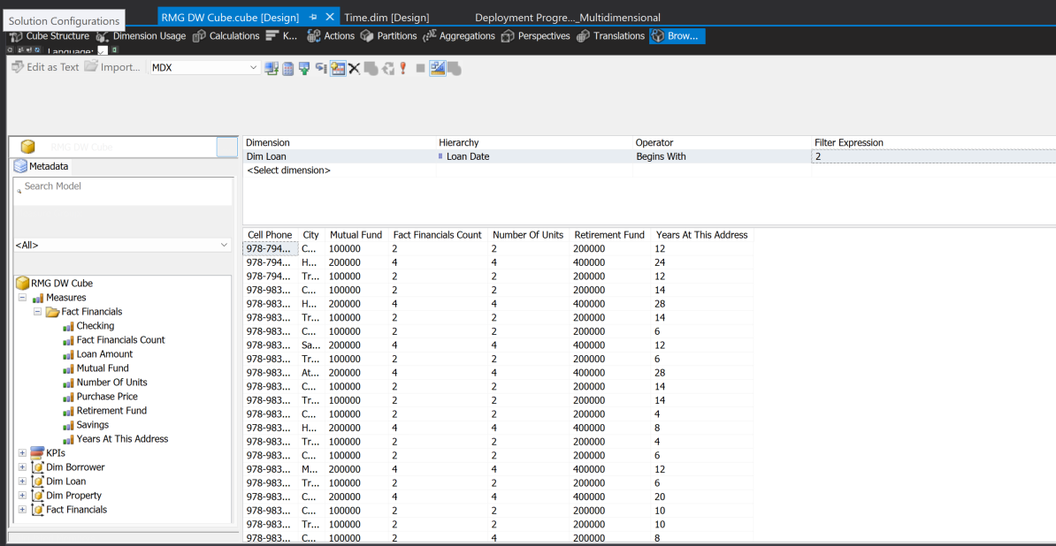

**Opened SSRS and created the data source and Dataset from the SSAS server. Gets the same quesry screen as in SSMS**

