ED KIIRU

Mortgage R2:SP5:Story 7

**Start a new Project**

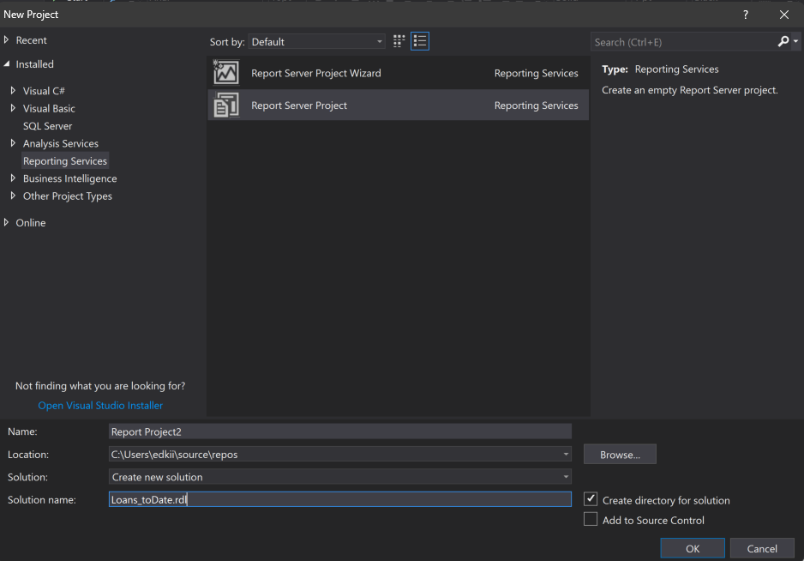

**Created the Stored procedure that will create the dataset and Parameters for for the report**

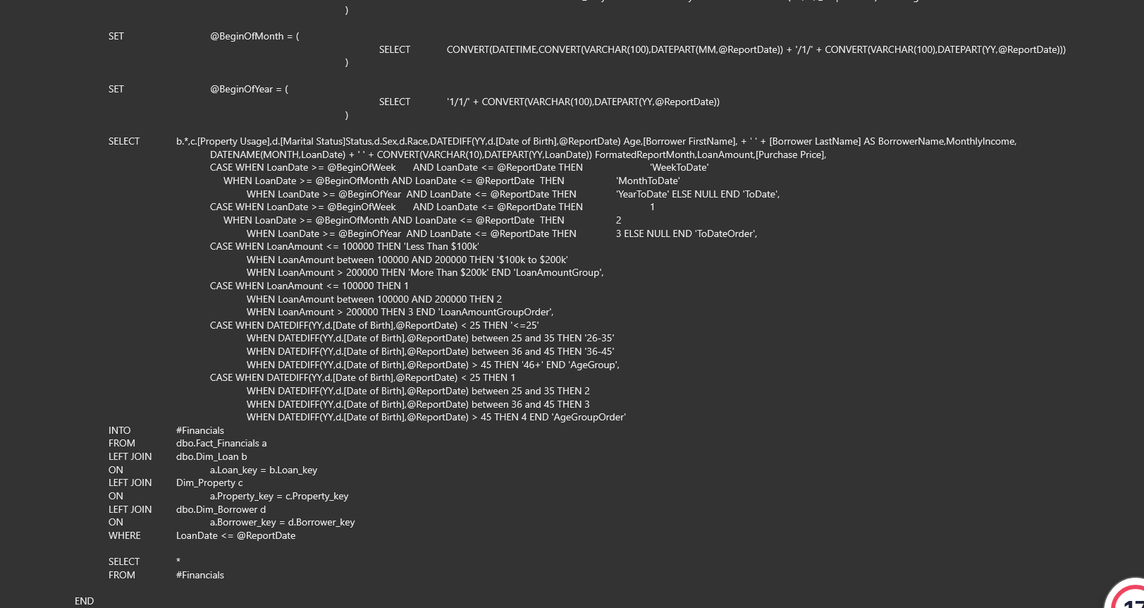



**Executed the stored procudure**

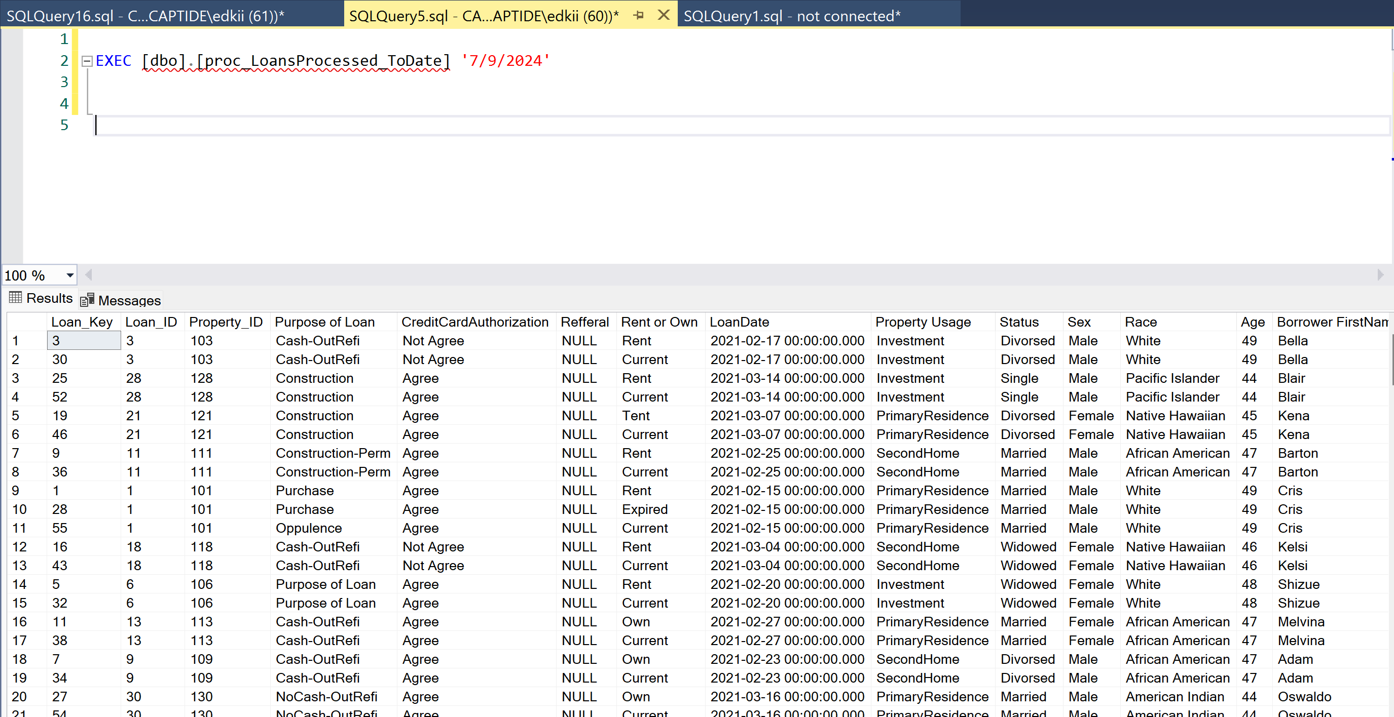

**Created the Loans to date data set**

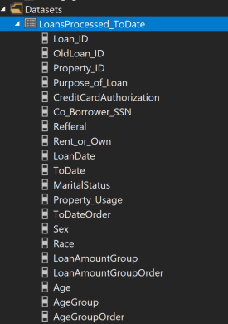

**Configured the shared data set**

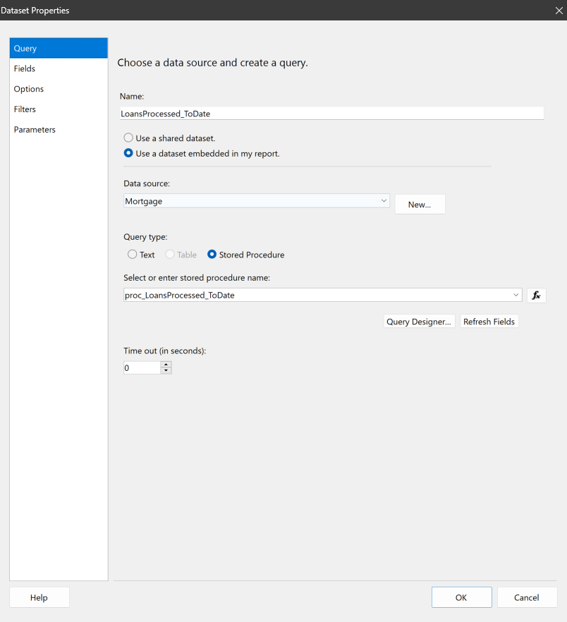

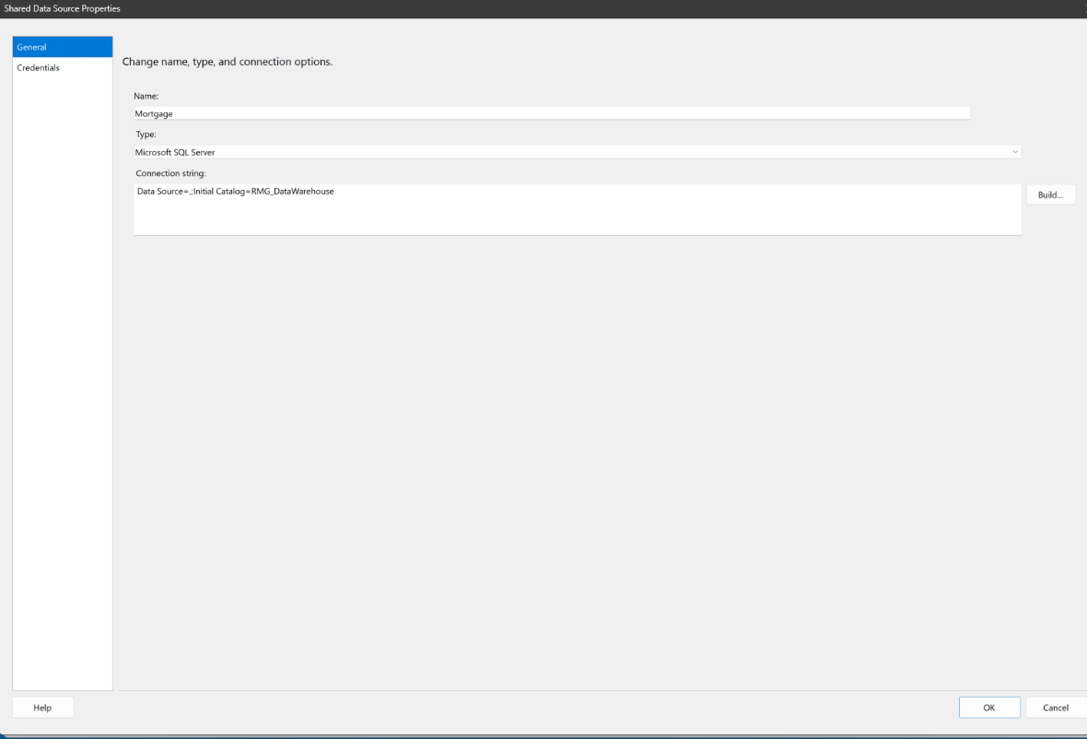

**Configured the Loan purpose data set**

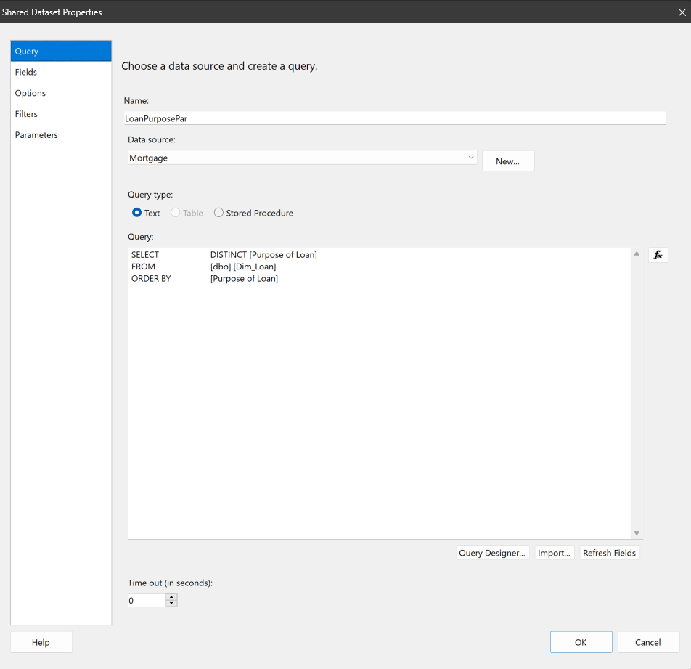

**Configured the report date dataset**

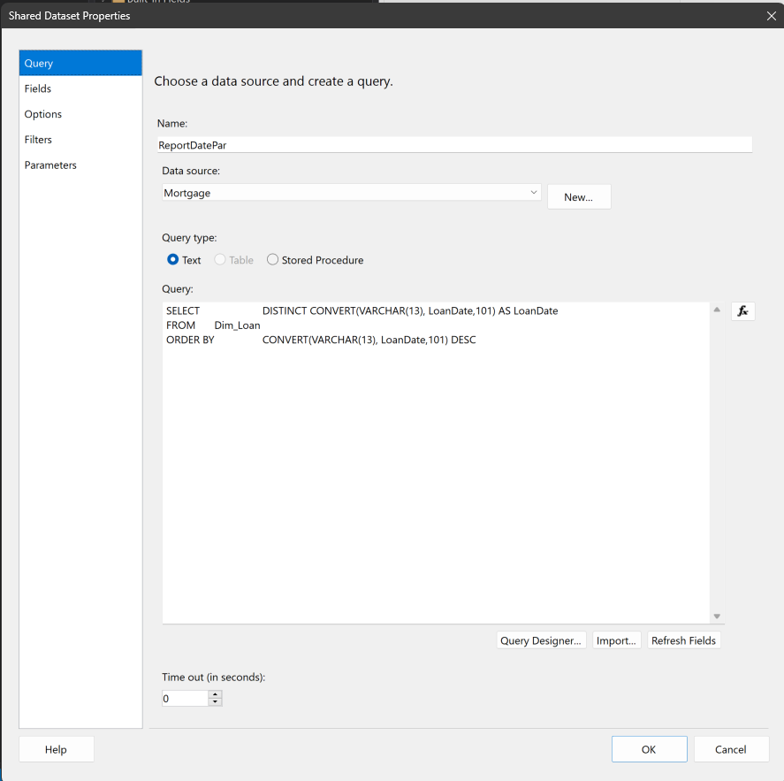

**Configured the loan Amount data set**

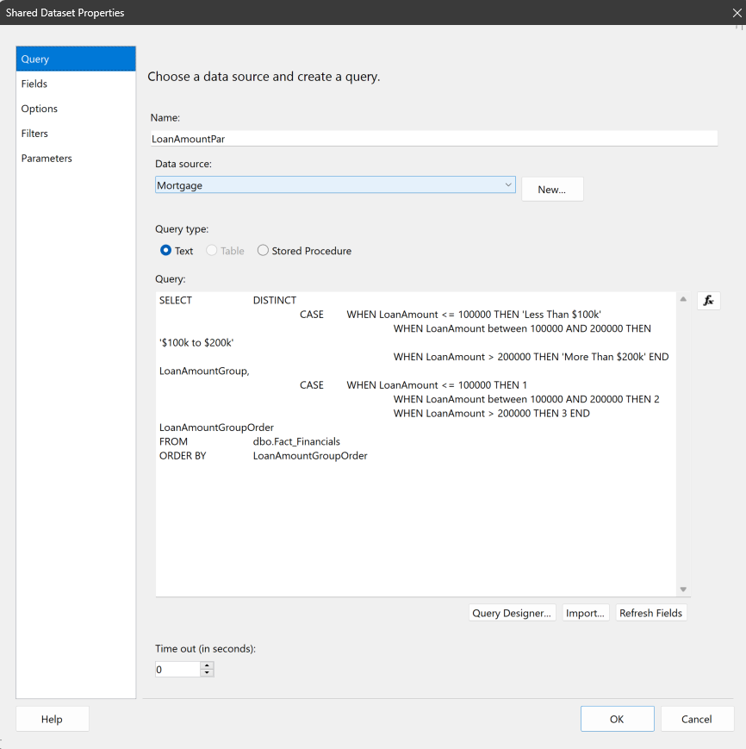

**Configured the demographics data set**

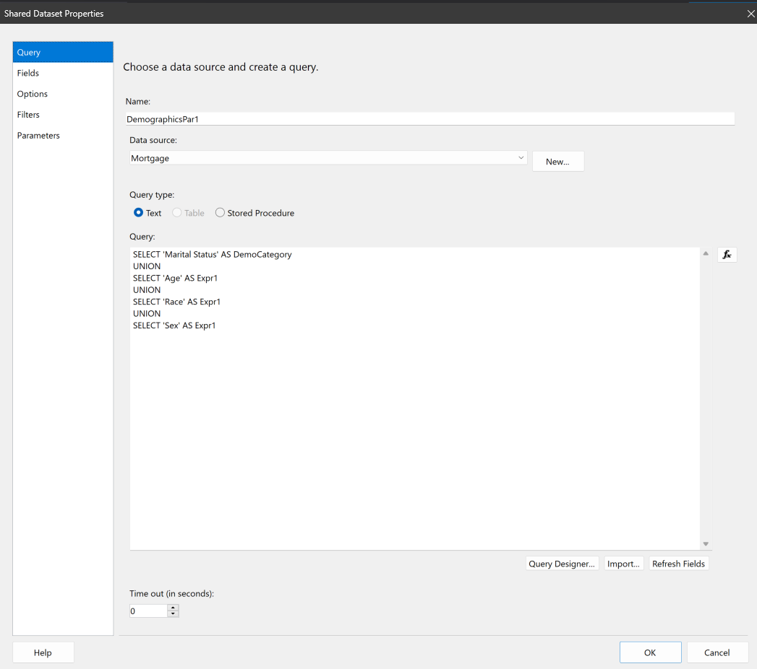

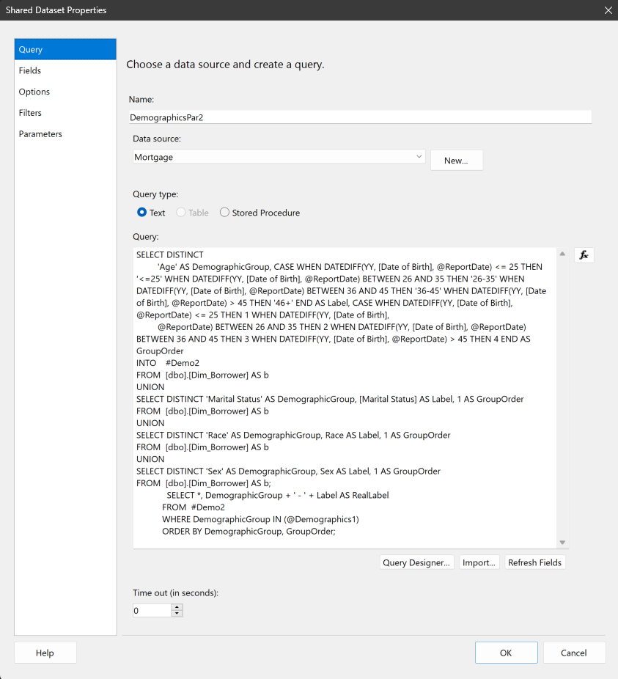

**Final Loans to Date dashboard**

