**ED KIIRU**

***SSRS Dashboard displaying the following…***

1. The Dashboard will consist of 3 Gauges. *(Positioned at the Top)*
2. **Course Count (Gauge)** – This will display a gauge showing the Count of all Active Courses
3. **Section Count (Gauge)** – This will display a gauge showing the Count of all Active Sections
4. **Event Count (Gauge)** – This will display a gauge showing the Count of all Active Events
5. The Dashboard will consist of 2 Charts. *(Positioned in the middle Top)*
6. **Curriculum Count (Pie Chart)** – This will display a pie chart showing the Count of Active Paths / Courses / Sections / Events
7. **Course Event Count (Bar Chart)** – This will display each course with a label that displays a count of the # of Events in that course.
8. The Dashboard will consist of 1 matrix. *(Positioned at the Bottom)*
9. **Curriculum Manager (Matrix)** – This will display a matrix with Drilldowns for every group on the following …

Paths / Courses / Sections / Events

*Follow the below rules when creating the Dashboard.*

1. **Create 4 Cascading Parameters**: Path / Course / Section / Event - When a user runs the report, everything should be selected by default. When a user selects a filter, everything below the selection should be filtered by current selections.

5. **Formatting** – This chart must have the following formats

a. Title

b. Matching Color Scheme (This must be presentable for Business)

c. A Colaberry Company Logo Included

d. Any other formatting you think is needed to make this report user friendly.

**What to Submit – in a word document**.

1. a. A screenshot of the final report

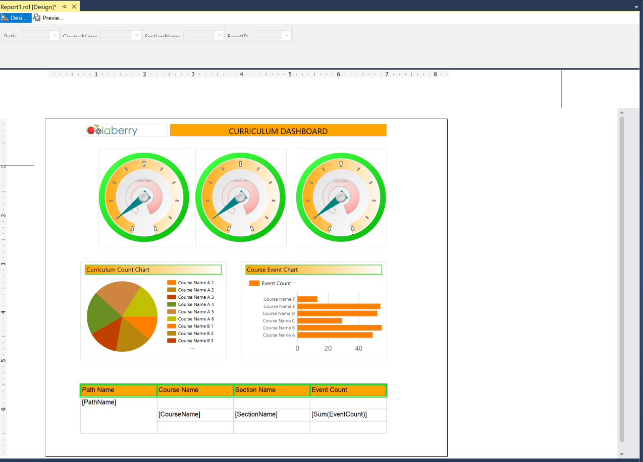

b. Screenshot to prove that your cascading parameters work

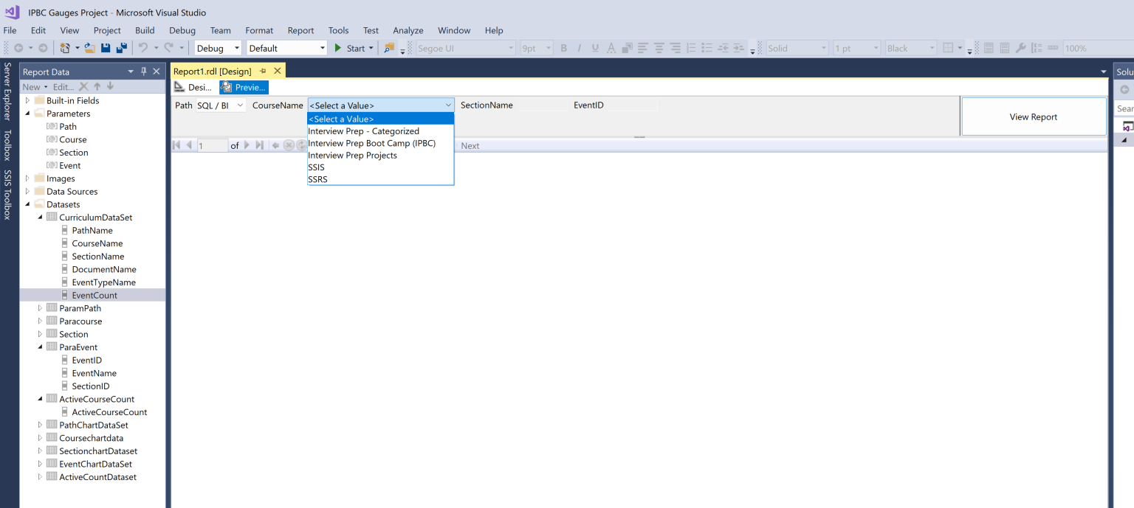

c. Screenshot of the matrix collapsed and expanded.

