**The Battle of Neighborhoods**

Edison Lecca

April 24, 2019

1. Introduction
   1. Background

Nowadays when an investor has to open a new restaurant in a big city has to choose the best location. Let’ talk about San Francisco which a very busy city, best known for tourist attractions and his business, therefore this city has restaurants a lot. Therefore, the correct location is important for an investor.

* 1. Problem

This project aims to recommend to an investor which are the best places to open a new restaurant based on data like crime rate and housing cost.

1. Data

We can use data form the website DataSF where can access the city’s crime rate and housing price. We’ll work with data from:

* <https://data.sfgov.org/Public-Safety/Police-Department-Incident-Reports-2018-to-Present/wg3w-h783> (Police Department Incident Reports)
* <https://www.kaggle.com/datasf/sf-historic-secured-property-tax-rolls> (SF Historic Secured Property Tax Rolls)

1. Exploratory data analysis

**Crimes**

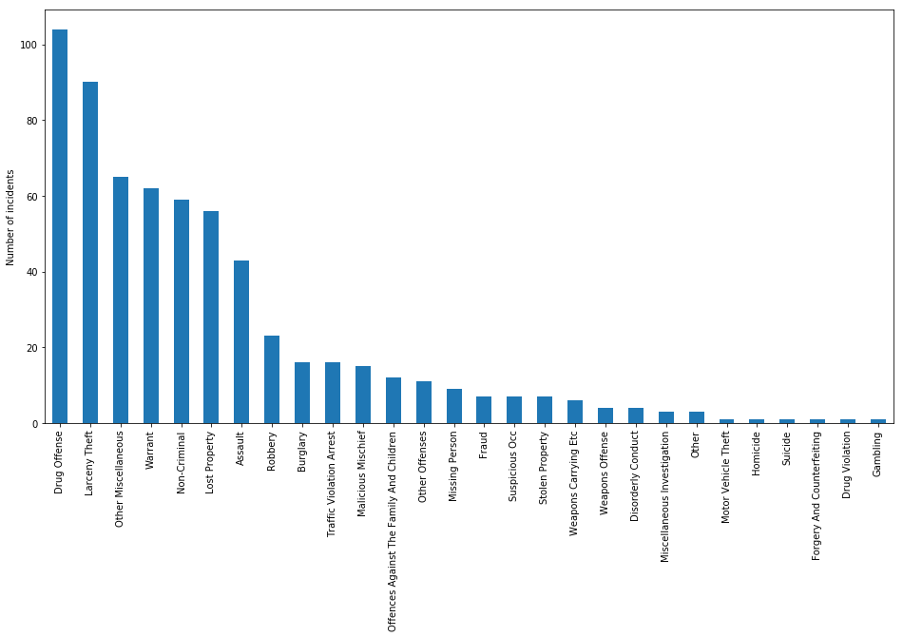

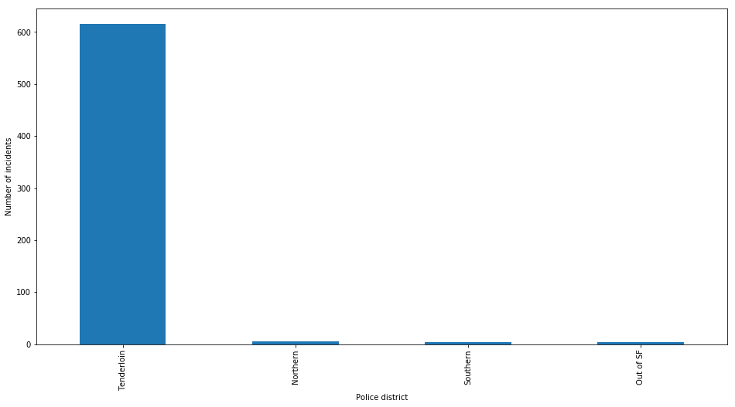Housing

