**CSC8499 Individual Project:AR Technology Applied to the Development of Educational Software Applications**

**Project Description**

Ting Zhang

MSc in Advanced Computer Science,

School of Computing Science, Newcastle University.

[t.zhang32@newcastle.ac.uk](mailto:Jason.Steggles@ncl.ac.uk)

The project works in the unity3D engine, the following points are explained：

Unity3D version: 2019.2.9f1

Code module: Figure 1

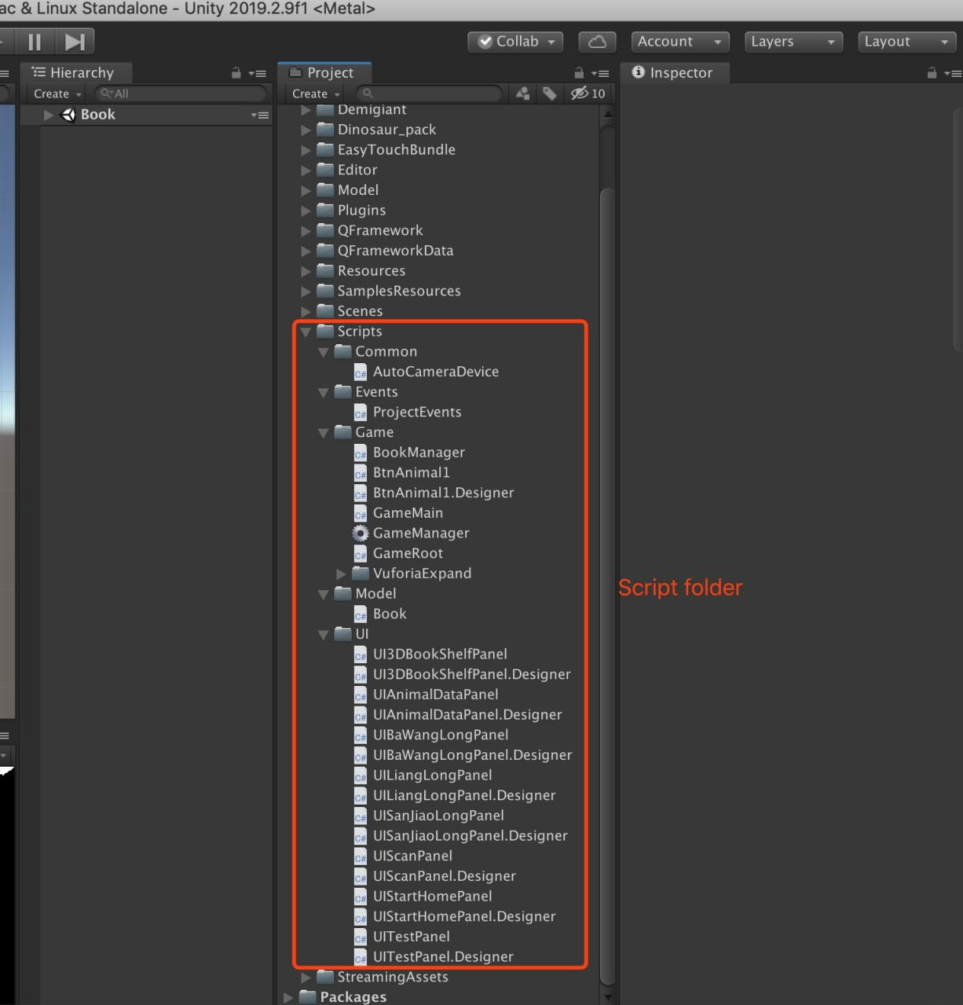

Figure 1

AR package: Figure 2

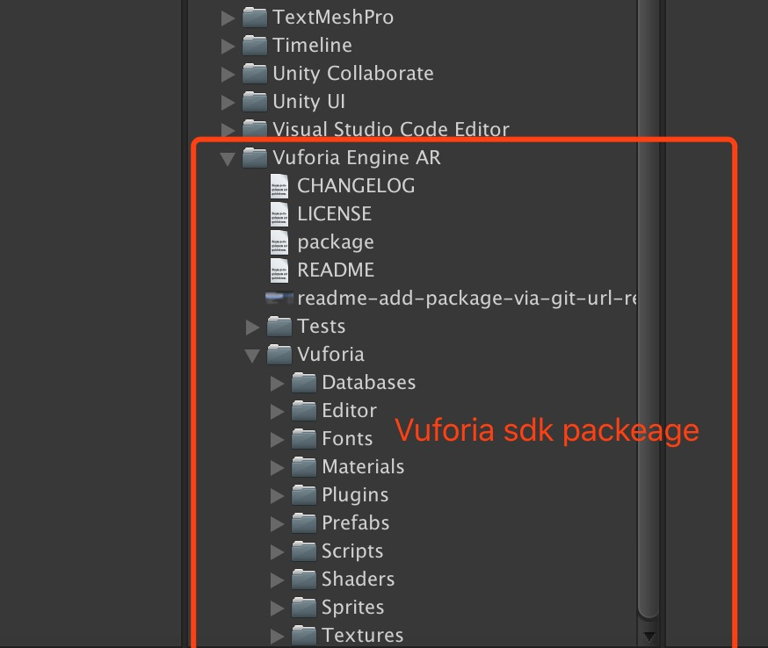

Figure 2

Rare Animal 3D Models：Figure 3

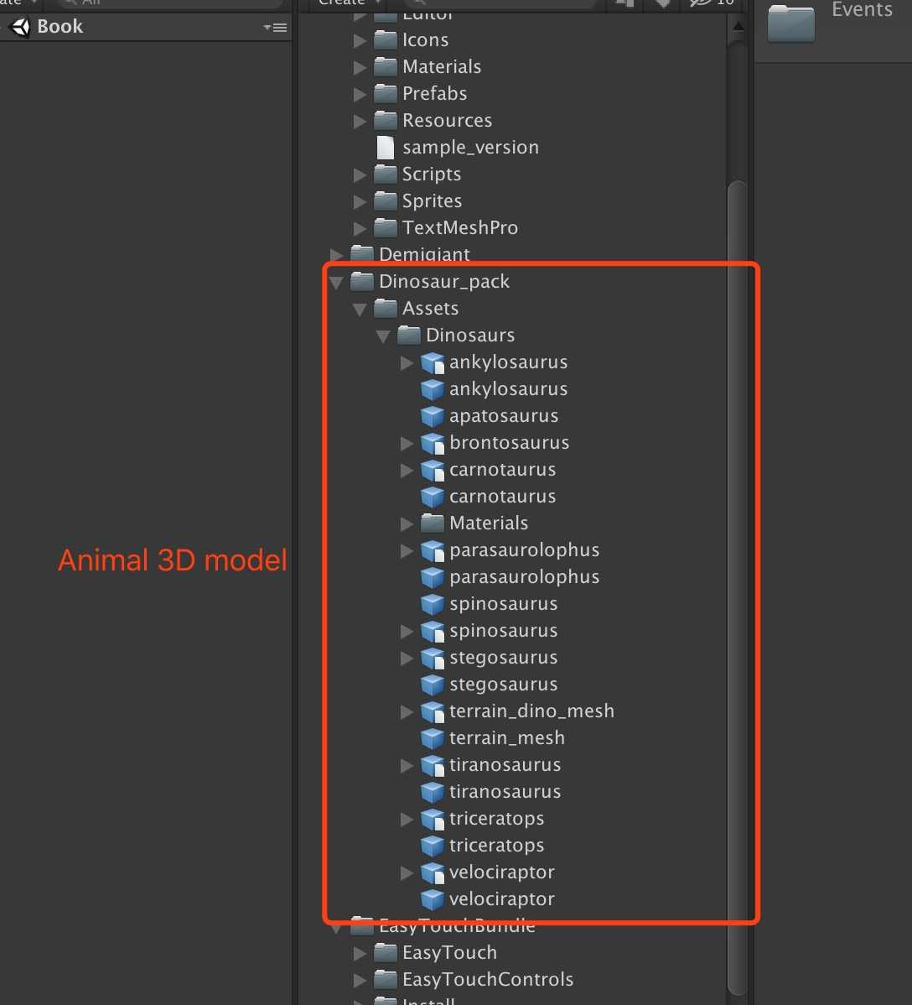

Figure 3

Scene Interface：Figure 4

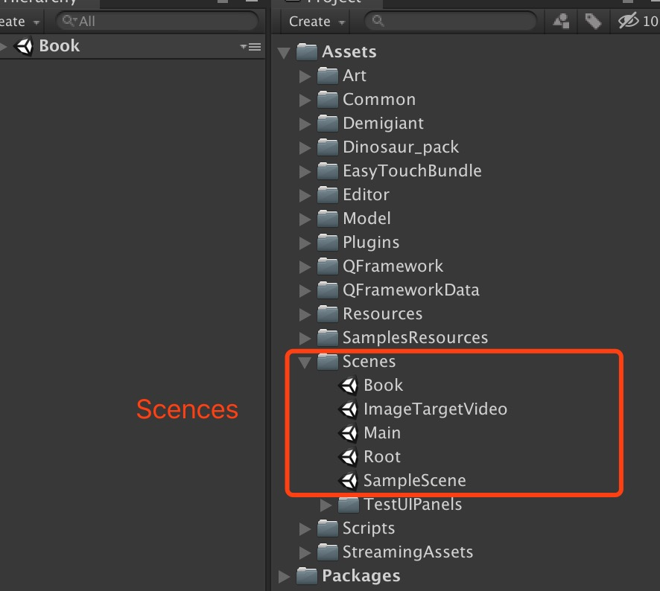

Figure 4

Program running：Figure 5

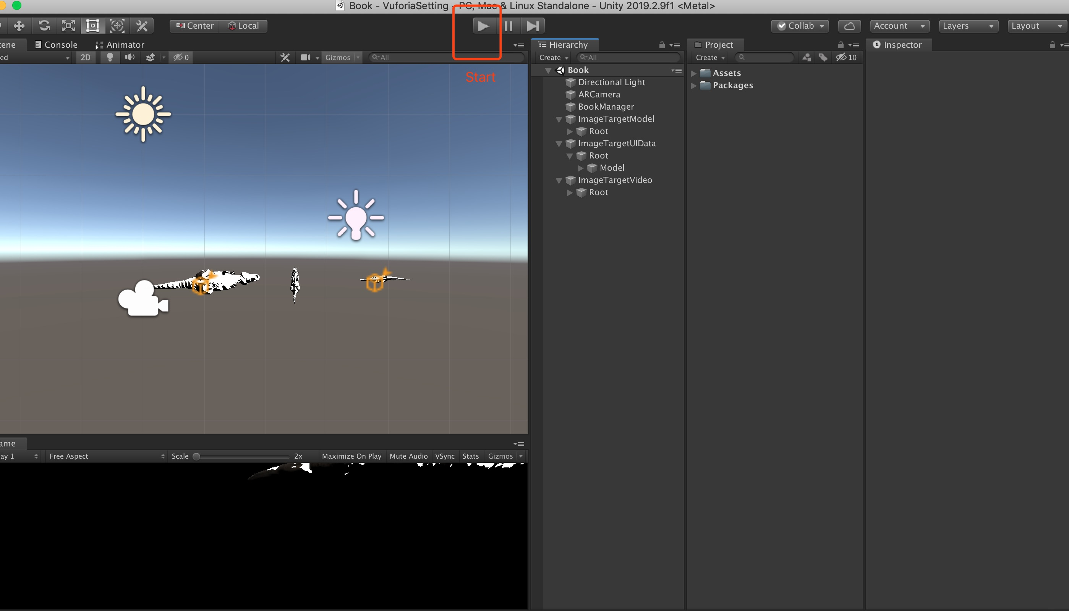

Figure 5

File location for rare animal recognition images：Figure 6

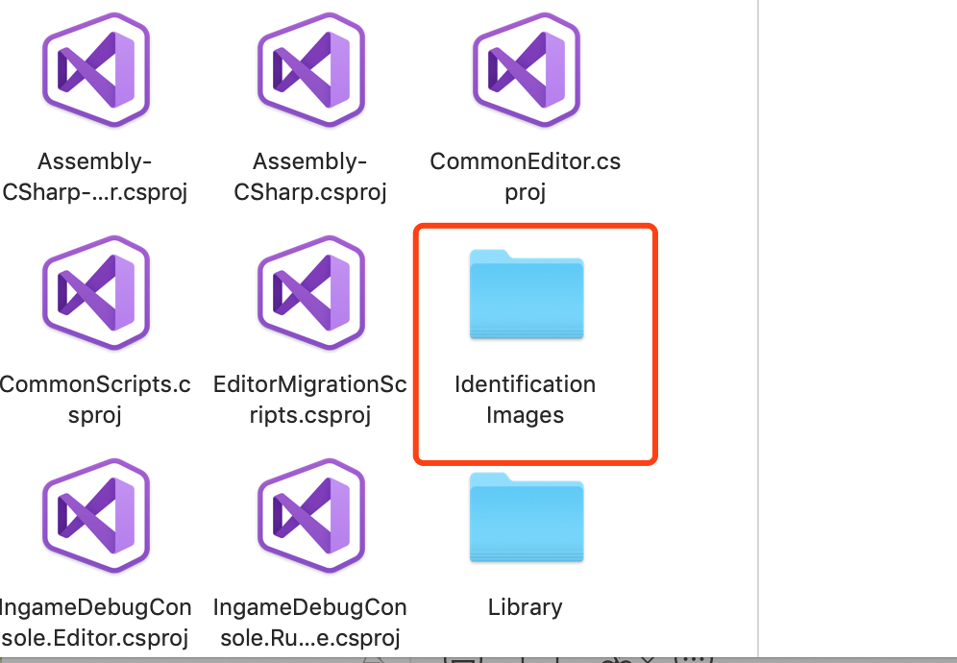

Figure 6

Android program runner package for Android 9.0+：Figure 7

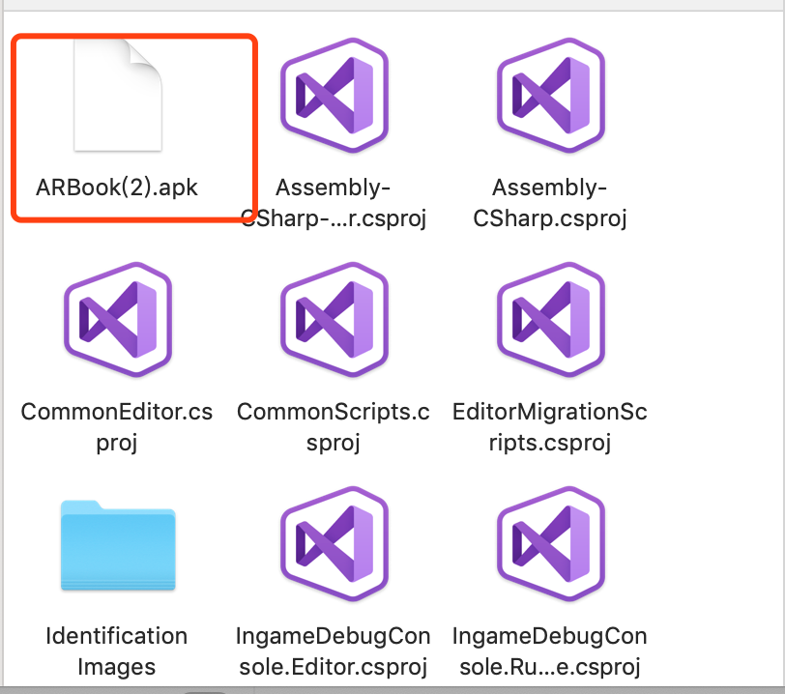

Figure 7