CodeStreet
BenefitIQ
Turning Unclaimed Card Value into Measurable, Real-Time Engagement
Theme: Benefit-Underutilization Analytics
Track: Idea Submission — Round 1
Team Name: [Your Team Name]
Team Members: [Name 1 — Roll No.] [Name 2 — Roll No.] [Name 3 — Roll No.]
College: Karunya Institute of Technology and Sciences

Table of Contents
1. Executive Summary
2. Problem Statement & Market Context
3. Proposed Solution
4. What Makes This Different
5. System Architecture
6. Technical Stack
7. Methodology — Mapped to Challenge Tasks
8. Scalability & Technical Feasibility
9. Business Relevance & Impact
10. Implementation Roadmap
11. Conclusion

1. Executive Summary
BenefitIQ is an AI-driven analytics and engagement engine that identifies, quantifies, and proactively surfaces the card benefits a member has already paid for but never uses. It turns a vague sense of “my card probably has some perks” into a specific, dollar-denominated, personally relevant statement: exactly which benefits are going unclaimed, what they are worth, and the single next action that recovers that value.
The system pairs a deterministic entitlement-mapping engine with a machine-learning prioritization layer, so that every nudge sent to a card member is both accurate (grounded in real eligibility rules) and well-timed (ranked by a propensity model that predicts whether that member will actually act on it). The same underlying data powers a second, business-facing view: a portfolio-level dashboard that gives American Express a defensible, dollar-denominated answer to a question it currently cannot answer precisely — how much entitled value is going unclaimed across the book of business, and where.
The solution is scoped to be realistically buildable within the hackathon timeline on a synthetic dataset, while every architectural decision — the catalog-driven rules engine, the cloud-native microservice layout, the explainability layer — is chosen specifically because it survives the transition from prototype to a real, auditable, production financial system.

2. Problem Statement & Market Context
Card issuers invest heavily in benefit ecosystems — purchase protection, return protection, travel-delay insurance, lounge access, extended warranty, cashback categories — but have no reliable way to measure how much of that entitled value actually gets used. Card members, in turn, are frequently unaware of coverage they already hold, so the perceived value of the card quietly drifts below its actual value. This gap is a top-of-funnel retention risk that is invisible until a member downgrades or churns.
This is not an abstract concern. Independent industry research on rewards card usage gives a directional sense of scale: a 2022 LendingTree survey found that close to seven in ten rewards cardholders were sitting on some unused cash back, points, or miles, with roughly four in ten having redeemed nothing at all in the past year, and a meaningful share of that group holding $100 or more in unclaimed cash-back value alone. A separate CreditCards.com poll found that about one in four cardholders redeemed no rewards whatsoever over a twelve-month period. These figures describe rewards points specifically — the underutilization of protection and insurance-style benefits, which are the focus of this challenge, is typically even less visible to the cardholder because there is no running balance to remind them it exists.
For a premium issuer whose brand promise rests on the richness of its benefit ecosystem, this gap is a direct, quantifiable threat to perceived value, retention, and the return on every dollar invested in benefit design. BenefitIQ is built to close it from both sides of the relationship at once: the card member sees exactly what they are leaving unclaimed, and American Express sees exactly where the ecosystem is underperforming and by how much.

3. Proposed Solution
BenefitIQ continuously reconciles a card member's transaction history against the full entitlement catalog of their card product, flags every benefit they qualify for but have not claimed, assigns each flag a realistic dollar value, and decides — using a trained propensity model rather than a blanket broadcast — who to notify, about what, and when. It is delivered as two connected experiences drawing on one shared data and decision layer:
- Card Member Experience — a “Value You're Missing” view inside the existing AmEx app/web dashboard that shows a running dollar total of unclaimed entitlements, broken down by category, with a one-tap path to activate or claim each one before it expires.
- Business Analyst Experience — a portfolio-level dashboard that aggregates the same signal across segments, card products, and geographies, giving product and marketing teams a defensible ROI case for benefit design decisions and nudge campaigns.
Both views are powered by the same five-stage pipeline, described in detail in Section 6: entitlement mapping, dollar-value quantification, propensity-based prioritization, nudge orchestration, and continuous audit logging.

4. What Makes This Different
Most “benefit visibility” tools on the market today are static: a list of perks in a terms-and-conditions PDF, or at best a monthly digest email. BenefitIQ is deliberately built around five choices that move it from a reporting tool to a decision system:
- 1. A benefit-entitlement graph, not hardcoded rules — each card product's benefits are described in a structured catalog (benefit type, eligibility rule, value range, redemption window) rather than in application code. Onboarding a new card product becomes a configuration change, not a re-engineering effort — this is what makes the system scale to AmEx's full product line rather than one card at a time.
- 2. Hybrid rules + ML matching — eligibility itself is deterministic and auditable (a purchase either matches a benefit rule or it doesn't), while the decision of who to nudge and when is a learned propensity score. This keeps the system explainable where it must be (eligibility) and adaptive where it should be (engagement timing).
- 3. Probability-weighted dollar valuation — instead of a flat “you have an unused benefit” flag, every entitlement gap is priced using the historical redemption-value distribution for that benefit type and tier, so the number a member sees is a realistic estimate, not a marketing placeholder.
- 4. Event-triggered, contextual nudges — a flight booking transaction can trigger a travel-delay-insurance nudge within the relevant window; a benefit nearing its redemption deadline triggers a time-decay nudge. This replaces generic monthly digests with moments that are actually relevant to the member's current activity.
- 5. Built-in explainability — every nudge carries a SHAP-based explanation of the top factors behind it. This matters twice over: it lets card members trust why they were notified, and it gives AmEx's compliance and audit functions a defensible trail for every automated decision — a non-negotiable requirement for anything touching financial entitlements.

5. System Architecture
The architecture is organized as seven layers, each independently deployable and independently scalable, so that the system can start on synthetic hackathon data and move to production data sources without a redesign.
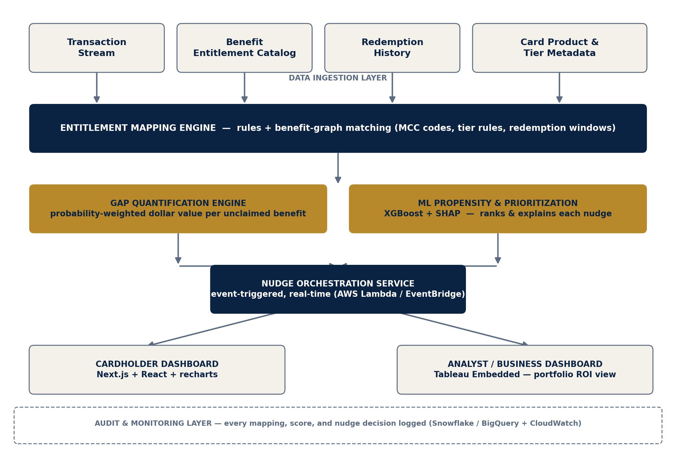
Figure 1: BenefitIQ end-to-end architecture

5.1 Layer-by-Layer Description
- Data Ingestion Layer — consumes the transaction stream, the benefit entitlement catalog, historical redemption records, and card product/tier metadata. In the hackathon build this is a synthetic dataset generated to mirror realistic distributions; in production it maps directly onto existing AmEx transaction and card-product systems.
- Entitlement Mapping Engine — matches each transaction against the benefit catalog using an indexed rules evaluation (merchant category code, transaction amount, geography, timing) to flag entitlements the member qualifies for but has not exercised.
- Gap Quantification Engine — converts each flagged entitlement into a probability-weighted dollar estimate using historical redemption-value distributions for that benefit type and card tier.
- ML Propensity & Prioritization Layer — an XGBoost model scores the likelihood that a given member will act on a given nudge, using features such as past redemption behavior, notification engagement history, tenure, and recency; SHAP values attach a plain-language explanation to every score.
- Nudge Orchestration Service — an event-driven service (AWS Lambda / EventBridge, or GCP Cloud Functions / Pub/Sub) that decides the channel, timing, and content of each nudge and enforces frequency caps so members are never over-messaged.
- Presentation Layer — the card member dashboard (Next.js, React, recharts) and the analyst dashboard (Tableau Embedded Analytics), both reading from the same underlying decision layer so the two views are always consistent.
- Audit & Monitoring Layer — every mapping decision, valuation, propensity score, and nudge is logged immutably to the analytics warehouse, giving compliance and product teams a complete, queryable trail.

6. Technical Stack
The stack is deliberately built entirely from the technologies suggested for this theme, with one addition (recharts) drawn from the team's existing production experience building dashboard-heavy fintech interfaces.
Layer | Technology
Frontend — Card Member | React + Next.js, Tailwind CSS, shadcn/ui, recharts for embedded charts
Frontend — Analyst | Tableau Embedded Analytics
Backend & APIs | Python FastAPI (entitlement, gap, and scoring services), Node.js (API gateway / BFF for the Next.js frontend)
Data Analytics | Python pandas and NumPy for transaction processing and gap calculation
Machine Learning | XGBoost (propensity scoring), scikit-learn (baseline/interpretable model), SHAP (explainability)
Cloud Platform | AWS (Lambda, EventBridge, S3, ECS/Fargate) — GCP equivalents as an alternative
Data Warehouse | Snowflake or BigQuery for the unified transaction + entitlement + audit warehouse

7. Methodology — Mapped to Challenge Tasks

7.1 Entitlement Mapping Algorithm
Each card product's benefit catalog is stored as structured JSON: benefit type, eligibility predicate (merchant category codes, amount thresholds, geography, timing window), value range, and redemption deadline. Incoming transactions are indexed by merchant category code so that rule evaluation is a fast lookup rather than a full catalog scan, keeping the mapping step close to linear time even as the catalog grows. The output is a per-member list of entitlements: claimed, unclaimed-and-active, and unclaimed-and-expiring.

7.2 Dollar-Value Gap Quantification
Each unclaimed entitlement is priced using the historical redemption-value distribution for that benefit type and card tier — for example, the median and interquartile range of past travel-delay insurance payouts — rather than a single flat figure. This produces both a point estimate (“about $85”) and a confidence range, which is important for credibility: an over-confident number is quickly distrusted, while a probability-weighted range reads as considered and realistic.

7.3 Card Member and Analyst Dashboards
The card member dashboard leads with a single “value you're missing” figure, then breaks it down by category (protection, travel, lounge, cashback) with a one-tap activation or claim path for each item, built with recharts for the category breakdown and trend views. The analyst dashboard aggregates the same signal by cohort, card product, tenure, and geography, and tracks the before/after engagement uplift of every nudge campaign — turning benefit design from a qualitative decision into a measurable one.

7.4 Nudge Logic and Personalization
Three trigger types drive nudges: event-based (a transaction that unlocks a time-bound benefit, such as a flight booking triggering a travel-insurance nudge), decay-based (a benefit approaching its redemption deadline), and threshold-based (accumulated unclaimed value crossing a meaningful figure). Every candidate nudge is scored by the XGBoost propensity model before being sent, so the system prioritizes members likely to act rather than broadcasting to everyone — protecting both engagement quality and message frequency limits.

7.5 Testing, Evaluation, and Optimization
The entitlement mapping engine is validated against a labeled synthetic test set for precision and recall. The propensity model is evaluated on AUC-ROC and calibration, since a well-calibrated “70% likely to act” score matters more here than raw accuracy. Nudge effectiveness is measured through a simulated holdout design — a nudged cohort against a matched control — to estimate engagement uplift before any real campaign spend is committed. End-to-end latency from transaction ingestion to nudge decision is benchmarked with a target of under two seconds, so the experience feels immediate rather than batch-processed.

8. Scalability & Technical Feasibility
- Catalog-driven onboarding — adding a new card product means adding a JSON entitlement definition, not writing new application code, so the system scales across AmEx's full product line without re-engineering.
- Horizontally scalable services — the FastAPI microservices are stateless and containerized, so they scale out under ECS/Fargate or Kubernetes during peak transaction periods such as holiday travel season.
- Elastic, event-driven core — Lambda/EventBridge-based orchestration means compute cost tracks actual transaction volume rather than requiring always-on capacity sized for peak load.
- Separated storage and compute — Snowflake or BigQuery decouple data volume growth from query performance, so the warehouse scales independently of the transaction-processing path.
- Realistic build path — every component listed above is buildable and demonstrable on a synthetic dataset within the hackathon timeline, using only open-source or freely available tooling, with no dependency on production banking data or proprietary APIs.

9. Business Relevance & Impact
BenefitIQ is designed to move three metrics American Express already cares about, without requiring a new benefit or a new product to be launched.
- Retention — a card member who can see, in dollar terms, the value they are already receiving is less likely to question their membership fee or consider a competing card at renewal time. Given that industry surveys show a majority of rewards cardholders are sitting on some unclaimed value, even a modest conversion of that group into active claimants is a meaningful, measurable retention lever.
- Perceived value and satisfaction — surfacing unclaimed protection and insurance benefits — the parts of the card ecosystem members are least aware of, since there is no running balance to remind them — directly reinforces the premium positioning American Express has built its brand around.
- Product and marketing intelligence — the analyst dashboard gives product teams, for the first time, a dollar-denominated, segment-level view of which benefits are chronically underused, turning future benefit-package design and marketing spend into a data-informed decision rather than a guess.
Because the underlying architecture separates the eligibility logic (deterministic, auditable) from the engagement logic (learned, tunable), the same system can be extended over time to new benefit types, new card products, and new engagement channels without a structural rebuild — making this a durable platform investment rather than a one-off campaign tool.

10. Implementation Roadmap

10.1 Round 1 (Idea Stage — Current)
- Finalize the entitlement catalog schema and synthetic dataset design (transactions, card tiers, redemption history).
- Complete architecture, algorithm design, and dashboard wireframes (this document).

10.2 Round 2 (Finale — If Shortlisted)
- Generate the synthetic dataset and stand up the entitlement mapping and gap quantification engines.
- Train the XGBoost propensity model on synthetic redemption-outcome labels; integrate SHAP explanations.
- Build the Next.js card member dashboard and a lightweight analyst view; wire up a simulated nudge flow end to end.
- Stretch goals if time allows: live SHAP explanation panel, Kafka-simulated transaction streaming, full Tableau Embedded analyst view.

10.3 Beyond the Hackathon
- Pilot on an anonymized, sandboxed subset of real entitlement and redemption data under existing data-governance controls.
- Run an opt-in A/B nudge campaign with a real card member cohort to replace synthetic propensity labels with observed outcomes.
- Expand the entitlement catalog to the full American Express product suite, one JSON configuration at a time.

11. Conclusion
BenefitIQ addresses the Benefit-Underutilization Analytics challenge directly: it maps entitlements to transactions, prices the gap in real dollars, surfaces it through purpose-built dashboards for both card members and analysts, and drives action through explainable, propensity-ranked nudges — exactly the five tasks the theme asks for, built on exactly the technology stack it suggests. More importantly, it is designed from the ground up to be something American Express could realistically take beyond a hackathon prototype: a catalog-driven, auditable, horizontally scalable system that turns an invisible source of member dissatisfaction into a measurable, ownable metric.

