1. **mbsSdk/componets :**

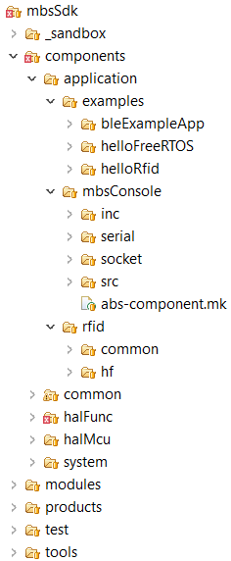

1. **mbsSdk/componets/Common :**

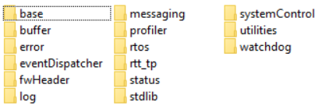

1. **/ base/inc/mbsCompilerAttrs.h**

**-- define** MBS_ATTR_PACKED **__attribute__**((packed))

1. **/buffer/src/mbsBuffer.c**

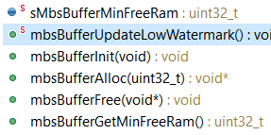

**--buffer/src/mbsBufferDynamic.c**

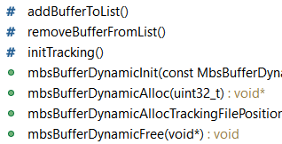

1. **/error/src/mbsAssert.c**

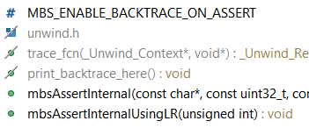

**--/error/src/mbsError.c**

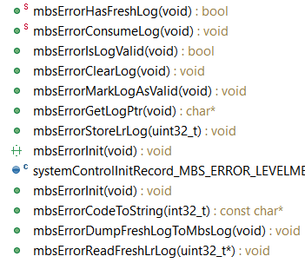

1. **/eventDispatcher/src/eventDispatcher.c**

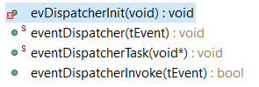

1. **/log/src/mbsLog.c**

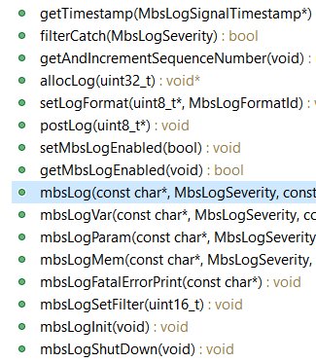

**/messaging/src/mbsMessagingRegistry.c**

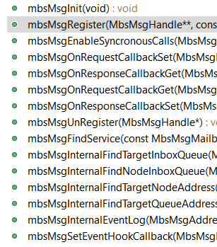

1. **/messaging/src/mbsMessaging.c**

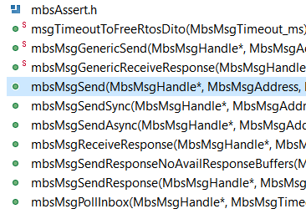

1. **/systemControl/src/systemControl.c**

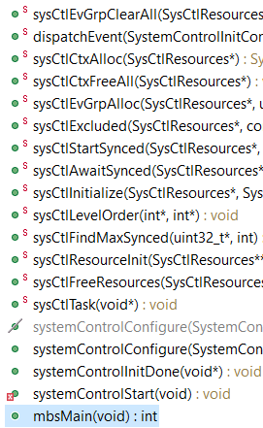

**mbsMain()**

1. **/utilities/…crc**

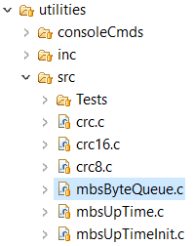

1. **mbsSdk/componets/HalFunc :**

Hardware Abstract Layer

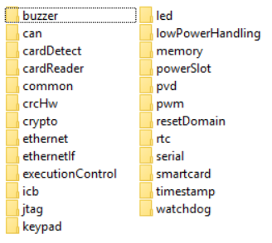

1. **memory: /mbsSdk/components/halFunc/memory/**

--/consoleCmds/src/halMemoryCmds.c

1. **PWM: /pwm/specific/common/src/halPwmCommon.c**

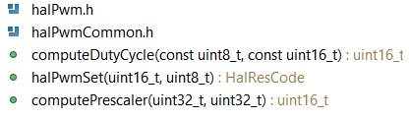

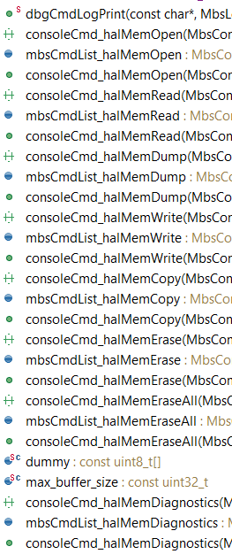

/generic/src/halMemory.c

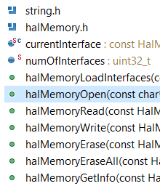

/specific/eeprom/stm32/src/stm32Eeprom.c

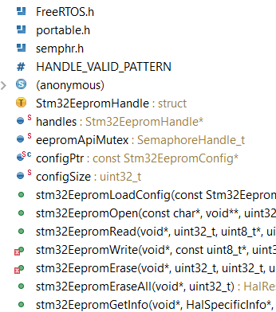

/specific/spiFlash/src/halMemSpiFlash.c

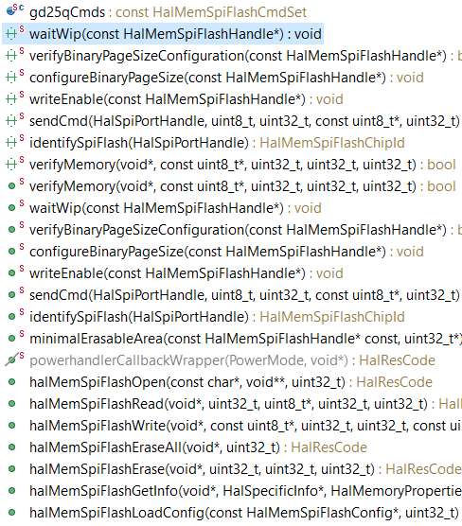

1. **mbsSdk/componets/HalMcu :**

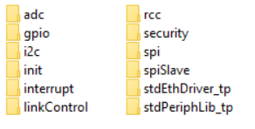

1. **/spi/**

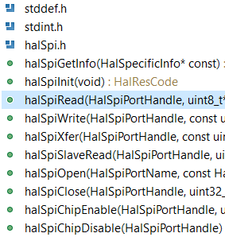

1. **mbsSdk/componets/System :**

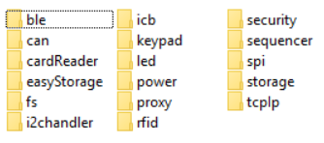

1. **/outputSequencer.h**

