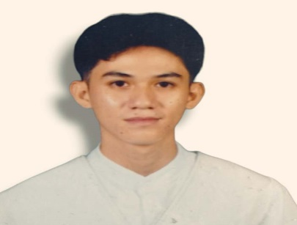**BAROGA, EDMARK L.**

Blk 7 Lot 6 South gawaran Molino 7

Contact No. (+63) 9198204865

Gmail: baroga.edmarksn3ict11c@gmail.com

# PERSONAL INFORMATION

Date of birth : October 4, 2002

Age : 21 years old

Gender : Male

Civil Status : Single

Nationality : Filipino

Religion : Roman Catholic

Language : Tagalog & English

Mother’s Name : Leticia L. Baroga

Father’s Name : Edgar L. Baroga

# QUALIFICATIONS AND SKILLS

* Communication skills.
* Teamwork and collaboration
* Professionalism and strong work ethic.
* Patient
* Dedicated to work
* Good in managing time

# CAREER OBJECTIVES

To obtain a challenging position at a respected organization that will allow me to broaden my learning, knowledge, and skills. Moreover, to secure a career opportunity that will enable me to put my skills to good use while making a significant contribution to the company.

# EDUCATIONAL ATTAINMENT

Secondary : Information Communication and Technology 2021-2023

|  |  |  |  |  |
| --- | --- | --- | --- | --- |
| Strand At SHS san Nicolas lll Junior to Senior  High School  Bacoor,Cavite | | | |  |
| Bacoor National High School-Gawaran Annex | | | | 2016-2020 |
| Bacoor City |  |  |  |
| Primary : Gawaran Elementary School  Bacoor City  **AWARDS RECEIVED**    Senior High School |  |  |  | 2010-2016 |
| • Work immersion awardee |  |  |  | 2022-2023 |
|  |  |  |  |  |
| **CHARACTER REFERENCES**    Chloe T. Palomar Charmel D. Nueva  Bacoor Cavite Bacoor Cavite  Working Student  0938-712-7658 0930-283-3589 |  |  |  |  |

**BAROGA, EDMARK L.**

Applicant