Genre Classification through Token Analysis of Movie Subtitle Files
Edmond C. Malone
Computer Science Department
Troy University, Alabama
emalone212390@troy.edu

Abstract
Machine learning is is used in various industries to aid with making predictions and insights with the use of existing data that can help reduce manual effort. This paper will demonstrate an additional path to classify movies genres with only common words. There is domain focus of this project is the movie industry. The data source is an SRT file and we will use the that file to classify a genre of a movie. The application will test the the data against a few popular machine learning algorithms that are best to to solve multi classification problems.

I. Introduction
Categorizing movies make it easier for viewers to determine what they like and want to see. Genres contains four elements of a movie: story, setting,and plot which equal to the genre of any film. Movie genres can determine with various other elements besides the previous mentioned. Movie text and pattens can also be used to determine genre for movies. By exploring common used words in each genre of movie we will be able to classify movies with only common word data in each genre and classify each movie with the correct genre.

II. Proposed work
Data Set 2.1
The data that was used for this project are SubRip Subtitle or better known as SRT File. The SRT file is a plain text file that contains information that relates to how subtitles should appear on the screen. The file consist of the time sequential number for the subtitle, start and end time of the text to ensure text match the audio, the text that will be displayed on the screen. This data was gathered from subscene.com. The genres that are used in this paper are Action, Horror and Romance. To utilize the SRT file to classify movie genres the data will need to be preprocessed. At this time I have acquired 20 SRT files for various genres Action,Horror and Romance movies.

Movie name extraction: This process is to extract the movie actual name from the file path that was selected. The purpose of this step is to keep the data in the training set clean without any full file path but only the movie name. This step is not necessary but it help to keep the movie name column header data clean.

Create a word bank of common words: To fully identify and create a word bank of common used word s for each movie genre we will have to manually identify the common words in each individual genre and use that word as a column header for column names. The Each table row will represent the individual movie and the number of frequent use of the word in the given movie.

To complete this task I used various of libraries such as pysrt which allowed me to parse the desired text section of an SRT file. The library beautiful soup allowed me to separate the text from the HTML tags.

We performed upper to lowercase to the text: We applied the lower method on the words to make it easier to verify the uppercase words and lowercase are identified as the same text and will not be separated.

We tokenized the corpus text and applied frequency distribution on the top 300 words words. This step allowed us to gain insight of common words that is frequently used in each genre which helped us to create our word bank and to obtain the data for each cell for a movie.
For the movies that do not have a value to that reflects the header name a zero will be placed in the cell field. This is will be accurate description of the values not present in the corpus.
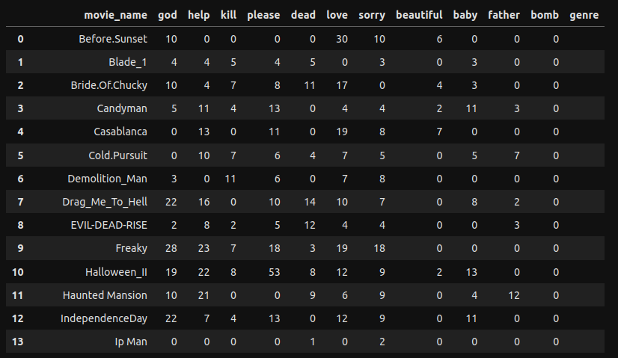
Figure 2. data table of various movies which list the sum of frequent used words for in a movie.

Exploratory Data analysis 2.2
In statistics, exploratory dat analysis is a approach to analyze dataset to summarize the main points. Usually with visual methods. With this analysis we are able to identify the frequent used words that is contained in a various movies and to correlate the sum of each word for each movie to a genre.
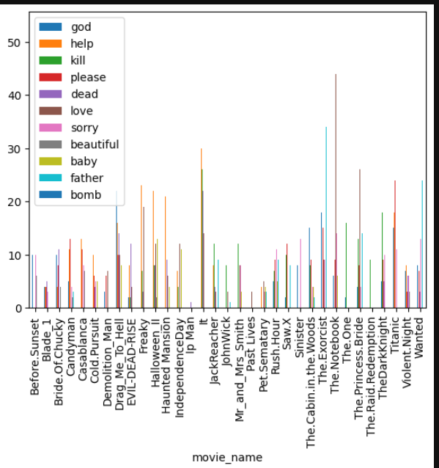

Figure 3. Bar graph of the sum of frequent used words in a movie

Data labeling 2.3
Because the SRT file does not know or contain the genre of the movie we will have to manually add the target values to the movie _genre column. After the file SRT before you can train the model to get results. You will have to label each movie row with its respective genre.
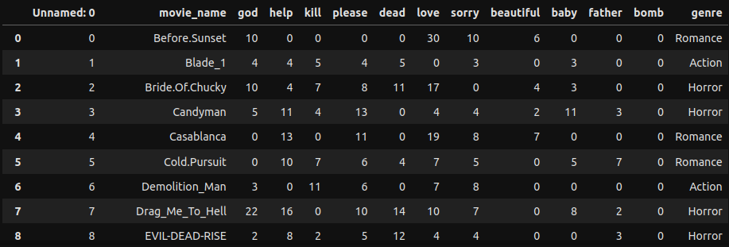

Figure 4. Data Table of the the completed genre column

We import the training data and split the data into 80% training and 20% test data. Doing this would give you better results. From my analysis I noticed if the data set is plentiful and the training set is greater than 50 % you will get better results than not having sufficient data and the training set is less than the test set. We will be using two classification machine learning algorithms. Decision tree and K-Nearest Neighbor

Decision Tree 2.4
The Decision Tree is one of the useful supervised learning algorithms that is used for both clasification and regression. It build reverse tree structure where each node is a feature and the leaf nodes are the results of the algorithm. The tree is created by iterating splitting the training data into subsets that is based on the values of their attributes until its criteria is met.

K nearest neighbor 2.5
The K-nearest neighbor is another classification algorithm in the machine learning arsenal. KNN predicts the label of a data point by by calculates the distance between the input data point and all of the training examples, byu using a chosen distance method.

Results 2.6
We used the same training data and test data for both algorithms. The results of the of both algorithms was different depending on the the size of the training data and test data. The K-nearest neighbor algorithm proved to outperform the decision tree algorithm on various predictions.

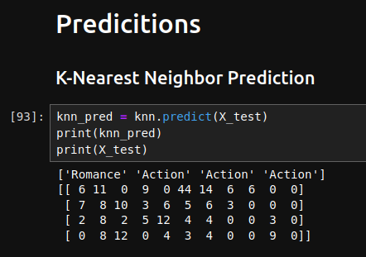
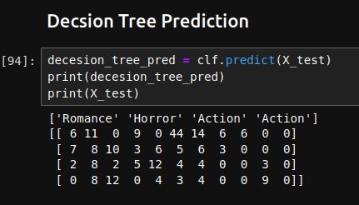

Figure 5. Predictions of KNN and Decision Tree.

Accuracy 2.7
To compute the subset accuracy the set of labels predicted for the sample must exactly match the corresponding set of labels.

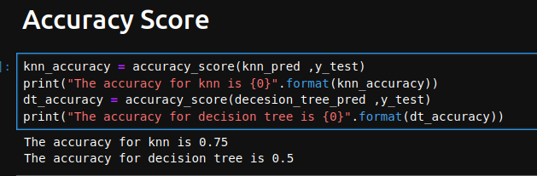

Figure 6 the output of the accuracy score

Related work :

III. Future Work
There are some improvement we can add to increase the accuracy of the prediction. One of the approach is to obtain more SRT files for the purpose to create a training set to produce better results. The second approach can compliment the previous approach by conducting analysis to determine the more common words that span the same genre.

IV .Conclusion
Our proposed method to use common tokenized words from various genres to categorize movie genres has proven to be successful. With providing decent accuracy scores ,the analysis and research proven this method can potential be helpful categorizing movie genres.

References

[1] https://subscene.com/

[2] https://www.nltk.org/

[3] https://scikit-learn.org/

[4] https://pypi.org/project/beautifulsoup4/

[5] https://www.geeksforgeeks.org/decision-tree/

[6] https://blog.hubspot.com/marketing/srt-file

[7] https://monkeylearn.com/unstructured-data/

[8] https://milnepublishing.geneseo.edu/exploring-movie-construction-and-production/chapter/2-what-is-genre-and-how-is-it-determined/

[9] https://machinelearningmastery.com/types-of-classification-in-machine-learning/

[10] https://www.ibm.com/topics/machine-learning

[11] https://www.educative.io/answers/what-is-the-accuracyscore-function-in-sklearn

[12] https://www.kdnuggets.com/2022/07/knearest-neighbors-scikitlearn.html

