COMP 1536 Team Project

Peripheral Recommendations

Cameron Lay, A00816870

Jason Huang, A00932687

Daniel Zhang, A00842986

Chao-Chun ‘Joseph’ Yang, A00950913

Sunguk ‘Edmund’ Ham, A00979841

COMP 1536 - Web Development

Benjamin Yu

February 2, 2017

Table of Contents

1. Milestone Two
   1. Site Map
   2. Wireframe Design
      1. Design Reasons
      2. Home Page
      3. Product Page # 1, 2, 3 Design
      4. Product Page Expanded
      5. Info Page
      6. Main Page Print View
      7. Product Page Print View # 1 - # 3
      8. Info Page Print View
      9. Site Map Page
      10. User Sign-Up
      11. Forum Page
   3. Proposed Color Schemes
      1. Color Scheme # 1
      2. Color Scheme # 2

Appendices

1. Milestone One
   1. Topic
      1. Site Purpose
      2. Site Goals
      3. Target Audience
      4. What the site would like to accomplish
      5. Type of Content
      6. Success Factors
      7. Similar Sites
   2. Functional Requirements
      1. A form of user input
      2. A list e.g. glossary or catalogue
   3. Work Plan
      1. How we will schedule to meet deadlines

**Site Map**

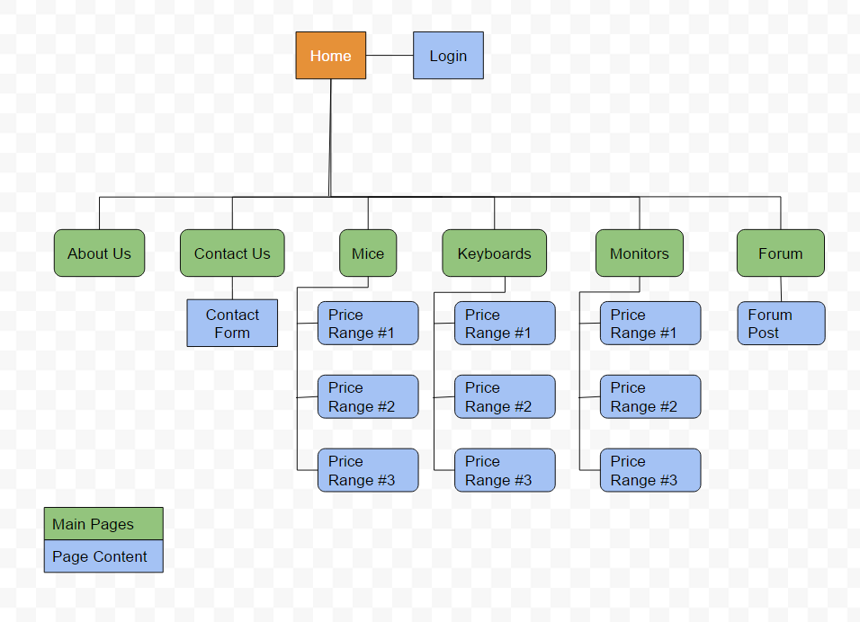

Our site is a more traditional hierarchical style site with defined main pages. This combined with shallow depth to each branch will allow it to be simple to navigate. Each content page will be more of a linear style with no hard page breaks in them. This will make it easier to skim through more information faster and smoother.

**Wireframe Design**

**Design Reasons**

For our home page, we chose a basic three-box layout that can be seen on the first page of our wireframe design. Additionally, the three boxes will link to each product that we have chosen. For our content pages, we went with a two-column layout with images on the left and text content displayed on the right. Our text boxes will display a five-star rating system as well as important point-form information on the product with the option to expand for a full in-depth review of the product. When expanded the text boxes will push down the content below as seen on our product page expanded version. Our site will also feature a fixed scroll, top aligned navigation bar that will give visitors the option to navigate around our website. Our website will be fixed design mainly aimed at the current 1080p resolution as it is the most common in today's computers. While it may contain lots of ‘white space’ on higher resolution screens they are a minority in today’s market. Our logo will be located in the navigation bar on the left-hand side as well as on the home page.

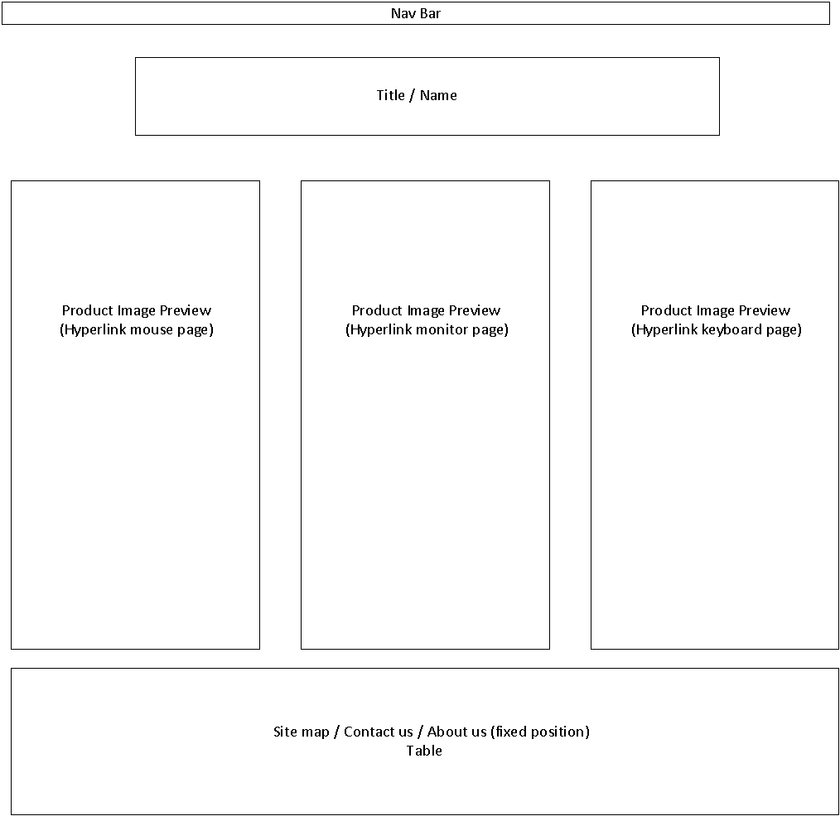**Home Page**

For the home page, we decided to use a three-box format for our main content pages. Our title page also includes the site-wide navigation bar that includes links to all main pages as well as the login page. It also includes the site-wide footer that has links the site map and our About Us and Contact Us pages.

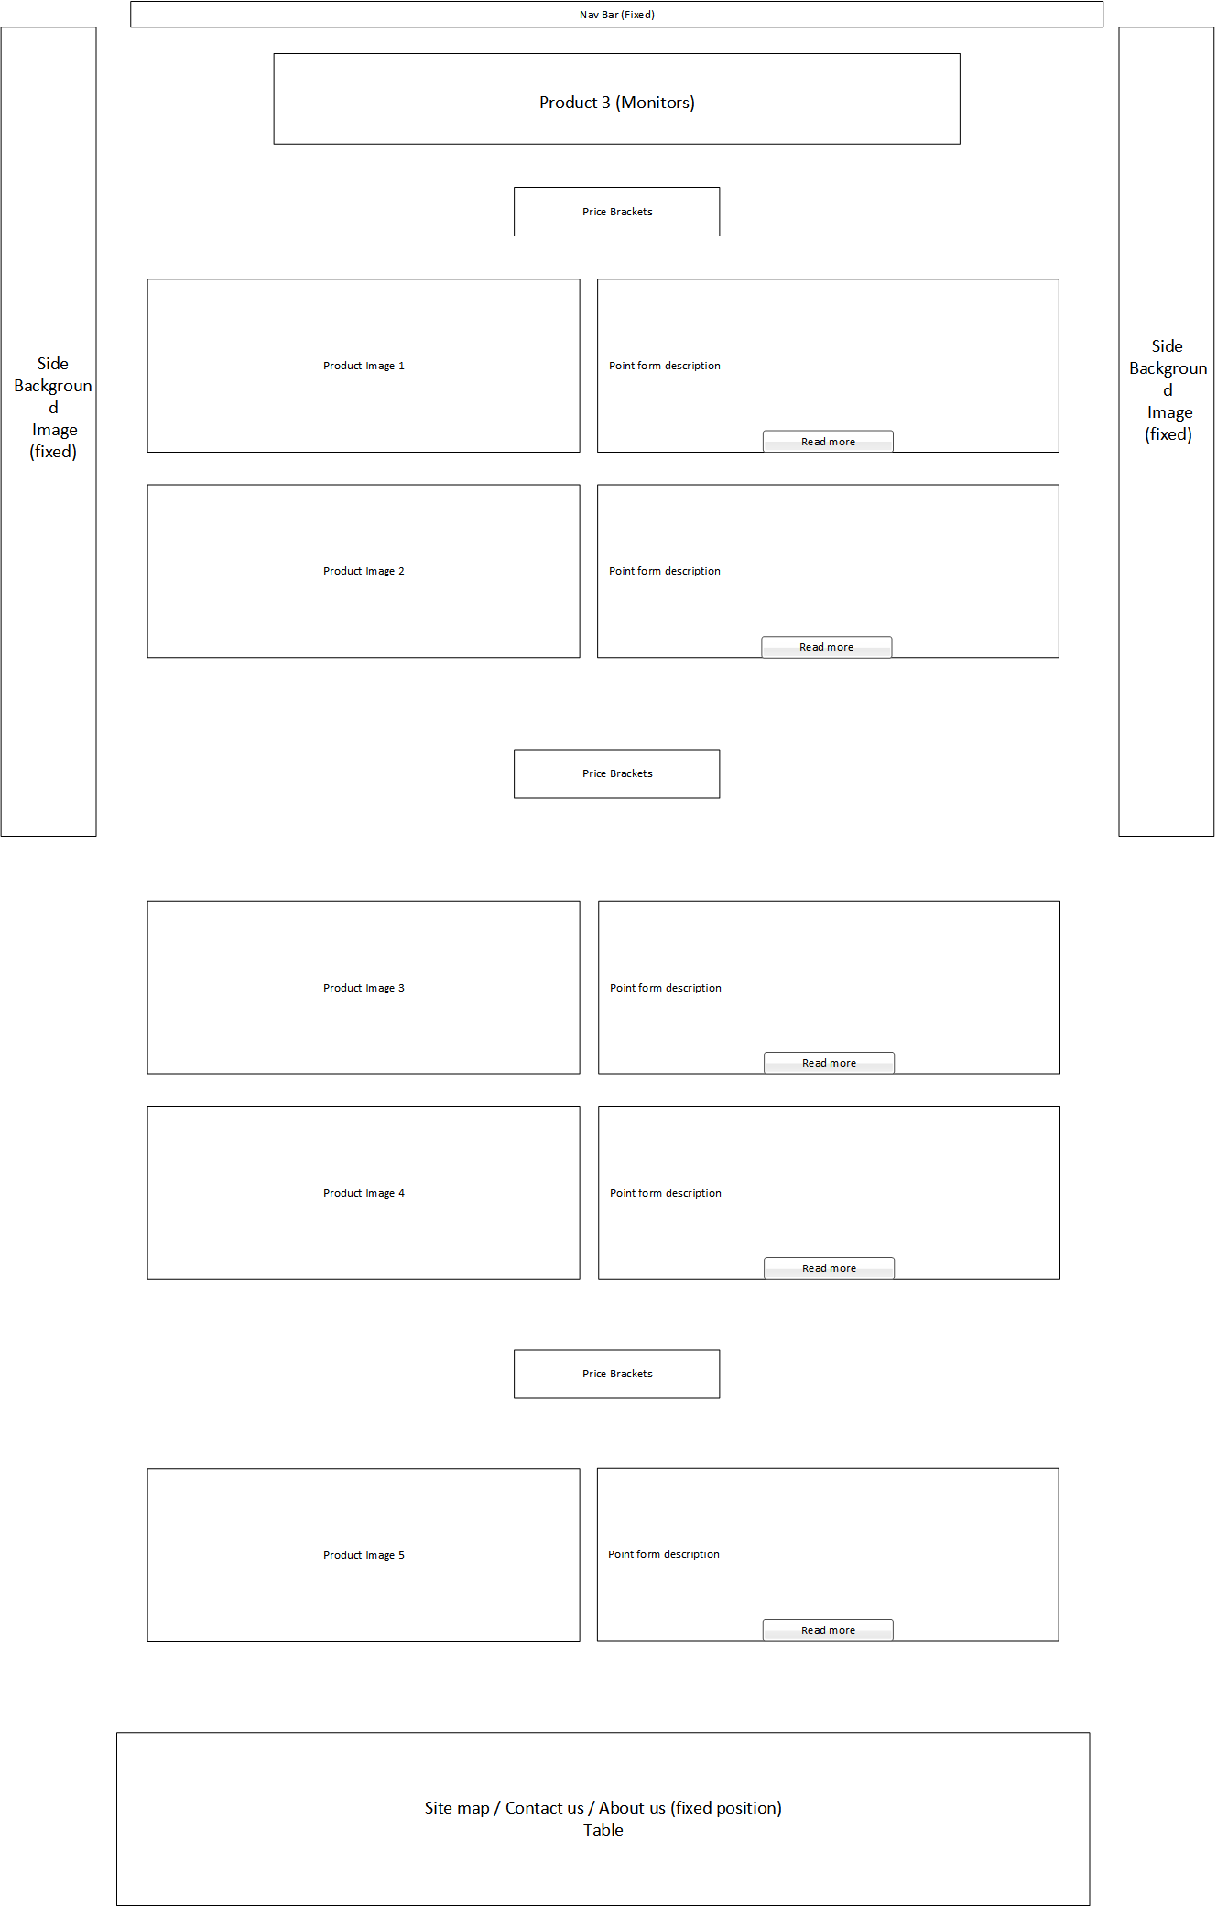**Product Page # 1 - # 3**

For the content page, we chose to use a two-box format which will show images and descriptions explicitly. The background color will be dark gray, and it will also have one background image that is divided in half on the side of the page. The descriptions will be shown in point form for quick digestion with the option to expand for a full review of the product.

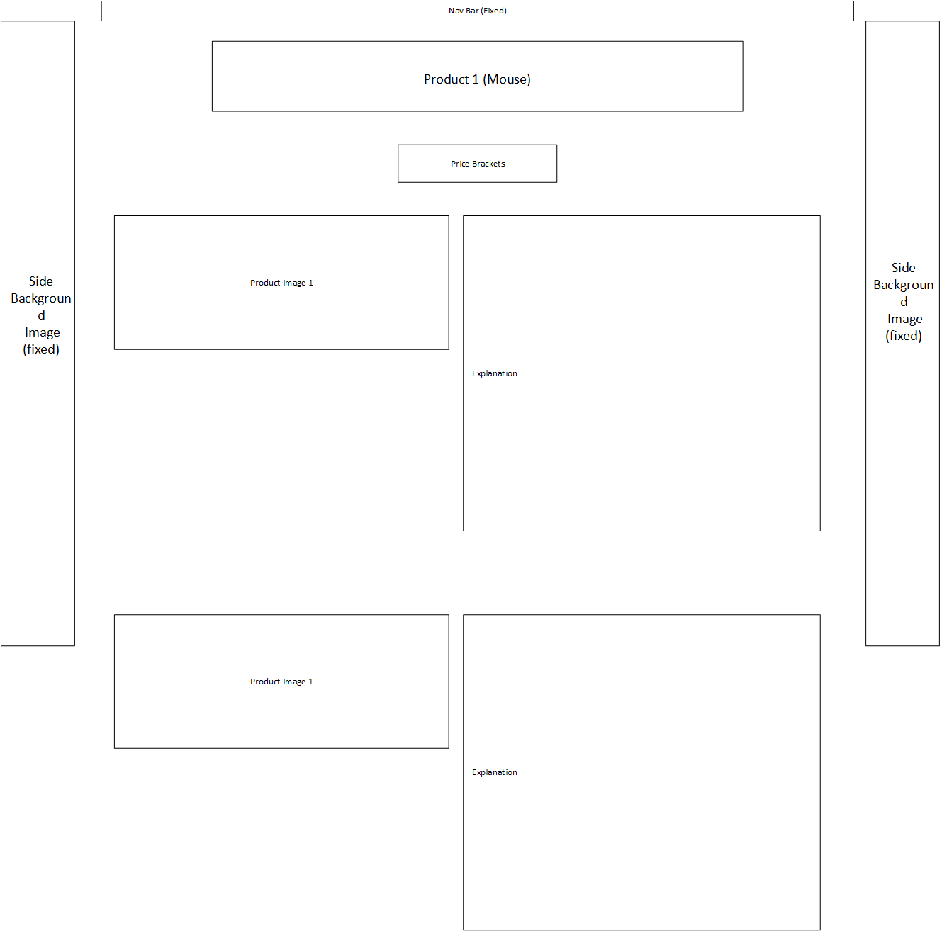**Product Page Expanded**

This is an example of how our product pages will look with the text description expanded for a full review. The text box will expand and push content below it further down the page.

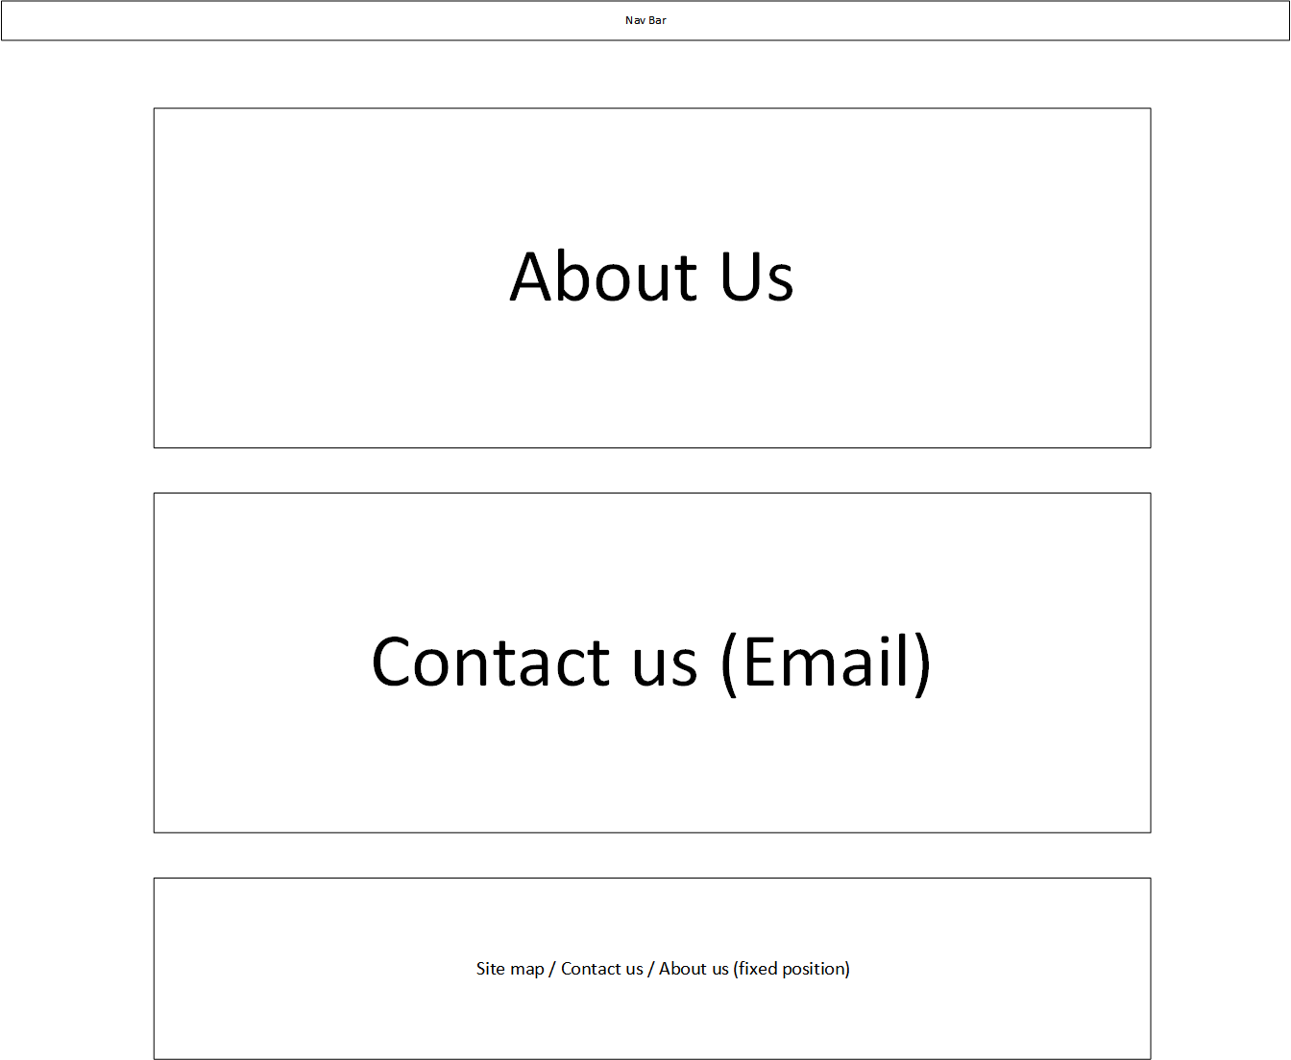**Info Page**

Our info page will have an About Us section as well as a Contact Us section with a contact form within. The About Us section will include a brief introduction about each group member as well as information regarding the website itself. Users can submit feedback regarding the website or products via a contact form where they can input their email, subject, and name so that they can directly message us. We will continue the colour scheme of contrasting colour boxes on top of a dark gray background.

**Main Page Print View**

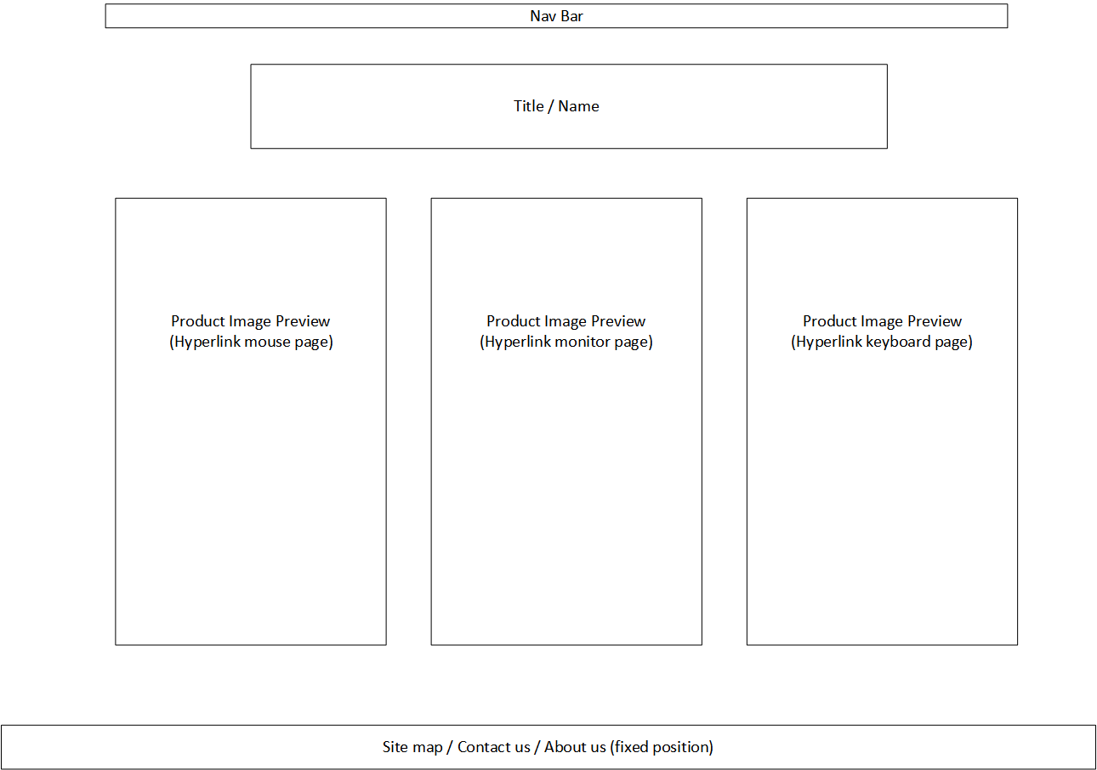

Our color scheme for page printing will change to a white background with black text to minimize ink usage. We will also try to minimize image and media display as well to help reduce ink. This is true for all pages of our site.

**Product Page Print View # 1 - # 3**

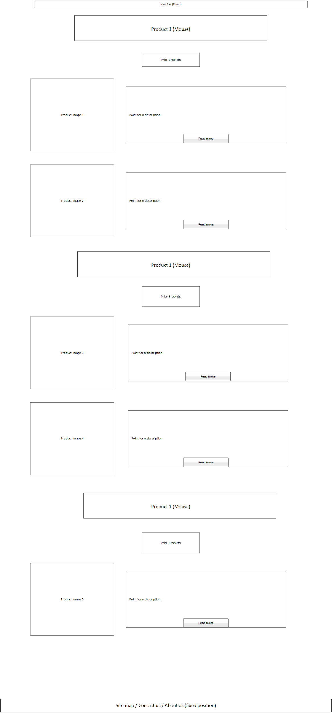

**Info Page Print View**

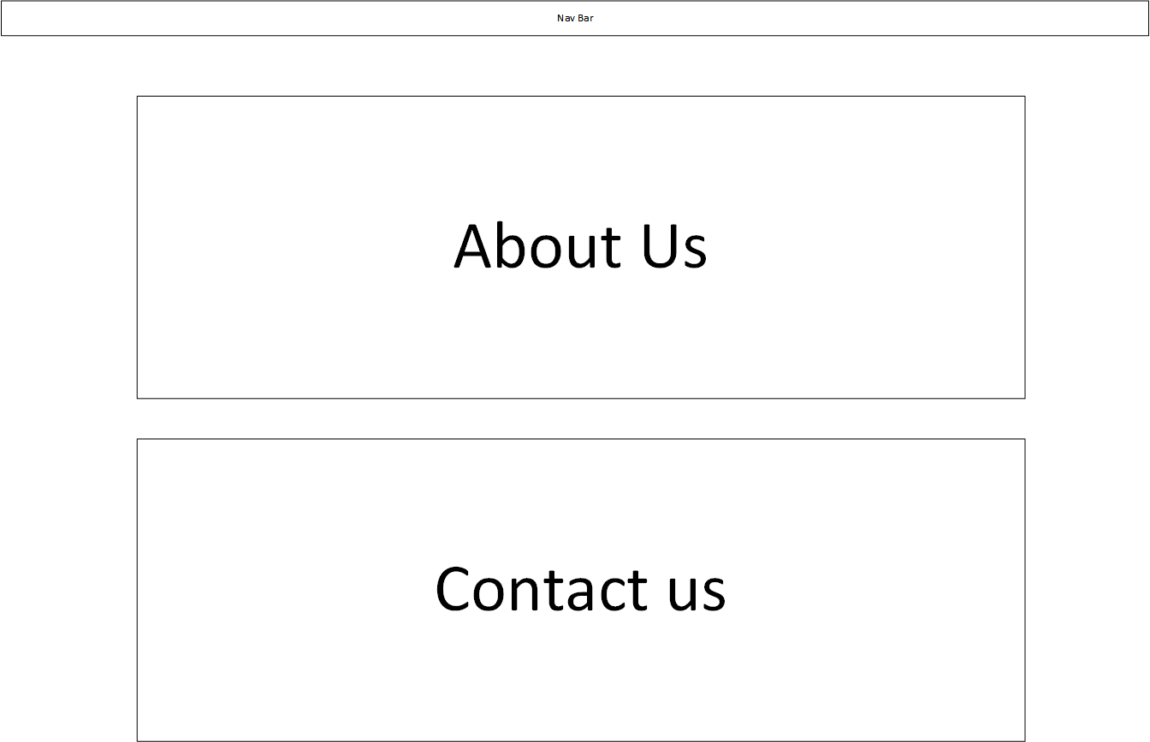

**Site Map Page**

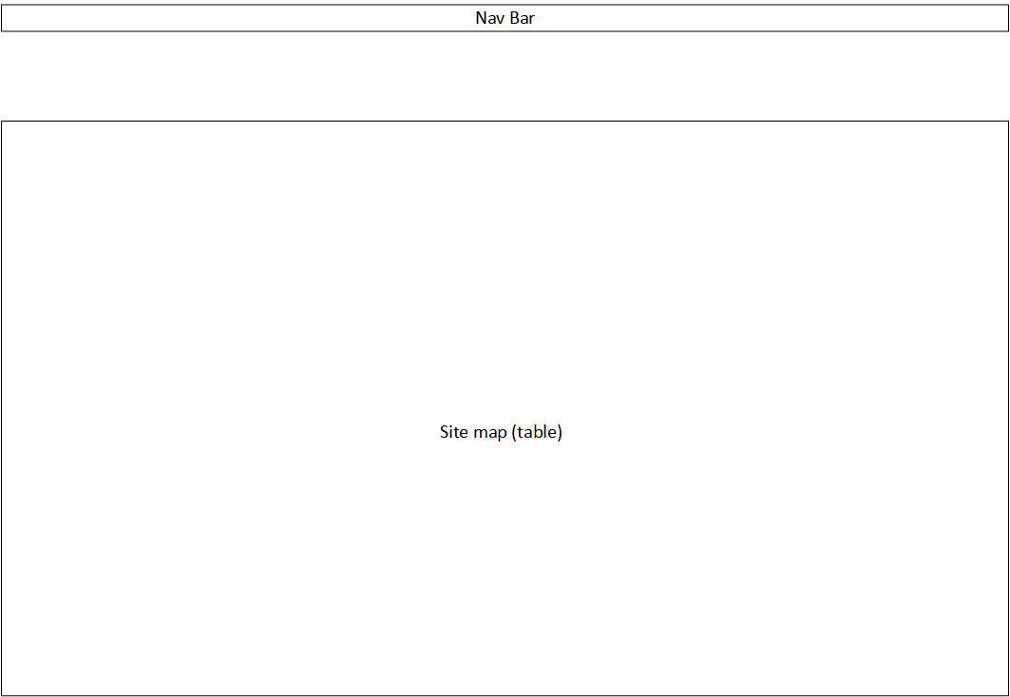

Our site map page will include the site-wide navigation bar but will not include the site-wide footer. As for the sitemap, it will be in table format with links to all pages on our site as well as showing how they are connected.

**User Sign-Up**

Our site will include a membership sign-up that will give the user posting access on our site forum. This will require users to choose a username and create a password.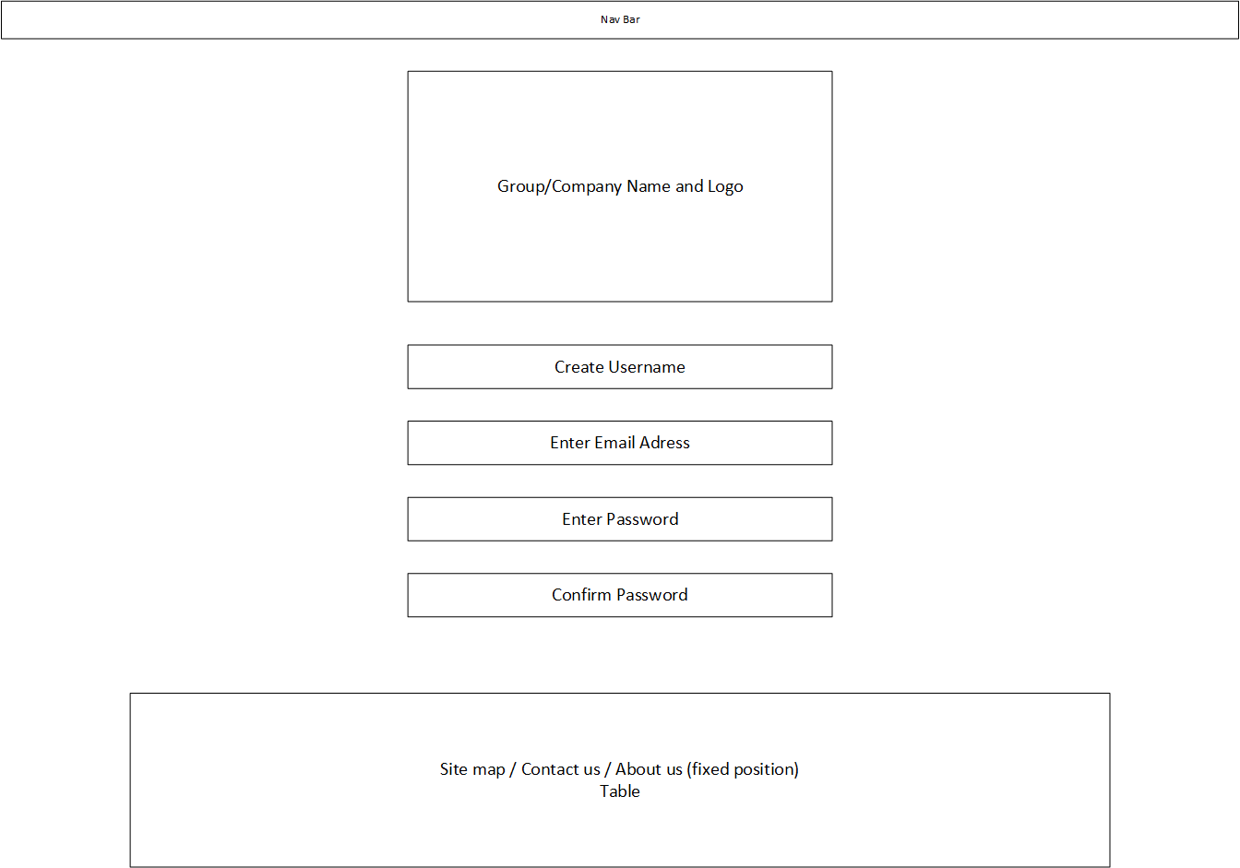

**Forum Page**

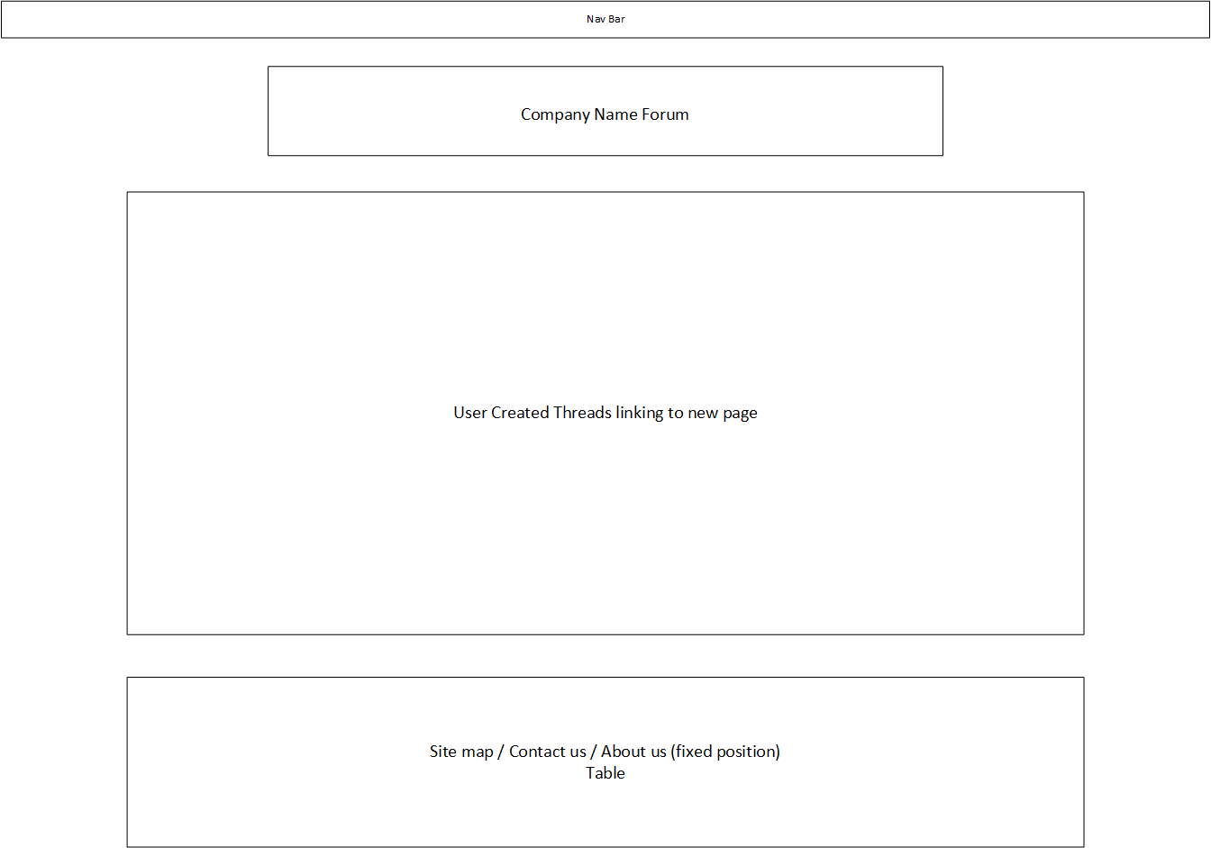

Our forum will be a way for our users to interact with the site community. This option will be restricted to site members. The members will be able to create a thread of their own or choose to comment on a pre-existing thread.

**Proposed Color Schemes**

**Proposed color scheme #1:**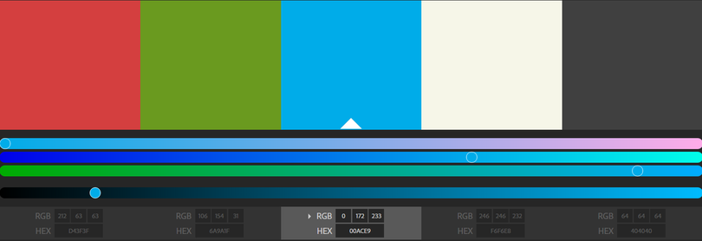

For our first proposed color scheme, we chose a more muted color palate that wouldn’t take away from the content and images of the products. The first three colors are going to be used for header background colors as well as icon colors. The fourth color will be used for text, and the final color will be the main background color.

**Proposed color scheme #2:**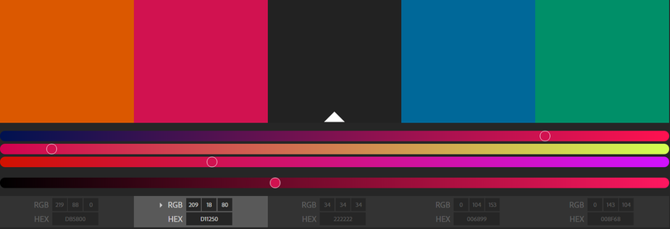

For the second proposed color scheme, we chose a more vibrant color palette that would be used to catch the attention of potential visitors. The first two, as well as the last two colors, would be header and icon colors. They bring in lots of contrast against the darker background color. As for text, it would be white to give clear readability on the dark background.

**Appendix: A**

**Peripheral Recommendations**

**Site Purpose**

The purpose of the site is to help consumers find the gaming peripherals that fits their needs. This will be done by providing them with in-depth reviews, technical specifications and what they mean, as well as different aesthetic options.

**Site Goals**

The goal of the site is to have a well-designed, aesthetically pleasing, and functional website that will introduce customers to a selection of peripherals from a wide range of price points. We want customers to be able to easily view and compare their options before making a purchase on a mouse, keyboard, or monitor.

**Target Audience**

The website is to target the gaming community that is interested in enhancing their experience by investing money into better or newer equipment. We are going to focus on the design of the website to attract a younger audience because the majority of gamers are aged between 13-35, and they have a greater willingness to invest into gaming peripherals.

**What the Site Would Like to Accomplish**

The major accomplishment of the website will be to satisfy customers who are looking to buy peripherals by providing information on a number of options that they should consider. Also, providing easily-accessible information is a vital factor for the website. Eventually, despite the fact that the website is about peripherals, it will be as crucial as the sites that compare and review other main components of the computer, such as graphics cards and processors.

**Type of Content**

The website will be featuring several types of peripherals, such as mice, keyboards, and monitors. The products compatibility with the different computers, price ranges, pictures of the products, and links to the sites where people can purchase the products will also be included on the site. Also, a customer review forum will account for part of the site. Due to the fact that this website is targeted at all gamers, not specifically professionals, recommendations as well as technical specifications and why they are important will be included for each product. The website will have easily readable text with clear colors, and high-quality pictures of the peripherals.

**Success Factors**

The success factors for our website are; easy to access, a modern design and quality information on gaming peripherals. Detailed menus will easily help users navigate our website. A modern design will make our website stand out among similar sites. We will provide consumers and users with quality information on gaming peripherals such as specifications as well as an in-depth review. This will help consumers and users make an informed decision on what peripheral to purchase.

**Similar Sites**

[Tomshardware.com](http://www.tomshardware.com/) reviews many computer components including peripherals and they give in-depth analysis as well as hardware specifications and recent news on products. They have a forum, news, and opinions section where users can find information about a product from many different sources. While Tomshardware does have an abundance of content they don’t focus on any one category in particular, this can be overwhelming to consumers new to the gaming or desktop industry who may be looking for one specific component such as peripherals.

[PC Part Picker](https://ca.pcpartpicker.com/guide/) is a comparison site for PC hardware parts such as motherboards, video cards, power supplies. The concept will be similar but PC Part Picker’s focus is on building a complete computer while ours focus is on guiding the consumer into picking the peripheral that fits their needs. Items can be compared and buyers can post reviews for the bought product. While PC Part Picker is mainly focused on cost, technical specs and a 5 star rating system ours will focus on personal reviews and recommendations with technical specs and cost just being one of many factors.

**Functional Requirements**

**Forms of User Input**

The site will feature a members signup as well as a forum posting page. Members of the site will be able to give their own thoughts on the site as well as to add their own personal experiences with various peripherals. There will also be a ‘Contact Us’ page which will allow users to give us input directly.

**Included Lists**

Products will be listed by peripheral type (Mouse, Monitor, Keyboard), with a subcategory of manufacturer (i.e. Razer, Corsair, Logitech). The items be listed by price, lowest to highest. Items mainly be shown by image, on mouse over, specs will be shown in a small window. A menu list will also be presented at the top of the page, for people who wish to navigate through the website in a traditional way.

**Work Plan**

**Scheduling**

Our work plan consists of dividing the work into sections. We will assign a team member to a certain section in which they will focus on. All our members are in the same set which makes it easier to organize and schedule group meetings. We have multiple communication channels such as Discord, Slack and breaks in between classes. This will help in making sure our members are meeting deadlines and communicating with other group members during the project.