Task 1: Qualitative Risk Assessment
Analysis: Relationship between Likelihood, Impact, and the resulting Risk Score
Likelihood is the probability that a risk event will occur while Impact is the potential consequences if the risk event occurs. The formula Risk Score = Probability × Impact creates a two-dimensional assessment that balances how frequently a risk might occur against how severe the consequences would be if it did.
R001 – Ransomware Attack (Score: 12)
The likelihood of a ransomware attack is moderate due to the prevalence of cyberattacks targeting customer databases, although existing controls (Backup, Antivirus) reduce full exploitation. The impact is high because a successful attack could cause data unavailability, operational disruption, and significant financial loss. reflecting substantial organizational exposure
R002 – Insider Threat (Score: 8)
Although the likelihood is relatively low since insider incidents are less frequent, the impact is high since insider incidents are difficult to detect and can lead to prolonged data misuse. This risk highlights the importance of access governance and monitoring.
R003 – Phishing Attack (Score: 8)
The likelihood is high because phishing campaigns are easy to execute and widely used due to frequent attempts and reliance on human behavior, which is difficult to fully control. However, the impact is relatively low to moderate as compromised credentials can be leveraged to escalate into more severe security incidents. The risk score reflects the persistent nature of social engineering threats.
R004 – System Failure (Score: 9)
System failure likelihood is moderate due to reliance on infrastructure with a single point of failure, despite redundancy measures. The impact is also moderate, as email outages affect productivity but not critical data assets. The resulting risk score of 9 represents moderate operational risk.
R005 – Data Breach (Score: 10)
Although the probability of occurrence is lower, the extremely high impact drives the overall risk score. This analysis demonstrates that risks involving sensitive data are prioritized based on potential damage rather than frequency alone.
R006 – Compliance Violation (Score: 6)
Compliance violations are assessed with a low to moderate likelihood because policies exist but may not be consistently enforced. The impact is moderate, as penalties and corrective actions can affect operations and finances. This risk requires continuous monitoring to prevent escalation to a higher priority level.
R007 – Third-Party Failure (Score: 6)
The likelihood of third-party failure is low to moderate due to vendor management practices and contractual controls. The impact is moderate, as service disruptions affect operations but are often temporary. This results in a risk score of 6, reflecting moderate dependency risk.
Prioritization:
- R001 – Ransomware Attack (Critical):
This risk requires immediate attention due to its potential to disrupt access to critical customer data and cause significant financial and operational damage. The risk score places it firmly in the Critical range, justifying executive-level visibility.
- R005 – Data Breach (High):
This risk is prioritized due to its severe impact on customer data confidentiality and regulatory compliance. Despite a lower likelihood, the magnitude of potential damage warrants urgent management action.
- R003 – Phishing Attack (High):
Phishing is prioritized because of its high likelihood and ability to act as an entry point for more severe incidents such as credential theft or ransomware attacks.
Evidence
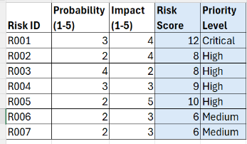
Task 2: Quantitative Risk Assessment (ALE)
Definitions:
SLE: Single Loss Expectancy is the financial impact of a single risk event.
ARO: Annual Rate of Occurrence is the estimated frequency of a risk event occurring per year.
ALE: Annualized Loss Expectancy is the expected monetary loss for an asset due to a risk over a one-year period.
Analysis
The Highest ALE is $1,000,000 per year.
The risks with highest financial exposure are:
- R001 – Ransomware Attack
- R002 – Insider Threat
- R005 – Data Breach
While ransomware is prioritized as Critical due to its high impact and medium likelihood, the quantitative analysis reveals that insider threats demand equal financial attention despite a lower qualitative score, highlighting a key insight from integrating both methodologies. This $3.25 million total annual exposure underscores the need for a balanced security investment strategy that addresses operational disruption, internal vulnerabilities, and regulatory compliance in parallel, rather than focusing on a single threat vector. The analysis confirms that a layered defense approach, validated by cost-benefit analysis against ALE, is essential for effective risk management and resource allocation.
Evidence
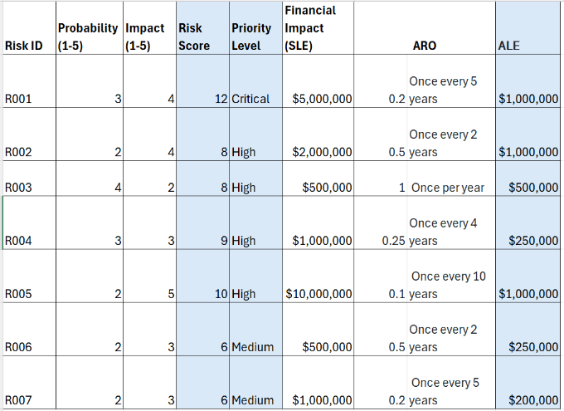
Task 3: Risk Treatment Strategy Analysis
Evaluation
The relationship between current controls and treatment strategies demonstrates a logical alignment; technical controls support risk reduction strategies, while contractual mechanisms align with risk transfer. However, the evaluation reveals that the organization focuses primarily on control–strategy matching rather than assessing whether the controls are sufficient for the severity of each risk. Several high-priority risks with significant financial exposure rely on baseline or single-layer controls that may not adequately reduce risk to an acceptable level. This gap indicates the need to evaluate not only the appropriateness of controls, but also their effectiveness and depth in relation to likelihood, impact, and overall risk severity.
Recommendation
For Risk R005 (Data Breach), an enhanced risk reduction strategy based on a defense-in-depth approach is recommended. The current reliance on encryption alone addresses only one aspect of the threat and leaves other attack vectors unmitigated. Implementing layered controls such as Data Loss Prevention (DLP), User and Entity Behavior Analytics (UEBA), Privileged Access Management (PAM), and security awareness training would provide broader coverage across the attack lifecycle. This approach would more effectively lower residual risk, strengthen regulatory compliance, and align security investments with the organization’s financial exposure.
Evidence
