Conteúdos

Abstract 2
1. historia 2
1.1 Origens 2
1.2 Motivações 3
2 Realidade 3
2.1 Tecnologia 3
2.2 Futuro 3
3. Aplicações 3
3.1 Utilidade 3
3.2 Uso Doméstico 3
4. Acção Social 3
4.1 Augmented Rallity Campaign 2010 4
5. Best Apps 4
5.1 Modelos de Negócio 4
5.2 Top Ten 4

Author Guidelines for ‘Artigo de divulgação de cav’

Edna Stella Quaresma Ist82317
Luis Filipe Santos Ist******

Instituto Superior Técnico
Taguspark,Oeiras, Portugal
E-mail: {ednastella, lfsantos}@hotmail.com

Abstract
Neste documento pretendemos demonstrar factos relativos as estado evolutivo da Realidade Aumentada. Este tema ameaça fazer parte integral da vida quotidiana tornando-se imprescindível estudá-lo para maior compreensão. Aqui ficarão esclarecidos alguns aspectos tecnicos da do tema respondendo a questões cruciais da cadeira em que o projeto se encontra inserido (Comunicação Multimédia), valorizando por isso os aspectos visuais e auditivos desta tencologia.

Index Terms— One, two, three, four, five

1. historia
A Realidade Aumentada foi trabalhada durante decadas,antes do seu surgimento como a conhecemos nos dias de hoje.
A ideia base da tecnologia é a criação duma versão do mundo que não é real, mas que melhora a versão real.

1.1 Origens
Morton Heiling, conhecido como o pai da Ralidade Virtual, como resultado do seu trabalho de investigação entre as decadas de 1950 e 1960.

.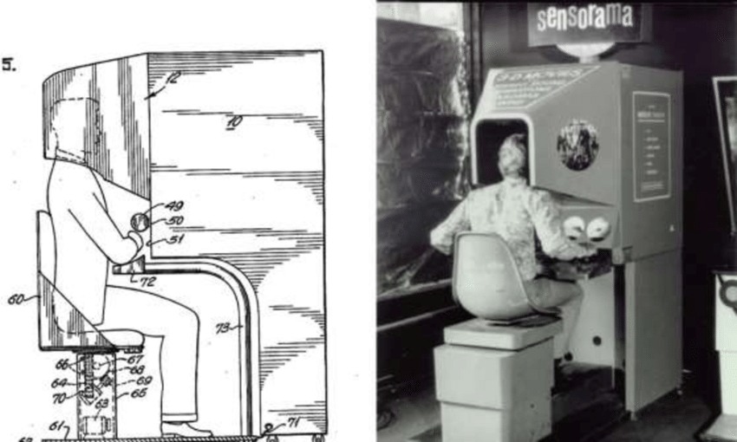
Figure 1 - Sensorama Simulator
Morton Heiling, conhecido como o pai da Ralidade Virtual, como resultado do seu trabalho de investigação entre as decadas de 1950 e 1960.
Pantenteou a sua criação de nome “Sensorama Simulator” ao quan chamou “theatre experience” em Agosto de 1962. A invenção permitia a simulação duma experiencia usando uma imagem visual, vento e vibrações.

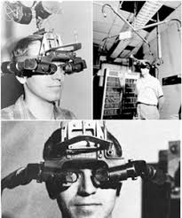
Posteriormente em 1968 Ivan Sutherland, Professor da Universidade de Harvard na área das ciencias de computação, e o seu aluno Bob Sproull inventaram “The Sword of Damocles”. O primeiro Display System de Realidade Aumentada literalmente Head-Mounted. O seistema usava graficos gerados por computador para mostar aos utilizadores simples Wireframes.Sutherlnad ficou conhecido como o “Pai dos Gráficos”
Figure 2-The Sword of Damocles

Em 1974, Myron Krueger, construiu um laboratório de ‘realidade artificial’ ao qual chamou “Videoplace”. O espaço combinava projectors e camaras de video, que emitiam para o ecrã silhuetas que envolviam os utilisadores num ambiente interativo.

O investigador Tom Caudell lacrou o nome Realidade Aumentada em 1990 e a Australiana Jullie Martin creou a primeira produçao de cinema em realidade aumentada “Dancing inCuberspace” recorrendo a acrobatas que dançavam a volta de objectos virtuais no palco.

Pesquisas na area de Naval resultam no Sistema BARS (Battlefield Augmented Reality System) enquanto a nave NASA X-38 voava usando Hybrid Synthetic Vision, um Sistema de Realidade Aumentada que sobrepõe os dados do mapa de forma a melhorar a navegação visual durante os testes de voo.

Vor volta do ano 2000 o ARToolKot da Hirokazu Kato combinou graficos virtuais com vida real, usando video tracking para sobreposição grafica numa camara de video.

1.2 Motivações
O insulto comum "fora de contato com a realidade" refere-se a pensamentos e ideias anormais, mas a conotação negativa não assustou os investigadores de tentar criar uma versão do mundo que fosse irreal, mas boa.

Até a imprenssa (escrita) começou a utilizer AR. A Esquire Magazine solicita ao leitores que façam o scan da capa de forma a ter Robert Downey Jr. ao vivo na página.

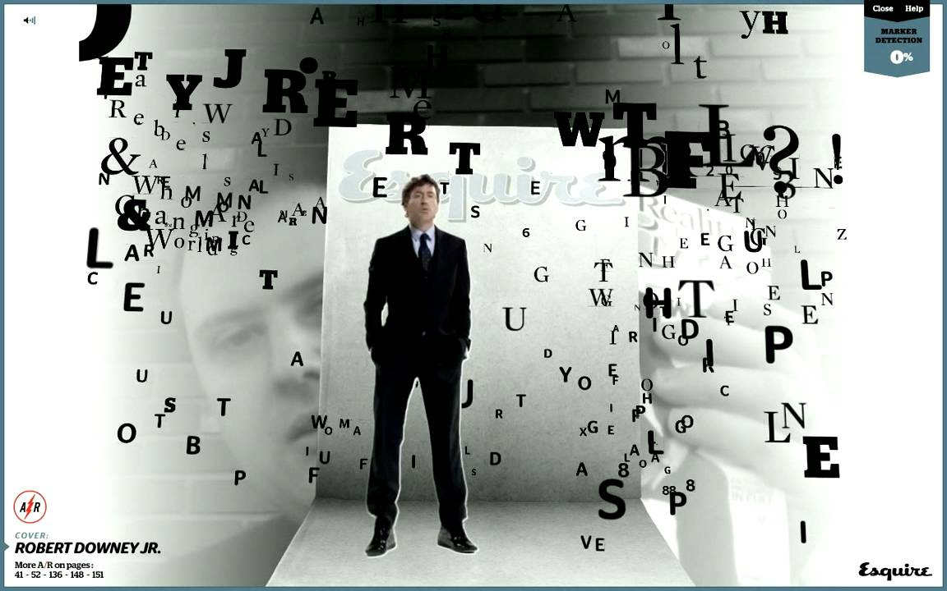
Figure 3 - Robert Downey Jr. in Esquire Magazine

2 Realidade
The paper title (on the first page) should begin 1.38 inches (35 mm) from the top edge of the page, centered, completely capitalized, and in Times 14-point, boldface type. The authors’ name(s) and affiliation(s) appear below the title in capital and lower case letters. Papers with multiple authors and affiliations may require two or more lines for this information.

2.1 Tecnologia
To achieve the best rendering, we strongly encourage you to use Times-Roman font. In addition, this will give the set of papers a more uniform look. Use a font that is no smaller than nine point type and no bigger than ten point type throughout the paper, including figure captions.
In nine point type font, capital letters are 2 mm high. If you use the smallest point size, there should be no more than 3.2 lines/cm (8 lines/inch) vertically. This is a minimum spacing; 2.75 lines/cm (7 lines/inch) will make the paper much more readable. Larger type sizes require correspondingly larger vertical spacing. Please do not double-space your paper. True-Type 1 fonts are preferred.
The first paragraph in each section should not be indented, but all following paragraphs within the section should be indented as these paragraphs demonstrate.

2.2 Futuro
Major headings, for example, “1. Introduction”, should appear in all capital letters, bold face if possible, centered in the column, with one blank line before, and one blank line after. Use a period (“.”) after the heading number, not a colon. It is suggested all headings are numbered in an automatic way.

3. Aplicações
Subheadings should appear in lower case (initial word capitalized) in boldface. They should start at the left margin on a separate line.
Sub-subheadings, as in this paragraph, are discouraged. However, if you must use them, they should appear in lower case (initial word capitalized) and start at the left margin on a separate line, with paragraph text beginning on the following line. They should be in italics.

3.1 Utilidade
Illustrations must appear within the designated margins. They may span the two columns. If possible, position illustrations at the top of columns, rather than in the middle or at the bottom. Caption and number every illustration with font size 10. Each figure should be minimally described in the text and should not appear before it is mentioned in the text.
If you want to include material such as video, and audio do it by using a link included as reference.

3.2 Uso Doméstico
Illustrations must appear within the designated margins. They may span the two columns. If possible, position illustrations at the top of columns, rather than in the middle or at the bottom. Caption and number every illustration with font size 10. Each figure should be minimally described in the text and should not appear before it is mentioned in the text.
If you want to include material such as video, and audio do it by using a link included as reference.

4. Acção Social
Use footnotes sparingly (or not at all!) and place them at the bottom of the column on the page on which they are referenced. Use Times 9-point type, single-spaced. To help your readers, avoid using footnotes altogether and include necessary peripheral observations in the text (within parentheses, if you prefer, as in this sentence).

4.1 Augmented Rallity Campaign 2010

5. Best Apps
List and number all bibliographical references at the end of the paper. The references can be numbered in alphabetic order or in order of appearance in the document.
All the references in the list MUST be referred in the text at some stage. When referring to them in the text, type the corresponding reference number in square brackets as shown at the end of this sentence [1]. It is suggested that all references are introduced as links to be list of references to

5.1 Modelos de Negócio
Illustrations must appear within the designated margins. They may span the two columns. If possible, position illustrations at the top of columns, rather than in the middle or at the bottom. Caption and number every illustration with font size 10. Each figure should be minimally described in the text and should not appear before it is mentioned in the text.
If you want to include material such as video, and audio do it by using a link included as reference.

5.2 Top Ten
Illustrations must appear within the designated margins. They may span the two columns. If possible, position illustrations allow automatic updating. The various elements in a reference must be ordered and formatted as in the examples in the following depending on their type, e.g. conference paper, journal paper, book.

referencias

- G. O. Young, “Synthetic structure of industrial plastics (Book style with paper title and editor),” in Plastics, 2nd ed. vol. 3, J. Peters, Ed. New York: McGraw-Hill, 1964, pp. 15–64.
- W.-K. Chen, Linear Networks and Systems (Book style). Belmont, CA: Wadsworth, 1993, pp. 123–135.
- H. Poor, An Introduction to Signal Detection and Estimation. New York: Springer-Verlag, 1985, ch. 4.
- B. Smith, “An approach to graphs of linear forms (Unpublished work style),” unpublished.
- E. H. Miller, “A note on reflector arrays (Periodical style—Accepted for publication),” IEEE Trans. Antennas Propagat., to be published.
- J. Wang, “Fundamentals of erbium-doped fiber amplifiers arrays (Periodical style—Submitted for publication),” IEEE J. Quantum Electron., submitted for publication.
- C. J. Kaufman, Rocky Mountain Research Lab., Boulder, CO, private communication, May 1995.
- Y. Yorozu, M. Hirano, K. Oka, and Y. Tagawa, “Electron spectroscopy studies on magneto-optical media and plastic substrate interfaces(Translation Journals style),” IEEE Transl. J. Magn.Jpn., vol. 2, Aug. 1987, pp. 740–741 [Dig. 9th Annu. Conf. Magnetics Japan, 1982, p. 301].
- M. Young, The Techincal Writers Handbook. Mill Valley, CA: University Science, 1989.
- J. U. Duncombe, “Infrared navigation—Part I: An assessment of feasibility (Periodical style),” IEEE Trans. Electron Devices, vol. ED-11, pp. 34–39, Jan. 1959.
- S. Chen, B. Mulgrew, and P. M. Grant, “A clustering technique for digital communications channel equalization using radial basis function networks,” IEEE Trans. Neural Networks, vol. 4, pp. 570–578, July 1993.
- R. W. Lucky, “Automatic equalization for digital communication,” Bell Syst. Tech. J., vol. 44, no. 4, pp. 547–588, Apr. 1965.
- S. P. Bingulac, “On the compatibility of adaptive controllers (Published Conference Proceedings style),” in Proc. 4th Annu. Allerton Conf. Circuits and Systems Theory, New York, 1994, pp. 8–16.
- G. R. Faulhaber, “Design of service systems with priority reservation,” in Conf. Rec. 1995 IEEE Int. Conf. Communications, pp. 3–8.
- W. D. Doyle, “Magnetization reversal in films with biaxial anisotropy,” in 1987 Proc. INTERMAG Conf., pp. 2.2-1–2.2-6.
- G. W. Juette and L. E. Zeffanella, “Radio noise currents n short sections on bundle conductors (Presented Conference Paper style),” presented at the IEEE Summer power Meeting, Dallas, TX, June 22–27, 1990, Paper 90 SM 690-0 PWRS.
- J. G. Kreifeldt, “An analysis of surface-detected EMG as an amplitude-modulated noise,” presented at the 1989 Int. Conf. Medicine and Biological Engineering, Chicago, IL.
- J. Williams, “Narrow-band analyzer (Thesis or Dissertation style),” Ph.D. dissertation, Dept. Elect. Eng., Harvard Univ., Cambridge, MA, 1993.
- N. Kawasaki, “Parametric study of thermal and chemical nonequilibrium nozzle flow,” M.S. thesis, Dept. Electron. Eng., Osaka Univ., Osaka, Japan, 1993.
- J. P. Wilkinson, “Nonlinear resonant circuit devices (Patent style),” U.S. Patent 3 624 12, July 16, 1990.
- IEEE Criteria for Class IE Electric Systems (Standards style), IEEE Standard 308, 1969.
- Letter Symbols for Quantities, ANSI Standard Y10.5-1968.
- R. E. Haskell and C. T. Case, “Transient signal propagation in lossless isotropic plasmas (Report style),” USAF Cambridge Res. Lab., Cambridge, MA Rep. ARCRL-66-234 (II), 1994, vol. 2.
- E. E. Reber, R. L. Michell, and C. J. Carter, “Oxygen absorption in the Earth’s atmosphere,” Aerospace Corp., Los Angeles, CA, Tech. Rep. TR-0200 (420-46)-3, Nov. 1988.
- (Handbook style) Transmission Systems for Communications, 3rd ed., Western Electric Co., Winston-Salem, NC, 1985, pp. 44–60.
- Motorola Semiconductor Data Manual, Motorola Semiconductor Products Inc., Phoenix, AZ, 1989.
- (Basic Book/Monograph Online Sources) J. K. Author. (year, month, day). Title (edition) [Type of medium]. Volume issue). Available: http://www.(URL)
- J. Jones. (1991, May 10). Networks (2nd ed.) [Online]. Available: http://www.atm.com
- (Journal Online Sources style) K. Author. (year, month). Title. Journal [Type of medium]. Volume(issue), paging if given. Available: http://www.(URL)
- R. J. Vidmar. (1992, August). On the use of atmospheric plasmas as electromagnetic reflectors. IEEE Trans. Plasma Sci. [Online]. 21(3). pp. 876—880. Available: http://www.halcyon.com/pub/journals/21ps03-vidmar

Bibliografia

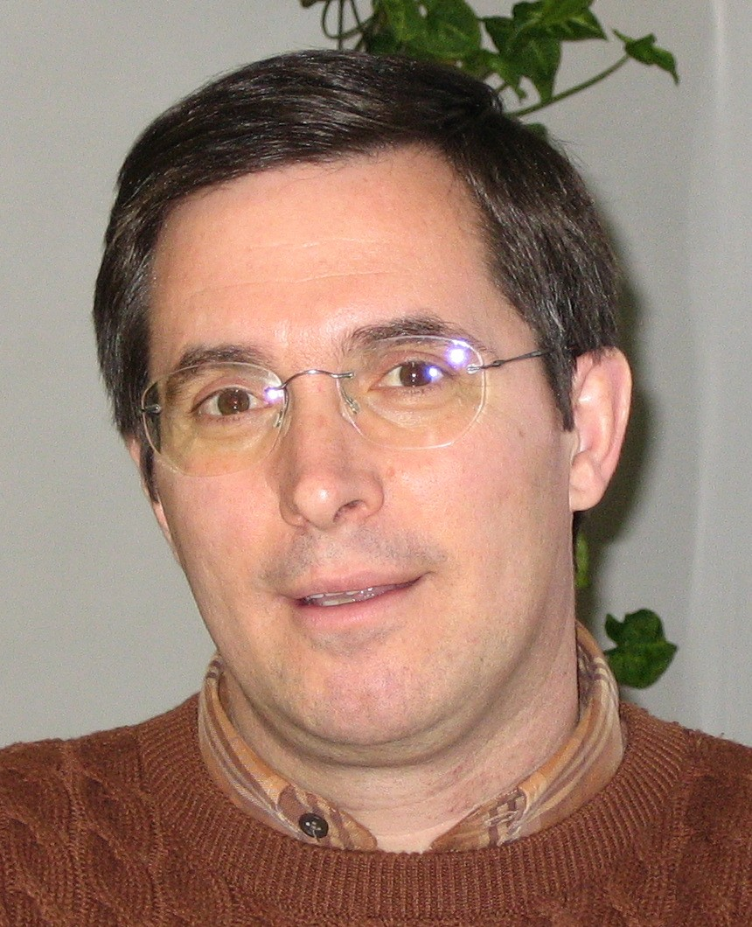
First A. Author and the other authors may include biographies at the end of regular papers. The first paragraph may contain a place and/or date of birth (list place, then date). Next, the author’s educational background is listed. The degrees should be listed with type of degree in what field, which institution, city, state or country, and year degree was earned. The author’s major field of study should be lower-cased.
The second paragraph uses the pronoun of the person (he or she) and not the author’s last name. It lists military and work experience, including summer and fellowship jobs. Job titles are capitalized. The current job must have a location; previous positions may be listed without one. Information concerning previous publications may be included. Try not to list more than three books or published articles. The format for listing publishers of a book within the biography is: title of book (city, state: publisher name, year) similar to a reference. Current and previous research interests ends the paragraph.
The third paragraph begins with the author’s title and last name (e.g., Dr. Smith, Prof. Jones, Mr. Kajor, Ms. Hunter). List any memberships in professional societies other than the IEEE. Finally, list any awards and work for IEEE committees and publications. If a photograph

is provided, the biography will be indented around it. The photograph is placed at the top left of the biography. Personal hobbies will be deleted from the biography.

