Esercizio 2 sessione 2, 2012

Let L= {a^i b^j c^k | i >= 0 and j + k = i}

- Define a context-free grammar G such that L(G) = L
- Say, justifing your answear,
  - whether G is LL(1) or not
  - whether G is LALR(1) or not.

_______________________________________________________________________________

1)
G:
S → aSc | B
B → aBb | empty

2)
First and Follow Table
 | First | Follow
S | a, empty | $ c
B | a, empty | B $ c

a)
LL(1) Predictive Parsing Table
 | a | b | c | $
S | S → aSc  S → B |  | S → B | S → B
B | B → aBb | B → empty | B → empty | B → empty

G is not LL(1) because there are multiple defined entries in the LL(1) predictive parsing table.

b)
I₀ | I₁: goto(I_{0,} S) | I₂: goto(I_{0,} a) | I₃: goto(I_{0,} B)
  S' → .S
  S → .aSc
  S → .B
  B → .aBb
  B → .
  S' → S.
  S → a.Sc
  B → a.Bb
  S → .aSc
  S → .B
  B → .aBb
  B → .
  S → B.
I4: goto(I2, S) | I₅: goto(I₂, B) | I₆: goto(I₄, c) | I₇: goto(I₅, b)
  S → aS.c
  B → aB.b
  S → B.
  S → aSc.
  B → aBb.

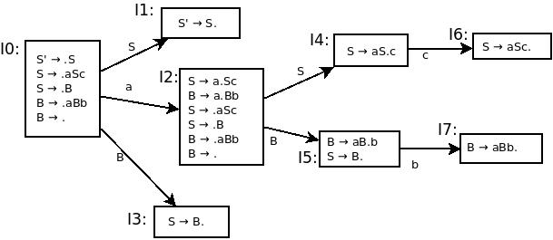
Kernel LR(0) itams:
01 S' → .S
02 B → .
11 S' → S.
21 S → a.Sc
22 B → a.Bb
23 B → .
31 S → B.
41 S → aS.c
51 B → aB.b
52 S → B.
61 S → aSc.
71 B → aBb.

Closure LR(0) Items

01 | 02 | 11 | 21
  S' → .S , &
  S → .aSc , &
  S → .B , &
  B → .aBb , &
  B → . , &
  B → . , &
  S' → S. , &
  S → a.Sc , &
  S → .aSc , c
  S → .B , c
  B → .aBb , c
  B → . , c
22 | 23 | 31 | 41
  B → a.Bb , &
  B → .aBb , b
  B → . , b
  B → . , &
  S → B. , &
  S → aS.c , &
51 | 52 | 61 | 71
  B → aB.b , &
  S → B. ,&
  S → aSc. , &
  B → aBb. , &

Propaghation Graph:

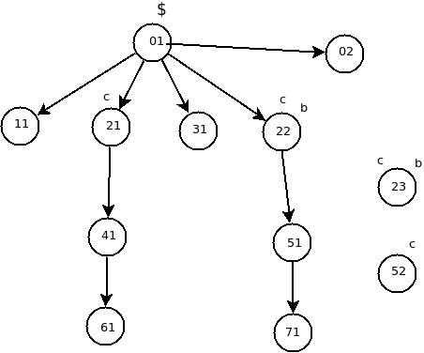

 | a | b | c | $ | S | B
0 | s2 |  |  | B → empty | g1 | g3
1 |  |  |  | acc
2 | s2 | B → empty | B → empty |  | g4 | g5
3 |  |  |  | S → B
4 |  |  | s6
5 |  | s7 | S → B
6 |  |  | S → aSc | S → aSc
7 |  | B → aBb | B → aBb | B → aBb

