Survey structure

About the survey
The Horizon EU ENTRANCE project aims to define a methodology to assess building performance that could support the identification of effective renovation strategies towards more electrified, energy efficient and flexible buildings.
A building renovation involves a multiplicity of, often opposing, objectives, perspectives, constraints, and variables, that must be properly quantified to evaluate alternatives. WP2 employs the Analytic Hierarchy Process (AHP), a multi-criteria decision-making method, to translates subjective opinions into commensurable quantities and priority scores.
The goal of this survey is to gather information on stakeholders’ to support the selection of performance indicators that can provide meaningful and relevant information for a building renovation.

About the respondent
Prompt question for Name, Role, Pilot, Country, Email. Is a Renovation under consideration?

Decision criteria
Building on the previous interviews we highlighted eight domains that we believe are critical criteria to consider for a renovation. Hereafter you can familiarise yourself with the criteria:
- Energy performance,
- Water use,
- Climate impact,
- Economic performance,
- Indoor Environmental Quality (IEQ),
- Energy system integration,
- Practical implementation.
Is there one or more criterion in our list you don’t think being relevant? Drop down list with checkbox
Is there an important criterion for your building operations that was not included in our list? Note it here ________
If the user define a new criteria or want to exclude one or more, adjust the next steps to correctly perform all the calculations.

Define level of priority
Implement a tier-list system with blocks for each criteria (pre-defined and user defined if any) that the user can interact with. The user must be able to move criterion block an place them in the priority level of their choice. Keep the tier sort as a lightweight, low-commitment first pass (drag-and-drop, no numbers shown) so it doesn't bias the subsequent numeric judgments. An example here:
The tier-list should help the user in filling the criteria matrix in a consistent way.
Tier distance | Recommended range (integer or reciprocal fractions) | Rationale
Same tier (A-A, B-B, C-C) | 1–3 | Criteria are close but not necessarily equal
Adjacent tiers (A-B, B-C) | 3–5 | Weak-to-moderate dominance
Extreme tiers (A-C) | 7–9 | Demonstrated-to-extreme dominance

Pairwise comparison
For each pair of criteria A-B, we ask you to grade the relative “priority” by assigning a weight between 1 (equal importance) and 9 (extreme importance).
Based on stakeholders priority tiers (A = top, B = mid, C = low), the tool guides pairwise scoring using tier-distance-based recommended ranges, and progressively infers remaining scores as the matrix fills in. Surface this as a non-binding suggestion ("Based on your answers so far, this comparison looks like it should be ranked in the ranged X-Y to preserve transitive chains (judgment consistency)") rather than auto-moving it, preserving user control over the final placement.
Prompt a series of question for n(n-1)/4 comparison on a spanning-tree-first pattern, where have every criterion compared at least once against a common reference criterion.
e.g. question: Do you find criterion A more important than criterion B? (suggested range: based on tier distance of criteria A and B)
Yes) How important is criterion A relative to criterion B? (suggested scale)
No) How important is criterion A relative to criterion B? (suggested scale -> the tool will compute it as its reciprocal)
Equal importance) Automatically assign grade 1

Review responses and check consistency ratio
Compute the remaining comparison for the missing pairs via geometric mean propagation through the known chains (the same logarithmic least-squares approach used for incomplete AHP matrices). Display the matrix filled with user-defined scores (in green) and estimated values (in yellow).
 | Energy performance | Water use | Climate impact | Economic performance | IEQ | Energy system integration | Technical feasibility | Social impact
Energy performance | 1 |  |  |  |  | 5
Water use |  | 1 |  |  |  | 1/7
Climate impact |  |  | 1
Economic performance |  |  |  | 1
IEQ |  |  |  |  | 1
Energy system integration | 1/5 | 7 |  |  |  | 1
Technical feasibility |  |  |  |  |  |  | 1
Social impact |  |  |  |  |  |  |  | 1

Plot priorities
Display a plot with the criteria priority score computed with the AHP
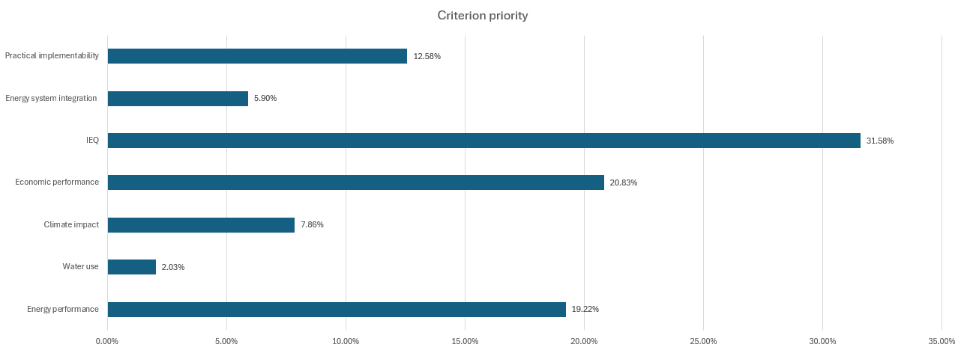

Submit survey

