COMP3074
Mobile Application Development I
FINAL PROJECT
APPLICATION DESIGN PROPOSAL

Application Name: ___Restaurant Guide________________
Team ID (from D2L): ________12______________________
Submission Date: ________Oct 2/2026_________________

Group size: maximum 5 students

Project Information
# | Student Name | Student ID | Primary Role / Responsibility
1 | Kalid Ali | 101577665 | Team leadership and overall integration
2 | Mohamed Amine OUATAR | 101579629 | Data research and external resource integration
3 | Joshua Zaakir | 101578900 | Data research and external resource integration
4 | Phillip Onofua | 101489064 | UI/UX Interaction Development

1. Project Overview
This is an Android mobile application designed to help users organize and manage a personal collection of restaurants. Instead of relying on scattered notes, saved links, screenshots or memory, users can maintain restaurant information in one standalone application and quickly retrieve it when deciding where to eat.
The application allows users to add, edit, view, search, and delete restaurant records. Each restaurant can contain a name, address, one or more phone numbers, description, ratings (1-5), and custom tags(e.g Halal, Vegan, Indian).
The application can display a restaurant’s location on a Google map, obtain users current location after permission is granted, and provide an option to obtain directions to a selected restaurant. Users can also share restaurant information through email.
The application will use Kotlin, Android Studio, Jetpack Compose, MVVM, and Room/SQLite for local data storage. No backend or cloud database required. The goal is to produce a complete and functional mobile prototype with a controlled scope that can be progressively developed across project milestones.

2. Project Objectives
- Implement complete restaurant management functionality that allows users to add, view, edit, delete restaurant records containing a name, address, phone number(s), description, tags, and 1-5 rating
- Apply search and filtering functionality so users can locate saved restaurants by restaurant name and by user-defined tags
- Apply persistent local storage using Room/SQLite so that all restaurant records remain available after the application is closed and reopened.
- Provide location-based functionality that displays a selected restaurant on a full screen Google map, obtains user’s current location (with permission), and provides directions to the restaurant
- Facilitate email-based sharing of restaurant information
- Implement splash screen with application logo/name and an About screen containing team members’ information

3. Target Users
The primary users are individuals who dine out regularly, and want to maintain a searchable organized list of restaurants they have visited, enjoyed or want to remember.

4. Functional Requirements
ID | Functional Requirement | Priority
Data Management (CRUD)
FR-01 | The application must display a scrollable list of all saved restaurants | Must Have
FR-02 | The application must allow users to add and save a new restaurant record | Must Have
FR-03 | The application must display the complete details of a selected restaurant | Must Have
FR-04 | The application must allow a user to modify and update fields of an existing restaurant | Must Have
FR-05 | The application must allows user to permanently delete a restaurant record after confirmation | Must Have
Data Attributes and Scoring

FR-06 | The application must store restaurant name, description,physical address, phone number(s), custom tags, | Must Have
FR-07 | The application must allow users to assign and update 1-5 star integer rating for any restaurant record | Must Have
FR-08 | The application must assist the user in entering a restaurant's physical address using clearly separated address fields and/or formatting assistance so that the saved address can be displayed consistently | Must Have
Search and Filtering

FR-00 | The application must allow a user to search saved restaurants by entering text string matching restaurants’ name | Must Have
FR-10 | The application must allow a user to filter the list of restaurant by selecting one or more user-defined tags | Must Have
Maps & Location Services

FR-11 | The application must use the saved restaurant address to identify and display the restaurant's location on an embedded Google map | Must Have
FR-13 | The application must provide a full-screen map view with an option to get directions to the selected restaurant. | Must Have
FR-13 | When directions are requested, the application must obtain the user's current location, with appropriate permission handling, and use it as the starting point for the directions request | Must Have
FR-14 | The application must open Google Maps with the user's current location and selected restaurant as the origin and destination; | Must Have
FR-15 | The application must handle cases where the user denies location permission or the current device location cannot be obtained by displaying an appropriate message and preventing the directions request from proceeding incorrectly | Must Have
Sharing

FR-16 | The application must allow the user to share a selected restaurant's information through email, including relevant details such as restaurant name, address, phone number(s), rating, tags, and description. | Must Have
Application Navigation and supporting screens

FR-17 | The application must display a Splash screen containing the application logo and/or application name when the application starts. | Must Have
FR-19 | The application must provide an About screen containing the names of all team members and basic application/project information. | Must Have
Bonus/Optional features

FR-20 | The application could provide an option to share restaurant information through Facebook in addition to email sharing | Could Have
FR-21 | The application could provide an option to share restaurant information through Twitter/X in addition to email sharing | Could Have
Usability features
FR-22 | The application should display an appropriate empty-state or no-results message when no restaurants are saved or when a search/filter produces no matching restaurants | Should Have
Input validation & Error handling
FR-23 | The application must validate required restaurant information before saving and display clear validation messages when required or invalid information is entered | Must Have

5. Application Screens and Navigation

Screen | Purpose | Main UI Components
Splash Screen | Introduce application when it starts | Application logo, application name
Restaurant List | Display and manage all saved restaurants | Restaurant list, search field, tag filter, add button, navigation/menu
Add Restaurant | Create a new restaurant record | Text fields, address fields, phone field(s),description field, tag input, star rating input, save button
Restaurant Details | Display complete information for a selected restaurant | Restaurant information, rating, tags, edit, delete, map, directions, email share
Edit Restaurant | Modify an existing restaurant record | Pre-filled fields, rating, tags, Save button
Full-Screen Map | Display the selected restaurant's location | Google map, restaurant marker, directions option
About | Display application and team information | Application information, team member names
Confirmation / Dialogs | Confirm destructive actions and display important messages | Delete confirmation, permission/error messages

Navigation diagram:
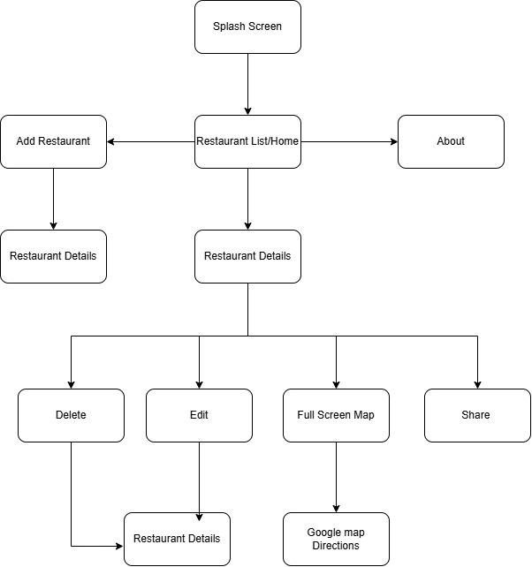

6. Wireframes / UI Mockups

6.1 Restaurant List

Screen 1: Restaurant List  Display and manage all saved restaurants  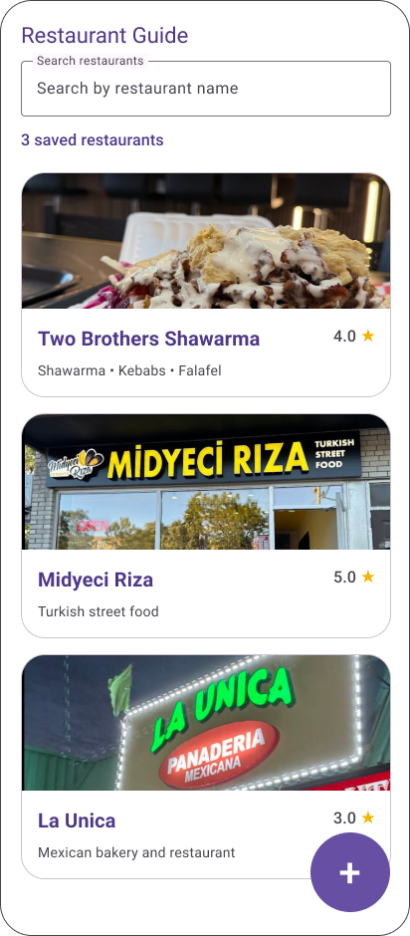 | Screen 2: Restaurant List  Apply search and filtering functionality so users can locate saved restaurants by restaurant name and by user-defined tags  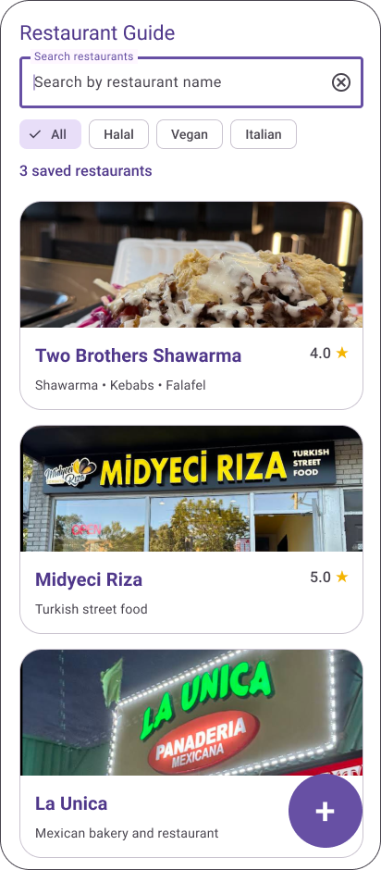

6.2 Restaurant Details

Screen 3: Restaurant List  Apply search and filtering functionality so users can locate saved restaurants by restaurant name and by user-defined tags  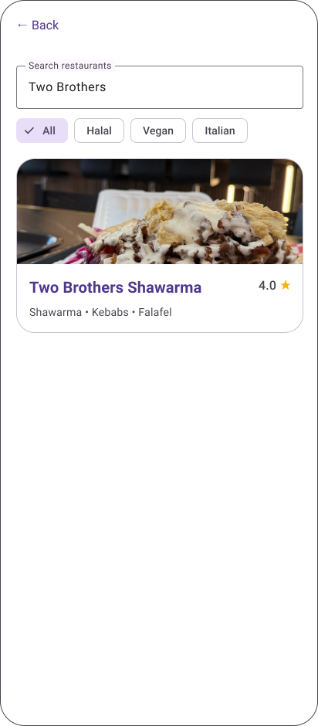 | Screen 4: Restaurant Details  Display complete information for a selected restaurant  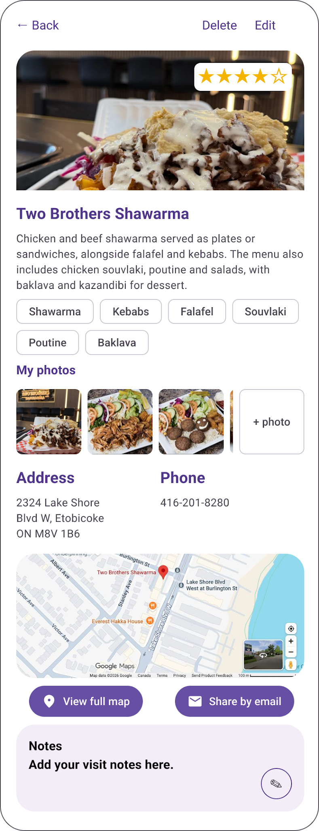

6.3 Data Management (CRUD)

Screen 5: Add Restaurant  Create a new restaurant record  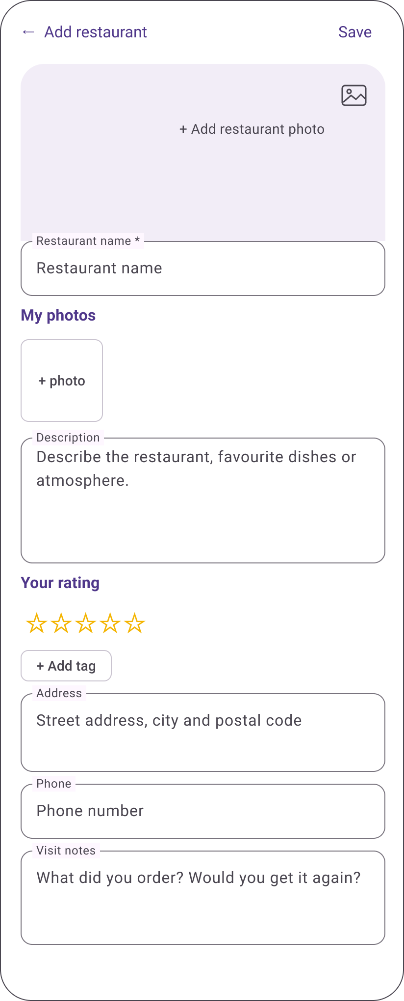 | Screen 6: Edit Restaurant  Modify an existing restaurant record  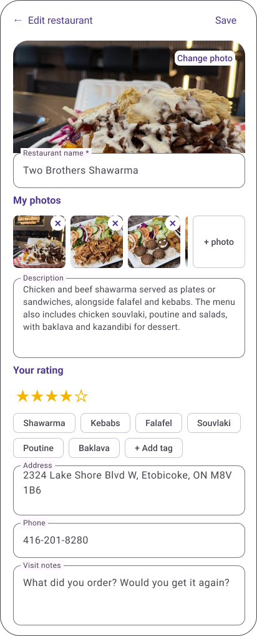

6.4 Confirmation / Dialogs

Screen 7: star rating input  User rating from 1 to 5 stars  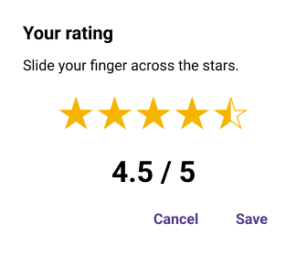  Screen 8: Input validation & Error handling  display clear validation messages when required or invalid information is entered  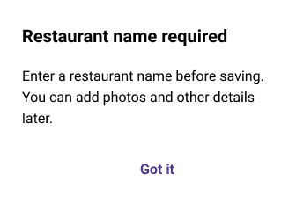 | Screen 9: Restaurant Details  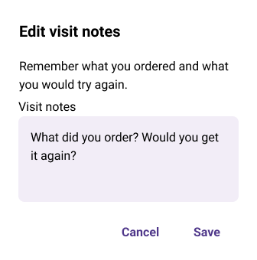

6.5 Restaurant Details

Screen 10: Restaurant Details  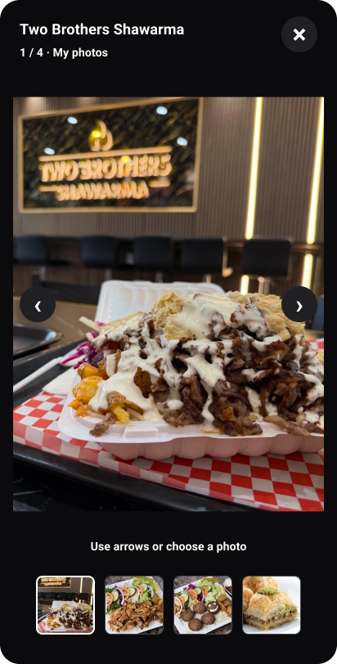 | Screen 11: Restaurant Details  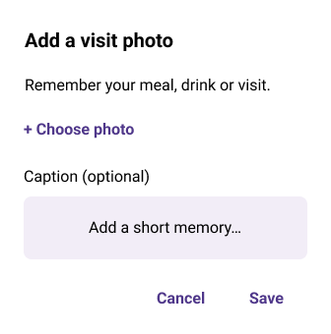

6.6 Confirmation / Dialogs

Screen 12: Confirmation / Dialogs  Confirm destructive actions and display important messages  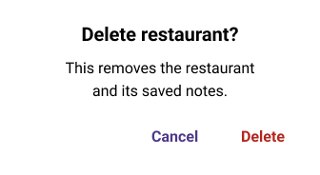 | Screen 13: Restaurant List  Display and manage all saved restaurants  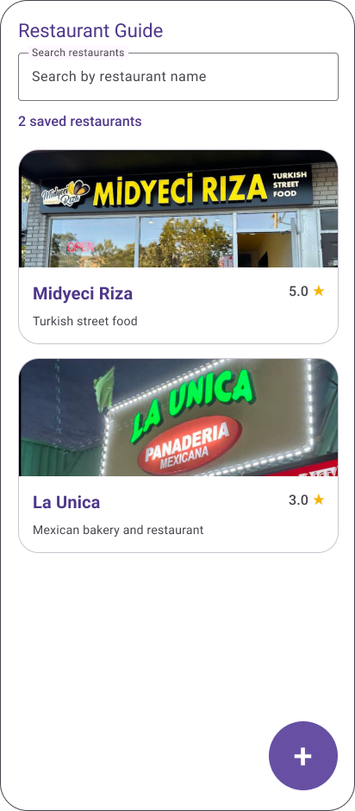

7. Data Design
Describe the information the application needs to store or manage. Identify the main data entities/classes. Add additional tables as needed. If relationships exist, include a simple data model or class diagram.
Entity / Class Name: Restaurant
Attribute | Data Type | Description
id | int | Unique identifier for each restaurant
name | String | Name of the restaurant
address | String | Physical address of the restaurant
phone | String | Restaurant phone number
description | String | Short description of the restaurant
tags | String | User-defined tags such as Halal, Vegan, Indian
rating | Int | User rating from 1 to 5 stars

Data model / class diagram:
Restaurant
id: Int
name : String
address : String
phone : String
description : String
tags : String
rating : Int

8. External APIs and Services
Identify external APIs, web services, AI services, or third-party libraries. Explain why each is needed, how the app communicates with it, what data is exchanged, and whether authentication/API keys are required. If none are planned, state this explicitly. Do not include API keys, passwords, or access tokens.
API / Service | Purpose | Data Sent | Data Received
Google Maps | Display restaurant location and provide directions | Restaurant address and user location when directions are requested | Map location, restaurant marker, and directions
Google Maps will be used to display the selected restaurant location and provide directions. The application will send the restaurant address and, when required, the user's current location. The application will use Android location permissions for the user's location. No custom backend or cloud database is required.
9. Technical Design
Summarize the proposed technical implementation.
Development Platform:
Android Studio
Programming Language:
Kotlin
Minimum Android Version / API Level:
API24
Data Storage:
Room Database / SQLite for local storage
Architecture / Application Structure:
MVVM (Model-View-ViewModel)
External Libraries:
Jetpack Compose, Room, Google Maps SDK, Android Jetpack libraries
APIs / Web Services:
Google Maps API / Google Maps SDK
Briefly explain how the major parts of the application will work together:
The application will be developed using Kotlin and Jetpack Compose in Android Studio. The UI will use Compose screens for displaying and entering restaurant information. The MVVM architecture will separate the user interface, application logic, and data. Room will store restaurant records locally in an SQLite database. Google maps will be used to display restaurant locations and provide directions. The application will not require a backend server or cloud database.
10. Team Responsibilities
Describe the initial division of work. All members are expected to contribute to implementation and understand the overall application.
Team Member | Primary Responsibilities
Kalid Ali | Team leadership and integration: coordinate the team’s workflow and integrate the application’s components.
Phillip Onofua | UI and interaction development: develop wireframes and implement the user interface.
Mohamed Amine OUATAR | Research restaurant data, integrate external resources, and implement search functionality.
Joshua Zaakir | Research restaurant data, integrate external resources, and implement search functionality.
All team members | Test the application and ensure that their respective components are implemented correctly.

11. Development Plan

Stage / Milestone | Planned Work | Responsible Member(s) | Target Date
Design document | Finalize design documentation, wireframes, assets, and API for the project | All members;  Kalid coordinates | Oct 2, 2026
UI prototype | Begin working on a prototype with a functional UI. | Phillip: UI  Kalid: integration | Oct 11, 2026
Core data and CRUD | Implement the system by adding restaurants, editing details, searching, mapping screens in the details page, and data validation | All members;  Kalid integrates | Oct 25, 2026
Functional prototype | Implement the functional UI with the CRUD system developed to have a functioning prototype | Mohamed/Joshua: resources;  Phillip: UI  Kalid: integration | Nov 8, 2026
Integration and testing | Test user workflow, filtering system with tags, data saving, error handling, and detect major bugs found. | All team members | Nov 29, 2026
Final implementation | Complete any remaining requirements, and improve the user experience while looking out and fixing last-minute bugs found while polishing the final product. | All members;  Kalid coordinates | Dec 6, 2026
Presentation | Prepare and rehearse the final presentation explaining our design decisions | All team members | Dec 11, 2026  Course deadline

12. Risks and Challenges
Identify at least three potential challenges and explain their impact and mitigation.
Risk / Challenge | Potential Impact | Proposed Solution / Mitigation
Google Maps integration | Maps may not work correctly or may require configuration | Test the map functionality early and follow the official Android documentation
Location permission | The user may deny location permission. | Display a clear message and prevent directions from being requested without a valid location
Room database errors | Restaurant data may not save or load correctly | Test CRUD operations separately before combining them with the UI
Project time limitations | Some advanced feature may not be completed | Focus on the MVP first and implement optional features only if time remains

13. Minimum Viable Product (MVP)
The MVP will be considered successful when the following functionality works reliably:
1. The application must allow users to add, view, edit and delete restaurant records containing the restaurant name, address, phone number(s), description, tags, and a 1-5 star rating.
2. The application must display all saved restaurants in a list and allow users to search restaurants by name and filter them using user-defined tags.
3. Restaurant information must be stored locally using Room/SQLite so saved restaurant records remain available after the application is closed and reopened.
4. The application must allow users to view a selected restaurant’s location on Google Maps and provide directions using the user’s current location after permission is granted
5. The application must allow users to share selected restaurant information through email and include a Splash Screen and About Screen.
14. Optional / Future Features
List features the team would like to implement if sufficient development time remains. These should not be required for the basic operation of the application.
1. Provide an option to share restaurant information through Facebook in addition to email sharing.
2. Provide an option to share restaurant information through Twitter/X in addition to email sharing.
3. Add additional restaurant filtering options, such as filtering restaurants by rating.
4. Add a favorite feature that allows users to mark selected restaurants for quicker access.
15. References and Resources
List Android/API documentation, libraries, tutorials, articles, design resources, and AI tools used in preparing the proposal. Use a consistent citation format.
- Google. Android Developers – Jetpack Compose Documentation.
- Google. Android Developers – Room Persistence Library.
- Google. Google Maps SDK for Android Documentation.
- Google. Android Developers – Location Permissions.
- OpenAI. ChatGPT – Used to assist with planning and organization of the application design proposal.
16. Team Declaration
By submitting this proposal, the team confirms that the proposed project is achievable within the course timeframe; all members participated in planning; responsibilities were discussed; external code, libraries, APIs, and resources will be appropriately acknowledged; and the final project will represent the team's own development work.
1. Kalid Ali
2. Mohamed Amine Ouatar
3. Joshua Zaakir
4. Phillip Onofua

Submission Checklist
☐ Project title and team information
☐ Project overview and objectives
☐ Target users
☐ Functional requirements
☐ Screen/navigation design
☐ Wireframes
☐ Data design
☐ API/service information, if applicable
☐ Technical design
☐ Team responsibilities
☐ Development plan
☐ Risks and challenges
☐ MVP definition
☐ Optional features
☐ References

