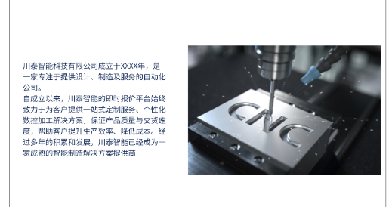一、公司介绍

川泰智能科技有限公司成立于XXXX年，是一家专注于提供设计、制造及服务的自动化公司。

自成立以来，川泰智能CNC加工订购平台始终致力于为客户提供一站式定制服务、个性化数控加工解决方案，保证产品质量与交付速度，帮助客户提升生产效率、降低成本。经过多年的积累和发展，川泰智能已经成为一家成熟的智能制造解决方案提供商。

1. Company introduction

Chuantai Intelligent Technology Co., Ltd. was established in XXXX, is a focus on providing design, manufacturing and service automation company.

Since its establishment, Chuantai intelligent CNC machining ordering platform has always been committed to providing customers with one-stop customized services, personalized CNC machining solutions, to ensure product quality and delivery speed, to help customers improve production efficiency and reduce costs. After years of accumulation and development, Chuantai Intelligent has become a mature intelligent manufacturing solution provider.

二、服务概述

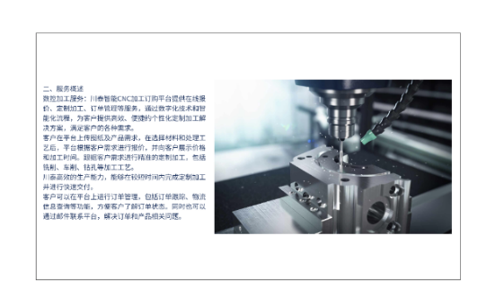数控加工服务：川泰智能CNC加工订购平台提供在线报价、定制加工、订单管理等服务，通过数字化技术和智能化流程，为客户提供高效、便捷的个性化定制加工解决方案，满足客户的各种需求。

客户在平台上传图纸及产品需求，在选择材料和处理工艺后，平台根据客户需求进行报价，并向客户展示价格和加工时间。跟据客户需求进行精准的定制加工，包括铣削、车削、钻孔等加工工艺。

川泰高效的生产能力，能够在较短时间内完成定制加工并进行快速交付。

客户可以在平台上进行订单管理，包括订单跟踪、物流信息查询等功能，方便客户了解订单状态。同时也可以通过邮件联系平台，解决订单和产品相关问题。

2. Service Overview

CNC machining services: Chuantai intelligent CNC machining ordering platform provides online quotation, customized processing, order management and other services, through digital technology and intelligent process, to provide customers with efficient and convenient personalized customized processing solutions to meet the various needs of customers.

Customers upload drawings and product requirements on the platform, after selecting materials and processing processes, the platform makes quotations according to customer needs, and shows customers the price and processing time. Customized machining according to customer requirements, including milling, turning, drilling and other processing processes.

Chuantai's efficient production capacity enables custom processing and fast delivery in a short time.

Customers can carry out order management on the platform, including order tracking, logistics information query and other functions, so as to facilitate customers to understand the order status. At the same time, you can also contact the platform by email to solve orders and product-related problems.

三、管理团队

川泰智能的管理团队由一批具有丰富行业经验和技术背景的专业人士组成。公司核心成员在数控加工等领域具有深厚的理论知识和实践经验。通过高效协作，为客户提供卓越的产品和服务。

3. Management team

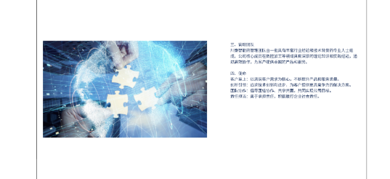The management team of Chuantai Intelligent is composed of a group of professionals with rich industry experience and technical background. The core members of the company have deep theoretical knowledge and practical experience in CNC machining and other fields. Provide customers with superior products and services through efficient collaboration.

**3and4**

四、使命

● 客户至上：以满足客户需求为核心，不断提升产品和服务质量。

● 创新引领：追求技术创新和进步，为客户提供更具竞争力的解决方案。

● 团队协作：倡导团结协作、共享共赢，共同实现公司目标。

● 责任担当：勇于承担责任，积极履行企业社会责任。

Iv. Mission

● Customer first: to meet customer needs as the core, and constantly improve the quality of products and services.

● Innovation leadership: the pursuit of technological innovation and progress, to provide customers with more competitive solutions.

● Team cooperation: advocate unity and cooperation, sharing and win-win, to achieve the company's goals.

● Responsibility: Have the courage to take responsibility and actively fulfill corporate social responsibility.

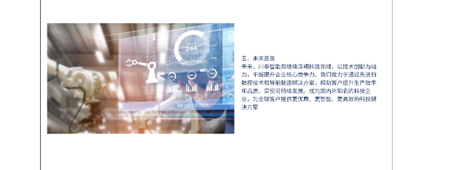五、未来愿景

未来，川泰智能将继续深耕科技领域，以技术创新为动力，不断提升企业核心竞争力。我们致力于通过先进的数控技术和智能制造解决方案，帮助客户提升生产效率和品质，实现可持续发展。成为国内外知名的科技企业，为全球客户提供更优质、更智能、更高效的科技解决方案

5. Future Vision

In the future, Chuantai Intelligent will continue to deepen the field of science and technology, take technological innovation as the driving force, and constantly improve the core competitiveness of enterprises. We are committed to helping customers improve production efficiency and quality through advanced numerical control technology and intelligent manufacturing solutions to achieve sustainable development. To become a well-known technology enterprise at home and abroad, providing better, smarter and more efficient technology solutions for global customers