Data Interpretation Session

Based on Key Research Questions

Your name

01 February 2023

Table of Contents

## Joint Data Interpretation

The Joint Data Interpretation allows to make sense of the data.

The interpretation can make use of the “**Protection Risk Equation**” Analysis (See [Protection Gap Framework for Analysis](https://www.unhcr.org/50aa57ad9.pdf)) to look at 1) Harmful, discriminatory and/or protective contextual factors, 2) Current threats to the population, 3) Rights violations and abuses, 4) Threat effect on the population and 5) Existing capacities to address protection threats .

## Charts

### plot_select_one

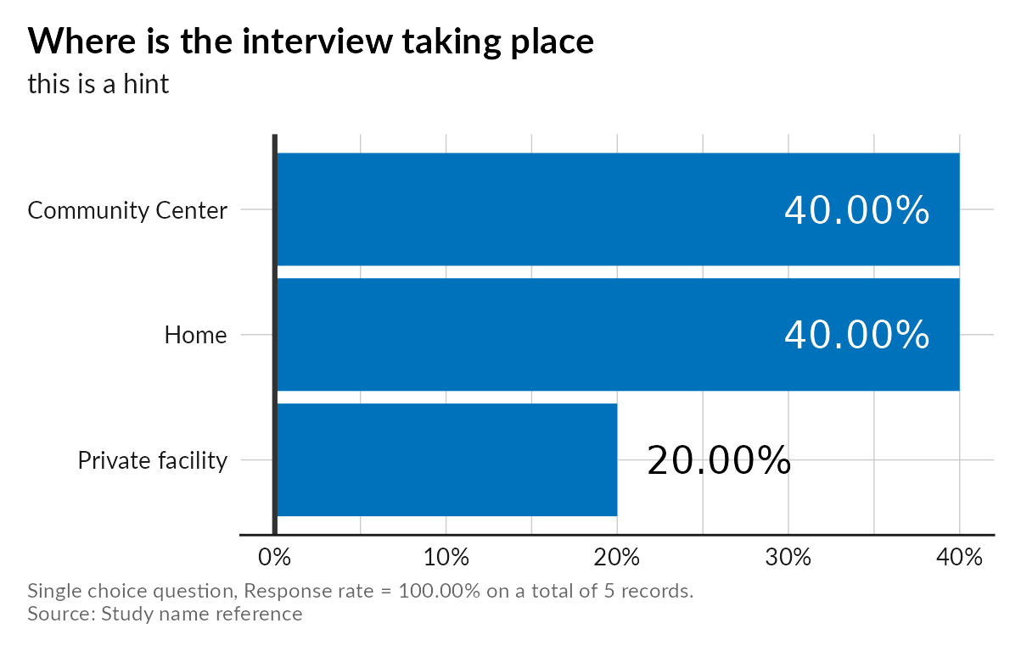

### plot_select_multiple

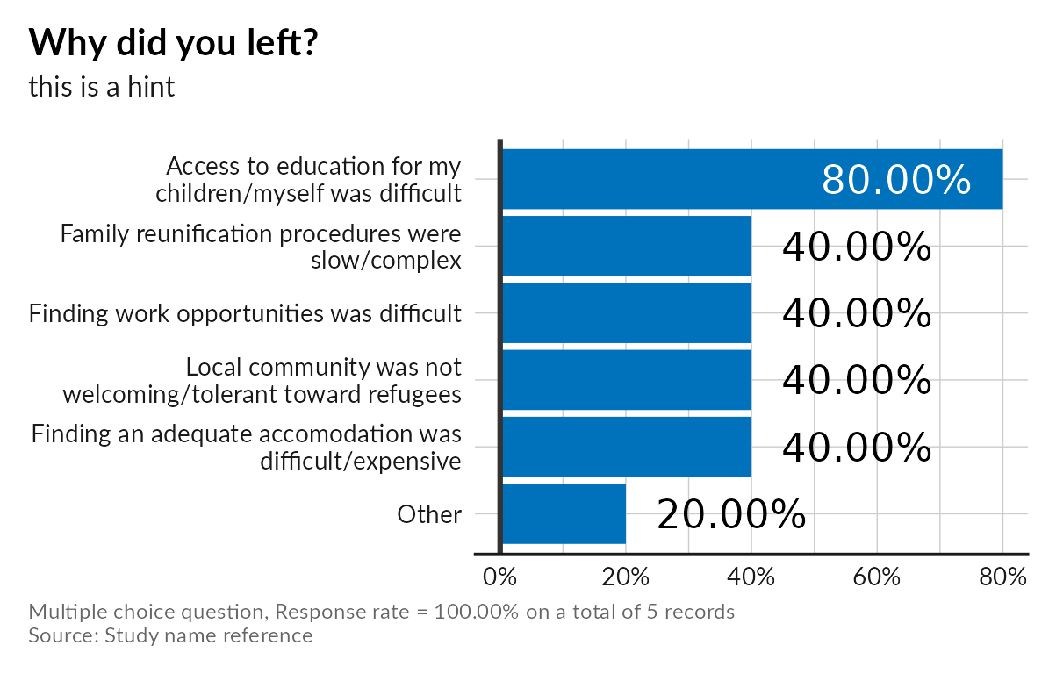

### plot_integer

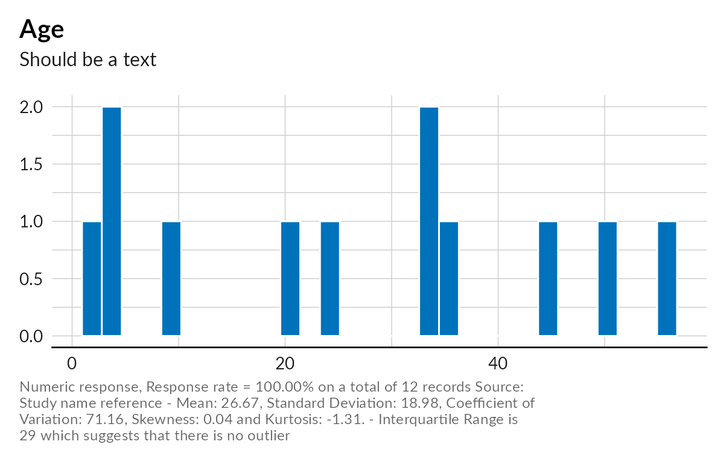

### plot_text

