TREE POEM
PROGRAM
1
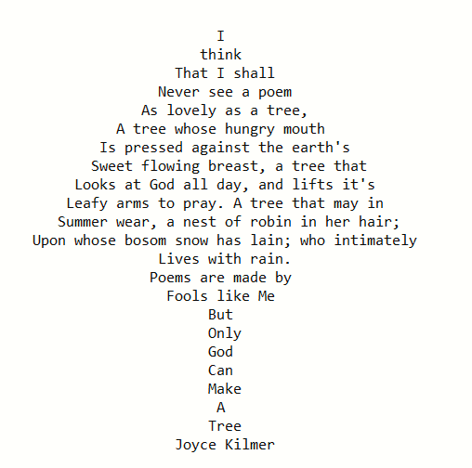
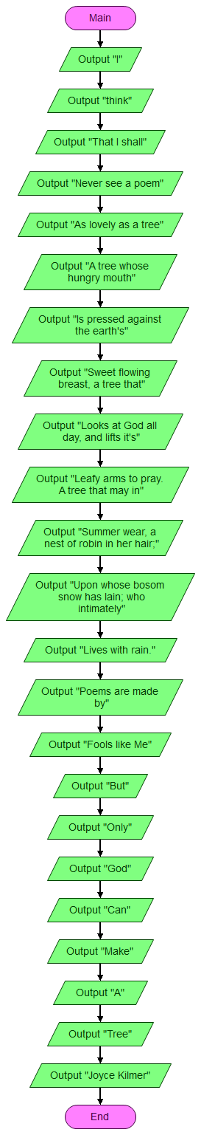

PROGRAM
2
MITSUBISHI

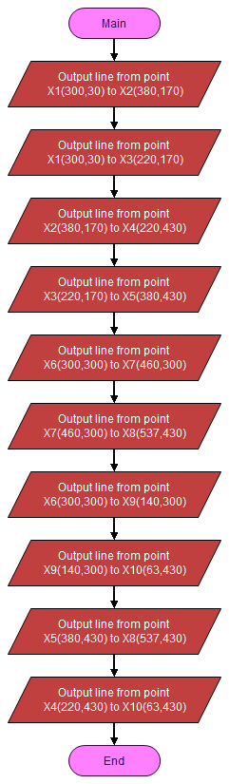

PROGRAM
3
CHEVROLET

Start

line(550,450,425,225)
line(550,450,675,225)
line(425,225,550,0)
line(675,225,550,0)

line(550,450,300,450)
line(550,450,400,650)
line(300,450,150,650)
line(150,650,400,650)

line(550,450,800,450)
line(550,450,700,650)
line(800,450,950,650)
line(700,650,950,650)
End

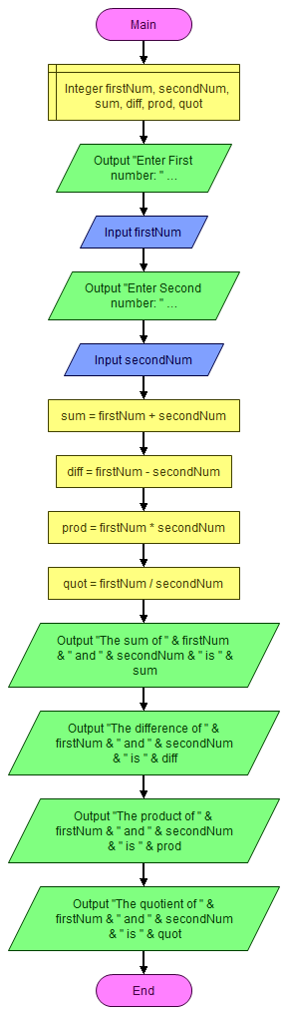
PROGRAM
4
ARITHMETIC

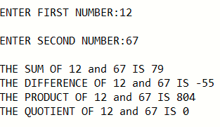

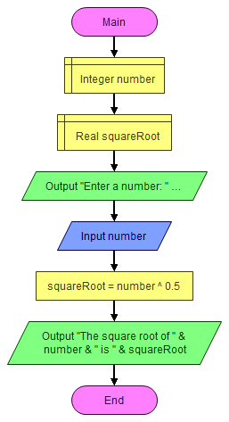
PROGRAM
5
SQUARE ROOT



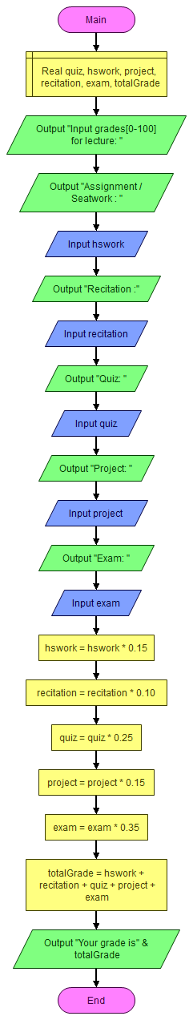
PROGRAM
6
GRADES CALCULATOR

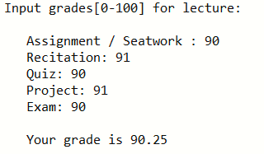

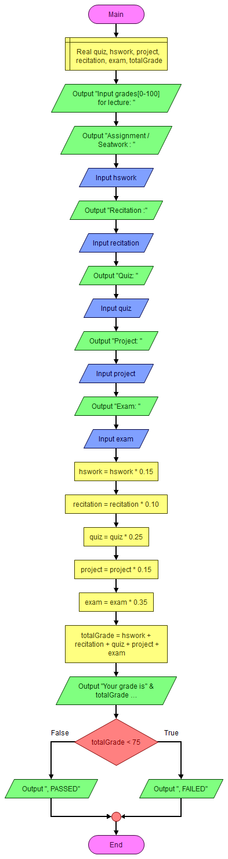
PROGRAM
7
GRADES CALC. WITH REMARKS

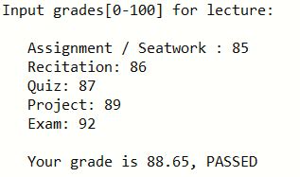

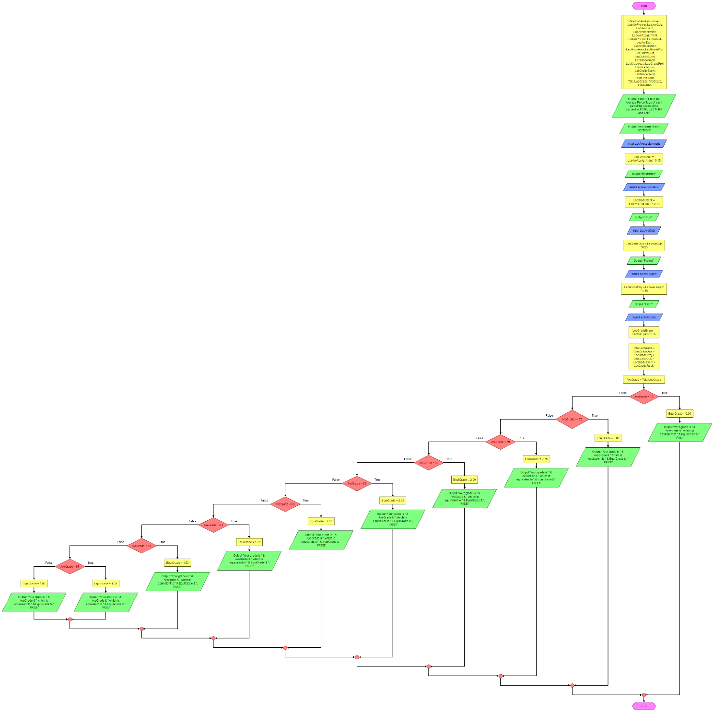
PROGRAM
8
GRADES CALC. EQUIVALENT GRADE

ZOOM AT 350% TO SEE THE CONTENT

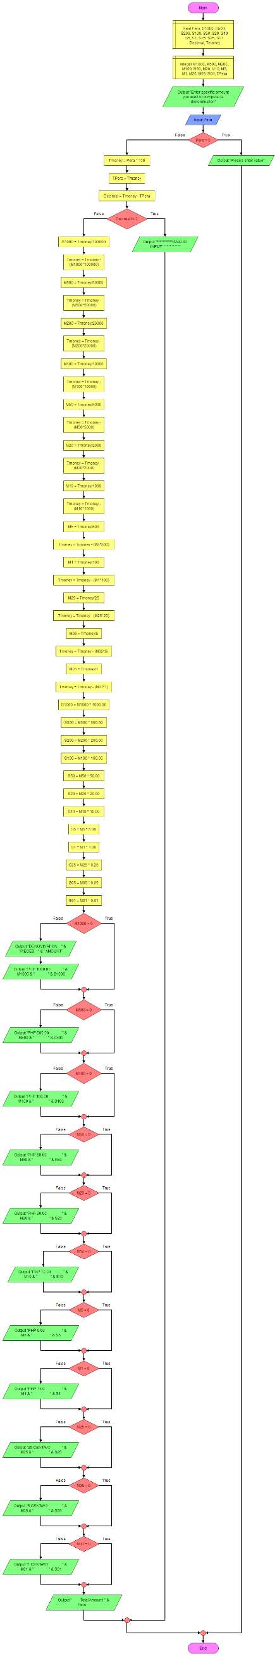
PROGRAM
9
MONEY DENOMINATION

PROGRAM
10
GRADES CALC. USING SWITCH
A
A

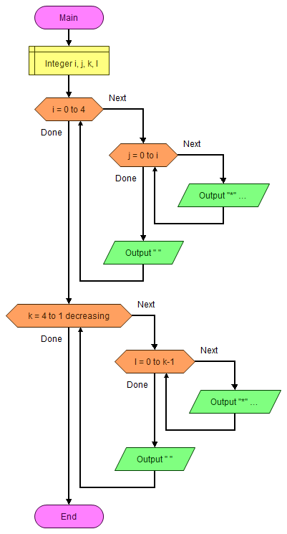
PROGRAM
11
RIGHT ARROW

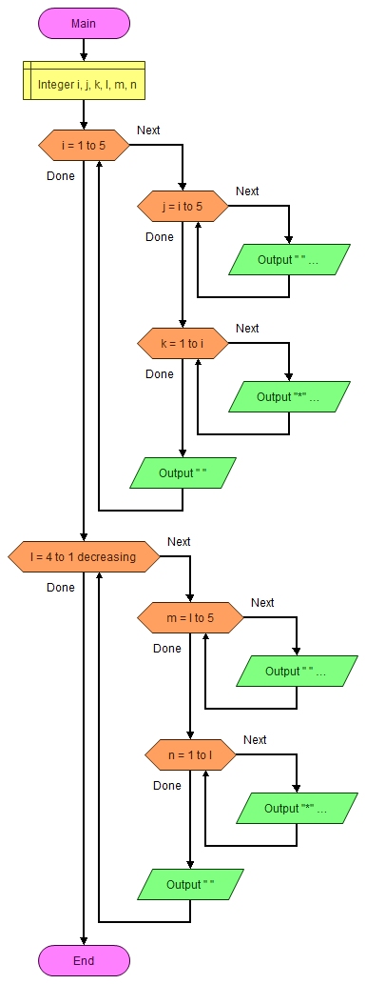
PROGRAM
12
LEFT ARROW

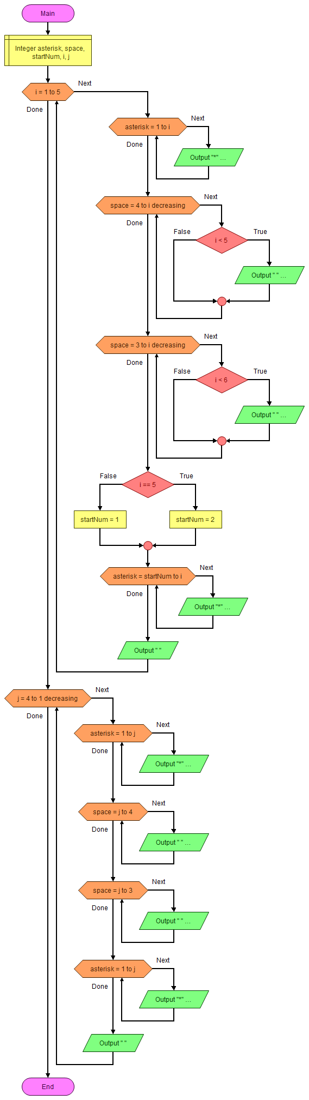
PROGRAM
13
DIVERGING ARROWS

PROGRAM
14
GRADE CALC. TRY AGAIN
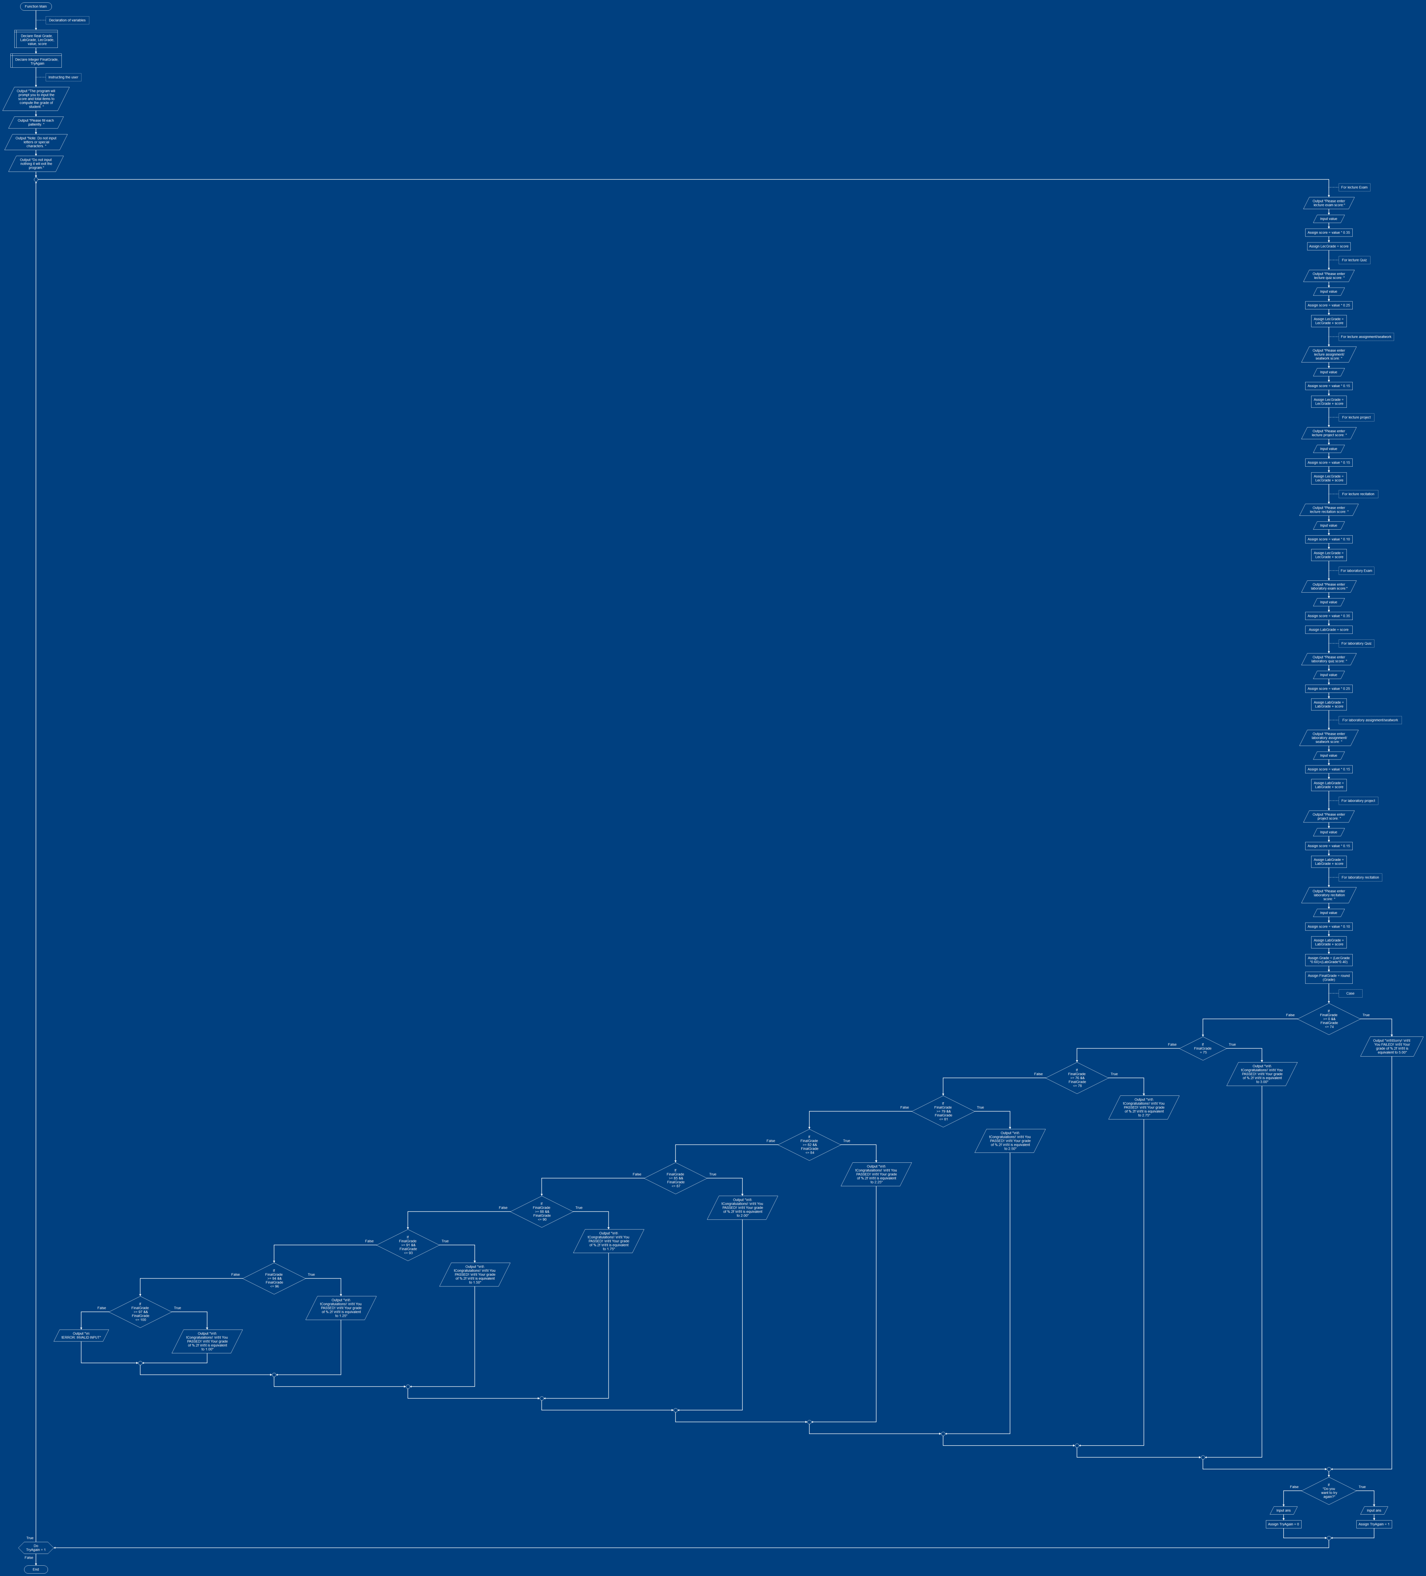

ZOOM AT 350% TO READ THE CONTENT

PROGRAM
15
GRADE CALC W/ ERROR TRAPPING

PROGRAM
16
GRADE CALC MULTIPLE GRADES

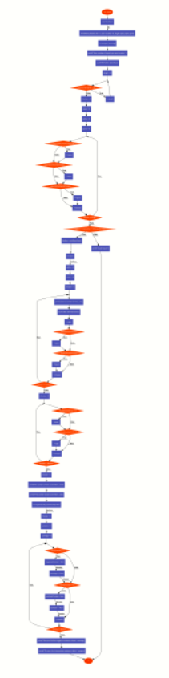
PROGRAM
17
SUM OF ODD,EVEN,+ AND -

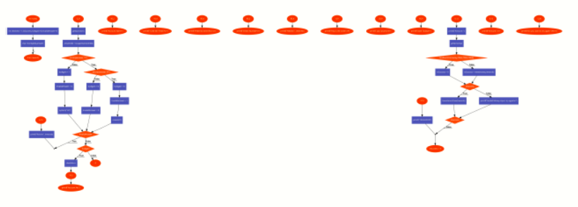
PROGRAM
18
CHEQUE

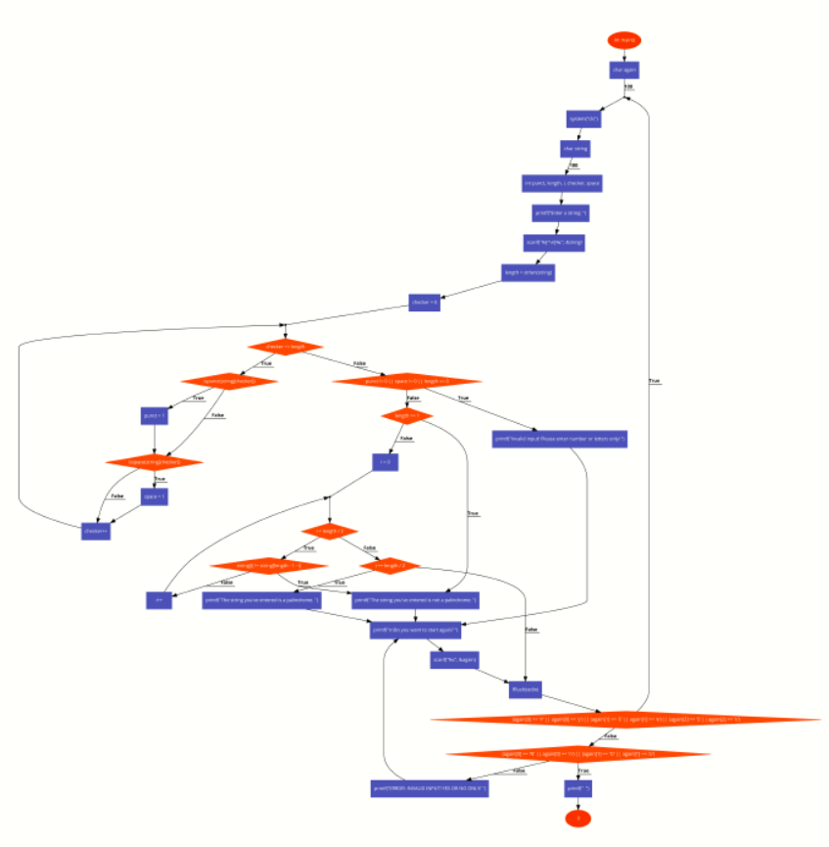
PROGRAM
19
PALINDROME

