Nhap mon cong nghe phan mem 20_3

Team 05

Abstract

This is a small project in our university course. The project is about a product that is an e-commerce website, a software product. The duration of this project is in the 1st semester of 2022

WINSHOP

User Interface Prototype

Winshop

User Interface Prototype

Version 1.0

Revision History

|  |  |  |  |
| --- | --- | --- | --- |
| **Date** | **Version** | **Description** | **Author** |
| 14/12/2022 | 1.0 | Preliminary version | Group 05 |
|  |  |  |  |
|  |  |  |  |
|  |  |  |  |

Table of Contents

**1. Introduction 4**

**1.1 Purpose 4**

**1.2** **Link** 4

**2. Executing Prototypes 5**

**2.1** **Homepage** 5

*2.1.1* *Description of Homepage* 6

*2.1.2* *Prototype* *in Homepage* 7

**2.2** **SignIn Page** 9

*2.2.1* *Description of SignIn Page* 9

*2.2.2* *Prototype in SignIn Page* 9

**2.3** **SignUp Page** 10

*2.3.1* *Description of SignUp Page* 10

*2.3.2* *Prototype in SignUp Page* 10

**2.4** **Shop Page** 11

*2.4.1* *Description of Shop Page* 11

*2.4.2* *Prototype in Shop Page* 12

**2.5** **Detail Page** 13

*2.5.1* *Description of Detail Page* 13

*2.5.2* *Prototype in Detail Page* 14

**2.6** **Cart Page** 15

*2.6.1* *Description of Cart Page* 15

*2.6.2* *Prototype in Cart Page* 16

**2.7** **Checkout Page** 16

*2.7.1* *Description of Checkout Page* 16

*2.7.2* *Prototype in Checkout Page* 17

**2.8** **Dashboard Page** 18

*2.8.1* *Description of Dashboard Page* 18

*2.8.2* *Prototype of Dashboard Page* 18

**2.9** **Manage Users Page** 19

*2.9.1* *Description of Manage Users Page* 19

*2.9.2* *Prototype in Manage Users Page* 20

**2.10** **Manage Product Page** 21

*2.10.1* *Description of Manage Product Page* 21

*2.10.2* *Prototype in Manage Product Page* 22

**2.11** **Manage Orders Page** 23

*2.11.1* *Description of Manage Orders Page* 23

*2.11.2* *Prototype in Manage Orders Page* 24

Software Architecture Document

# Introduction

This Winshop project is built to create opportunities for everyone who needs to shop online, without wasting time searching for products. The products of the Winshop sold are completely guaranteed quality and the price is cheaper than the market price.

This document elaborates the software architecture document for “Winshop system” The system architecture is abstracted into many views and components which are explained in detail.

## Purpose

The User Interface Prototype (UIP) provides a comprehensive overview of the Winshop application's interface. It presents several different prototypes of an interface that are used to perform user tests to describe various aspects of the application before we turn the design into code, creating the finished product official use.

* 1. **Link**

View User Interface on Figma: <https://www.figma.com/file/WzGcrlSefb1RE8z5I6otHU/WINSHOP?node-id=0%3A1&t=ykjO6tdlaeV5cbdI-3>

View Flow Prototype for User: <https://www.figma.com/proto/WzGcrlSefb1RE8z5I6otHU/WINSHOP?node-id=0%3A1&scaling=min-zoom&starting-point-node-id=1%3A3&show-proto-sidebar=1>

View Flow Prototype for Admin: <https://www.figma.com/proto/WzGcrlSefb1RE8z5I6otHU/WINSHOP?node-id=0%3A1&scaling=min-zoom&starting-point-node-id=52%3A233&show-proto-sidebar=1>

# Executing Prototypes

* 1. **Homepage**

Section 1

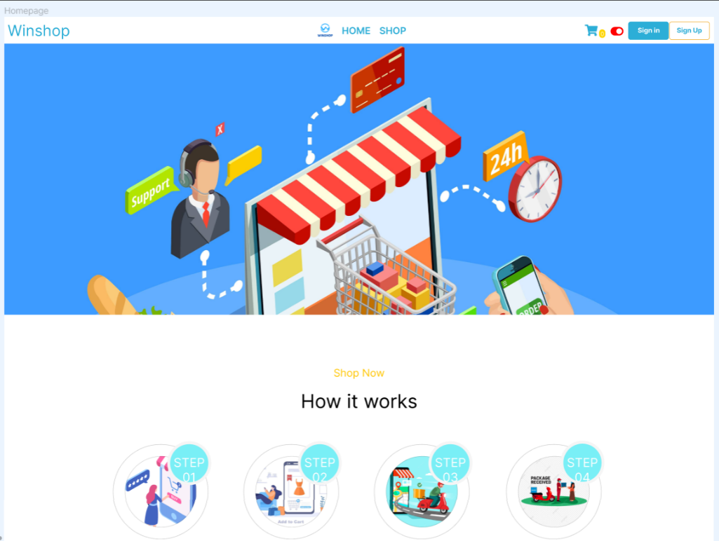

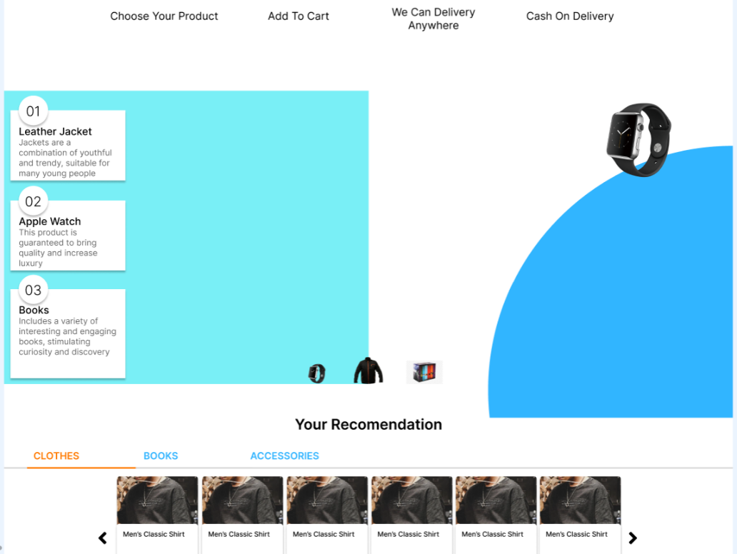Section 2

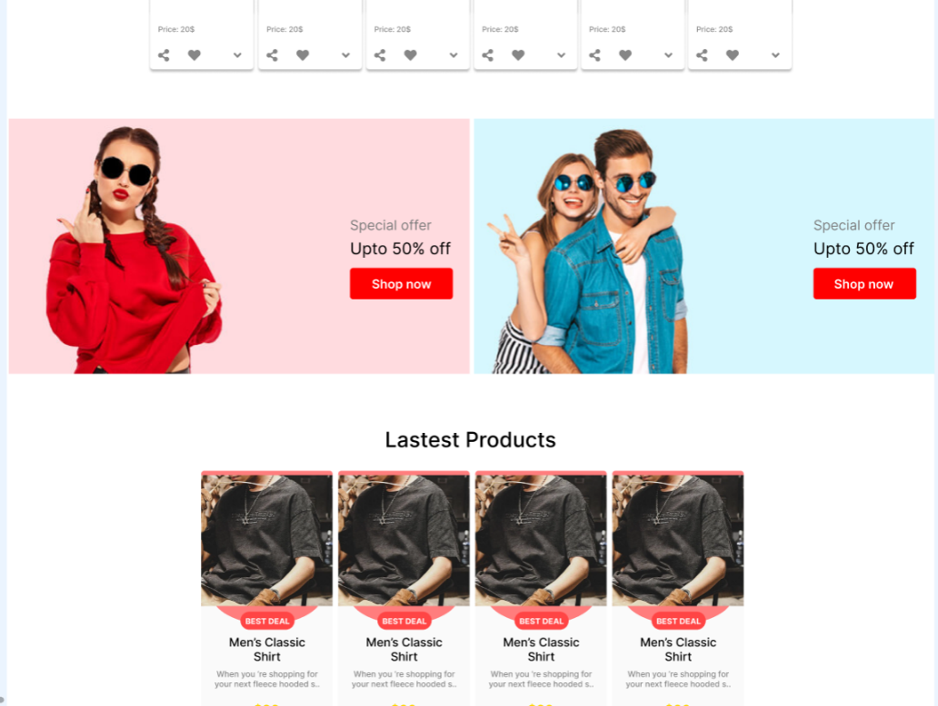Section 3

Section 4

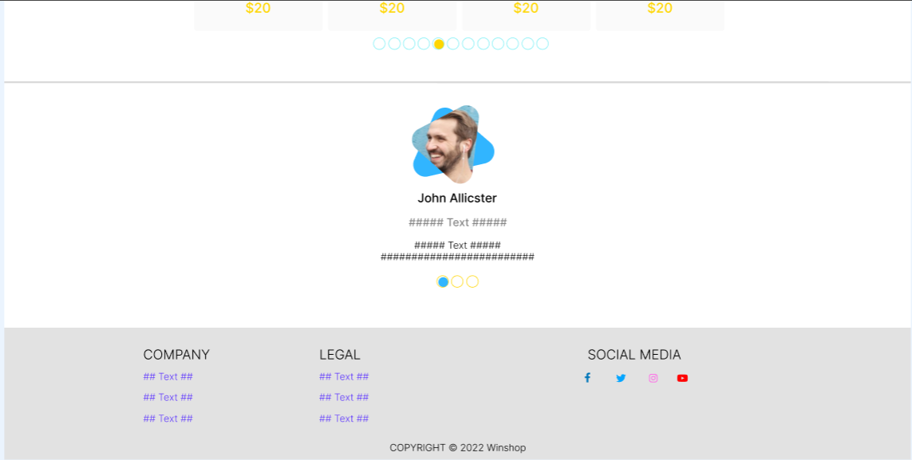

* + 1. *Description of Homepage*

The Homepage of the Winshop application consists of 4 sections:

* Section 1:

Part one is a brief introduction, summarizing the operation of the application for users, including four basic steps of an e-commerce website that is selecting the product you want to buy, adding to the cart, Deliver goods to customers and pay for goods.

* Section 2:

The second part is to introduce the items and products available on the e-commerce application, briefly describe the types of goods and attract customers to try the popular products on the application.

* Section 3:

Part three is a place to popularize customers with hot promotions currently on the application and encourage customers to quickly own popular products at great prices.

* Section 4:

Section four shows customer reviews and feedback about the e-commerce application along with the information of the e-commerce website, the owner of the Winshop application, contact information and links on the website. social platform to be able to easily interact with customers through a variety of media on cyberspace.

* + 1. *Prototype* *in Homepage*
* If from the Homepage interface click to switch to another interface, clicking on these clusters will return to the Homepage interface page:
  + phrase 'Winshop'
  + phrase 'HOME'
  + Website logo
* Clicking on the phrase 'SHOP' will go to the store's interface page on the website, where customers can search, select, and view the products they want to buy.
* Clicking on the cart logo will go to the interface of the shopping cart on the website, where customers can search, select, view, delete products that they have added to the cart before. There is a display of the number of products in the cart, that display is next to the cart logo.
* Clicking on the 'Sign in' box will go to the customer login interface page on the website, where customers can log in to the account they have created before, if they do not have an account, they can register a new account to use on the app.
* Clicking on the 'Sign up' box will go to the new customer account registration interface on the website, where customers can register a new account to use on the application, if you already have 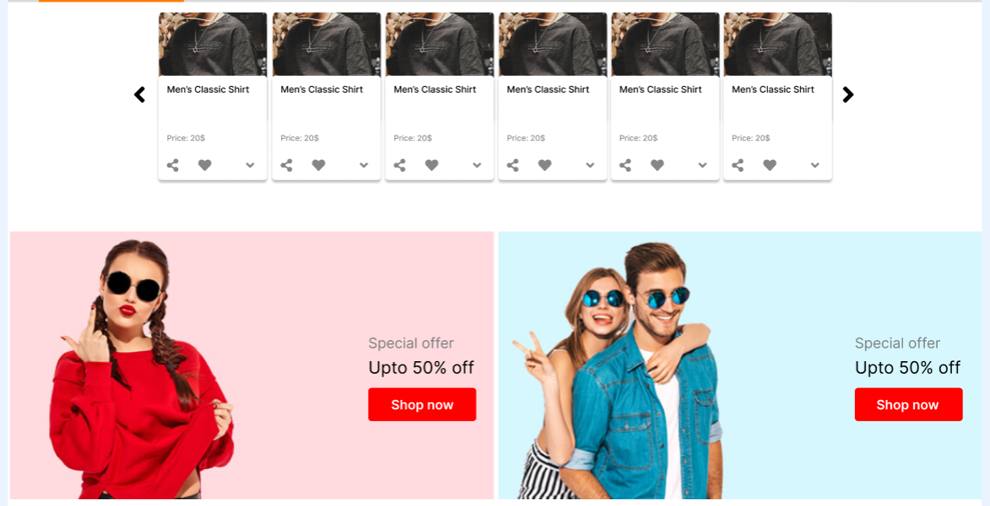an account, you can log into the account you created earlier.
* Clicking on the featured products box will go to the interface page displaying details about that product.
* 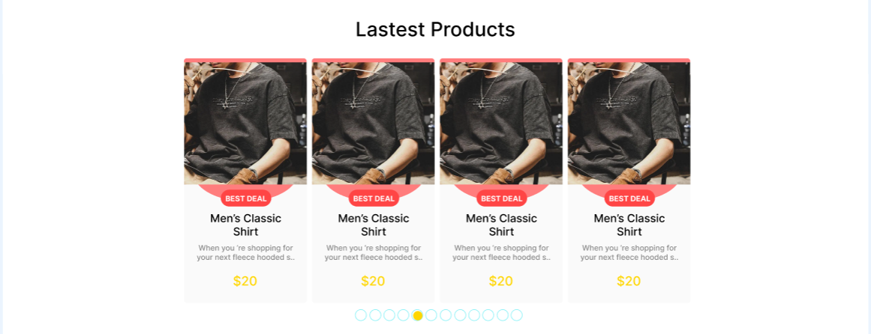Clicking on the 'Shop now' box will go to the store interface page displaying the products included in the application.
* Clicking on the promotional product box will go to the interface page displaying detailed information about that product.
  1. 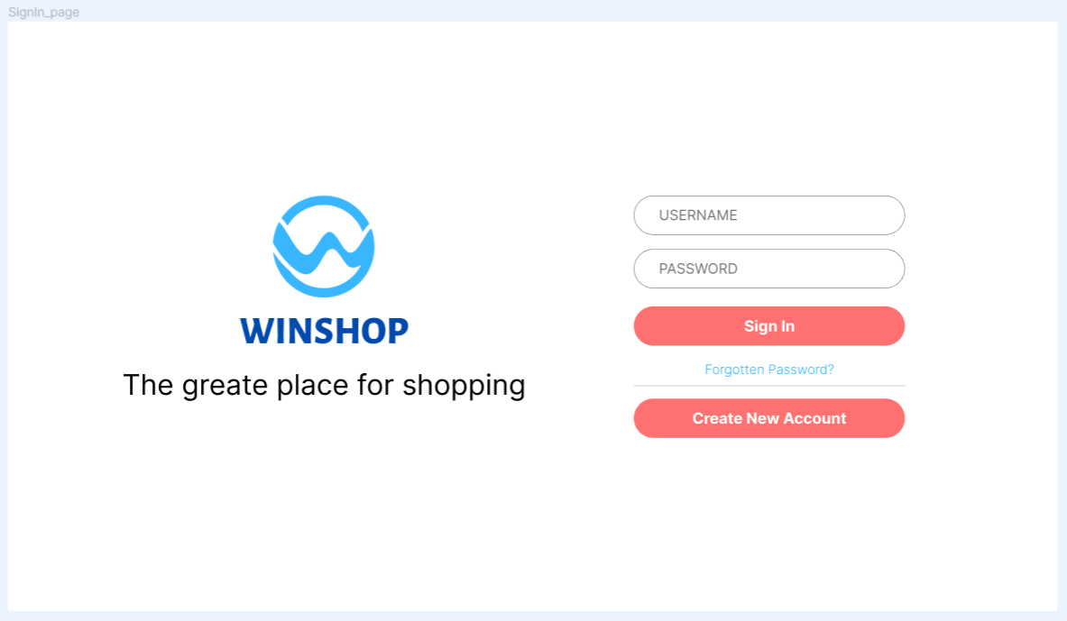**SignIn Page**
     1. *Description of SignIn Page*

The SignIn page of the Winshop application consists of 2 sections:

* Section 1:

The first part on the left side of the interface page is the part that displays the logo of the application as a brand affirmation of the e-commerce website to customers and makes a strong impression with the slogan that defines what Winshop is.

* Section 2:

The second part on the right side of the interface page is the part that displays the items so that users can log in to the previously created account on the application, if you do not have an account, you can create a new account.

* + 1. *Prototype in SignIn Page*
* Clicking on the Winshop logo will go to the Homepage interface page
* Clicking on the 'Create New Account' box will take you to the SignUp page interface
  1. 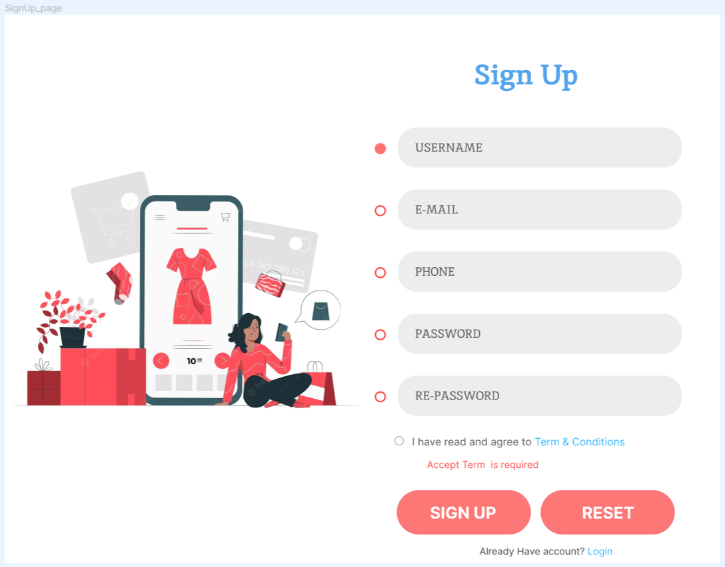**SignUp Page**
     1. *Description of SignUp Page*

The SignUp page of the Winshop application consists of 2 sections:

* Section 1:

The first part on the left of the interface page is the part of the image displayed for the purpose of harmonizing the look of the customer when first registering an account on the application.

* Section 2:

The second part on the right of the interface page is the section that displays the items for users to fill in information to register for a new account on the application, if you already have an account, you can log in again.

* + 1. *Prototype in SignUp Page*
* Clicking on the phrase 'Login' will go to the interface of SignIn page
  1. 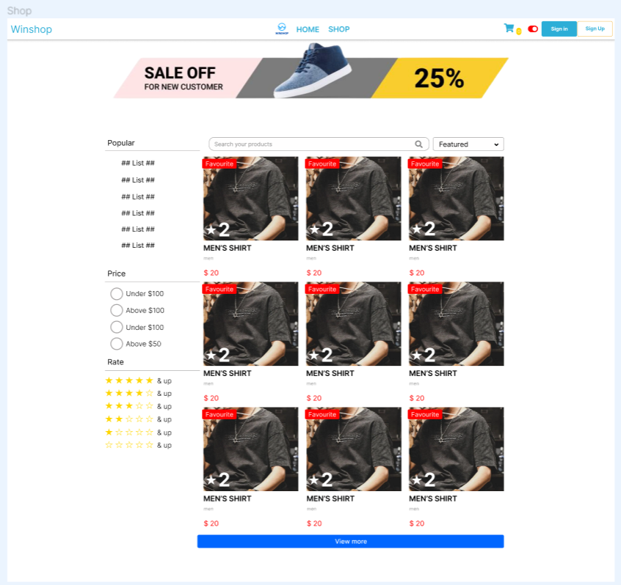**Shop Page**
     1. *Description of Shop Page*

The Shop page of the Winshop application consists of 2 sections:

* Section 1:

The first part is the functional clusters on the left side of the interface page and above the product display. Users can use these functional clusters to be able to search and select the products they want quickly and in accordance with customer's personal criteria.

* Section 2:

The second part shows the list of products available in the app store, the product can be labeled popular, hot selling, hot,... and the number of stars rated on that product. Can display the list according to the function item selected by the customer.

* + 1. *Prototype in Shop Page*
* Clicking on these clusters will return to the Homepage interface page:
  + phrase 'Winshop'
  + phrase 'HOME'
  + Website logo
* Clicking on the phrase 'SHOP' will go to the store's interface page on the website, where customers can search, select, and view the products they want to buy.
* Clicking on the cart logo will go to the interface of the shopping cart on the website, where customers can search, select, view, delete products that they have added to the cart before. There is a display of the number of products in the cart, that display is next to the cart logo.
* Clicking on the 'Sign in' box will go to the customer login interface page on the website, where customers can log in to the account they have created before, if they do not have an account, they can register a new account to use on the app.
* Clicking on the 'Sign up' box will go to the new customer account registration interface on the website, where customers can register a new account to use on the application, if you already have an account, you can log into the account you created earlier.
* Clicking on the product box in the list will go to the interface page displaying detailed information about that product.

* 1. 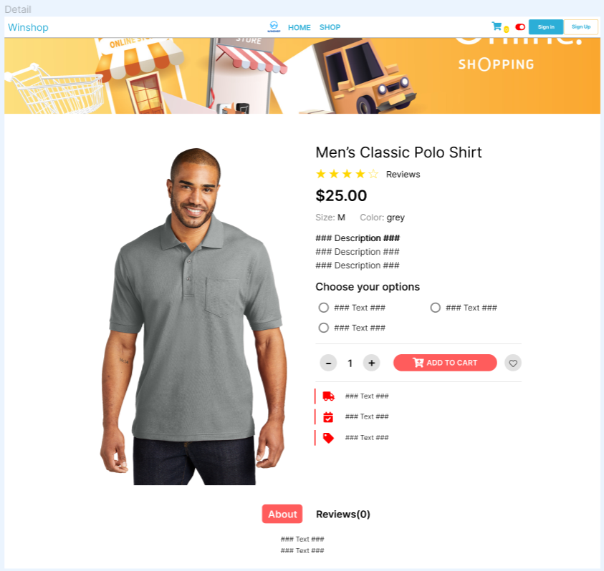**Detail Page**
     1. *Description of Detail Page*

The Detail page of the Winshop application consists of 2 sections:

* Section 1:

The first part is the image of that product with detailed product information presented next to it. In addition, it is also common that customers enjoy the accompanying services when purchasing products, being able to add products to the cart.

* Section 2:

The second section at the bottom of the interface page is the part that shows a bit of the story about that product and the review of that product experience from customers.

* + 1. *Prototype in Detail Page*
* Clicking on these clusters will return to the Homepage interface page:
  + phrase 'Winshop'
  + phrase 'HOME'
  + Website logo
* Clicking on the phrase 'SHOP' will go to the store's interface page on the website, where customers can search, select, and view the products they want to buy.
* Clicking on the cart logo will go to the interface of the shopping cart on the website, where customers can search, select, view, delete products that they have added to the cart before. There is a display of the number of products in the cart, that display is next to the cart logo.
* Clicking on the 'Sign in' box will go to the customer login interface page on the website, where customers can log in to the account they have created before, if they do not have an account, they can register a new account to use on the app.
* Clicking on the 'Sign up' box will go to the new customer account registration interface on the website, where customers can register a new account to use on the application, if you already have an account, you can log into the account you created earlier.
* Clicking on the 'ADD TO CART' box will automatically add the product to the cart and go to the interface page of the Cart page.
  1. 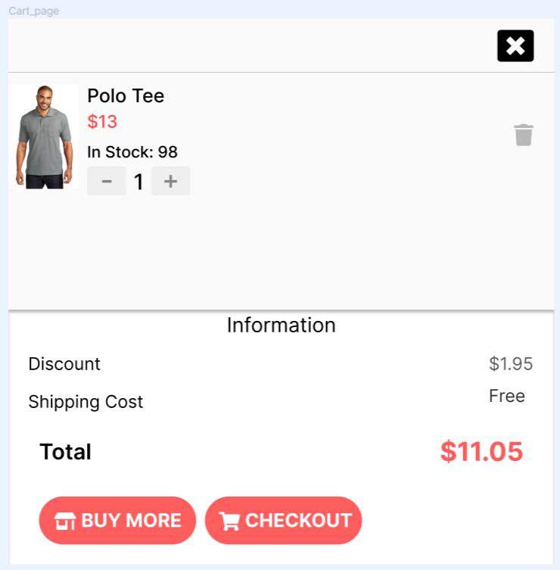**Cart Page**
     1. *Description of Cart Page*

The Cart page of the Winshop application consists of 2 sections:

* Section 1:

The first part located at the top of the interface page is an image of that product with information about the quantity you want to buy and how much of that product is still in the store on the app, you can remove that product from the cart.

* Section 2:

The second part at the bottom of the interface page is the information about the invoice to pay for all the products currently in the cart, if you decide to buy, the customer can proceed to the CHECKOUT page to pay, vice versa. You can return to the app store to continue shopping.

* + 1. *Prototype in Cart Page*
* Clicking on the 'BUY MORE' box will take you to the Shop page interface.
* Clicking on the 'CHECKOUT' box will take you to the interface of the Checkout page.
* Clicking on the 'X' box will close the Cart page and return to the previous interface.

* 1. 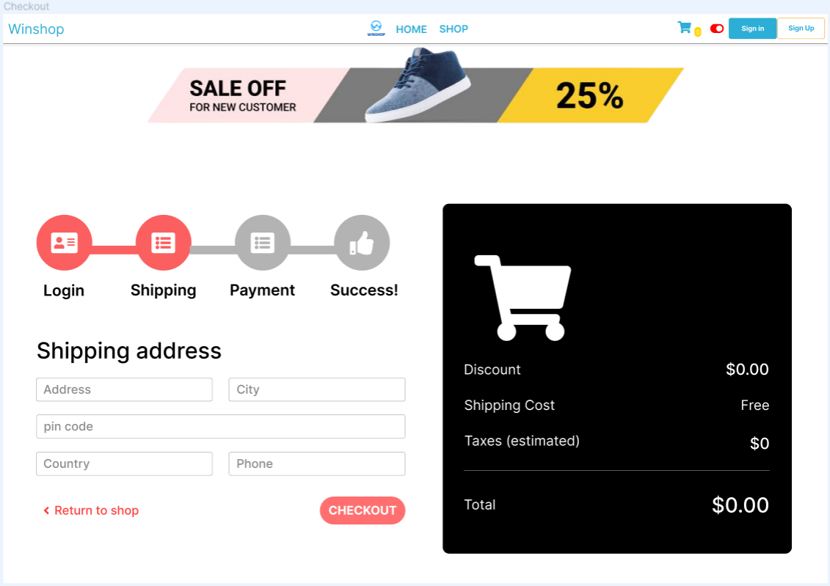**Checkout Page**
     1. *Description of Checkout Page*

The Checkout page of the Winshop application consists of 2 sections:

* Section 1:

The first part on the left side of the interface page displays information boxes for customers to fill in for the purpose of receiving goods and confirming information. In addition, customers can also see what stage their products are being processed at. If you do not want to pay, you can return to the store on the app to continue shopping.

* Section 2:

The second part on the right side of the interface page displays the fees that customers need to pay, and whether promotions are being applied.

* + 1. *Prototype in Checkout Page*
* Clicking on these clusters will return to the Homepage interface page:
  + phrase 'Winshop'
  + phrase 'HOME'
  + Website logo
* Clicking on the phrase 'SHOP' will go to the store's interface page on the website, where customers can search, select, and view the products they want to buy.
* Clicking on the cart logo will go to the interface of the shopping cart on the website, where customers can search, select, view, delete products that they have added to the cart before. There is a display of the number of products in the cart, that display is next to the cart logo.
* Clicking on the 'Sign in' box will go to the customer login interface page on the website, where customers can log in to the account they have created before, if they do not have an account, they can register a new account to use on the app.
* Clicking on the 'Sign up' box will go to the new customer account registration interface on the website, where customers can register a new account to use on the application, if you already have an account, you can log into the account you created earlier.
* Clicking on the phrase 'Return to shop' will return to the interface of Shop Page
  1. 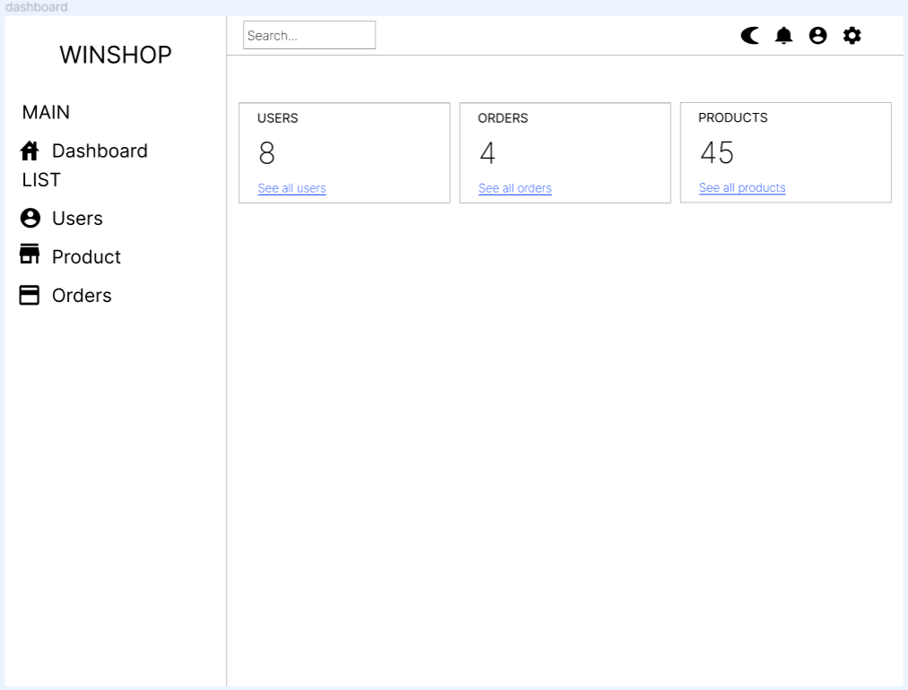**Dashboard Page**
     1. *Description of Dashboard Page*

The Dashboard page of the Winshop application consists of 2 sections:

* Section 1:

The first part is located on the left side of the interface page, showing admin the user management boxes, products, inventory,... on the application. You can search for management functions and customize the interface, account,...

* Section 2:

The second part on the right of the interface page displays the information being managed on the admin page. There is a display of the number of objects in each information being managed.

* + 1. *Prototype of Dashboard Page*
* If from the Dashboard page interface click to switch to another interface, clicking on these clusters will return to the Dashboard page interface page:
  + phrase 'Winshop'
  + phrase 'Dashboard'
* Clicking on the 'User' box and phrase ‘See all users’ will go to the Manage Users interface page to manage customer accounts on the application.
* Clicking on the 'Product' box and phrase ‘See all products’ will go to the Manage Product interface page to manage the products in the store on the app.
* Clicking on the 'Orders' box will go to the Manage Order interface page to manage paid, unpaid products and process orders on the application.
  1. **Manage Users Page**

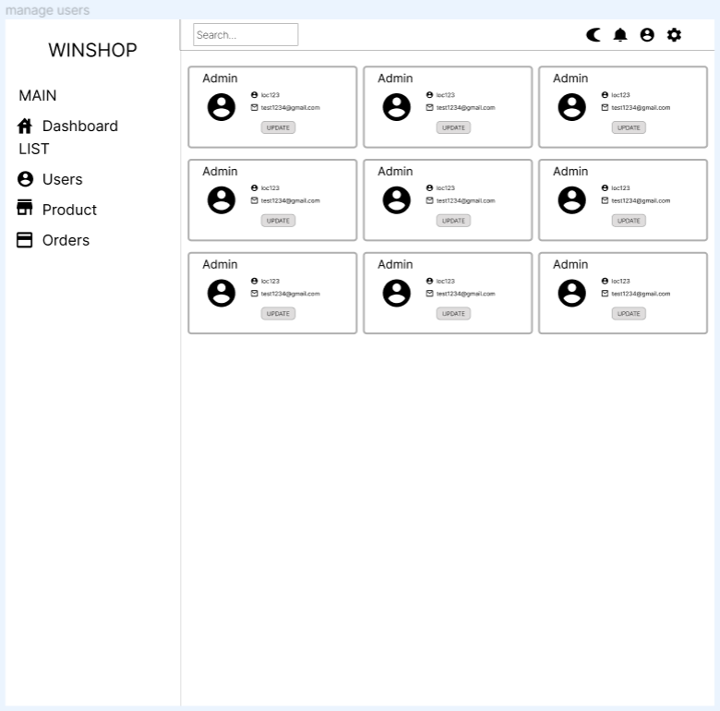

* + 1. *Description of Manage Users Page*

The Manage Users page of the Winshop application consists of 2 sections:

* Section 1:

The first part is located on the left side of the interface page, showing admin the user management boxes, products, inventory,... on the application. You can search for management functions and customize the interface, account,...

* Section 2:

The second part on the right of the interface page displays the number and information about customer accounts, admin accounts that have been created on the application.

* + 1. *Prototype in Manage Users Page*
* Clicking on these clusters will return to the Dashboard page interface page:
  + phrase 'Winshop'
  + phrase 'Dashboard'
* Clicking on the 'User' box and phrase ‘See all users’ will go to the Manage Users interface page to manage customer accounts on the application.
* Clicking on the 'Product' box and phrase ‘See all products’ will go to the Manage Product interface page to manage the products in the store on the app.
* Clicking on the 'Orders' box will go to the Manage Order interface page to manage paid, unpaid products and process orders on the application.
* Clicking on the 'Update' box will appear a form to edit
  1. 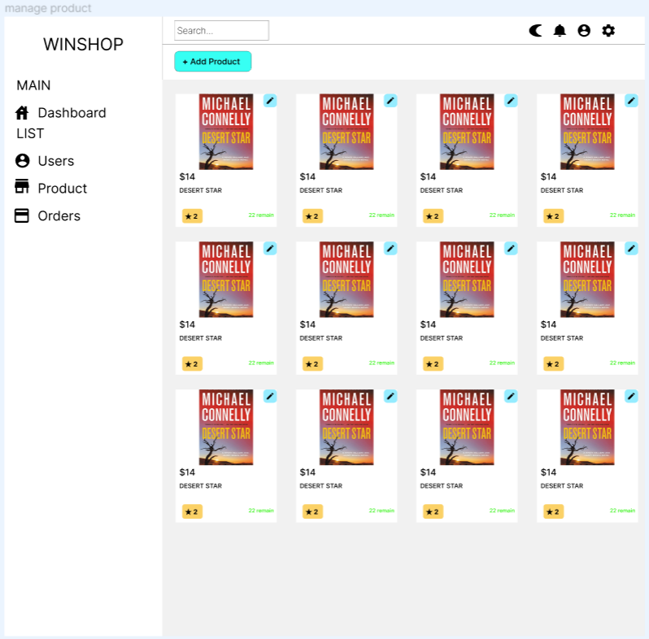**Manage Product Page**
     1. *Description of Manage Product Page*

The Manage Product page of the Winshop application consists of 2 sections:

* Section 1:

The first part is located on the left side of the interface page, showing admin the user management boxes, products, inventory,... on the application. You can search for management functions and customize the interface, account,...

* Section 2:

The second part on the right of the interface page displays the quantity and information, the unit price of the products in the store on the application. Admin can edit the information of those products.

* + 1. *Prototype in Manage Product Page*
* Clicking on these clusters will return to the Dashboard page interface page:
  + phrase 'Winshop'
  + phrase 'Dashboard'
* Clicking on the 'User' box and phrase ‘See all users’ will go to the Manage Users interface page to manage customer accounts on the application.
* Clicking on the 'Product' box and phrase ‘See all products’ will go to the Manage Product interface page to manage the products in the store on the app.
* Clicking on the 'Orders' box will go to the Manage Order interface page to manage paid, unpaid products and process orders on the application.
  1. 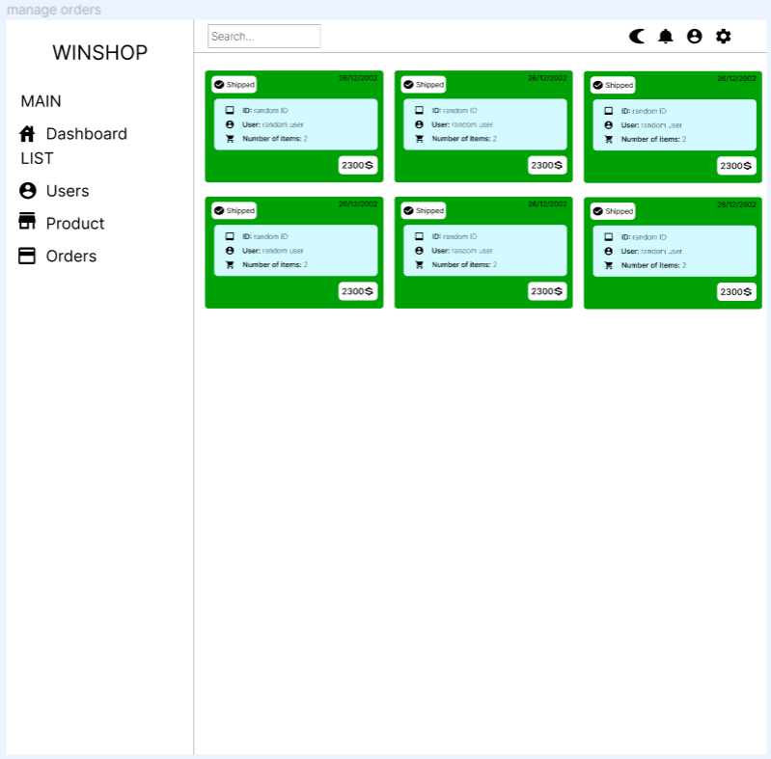**Manage Orders Page**
     1. *Description of Manage Orders Page*

The Manage Order page of the Winshop application consists of 2 sections:

* Section 1:

The first part is located on the left side of the interface page, showing admin the user management boxes, products, inventory,... on the application. You can search for management functions and customize the interface, account,...

* Section 2:

The second part on the right side of the interface page displays the quantity and information of orders being processed on the application, including unpaid or paid orders.

* + 1. *Prototype in Manage Orders Page*
* Clicking on these clusters will return to the Dashboard page interface page:
  + phrase 'Winshop'
  + phrase 'Dashboard'
* Clicking on the 'User' box and phrase ‘See all users’ will go to the Manage Users interface page to manage customer accounts on the application.
* Clicking on the 'Product' box and phrase ‘See all products’ will go to the Manage Product interface page to manage the products in the store on the app.
* Clicking on the 'Orders' box will go to the Manage Order interface page to manage paid, unpaid products and process orders on the application.