<Project Name>

Version <1.0>

[Note: The following template is provided for use with the Rational Unified Process. Text enclosed in square brackets and displayed in blue italics (style=InfoBlue) is included to provide guidance to the author and should be deleted before publishing the document. A paragraph entered following this style will automatically be set to normal (style=Body Text).]

[To customize auto

matic fields in Microsoft Word (which display a gray background when selected), select File>Properties and replace the Title, Subject and Company fields with the appropriate information for this document. After closing the dialog, automatic fields may be updated throughout the document by selecting Edit>Select All (or Ctrl-A) and pressing F9, or simply click on the field and press F9. This must be done separately for Headers and Footers. Alt-F9 will toggle between displaying the field names and the field contents. See Word help for more information on working with fields.]

Revision History

|  |  |  |  |
| --- | --- | --- | --- |
| **Date** | **Version** | **Description** | **Author** |
| <dd/mmm/yy> | <x.x> | <details> | <name> |
|  |  |  |  |
|  |  |  |  |
|  |  |  |  |

Table of Contents

1. Use-case Model 4

2. Use-case Specifications 4

2.1 Use-case: Add a product to cart 4

2.2 Use-case: Create a new account **Error! Bookmark not defined.**

# Use-case Model

[*Put an image of the use-case diagram modeling all use-cases in this section*]

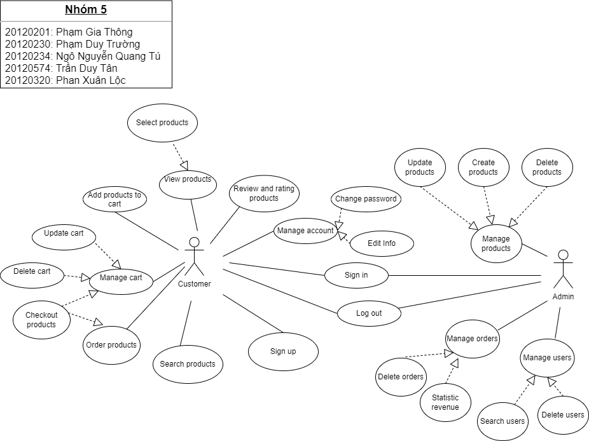

# Use-case Specifications

## Use-case: Checkout products

|  |  |
| --- | --- |
| Use case Name | Checkout products |
| Brief description | This use-case describes how the Customer can check out the products |
| Actors | Customer |
| Basic Flow | 1. At the homepage, the user clicks a product 2. The user clicks the ‘Cart’ field to see the detail of product and select to buy products 3. The products are added to the user’s cart 4. System displays the ordered products 5. Users clicks on ‘Checkout` button to start checking out products 6. System displays a form (address, name, phone, …) to require customers to verify order 7. Confirm the products 8. Display form for customer to choose payment method (credit card, or visa, …) and click the button `Pay` 9. Open response pay if success and send the email to customer. |
| Alternative Flows | **Alternative flow 1: User cannot find products in cart**   1. From #1 of the basic flow, user choose product again 2. Continue step #2 in the basic flow   **Alternative flow 2: Shopping**  **cart has already had the product**   1. From #3 of the basic flow, system increases the quantity of the product 2. Continue step #4 |
| Pre-conditions | 1. User goes to homepage of website 2. Log in account |
| Post-conditions | The user successfully checkout ordered items in the cart |