# Software Design Principles Notes

Contents

Software Design Principles Notes 1

Aim of software design patterns: 3

State Design Pattern: 10

Key Participants: 10

**State:** 10

**Concrete State:** 10

**Context:** 11

Strategy Pattern: 14

Key Participants: 14

**Strategy:** 14

**Concept Strategy:** 14

**Context:** 14

Implementation with code: 15

Observer Pattern: 17

Key participants: 17

**Subject** 17

**Observer** 17

**ConcreteSubject** 17

**ConcreteObserver** 17

Implementation w/ code: 18

**Subject:** 18

**Observer:** 18

**CurrCondDisplay (Concrete Observer)** 18

**Weather Data (Concrete Subject)** 19

**Implementation for main programme:** 20

Iterator Design Pattern: 22

Key participants: 22

**Iterator:** 22

**Aggregate:** 22

**Concreate Iterator:** 22

**ConcreteAggregate:** 23

Implementation w/ Code: 23

**Iterator:** 23

Interface: 24

**Example Usage:** 24

Decorator Pattern: 25

Key Participants: 25

**Component:** 25

**ConcreteComponent:** 25

**Decorator:** 25

**ConcreteDecorator:** 26

Implementation with Code: 26

**Component:** 26

**ConcreteComponent:** 26

Decorator: 26

**ConcreteDecorator:** 27

Factory Method Pattern 28

Key participants 28

**Product** 28

**ConcreteProduct** 28

**Creator** 28

**ConcreteCreator** 28

Implementation w/ Code: 29

**Product:** 29

**ConcreteProduct:** 30

**Creator:** 30

**ConcreteCreator:** 31

Abstract Factory Design Pattern: 33

Key participants: 33

**AbstractFactory** 33

**ConcreteFactory** 33

**AbstractProduct** 33

- Declares an interface for a type of product object 33

**ConcreteProduct** 33

Singleton Design Pattern: 36

Command Design Pattern: 38

Key participants: 38

Command: 38

Concrete Command: 38

Client: 38

Invoker: 39

Receiver: 39

Composite Pattern: 41

Key participants: 42

Component: 42

Leaf: 42

Composite: 42

Client: 42

## Design Patterns – Recurring problems in software

Benefit of design patterns:

* Improve code maintainability, reusability, and readability
* Help teams communicate using share terminology
* Provide well-tested solutions to common problems

## Aim of software design patterns:

1. **Buildable** - can be implemented without error
2. **Maintainable** - can be updated relatively easily
3. **Extendable** - can add new features without affecting existing features unnecessarily
4. **Reusable** - can be ported over to other similar projects

**Cohesion:**

- Describes how much a component contributes to a **single** purpose

- Low cohesion -> more complex, changes are harder to implement, therefore harder to reuse

Hence, we want **high** cohesion.

1. Operation cohesion
2. Class Cohesion
3. Specialisation Cohesion

**Coupling:**

- Describes the number of **interconnections** between components

If components have high coupling:

1. Changes in one component likely to affect the other
2. Implementing a functionality may be more difficult as multiple components are involved
3. Harder to test the system, due to issues arising from multiple components
4. Inheritance Coupling  
   - Try to move attributes to sub classes if only required by one subclass, reduces the need for unnecessary inheritance of attributes
5. Interaction Coupling  
   - Try to have as few parameters as possible between messages in a sequence diagram

**State:**

- Current condition of an object

- Determined by:

1. Current value of the object’s **attributes**

2) **Links** it has with other objects

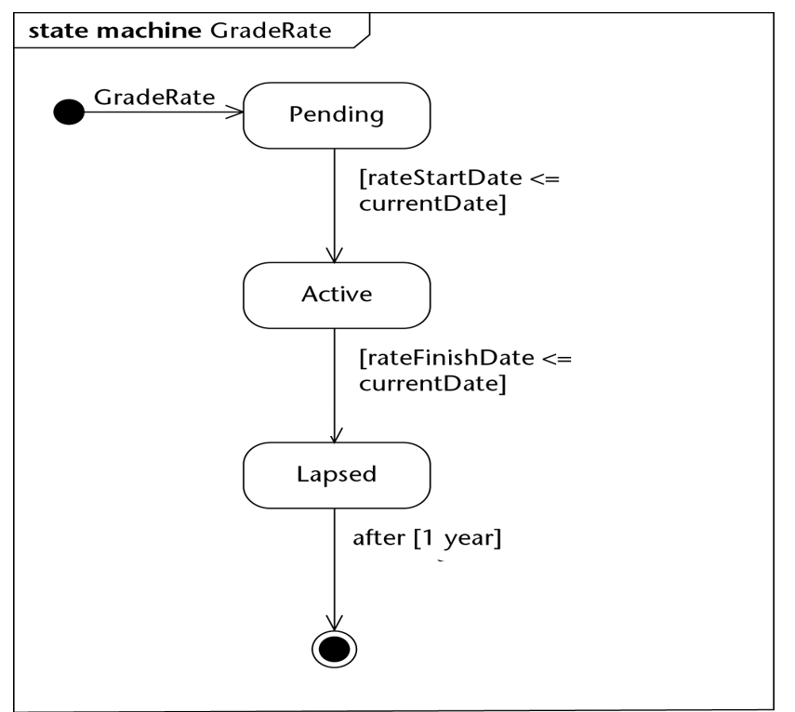

Types of triggers:

1. Change trigger

- Occurs when condition becomes true

1. Call trigger

- Occurs when an object receives a call of one of its operations either from another object or from itself

1. Relative-Time trigger

- Caused by the passage of a designated period of time after a specified event (usually entry to the current state)

1. Signal Trigger

- Occurs when an object receives a signal (async communication)

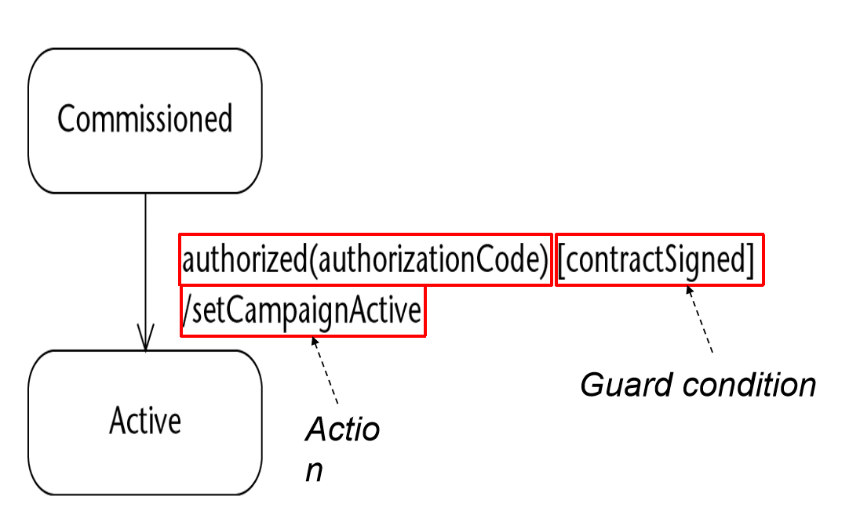

**Transitions:**  
- Transition is fired when following conditions are satisfied:

* Entity is in the state of the source state
* Event specified in label occurs
* Guard condition specified in the label is evaluated to be true

When a transition is fired, actions associated with it are executed

**Internal Activities:**

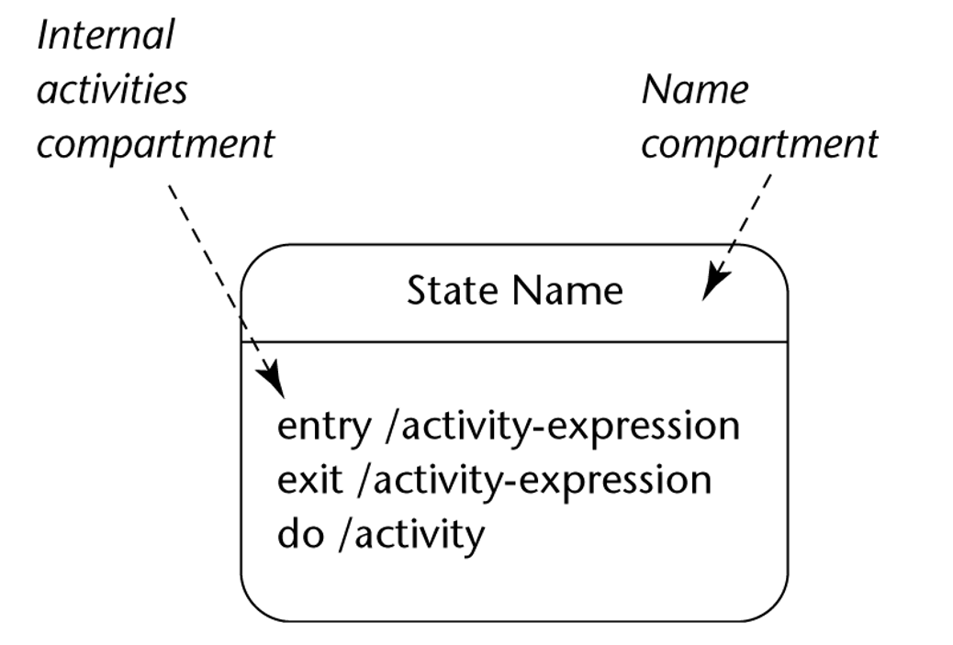

**UML Notation:**

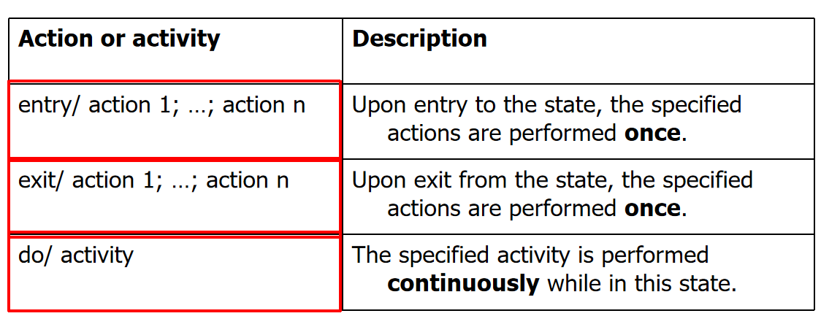

**Example:**

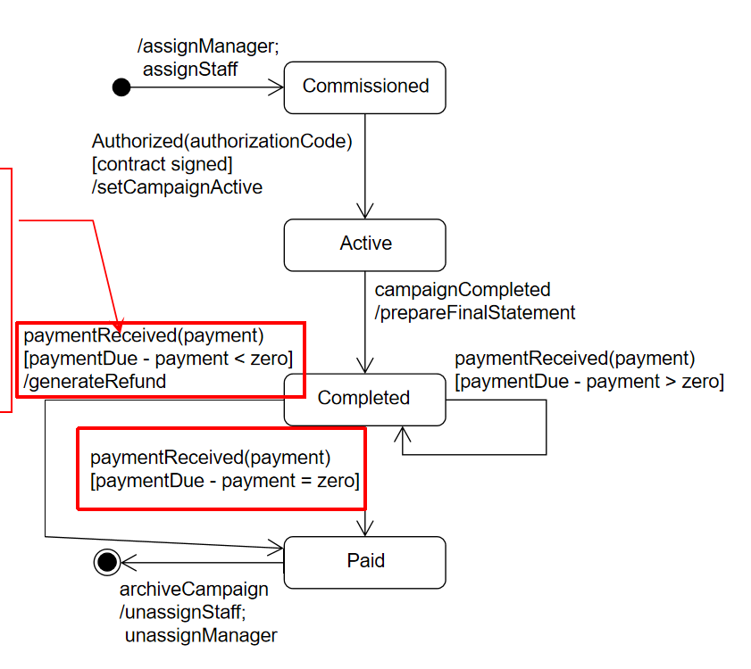

**Junction and Choice Psuedostates:**

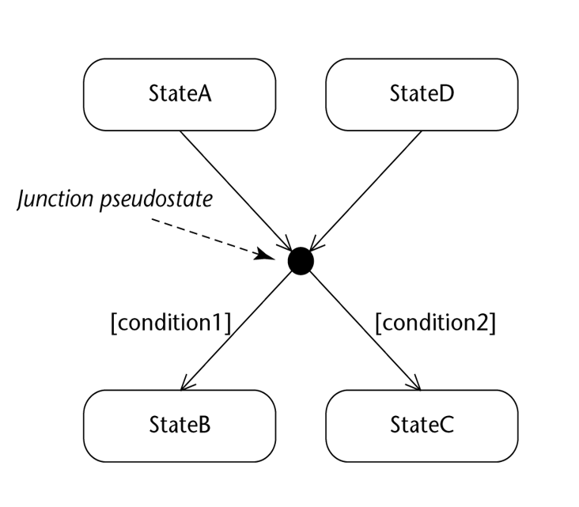

- UML says that object can end up in **any** resulting state if there is no priority, would result in ill-formed state machine

**Full State Machine Example:**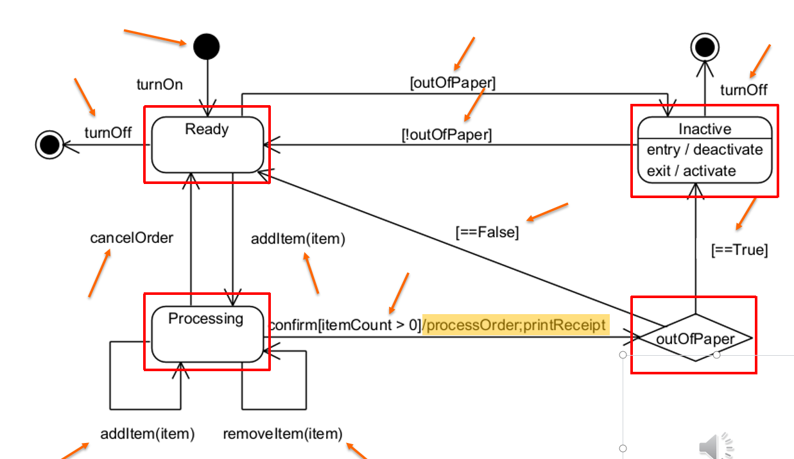

**Design Principle:**

1. Program to an interface, not an implementation

* Interface” means “supertype

1. Encapsulate what changes

* Identify the aspects of your application that vary and separate them from what stays the same

1. Favour composition over inheritance
   * “Has-a” is better than a “is-a”
2. Strive for loosely coupled designs between objects that interact
3. “Open-Closed” principle
   * Classes should be open for extension, but closed for modification
4. Dependency inversion principle
   * High-level modules should not depend on low-level modules; both should depend on abstractions

# State Design Pattern:

Allows an object to alter its behaviour when its internal state changes

The object will appear to change its class (a.k.a objects for states)

Applicability:

* Object’s behaviour depends on its state, must change it’s behaviour at runtime depending on that state:
  + Operations have large, multi-part conditional statements that depend on that state
  + Same conditional structure over many operations
  + State design pattern puts each branch in the conditional as a separate class -> each state is an object, can vary independentlyA computer screen shot of a diagram

    Description automatically generated

## Key Participants:

### **State:**

Defines an interface to encapsulate the behaviour of all states in the context

### **Concrete State:**

Implements the behaviour using the state interface

### **Context:**

Configures with state objects, maintains an instance to a ConcreteState object that represents its current state

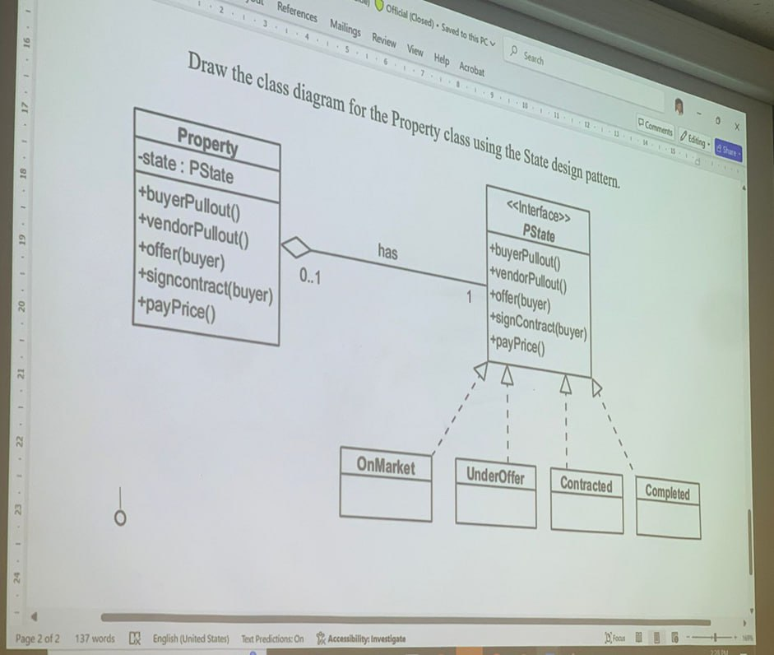

  public class Property

    {

        private PState _state;

        private bool _success = false;

        public Property()

        {

            _state = new OnMarket(); // Initial state

        }

        public void SetState(PState state)

        {

            _state = state;

        }

        public bool IsSaleSuccessful()

        {

            return _success;

        }

        public void MarkSaleSuccess()

        {

            _success = true;

        }

        public void BuyerPullout()

        {

            _state?.BuyerPullout(this);

        }

        public void VendorPullout()

        {

            if (_success)

            {

                Console.WriteLine("Vendor cannot pull out - sale is complete with success = True");

            }

            else

            {

                _state?.VendorPullout(this);

            }

        }

        public void Offer(Buyer buyer)

        {

            if (_success)

            {

                Console.WriteLine("Cannot offer - sale is complete with success = False");

            }

            else

            {

                _state?.Offer(this, buyer);

            }

        }

        public void SignContract(Buyer buyer)

        {

            _state?.SignContract(this, buyer);

        }

        public void PayPrice()

        {

            _state?.PayPrice(this);

        }

    }

-------

    public interface PState

    {

        void BuyerPullout(Property property);

        void VendorPullout(Property property);

        void Offer(Property property, Buyer buyer);

        void SignContract(Property property, Buyer buyer);

        void PayPrice(Property property);

    }

-------------

    public class OnMarket : PState

    {

        public void BuyerPullout(Property property)

        {

            Console.WriteLine("No buyer to pull out. The property is on the market.");

        }

        public void VendorPullout(Property property)

        {

            Console.WriteLine("Vendor pulls out. Sale is complete with success = False.");

            property.SetState(new Completed());

        }

        public void Offer(Property property, Buyer buyer)

        {

            Console.WriteLine("Offer made.");

            property.SetState(new UnderOffer());

        }

        public void SignContract(Property property, Buyer buyer)

        {

            Console.WriteLine("No buyer to sign contract.");

        }

        public void PayPrice(Property property)

        {

            Console.WriteLine("Contract not yet signed.");

        }

    }

# Strategy Pattern:

* Defines a family of algorithms, encapsulates each one and makes them interchangeable
* Algorithm may vary independently from the clients that use it
* Known as policy design

Applicability:  
- Sometimes there are many ways to achieve a task (such as payment)

* “Correct” way is dependent on circumstances
* Wish to change strategy used during runtime, or want to keep implementation details secret

## Key Participants:

### **Strategy:**

* Defines an interface common to all supported algorithms

### **Concept Strategy:**

* Implements the algorithm using Strategy Interface

### **Context:**

* Maintains a reference to a strategy object
* Configured with a ConcreteStrategy object
* May define an interface that lets Strategy access its data

**Example:**  
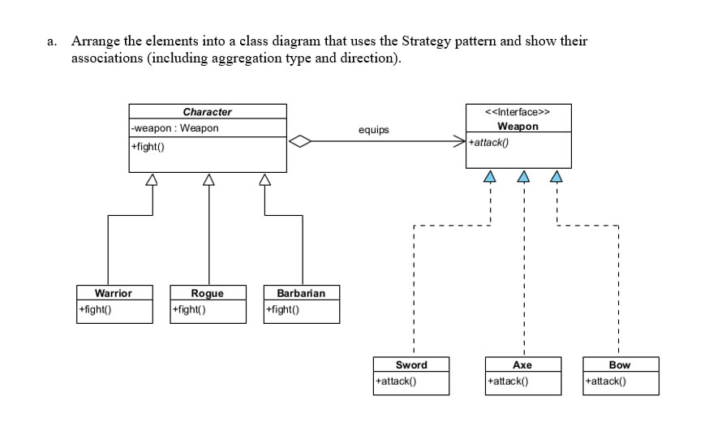

## Implementation with code:

 public abstract class Character

    {

        private Weapon _weapon;

        // Empty constructor

        protected Character()

        {

        }

        // Property for accessing and changing the weapon

        public Weapon MyWeapon

        {

            get { return Weapon; }

            set { Weapon = value; }

        }

        public Weapon Weapon { get => _weapon; set => _weapon = value; }

        // Abstract method to be implemented by subclasses

        public abstract void Fight();

    }

 // Warrior.cs

    public class Warrior : Character

    {

        public Warrior()

        { }

        public override void Fight()

        {

            MyWeapon?.Attack(); // Call Attack if MyWeapon is not null

        }

    }

----------------------

# Observer Pattern:

Defines a one-to-many dependency between objects, so when one object changes state, all its dependents are notified and updated immediately

## Key participants:

### **Subject**

* Provides interface to register/remove/notify observers

### **Observer**

* Defines interface for update notification

### **ConcreteSubject**

* Object being observed
* Sends notification to observers when state is changed

### **ConcreteObserver**

* Observing object
* Implements observer interface update() method

Example:

## Implementation w/ code:

### **Subject:**

// Subject interface with methods to register, remove, and notify observers

interface Subject

{

    void RegisterObserver(Observer o); // Register an observer

    void RemoveObserver(Observer o);   // Remove an observer

    void NotifyObservers();            // Notify all observers of a change

}

### **Observer:**

// Observer interface with an update method to receive state changes

interface Observer

{

    void Update(float temp, float humidity, float pressure); // Update the observer with new data

}

### **CurrCondDisplay (Concrete Observer)**

// Concrete observer implementation that displays current conditions

class CurrentConditionsDisplay : Observer

{

    private float temperature; // Store the temperature for display

    private float humidity;    // Store the humidity for display

    private float pressure;    // Store the pressure for display

    private Subject weatherData; // Reference to the Subject to allow deregistration if needed

    // Constructor registers itself as an observer of the provided Subject

    public CurrentConditionsDisplay(Subject weatherData)

    {

        this.weatherData = weatherData;

        weatherData.RegisterObserver(this);

    }

    // Update method called by Subject with new data

    public void Update(float temperature, float humidity, float pressure)

    {

        this.temperature = temperature;

        this.humidity = humidity;

        this.pressure = pressure;

        Display(); // Display updated data

    }

    // Display method to print the current conditions, including pressure

    public void Display()

    {

        Console.WriteLine("Current conditions: " + temperature + "F degrees, "

                          + humidity + "% humidity, and "

                          + pressure + " pressure");

    }

}

### **Weather Data (Concrete Subject)**

// Concrete implementation of the Subject interface

class WeatherData : Subject

{

    private List<Observer> observers; // List to hold observers that are watching this subject

    private float temperature;        // Current temperature data

    private float humidity;           // Current humidity data

    private float pressure;           // Current pressure data

    // Constructor initializes the list of observers

    public WeatherData()

    {

        observers = new List<Observer>();

    }

    // Register an observer by adding it to the observers list

    public void RegisterObserver(Observer o)

    {

        observers.Add(o);

    }

    // Remove an observer from the observers list

    public void RemoveObserver(Observer o)

    {

        observers.Remove(o);

    }

    // Notify all registered observers by calling their update method

    public void NotifyObservers()

    {

        foreach (Observer observer in observers)

        {

            observer.Update(temperature, humidity, pressure);

        }

    }

    // This method is called when the measurements change

    public void MeasurementsChanged()

    {

        NotifyObservers(); // Notify observers about the change

    }

    // Method to simulate new weather data and notify observers

    public void SetMeasurements(float temperature, float humidity, float pressure)

    {

        this.temperature = temperature;

        this.humidity = humidity;

        this.pressure = pressure;

        MeasurementsChanged(); // Call MeasurementsChanged to update observers

    }

}

### **Implementation for main programme:**

// Test program to demonstrate the Observer pattern

class WeatherStation

{

    static void Main(string[] args)

    {

        WeatherData weatherData = new WeatherData(); // Create the Subject

        // Create an observer and register it to receive updates from WeatherData

        CurrentConditionsDisplay currentDisplay = new CurrentConditionsDisplay(weatherData);

        // Simulate new weather measurements

        weatherData.SetMeasurements(80, 65, 30.4f);

        weatherData.SetMeasurements(82, 70, 29.2f);

        weatherData.SetMeasurements(78, 90, 29.2f);

    }

}

# Iterator Design Pattern:

Provides a way to access the elements of an aggregate object sequentially without exposing its underlying representation

* Loose coupling between client and aggregate/iterator classes

## Key participants:

### **Iterator:**

* Defines the interface for accessing and traversing elements
  + Next() advances to the next element and returns it as an Object
  + hasNext() returns true if there is another element in the aggregate, false otherwise

### **Aggregate:**

* Defines the interface for creating an iterator object

### **Concreate Iterator:**

* Implements the Iterator interface
* Keeps track of current position

### **ConcreteAggregate:**

* Implements the iterator creation interface to return an instance of ConcreteIterator

## Implementation w/ Code:

### **Iterator:**

class OddIterator : Iterator {

    List<int> values;

    int position = 0;

public OddIterator(List<int> values) {

    this.values = values;

    // Move position to first odd number, skip even numbers

    while ((position < values.Count) && (values[position] % 2 != 0)) {

        position++;

    }

}

public bool hasNext() {

    return position < values.Count;

}

public object next() {

    int value = values[position];

    position++;

    // Move position to next odd number, skip even numbers

    while ((position < values.Count) && (values[position] % 2 != 1)) {

        position++;

    }

    return value;

}

}

### Interface:

interface Iterator {

    public bool hasNext();

    public object next();

}

### **Example Usage:**

// Example usage

List<int> list = new List<int>();

list.Add(1);

list.Add(2);

list.Add(3);

// Create an iterator for odd numbers

OddIterator oddIterator = new OddIterator(list);

while (oddIterator.hasNext()) {

    Console.WriteLine((int)oddIterator.next());

}

# Decorator Pattern:

* Attaches additional responsibilities to an object dynamically
* Provides a flexible alternative to subclassing for extending functionality

## Key Participants:

### **Component:**

* Defines the interface for objects that can have responsibilities added to them dynamically

### **ConcreteComponent:**

* Defines an object to which additional responsibilities can be attached

### **Decorator:**

* Maintains a reference to a Component object
* Defines an interface that conforms to the Component

### **ConcreteDecorator:**

* Adds responsibilities to the component

## Implementation with Code:

### **Component:**

public abstract class Beverage {

    protected string description = "Unknown Beverage”;

    public virtual string getDescription() {

      return description;

    }

    public abstract double cost();

}

### **ConcreteComponent:**

public class HouseBlend: Beverage

{

    public HouseBlend() {

      base.description = "House Blend";

    }

    public override double cost() { return 4.50; }

}

public class DarkRoast: Beverage

{

    public DarkRoast() {

      base.description = "Dark Roast";

    }

    public override double cost() { return 4.00; }

}

### Decorator:

public abstract class CondimentDecorator: Beverage {

    public abstract override string getDescription();

}

### **ConcreteDecorator:**

public class Mocha: CondimentDecorator {

    private Beverage beverage;

    public Mocha(Beverage beverage) {

        this.beverage = beverage;

    }

    public override string getDescription() {

        return beverage.getDescription() + ", mocha";

    }

    public override double cost() {

        return 0.80 + beverage.cost();

    }

}

# Factory Method Pattern

* Defines an interface for creating an object, but lets the subclasses decide which class to instantiate
* Lets a class defer instantiation into subclasses

## Key participants

### **Product**

* Defines interface for objects that the factory method creates

### **ConcreteProduct**

* Implements the Product interface

### **Creator**

* Declares the factory method, which returns an object of type Product
* May also define a default implementation of factory method that returns a default ConcreteProduct

### **ConcreteCreator**

* Overrides the factory method to return ConcreteProduct

Example:

## Implementation w/ Code:

### **Product:**

abstract class Pizza

{

    public void Prepare()

    {

        Console.WriteLine($"Preparing {this.GetType().Name}");

    }

    public void Bake()

    {

        Console.WriteLine($"Baking {this.GetType().Name}");

    }

    public virtual void Cut()

    {

        Console.WriteLine($"Cutting {this.GetType().Name} in standard way");

    }

    public void Box()

    {

        Console.WriteLine($"Boxing {this.GetType().Name}");

    }

}

### **ConcreteProduct:**

class NYStyleCheesePizza : Pizza

{

    public override void Cut()

    {

        Console.WriteLine($"Cutting {this.GetType().Name} into traditional New York slices");

    }

}

class NYStyleHawaiianPizza : Pizza

{

    // Uses default Cut() implementation

}

class ChicagoStyleCheesePizza : Pizza

{

    public override void Cut()

    {

        Console.WriteLine($"Cutting {this.GetType().Name} into square slices (Chicago Style)");

    }

}

class ChicagoStyleHawaiianPizza : Pizza

{

    // Uses default Cut() implementation

}

### **Creator:**

abstract class PizzaStore

{

    // Factory method to create a pizza, implemented by subclasses

    protected abstract Pizza CreatePizza(string type);

    // Method to order a pizza

    public Pizza OrderPizza(string type)

    {

        Pizza pizza = CreatePizza(type);

        if (pizza != null)

        {

            pizza.Prepare();

            pizza.Bake();

            pizza.Cut();

            pizza.Box();

        }

        else

        {

            Console.WriteLine("Sorry, we don't have that type of pizza.");

        }

        return pizza;

    }

}

### **ConcreteCreator:**

class NYStylePizzaStore : PizzaStore

{

    protected override Pizza CreatePizza(string type)

    {

        if (type == "cheese")

        {

            return new NYStyleCheesePizza();

        }

        else if (type == "hawaiian")

        {

            return new NYStyleHawaiianPizza();

        }

        else

        {

            return null;

        }

    }

}

class ChicagoStylePizzaStore : PizzaStore

{

    protected override Pizza CreatePizza(string type)

    {

        if (type == "cheese")

        {

            return new ChicagoStyleCheesePizza();

        }

        else if (type == "hawaiian")

        {

            return new ChicagoStyleHawaiianPizza();

        }

        else

        {

            return null;

        }

    }

}

# Abstract Factory Design Pattern:

* Provides an interface for creating families of related or dependent objects without specifying their concrete classes

## Key participants:

### **AbstractFactory**

* Declares an interface for operations that create abstract product objects

### **ConcreteFactory**

* Implements the operations to create concrete product objects

### **AbstractProduct**

### Declares an interface for a type of product object

### **ConcreteProduct**

* Defines product object to be created by the corresponding concrete factory
* Implements the AbstractProduct interface

Example:

**Implementation with Code:**

**Abstract Factory:**

<Interface>

public interface IPizzaIngredientFactory

{

    IDough CreateDough();

    ITopping CreateTopping();

}

**ConcreteFactory:**

public class NYPizzaIngredientFactory : IPizzaIngredientFactory

{

    public IDough CreateDough()

    {

        return new ThinCrustDough();

    }    public ITopping CreateTopping()

    {

        return new Pepperoni();

    }

}

public class ChicagoPizzaIngredientFactory : IPizzaIngredientFactory

{

    public IDough CreateDough()

    {

        return new ThickCrustDough();

    }    public ITopping CreateTopping()

    {

        return new Beef();

    }

}

**Abstract Product:**

<Interface>

// Abstract Products

public interface IDough { }

public interface ITopping { }

**ConcreteProduct:**

public class ThinCrustDough : IDough { }

public class ThickCrustDough : IDough { }

public abstract class Cheese : ITopping { }

public class ReggianoCheese : Cheese{ }

public class MozzarellaCheese : Cheese{ }

public class Pepperoni : ITopping { }

public class Beef : ITopping { }

**Client:**

**Differences between Factory Method and Abstract Factory**

* Factory Method
  + Uses subclasses that override a factory method
  + Creates a single object
* Abstract Factory
  + Uses object composition
  + Creates a family of objects

# Singleton Design Pattern:

* Ensures that only one instance of the class is created
* Provides a global point of access to the single instance
* Declares a private constructor

Use Singleton when there must be at most one instance of a class

* Instance must be accessible to clients from a well-known access point

One instance is extensible by subclassing

* Clients can use the subclass without modifying code

**Player Instance:**

public class Player

    {

        private static Player uniqueInstance = null;

        private readonly Command[] commands = new Command[12];

        private Command lastCommand;

        private int hp;

        private int maxHp;

        private int mp;

        private int maxMp;

        private int magicPower;

        // Private constructor for Singleton

        private Player(int maxHp, int maxMp, int magicPower)

        {

            this.maxHp = maxHp;

            this.maxMp = maxMp;

            this.magicPower = magicPower;

            this.hp = maxHp;

            this.mp = maxMp;

            for (int i = 0; i < commands.Length; i++)

            {

                commands[i] = new NoCommand();

            }

            lastCommand = new NoCommand();

        }

**Set Instance:**

     // Singleton instance retrieval

        public static Player getInstance(int maxHp, int maxMp, int magicPower)

        {

            if (uniqueInstance == null)

            {

                uniqueInstance = new Player(maxHp, maxMp, magicPower);

            }

            return uniqueInstance;

        }

# Command Design Pattern:

* Encapsulates a request as an object
* Let’s parameterise clients with different requests
* Supports undoable operations

## Key participants:

## Command:

Declares an interface for executing an operation

## Concrete Command:

Defines a binding between a Receiver object and an action

Implements execute() by invoking corresponding operations on the Receiver

## Client:

Creates a ConcreteCommand object and sets it receiver

## Invoker:

Asks the Command to carry out the request by calling execute()

## Receiver:

Knows how to perform the operations associated with carrying out a request

Any class may serve as a Receiver

Example:

Implementation with Code:

**Invoker (Player):**

    public class Player

    {

        private static Player uniqueInstance = null;

        private readonly Command[] commands = new Command[12];

        private Command lastCommand;

 // Setter for commands

        public void setCommand(Command command, int slot)

        {

            commands[slot] = command;

        }

        // Execute a command

        public void hotkeyPushed(int slot)

        {

            commands[slot].execute();

            lastCommand = commands[slot];

        }

        // Undo the last executed command

        public void undoKeyPushed()

        {

            lastCommand.undo();

        }

**Command & ConcreteCommand:**

public interface Command

    {

        void execute();

        void undo();

    }

    public class NoCommand : Command

    {

        public void execute()

        {

            Console.WriteLine("No command set!");

        }

        public void undo()

        {

            Console.WriteLine("No command set!");

        }

    }

    public class DrinkHealingPotionCommand : Command

    {

        private readonly HealingPotion healingPotion;

        public DrinkHealingPotionCommand(HealingPotion healingPotion)

        {

            this.healingPotion = healingPotion;

        }

        public void execute()

        {

            int healed = healingPotion.drink();

            healingPotion.getPlayer().heal(healed);

            Console.WriteLine($"Player is healed for {healed} HP and now has {healingPotion.getPlayer().getHp()} HP");

        }

        public void undo()

        {

            int healed = healingPotion.drink();

            healingPotion.getPlayer().takeDamage(healed);

            healingPotion.incrementDoses();

            Console.WriteLine($"Undoing drinking healing potion for {healed} HP.");

        }

    }

# Composite Pattern:

* Allows you to compose objects into tree structures to represent part-whole hierarchies
* Let’s client treat individual objects and compositions of objects uniformly

## Key participants:

## Component:

Declares an interface for objects in the composition

Implements default behaviour where appropriate

Declares an interface for managing its child components

## Leaf:

Represents objects in the comparison with no children

## Composite:

Defines behaviour for components with children

Stores child components

## Client:

Manipulates objects in the composition

Implementation with Code:

**Component (GameEntity):**

    public abstract class GameEntity

    {

        public virtual void add(GameEntity ge)

        {

            throw new NotSupportedException();

        }

        public virtual void remove(GameEntity ge)

        {

            throw new NotSupportedException();

        }

        public virtual GameEntity getChild(int index)

        {

            throw new NotSupportedException();

        }

        public virtual void print()

        {

            throw new NotSupportedException();

        }

        public virtual string getDescription()

        {

            throw new NotSupportedException();

        }

        public virtual string Name

        {

            get

            {

                throw new NotSupportedException();

            }

        }

        public virtual string Profession

        {

            get

            {

                throw new NotSupportedException();

            }

        }

    }

**Composite (Team):**

 public class Team: GameEntity

    {

        private string name;

        private List<GameEntity> gameEntities;

        public string Name

        {

            get

            {

                return name;

            }

        }

        public Team(string name)

        {

            this.name = name;

            gameEntities = new List<GameEntity>();

        }

        public override string getDescription()

        {

            return $"Team {Name}";

        }

        public override void add(GameEntity ge)

        {

            gameEntities.Add(ge);

            Console.WriteLine($"{ge.getDescription()} joins {Name}!");

        }

        public override void remove(GameEntity ge)

        {

            gameEntities.Remove(ge);

            Console.WriteLine($"{ge.getDescription()} leaves {Name}!");

        }

        public override GameEntity getChild(int index)

        {

            return gameEntities[index];

        }

        public override void print()

        {

            Console.WriteLine(Name.ToUpper() + ":");

            TeamIterator iter = createIterator();

            while (iter.hasNext())

            {

                Console.Write($"    ");

                GameEntity ge = (GameEntity)iter.next();

                ge.print();

            }

        }

        public TeamIterator createIterator()

        {

            return new TeamIterator(gameEntities);

        }

    }

**Iterator for Composite (TeamIterator):**

 public class TeamIterator

    {

        private List<GameEntity> teams;

        private int position = 0;

        public TeamIterator(List<GameEntity> teams)

        {

            this.teams = teams;

        }

        public bool hasNext()

        {

            return position < teams.Count;

        }

        public Object next() {

            return teams[position++];

        }

    }

**Leaf (NPC):**

 public class NPC: GameEntity

    {

        private string name;

        private string profession;

        public NPC(string name, string profession)

        {

            this.name = name;

            this.profession = profession;

        }

        public string Name

        {

            get

            {

                return name;

            }

        }

        public string Profession

        {

            get

            {

                return profession;

            }

        }

        public override string getDescription()

        {

            return $"{name} the {profession}";

        }

        public override void print()

        {

            Console.WriteLine(getDescription());

        }

    }

**Leaf (PC):**

    public class PC:GameEntity

    {

        private string name;

        private string profession;

        public PC(string name, string profession)

        {

            this.name = name;

            this.profession = profession;

        }

        public string Name

        {

            get

            {

                return name;

            }

        }

        public string Profession

        {

            get

            {

                return profession;

            }

        }

        public override string getDescription()

        {

            return $"{name} the {profession}";

        }

        public override void print()

        {

            Console.WriteLine(getDescription());

        }

    }

**Arena (Client):**

    public class Arena

    {

        private GameEntity gameEntity;

        public Arena(GameEntity ge)

        {

            this.gameEntity = ge;

        }

        public void addEntity(GameEntity ge)

        {

            gameEntity.add(ge);

        }

        public void removeEntity(GameEntity ge)

        {

            gameEntity.remove(ge);

        }

        public void print()

        {

            gameEntity.print();

        }

    }

# Adapter Pattern:

* Converts the interface of a class into another interface the client expects
* Let’s classes work together that could not otherwise because of incompatible interfaces
* Wrapper

## Key participants:

## Target:

Defines the interface that the Client uses

## Client:

Uses objects conforming to the Target interface

## Adaptee:

Defines an existing interface that needs adapting

## Adapter:

Adapts the interface of the Adaptee to the Target interface

-> Now able to use an existing class, making new versions backwards-compatible

-> Create reusable class that cooperates with unrelated or unforeseen classes

Implementation with code:

   public interface MediaPlayer

    {

        void Play(MediaFile mediaFile);

    }

    public class MP3PlayerAdapter : MediaPlayer

{

    private MP3Player _mp3Player;

    public MP3PlayerAdapter(MP3Player mp3Player)

    {

        _mp3Player = mp3Player;

    }

    public void Play(MediaFile mediaFile)

    {

        // We expect mediaFile to be an MP3File

        if (mediaFile is MP3File mp3File)

        {

            // Delegate to the MP3Player

            _mp3Player.playMP3(mp3File.Name);

        }

        else

        {

            Console.WriteLine($"Cannot play file: {mediaFile.Name} (not an MP3)");

        }

    }

    }

# Facade:

* Provides a unified interface to a set of interfaces in a subsystem
* Defines a higher-level interface that makes the subsystem easier to use

## Key participants:

## Facade:

* Knows which subsystem classes are responsible for a request
* Delegates client requests to appropriate subsystem objects

## Subsystem Classes:

* Implement subsystem functionality
* Handle work assigned by the Façade object
* Have no knowledge of the Façade (do not keep a reference to it)

* **Clients are shielded from subsystem components**
  + Reduces number of objects that clients deal with
  + Makes the subsystem easier to use
* **Promotes weak coupling between subsystem and clients**
  + Allows varying of subsystem components without affecting clients
* **Does not prevent using system classes if necessary**

Advantages:

* Reduces dependencies between objects
* Simplifies system maintenance

Disadvantages:

* Results in more “wrapper” classes or methods
* May result in increased complexity and development time
* May cause decrease in runtime performance

Implementation w/ Code:

 public class Item

    {

        private string name;

        private double price;

        private int quantity;

        // constructor, getters and setters

        // Constructor

        public Item(string name, double price, int quantity)

        {

            this.name = name;

            this.price = price;

            this.quantity = quantity;

        }

        // Properties

        public string Name

        {

            get { return name; }

            set { name = value; }

        }

        public double Price

        {

            get { return price; }

            set { price = value; }

        }

        public int Quantity

        {

            get { return quantity; }

            set { quantity = value; }

        }

    }

System(s):

public class OrderSystem

    {

        public void confirmOrder()

        {

            Console.WriteLine("Order is confirmed.");

        }

        public void setDelivery()

        {

            Console.WriteLine("Delivery details are set.");

        }

    }

public class InventorySystem

    {

              private Dictionary<string, Item> inventory = new Dictionary<string, Item>();

        public void addItem(Item item)

        {

            inventory[item.Name] = item;

        }

        public Item getItem(string name)

        {

            return inventory[name];

        }

        public bool checkAvailability(string itemName, int quantity)

        {

            Console.WriteLine($"Checking stock for {itemName}...");

            return inventory[itemName].Quantity >= quantity;

        }

        public void reduceStock(string itemName, int quantity)

        {

            Console.WriteLine(

            $"Reducing stock of {itemName} by {quantity}");

            inventory[itemName].Quantity -= quantity;

        }

    }

public class PaymentSystem

    {

        private double balance = 0.0;

        public void addFunds(double amount)

        {

            Console.WriteLine($"\nAdding ${amount:N2} to balance");

            balance += amount;

            Console.WriteLine($"Current funds: ${balance:N2}");

        }

        public bool processPayment(double amount)

        {

            Console.WriteLine(

                $"Processing payment of ${amount:N2}...");

            if (amount <= balance)

            {

                balance -= amount;

                Console.WriteLine("Payment successful.");

                Console.WriteLine($"Funds left: ${balance:N2}");

                return true;

            }

            else

            {

                Console.WriteLine(

                    "Payment unsuccessful: insufficient funds.");

                return false;

            }

        }

    }

Façade:

public class ShoppingCartFacade

    {

        private InventorySystem inventorySystem;

        private PaymentSystem paymentSystem;

        private OrderSystem orderSystem;

        public ShoppingCartFacade(

            InventorySystem inventorySystem,

            PaymentSystem paymentSystem,

            OrderSystem orderSystem)

        {

            this.inventorySystem = inventorySystem;

            this.paymentSystem = paymentSystem;

            this.orderSystem = orderSystem;

        }

        public void checkout(string itemName, int quantity)

        {

            Console.WriteLine("\nStarting checkout process...");

            // 1) Check if there is sufficient stock of the item

            bool inStock = inventorySystem.checkAvailability(itemName, quantity);

            if (!inStock)

            {

                Console.WriteLine("Insufficient stock.");

                return;

            }

            // 2) Check if user has sufficient funds

            //    (We need the price from InventorySystem)

            Item item = inventorySystem.getItem(itemName);

            double totalAmount = item.Price * quantity;

            bool paymentSuccess = paymentSystem.processPayment(totalAmount);

            if (!paymentSuccess)

            {

                Console.WriteLine("Insufficient stock.");

                return;

            }

            // 3) Reduce the stock

            inventorySystem.reduceStock(itemName, quantity);

            // 4) Confirm the order and set delivery details

            orderSystem.confirmOrder();

            orderSystem.setDelivery();

            Console.WriteLine();

        }

    }

# Template

* Defines the skeleton of an algorithm in a method deferring some steps to subclasses
* Lets subclasses redefine certain steps of an algorithm without changing the algorithm’s structure

## Key participants:

## Abstract Class:

* Implements a template method defining the skeleton of an algorithm
* Defines abstract primitive operations that concrete subclasses implement as steps of an algorithm
* Template method calls primitive operations and/or other operations defined in AbstractClass or other objects

## Concrete Class:

* Implements the primitive operations to carry out subclass-specific steps of the algorithm

* **Template methods are a fundamental technique for code reuse**
  + Common methods are inherited by subclasses
  + Only specialised methods are implemented by subclasses
* **Algorithm is only in AbstractClass**
  + Changes to the algorithm are done in one place
  + New ConcreteClasses are easy to add

Hooks vs Abstract Methods:

* Use abstract method when the subclass must provide an implementation
* Use hook when the subclass may or may not provide an implementation
  + Algorithm step is optional
  + Subclass does something extra
  + Subclass makes a decision for algorithm

abstract class CharacterCreator

{

    public void createCharacter()

    {

        chooseRace();

        assignAbilities();

        if (isSpellcaster())

        {

            assignSpells();

        }

        finalizeCharacter();

    }

    protected void chooseRace()

    {

        Console.WriteLine("Choosing race...");

    }

    protected void finalizeCharacter()

    {

        Console.WriteLine("Character creation complete.");

    }

    protected abstract void assignAbilities();

    protected abstract bool isSpellcaster();

    protected virtual void assignSpells() { }

}

class WarriorCreator : CharacterCreator

{

    protected override void assignAbilities()

    {

        Console.WriteLine("Assigning warrior abilities: Block, Shield Bash");

    }

    protected override bool isSpellcaster()

    {

        return false;

    }

}

class WizardCreator : CharacterCreator

{

    protected override void assignAbilities()

    {

        Console.WriteLine("Assigning wizard abilities: Focus, Quick Cast");

    }

    protected override bool isSpellcaster()

    {

        return true;

    }

    protected override void assignSpells()

    {

        Console.WriteLine("Assigning spells: Fireball, Slow, Magic Missile");

    }

}