In this activity, you will be given a series of problems that will challenge your logical understanding of C++ covered by the modules, and not. For each problem, you are expected to create a project and write a working solution depending on the requirements of the problem.

Always keep in mind, *think outside the box*.

**Objective/s:**

At the end of this activity, the students are expected to be able to:

* discuss the differences between the given problems in terms of implementation
* identify the different approaches applicable to *cout<<* statements
* write a working variations of our “Hello World” application

**Material/s Needed:**

* Visual Studio Code
* MinGW

**Procedure:**

1. Make sure you have a running version of the “Hello World” application shown in Module 004. If not, review the steps to setup your Work Environment.
2. There will be a series of problems you are required to code. For each, you need to provide C++ codes for the actual solution.
3. Keep the project files for record as they may be requested by the instructor.

**Questions:**

1. Write a program that displays “Hello” in one line, and “World” in another line using exactly two (2) COUT statements.
2. Write a program that displays “Hello” in one line, and “World” in another line using exactly ten (10) COUT statements.
3. Write a program that displays “Hello” in one line, and “World” in another line using exactly one (1) for the “Hello” and exactly five (5) COUT statements for the “World”.
4. What can you conclude from this activity?

**INSTRUCTIONS FOR THE STUDENTS:**

* *The filename of your lab activity should be:*

*“<Last Name><First Name>-LaboratoryExercise0<XX>”*

* *Provide screenshots of your VS codes and program output copied to a Word file.*
* *Upload the Word file to the link provided for the activity in the LMS.*

**Answers:**

Number 1.

C++ codes

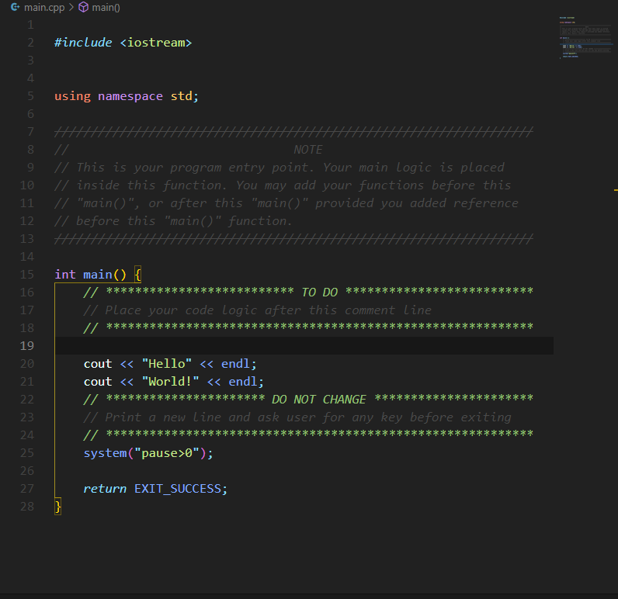

Program output :

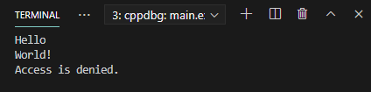

Number 2.

C++ codes

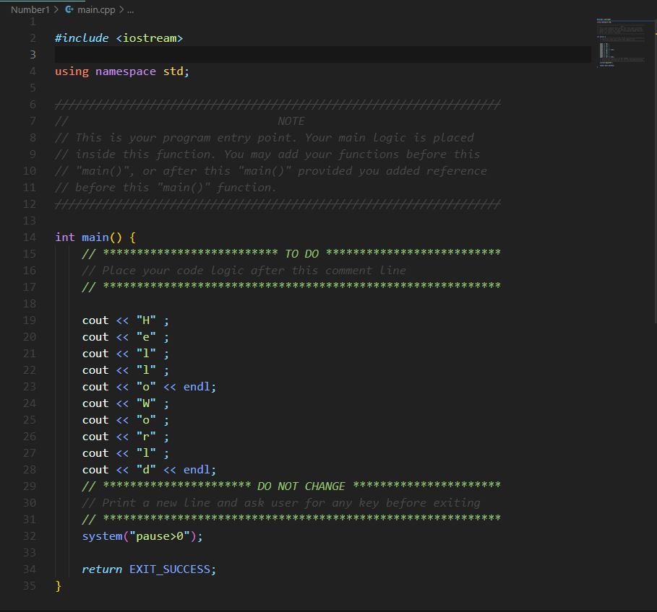

Program Output :

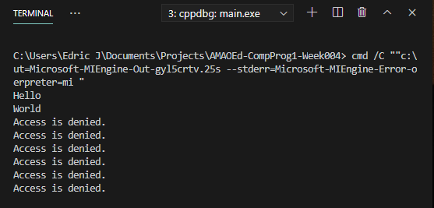

Number 3.

C++ codes

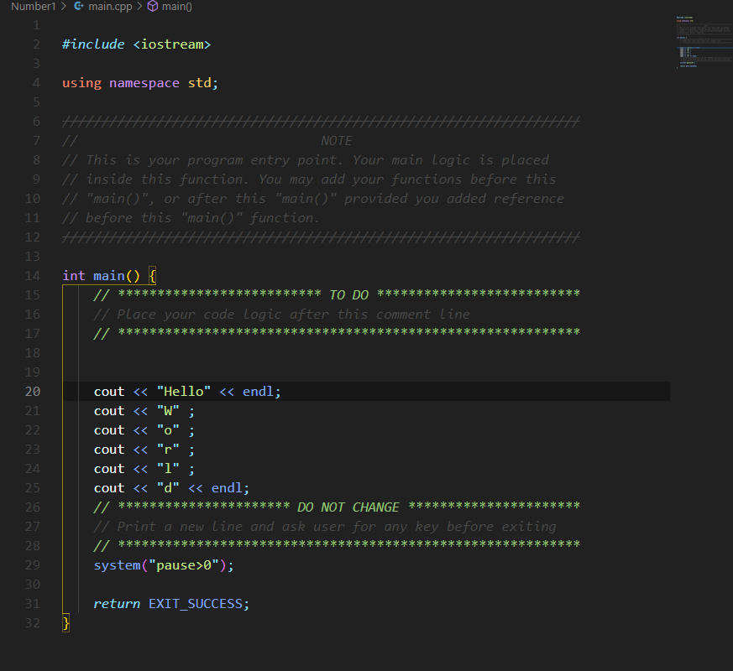

Program Output:

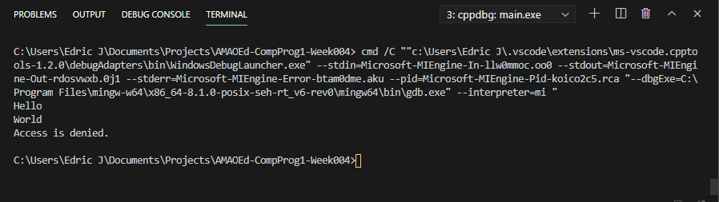

**Conclusion**

chocolatey

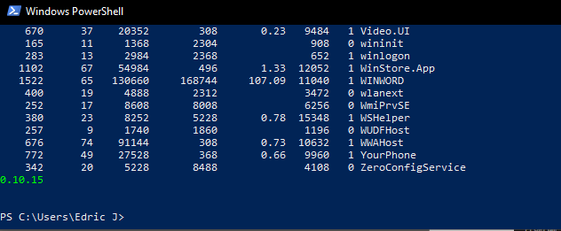

MinGW

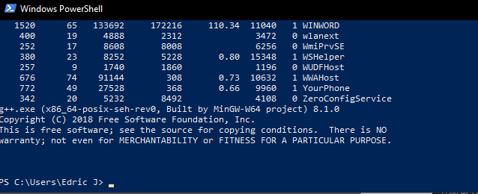

VS Code

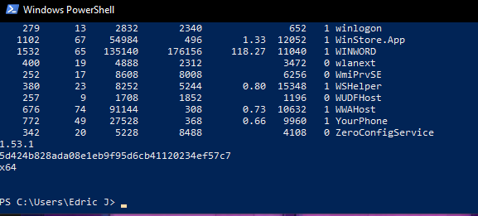

Git

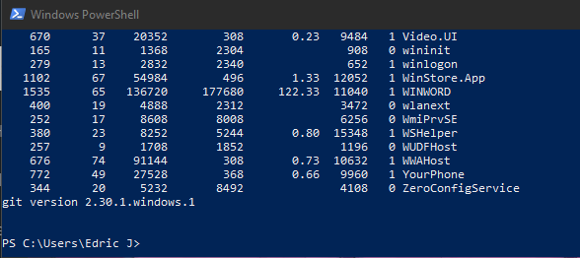

VS Code errors

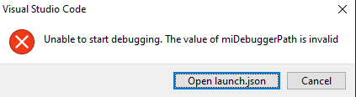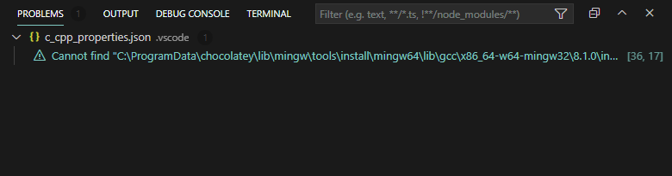

My conclusion after following steps that were presented in Module004 and windows.md in the folder “docs” from amaoed-cpp-template is I can’t seem to run the program using the template. 1 problem accurs and I cant locate the chocolatey even though I installed chocolatey already. So I created my own script to generate the program which seems not perfect because everytime I run and debug, “Access is denied” appears.