DSP Playground

Project Description

Goal: to get hands-on the DSP functionalities, to later dive deeper into it. Use the CMSIS library in order to use the fast filtering functions - Biquad Cascade IIR Filter for this project. Learn what it is and how it works.

To be done: Generate a sawtooth wave of 440Hz out of the DAC (max amplitude).

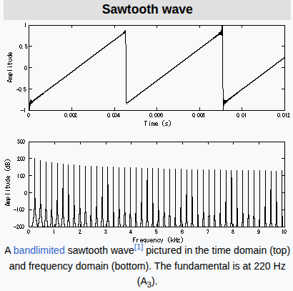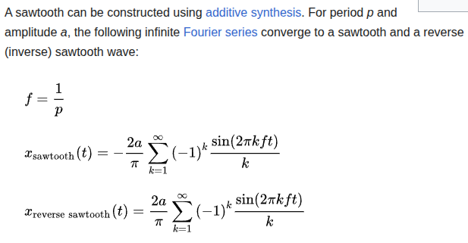

Note that this wave if harmonic-composed (evens and odds). If a low-pass filter such that the cutoff frequency is between 440Hz and 880Hz is applied, the result should be a 440Hz sine wave.
I have to input the DAC signal into a ADC channel (preferably storing data through DMA). Then apply such a filter and apply the result to the other DAC channel. This should be as close to a sine wave as possible.
It would be really cool to play both waves using a speaker, and hear the difference. Compare the sine sound with the diapason (they are ideally identical).

