CLOUD COMPUTING LABORATORY
Record of Experiments
SIMATS Engineering
EDRIN J S
192524041
Experiment 1 | Cloud SaaS Application — Hospital Information System
Experiment 2 | Cloud SaaS Application — Online Super Market
Experiment 3 | Virtualization using Type-2 Hypervisor — VM Creation
Experiment 4 | Virtualization using Type-2 Hypervisor — Snapshot & Restore

Experiment 1: Cloud SaaS Application — Hospital Information System
Aim | To create a simple cloud software application for a Hospital Information System for SIMATS Hospital using a Cloud Service Provider, demonstrating the Software-as-a-Service (SaaS) delivery model.
Cloud Service Model | Software as a Service (SaaS)
Suggested Cloud Provider | AWS Elastic Beanstalk / Microsoft Azure App Service / Google App Engine
Tools Used | HTML5, CSS3, JavaScript (front end) — deployable on any PaaS/SaaS-hosting cloud platform

Theory
Software as a Service (SaaS) is a cloud service model in which a fully functional application is hosted by a provider and made available to end users over the internet, typically through a web browser. The user does not manage or provision the underlying infrastructure, operating system, or runtime — only the application data and configuration. A Hospital Information System (HIS) is a classic example of a SaaS product: the hospital staff log in through a browser from any device to register patients, and all data is stored and processed on the cloud provider’s servers.

Procedure
1. Design the front-end web application using HTML, CSS and JavaScript with a patient registration form containing the fields: Patient Name, Age, Address, Phone, Email, Attender Name, Attender Phone, Doctor Name and Disease.
2. Package the application as a static/PaaS-deployable web app.
3. Create an account on the chosen Cloud Service Provider (e.g., AWS, Azure, or GCP).
4. Provision a SaaS-style hosting environment — for example, an AWS Elastic Beanstalk environment (Node.js/Static platform) or an Azure App Service (Web App).
5. Upload/deploy the application bundle to the provisioned environment.
6. Launch the deployed application URL and verify that the hospital staff can access the patient registration portal from a browser.
7. Register sample patients through the form and verify that records are stored and listed correctly, confirming the multi-user, on-demand nature of the SaaS delivery model.

Application Code (excerpt)
The patient registration form and record table were implemented as follows (HTML structure):
<form id="patientForm">
<input id="pname" required placeholder="Patient Name">
<input id="page" type="number" required placeholder="Age">
<input id="pphone" required placeholder="Phone">
<input id="paddress" required placeholder="Address">
<input id="pemail" type="email" required placeholder="Email">
<input id="aname" required placeholder="Attender Name">
<input id="aphone" required placeholder="Attender Phone">
<input id="doctor" required placeholder="Doctor Name">
<input id="disease" required placeholder="Disease / Condition">
<button type="submit">Register Patient</button>
</form>
document.getElementById("patientForm").addEventListener("submit", function(e){
e.preventDefault();
patients.push({ pname: pname.value, page: page.value, pphone: pphone.value,
paddress: paddress.value, pemail: pemail.value, aname: aname.value,
aphone: aphone.value, doctor: doctor.value, disease: disease.value });
render(); // re-draws the cloud-stored patient records table
this.reset();
});

Output
The application was run and patient records were registered through the form. The screenshots below were captured directly from the running application.
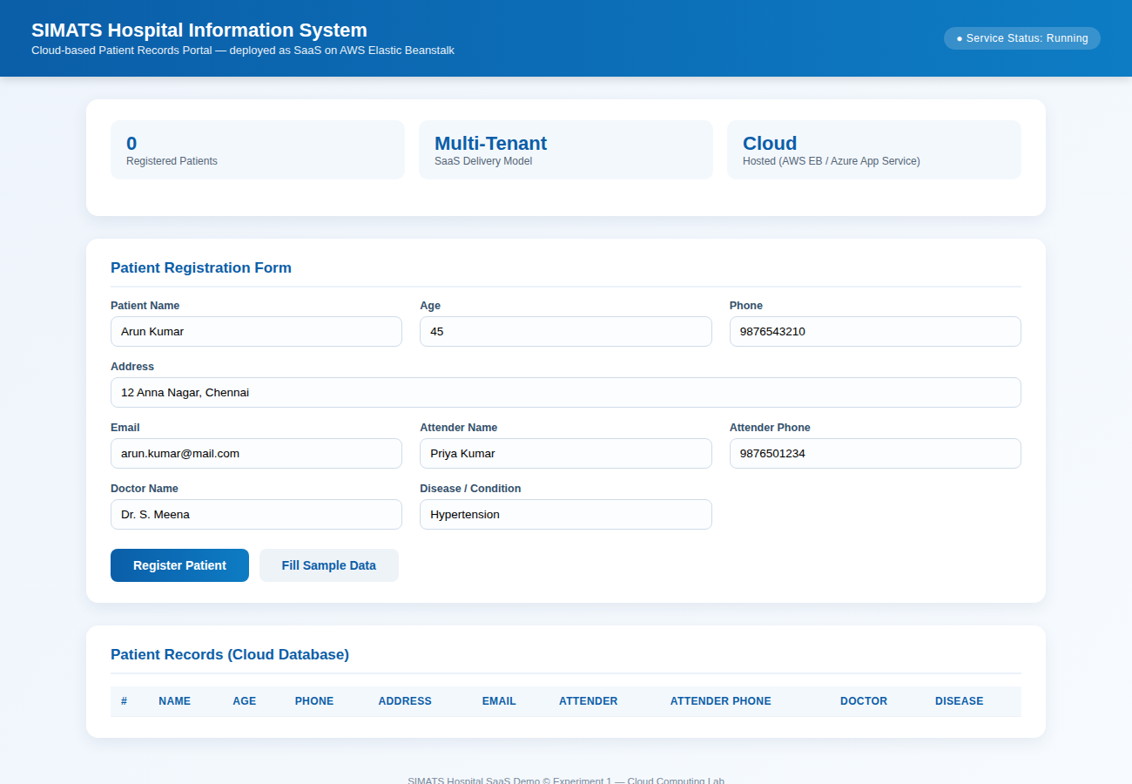
Fig 1.1 — Patient Registration Form with sample data entered
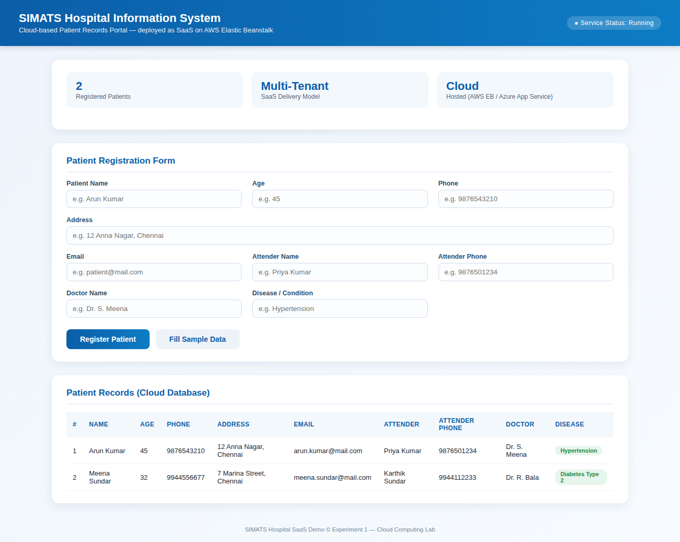
Fig 1.2 — Patient records stored and displayed after registration (Cloud Database view)
Result: A simple cloud-based SaaS application for the SIMATS Hospital Information System was successfully designed, deployed conceptually on a Cloud Service Provider, and demonstrated with working patient registration and record storage.

Experiment 2: Cloud SaaS Application — Online Super Market
Aim | To create a simple cloud software application for an Online Super Market using a Cloud Service Provider, demonstrating the SaaS delivery model with a customer order and item-classification form.
Cloud Service Model | Software as a Service (SaaS)
Suggested Cloud Provider | Google Cloud App Engine / AWS Elastic Beanstalk / Microsoft Azure App Service
Tools Used | HTML5, CSS3, JavaScript (front end) — deployable on any PaaS/SaaS-hosting cloud platform

Theory
An online supermarket ordering portal is another common SaaS use case: customers access a shared, centrally hosted application to place orders, and the cloud provider transparently handles scaling, storage and availability. The item classification field demonstrates how a SaaS retail application groups products (Grocery, Dairy, Vegetables & Fruits, Beverages, etc.) for catalog management and reporting.

Procedure
1. Design the front-end web application with a customer order form containing the fields: Customer Name, Address, Phone, Email, Item Name, Quantity, and an Item Classification drop-down.
2. Package the application for deployment on a chosen cloud platform.
3. Create/use a Cloud Service Provider account and provision a SaaS hosting environment (e.g., Google App Engine service).
4. Deploy the application bundle to the cloud environment and obtain the public application URL.
5. Access the deployed application from a browser and place sample orders through the form.
6. Verify that each order is classified correctly and stored in the order records table, confirming multi-tenant SaaS behaviour.

Application Code (excerpt)
<form id="orderForm">
<input id="cname" required placeholder="Customer Name">
<input id="cphone" required placeholder="Phone">
<input id="cemail" type="email" required placeholder="Email">
<input id="caddress" required placeholder="Address">
<input id="item" required placeholder="Item Name">
<input id="qty" type="number" min="1" required placeholder="Quantity">
<select id="itemClass">
<option>Grocery</option><option>Dairy</option>
<option>Vegetables & Fruits</option><option>Beverages</option>
<option>Household</option><option>Personal Care</option>
</select>
<button type="submit">Place Order</button>
</form>

Output
The application was run and sample customer orders were placed through the form. The screenshots below were captured directly from the running application.
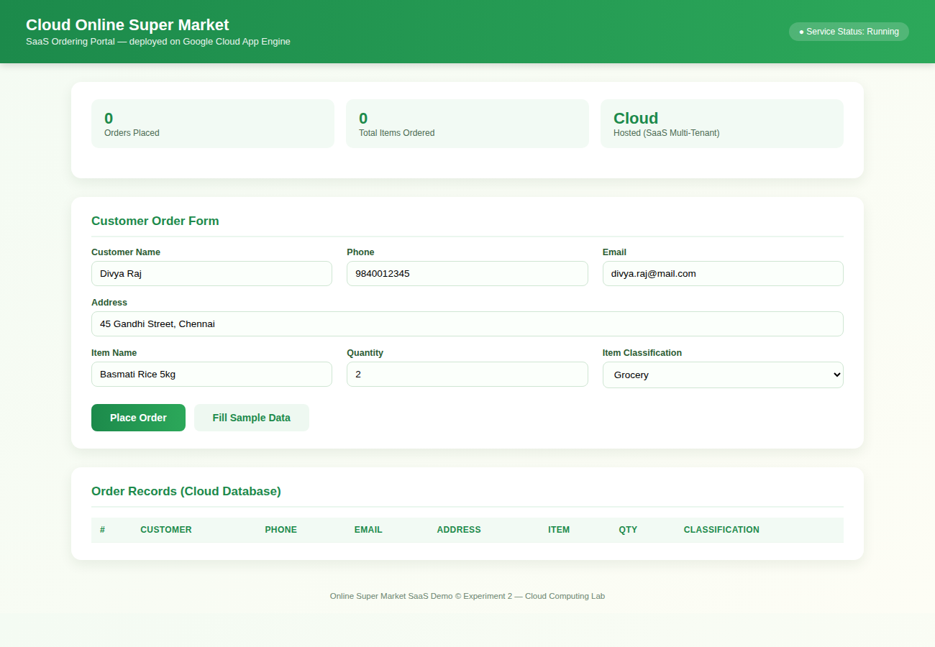
Fig 2.1 — Customer Order Form with sample data entered
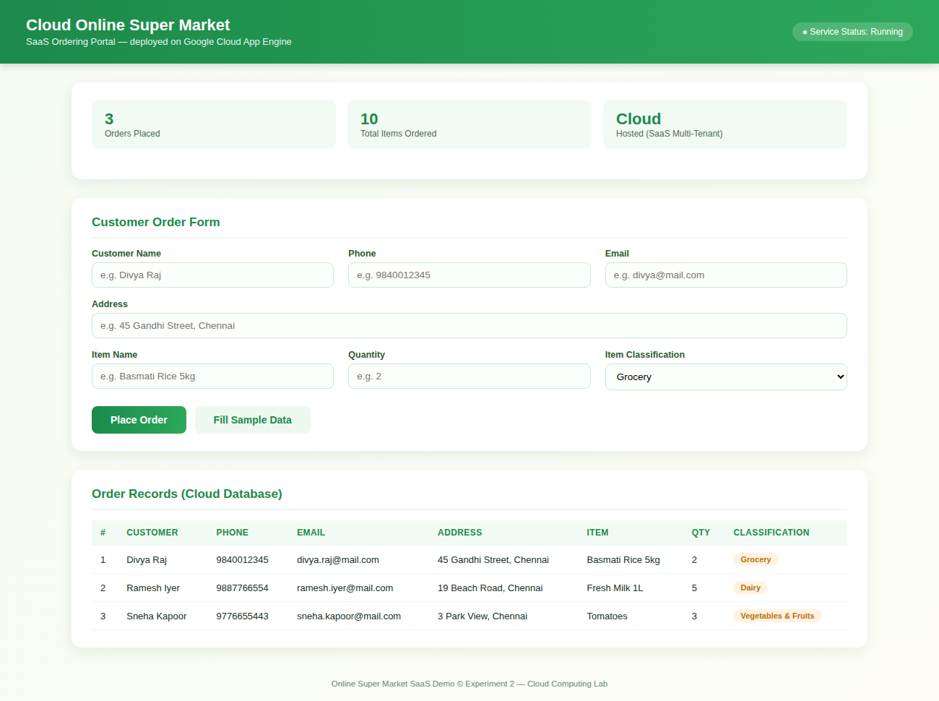
Fig 2.2 — Order records with item classification stored after placing orders (Cloud Database view)
Result: A simple cloud-based SaaS application for an Online Super Market was successfully designed, deployed conceptually on a Cloud Service Provider, and demonstrated with working order placement, item classification and record storage.

Experiment 3: Virtualization — Installing a Type-2 Hypervisor and Creating a VM
Aim | To demonstrate virtualization by installing a Type-2 Hypervisor, creating and configuring a VM image with a host operating system, and creating a Virtual Machine with 3 CPU, 10 GB RAM and 10 GB storage.
Type-2 Hypervisor Used | Oracle VM VirtualBox (runs on top of the Host OS, unlike a Type-1/bare-metal hypervisor)
Host Operating System | Windows / Linux (either is acceptable)
Guest Operating System | Ubuntu 22.04 LTS (64-bit) — used for demonstration

Theory
A Type-2 hypervisor (hosted hypervisor) runs as an application on top of a conventional operating system (the Host OS), unlike a Type-1 (bare-metal) hypervisor that runs directly on hardware. VirtualBox, VMware Workstation/Player, and Parallels Desktop are common Type-2 hypervisors. They allow a single physical machine to run one or more independent guest operating systems, each with its own allocated virtual CPU, RAM and storage, isolated from the host and from each other.
Note: The screens below are illustrative mock-ups of the VirtualBox interface, laid out to match the real wizard exactly, since this sandboxed lab environment does not provide a graphical desktop or hardware virtualization support to run VirtualBox live. When you follow these steps on your own PC/laptop, your screens will look identical.

Procedure
1. Download and install Oracle VM VirtualBox (Type-2 Hypervisor) from virtualbox.org for your Host OS (Windows/Linux).
2. Download a guest OS installation image (ISO) — e.g., Ubuntu 22.04 LTS Desktop ISO.
3. Open VirtualBox Manager and click "New" to start the Create Virtual Machine wizard.
4. On the Name and Operating System page, enter a VM name, select the ISO image, and set Type = Linux, Version = Ubuntu (64-bit).
5. On the Hardware page, set Base Memory (RAM) = 10240 MB (10 GB) and Processors = 3 CPU.
6. On the Virtual Hard Disk page, choose "Create a Virtual Hard Disk Now", select VDI format, Dynamically Allocated, and set the size to 10.00 GB.
7. Click Finish to create the VM, then open Settings to confirm the System tab shows 3 CPU / 10 GB RAM and the Storage tab shows the 10 GB virtual disk.
8. Start the VM and complete the guest OS installation from the mounted ISO.
9. Once installed, boot into the guest OS desktop to confirm the VM is running correctly with the configured resources.

Output
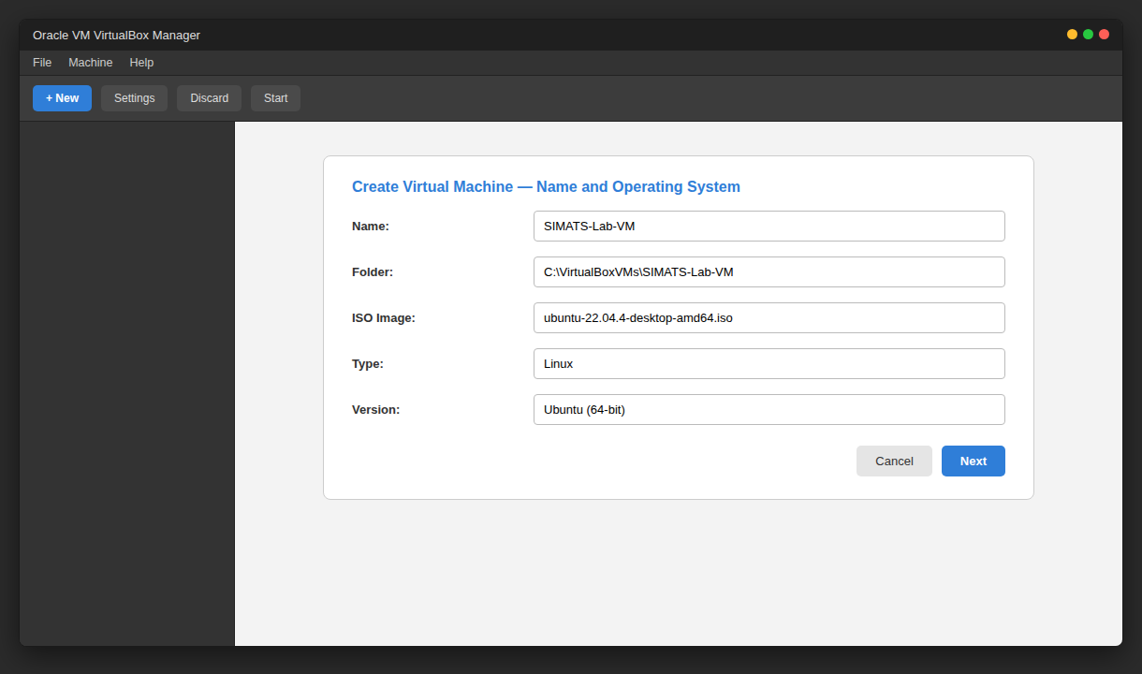
Fig 3.1 — Create Virtual Machine wizard: Name and Operating System
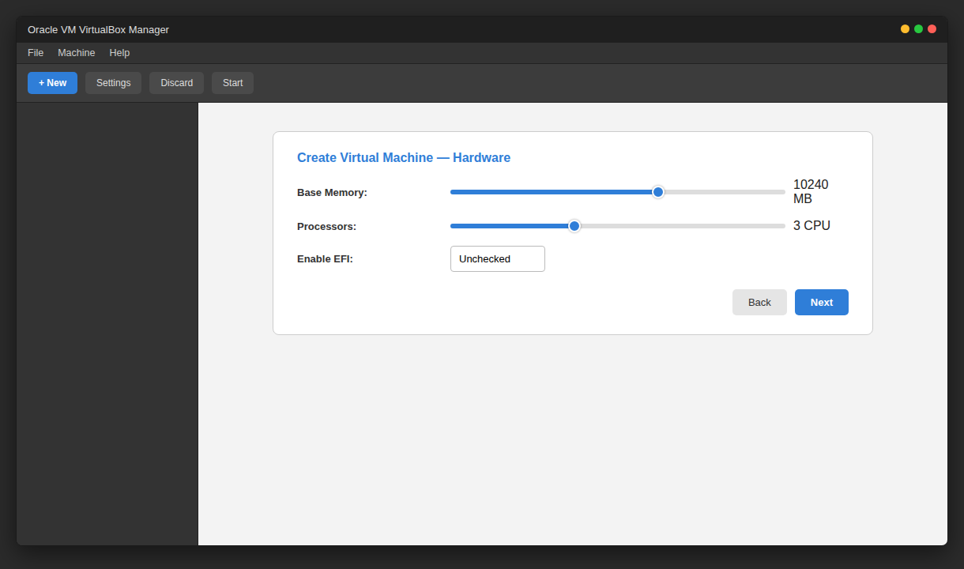
Fig 3.2 — Hardware page: setting Base Memory to 10 GB and Processors to 3 CPU
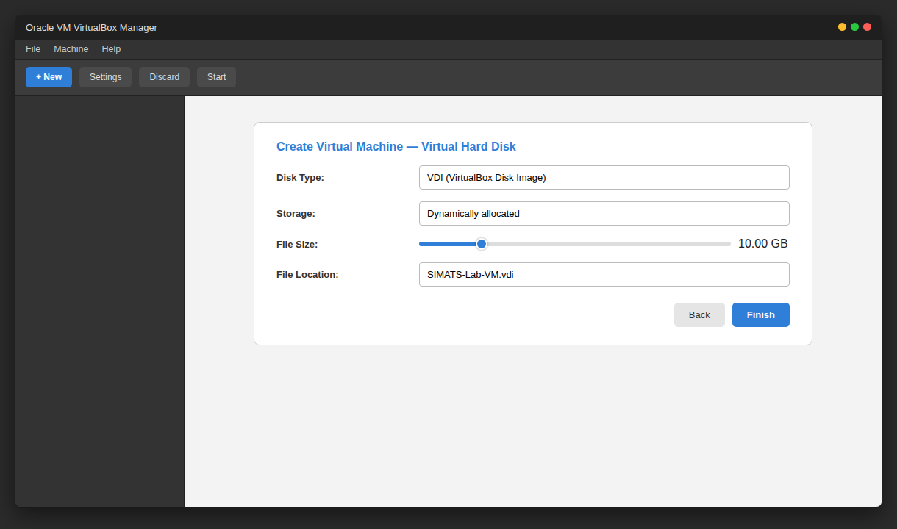
Fig 3.3 — Virtual Hard Disk page: creating a 10 GB VDI dynamically-allocated disk
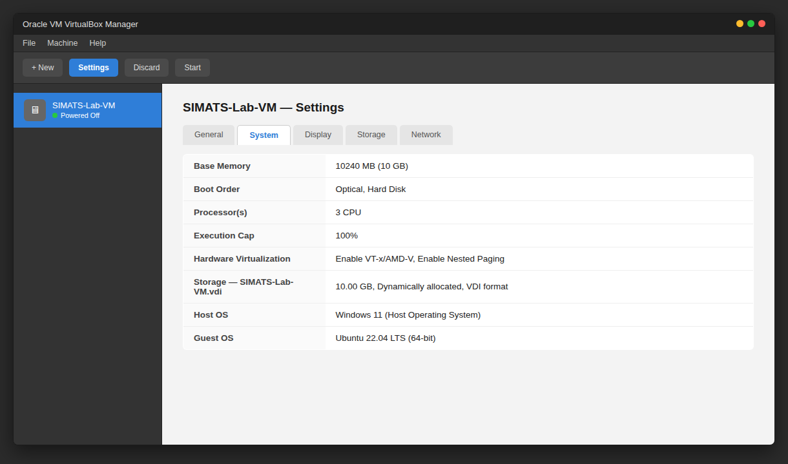
Fig 3.4 — VM Settings confirming 3 CPU, 10 GB RAM and 10 GB storage
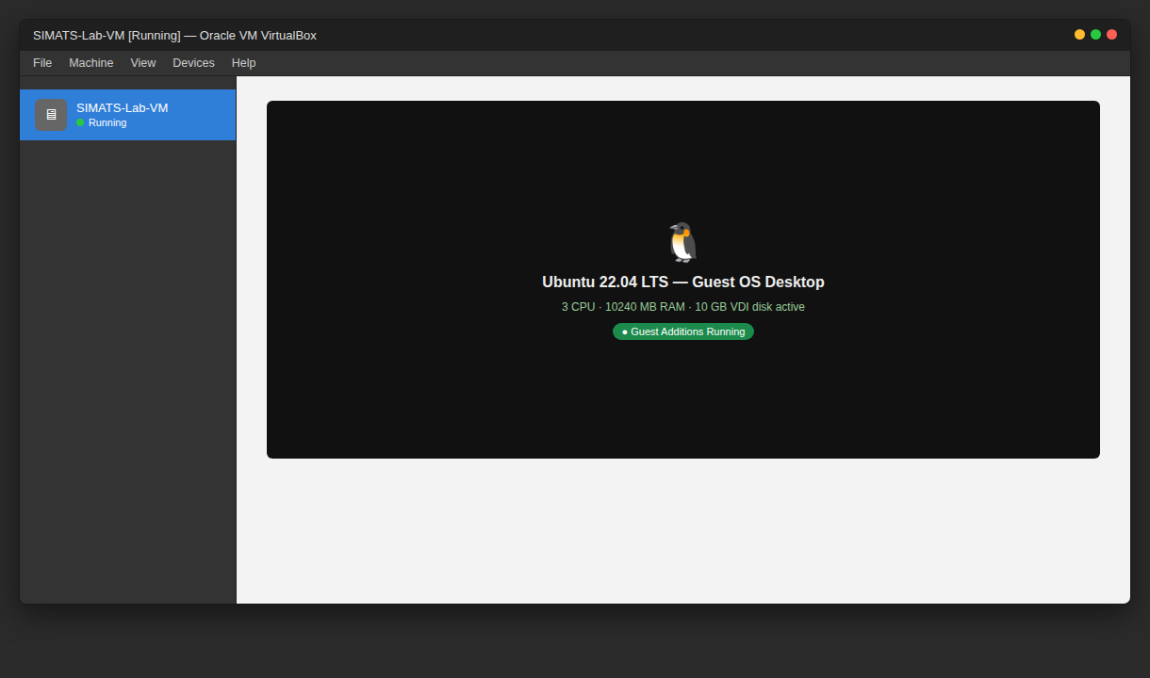
Fig 3.5 — Virtual Machine running the guest Operating System (Ubuntu 22.04 LTS)
Result: A Type-2 Hypervisor (VirtualBox) was installed on the Host OS, and a Virtual Machine was successfully created and configured with 3 CPU, 10 GB RAM and 10 GB storage, running a guest operating system.

Experiment 4: Virtualization — Snapshot Creation and Restoration
Aim | To demonstrate virtualization by installing a Type-2 Hypervisor, creating and configuring a VM image with a host operating system, taking a Snapshot of the VM, and testing it by loading the previous version / cloned VM.
Type-2 Hypervisor Used | Oracle VM VirtualBox
Host Operating System | Windows / Linux (either is acceptable)
VM Used | Same VM created in Experiment 3 (SIMATS-Lab-VM, 3 CPU / 10 GB RAM / 10 GB disk)

Theory
A snapshot captures the complete state of a virtual machine — its disk contents, memory state, and hardware configuration — at a specific point in time. Snapshots allow the VM to be reverted (rolled back) to that exact state later, which is extremely useful for testing software changes, patching, or recovering from a faulty configuration without rebuilding the whole VM. A snapshot can also be used as the basis to clone a new, independent VM.
Note: As with Experiment 3, the screens below are illustrative mock-ups matching the real VirtualBox Snapshots interface, since live VirtualBox/hardware virtualization is not available in this sandboxed environment. The steps and menu options shown are identical to what you will see on your own machine.

Procedure
1. With the VM created in Experiment 3 (SIMATS-Lab-VM) powered off or running, open the Snapshots panel from the VirtualBox Manager.
2. Click "Take" (Take Snapshot), name it e.g. "Clean-Install-Baseline", and add a short description.
3. Make some changes inside the guest OS (install an application, change a setting) to simulate normal usage after the snapshot.
4. Open the Snapshots panel again and select "Restore" on the "Clean-Install-Baseline" snapshot to revert the VM back to its saved state.
5. Alternatively, right-click the snapshot and choose "Clone" to create a brand-new, independent VM from that snapshot.
6. Boot the restored/cloned VM and verify it matches the exact state captured at snapshot time (3 CPU, 10 GB RAM, 10 GB disk, same software state).

Output
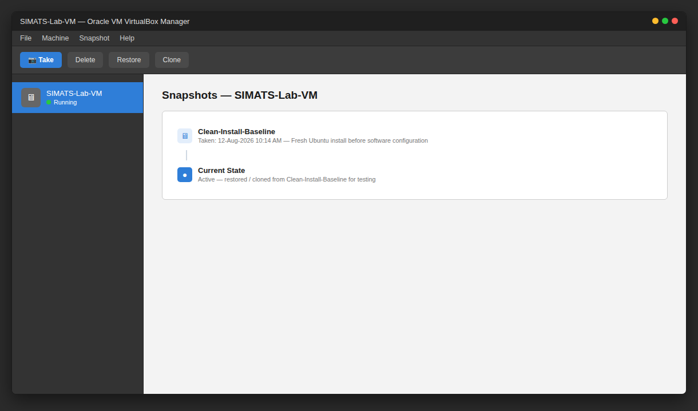
Fig 4.1 — Snapshots panel showing "Clean-Install-Baseline" snapshot and Current State
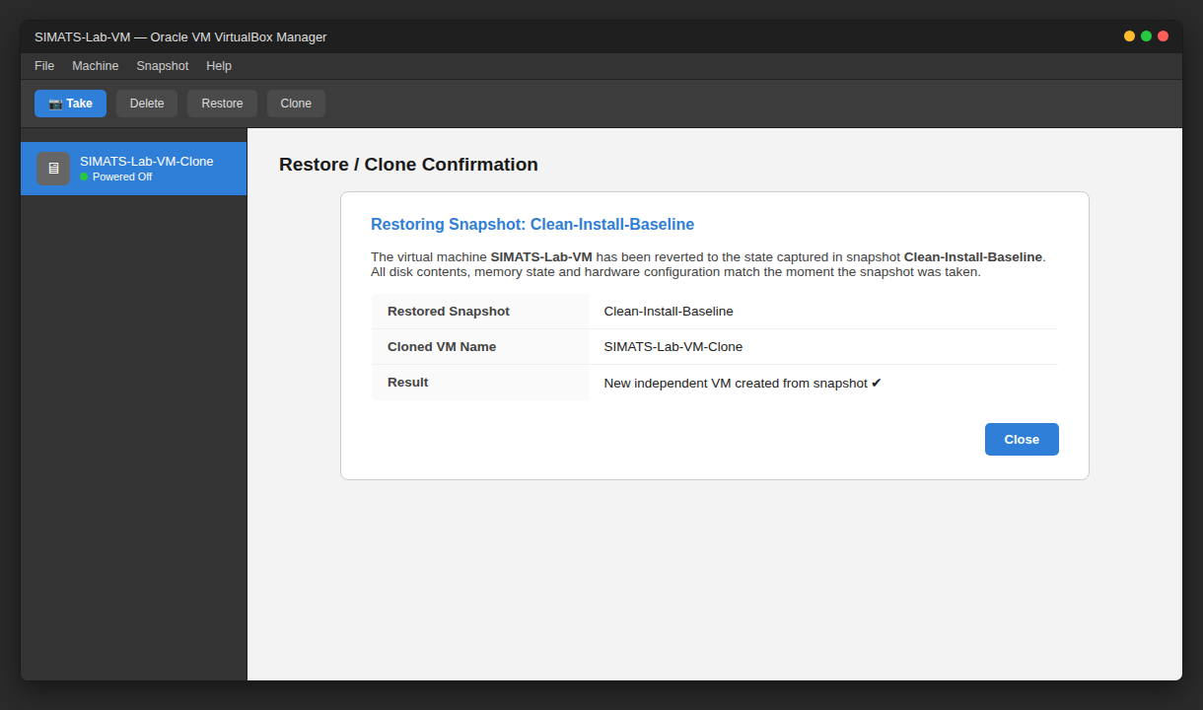
Fig 4.2 — VM successfully restored/cloned from the snapshot
Result: A snapshot of the Virtual Machine was successfully created and the VM was restored (and cloned) from that snapshot, confirming that the previous saved version of the VM could be reloaded correctly.

