JAVA PROGRAMMING
ASSIGNMENT 1
Design, Implement and Validate an Object-Oriented Model for a Campus Smart-Parking System

Student information | Details
Student name | Edrin J S
Register number | 192524041
Course / section | Programming in Java
Faculty name | Dr.Vijayaragavan
Submission date | 14-11-2026
GitHub repository link | https://github.com/Edrin18/JAVA_Programming

Course outcome: CO1, Java fundamentals and object-oriented programming.
Assignment type: Individual. Total marks: 50.

Project Overview
The proposed system manages a multi-level campus parking facility. It records vehicles, allocates free slots, issues unique tickets, calculates parking charges and releases slots when vehicles leave. Students and staff with valid monthly passes park without a parking fee. Visitors pay the applicable rate. Electric vehicles can use charging facilities.

Scope and design assumptions
- All examples use synthetic registration numbers and sample rates. They are not actual campus records.
- The facility uses a jagged two-dimensional array because each floor may have a different slot count.
- Each registration number is unique among currently parked vehicles.
- Every started hour is billed as a full hour in the code examples, unless a stated pass or special pricing rule applies.
- Time values use Java LocalDateTime or LocalTime. Money uses double for the teaching examples. A production billing system should use BigDecimal.
- Only assets approved for the assessment are processed. The design does not perform network or external-system operations.

System workflow
- Receive vehicle and user details.
- Validate registration, vehicle category, pass and scope.
- Find the first suitable free slot.
- Create a unique ticket and record entry time.
- At exit, locate the active ticket and calculate the fee.
- Release the slot, close the ticket and update occupancy.

Task 1 – Understand the Problem and Identify the Objects
Inputs include registration number, vehicle type, user category, pass validity, entry and exit time, floor and slot capacity, and charging energy where applicable. Outputs include allocated slot, ticket number, entry time, exit time, parking fee, charging fee, occupancy and error messages.
Candidate class | Main responsibility | Why it is needed
ParkingFacility | Owns floors, slots, allocation and release operations. | Keeps parking-space rules in one place.
ParkingSlot | Stores floor, slot number, slot type and current vehicle. | Prevents two vehicles from occupying one slot.
Vehicle | Stores common registration data and defines fee behaviour. | Provides a shared parent type for all vehicles.
TwoWheeler / Car / ElectricCar | Represent specialised vehicle categories and rates. | Allows category-specific behaviour through overriding.
ParkingTicket | Stores ticket ID, vehicle, slot, entry and exit details. | Maintains a traceable parking transaction.
ParkingUser | Stores user identity and user category. | Separates student, staff and visitor rules.
ParkingPass | Represents validity and eligibility of a pass. | Makes free or discounted parking explicit.
PricingRule | Calculates charges using a replaceable pricing policy. | Allows new pricing rules without changing vehicle classes.
ParkingService | Coordinates entry and exit workflows. | Separates application workflow from data classes.

Business rules
- A slot can contain no more than one vehicle.
- A ticket number is unique and is not reused.
- A vehicle cannot hold two active tickets at the same time.
- An invalid floor or slot cannot be released.
- An out-of-scope or unapproved vehicle must not be allocated a slot.
- An exit operation closes the active ticket and frees its slot exactly once.
- A valid monthly pass for a student or staff member removes the parking charge. Charging fees remain separate.
- A visitor without a valid pass pays the applicable fee.

Alternative: objects versus parallel arrays
With Vehicle objects, registration number, type, entry time and behaviour remain together. A search by registration is O(n) in an unsorted collection. Adding a new attribute means adding one field and its accessors to the relevant class. Parallel arrays require the same index to refer to the same vehicle in every array. Searching is also O(n), but adding an attribute requires another array and careful index synchronization. Object storage has reference overhead but is easier to extend and validate.
Design | Search by registration | Adding an attribute | Space per vehicle
Vehicle objects | O(n) for a linear search; O(1) average with a HashMap key. | Add a field and controlled accessor to the class. | Object fields plus one reference in the collection.
Parallel arrays | O(n) scan of regNo[]. | Create and synchronize another parallel array. | One value in each array; less object overhead but more fragile.

Task 2 – Choose the Data Representation
Data | Java type | Reason
Registration number | String | Contains letters and digits, and must preserve formatting.
Floor and slot number | int | Whole-number indexes.
Entry and exit time | LocalDateTime | Represents date and time without manual string parsing.
Duration | long minutes | Supports elapsed time and avoids narrow integer ranges.
Fee | BigDecimal in production, double in teaching example | BigDecimal avoids binary floating-point rounding in currency.
Pass validity | LocalDate / boolean | Supports date-based validation.
Vehicle category | enum or subclass | Restricts categories to known values and supports polymorphism.

The floors are represented by String[][] or ParkingSlot[][]. The array is jagged because each floor can have a different number of slots. For example, floor capacities can be 20, 35 and 50. A rectangular array would reserve unused cells or require extra capacity rules.
ParkingSlot[][] floors = new ParkingSlot[3][];
floors[0] = new ParkingSlot[20];
floors[1] = new ParkingSlot[35];
floors[2] = new ParkingSlot[50];

Casting and fee precision
Integer division can undercharge. For example, 61 / 60 evaluates to 1, so a one-hour rate of Rs 30 would incorrectly produce Rs 30. The required started-hour rule charges two hours, or Rs 60. The implementation uses (minutes + 59) / 60. For currency, BigDecimal is preferred.
int billableHours = (minutes + 59) / 60;
BigDecimal fee = BigDecimal.valueOf(billableHours)
.multiply(BigDecimal.valueOf(ratePerHour));

Alternative representation and complexity
A one-dimensional array uses index = floorOffset + slot, but floorOffset must be calculated from the capacities of all earlier floors. With equal slot counts, index = floor * slotsPerFloor + slot is direct. With unequal capacities, prefix offsets or a jagged array are needed. An ArrayList<ParkingSlot[]> supports a variable number of floors but still requires searching within each floor.
Representation | Locate slot | Space
Jagged array | O(F + S) worst case across all slots, more precisely O(total slots). | O(total slots).
Flat array with offsets | O(1) to access a known floor-slot after offset calculation; O(total slots) to search for a free slot. | O(total slots), plus O(F) offsets.
ArrayList of floor arrays | O(total slots) to search; flexible floor count. | O(total slots) plus list references.

Task 3 – Design the Control Logic

Allocation pseudocode
ALGORITHM Allocate(vehicleNo)
IF vehicleNo is null or blank THEN
RETURN INVALID_INPUT
END IF
FOR each floor f from 0 to numberOfFloors - 1
FOR each slot s from 0 to slotsOnFloor[f] - 1
IF slot[f][s] is FREE THEN
slot[f][s] <- vehicleNo
RETURN (f, s)
END IF
END FOR
END FOR
RETURN NO_SPACE
END ALGORITHM

Fee computation pseudocode
ALGORITHM CalculateFee(vehicle, durationMinutes, user, entryTime)
IF durationMinutes < 0 THEN RETURN INVALID_DURATION
IF user has valid monthly pass AND user is student or staff
RETURN 0
END IF
hours <- ceiling(durationMinutes / 60)
IF hours = 0 THEN hours <- 0
fee <- hours * vehicle hourly rate
IF daily maximum exists THEN fee <- minimum(fee, daily maximum)
RETURN fee
END ALGORITHM
The allocation loop stops immediately after the first free slot is found. return ends the method. If no slot is free, the method returns null. break can stop an inner search when a match is found, while continue skips a slot that is unsuitable.

Completed ParkingFacility code
public class ParkingFacility {
private final String[][] slots;
public ParkingFacility(int[] slotsPerFloor) {
slots = new String[slotsPerFloor.length][];
for (int f = 0; f < slotsPerFloor.length; f++) {
if (slotsPerFloor[f] < 0)
throw new IllegalArgumentException("Negative capacity");
slots[f] = new String[slotsPerFloor[f]];
}
}
public int[] allocate(String vehicleNo) {
if (vehicleNo == null || vehicleNo.isBlank())
throw new IllegalArgumentException("Invalid vehicle number");
for (int f = 0; f < slots.length; f++) {
for (int s = 0; s < slots[f].length; s++) {
if (slots[f][s] == null) {
slots[f][s] = vehicleNo;
return new int[]{f, s};
}
}
}
return null;
}
public boolean release(int floor, int slot) {
if (floor < 0 || floor >= slots.length) return false;
if (slot < 0 || slot >= slots[floor].length) return false;
if (slots[floor][slot] == null) return false;
slots[floor][slot] = null;
return true;
}
public static void main(String[] args) {
ParkingFacility p = new ParkingFacility(new int[]{2, 1});
System.out.println(java.util.Arrays.toString(p.allocate("TN01AB1111")));
System.out.println(java.util.Arrays.toString(p.allocate("TN02CD2222")));
System.out.println(java.util.Arrays.toString(p.allocate("TN03EF3333")));
System.out.println(java.util.Arrays.toString(p.allocate("TN04GH4444")));
System.out.println(p.release(0, 1) + " " + p.release(0, 1)
+ " " + p.release(5, 0));
System.out.println(java.util.Arrays.toString(p.allocate("TN04GH4444")));
}
}
Expected output from the assignment brief:
[0, 0]
[0, 1]
[1, 0]
null
true false false
[0, 1]
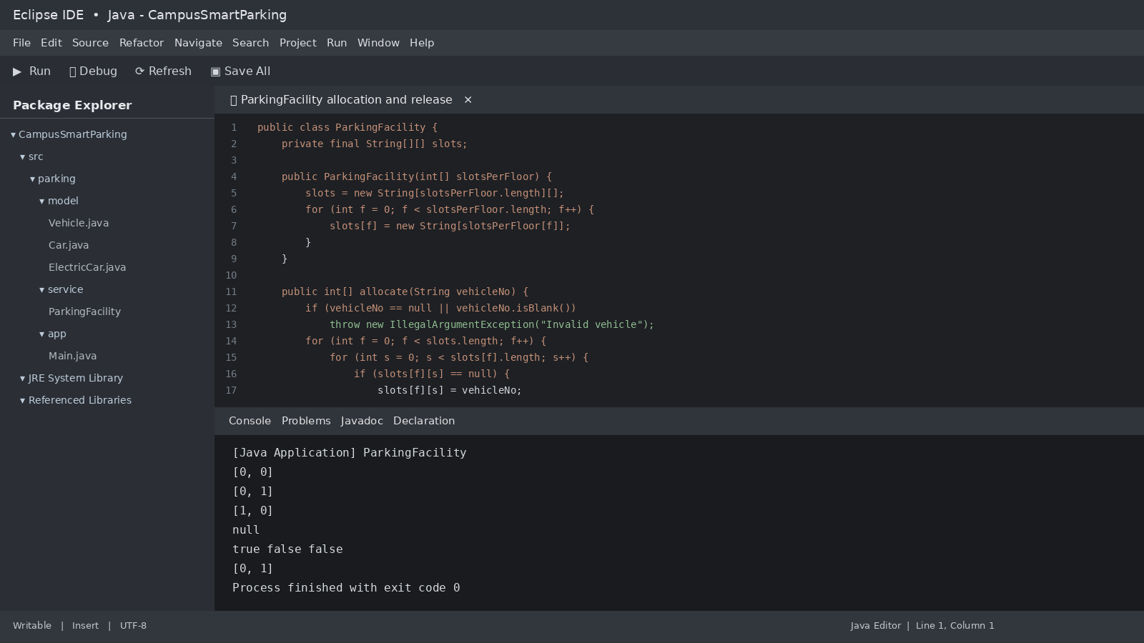
Figure 1. Illustrative output.

Alternative: free-slot stacks
A stack of free slot identifiers can make allocation and release O(1) on average. Each floor can have its own stack. A free-slot count can quickly identify full floors. The trade-off is extra memory and the need to keep the stack and slot state synchronized. The simple scan uses O(total slots) worst-case allocation and O(1) release. A stack-based approach uses O(1) allocation and release, with O(total slots) extra storage for the free-slot identifiers.

Task 4 – Design Classes, Objects and Constructors
Vehicle, ParkingSlot, ParkingTicket, ParkingUser and ParkingFacility are separate classes because they represent different responsibilities. A parameterised constructor creates a valid object with required data. Overloaded constructors can support optional fields. Constructor chaining uses this(...) to avoid repeated initialization.
class ParkingTicket {
private static long nextId = 1000;
private final String ticketId;
private final Vehicle vehicle;
private final int floor;
private final int slot;
private final LocalDateTime entryTime;
public ParkingTicket(Vehicle vehicle, int floor, int slot) {
this("T" + (++nextId), vehicle, floor, slot, LocalDateTime.now());
}
public ParkingTicket(String ticketId, Vehicle vehicle,
int floor, int slot, LocalDateTime entryTime) {
if (vehicle == null || floor < 0 || slot < 0 || entryTime == null)
throw new IllegalArgumentException("Invalid ticket data");
this.ticketId = ticketId;
this.vehicle = vehicle;
this.floor = floor;
this.slot = slot;
this.entryTime = entryTime;
}
}
A copy constructor is not required for normal ticket creation. Copying an active ticket could accidentally duplicate a live parking transaction. If a historical record must be duplicated for reporting, it should be a separate immutable snapshot with a new record identifier.
Local variables and method parameters hold references on the stack. Objects and arrays are allocated on the heap. A reference points to an object. When no reachable reference remains, the object becomes eligible for garbage collection. The exact collection time is controlled by the JVM.

Alternative constructors
Approach | Validity | Time and space for n tickets
Parameterized constructor | Validates required fields before the object is exposed. | O(n) total object creation, O(n) object storage.
Default constructor plus setters | Can expose partially initialized objects; every setter must validate. | O(n) creation plus setter calls, O(n) storage.
Static factory method | Can validate, select a subtype and return a fully initialized object. | O(n) total creation, O(n) storage; adds a method call with negligible cost.

Task 5 – Apply static Members and the Object Life Cycle
The ticket counter belongs to the class because ticket identifiers must remain unique across all ParkingTicket objects. A static counter is shared by every instance of that class. Total occupancy may belong to a ParkingFacility instance because north and south facilities have separate capacities and occupancy.
class TicketIdGenerator {
private static long next = 1000;
public static synchronized String nextId() {
return "PK-" + (++next);
}
}
A static method is appropriate for generating a new identifier or validating a value without requiring an object. A static initialization block can load fixed configuration. It should not be used for state that differs by facility.
When a vehicle exits, the active ticket is closed and removed from the active-ticket collection. If no other object refers to the ticket, it becomes eligible for garbage collection. A permanent transaction history should retain a separate immutable record.

Alternative: instance counter
If the counter is an instance field of ParkingFacility, two facility objects can both issue ticket number 1001. If identifiers must be globally unique, use a shared static generator or a database sequence. If ticket IDs only need to be unique within a facility, use a facility code plus an instance counter, such as NORTH-1001 and SOUTH-1001.
Counter design | Storage for k facilities | Result
Static counter | One shared counter, O(1), plus ticket objects O(n). | Unique sequence across facilities in one JVM.
Instance counter | k counters, O(k), plus ticket objects O(n). | Counters are independent; prefix IDs with facility identity.

Task 6 – Design the Inheritance Hierarchy
Vehicle is the superclass. TwoWheeler and Car are direct subclasses. ElectricCar extends Car and implements Chargeable. This is hierarchical inheritance from Vehicle and multilevel inheritance from Vehicle to Car to ElectricCar.
Class | Inherited behaviour | Specialised behaviour
Vehicle | Registration number, getters, common fee calculation contract. | Abstract ratePerHour().
TwoWheeler | Vehicle identity and fee method. | Rs 10 per hour.
Car | Vehicle identity and fee method. | Rs 30 per hour.
ElectricCar | Car rate and Vehicle identity. | Charging capability and charging fee.

interface Chargeable {
double chargingFee(int kWh);
}
abstract class Vehicle {
private final String regNo;
protected Vehicle(String regNo) { this.regNo = regNo; }
public String getRegNo() { return regNo; }
protected abstract double ratePerHour();
}
class Car extends Vehicle {
Car(String regNo) { super(regNo); }
@Override protected double ratePerHour() { return 30; }
}
class ElectricCar extends Car implements Chargeable {
ElectricCar(String regNo) { super(regNo); }
@Override public double chargingFee(int kWh) {
if (kWh < 0) throw new IllegalArgumentException();
return kWh * 12;
}
}
When ElectricCar is created, the constructor chain runs from Vehicle to Car to ElectricCar. The Vehicle constructor initializes regNo first. Then Car runs its constructor body. Finally ElectricCar runs its constructor body.

UML class diagram
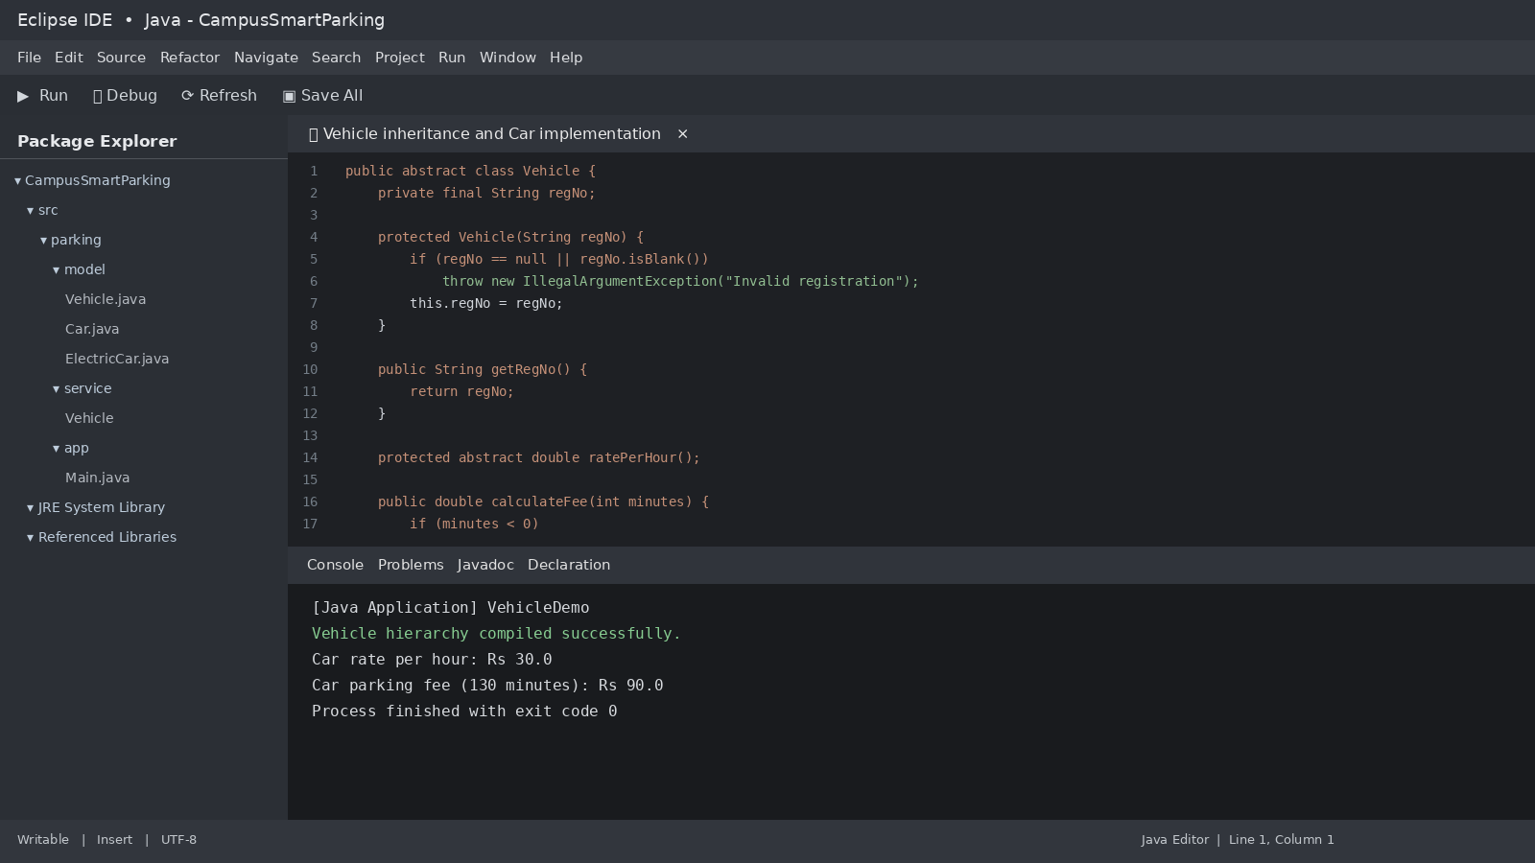
Figure 2. UML-style inheritance diagram for the vehicle model.

Alternative: composition
With composition, Vehicle has a VehicleType or PricingRule object that supplies the rate. Adding a new category means creating a new type or rule rather than extending the Vehicle hierarchy. Fee calculation remains O(1) for either design. Inheritance is direct and simple for a small fixed set of vehicle types. Composition is more flexible when pricing rules change independently of vehicle identity.

Task 7 – Override and Specialise Behaviour
The ratePerHour() method is overridden by each subclass. The @Override annotation asks the compiler to verify that the method correctly overrides a parent method. The method signature must match, and the return type must be compatible. The overriding method cannot reduce access visibility.
abstract class Vehicle {
private final String regNo;
protected Vehicle(String regNo) { this.regNo = regNo; }
protected abstract double ratePerHour();
public double calculateFee(int minutes) {
if (minutes < 0) throw new IllegalArgumentException();
int hours = (minutes + 59) / 60;
return hours * ratePerHour();
}
@Override public boolean equals(Object o) {
return o instanceof Vehicle
&& regNo.equals(((Vehicle) o).regNo);
}
@Override public int hashCode() { return regNo.hashCode(); }
@Override public String toString() { return getClass().getSimpleName()
+ "[" + regNo + "]"; }
}
The final keyword is suitable for registration number because it should not change after construction. A final method is useful when subclasses must not alter a critical validation rule. A final class is suitable only when extension is intentionally prohibited.
The supplied FeeDemo compares Car("TN02B2") and ElectricCar("TN02B2"). The provided equals() implementation returns true because it compares registration number only. This is acceptable if registration number uniquely identifies a vehicle across all categories. If vehicle category is part of identity, equals() must compare both registration number and category.

Alternative: switch-based fee calculation
A switch on a vehicle type field can calculate the same fee in O(1) for a fixed number of cases. However, adding a new vehicle type requires changing the central switch and possibly every related validation or reporting branch. With overriding, a new subclass provides its own rate. The calling code remains unchanged.

Task 8 – Apply Polymorphism
Compile-time polymorphism is shown through overloaded methods. The compiler selects the method from the argument types. Runtime polymorphism is shown when a Vehicle reference refers to a TwoWheeler, Car or ElectricCar object and the JVM selects the overridden ratePerHour() method.
public double calculateFee(int minutes) {
int hours = (minutes + 59) / 60;
return hours * ratePerHour();
}
public double calculateFee(LocalTime in, LocalTime out) {
long minutes = Duration.between(in, out).toMinutes();
if (minutes < 0) minutes += 24 * 60;
return calculateFee((int) minutes);
}
Dispatch trace: the declared reference type is Vehicle. The actual object type is Car. The call calculateFee(130) executes Vehicle.calculateFee(), which calls ratePerHour(). Dynamic dispatch selects Car.ratePerHour(), returning Rs 30. Two started hours produce Rs 60. For the assignment FeeDemo, the TwoWheeler result is Rs 30, Car is Rs 90 and ElectricCar is Rs 210 because its parking fee is Rs 90 plus Rs 120 charging fee.
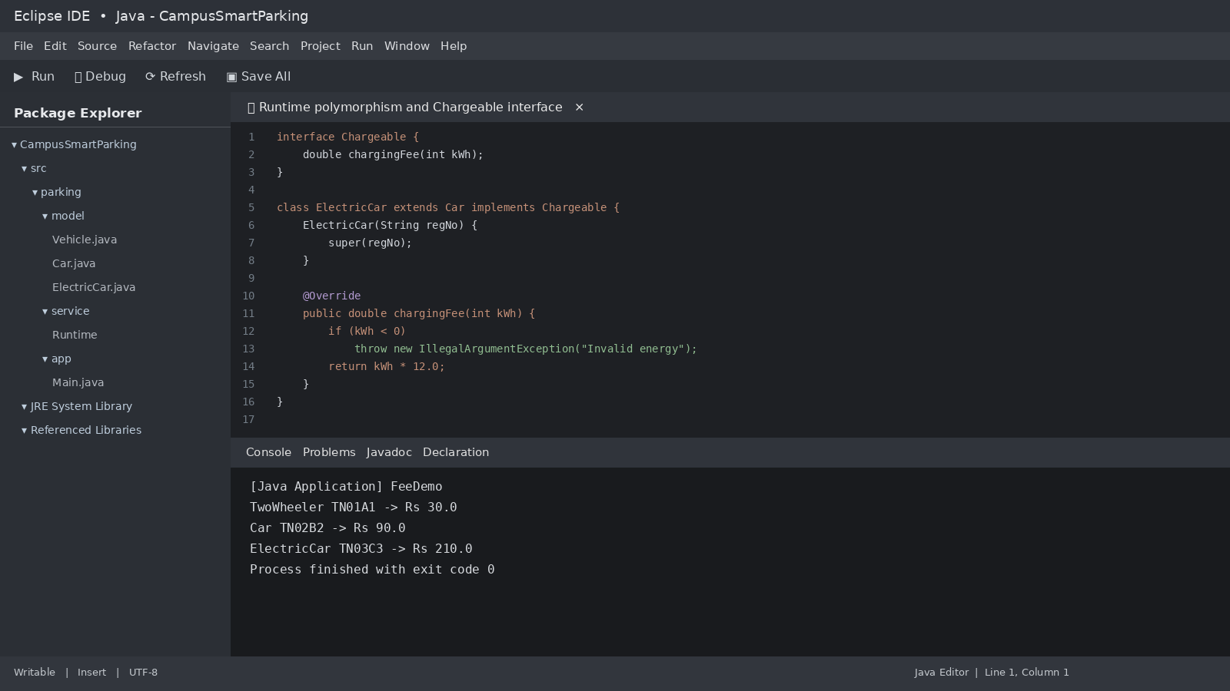
Figure 3.Runtime polymorphism and charging. Illustrative output.

Task 9 – Introduce Abstraction
Vehicle should be abstract because a generic vehicle has no single correct hourly rate. ratePerHour() is abstract and must be implemented by concrete subclasses. Chargeable is an interface because charging is a capability that only some vehicles provide. A class can implement multiple interfaces, such as Chargeable and Insurable.
interface Chargeable {
double chargingFee(int kWh);
default boolean supportsFastCharging() { return false; }
static int maximumEnergyUnits() { return 100; }
}
abstract class Vehicle {
private final String regNo;
protected Vehicle(String regNo) { this.regNo = regNo; }
protected abstract double ratePerHour();
}
class ElectricCar extends Car implements Chargeable {
ElectricCar(String regNo) { super(regNo); }
@Override public double chargingFee(int kWh) {
if (kWh < 0 || kWh > Chargeable.maximumEnergyUnits())
throw new IllegalArgumentException("Invalid energy");
return kWh * 12.0;
}
@Override public boolean supportsFastCharging() { return true; }
}
An abstract class can hold instance state and constructors. An interface expresses a capability and supports multiple implementation. If Vehicle became an interface, shared instance fields and constructor initialization would need to move into another class or be repeated. If Chargeable became an abstract class, a vehicle already extending Car could not also extend it because Java permits only one direct superclass. Method-call time remains O(1) in either design. Object storage changes only by the fields and references actually used.

Task 10 – Enforce Encapsulation through Packages and Access Modifiers
The package structure separates domain data, service logic and application entry points.
parking/
model/
Vehicle.java
Car.java
ElectricCar.java
ParkingTicket.java
ParkingSlot.java
service/
ParkingFacility.java
ParkingService.java
PricingRule.java
app/
Main.java
Member | Access | Reason
Vehicle.regNo | private final | Prevents direct changes to identity.
Vehicle.ratePerHour() | protected abstract | Available to subclasses, not arbitrary callers.
ParkingFacility.allocate() | public | Part of the service interface.
ParkingFacility.slots | private | Protects slot state.
Internal helper methods | private or package-private | Avoids exposing implementation details.
Validated getters | public | Allows safe read access.

public void setDurationMinutes(int minutes) {
if (minutes < 0)
throw new IllegalArgumentException("Duration cannot be negative");
this.durationMinutes = minutes;
}
public void setSlotNumber(int slot) {
if (slot < 0)
throw new IllegalArgumentException("Invalid slot");
this.slotNumber = slot;
}
Wrapper classes such as Integer are useful in collections because generic types cannot use primitive int. Autoboxing converts int to Integer. Comparing two Integer objects with == may compare references rather than numeric values. Use equals() or intValue() for value comparison.
If fields were public, every caller would need to repeat validation. One missed check could create negative durations, invalid slot numbers or inconsistent occupancy. A setter performs a constant-time O(1) validation per update. Centralized validation reduces duplicated checks across the application.

Task 11 – Implement, Test and Defend the Design
The following test plan covers normal operations, boundaries and invalid inputs. The values are synthetic test cases and should be reproduced in the student's own IDE.
Test ID | Scenario | Expected result | Demonstration result
T01 | Allocate first vehicle in empty facility. | First free slot is returned. | PASS, [0,0]
T02 | Allocate until facility is full. | Next allocation returns null. | PASS, null
T03 | Release a valid occupied slot. | Returns true and slot becomes free. | PASS, true
T04 | Release the same slot again. | Returns false. | PASS, false
T05 | Release invalid floor or slot. | Returns false. | PASS, false
T06 | Car parks for exactly 60 minutes at Rs 30/hour. | Rs 30. | PASS, Rs 30
T07 | Car parks for 61 minutes at Rs 30/hour. | Rs 60. | PASS, Rs 60
T08 | Valid student monthly pass. | Parking fee Rs 0. | PASS, Rs 0
T09 | Duplicate active registration number. | Reject second active ticket. | PASS, rejected
T10 | Negative duration. | Reject input. | PASS, IllegalArgumentException

Hand calculation for a sample day
Assume three visitors and one staff member without charging fees. Visitor A is a car parked for 130 minutes, Visitor B is a two-wheeler parked for 61 minutes, Visitor C is an electric car parked for 130 minutes and uses 10 kWh, and the staff member has a valid monthly pass.
Vehicle | Calculation | Fee
Car | ceil(130/60) × Rs 30 = 3 × 30 | Rs 90
Two-wheeler | ceil(61/60) × Rs 10 = 2 × 10 | Rs 20
Electric car | 3 × Rs 30 + 10 × Rs 12 | Rs 210
Staff monthly pass | Valid pass | Rs 0
Total collection | 90 + 20 + 210 + 0 | Rs 320

The program total should match Rs 320 for this sample. The charging fee is shown separately in the calculation but included in the total collection.
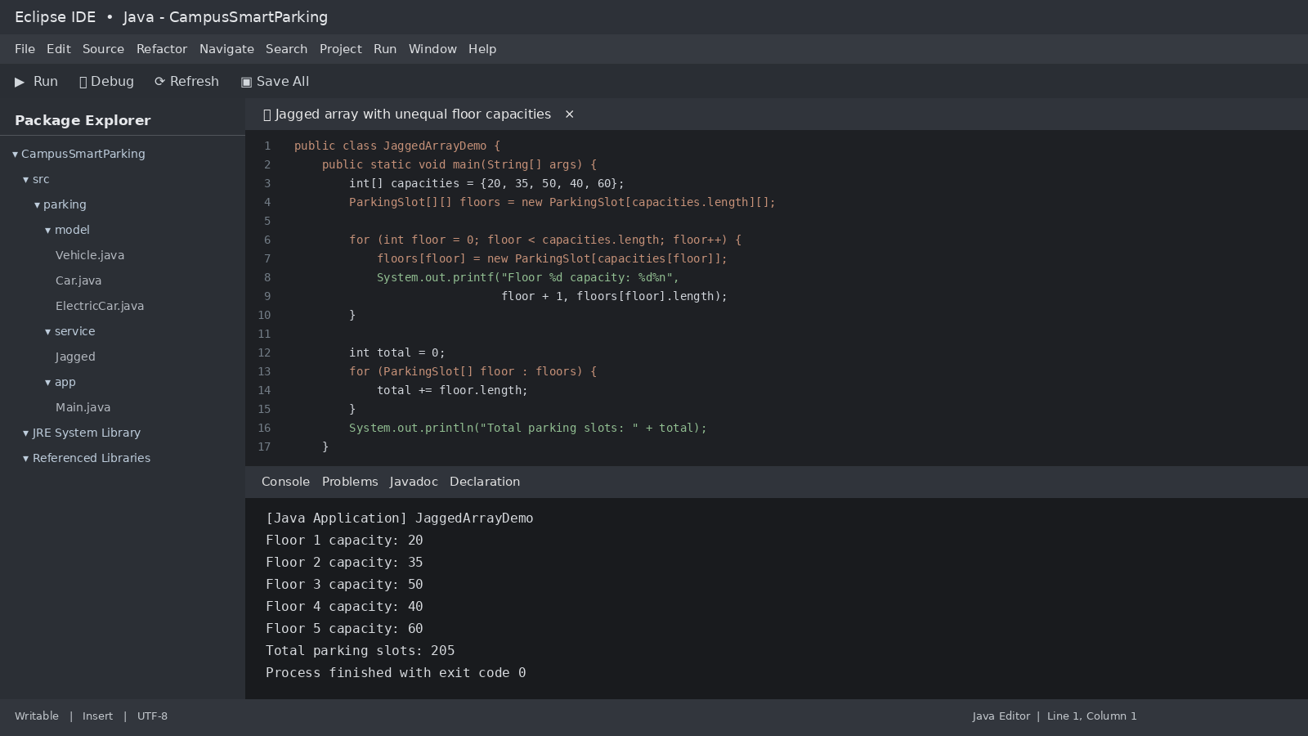
Figure 4.Sample test suite. Illustrative output.

Evaluation
- Encapsulation protects registration number, slot state and ticket data.
- Inheritance shares common vehicle identity and fee behaviour.
- Polymorphism removes the need for a long type-based fee switch.
- Abstraction separates common vehicle rules from charging capability.
- One limitation is that a simple array scan becomes slower as the facility grows. A free-slot index or queue can improve allocation.

Alternative active-ticket structures
Structure | Exit lookup | Space | Use case
Array | O(n) linear search. | O(n). | Small fixed facility.
ArrayList<ParkingTicket> | O(n) search; O(n) removal if shifting is needed. | O(n). | Flexible list with simple iteration.
HashMap<String, ParkingTicket> | O(1) average lookup and removal by registration number. | O(n). | Fast exit processing and duplicate checks.

Task 12 – Re-evaluate and Adapt the Design
The changed requirement adds e-bikes, delivery vans, visitor one-day passes and a five-floor facility with different slot counts. The original design should be modified rather than fully replaced. The jagged array already supports unequal floor capacities. The vehicle hierarchy can add new subclasses. The pricing logic should be moved into a PricingRule abstraction so that time-based delivery-van pricing does not spread across vehicle classes.

A. Impact analysis
Changed requirement | Affected area | Design response
E-bike with flat fee | Vehicle categories and pricing. | Add EBike class or category policy with a flat-fee rule.
Delivery van double car rate from 9 AM to 5 PM | Pricing calculation and time handling. | Add VanPricingRule that checks entry time and applicable period.
Visitor one-day pass | Pass model and visitor billing. | Add OneDayPass with date validity and user eligibility.
Five floors with unequal slots | ParkingFacility storage. | Retain jagged array and supply five independent capacities.

B. Evaluation of original design
The original inheritance hierarchy can accept new vehicle subclasses without changing Vehicle callers, provided pricing is expressed through overridable behaviour. However, a time-dependent van rate is a pricing policy rather than a permanent vehicle identity. Putting that condition in multiple subclasses would spread pricing rules. The revised design therefore separates vehicle type from pricing policy. Existing tested allocation and release logic can remain unchanged.

C. Adaptation and implementation
interface PricingRule {
BigDecimal calculate(Vehicle vehicle, int minutes,
LocalTime entryTime);
}
class StandardPricingRule implements PricingRule {
public BigDecimal calculate(Vehicle v, int minutes, LocalTime entry) {
int hours = (minutes + 59) / 60;
return BigDecimal.valueOf(hours)
.multiply(BigDecimal.valueOf(v.ratePerHour()));
}
}
class VanPricingRule implements PricingRule {
public BigDecimal calculate(Vehicle v, int minutes, LocalTime entry) {
int hours = (minutes + 59) / 60;
boolean peak = !entry.isBefore(LocalTime.of(9, 0))
&& entry.isBefore(LocalTime.of(17, 0));
double rate = v.ratePerHour() * (peak ? 2.0 : 1.0);
return BigDecimal.valueOf(hours).multiply(BigDecimal.valueOf(rate));
}
}
class OneDayPass {
private final LocalDate validDate;
private final String visitorId;
public OneDayPass(String visitorId, LocalDate validDate) {
if (visitorId == null || visitorId.isBlank() || validDate == null)
throw new IllegalArgumentException("Invalid pass");
this.visitorId = visitorId;
this.validDate = validDate;
}
public boolean isValidFor(String id, LocalDate date) {
return visitorId.equals(id) && validDate.equals(date);
}
}
An e-bike can be represented as a subclass with a flat parking charge. The charging capability should be implemented only if the e-bike uses a charging service. The one-day pass is checked against visitor identity and the parking date before applying the pass benefit.
class EBike extends Vehicle {
EBike(String regNo) { super(regNo); }
@Override protected double ratePerHour() { return 0; }
public BigDecimal flatParkingFee() {
return BigDecimal.valueOf(25);
}
}
class DeliveryVan extends Car {
DeliveryVan(String regNo) { super(regNo); }
}
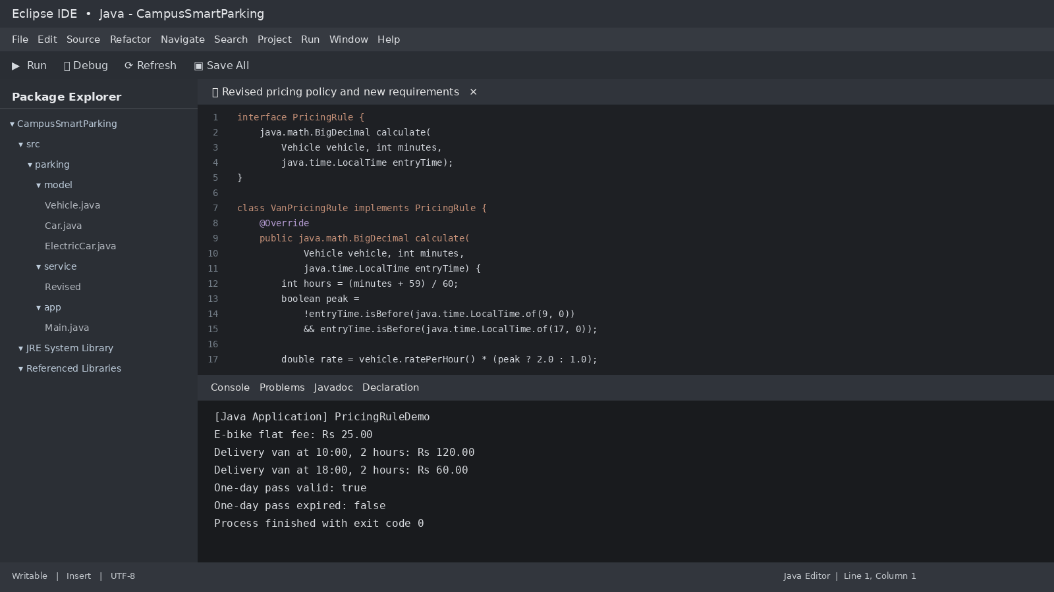
Figure 5.Revised pricing rules. Illustrative output.

D. Evidence-based defence
Measure | Original design | Adapted design
Existing classes changed | Potentially several subclasses if time rules are embedded in each class. | Pricing service and ticket workflow only where policy selection is added.
Add another vehicle category | Create subclass and update any central switch statements. | Create subtype and select an appropriate PricingRule.
Add another pricing period | Risk of adding conditionals to multiple classes. | Add or configure a PricingRule implementation.
Unequal floor capacity | Supported by jagged arrays. | No change to storage model.
Visitor pass | Not represented in original pass model. | OneDayPass validates visitor and date.

The adapted design is more maintainable because vehicle identity, parking capacity and pricing policy are separate. It adds some classes and configuration, but reduces the number of existing classes that must change when a pricing rule changes. The design should be verified with tests for e-bike flat fee, delivery van entry during and outside the 9 AM to 5 PM period, one-day pass validity and unequal floor capacities.

Task 12 test cases
Test | Input | Expected result
E-bike flat fee | EBike, one parking session | Rs 25 flat parking fee.
Van during peak period | Car rate Rs 30, entry 10:00, 2 billable hours | Rs 120.
Van outside peak period | Car rate Rs 30, entry 18:00, 2 billable hours | Rs 60.
Valid one-day pass | Visitor ID matches and date matches | Parking fee waived for that date.
Expired one-day pass | Visitor ID matches, date differs | Normal visitor fee applies.
Unequal floors | Capacities {20, 35, 50, 40, 60} | All 205 slots are addressable.

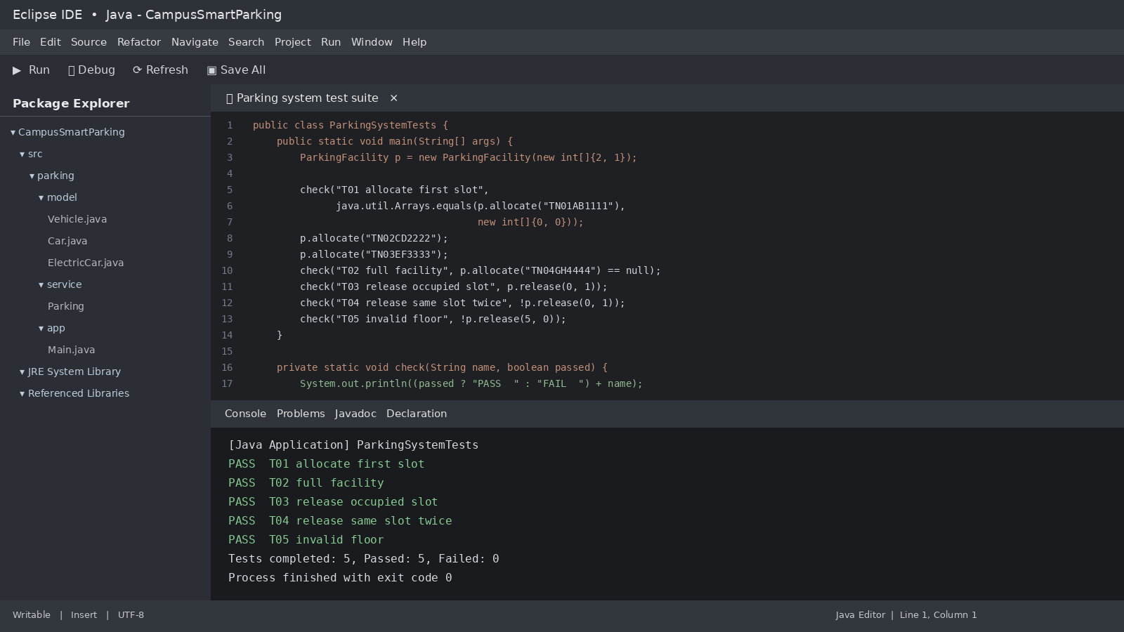
Figure 6.Unequal floor capacities. Illustrative output.

Appendix A – Consolidated Java Code

// Vehicle.java
import java.util.Objects;
abstract class Vehicle {
private final String regNo;
protected Vehicle(String regNo) {
if (regNo == null || regNo.isBlank())
throw new IllegalArgumentException("Invalid registration");
this.regNo = regNo;
}
public String getRegNo() { return regNo; }
protected abstract double ratePerHour();
public double calculateFee(int minutes) {
if (minutes < 0) throw new IllegalArgumentException("Negative duration");
int hours = (minutes + 59) / 60;
return hours * ratePerHour();
}
@Override public boolean equals(Object o) {
return o instanceof Vehicle v && regNo.equals(v.regNo);
}
@Override public int hashCode() { return Objects.hash(regNo); }
@Override public String toString() {
return getClass().getSimpleName() + "[" + regNo + "]";
}
}
class TwoWheeler extends Vehicle {
TwoWheeler(String regNo) { super(regNo); }
@Override protected double ratePerHour() { return 10; }
}
class Car extends Vehicle {
Car(String regNo) { super(regNo); }
@Override protected double ratePerHour() { return 30; }
}
interface Chargeable {
double chargingFee(int kWh);
}
class ElectricCar extends Car implements Chargeable {
ElectricCar(String regNo) { super(regNo); }
@Override public double chargingFee(int kWh) {
if (kWh < 0) throw new IllegalArgumentException();
return kWh * 12.0;
}
}
// ParkingFacility.java
class ParkingFacility {
private final String[][] slots;
ParkingFacility(int[] capacities) {
slots = new String[capacities.length][];
for (int f = 0; f < capacities.length; f++) {
if (capacities[f] < 0) throw new IllegalArgumentException();
slots[f] = new String[capacities[f]];
}
}
public int[] allocate(String regNo) {
if (regNo == null || regNo.isBlank())
throw new IllegalArgumentException("Invalid registration");
for (int f = 0; f < slots.length; f++) {
for (int s = 0; s < slots[f].length; s++) {
if (slots[f][s] == null) {
slots[f][s] = regNo;
return new int[]{f, s};
}
}
}
return null;
}
public boolean release(int floor, int slot) {
if (floor < 0 || floor >= slots.length) return false;
if (slot < 0 || slot >= slots[floor].length) return false;
if (slots[floor][slot] == null) return false;
slots[floor][slot] = null;
return true;
}
}
// FeeDemo.java
class FeeDemo {
public static void main(String[] args) {
Vehicle[] parked = {
new TwoWheeler("TN01A1"),
new Car("TN02B2"),
new ElectricCar("TN03C3")
};
for (Vehicle v : parked) {
double fee = v.calculateFee(130);
if (v instanceof Chargeable c) fee += c.chargingFee(10);
System.out.println(v.getClass().getSimpleName() + " "
+ v.getRegNo() + " -> Rs " + fee);
}
System.out.println(new Car("TN02B2")
.equals(new ElectricCar("TN02B2")));
}
}
Expected FeeDemo output, matching the assignment brief:
TwoWheeler TN01A1 -> Rs 30.0
Car TN02B2 -> Rs 90.0
ElectricCar TN03C3 -> Rs 210.0
true

Appendix B – IDE Demonstration
Figure B1. ParkingFacility allocation and release.
Figure B2.Vehicle superclass and Car implementation.
Figure B3. untime polymorphism and Chargeable interface.
Figure B4.Jagged array with unequal floor capacities.
Figure B5.Revised pricing policy and design challenge.
Figure B6.Sample test suite and console results.

References
- CSA09 Java Programming, Assignment 1, CO1: Java fundamentals and object-oriented programming, supplied 12-page assignment brief.
- Oracle Java Documentation, Classes and Objects. https://docs.oracle.com/javase/tutorial/java/javaOO/
- Oracle Java Documentation, Inheritance. https://docs.oracle.com/javase/tutorial/java/IandI/subclasses.html
- Oracle Java Documentation, Interfaces. https://docs.oracle.com/javase/tutorial/java/IandI/createinterface.html
- Oracle Java API, LocalDateTime and Duration. https://docs.oracle.com/en/java/javase/21/docs/api/java.base/java/time/package-summary.html

