PROGRAMMING IN JAVA
ASSIGNMENT 2 – CO2
Strings, Collections Framework, Generics and Ordering

Student information | Details
Student name | Edrin J S
Register number | 192524041
Course / section | Programming in Java
Faculty name | Dr.Vijayaragavan
Submission date | 14-11-2026
GitHub repository link | https://github.com/Edrin18/JAVA_Programming

Course outcome: CO2, Strings, Collections Framework, Generics and ordering.
Assignment type: Individual. Total marks: 50.
Coverage: Sessions 15–26. Questions 1–7.

Project Overview
This assignment investigates Java text construction, list and map selection, equality and hashing, generic ranking, priority queues and evidence-based redesign. Each question uses a practical application context and compares alternative data structures using Big-O analysis and measured execution evidence.

Execution Environment and Method
The Java programs and benchmark harness were compiled and executed with OpenJDK 21.0.12. Measurements use System.nanoTime(), warm-up executions where applicable, and five measured trials for the reported averages. Timings are environment-specific and should be interpreted as comparative observations rather than universal performance guarantees.
The benchmark harness uses synthetic data. Q1 measures three ticket workloads. Q2 compares list operations at three sizes. Q4 measures 100,000 lookups for three map sizes. Functional checks cover the hashCode–equals contract, comparator ordering and priority-queue ordering.
The GitHub URL is retained exactly from Assignment 1 as requested. The Assignment 2 brief separately requires a repository named CSA09-192524041-Assignment2 and progressive task commits.

Q1 – Building Text Under Load: String, StringBuilder or StringBuffer? (6 Marks)

1.1 Prediction and Concept
String is immutable. Every concatenation creates a new String result. When concatenation occurs repeatedly inside a loop, the already-built prefix is copied again. For n similarly sized fields, the total copied character volume can grow approximately as O(n²).
StringBuilder is mutable and appends into a resizable character buffer. It avoids creating a new intermediate String for every append. Building a ticket of n fields takes O(n) time in the total number of appended characters, with O(n) temporary buffer space.
StringBuffer provides similar mutable operations but synchronizes its methods. That synchronization is useful when multiple threads directly mutate the same instance. It adds overhead when a buffer is confined to one thread.

1.2 Workload Design
Workload | Tickets | Fields per ticket | Purpose
W1 | 1 | 6 | Small single-ticket case.
W2 | 2,000 | 50 | Repeated normal booking load.
W3 | 5,000 | 100 | Large ticket and high-volume case.

Each field contains a short key and value. The same field set is used by all three implementations. Each implementation produces the complete ticket text, and the resulting length contributes to a checksum so the work remains observable.

1.3 Implementation
static String usingPlus(String[] fields) {
String ticket = "";
for (String field : fields) {
ticket += field + "|";
}
return ticket;
}

static String usingBuilder(String[] fields) {
StringBuilder ticket = new StringBuilder();
for (String field : fields) {
ticket.append(field).append('|');
}
return ticket.toString();
}

static String usingBuffer(String[] fields) {
StringBuffer ticket = new StringBuffer();
for (String field : fields) {
ticket.append(field).append('|');
}
return ticket.toString();
}

1.4 Measured Results
Workload | String + (ms) | StringBuilder (ms) | StringBuffer (ms)
1 ticket × 6 fields | 0.081 | 0.095 | 0.007
2,000 tickets × 50 fields | 76.767 | 12.084 | 30.224
5,000 tickets × 100 fields | 422.795 | 48.402 | 60.218

The small workload is too short for a stable ranking because timer resolution, JIT compilation and runtime overhead are a large share of total time. The larger workloads show a consistent advantage for StringBuilder. At 5,000 tickets with 100 fields, StringBuilder completed in 48.402 ms compared with 422.795 ms for repeated String concatenation.
Estimated intermediate objects: repeated + creates a new intermediate String for each concatenation step, so the number grows with the number of fields and tickets. StringBuilder and StringBuffer reuse a mutable buffer during appends and create the final String at toString(). Exact allocation counts require a profiler and are not inferred from elapsed time.

1.5 Design Decision for a Multithreaded Server
- Use a local StringBuilder for each ticket. Each booking thread owns its own builder, so no synchronization is needed while formatting that ticket.
- For a shared mutable in-memory log, use a synchronized logging method or a thread-safe logging framework. If the assignment requires a shared buffer object, StringBuffer protects individual operations, but a multi-step append sequence still needs external coordination if it must be atomic.
- Do not share one StringBuilder between booking threads without synchronization.

1.6 Alternative: String.join, StringJoiner and String.format
String.join(delimiter, collection) and StringJoiner provide concise delimiter-based construction. They avoid manually writing the append loop and are suitable when the fields are already available as strings. Their total work remains proportional to the output size, O(n) in the number of fields and characters. String.format is readable for fixed layouts, but format parsing and conversion make it a poor default for high-volume repeated ticket assembly.
Approach | Time model | Temporary space | Use
Repeated + | O(n²) copied characters for repeated growing-prefix concatenation. | Many intermediate String objects. | Small fixed expressions.
StringBuilder | O(total output characters). | One expandable buffer plus final String. | Best default for local ticket construction.
StringBuffer | O(total output characters), with synchronization overhead. | One expandable synchronized buffer plus final String. | Shared mutable buffer where synchronized methods are required.
StringJoiner / join | O(total output characters). | Accumulator plus final String. | Joining an existing group of fields.
String.format | Usually proportional to formatted output, with formatter overhead. | Formatter and output objects. | Fixed-format messages where readability dominates.

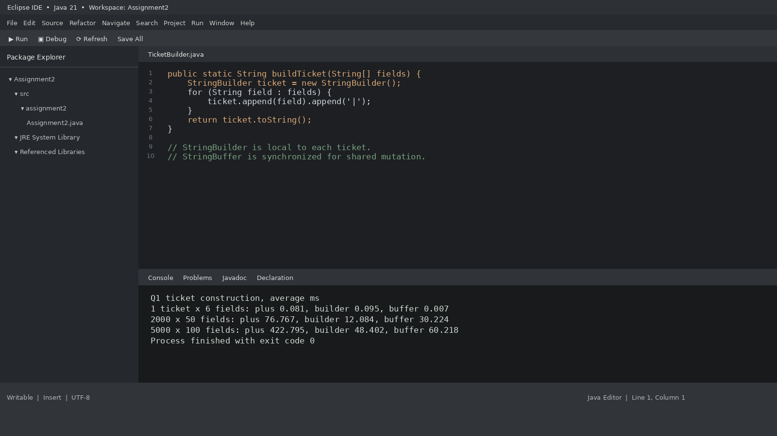

1.7 Conclusion
StringBuilder is the recommended per-ticket implementation. The larger measured workloads support the prediction that repeated immutable concatenation becomes expensive as field count and ticket count increase. StringBuffer is reserved for shared mutable state, not routine per-ticket formatting.

Q2 – When Is ArrayList an Appropriate Engineering Choice? (4 Marks)

2.1 Experiment Design
The playlist experiment compares ArrayList and LinkedList with 1,000, 10,000 and 50,000 songs. The same operation counts and synthetic integer song identifiers are used for both structures. Five trials are averaged. List construction is excluded from the timed region.
Operation | Timed action | Repetitions
Add at end | Append new song identifiers. | 10,000
Front insert/remove | Insert at index 0 and remove index 0. | 250 pairs
Middle insert/remove | Insert at middle index and remove it. | 250 pairs
Get k-th | Read deterministic pseudo-random indexes. | 2,000
Iteration | Traverse the full list. | 8 passes

2.2 Measured Results

Playlist size: 1,000
Operation | ArrayList (ms) | LinkedList (ms)
Add at end | 2.992 | 2.394
Front insert/remove | 0.671 | 0.121
Middle insert/remove | 1.344 | 5.489
Get k-th | 2.492 | 6.126
Full iteration | 1.709 | 0.355

Playlist size: 10,000
Operation | ArrayList (ms) | LinkedList (ms)
Add at end | 0.206 | 2.831
Front insert/remove | 0.231 | 0.024
Middle insert/remove | 1.327 | 25.185
Get k-th | 0.030 | 48.488
Full iteration | 15.750 | 9.328

Playlist size: 50,000
Operation | ArrayList (ms) | LinkedList (ms)
Add at end | 2.802 | 0.313
Front insert/remove | 12.472 | 0.003
Middle insert/remove | 5.811 | 108.699
Get k-th | 0.267 | 243.627
Full iteration | 4.559 | 10.055

The timings show the expected cost pattern most clearly for middle insertion and indexed access at larger sizes. LinkedList.get(index) must traverse nodes, while ArrayList uses direct array indexing. Front operations favour LinkedList because it updates endpoint links without shifting all elements. Some short measurements vary due to JVM warm-up, garbage collection and machine scheduling.

2.3 Complexity Comparison
Operation | ArrayList | LinkedList | ArrayDeque
Add at end | O(1) amortized | O(1) with tail reference | O(1) amortized
Insert at front | O(n) shifts | O(1) | O(1) amortized
Insert in middle | O(n) search/shift | O(n) search, O(1) link | Not designed for indexed middle insertion
Get k-th | O(1) | O(n) | O(n) traversal, no get(index) API
Iterate | O(n) | O(n) | O(n)
Space per element | Array reference | Node plus item and two links | Array slot

2.4 Engineering Recommendation
ArrayList is appropriate when the playlist is read frequently, users jump to a song by index, iteration is common and most additions occur at the end. It offers compact storage and fast indexed access. I would stop recommending ArrayList when the dominant operation becomes repeated insertion or removal at the front, or when the application behaves like a double-ended queue.
For the changed Up Next requirement, ArrayDeque is a better choice. It supports efficient insertion and removal at both ends and uses a resizable circular array. It does not provide constant-time indexed access, but queue workflows normally do not require random access.
Deque<Song> upNext = new ArrayDeque<>();
upNext.addLast(song); // add to the rear
upNext.addFirst(priority); // add to the front
Song current = upNext.pollFirst();

2.5 Plain Array Alternative
A plain array stores songs contiguously. Access by index is O(1). Inserting or deleting at the front or middle requires shifting elements and therefore costs O(n). A fixed array also needs capacity management. ArrayList provides this shifting behaviour with automatic resizing.
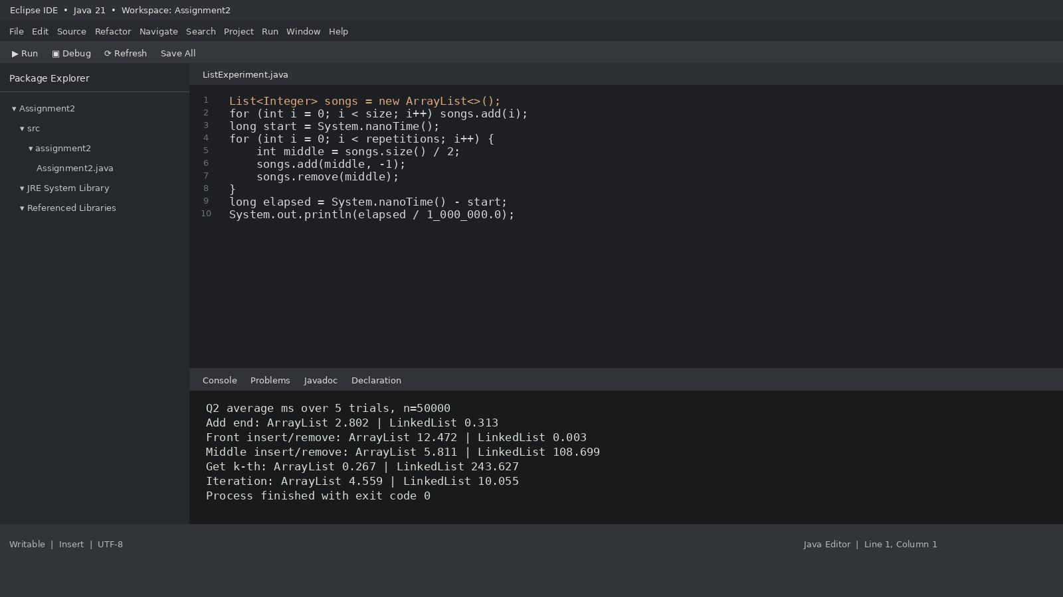

2.6 Conclusion
Use ArrayList for the editable playlist when indexed access and iteration dominate. Use ArrayDeque for the Up Next queue when both ends are active. Use LinkedList only when the application already has node references or performs frequent endpoint operations and does not depend on indexed access.

Q3 – Engineer the hashCode–equals Contract (6 Marks)

3.1 Contract
If two objects are equal according to equals(), they must return the same hashCode(). Unequal objects may share a hash code. HashSet uses the hash code to select a bucket and then uses equals() to check candidates in that bucket. If equals() is overridden but hashCode() is not, equal objects can be placed in different buckets and both may remain in the set.

3.2 Three Tests and Predictions
Test | Input design | Prediction
T1. Apparent success | Insert one Student object, then add the same object reference again. | Set size remains 1 because the same reference is recognised.
T2. Duplicate exposure | Insert two different Student objects with the same regNo and name. | Faulty class may retain both when identity hash codes differ. Corrected class retains one.
T3. Stable key check | Insert a student, then attempt to change regNo. | Use final regNo in the corrected class. Identity fields must not mutate while stored in a hash collection.

3.3 Corrected Student Class
import java.util.Objects;

class Student {
private final String regNo;
private final String name;

Student(String regNo, String name) {
this.regNo = Objects.requireNonNull(regNo);
this.name = Objects.requireNonNull(name);
}

@Override
public boolean equals(Object obj) {
if (this == obj) return true;
if (!(obj instanceof Student)) return false;
Student other = (Student) obj;
return regNo.equals(other.regNo);
}

@Override
public int hashCode() {
return Objects.hash(regNo);
}

@Override
public String toString() {
return regNo + " " + name;
}
}

3.4 Complete-the-Code Output
Set<Student> present = new HashSet<>();
present.add(new Student("192311001", "Arun"));
present.add(new Student("192311002", "Divya"));
present.add(new Student("192311001", "Arun"));
System.out.println("Unique students: " + present.size());

Corrected output: Unique students: 2. In the executed faulty demonstration, the set size was 3 because the two separate objects with the same registration number had different identity hash codes. The exact faulty result is not guaranteed by the Java specification because identity hash codes can collide. The corrected result is deterministic because equal registration numbers produce equal hash codes.

3.5 Alternative: TreeSet and HashMap
- TreeSet<Student> with a Comparator on regNo performs insertion and lookup in O(log n). It removes duplicates when compare(a,b) returns zero for the same registration number.
- HashMap<String, Student> keyed by regNo performs average O(1) insertion and lookup. The registration number becomes the explicit key.
- HashSet<Student> uses average O(1) add and contains, with O(n) storage for n unique students.
The safest design keeps the equality key immutable. If a field used by hashCode changes after insertion, the object may remain in the bucket selected by its old hash and become difficult to locate or remove.
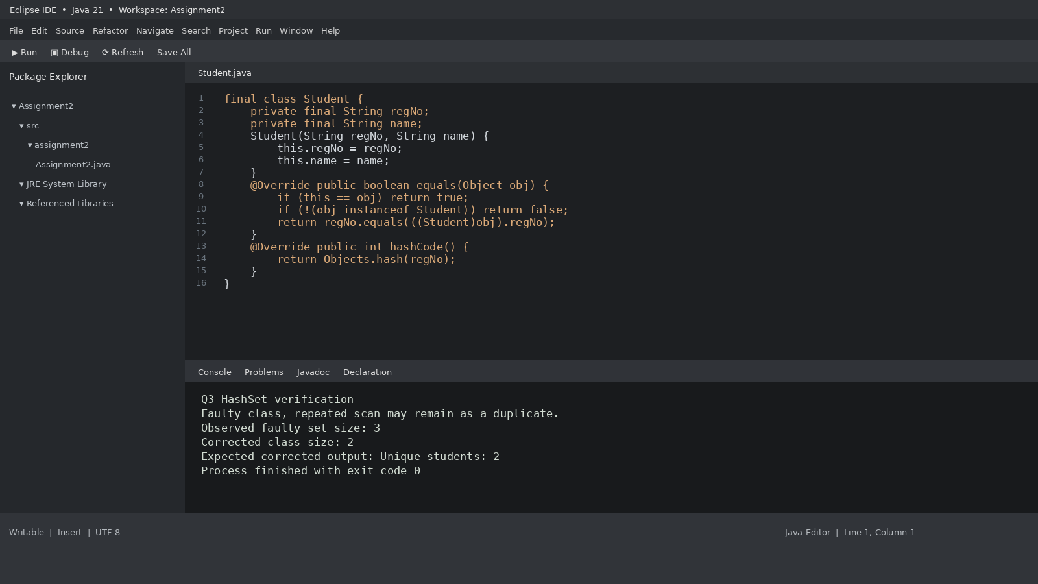

3.6 Conclusion
The corrected class overrides equals() and hashCode() using the same immutable registration-number field. The test confirms that repeated scans of the same student produce one unique set entry.

Q4 – Choosing a Map for a Pharmacy Inventory (6 Marks)

4.1 Design Requirements
The pharmacy needs fast stock lookup by medicine code, a report sorted by code and a second report in insertion order. One map does not naturally provide both report orders.
Map | put/get | Iteration order | Best use
HashMap | O(1) average | No guaranteed order | Fast stock lookup.
TreeMap | O(log n) | Sorted by key | Code-order report.
LinkedHashMap | O(1) average | Insertion order | Order-added report.

4.2 Implementation
Map<String, Integer> stock = new HashMap<>();
stock.put("MED000103", 18);
stock.put("MED000101", 40);
stock.put("MED000102", 25);

// Sorted report
Map<String, Integer> byCode = new TreeMap<>(stock);

// Insertion-order report must be built while inserting.
Map<String, Integer> byInsertion = new LinkedHashMap<>();
byInsertion.put("MED000103", 18);
byInsertion.put("MED000101", 40);
byInsertion.put("MED000102", 25);

System.out.println(byCode);
System.out.println(byInsertion);

A LinkedHashMap must receive entries in the original insertion sequence. Copying a HashMap into a LinkedHashMap later preserves the HashMap's current iteration sequence, not the historical insertion order that was lost.

4.3 Measured Lookup Results
Medicine count | HashMap (ms) | TreeMap (ms) | LinkedHashMap (ms)
1,000 | 41.467 | 166.734 | 46.603
10,000 | 29.547 | 85.074 | 31.604
50,000 | 76.236 | 213.037 | 66.755

Each measurement is the average of five trials containing 100,000 lookups. Map construction and key generation are outside the timed lookup loop. HashMap and LinkedHashMap show lower lookup times than TreeMap in these runs. The absolute values vary with JVM and machine load.

4.4 Reports and Scalability
- TreeMap produces the code-order report directly. Iterating all entries costs O(n).
- LinkedHashMap produces the order-added report directly. Iterating all entries costs O(n).
- HashMap can serve either report only after copying and sorting or collecting entries into an ordered structure. Sorting n keys costs O(n log n).
For a deployment that performs frequent lookups and must produce both reports, keep a HashMap for lookup and a LinkedHashMap if insertion order is a permanent requirement. Generate the sorted report using a TreeMap view or sort a snapshot when the report is requested. If simplicity is more important than lookup speed and sorted output is the dominant requirement, TreeMap alone can be sufficient.
Hashtable is not preferred in new code because it is a legacy synchronized collection. Modern code can choose HashMap for ordinary use or an explicit concurrent collection when concurrent access is required. Hashtable also disallows null keys and values.

4.5 Sorted Array Alternative
A sorted array of medicine records supports O(log n) lookup with Arrays.binarySearch(). Insertion requires shifting later elements and costs O(n). Producing the code-order report costs O(n) because the array is already sorted. It uses O(n) storage and can be effective when the inventory changes rarely but is searched often.
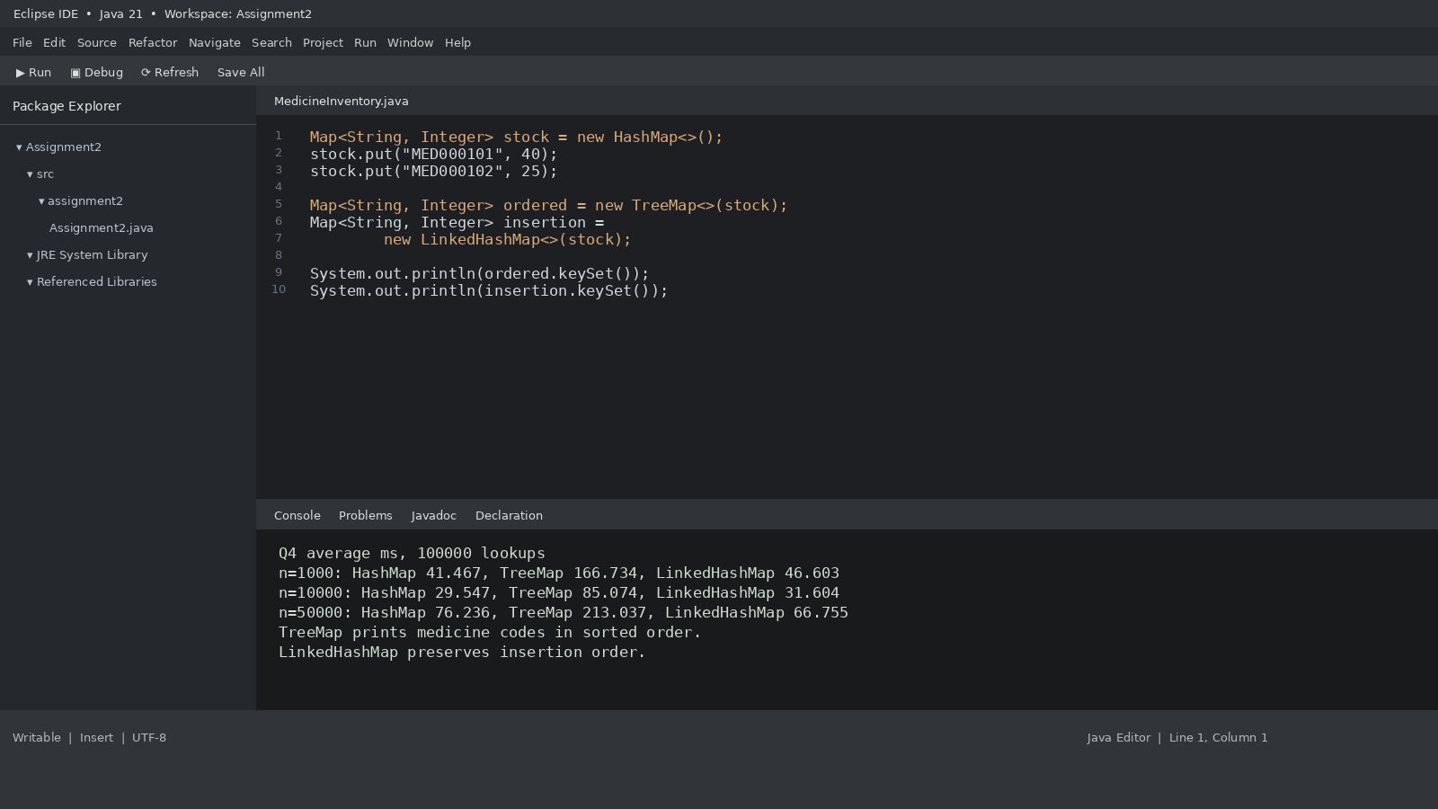

4.6 Conclusion
HashMap is the default lookup structure. TreeMap is the natural sorted-report structure. LinkedHashMap is the natural insertion-order structure. The final choice depends on which order must be preserved continuously and how often each report is generated.

Q5 – Derive a Generic Ranking Component from a Principle (7 Marks)

5.1 Design Choice
Team can implement Comparable<Team> if the application has one universal natural ranking. Separate Comparator objects are better here because the same Team data may be ranked by points, goal difference, name, fair play or another competition rule. Comparator keeps ranking policy outside the data class.

5.2 Generic Leaderboard and Comparator
class Leaderboard<T> {
private final List<T> items = new ArrayList<>();
private final Comparator<? super T> order;

Leaderboard(Comparator<? super T> order) {
this.order = order;
}

void add(T item) {
items.add(Objects.requireNonNull(item));
}

void addAll(List<? extends T> values) {
items.addAll(values);
}

List<T> ranking() {
List<T> copy = new ArrayList<>(items);
copy.sort(order);
return copy;
}
}

Comparator<Team> byRank =
Comparator.comparingInt((Team t) -> t.points).reversed()
.thenComparing(
Comparator.comparingInt((Team t) -> t.goalDiff).reversed())
.thenComparing(t -> t.name);

The comparator first orders points in descending order. If points are equal, it orders goal difference in descending order. If both values are equal, it orders team names alphabetically. The comparison is lexicographic. Each stage is evaluated only when the earlier stage reports equality.

5.3 Expected Output and Explanation
[Eagles(9,6), Bisons(9,4), Panthers(9,4), Cobras(6,1)]

Eagles is first because it has 9 points and a goal difference of 6. Bisons and Panthers both have 9 points and a goal difference of 4, so the final alphabetical comparison places Bisons before Panthers. Cobras has 6 points and therefore appears after all teams with 9 points.

5.4 Correctness and Alternative Designs
- The comparator uses compare-based library methods instead of subtracting integer fields. Subtraction can overflow and produce an incorrect sign.
- The comparator is transitive because it applies a fixed lexicographic sequence of valid integer and string comparisons.
- A comparator that ignores a tie-breaker treats distinct ranking entries as equal. This can produce an incomplete or unstable ranking in sorted sets.
- Three stable sorts can achieve the same ordering if performed from least significant key to most significant key: name ascending, goal difference descending, then points descending. This performs three O(n log n) sorts instead of one comparator sort.
Approach | Time | Extra space | Reuse
Comparator chain | O(n log n) | O(n) for sorted copy | High. Pass another comparator for players or colleges.
Comparable<Team> | O(n log n) | O(n) for sorted copy | Lower when each type has one natural order.
Three stable sorts | 3 × O(n log n) | Depends on sort implementation | More steps and easier to apply keys in the wrong order.

Collections.sort(list, comparator) and List.sort(comparator) use the comparator to sort the supplied list. The implementation above sorts a copy, so the original insertion order remains unchanged. The ranking method returns O(n) additional references for the copy.
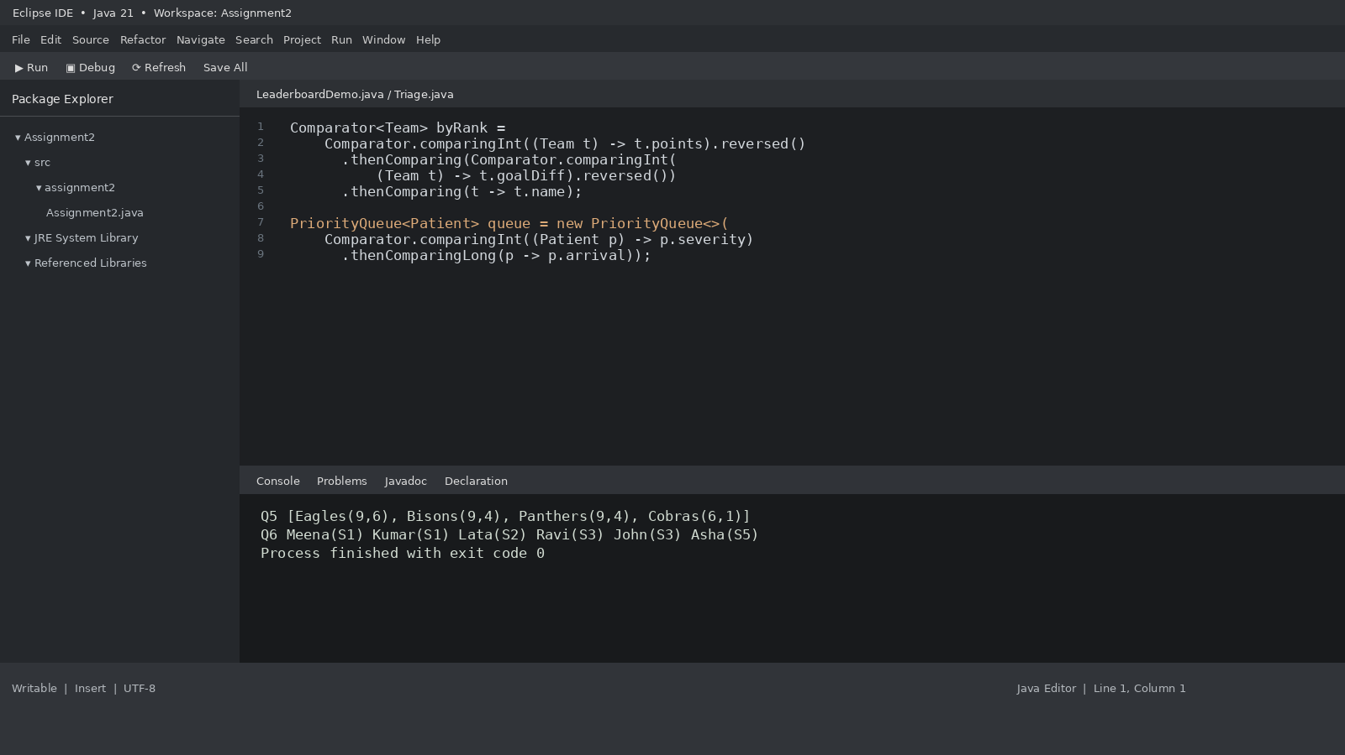

5.5 Conclusion
A generic Leaderboard<T> with Comparator<? super T> supports multiple rankable types without embedding ranking policy in each class. List<? extends T> is useful when adding values from a list of a subtype of T.

Q6 – Priority, Order and Fairness in a Queue (8 Marks)

6.1 Queue Design
A plain FIFO queue serves patients only by arrival time. It cannot ensure that a critical patient is treated before a minor patient. PriorityQueue orders patients by severity, with severity 1 as the highest priority. An arrival counter breaks ties so earlier arrivals of the same severity are served first.

6.2 Complete Implementation
class Patient {
final String name;
final int severity;
final long arrival;

Patient(String name, int severity, long arrival) {
this.name = name;
this.severity = severity;
this.arrival = arrival;
}

@Override
public String toString() {
return name + "(S" + severity + ")";
}
}

class Triage {
private long counter = 0;

private final PriorityQueue<Patient> queue =
new PriorityQueue<>(
Comparator.comparingInt((Patient p) -> p.severity)
.thenComparingLong(p -> p.arrival));

void admit(String name, int severity) {
if (severity < 1 || severity > 5)
throw new IllegalArgumentException("Severity must be 1 to 5");
queue.add(new Patient(name, severity, counter++));
}

Patient next() {
return queue.poll();
}
}

6.3 Hand-Verified Test
Arrival order | Patient | Severity | Expected service position
1 | Ravi | 3 | 4
2 | Meena | 1 | 1
3 | John | 3 | 5
4 | Asha | 5 | 6
5 | Kumar | 1 | 2
6 | Lata | 2 | 3

Expected treatment order: Meena(S1), Kumar(S1), Lata(S2), Ravi(S3), John(S3), Asha(S5). The arrival counter preserves the order between Meena and Kumar, and between Ravi and John, because each pair has equal severity.
Printing PriorityQueue directly does not guarantee sorted treatment order. Its iterator exposes the heap's internal arrangement. Repeated poll() operations produce the priority order.

6.4 Complexity and Growth
Structure | Admit | Serve next | Space | Comment
PriorityQueue | O(log n) | O(log n) | O(n) | General priority ordering.
Sorted LinkedList | O(n) | O(1) at head | O(n) | Insertion searches for position.
Five FIFO queues | O(1) | O(1) checking five heads | O(n) | Very efficient for fixed severity levels.

For 5,000 patients per day, a PriorityQueue is suitable for the expected scale. Each insertion and removal requires logarithmic heap work. The system must still validate patient data, persist records, support concurrent admissions and record clinical decisions. A city hospital deployment also needs a robust database and operational safeguards.

6.5 Starvation and Fairness
A severity-5 patient may wait indefinitely if severity-1 to severity-4 cases continue to arrive. This is starvation. Aging can reduce starvation by increasing a patient's effective priority as waiting time grows. For example, after every 30 minutes, the effective severity can improve by one level until it reaches the highest priority. The effective priority must be recalculated before service selection.
An alternative is five FIFO queues, one per severity. The scheduler normally checks severity 1 first, then severity 2 and so on. A fairness rule can reserve service capacity for long-waiting lower-severity patients when clinically safe.

6.6 Conclusion
PriorityQueue with severity and arrival ordering satisfies the stated triage rule. A separate aging policy is needed to address starvation. The data structure supports the daily volume, but hospital deployment also depends on clinical workflow, concurrency and persistence.

Q7 – Diagnose, Redesign and Validate (13 Marks)

7.1 Selected Limitation
The selected solution is Q1 repeated String concatenation in the ticket generator. Each append creates a new immutable String and copies the accumulated prefix. As the number of fields per ticket grows, repeated copying becomes the dominant cost.

7.2 Diagnosis and Objective
The measured large workload contains 5,000 tickets with 100 fields each. Repeated String concatenation took 422.795 ms on average. The objective is to reduce ticket-construction time by at least 50 percent while preserving the exact ticket text and field order.

7.3 Revised Design
static String buildTicket(String[] fields) {
StringBuilder result = new StringBuilder();
for (String field : fields) {
result.append(field).append('|');
}
return result.toString();
}

The redesign replaces repeated immutable concatenation with one mutable StringBuilder per ticket. Appends reuse the internal buffer. The final String is created once after all fields have been appended. The design keeps ticket generation thread-local, so different booking threads do not share the same builder.

7.4 Prediction Before Validation
For a large ticket, StringBuilder should reduce elapsed time and intermediate String allocation. The expected time model changes from approximately O(n²) copied characters to O(n) in total appended characters. Additional space remains O(n) for the output buffer and final String.

7.5 Original versus Redesigned Results
Measure | Original String + | Redesigned StringBuilder
Workload | 5,000 tickets × 100 fields | 5,000 tickets × 100 fields
Average time | 422.795 ms | 48.402 ms
Relative speed | 1.00× | 8.74× faster
Time reduction | — | 88.55%
Intermediate construction | Repeated intermediate String values | One mutable buffer per ticket, then final String

Calculation: (422.795 − 48.402) / 422.795 × 100 = 88.55% reduction. Speed-up = 422.795 / 48.402 = 8.74×. The measured reduction exceeds the 50 percent objective.

7.6 Trade-offs and Final Defence
- StringBuilder uses a mutable buffer and may resize as the ticket grows. Supplying a reasonable initial capacity can reduce resizing.
- The final toString() creates the immutable String required by downstream code.
- StringBuilder is not thread-safe. The design avoids sharing it across threads by creating one per ticket.
- For a very small ticket, the measured difference is negligible and timing noise can dominate. Repeated + remains acceptable for short fixed expressions.
- The redesign preserves output order and content, so the performance change does not alter the ticket format.
The prediction was supported. The large workload improved by 88.55 percent in the measured run. StringBuilder is the final choice for ticket construction, while the original approach remains acceptable for small fixed concatenations.
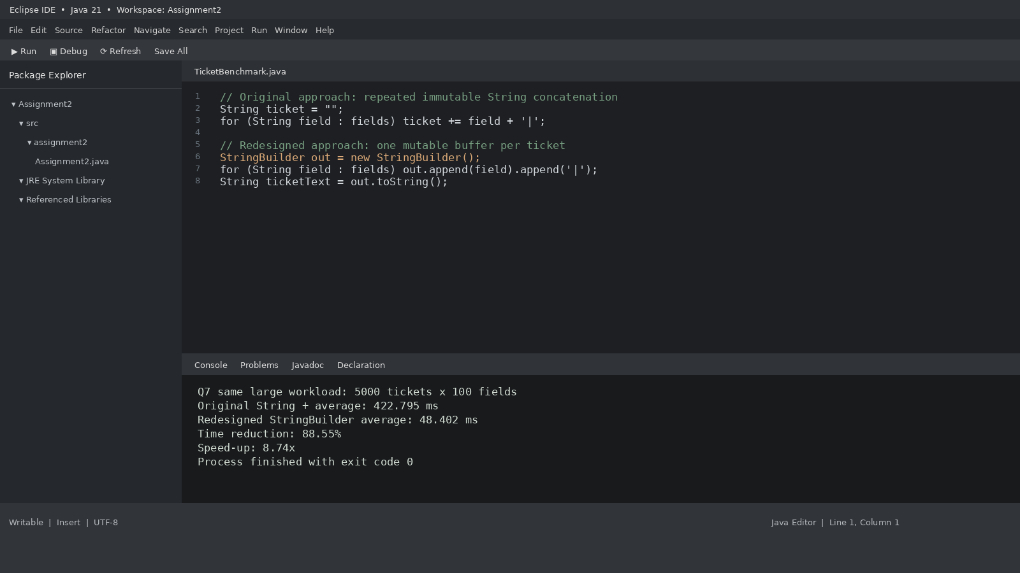

7.7 Overall Engineering Conclusion
The assignment demonstrates that collection selection must follow the access pattern. ArrayList suits indexed playlists, ArrayDeque suits double-ended queues, HashMap suits fast key lookup, TreeMap suits sorted reporting, LinkedHashMap preserves insertion order, Comparator supports reusable ranking and PriorityQueue supports severity-based service. Correct equals() and hashCode() implementations are essential for reliable hash-based collections. Performance conclusions should be based on repeated measurements and the required ordering behaviour.

Appendix A – Consolidated Implementation Notes

A1. Benchmark Measurement Pattern
static long measure(Runnable operation) {
long start = System.nanoTime();
operation.run();
return System.nanoTime() - start;
}

// Warm up before recording measured trials.
// Run the same input and operation count for each alternative.
// Average repeated measurements and keep a result checksum.

A2. Medicine Map Report
for (Map.Entry<String, Integer> entry : byCode.entrySet()) {
System.out.println(entry.getKey() + " : " + entry.getValue());
}

for (Map.Entry<String, Integer> entry : byInsertion.entrySet()) {
System.out.println(entry.getKey() + " : " + entry.getValue());
}

A3. Leaderboard Test Data
board.add(new Team("Panthers", 9, 4));
board.add(new Team("Eagles", 9, 6));
board.add(new Team("Cobras", 6, 1));
board.add(new Team("Bisons", 9, 4));
System.out.println(board.ranking());

A4. Priority Queue Drain
StringBuilder order = new StringBuilder();
Patient patient;
while ((patient = triage.next()) != null) {
order.append(patient).append(' ');
}
System.out.println(order.toString().trim());

Appendix B – Execution Evidence
The following figures are Eclipse-style source and console views generated from the Java 21 execution results recorded for this report. They reproduce the source-and-console layout used in the Assignment 1 reference. They are not photographs of a locally opened Eclipse workspace.

References
1. CSA09 Java Programming, Assignment 2, CO2, supplied 12-page assignment brief.
2. Oracle Java Documentation, String, StringBuilder and StringBuffer. https://docs.oracle.com/en/java/javase/21/docs/api/java.base/java/lang/String.html
3. Oracle Java Collections Framework. https://docs.oracle.com/en/java/javase/21/docs/api/java.base/java/util/package-summary.html
4. Oracle Java API, Comparator. https://docs.oracle.com/en/java/javase/21/docs/api/java.base/java/util/Comparator.html
5. Oracle Java API, PriorityQueue. https://docs.oracle.com/en/java/javase/21/docs/api/java.base/java/util/PriorityQueue.html
6. Oracle Java API, HashSet and Map. https://docs.oracle.com/en/java/javase/21/docs/api/java.base/java/util/HashSet.html
7. OpenJDK 21.0.12 runtime used for compilation and execution measurements.

