NAME : EDRIN J S
REG NO:192524041

Scaling and Normalization
Scaling and normalization adjust numeric features so they sit on similar scales, which matters for algorithms that rely on distance or gradients, such as KNN, SVM, neural networks, and k-means.

PROGRAM:

import pandas as pd
from sklearn.preprocessing import MinMaxScaler, StandardScaler, RobustScaler

df = pd.DataFrame({'income': [25000, 48000, 92000, 15000, 61000],
'age': [22, 35, 58, 19, 41]})

minmax = MinMaxScaler()
df[['income_norm', 'age_norm']] = minmax.fit_transform(df[['income', 'age']])

standard = StandardScaler()
df[['income_std', 'age_std']] = standard.fit_transform(df[['income', 'age']])

robust = RobustScaler()
df[['income_rob', 'age_rob']] = robust.fit_transform(df[['income', 'age']])

print(df)

Output:

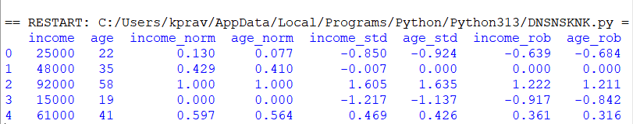

Parsing Dates
Real-world dates often show up in a mix of formats, so they first need to be parsed into a proper datetime type before any time-based sorting, filtering, or feature extraction can be done.

PROGRAM:
dates_raw = ['2024-01-15', '15/02/2024', 'March 3, 2024', '2024.04.20', '05-20-2024']

df_dates = pd.DataFrame({'date_str': dates_raw})

df_dates['parsed'] = pd.to_datetime(df_dates['date_str'], errors='coerce', dayfirst=False) print(df_dates)

def parse_flexible_date(s):
for fmt in ('%Y-%m-%d', '%d/%m/%Y', '%B %d, %Y', '%Y.%m.%d', '%m-%d-%Y'):
try:
return pd.to_datetime(s, format=fmt) except ValueError:
continue return pd.NaT

df_dates['parsed_manual'] = df_dates['date_str'].apply(parse_flexible_date)

df_dates['year'] = df_dates['parsed_manual'].dt.year df_dates['month'] = df_dates['parsed_manual'].dt.month
df_dates['day_of_week'] = df_dates['parsed_manual'].dt.day_name()

Output:
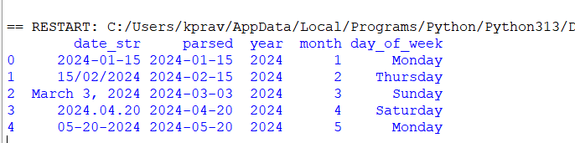

Handling Inconsistent Data
This step deals with messy categorical data — inconsistent casing, stray whitespace, and multiple entries that really refer to the same entity.

PROGRAM:
df_inc = pd.DataFrame({'city': [' New York', 'new york', 'NEW YORK', 'Los Angeles ', 'LA', 'los angeles']})

df_inc['city_clean'] = df_inc['city'].str.strip().str.lower()

alias_map = {'la': 'los angeles'}
df_inc['city_clean'] = df_inc['city_clean'].replace(alias_map)

print(df_inc)

df_mixed = pd.DataFrame({'value': ['10', '20.5', 'abc', '15', None]})
df_mixed['is_numeric'] = pd.to_numeric(df_mixed['value'], errors='coerce').notna() print(df_mixed)

df_dedup = df_inc.drop_duplicates(subset='city_clean')

OUTPUT:

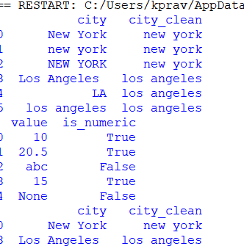

- Character Encoding

PROGRAM:
import chardet import pandas as pd

with open('data.csv', 'rb') as f: raw_data = f.read()
result = chardet.detect(raw_data)
print("Detected encoding info:", result)

df_enc = pd.read_csv('data.csv', encoding=result['encoding']) print(df_enc)

try:
df_wrong = pd.read_csv('data.csv', encoding='utf-8') except UnicodeDecodeError as e:
print("UnicodeDecodeError:", e)

