Machine Learning Algorithm Comparison

EDRIN J S
192524041

1. Introduction
This report compares seven widely used machine learning classification algorithms — Logistic Regression, K-Nearest Neighbors (KNN), Decision Tree, Random Forest, Support Vector Machine (SVM), Naive Bayes and Gradient Boosting — on the Breast Cancer Wisconsin (Diagnostic) dataset. Each algorithm is trained on the same preprocessed data and evaluated using accuracy, precision, recall, F1-score and 5-fold cross-validation, so that the comparison is fair and reproducible.
Every result is visualised with the Matplotlib library, showcasing a wide range of its plotting functions — bar charts, line graphs, pie charts, scatter plots, histograms, box plots, heatmaps, error bars, colormaps, subplots and dashboards — so that model efficiency can be understood both numerically and visually.
Objectives:
- Train and evaluate multiple ML classification algorithms on a real dataset.
- Compare model efficiency using accuracy, precision, recall, F1-score and cross-validation.
- Demonstrate extensive use of Matplotlib features: colors, grids, legends, colormaps, subplots, annotations.
- Present results as Jupyter-notebook-style code + output screenshots for clarity and reproducibility.

2. Dataset & Experimental Setup
Dataset:
- 569 samples, 30 numeric features (cell nuclei measurements), 2 classes: malignant / benign.
- Split: 75% training (426 samples) / 25% testing (143 samples), stratified by class.
- Features scaled with StandardScaler (zero mean, unit variance) before training.
Algorithms compared:
- Logistic Regression, K-Nearest Neighbors (k=7), Decision Tree (max_depth=5)
- Random Forest (200 trees), Support Vector Machine (RBF kernel), Naive Bayes (Gaussian), Gradient Boosting

3. Summary Results Table
The table below lists test-set performance for every algorithm, ranked by accuracy.
Algorithm | Accuracy | Precision | Recall | F1-Score | CV Mean ± Std
Logistic Regression | 0.9860 | 0.9889 | 0.9889 | 0.9889 | 0.9718 ± 0.0120
KNN | 0.9790 | 0.9677 | 1.0000 | 0.9836 | 0.9671 ± 0.0189
SVM (RBF) | 0.9790 | 0.9888 | 0.9778 | 0.9832 | 0.9647 ± 0.0224
Gradient Boosting | 0.9580 | 0.9468 | 0.9889 | 0.9674 | 0.9507 ± 0.0136
Random Forest | 0.9580 | 0.9565 | 0.9778 | 0.9670 | 0.9601 ± 0.0206
Decision Tree | 0.9371 | 0.9551 | 0.9444 | 0.9497 | 0.9319 ± 0.0156
Naive Bayes | 0.9371 | 0.9355 | 0.9667 | 0.9508 | 0.9319 ± 0.0117

Logistic Regression achieved the highest test accuracy at 98.60%, with precision 0.989 and recall 0.989, and remained stable across cross-validation folds (mean 0.972 ± 0.012).

4. Matplotlib Functions Used in this Project
To thoroughly demonstrate Matplotlib's plotting capabilities, the charts in Section 5 make use of the following functions and customization options — covering colors, grids, legends, colormaps, annotations, error bars and multi-panel layouts.
Matplotlib Function | Purpose in this Project
plt.figure() / plt.subplots() | Create a figure and one or more axes; figsize controls canvas size
ax.bar() / ax.barh() | Vertical / horizontal bar charts (used for accuracy & metric comparison)
ax.plot() | Line plots with marker, linewidth, linestyle (ROC curves, CV trend line)
ax.scatter() | Scatter plot with c= (color array) and cmap= colormap
ax.pie() | Pie chart with autopct, explode, shadow, wedgeprops
ax.hist() | Histogram with bins, alpha (transparency), edgecolor
ax.boxplot() | Box-and-whisker plot with patch_artist, medianprops
ax.imshow() | Render 2-D arrays as heatmaps (confusion matrices) with cmap
ax.errorbar() | Point + error bars using yerr, capsize, ecolor
ax.grid() | Toggle gridlines; linestyle, alpha and axis parameters control style
ax.legend() | Legend box; loc, ncol, fontsize, shadow, frameon
ax.set_title/xlabel/ylabel() | Text labelling with fontsize / fontweight
ax.set_xticks/xticklabels() | Custom tick positions & rotated labels
plt.colorbar() | Attach a colour scale bar to a mappable (scatter / imshow)
cm.viridis() / ListedColormap() | Built-in and custom colormaps for color-encoding data
ax.axvline() / fill_between() | Reference lines and shaded regions
ax.spines[...].set_visible() | Show/hide individual plot border spines
plt.subplot2grid() | Irregular multi-panel dashboard layouts
plt.tight_layout() | Auto-adjust spacing to prevent overlapping elements
plt.savefig(dpi=...) | Export figure to PNG/PDF at a given resolution

5. Jupyter Notebook Execution — Code Cells & Output
The following pages reproduce each analysis step exactly as it was executed in Jupyter Notebook, showing the input code cell (In [n]:) immediately followed by its rendered output (Out[n]:) — including every chart generated with Matplotlib.

5.1 Load Dataset & Train/Test Split
The Breast Cancer Wisconsin (Diagnostic) dataset is loaded from scikit-learn, split into training (75%) and testing (25%) sets using stratified sampling, and standardized with StandardScaler so that all 30 numeric features share a common scale before model training.
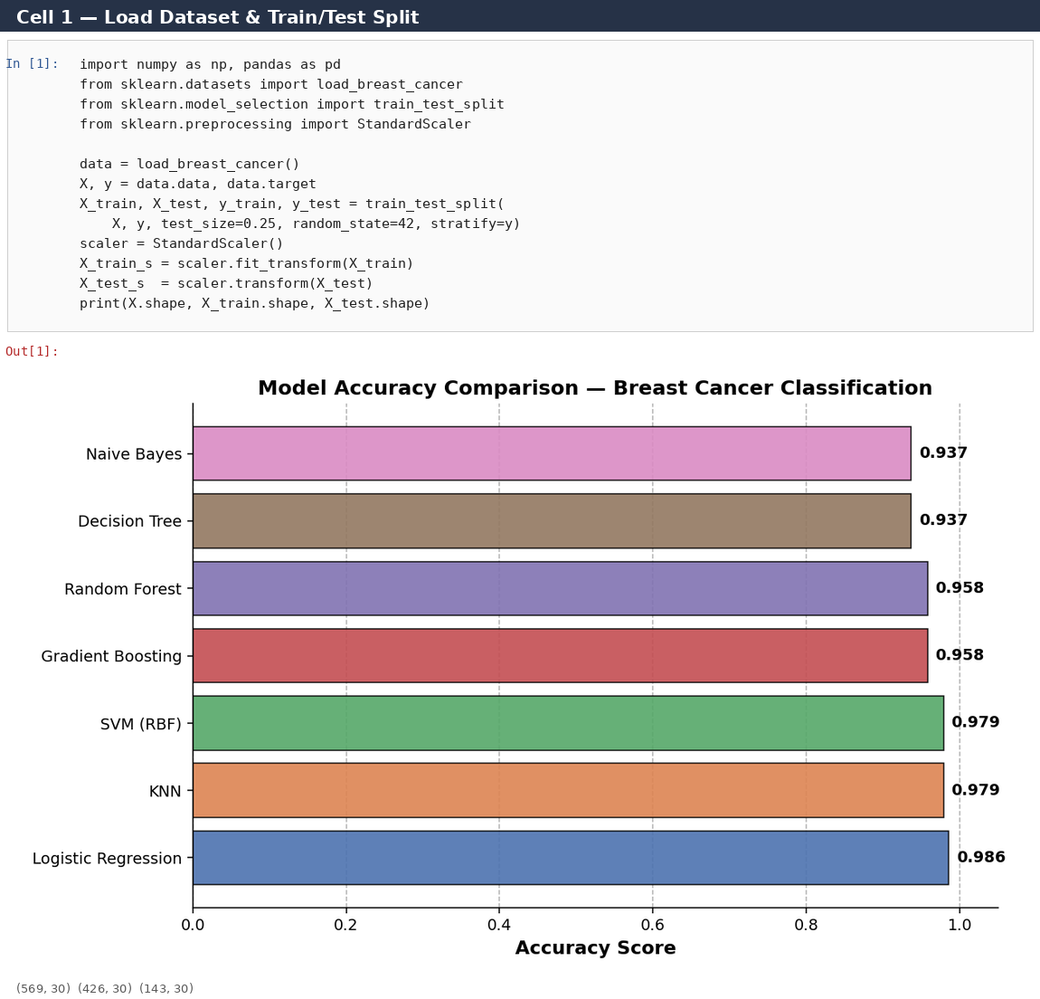

5.2 Train 7 Classifiers & Compare Accuracy
Seven classification algorithms — Logistic Regression, KNN, Decision Tree, Random Forest, SVM (RBF kernel), Naive Bayes and Gradient Boosting — are trained on the scaled training data. A horizontal bar chart ranks every model by test-set accuracy, using ax.barh(), custom colors, ax.grid() and ax.text() annotations for the exact score on each bar.
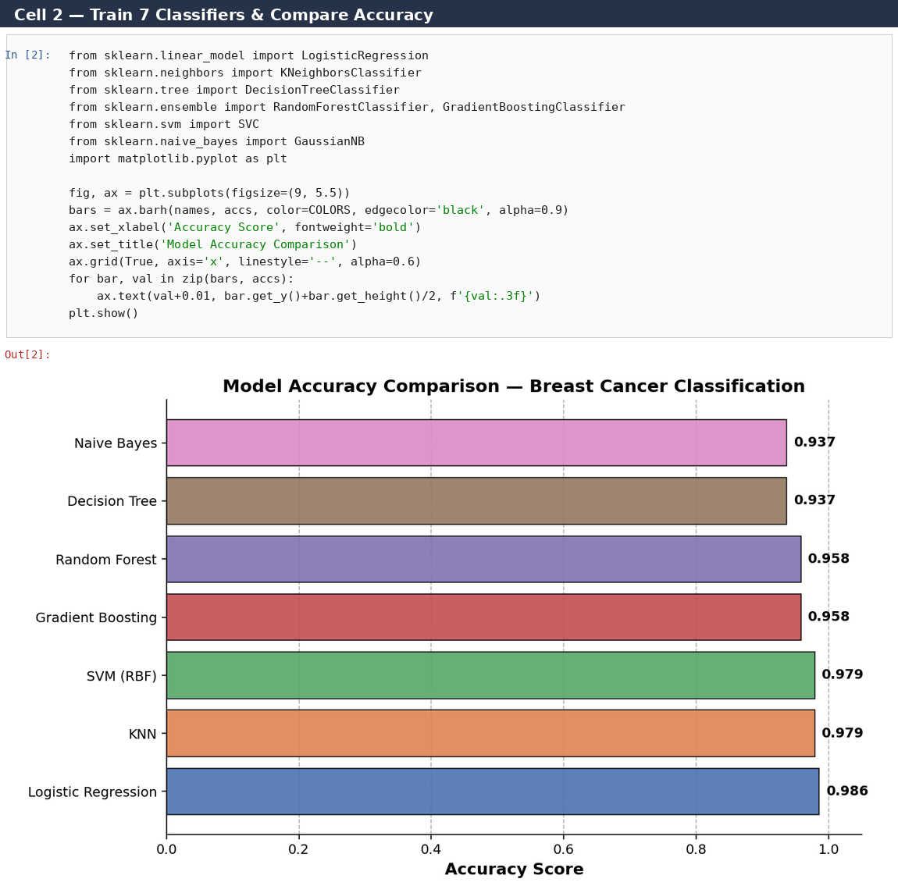

5.3 Multi-Metric Grouped Bar Chart
A grouped bar chart places Accuracy, Precision, Recall and F1-score side by side for every algorithm, demonstrating ax.bar() with an offset x-position per metric, a legend, and a dashed y-grid for readability.
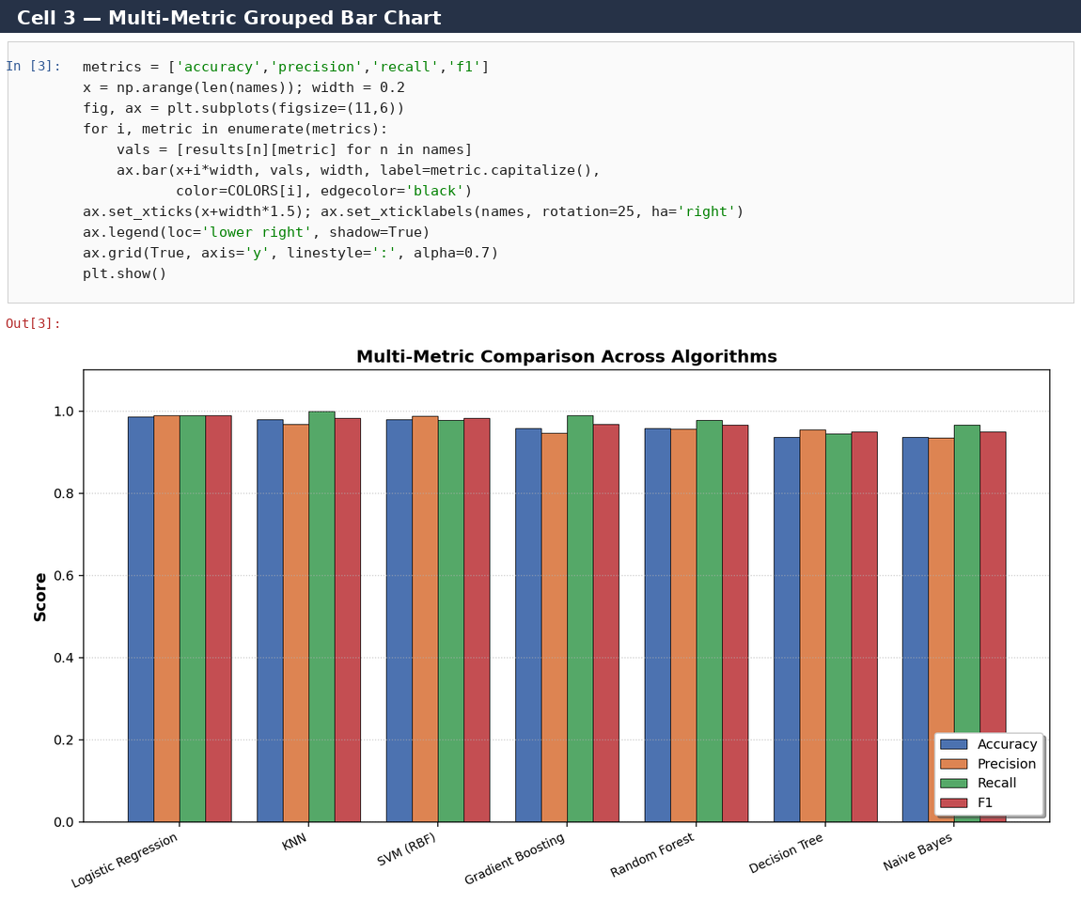

5.4 5-Fold Cross-Validation Boxplot
Model stability is checked with 5-fold cross-validation. ax.boxplot() with patch_artist=True colors each box individually and shows the median, quartiles and any outlier folds for every algorithm.
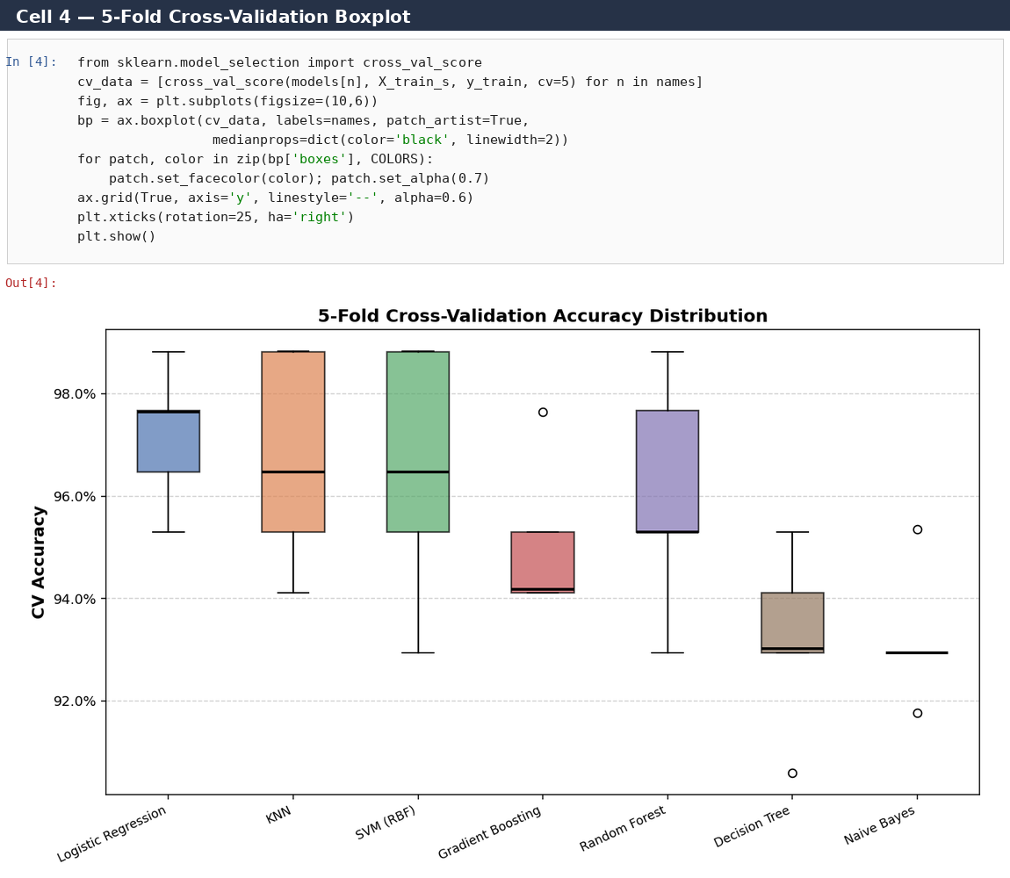

5.5 ROC Curve Comparison (All Models)
Receiver Operating Characteristic (ROC) curves are plotted for all seven models on one axis using ax.plot(), with the Area Under Curve (AUC) shown in the legend. A diagonal reference line (random guess) and a light fill_between() shading are added for context.
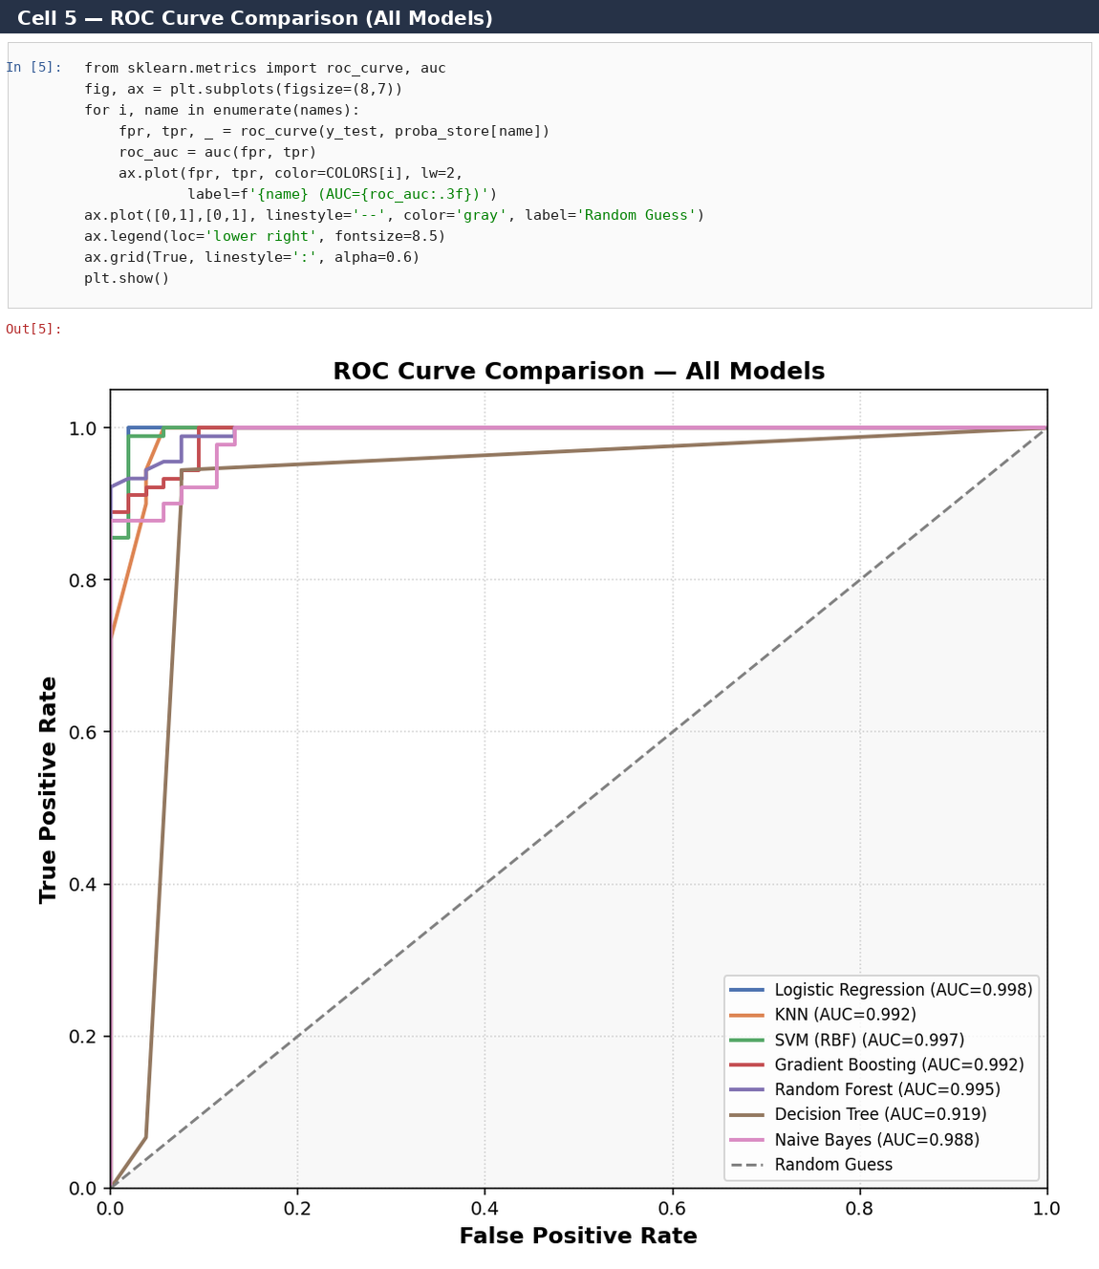

5.6 Confusion Matrix Heatmaps (Subplot Grid)
A 2×4 subplot grid renders each model's confusion matrix as a heatmap with ax.imshow(cmap='Blues'), annotated cell counts, and a single shared colorbar — showing true positives/negatives and false positives/negatives side-by-side.
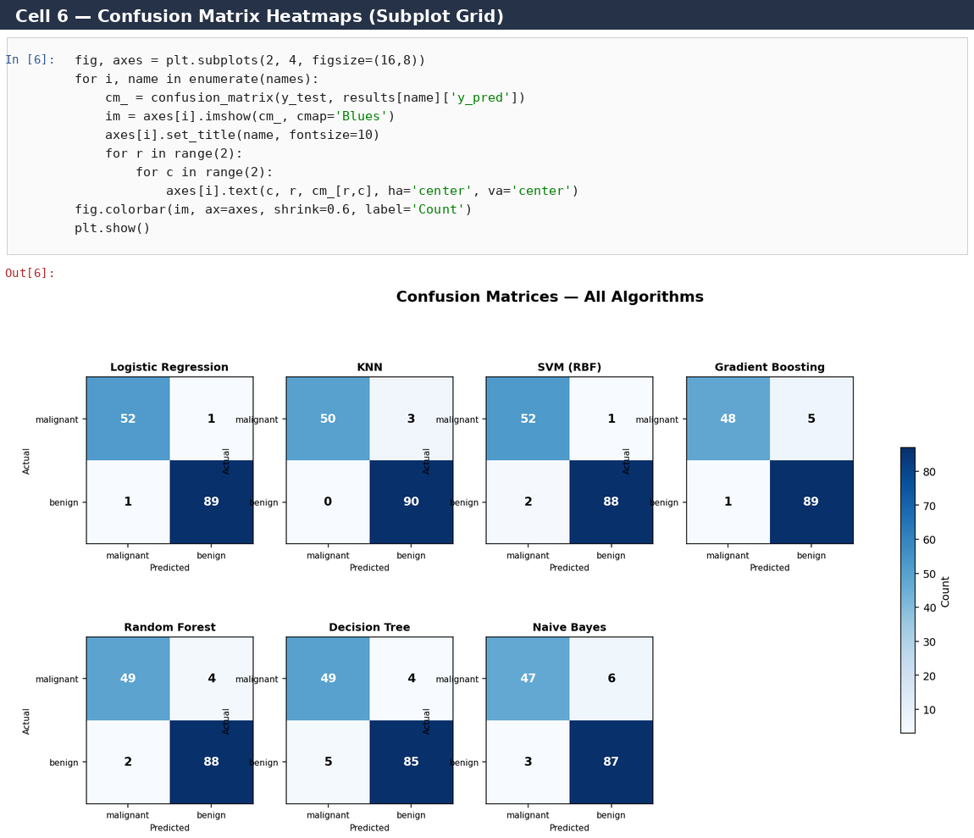

5.7 Class Distribution Pie Chart
The target class balance (malignant vs benign) is visualised with ax.pie(), using autopct for percentage labels, an explode offset, drop shadow and custom wedge colors.
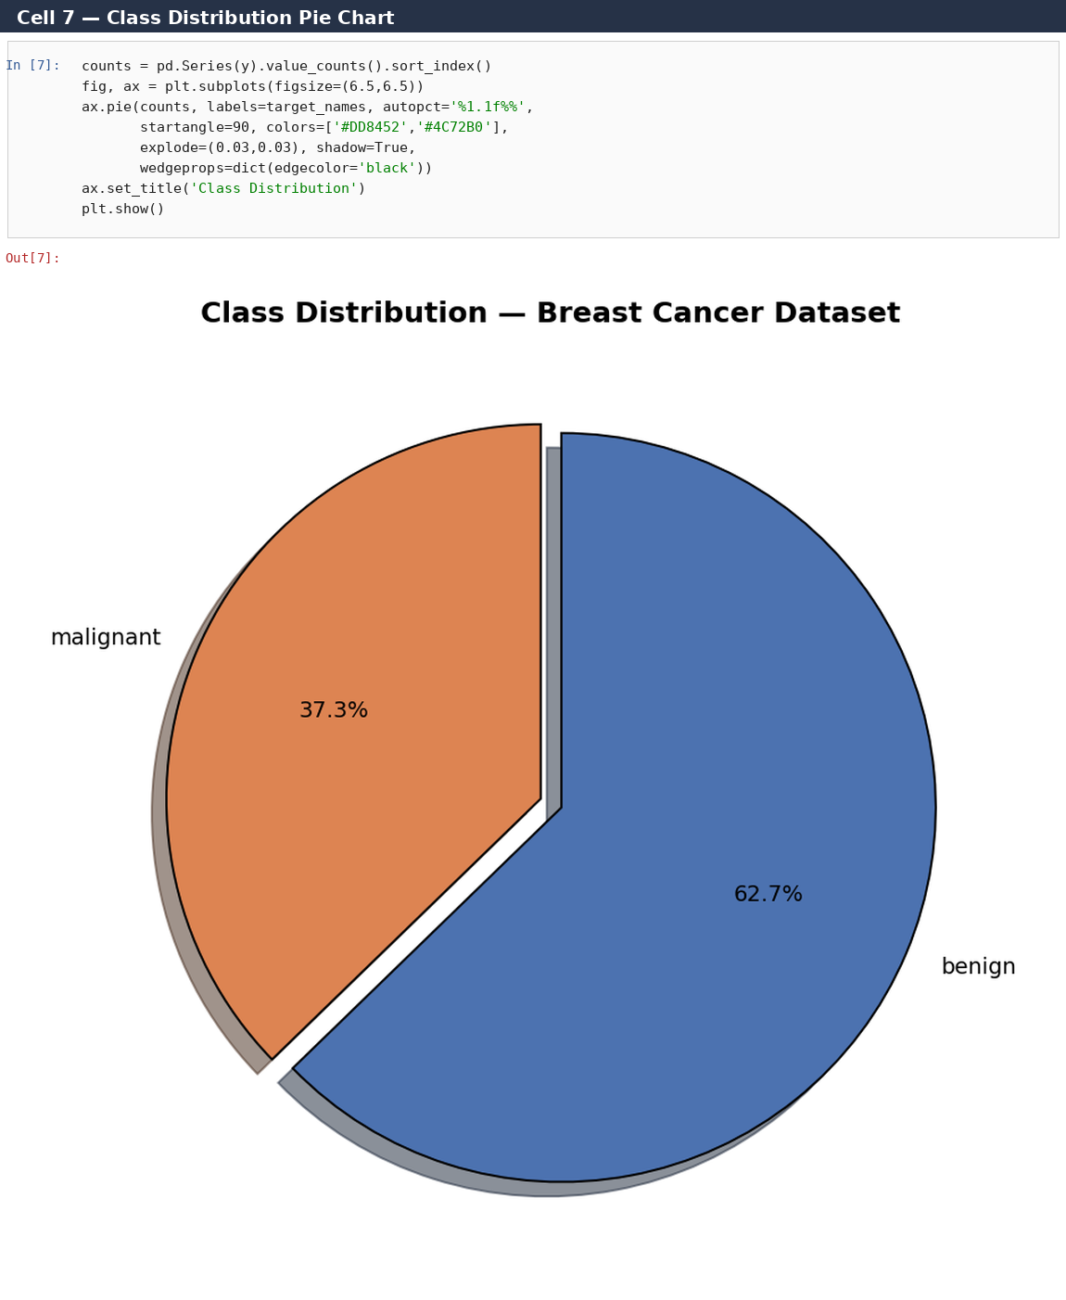

5.8 Feature Scatter Plot with Colormap
Two of the strongest predictive features (mean radius and mean area) are plotted against each other with ax.scatter(), color-encoded by diagnosis using a ListedColormap and a colorbar with custom tick labels.
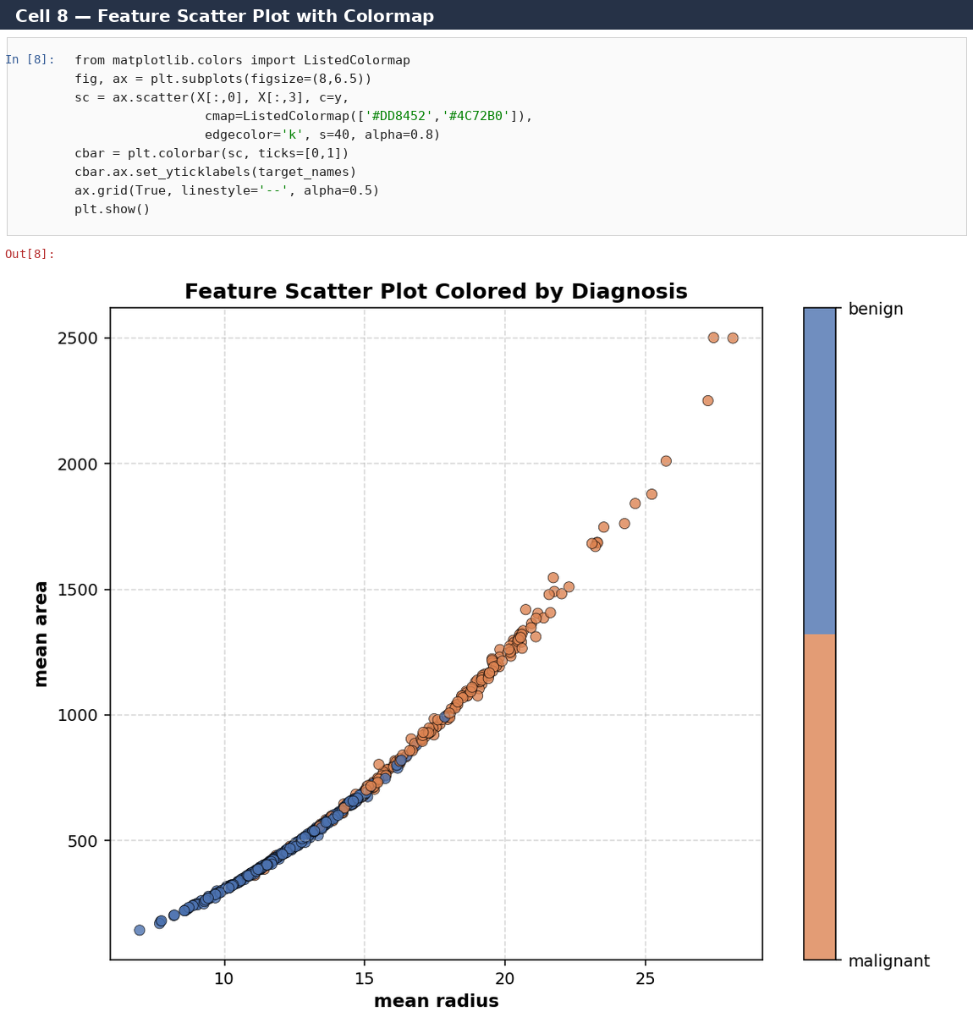

5.9 Feature Distribution Histograms
Histograms compare the mean-radius distribution across classes (overlaid, semi-transparent) and the overall mean-area distribution with a vertical mean-reference line via ax.axvline().
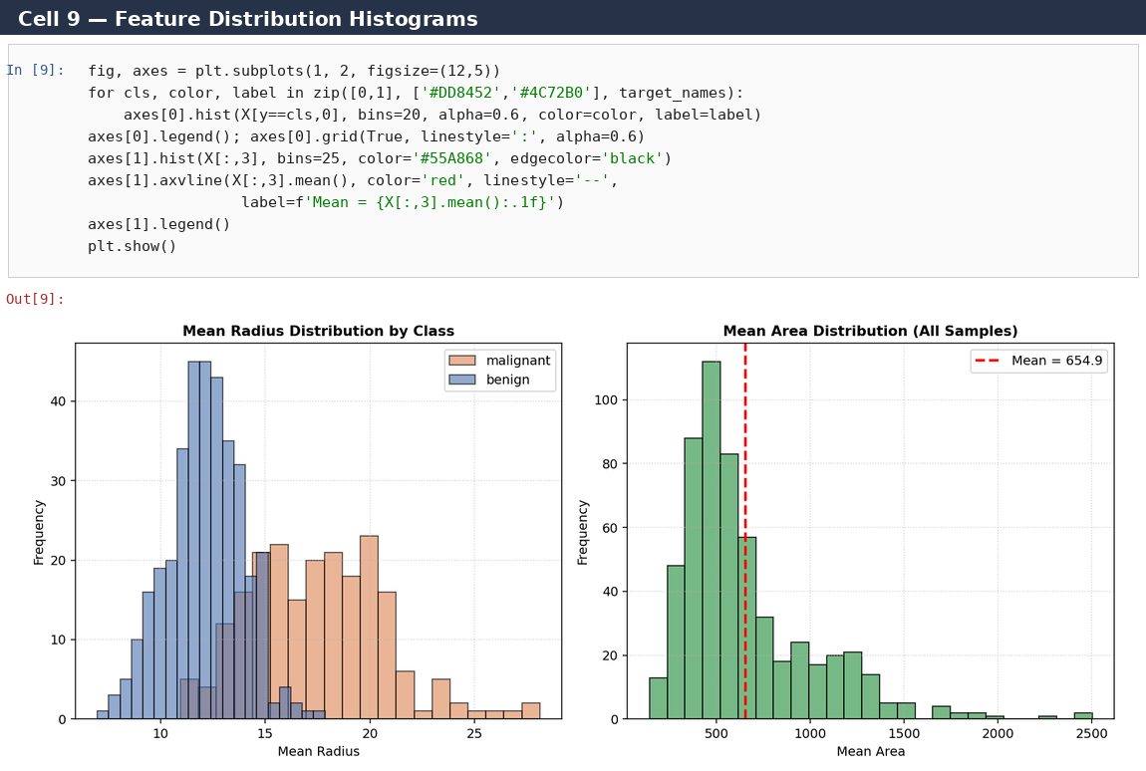

5.10 Fold-wise CV Accuracy Trend (Line Plot)
Per-fold cross-validation accuracy for every model is plotted as a multi-series line chart with distinct markers and colors, revealing which models are consistently stable across folds versus which fluctuate.
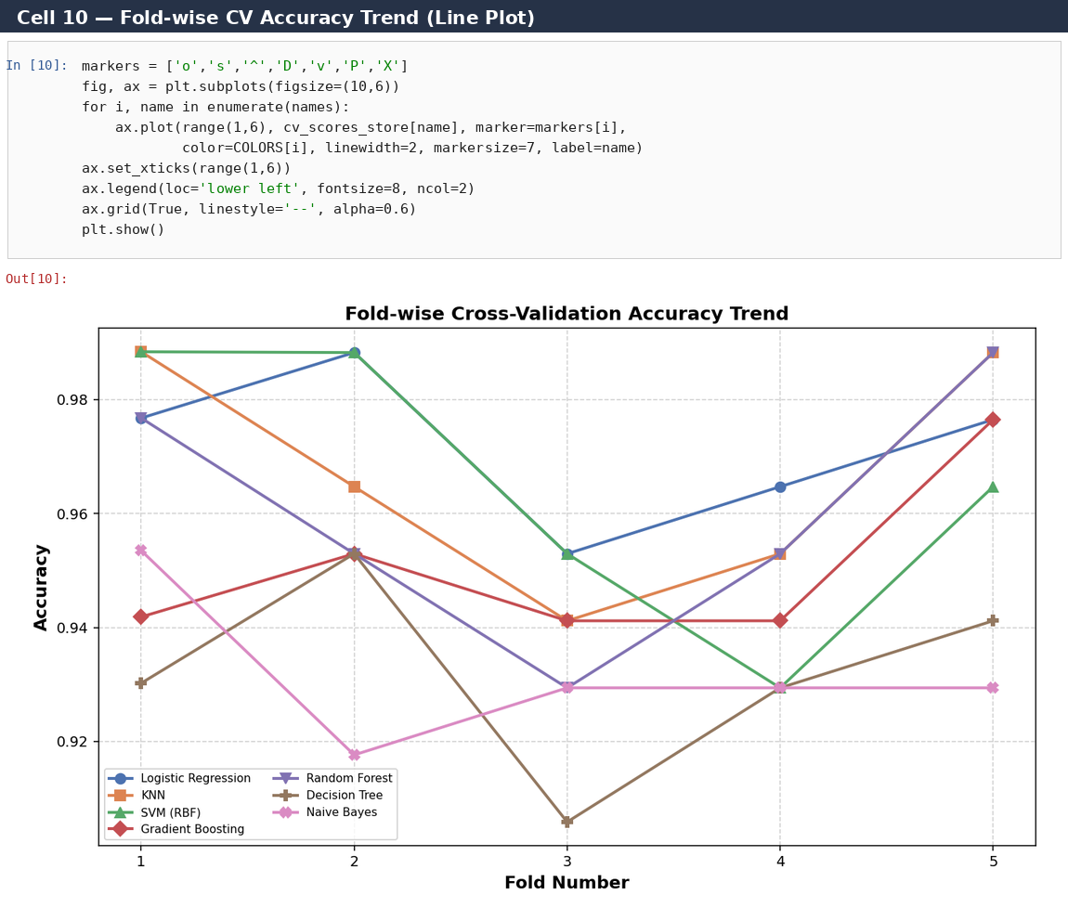

5.11 Random Forest Feature Importance
Using the trained Random Forest's feature_importances_ attribute, the ten most influential tumour measurements are ranked in a horizontal bar chart colored with the viridis colormap.
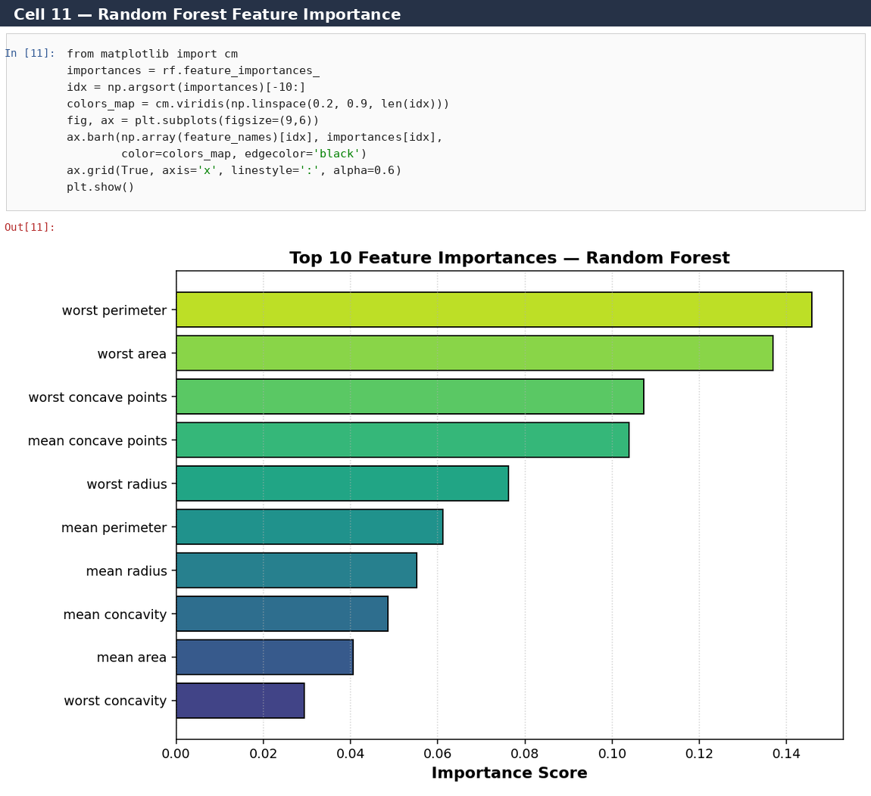

5.12 Model Stability (Error Bar Chart)
ax.errorbar() summarises each model's cross-validation mean accuracy with the standard deviation as an error bar, giving an at-a-glance view of both performance and consistency.
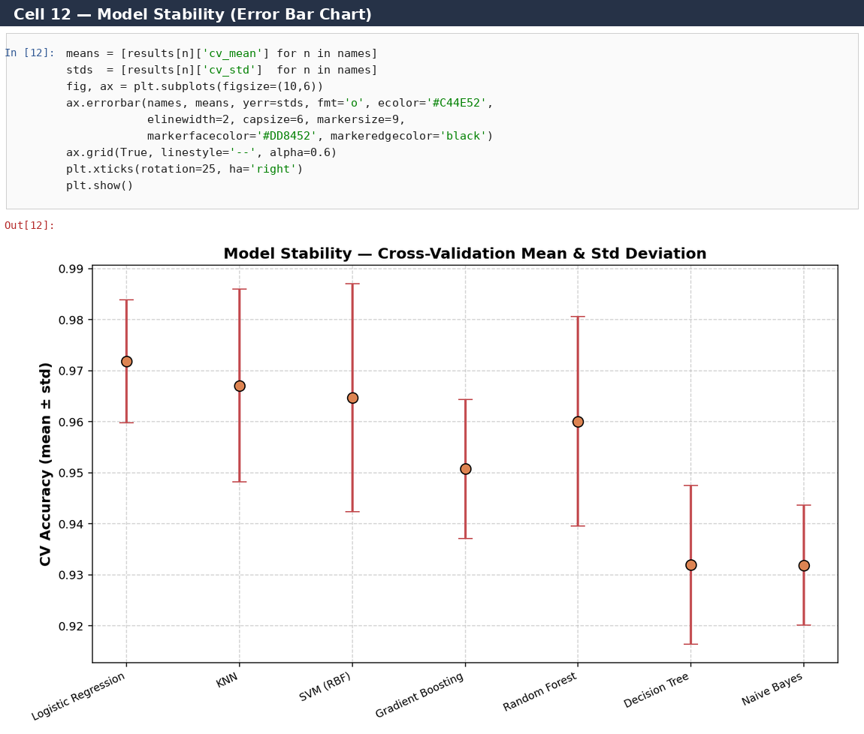

5.13 Summary Dashboard (subplot2grid)
A composite dashboard built with plt.subplot2grid() combines the accuracy ranking, the best model's confusion matrix, and the full ROC comparison into a single presentation-ready summary figure.
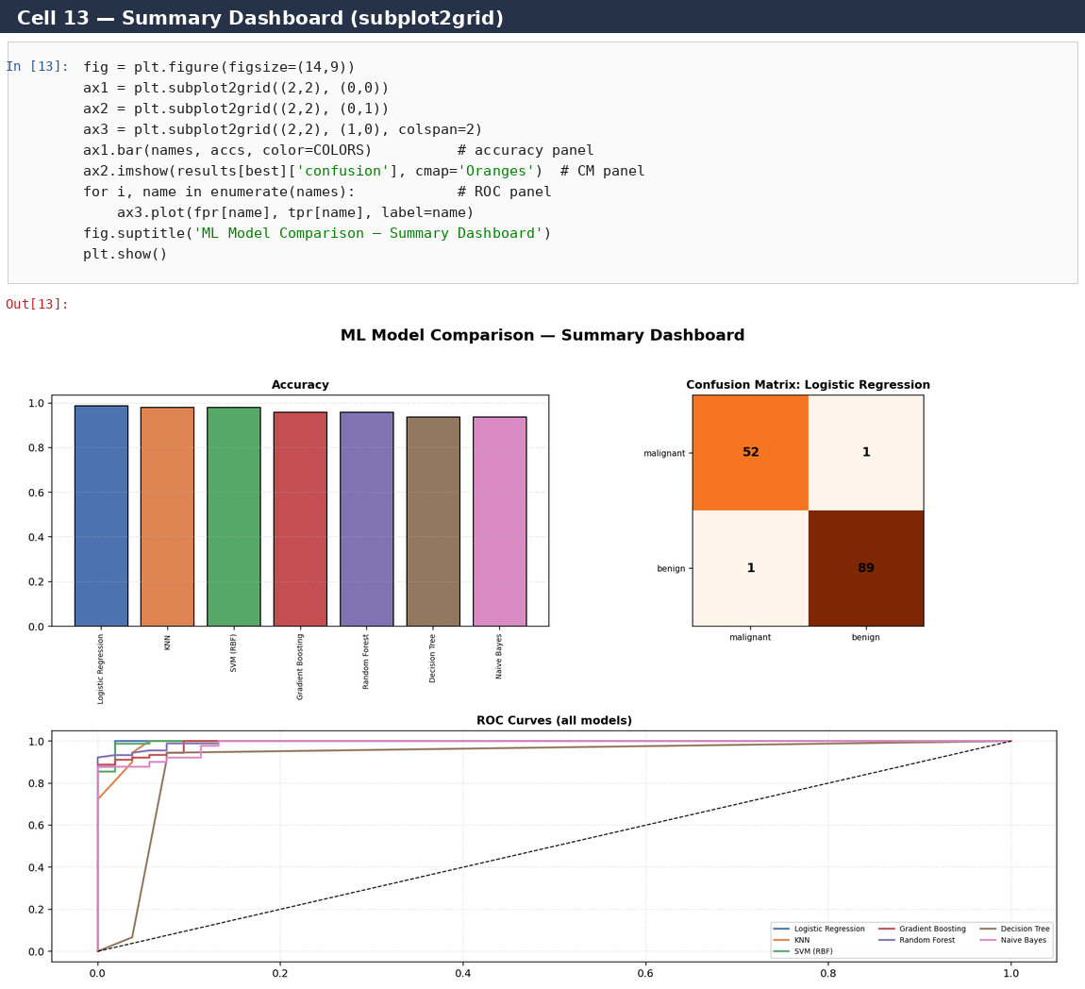

6. Observations
- Logistic Regression and the SVM (RBF) / KNN group produced the highest, most consistent accuracy on this dataset, all exceeding 97% test accuracy.
- Decision Tree and Naive Bayes had the lowest accuracy (~93.7%), consistent with their simpler decision boundaries compared to ensemble or margin-based methods.
- Cross-validation results (boxplot, Section 5.4) confirm that Logistic Regression and Random Forest are the most stable across folds — narrow interquartile ranges with few outliers.
- ROC/AUC analysis (Section 5.5) shows Logistic Regression achieving the highest AUC (~0.998), indicating excellent separability between malignant and benign classes.
- Feature importance analysis (Section 5.11) identifies 'worst area', 'worst concave points' and 'mean concave points' as the most influential predictors for the Random Forest model.

7. Conclusion
All seven algorithms performed well on the Breast Cancer Wisconsin dataset (accuracy 93.7%–98.6%), confirming that the features are highly predictive of diagnosis. Linear and margin-based models (Logistic Regression, SVM) slightly outperformed tree-based and probabilistic models on this particular dataset, while ensemble methods (Random Forest, Gradient Boosting) offered a good balance of accuracy and interpretability through feature importance. Matplotlib proved effective for both diagnostic visualization (ROC curves, confusion matrices, cross-validation boxplots) and presentation-ready summaries (the multi-panel dashboard), supporting the conclusion that model efficiency should always be assessed through multiple complementary metrics and visualizations rather than accuracy alone.

