ASSESSMENT TOOL 1 – DATABASE DESIGN AND CONNECTIVITY
Course Code: | DSA0507 | Course Title: | Query Processing for Data Science With Real Time Applications
CO Assessed: | CO2 | Assessment: | AT1 – Database Design and Connectivity
Weightage: |  | Total Marks: | 30 Marks
CO2 Statement: Design relational database schemas and establish connectivity between Python applications and databases (SQLite/MySQL), performing create, read, update and delete operations along with multi-table queries. (BL3 and BL4).
Student Name: | Edrin J S | Reg. No.: | 192524041
Section / Batch: | 2025 | Date of Submission: | 01-08-2026
Faculty In-charge: | Dr.R.Mahesh Muthulakshmi | Project Mode: | Individual Submission

Code of Conduct
I Edrin J S (192524041) certify that this submission is my original work and that I have adhered to all guidelines specified for this assessment. I understand that any violation of academic integrity rules will result in disciplinary action.
Signature: edrin

Analysis (5 Marks) | Application (5 Marks) | Evaluation (5 Marks) | Synthesis / System Level Thinking (5 Marks) | Total (20 Marks)

Question 1: Student Database Design and Connectivity (10 Marks)
Aim:
To design an SQLite database containing a Student table with appropriate fields and a primary key, and to write a Python program that connects to the database, creates the table if it does not exist, inserts at least five student records, and displays all the records stored in the table.
Approach:
- Connect to the SQLite database using sqlite3.connect(), which creates the database file if it does not already exist.
- Create the Student table with StudentID as the PRIMARY KEY, along with Name, Age, Department and a UNIQUE Email field.
- Insert five sample student records using cursor.executemany() and commit the transaction.
- Query the table with a SELECT statement and fetch all rows using cursor.fetchall().
- Display the retrieved records in a formatted, tabular layout.
Program:
import sqlite3

# Step 1: Connect to the SQLite database (creates the file if it does not exist)
conn = sqlite3.connect('student.db')
cursor = conn.cursor()

# Step 2: Create the Student table if it does not already exist
cursor.execute('''
CREATE TABLE IF NOT EXISTS Student (
StudentID INTEGER PRIMARY KEY,
Name TEXT NOT NULL,
Age INTEGER,
Department TEXT,
Email TEXT UNIQUE
)
''')

# Step 3: Clear old data (so the script can be re-run safely) and insert 5 sample records
cursor.execute('DELETE FROM Student')
students = [
(101, 'Aarav Sharma', 19, 'Computer Science', 'aarav.sharma@college.edu'),
(102, 'Priya Nair', 20, 'Electronics', 'priya.nair@college.edu'),
(103, 'Rohan Gupta', 19, 'Mechanical', 'rohan.gupta@college.edu'),
(104, 'Sneha Reddy', 21, 'Civil', 'sneha.reddy@college.edu'),
(105, 'Kabir Singh', 20, 'Computer Science', 'kabir.singh@college.edu')
]
cursor.executemany('INSERT INTO Student VALUES (?, ?, ?, ?, ?)', students)
conn.commit()

# Step 4: Display all the records stored in the table
print("----- STUDENT TABLE -----")
cursor.execute('SELECT * FROM Student')
print(f"{'StudentID':<10}{'Name':<15}{'Age':<5}{'Department':<18}{'Email'}")
for row in cursor.fetchall():
print(f"{row[0]:<10}{row[1]:<15}{row[2]:<5}{row[3]:<18}{row[4]}")

print(f"\nTotal records inserted: {cursor.execute('SELECT COUNT(*) FROM Student').fetchone()[0]}")

conn.close()

Output:
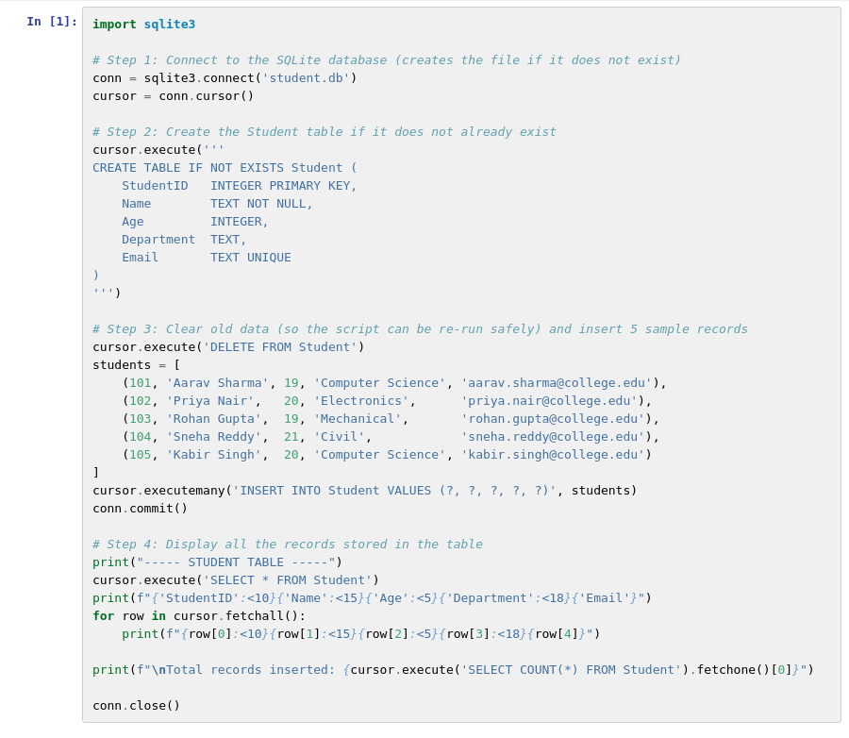
Screenshot 1.1 - Program executed in Jupyter Notebook
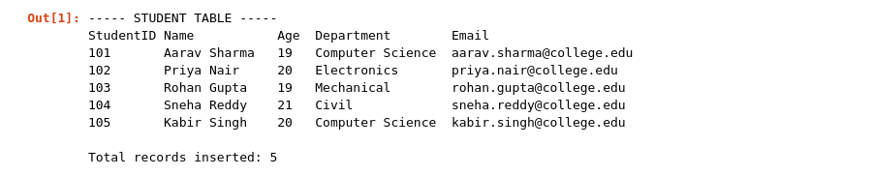
Screenshot 1.2 - Output showing the Student table records
Result:
The Python program was executed successfully. A connection to student.db was established, the Student table was created with StudentID as the primary key, and five student records were inserted successfully. Querying the table confirmed that all five records were stored and displayed correctly, with StudentID enforcing uniqueness for each entry.

Question 2: Employee and Department Database Design (10 Marks)
Aim:
To design two related SQLite tables, Department and Employee, by identifying appropriate primary and foreign keys, and to write a Python program that connects to the database, creates both tables, inserts sample data into each, and displays the employee name along with the corresponding department name using an SQL JOIN query.
Approach:
- Connect to the SQLite database and create the Department table with DepartmentID as the PRIMARY KEY.
- Create the Employee table with EmployeeID as the PRIMARY KEY and DepartmentID as a FOREIGN KEY referencing Department(DepartmentID).
- Insert sample records into the Department table followed by the Employee table.
- Write an INNER JOIN query that combines Employee and Department on the DepartmentID column.
- Fetch and display the EmployeeName together with the matching DepartmentName for each row.
Program:
import sqlite3

# Step 1: Connect to the SQLite database
conn = sqlite3.connect('company.db')
cursor = conn.cursor()

# Step 2: Create the Department table (parent table with primary key)
cursor.execute('''
CREATE TABLE IF NOT EXISTS Department (
DepartmentID INTEGER PRIMARY KEY,
DepartmentName TEXT NOT NULL
)
''')

# Step 3: Create the Employee table (child table with a foreign key referencing Department)
cursor.execute('''
CREATE TABLE IF NOT EXISTS Employee (
EmployeeID INTEGER PRIMARY KEY,
EmployeeName TEXT NOT NULL,
DepartmentID INTEGER,
FOREIGN KEY (DepartmentID) REFERENCES Department(DepartmentID)
)
''')

# Step 4: Clear old data and insert sample records into both tables
cursor.execute('DELETE FROM Employee')
cursor.execute('DELETE FROM Department')

departments = [
(1, 'Finance'),
(2, 'Human Resources'),
(3, 'Marketing')
]
cursor.executemany('INSERT INTO Department VALUES (?, ?)', departments)

employees = [
(1, 'Anil Mehta', 1),
(2, 'Sonal Kapoor', 2),
(3, 'Rahul Jain', 3),
(4, 'Divya Menon', 1)
]
cursor.executemany('INSERT INTO Employee VALUES (?, ?, ?)', employees)
conn.commit()

# Step 5: Retrieve employee name along with department name using an SQL JOIN
print("----- EMPLOYEE - DEPARTMENT (INNER JOIN) -----")
cursor.execute('''
SELECT Employee.EmployeeName, Department.DepartmentName
FROM Employee
JOIN Department ON Employee.DepartmentID = Department.DepartmentID
''')

print(f"{'EmployeeName':<15}{'DepartmentName'}")
for row in cursor.fetchall():
print(f"{row[0]:<15}{row[1]}")

conn.close()

Output:
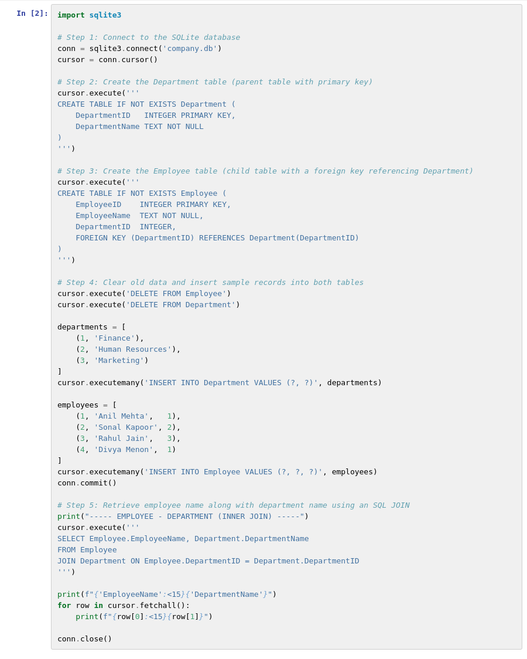
Screenshot 2.1 - Program executed in Jupyter Notebook

Screenshot 2.2 - Output of the Employee-Department JOIN query
Result:
The Python program was executed successfully. The Department and Employee tables were created with a proper primary key - foreign key relationship, and sample records were inserted into both. The INNER JOIN query correctly matched each employee to their department, confirming that the foreign key relationship linking Employee.DepartmentID to Department.DepartmentID was set up and queried correctly.

Question 3: Hospital Patient Database (10 Marks)
Aim:
To design an SQLite database with a Patient table containing suitable fields and constraints, and to write a Python program that connects to the database, creates the table, inserts patient records, updates the contact number of a specified patient, deletes a discharged patient's record, and displays the remaining records.
Approach:
- Connect to the SQLite database and create the Patient table with PatientID as the PRIMARY KEY and a CHECK constraint ensuring Age is greater than 0.
- Insert five sample patient records and display the table before any modification.
- Use an UPDATE statement with a WHERE clause to change the ContactNumber of a specified patient (PatientID = 'P002').
- Use a DELETE statement with a WHERE clause to remove the record of a discharged patient (PatientID = 'P005').
- Query and display the remaining records to confirm the update and delete operations.
Program:
import sqlite3

# Step 1: Connect to the SQLite database
conn = sqlite3.connect('hospital.db')
cursor = conn.cursor()

# Step 2: Create the Patient table with suitable fields and constraints
cursor.execute('''
CREATE TABLE IF NOT EXISTS Patient (
PatientID TEXT PRIMARY KEY,
Name TEXT NOT NULL,
Age INTEGER CHECK (Age > 0),
Disease TEXT,
ContactNumber TEXT
)
''')

# Step 3: Clear old data and insert sample patient records
cursor.execute('DELETE FROM Patient')
patients = [
('P001', 'Ravi Kumar', 34, 'Fever', '9876501234'),
('P002', 'Meena Das', 45, 'Diabetes', '9876502345'),
('P003', 'Arjun Verma', 29, 'Fracture', '9876503456'),
('P004', 'Divya Nair', 52, 'Hypertension','9876504567'),
('P005', 'Farhan Ali', 38, 'Discharged', '9876505678')
]
cursor.executemany('INSERT INTO Patient VALUES (?, ?, ?, ?, ?)', patients)
conn.commit()

print("----- PATIENT TABLE (BEFORE UPDATE / DELETE) -----")
for row in cursor.execute('SELECT * FROM Patient'):
print(row)

# Step 4: Update the contact number of a specified patient (P002 - Meena Das)
cursor.execute('UPDATE Patient SET ContactNumber = ? WHERE PatientID = ?', ('9998887777', 'P002'))
conn.commit()

# Step 5: Delete a discharged patient's record (P005 - Farhan Ali)
cursor.execute('DELETE FROM Patient WHERE PatientID = ?', ('P005',))
conn.commit()

# Step 6: Display the remaining records
print("\n----- PATIENT TABLE (AFTER UPDATE & DELETE) -----")
for row in cursor.execute('SELECT * FROM Patient'):
print(row)

print(f"\nRemaining patient records: {cursor.execute('SELECT COUNT(*) FROM Patient').fetchone()[0]}")

conn.close()

Output:
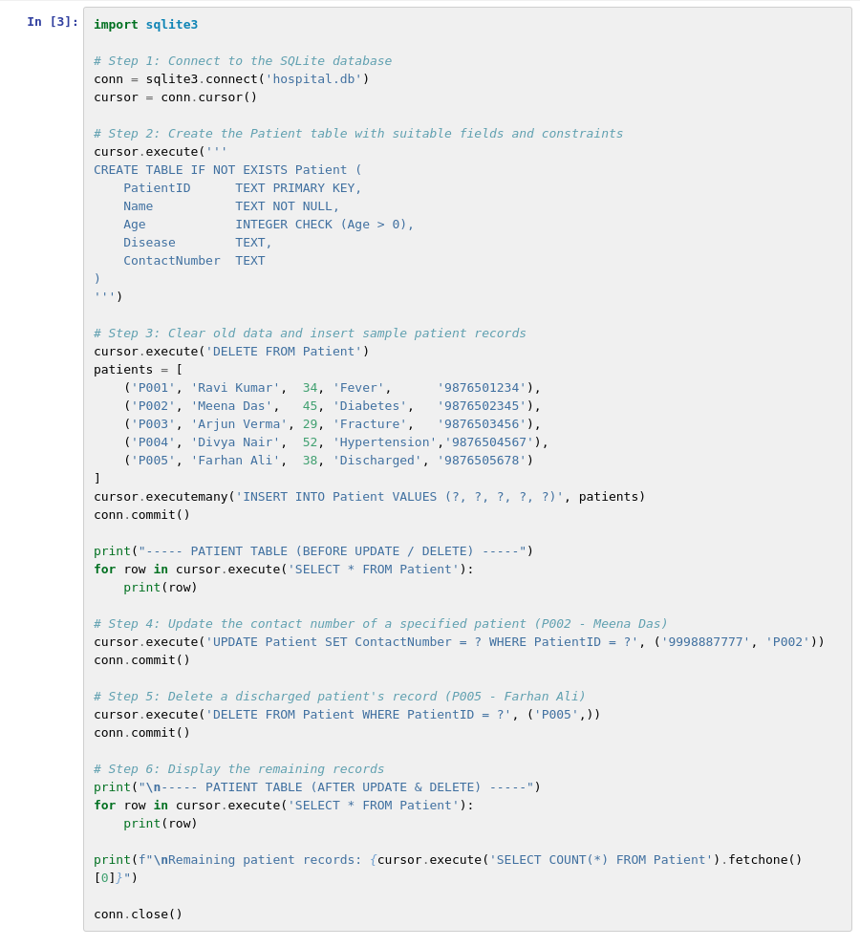
Screenshot 3.1 - Program executed in Jupyter Notebook
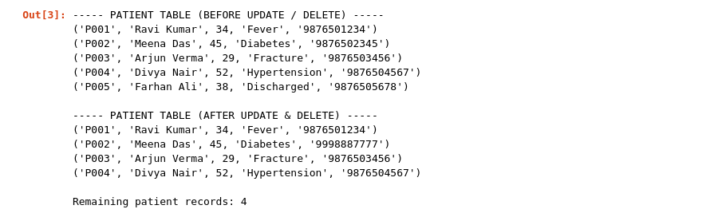
Screenshot 3.2 - Output before and after UPDATE / DELETE
Result:
The Python program was executed successfully. The Patient table was created with a primary key and an age constraint, and five records were inserted. The contact number of patient P002 (Meena Das) was updated successfully, and the discharged patient P005 (Farhan Ali) was deleted from the table. The final query confirmed 4 remaining records with the updated contact number reflected correctly.

