Contents
How to use this workbook 1
Introduction to the course 2
Module 1: What is data storytelling? 3
Why do data and analytics matter? 4
What are the benefits of data storytelling? 11
Converting insights into information 14
Module 2: Asking better data questions 18
What is a data question? 19
Translate and clarify questions 21
Module review 29
Underlying data quality 30
Main data qualities 31
Main types of data information 39
Module review 42
Building an insight 45
What is a hypothesis? 46
Developing the hypothesis 52
Actionable insight 54
Module review 57
Identify the audience 59
Who is my audience? 60
Empathy mapping 68
Module review 73
Building effective visuals 74
Where can visualisations be used? 75
Visualisation types 80
Focusing attention 106
How to emphasise the key points 109
Module review 119
Creating the story 120
Data narrative arc – telling the story! 121
Building the storyboard 123
Module review 127

How to use this workbook
 | Activity  This icon provides details of the group/individual activity or a point for everyone to discuss.
 | Key point  This icon highlights one of the major things to remember from the course.
 | Helpful hint  This icon guides you to tips or hints that will help you increase your effectiveness or efficiency in practising what you have learned.
 | Useful tool  This icon indicates a technique to help you implement your learning.

Introduction to the course
‘There is a story in your data. But your tools don’t know what that story is. That’s where it takes you—the analyst or communicator of the information—to bring that story visually and contextually to life.’
Cole Nussbaumer Knaflic, Storytelling with Data: A Data Visualization Guide for Business Professionals

Data storytelling is a powerful method of communicating insights, trends, and patterns found in data by presenting it in a compelling and engaging narrative format. It combines data analysis, visualisation, and storytelling techniques to make data more understandable and impactful for a wide audience.
Data storytelling aims to convey complex information in a way that is easy to comprehend and remember. This course is designed for anyone familiar with data and associated tools who wish to use them to communicate a story to a wider audience. Together, we will explore the fundamentals of data storytelling by looking at concepts such as understanding your audience, defining a clear message, crafting compelling narratives, and much more.
Although designed to be application agnostic, some activities may reference tools such as Microsoft Excel and Power BI.

Module 1: What is data storytelling?
Data storytelling is an essential skill in data analytics and communication. It is the art of compellingly and understandably conveying complex data-driven insights and findings using narratives and visualisations.
Combining data, analysis, and storytelling allows you to create a meaningful and impactful experience for your audience, enabling them to make informed decisions and gain valuable insights.
Data alone can be overwhelming and challenging to interpret for the average person. Data storytelling bridges this gap by presenting the data in a relatable and understandable context. It helps connect the audience to the data emotionally and intellectually, making it easier for them to grasp the underlying message and significance of the information.
Data storytelling is especially crucial in a data-driven world, where vast amounts of information are generated daily. The ability to transform this data into meaningful stories allows you to cut through the noise and focus on the most critical insights that can drive strategic decisions, improve operations, and enhance customer experiences.

By the end of this module, you will be able to:
- understand why data and analytics matter.
- comprehend the benefits of data storytelling.
- convert insight into information.

Why do data and analytics matter?

What is data?
Data refers to raw facts, observations, or measurements collected and recorded for various purposes. It can be in numbers, text, images, audio, or any other structured or unstructured representation. Data is the foundation for information, knowledge, and insights when properly processed and analysed.
 | According to research expert Petroc Taylor, the total amount of data created, captured, copied, and consumed globally increased rapidly, reaching 64.2 zettabytes in 2020.  Global data creation will grow to more than 180 zettabytes by 2025.  Contextually, one zettabyte is equivalent to one trillion gigabytes.
Data plays a crucial role in virtually every aspect of society in the digital age, from business and science to healthcare and entertainment. With the proliferation of technology, vast amounts of data are generated and stored through various sources such as sensors, devices, social media, and online interactions.
According to Forbes Technology Council member Adam Rogers, unstructured and semi-structured data (like JSON) now comprise an estimated 80% of data collected by enterprises.
This huge increase in data collection stems from the rise of mobile devices, applications, wearables, and the Enterprise Internet of Things (EIoT).
EIoT covers approximately nine billion devices in many business and corporate settings, such as medical, healthcare, transportation, and agriculture. YES, even your home – ‘ALEXA, turn on the lounge lights!’
Data can be categorised into two main types: quantitative data, which consists of numerical values and can be analysed statistically, and qualitative data, which involves descriptive attributes and requires more interpretive analysis. We will talk more about this later in the course.

Effective data management requires a stable data architecture that involves designing and organising data systems, databases, and data flows.
Data Architecture | Example Tool
RDMS  Relational Database Management Systems | SQL Server  Oracle  PostgreSQL  Access
Data Warehousing Solutions | Google BigQuery  Amazon Redshift  Azure Synapse Analytics
ETL  Extract, Transform, and Load Tools | Microsoft SSIS  Power Query – Excel 365
BIP  Business Intelligence Platforms | Power BI  Tableau  QlikView
Techniques like data mining, machine learning, and artificial intelligence are used to extract meaningful patterns and knowledge from large datasets.
And remember, responsible data handling is crucial; privacy and security concerns must also be addressed to ensure the ethical use of data and protect individuals’ rights and sensitive information.

Why is data important?
Data has become increasingly important in storytelling due to the exponential growth in the available information and the advancement of technology that enables us to collect, process, and analyse data more effectively.
In this era of data-driven decision making, incorporating data into storytelling adds depth, credibility, and impact to narratives. Data-driven storytelling involves data and analytics to identify patterns, trends, and insights supporting and enriching the narrative.

This integration enhances the storytelling experience and helps audiences better understand complex issues and make informed judgments. Here are a few of the reasons why:
- Data enhances credibility: Data is tangible evidence supporting a story’s claims. The narrative gains credibility when you include data to back up its assertions. Audiences are more likely to trust and engage with stories supported by relevant and accurate data. Credibility is crucial when discussing complex or controversial topics, as data provides an objective and impartial perspective.
- Creating emotional connections: Data-driven storytelling can evoke powerful emotions by presenting the human side of the data. You can elicit empathy and understanding from your audience by using data to illustrate the impact of events or decisions on individuals and communities. For example, data about poverty rates can be humanised by sharing the personal stories of those affected, fostering a stronger emotional connection with the issue.
- Uncovering hidden stories: Data analysis can reveal compelling stories that might otherwise remain hidden. Data often holds valuable insights and connections that can be brought to light through exploration and visualisation. You can discover unique angles and narratives that captivate your audience by delving into data.
- Providing context and depth: Data enriches storytelling by providing context and depth to the narrative. Data can offer a broader perspective and help audiences understand the bigger picture when discussing historical events, social issues, or economic trends. This multidimensional view enables people to make more informed judgments about the topics.
- Impactful visualisations: Data visualisations, such as charts, graphs, and infographics, bring numbers to life and make complex information more accessible. Visual representations of data make it easier for audiences to comprehend and remember the key messages in a story. Interactive data visualisations, in particular, enable audiences to explore the data themselves, enhancing engagement and understanding.
- Empowering data-driven journalism: In the digital age, data-driven journalism has become powerful in uncovering and reporting stories. Investigative journalists use data analysis to uncover corruption, track trends, and reveal societal issues. This data-driven approach to journalism fosters transparency and accountability while providing the public with evidence-based reporting.

- Persuasive advocacy: When advocating for a cause, data can be a persuasive tool to build a compelling case. By presenting data-supported arguments, advocates can influence public opinion and policy decisions. For instance, environmental activists may use data on rising temperatures and climate change impacts to advocate for policy changes to combat global warming.
- Driving business decisions: Data-driven storytelling is not limited to journalistic or advocacy purposes; it also plays a vital role in the business world. Companies use data analytics to understand customer behaviour, market trends, and performance metrics. Data-driven insights are invaluable when crafting marketing strategies or making strategic business decisions.
- Addressing misinformation: In an era of misinformation and fake news, data can be a valuable tool for fact-checking and debunking false claims. Data-backed stories can help correct misconceptions and promote a more accurate understanding of complex issues.
- Fostering critical thinking: Data-driven storytelling encourages critical thinking among audiences. By presenting data, you can enable your audience to interpret information, draw conclusions, and form their own opinions based on evidence, thus empowering individuals to be more discerning information consumers in a data-saturated world.

In conclusion, data-driven storytelling is a powerful approach that enhances narratives, adds credibility, and fosters a deeper understanding of complex issues.
By incorporating data and analytics into storytelling, we can create more compelling and persuasive narratives that resonate with audiences, drive informed decision making, and promote a more informed and enlightened society.

What is data analytics?
Analytics refers to systematic data analysis to derive meaningful insights, patterns, and trends that can inform decision making and drive improvements in various fields. It involves using mathematical, statistical, and computational techniques to process and interpret data, enabling businesses, organisations, and individuals to understand their operations better and make informed choices.
Data is generated at an unprecedented rate in the digital age, making analytics a crucial tool for extracting valuable information from this vast sea of information. The analytics process typically begins with data collection, where relevant data is gathered from various sources, such as databases, sensors, social media, and web interactions.
A recent report from Netflix, published in the journal insideBIGDATA, states that its recommendation algorithm influences about 80% of all content watched on the platform.
The result? Better retention and $1 billion in savings.
Once the data is collected, it is cleaned, organised, and transformed into a suitable format for analysis. Descriptive analytics examines historical data to understand what has happened in the past. Predictive analytics uses historical data and statistical algorithms to forecast future outcomes and trends. Prescriptive analytics suggests optimal actions to achieve specific goals based on the analysis.
Businesses use analytics to gain insights into customer behaviour, optimise operations, improve marketing strategies, and enhance overall performance. In healthcare, analytics can improve patient outcomes and optimise resource allocation. In finance, it aids risk assessment and investment decisions.
Analytics has also become essential in sports, education, and government to enhance performance, tailor services, and inform policies. As technology advances, analytics plays a vital role in extracting valuable knowledge from data, shaping a data-driven world where informed decisions lead to greater efficiency and success.
According to travel and tourism industry studies, 68% of tour operators use predictive analytics.
The results – how they can fine-tune their pricing strategies better, work on reputation management, and improve customer experience.

Why is data analytics important?
Analytics is a critical element in storytelling, as it allows you to uncover meaningful insights, enhance narratives, and connect with audiences on a deeper level. As data proliferates, integrating analytics in storytelling has become increasingly essential to make sense of vast information and effectively communicate compelling stories. Here are a few of the reasons why:
- Data-driven decision making: Analytics provides valuable data-driven insights that inform your creative decisions. By analysing data, such as audience preferences, engagement metrics, and content performance, you can tailor their narratives to resonate better with their target audience. This data-driven approach helps increase the likelihood of a story’s success and impact.
- Personalisation: Analytics enables you to create personalised experiences for your audience. By understanding the preferences and behaviours of individual users, content can be customised to suit their interests. Personalisation enhances audience engagement and fosters a stronger emotional connection with the story.
- Audience understanding: Analytics allow you to understand your audience better. You can identify the audience’s interests, concerns, and motivations by analysing demographic data, online behaviour, and social media interactions. This knowledge helps create more relevant, relatable stories that resonate with the intended audience.
- Identifying trends and patterns: Through analytics, you can identify trends and patterns in data, which can be woven into narratives to make them more relevant and timely. For instance, social media analytics can reveal real-time conversations and trending topics that can be incorporated into a story to increase its relevance and appeal.
- Fact-checking and verification: Analytics play a crucial role in fact-checking and verifying information before it is included in a story. Data analysis helps ensure the accuracy and reliability of the information presented, reducing the risk of spreading misinformation.
- Visualising data: Analytics allows you to visualise data engaging and compellingly. Data visualisations, such as charts, graphs, and infographics, make complex information more accessible and easily comprehended. Visualisations add depth and context to the story, enhancing the audience’s understanding and retention of the key messages.

- Story optimisation: Analytics provides real-time feedback on how a story is performing, allowing you to make iterative improvements and optimisations. You can refine their narratives by monitoring metrics such as page views, time spent on content, and bounce rates to keep audiences engaged and interested.
- Emotional impact: Analytics can help you gauge the emotional impact of their narratives. By tracking audience reactions and sentiment analysis, you can understand how their stories evoke emotions in the audience. This feedback lets them fine-tune their storytelling techniques to evoke the desired emotional response.
- Cross-platform storytelling: With analytics, you can assess the performance of their stories across different platforms and channels. Understanding which platforms resonate best with the target audience allows you to tailor content for specific platforms and maximise reach and engagement.
- Storytelling with artificial intelligence: Integrating AI and analytics opens up new possibilities in storytelling. AI-powered analytics can quickly analyse vast amounts of data, uncover hidden patterns, and generate insights that human storytellers might miss.
- Measuring impact and ROI: Analytics provide quantifiable metrics to measure the impact of a story and its return on investment. By tracking key performance indicators (KPIs) such as conversions, shares, and audience engagement, you can evaluate the success of their narratives and demonstrate their value to stakeholders.
In conclusion, analytics is a powerful tool that enhances storytelling by providing data-driven insights, personalisation, and a deeper audience understanding.
With analytics, you can create compelling, relevant, and impactful narratives that resonate with audiences across various platforms and channels.
As technology and data evolve, analytics integration in storytelling will continue to shape how stories are crafted, delivered, and received, fostering a more engaging and immersive storytelling experience.

Ethical considerations
Despite its numerous advantages, data-driven storytelling and analytics in storytelling also come with challenges. Data privacy, security, accuracy, and transparency are critical considerations, as you must ensure responsible handling of user data. Ethical concerns surrounding data usage and potential biases in data analysis must also be addressed to maintain trust with the audience.

What are the benefits of data storytelling?
As you now know, data storytelling is a powerful way of conveying complex information and insights through data and narratives. It involves presenting data compellingly and engagingly, often with the help of visualisations and storytelling techniques. This topic will explore the benefits of data storytelling and endeavour to guide you toward becoming a more effective storyteller.

Improved comprehension
Improved comprehension in data storytelling refers to an audience’s enhanced understanding and engagement when data is presented effectively and coherently in a narrative form.
It involves transforming complex datasets into compelling stories that are easily digestible and relatable to the target audience. This approach leverages data visualisation, clear language, and storytelling techniques to convey insights and key messages in a more accessible manner.
By incorporating data into a narrative structure, you can create a cohesive and logical flow connecting data points and highlighting patterns and trends. Using visuals, such as charts, graphs, and infographics, aids in simplifying complex information, making it easier for audiences to grasp the main takeaways.
Improved data storytelling comprehension makes data-driven information more understandable and fosters emotional connections with the audience. Human-centric stories that utilise real-life examples or scenarios resonate more deeply with individuals, resulting in higher engagement and retention of the presented data.
Effective data storytelling fosters better decision making, as audiences can more confidently interpret and act upon the insights derived from the data. It empowers individuals to harness the power of data to drive positive outcomes and create meaningful impacts in various domains, such as business, education, healthcare, and public policy.

Enhanced communication
Enhanced communication means using various techniques, tools, and strategies to convey insights and information from data, compellingly and understandably, effectively. It goes beyond presenting raw data and delves into crafting a narrative that resonates with the audience, making the information more engaging and impactful.
To enhance communication, you can leverage data visualisation techniques like graphs, charts, and infographics to simplify complex datasets and enable quick comprehension. They use storytelling principles to create a cohesive narrative, incorporating relatable examples and real-world scenarios to contextualise the data.
Moreover, they tailor the communication style to suit the target audience, ensuring the message is clear and relevant to different groups. Interactivity is vital in enhanced communication, allowing users to explore and interact with the data and fostering a deeper understanding.
Finally, embracing multimedia elements on the audience dashboard, such as animations and interactive slicers, enhances the storytelling experience, making it more immersive and memorable.
In essence, enhanced communication in data storytelling empowers audiences to grasp key insights effortlessly, facilitating better decision making and fostering data-driven understanding across various domains.

Fostering empathy
Data-driven stories can humanise the data and create empathy with the represented subjects or issues. Fostering empathy in data storytelling involves crafting narratives that emotionally connect with the audience, enhancing their understanding of complex data and encouraging them to care about the insights presented. These can be achieved through several key strategies, including:
- Humanise your data by incorporating real-life examples and personal stories.
- Utilise infographics, charts, and interactive elements to evoke emotions and create a visual impact for your audience.
- Consider the ethical implications of the data and storytelling process by demonstrating transparency, fairness, and sensitivity of the data.
- Empathy flourishes when the audience feel they can influence outcomes and contribute to positive change, so encourage participation and feedback.
You can foster empathy by weaving these elements together, enabling audiences to connect emotionally with data, understand its relevance to their lives, and be motivated to take meaningful action.

Data-driven decision making
Collecting, analysing, and interpreting data to identify patterns, trends, and correlations and then presenting this data in a narrative format can guide strategic choices and enable decision-makers can gain a deeper understanding of the context and implications of the data.
The process generally follows the pathway shown below:

By integrating data-driven decision making into data storytelling, you can communicate complex information in a more accessible manner, enabling stakeholders to comprehend and act upon the insights effectively.
This approach empowers businesses to make informed choices, optimise processes, identify opportunities, and address challenges efficiently based on concrete evidence, leading to more successful outcomes.
Data-driven decision making within data storytelling fosters a culture of data literacy and evidence-based decision making, ensuring organisations stay competitive and agile in an increasingly data-centric world, and stakeholders from different backgrounds and perspectives are more likely to align on key issues and priorities, leading to better collaboration and decision making.

Building trust
Data storytelling can enhance credibility and trust in the data and the insights presented. Data becomes more believable and trustworthy when presented transparently and coherently, which is essential to ensure that your audience believes and relies on your insights and conclusions.
Data storytelling is a crucial skill for data professionals, analysts, and leaders alike, enabling them to effectively communicate the value of data and drive positive outcomes based on data-driven insights.
In summary, you can now see that storytelling techniques enable effective communication of complex information by employing data analysis and visualisation to convey compelling narratives and combining insights from large datasets.
This approach empowers businesses and organisations to make informed decisions and engage audiences on a deeper level, enhancing understanding and driving actionable outcomes.

Converting insights into information
Insights are often abstract or intangible, while information provides a tangible and structured way to communicate that insight to others. Converting your insight into information (insight generation as it is sometimes known) will enable it to be shared with a broader audience, enabling you to disseminate your insights to people who can benefit from them.
When you convert insights into information, you make it easier for decision-makers to comprehend the implications of the insight, and backing up your insights with data and evidence strengthens their credibility, facilitating a more informed and data-driven decision-making process and increasing trust in the conclusions you draw.
By presenting an insight as information in a structured manner you can identify patterns, correlations, and potential solutions to problems, which can be shared and discussed with others, inviting collaboration and feedback leading to refinement and improvement of ideas with the culmination of better outcomes.
You also have a record of your observations and ideas when converting them into well-documented information. This documentation can be valuable for future reference, analysis, or historical context. The newly-acquired information can become part of the collective knowledge of an organisation or community. This knowledge can be preserved and transferred to new team members or future generations.
The insight generation process allows you to share your insight effectively with others or use it to make informed decisions.
Sharing knowledge fosters collaboration, learning, and growth.

Here’s a step-by-step guide to help you with this conversion:
Step | Title | Description
 | Clearly define the insight | Start by articulating your insight clearly and concisely. Understand what you have learned or discovered and be able to explain it in a few sentences.
 | Gather supporting data | Collect relevant data, facts, or examples that support your observation to provide evidence for its validity.  This data will strengthen your information and make it more convincing to others.
 | Organise the information | Structure your insight and supporting data logically. Create an outline or framework that highlights the key points and shows how they relate to each other.  This organisation will help make the information easier to understand.
 | Provide context | Offer context and background information to set the stage for your insight.  This context helps others understand the significance of your observation and how it fits into the broader picture.
 | Visualise the information | Utilise visual aids such as charts, graphs, or infographics to make your information more engaging and easily comprehended.  Visual representations can help simplify complex concepts and present data more digestibly.
 | Remove ambiguity | Ensure your information is unambiguous. Avoid jargon or technical terms that might be confusing to your audience.  Use simple language and straightforward explanations.
 | Relate it to the audience | Consider the audience you want to communicate with and tailor your information accordingly.  Use language and examples that resonate with your target audience’s knowledge and interests.
 | Incorporate storytelling | Humans are naturally drawn to stories. Weaving your insight into a compelling narrative can make the information more memorable and relatable.
 | Review and refine | Take the time to review your information, checking for any inconsistencies, errors, or gaps in your logic.  Refine the content to ensure it is accurate and compelling.
 | Present the information | Choose an appropriate medium to present your information, such as written reports, presentations, or online content.  Use a format that best suits your audience and the nature of the insight.

By following these steps, you can effectively convert your insight into clear, coherent, and persuasive information, enabling you to share your knowledge and ideas with others meaningfully.

Module review
Overall, data storytelling is about connecting data with human emotions, experiences, and insights. Combining data analysis with compelling storytelling techniques and effective visualisations allows you to communicate complex information that resonates with your audience and drives better decision making.
This module was about:
- understanding why data and analytics matter.
- comprehending the benefits of data storytelling.
- the importance of converting insight into information.

Review activities
You can discuss these with your trainer or write down some ideas for the business.
- Data for your stories – what data do you need for your reports in your organisation? Where is the data stored? How is the data accessed for your report?
- Analytics for your stories – what analytics do you use on your data?
- Your current insights – what insights do you have that need to be converted into information?

Module 2: Asking better data questions
A data question is an inquiry that seeks to gain insights, knowledge, or understanding from data. It is specific and well-defined, formulated to guide the analysis or exploration of data to extract meaningful information.
Each data question can vary in complexity and scope, ranging from simple descriptive queries to more advanced inferential or predictive questions.
They are fundamental to data analysis and are crucial in guiding the data analysis process, defining the appropriate methods and techniques, and ensuring that the results obtained from the data are relevant and meaningful for decision making and problem-solving.
Plus, they are extremely valuable in analysis as they help focus the investigation and direct efforts toward finding relevant answers.

By the end of this module, you will be able to:
- understand what a question is.
- translate and clarify traditional data questions into business speak.

What is a data question?
A data question is a fundamental inquiry that forms the backbone of data analysis and research endeavours. It represents a carefully crafted query designed to explore, investigate, and derive meaningful insights from data. Whether in science, business, social studies, or any other domain, data questions are pivotal in the quest for knowledge and understanding.
A data question is a specific, well-defined inquiry that seeks to uncover patterns, relationships, trends, or associations within a dataset. It guides you toward relevant answers and helps you stay on track while exploring vast and often complex datasets.
Formulating a data question requires careful consideration of the problem and available data. The question should be relevant, actionable, and aligned with the objectives of the analysis.
For example, if you work in a sales-driven environment, your data questions could be centred around understanding customer behaviour to improve marketing strategies or enhance product offerings in a business context.
Data questions can range in complexity and scope, catering to different analysis domains. Again, if you work in a sales-driven environment, here are some examples of data questions across different domains:
- Descriptive: A descriptive data question aims to summarise or describe the characteristics of a dataset. It seeks to understand the data’s distribution, patterns, and central tendencies. For example:
  - What is the average age of customers?
  - How many products were sold in each region last month?
- Exploratory: An exploratory data question seeks to understand patterns, relationships, and insights within a dataset without making specific predictions. It aims to uncover hidden trends and characteristics, helping storytellers understand the data’s structure and potential avenues for further analysis or investigation:
  - Is there a correlation between product sales and customer reviews?
  - Does temperature significantly correlate with ice cream sales in different regions during summer?

- Inferential: An inferential data question is a query that seeks to draw conclusions or make predictions about a population based on a sample dataset. It uses statistical analysis and hypothesis testing to infer broader patterns, relationships, or trends beyond the immediate data, providing insights into a larger context:
  - Can we conclude with statistical significance that a new marketing campaign increased website traffic?
  - Does the implementation of a new fitness program lead to a significant improvement in participants’ cardiovascular health?
- Predictive: A predictive data question forecasts future outcomes or trends based on historical data patterns. It involves using statistical techniques or machine learning algorithms to analyse past data and make informed predictions, enabling businesses and storytellers to anticipate future events or behaviour with a degree of accuracy.
  - Based on historical sales data:
- Can we forecast the demand for a product in the next quarter?
- What is the projected revenue for the next quarter?’
- Causal data: A causal data question seeks to understand the cause-and-effect relationship between variables. It aims to determine whether changes in one variable directly influence changes in another. These questions often require experimental designs or rigorous observational methods to establish causality rather than mere correlation:
  - Does changing the packaging of a product influence customer satisfaction?
  - Does regular exercise cause a reduction in cholesterol levels among middle-aged adults?
You may often employ various statistical and computational techniques, data visualisation tools, and machine learning algorithms to answer data questions. These methods enable you to derive valuable data insights and effectively communicate your findings.
Ultimately, data questions serve as the foundation of evidence-based decision making. They empower storytellers, business leaders, and policymakers to make informed choices, solve problems, and unlock data’s potential to drive positive outcomes.
By formulating precise and thoughtful data questions, you can embark on a journey of discovery and innovation that leverages the power of data to understand the business around you.

Translate and clarify questions
Now that we know what a data question is, we can focus on understanding that in data analysis, it is essential that questions are well-understood and can be accurately answered.

Understand the context
Before attempting to translate or clarify a data question, ensure you understand the context and the purpose behind the question; this typically involves grasping the underlying purpose, scope, and relevant variables to formulate meaningful insights.
You may need to ask for additional information to comprehensively understand what is being asked. The additional information may be discerning the data’s origin, structure, and biases.
Sometimes contextual understanding entails identifying why the question was asked in the first place. By comprehending this context, you should be able to interpret data accurately, align findings with the desired objectives, and provide actionable recommendations.
Ultimately, contextual comprehension empowers data-driven decision making and enhances the value extracted from the data for business benefit.
Scenario: We work in a sales-driven environment and have been asked to report on our progress. During a meeting with our manager, we were asked rather general questions – Where are you doing well? What are the popular products?
If we put these into a context (a sales environment), we will need some clarification.
Let’s take this question through the process of understanding and see what comes out on the other side.

Identify ambiguities
Firstly, look for any ambiguities or vague terms in the question. Ambiguous questions can lead to incorrect interpretations and answers, so identifying ambiguities in a data question is crucial for accurate analysis and interpretation.
Potential ambiguities could arise from ambiguous pronouns, undefined units, temporal references, or missing constraints.
Here is an example of the ambiguous question we were asked in the scenario:
What are our most popular products?
Reason – The term ‘popular’ could be interpreted differently depending on the context.
How is ‘popular’ defined:
- Highest sales.
- Best-sellers.
- Specific customer ratings.
If you encounter unclear terms or concepts, seek clarification from the person who posed the question. Properly addressing these ambiguities ensures that the data is appropriately collected and analysed, leading to reliable insights and informed decision making.

Rephrase the question
Once you clearly understand the question, rephrase it in your own words, as this can often help confirm your understanding and make the question more straightforward. If the question has multiple parts, break it into individual components for easier analysis.
Let’s take another look at the ambiguous question from earlier. Now that we have identified the ambiguity, we can look at the possibility of rewording the question:
What are our most popular products?
For the question to be clarified, criteria for measuring popularity should be explicitly stated, such as:
- Which products had the highest sales?
- Could you provide a list of our top 10 most sold products?
- Among our corporate clients, which products most frequently score five stars?

Define variables and metrics
If the question involves specific variables or metrics, ensure they are well-defined and understood. Knowing what each variable represents and its corresponding data type (e.g., categorical, numerical) is essential for the following:
- To define variables and metrics in a data question, clearly state the problem and context.
- Identify the relevant variables representing data attributes to be analysed.
- Choose appropriate quantitative metrics to evaluate and draw insights from the data.
- Define the data types and units for each variable and metric.
- Ensure clarity, specificity, and relevance in the question’s wording to facilitate accurate data collection and analysis.
Let’s take another look at the question from earlier. Now that we have identified the ambiguity and rephrased the question, we can look at the possibility of defining the parameters:
What are our most popular products?
For the clarified question to be measurable, measuring variables should be explicitly stated, such as:
- Which products had the highest sales in the first quarter?
- Could you list our top 10 best-selling products from the previous 12 months?
- Among our corporate clients, which products most frequently score five stars each month?
After much deliberation, we have decided to go with the following question – which products had the highest sales in the first quarter?

Check for data availability
Now that our question is taking shape, we must ensure that the necessary data to answer the question is available and accessible. If the required data is missing or incomplete, communicate this to the person asking the question so that they can make informed decisions.
Once you have defined the specific data question you want to answer, you can take recommended steps to check data availability for a data question. These are as follows:
- Identify the relevant datasets or sources that might contain the required data.
- Access public databases, repositories, or APIs to search for the data. Verify if the data is up-to-date and covers the required time frame.
- Check data licences and usage restrictions.
- Reach out to data owners or organisations for permission if needed.
- Consider alternative sources or adapt the question to the available data if data is unavailable. Remember to maintain data privacy and comply with legal regulations.
Now let’s revisit the question and determine our data availability.
Which products had the highest sales in the 1st quarter?
The company has an Oracle database that stores sales transactions.
The data in the Oracle database is updated in nearreal-time – the data is accurate within 30 minutes.
We do not have direct access to the information, but we can request from the data team the dataset needed for the report.
This dataset will be sent to us in CSV format.
As you can see, we have followed the guidelines to ensure the dataset’s availability and can move on to the next step.

Verify assumptions
Data questions may be based on certain assumptions, so to verify data assumptions, you must first understand the data’s source, collection methods, and potential biases.
Test assumptions like normality for statistical methods, ensuring they hold. Validate assumptions by using appropriate visualisations, statistical tests, and cross-references.
Adjust or transform data if needed, maintaining transparency in your process. Regularly revisit assumptions as insights unfold.
Once you have verified these assumptions, take your findings to the person asking the question to ensure the analysis meets their expectations.
In the scenario, we can again assume that we have done this and verified the data.
Which products had the highest sales in the 1st quarter?
We have ensured that the data is accurate, complete, and error-free.
Outliers and skewing results were absent in the data, which can significantly impact statistical analyses.
Plus, the data was queried from the Oracle database, accurately portraying the time frame of the first quarter (first three financial months).
We must remember that real-world data analysis often involves a combination of statistical tests, visualisations, and domain expertise to make informed decisions.
We are now ready for the next step – the presentation.

Use visualisations
Visualising the data can often provide better insights and help clarify complex questions.
Choosing the right type of visualisation – bar charts for comparisons, line graphs for trends, pie charts for proportions, and focusing on clarity and relevance will help to illustrate the data and its patterns, making it easier to understand.
And remember that labelling axes, providing legends, and titling your visual appropriately while avoiding clutter and excessive details can also ensure the visual is easily understandable without additional explanations.
In most visualisation applications, you can automate the updating of the data so the visual will reflect the latest information.
Lastly, accompany the visual with a concise explanation to enhance comprehension.

Now let’s revisit the question from the scenario and determine what would be an appropriate visual.
Which products had the highest sales in the 1st quarter?
The raw data contains a three-month dataset for the first quarter which can be grouped by the interrogation field – the product.
You could create a table visual showing the list of products and the three-month summary (imagined below):
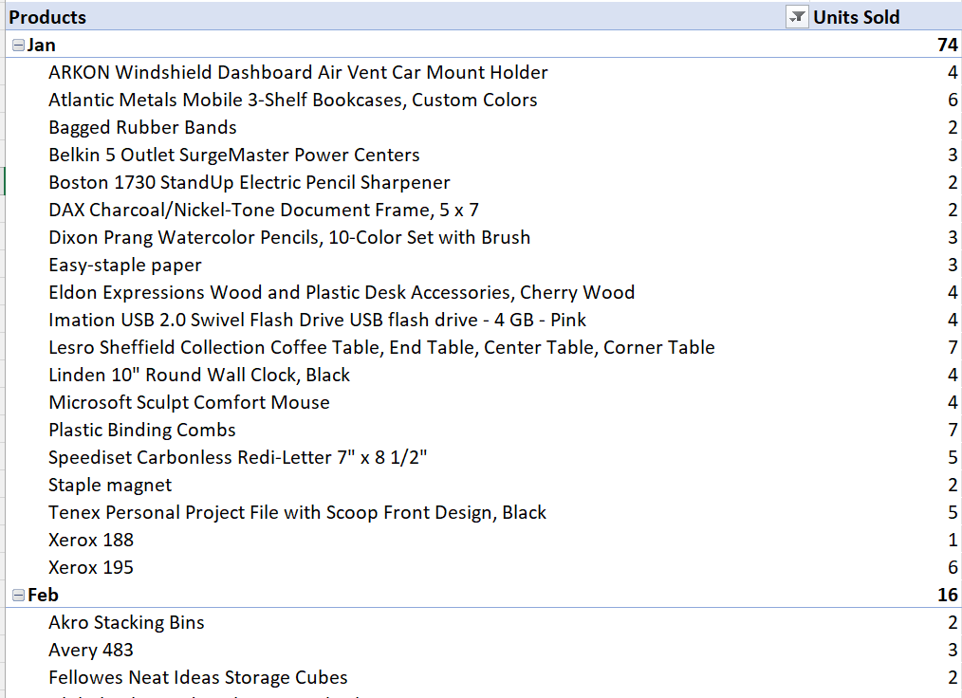But as you can see, the table has the potential to be a large and complex visual.
So as an alternative, you may wish to represent the story as a graph showing the key point of the question (imagined below).
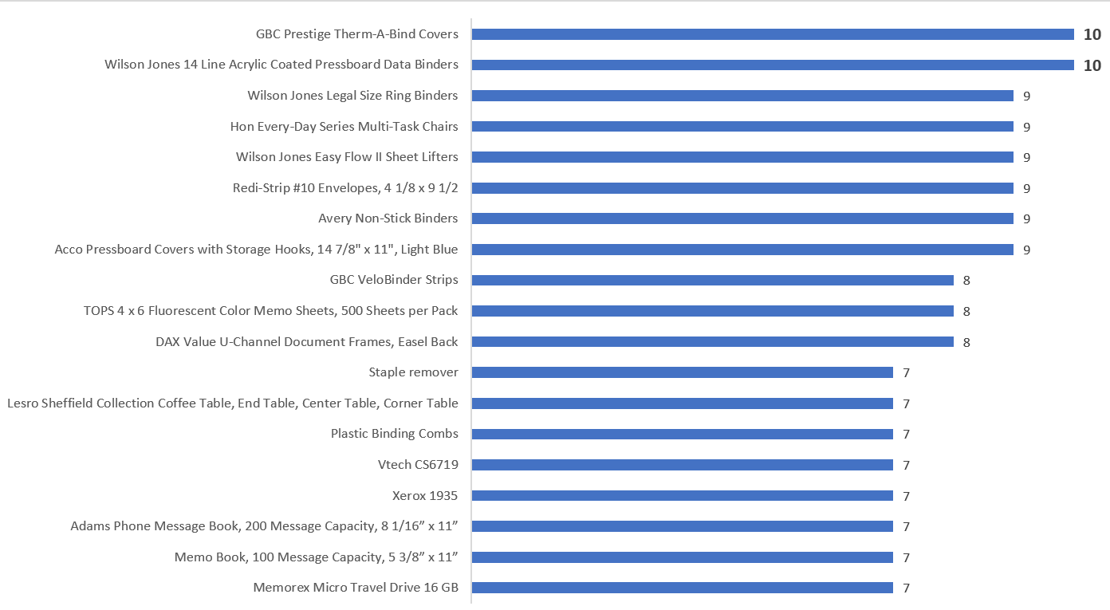

Ask for feedback
Feedback in data storytelling is crucial for improving the effectiveness of your communication and ensuring that your intended message is clear, impactful, and well-received. There are several different ways to give and receive feedback in the context of data storytelling.
The most common way of providing feedback happens after you have translated and clarified the question and shared your interpretation with the person who asked it. Seeking their feedback to confirm that your understanding aligns with their intention helps avoid miscommunication and ensures the analysis addresses the question.
Sometimes, your business may encourage other feedback forms such as peer reviews, multiuser testing, focus groups, and workshops.
Remember that feedback should be approached with an open mind and a willingness to improve.
Not all feedback may align with your vision, but diverse perspectives can help you create a more compelling and impactful data story.

Reflection activity
Think about the scenario, how your business gathers feedback, and how that may be improved in the future.

Iterate if necessary
If there are still uncertainties or additional information is provided, be prepared to iterate the process of translation and clarification until both parties have a clear understanding of the question.
Remember that effective communication and collaboration are key to successful data analysis – treat feedback as part of an iterative process.
Revise and improve your data story based on the feedback received.
Continue refining it until you achieve your desired outcome.
In summary, translating and clarifying the questions in data storytelling makes these inquiries comprehensible by transforming complex data-related queries into easily understandable language.
The ultimate goal is to bridge the gap between technical jargon and layperson understanding, ensuring that the audience grasps the purpose and significance of the data analysis.
The translation and clarification of data story questions play a pivotal role in unlocking the potential of data-driven narratives by making them accessible and meaningful to a wider audience.

Module review
In this module, we have seen that asking better questions in data storytelling is the art of framing inquiries that delve beyond surface-level insights, fostering deeper understanding and engagement. By formulating thoughtful, open-ended queries, data storytellers guide audiences to explore data’s nuances and significance. Effective questions provoke curiosity, stimulate critical thinking, and facilitate meaningful interpretations.
Crafting better questions involves clarity, relevance, and context. Instead of asking, ‘what are the sales figures?’ you could ask, ‘how have sales trends evolved, and what factors might explain fluctuations?’ This approach encourages a richer narrative, encouraging the audience to uncover patterns, relationships, and causality within the data.
Furthermore, addressing the ‘why’ and ‘how’ rather than just the ‘what’ encourages the exploration of underlying drivers. For instance, moving from, ‘did the marketing campaign succeed?’ to, ‘what aspects of the marketing strategy contributed to the campaign’s success, and how might they be replicated?’
Ultimately, asking better questions transforms data storytelling into a dynamic dialogue, sparking insights, fostering collaboration, and empowering audiences to extract profound meaning from the data presented.

This module was about:
- understanding what a question is.
- translating and clarifying traditional data questions into business speak.

Review activity
You can discuss this with your trainer or write down some ideas for the business.
Your questions – What questions do you regularly get asked for your reports in your organisation? How do you currently tackle those questions? What will you now do differently?

Module 3: Underlying data quality
In this module, you will learn that high-quality underlying data is essential in data storytelling to ensure accuracy, credibility, and meaningful insights.
Reliable data forms the bedrock upon which narratives are built, allowing for informed decision making and compelling communication.
Flawed or incomplete data can lead to misleading conclusions, eroding trust, and hindering the impact of the narrative.
By prioritising data quality, storytellers empower their audience to grasp the nuances of the information presented, fostering a deeper understanding of complex issues, and enabling more effective communication of the story’s key messages.

By the end of this module, you will be able to:
- Identify the four main data qualities: Filtered, gaps, specific, and naming.
- Understand the two main types of data: Quantitative and qualitative.

Main data qualities
The quality of the underlying data is the bedrock of effective data storytelling. It encompasses the accuracy, consistency, completeness, and reliability of the data used to craft a compelling narrative. Poor data quality can lead to misleading or incorrect insights, undermining the story’s credibility.
Accurate data ensures that the information presented is error-free and reflects reality. Consistency ensures that data points are uniform and comparable, allowing for meaningful analysis.
Completeness guarantees that all necessary data is included, preventing gaps that could distort the narrative. Reliability ensures that data sources are trustworthy and validated.
In data storytelling, high-quality underlying data lends credibility to the narrative, empowering storytellers to derive meaningful conclusions and actionable insights. It builds trust with the audience, enabling them to make informed decisions based on the story’s insights.
Data storytellers must rigorously validate and cleanse their data to ensure it meets these quality criteria, forming the cornerstone of a persuasive and impactful narrative.
Let’s examine four main issues often encountered in the underlying data.

Is the data filtered?
Filtered data can lead to problems in data storytelling due to its potential to distort the narrative, misrepresent patterns, and undermine the integrity of the insights being conveyed.
Filtering involves selecting a subset of data based on specific criteria, which can introduce bias and limit the scope of analysis.
While filtering may be necessary for certain analytical purposes, it should be used judiciously and its implications carefully considered when crafting a data-driven narrative.
Firstly, filtered data can create a skewed perspective by focusing only on certain aspects of the data while ignoring others, and this can lead to a one-sided or incomplete story that fails to capture the full complexity of the underlying trends.

Scenario 1
Omitting online sales data could skew the analysis.
For instance, excluding these figures might lead to a false perception of declining in-store sales, neglecting the significant revenue generated digitally.
This omission could result in misguided strategy adjustments, potentially hampering overall sales growth.
Secondly, filtered data can inadvertently highlight noise or outliers rather than genuine insights. The data story can become misleading or sensationalised when outliers are selectively included or excluded.
Scenario 2
When reviewing the monthly employee salary report, a top-level filter was applied to identify potential discrepancies.
This filter inadvertently highlighted a few unusually high executive salaries, overshadowing the overall pay structure within the business.
Furthermore, filtered data can hinder transparency and credibility. Stakeholders consuming a data-driven story may question the methodology and objectivity behind the analysis of the filtered data.
If readers or viewers suspect that relevant information has been omitted, it can erode trust in the narrative and the data storyteller. Trust is important in all data stories, especially in critical contexts such as scientific research or public policy discussions.
Moreover, filtered data may limit the ability to identify meaningful correlations and causal relationships. Analysts might overlook valuable insights from unexpected patterns by excluding data that doesn’t conform to certain preconceived notions.
Scenario 3
In a political survey, the responses expressing dissenting opinions were selectively omitted from the final report, presenting a skewed consensus.
This data filtration obscured non-conforming viewpoints, creating a misleading impression of public sentiment.
In data storytelling, context is key. Filtering should be transparently disclosed along with the reasons for the chosen criteria. Clearly articulating the limitations of filtered data helps the audience interpret the story accurately and form a more informed understanding.
Striking a balance between filtered and unfiltered data, and explaining the rationale behind filtering choices, ensures that the narrative remains grounded in reality and doesn’t mislead or manipulate.
In conclusion, while filtering data can be a valuable analytical tool, it poses risks in data storytelling. Filtered data can compromise the story’s effectiveness and integrity by distorting the narrative, emphasising outliers, undermining credibility, and inhibiting the discovery of meaningful insights.
Responsible and transparent use of filtering, combined with a broader context and consideration of potential biases, is essential for crafting accurate and impactful data-driven narratives.

Are there gaps in the data?
Gaps in data can significantly hinder the effectiveness of data storytelling, impeding the ability to convey meaningful insights and make informed decisions. Data storytelling is a powerful tool for conveying information, but its impact is compromised when gaps in data exist.
Firstly, data gaps can lead to incomplete or inaccurate analysis. When crucial data points are missing, the narrative may lack depth and nuance, potentially resulting in misleading conclusions.
Scenario 1
Suppose sales from one region aren’t recorded due to a technical glitch. In that case, the report might show a sudden drop in overall revenue triggering unnecessary stakeholder panic and misinformed decisions about reallocating resources or altering marketing strategies. Without complete data, the report lacks the context to accurately represent the company’s performance, potentially resulting in hasty actions that harm the business’s bottom line.
Secondly, data gaps erode the credibility of the story. Audiences, whether they are executives, stakeholders, or the general public, rely on accurate and comprehensive data to make informed judgments.
When gaps are evident, trust in the storyteller’s insights diminishes. This erosion of trust can hinder the acceptance and adoption of the story’s recommendations.
In an era where data-driven decision making is paramount, data gaps can be perceived as a lack of rigour or diligence, undermining the story’s impact.
Moreover, data gaps hinder providing context and a holistic view. Effective data storytelling involves providing a comprehensive understanding of the situation. It becomes challenging to paint a complete picture without all the relevant data.

Scenario 2
An HR report detailing employee satisfaction lacks survey data on employees working from home, weakening its credibility.
Without insights from this significant demographic, the report fails to present a comprehensive picture, potentially skewing conclusions and neglecting crucial improvements for remote work conditions.
Data gaps can also limit the identification of trends and patterns. Storytellers often aim to uncover insights that drive strategic decisions. However, if certain periods or variables are missing, the story might fail to recognise significant trends, hindering the ability to make accurate predictions or formulate effective strategies.
Scenario 3
In a finance report analysing consumer spending, missing data on cash transactions could obscure the complete picture.
If only credit card and digital payment data are considered, a significant portion of transactions might be overlooked.
This data gap could lead to an inaccurate assessment of trends, potentially masking the actual decline in overall consumer spending.
Furthermore, data gaps can impede the creation of engaging narratives, and as you are now starting to understand – storytelling relies on captivating an audience and evoking emotional responses.
Data can add credibility and emotional resonance to the story when presented effectively, and gaps interrupt the flow and coherence of the narrative, leading to disjointed storytelling.
In conclusion, gaps in data pose significant challenges to data storytelling. They can lead to incomplete analysis, erode credibility, hinder context and holistic understanding, limit trend identification, and impede engaging narrative creation.
To mitigate these problems, you must prioritise data quality and integrity as a storyteller, ensuring that all relevant information is collected, analysed, and presented effectively.
Addressing data gaps enhances the power of data storytelling, enabling storytellers to provide accurate insights, make informed recommendations, and drive meaningful change.

Does the data have specificity?
Another critical aspect of effective data storytelling is the specificity of the data. When data is specific, it provides context and relevance to the story. Generic or vague data points can leave the audience confused and disconnected.
Specific data also adds credibility and authenticity to the story. When you include concrete numbers, percentages, or examples, the audience will trust the presented information more. Vague claims can be met with scepticism, whereas precise data lends weight to the narrative.
Scenario 1
Consider a sales report that states, ‘sales increased last quarter.’
This underlying data lacks specificity and leaves questions unanswered.
In contrast, using specific data, we can create answers with more meaning.
‘Sales grew by 15% in the last quarter, driven by a 25% increase in online orders and a 10% increase in in-store purchases’ provides a clearer picture of what contributed to the growth.
Moreover, specificity assists you when making comparisons and drawing conclusions. When data points are well-defined, it becomes easier to spot trends, patterns, and anomalies. Specificity enables the audience to analyse and interpret data more effectively, leading to more informed decision making.
Scenario 2
Comparing the two statements from an IT report
‘Website A had more visitors than website B.’
This statement is less insightful and does not indicate its relevance or impact on the audience.
‘Website A received 2,500 visitors, whilst website B had 1,800 visitors, indicating a 38% higher traffic for website A.’
However, this statement offers a higher level of information and can guide your audience to a business decision or open up the possibility of a deeper dive into why.
Additionally, specific data supports personalised engagement. Tailoring the data story to the audience’s interests and needs enhances their connection to the information.
Generic data may fail to resonate with different audience segments, but specific data can be customised to address their concerns and preferences.
Furthermore, specific data facilitates storytelling continuity. It allows for a logical flow from one data point to another, guiding the audience through a cohesive narrative.
Specificity is the glue that holds the story together, ensuring that each piece of information contributes to the overall message and enables data-driven decision making.
When presented with concrete data, stakeholders can make more precise and impactful choices. Specific insights empower organisations to identify areas for improvement, allocate resources efficiently, and set achievable goals.
In conclusion, the importance of specificity in data storytelling cannot be overstated. Specific data contextualises the narrative, lends credibility, aids in comparison and analysis, supports personalised engagement, ensures storytelling continuity, and facilitates data-driven decision making.
By embracing specificity, data storytellers can transform raw information into a compelling and enlightening tale that resonates with their audience, fosters understanding, and drives meaningful action.

Does the data follow naming conventions?
Naming data is a crucial aspect of data as it forms the foundation upon which the entire narrative is built. Naming data involves assigning clear, concise, and meaningful labels to various data points, variables, and datasets.
This simple step holds immense significance in effectively communicating insights and facilitating a deeper understanding of the presented information.
Data naming conventions refer to the standardised rules and guidelines used to name and label various elements within a dataset, database, or data-related processes.
Following consistent naming conventions is crucial for maintaining data integrity, facilitating collaboration among data professionals, and ensuring that data is understandable and manageable.

Here are some common naming conventions in data:
Object | Description
Tables/columns | - Use descriptive and meaningful names that accurately represent the data.  - Avoid using abbreviations or acronyms that may be unclear to others.  - Use underscores or camelCase to separate words within a name (e.g., customer_name or customerName).  - Be consistent in naming across tables and columns within a database.
Files | - Use clear, concise, and meaningful names for data files.  - Include relevant information, such as date, project name, or content description.  - Use lowercase letters, underscores, or hyphens to separate words (e.g., sales_data_july_2023.csv).
Variables/functions | - Typically used in programming/scripting.  - Use descriptive names that convey the purpose of the variable or function.  - Follow standard naming conventions for the programming language being used.  - Choose meaningful abbreviations, if necessary, but avoid cryptic or overly short names.
Data types/units | - Include data type information in the column or variable name (e.g., age_int, revenue_float).  - Indicate units of measurement when relevant (e.g., temperature_Celsius).
Primary/foreign keys | - Use consistent naming for primary key columns across tables.  - Include the name of the referenced table in foreign key column names (e.g., customer_id, referring to the ‘customers’ table).
Date/time | - Use a standardised format for date and time values (e.g., yyyy-mm-dd for dates).  - Include relevant details in the column name (e.g., order_date, last_login_time).
Boolean/flags | - Use clear and intuitive names for Boolean or flag columns (e.g., is_active, has_permission).
Consistency | - Maintain consistent naming conventions across all data-related elements in a project.  - Document the conventions to ensure all team members understand and follow them.
Reserved words | - Avoid using reserved words or keywords of the programming language or database system.
Versioning | - Include version numbers or dates in the name when dealing with multiple versions of data.
It’s important to note that naming conventions may vary depending on the specific context, organisation, and industry. The key is to create clear and understandable names that promote efficient data management, sharing, and collaboration.
Many data tools, such as Power BI and Excel Pivots, contain tools to rename or relabel data fields.
Power BI even has the option to provide synonyms for the report to assist with the artificial intelligence Q&A tool.
In summary, naming data is an essential and often overlooked aspect of data storytelling. It underpins clarity, consistency, recall, data quality, and customisation, all critical for effective communication and comprehension.
Thoughtful and meaningful naming practices elevate data from a mere collection of numbers to a powerful tool for storytelling, enabling storytellers to convey insights, inspire action, and drive meaningful change.

Main types of data information
Quantitative and qualitative data are two distinct types of information used in research and analysis across various fields, such as science, social sciences, business, and more. They differ in their nature, methods of collection, and purposes, each offering unique insights into different aspects of a phenomenon.

What is quantitative data?
Quantitative data is characterised by its numerical nature and focuses on quantities, measurements, and statistical analysis. This type of data is objective and lends itself well to quantifiable analysis.
It involves counting, measuring, and assigning numerical values to variables, making it amenable to mathematical operations and statistical tests.
Quantitative data is often collected through structured surveys, experiments, and observations involving measurable attributes.
Below are several examples of quantitative data that can be used in a business context:
- Sales revenue – the total amount of money generated from selling products or services over a specific period provides insight into a business’s financial performance.
- Profit margin – the percentage of revenue that remains as profit after deducting all costs and expenses. Typically, this is a clear indicator of how efficiently a business operates and its ability to generate profit.
- Employee performance metrics – these measures usually include sales per employee, units produced per hour, or customer service response time and help assess the productivity and effectiveness of the workforce.
- Customer satisfaction ratings – numerical ratings or scores provided by customers to indicate their level of satisfaction with a product, service, or overall experience. This data helps businesses measure and improve customer loyalty and retention.
In short, quantitative data is measurable and numerical information expressed in quantities or amounts.

Guided activity
Scenario: you have been asked to analyse and visualise the monthly sales data of a company for the year 2023.
Using the data file provided by your trainer, complete the following tasks. This activity will assume using Excel; however, you may use whatever application you are familiar with.
- Open the file QuantitativeData.xlsx and select the Raw Data sheet.
- Starting in cell D1, input a label – Total Sales.
- In cell D2, input a label – Average Sales.
- In cell E1, create a function to calculate the total sales for the year. You can use the SUM function to add up all the sales amounts.
- In cell E2, Calculate the average monthly sales for the year. You can use the AVERAGE function to find the mean of the sales amounts.
- In cell D4, input a label – Highest Sales.
- In cell D5, input a label – Lowest Sales.
- In cell E4, create a function to calculate the HIGHEST sales for the year. You can use the MAX function.
- In cell E5, Calculate the LOWEST monthly sales for the year. You can use the MIN function.
- Create a conditional format rule that highlights the MAXIMUM sales for the year. You can use the following formula to achieve this =$B2=MAX($B$2:$B$13)
- Create a column chart to visualise the monthly sales data. The months should be on the X axis and the sales amounts on the Y axis.

What is qualitative data?
Qualitative data, on the other hand, is non-numerical and centres on understanding a subject’s underlying qualities, meanings, and nuances. This data type provides a deeper, subjective understanding of human behaviour, attitudes, and experiences.
It involves capturing descriptive information through interviews, focus groups, content analysis, and participant observations. Qualitative data often results in textual or visual representations, such as transcripts, field notes, photographs, or narratives.
It enables storytellers to explore complex phenomena, uncover underlying patterns, and gain insights into individuals’ perceptions, motivations, and emotions.
Qualitative data in the business world refers to non-numerical information that provides insights and understanding about various aspects of a business.
Below are some examples of where you might see qualitative data used in a business context:
- Customer feedback and reviews: You can include written customer reviews, typed feedback, and spoken testimonials about products or services. This information can provide valuable insights into customer preferences, satisfaction levels, and areas for improvement.
- Focus group discussions: Focus groups involve gathering small groups of individuals to discuss a specific topic or product. The discussions are usually open-ended and provide qualitative insights into consumer perceptions, opinions, and attitudes.
- Employee interviews and surveys: Qualitative data can be collected through employee interviews and surveys. This data might reveal insights into workplace culture, job satisfaction, and suggestions for organisational improvements.
- Competitor analysis and benchmarking: Qualitative data can also include information gathered through competitor analysis and benchmarking. This data type might involve studying competitors’ strategies, customer perceptions, and brand positioning to gain insights into market trends and potential opportunities.
Remember that qualitative data is often more subjective and interpretive than quantitative data. It helps provide context, depth, and a deeper understanding of the factors influencing business decisions and outcomes.

Collaboratively using both types
While quantitative data emphasises generalisability and statistical inference, qualitative data focuses on context, interpretation, and in-depth exploration.
Quantitative analysis seeks to establish relationships between variables and test hypotheses through statistical analysis, using tools like mean, standard deviation, correlation, and regression. It aims for objectivity and replicability, with findings applicable to broader populations.
In contrast, qualitative analysis aims to capture the richness and complexity of human experiences, often leading to the emergence of new theories or conceptual frameworks. It involves coding, categorisation, and thematic analysis to uncover themes and patterns within the data.
Storytellers often use quantitative and qualitative methods, known as mixed-methods analysis, to triangulate findings and gain a more comprehensive understanding of a topic. This approach leverages the strengths of both data types, providing a more holistic perspective and enhancing the validity and reliability of the analysis outcomes.
In conclusion, quantitative and qualitative data are two fundamental types of information used in research and analysis.
- Quantitative data allows for precise measurement, statistical comparison, and generalisation, making it suitable for addressing specific analysis questions and hypothesis testing. However, it may oversimplify complex phenomena and miss subtle nuances.
- Qualitative data provides a deeper understanding of human behaviour, social interactions, and cultural contexts. It allows storytellers to explore unanticipated insights and adapt their approach during data collection. However, qualitative findings are context-dependent and may lack statistical rigour and replicability.
Storytellers select the appropriate data type based on their analysis objectives, allowing them to gather valuable insights and contribute to advancing knowledge in their respective fields.

Module review
This module has shown that high-quality underlying data is imperative in data storytelling as it forms the bedrock of accurate insights and compelling narratives. And that we need to have a reliable dataset that ensures credibility, enhances decision making, and fosters meaningful audience connections.
Any flawed or incomplete data compromises the story’s integrity, leading you or your audience to misleading conclusions and lost engagement.
The synergy of robust data and skilful storytelling empowers impactful communication, driving informed actions and fostering a deeper understanding of complex concepts.

This module was about:
- identifying the four main data qualities – filtered, gaps, specific, naming.
- understanding the two main types of data – quantitative and qualitative.

Guided activity:
Analysing sales data (using Excel)

Objective: in this activity, you will learn to perform simple quantitative analysis using Microsoft Excel.
You will analyse sales data to gain insights into revenue trends, best-selling products, and sales performance.
Analyse the data:
- Open the file called quantitativedata.xlsx.
- Select the sheet tab called Sales Data.
- In cell E1, create a label Gross Revenue.
- In cell E2, calculate the gross revenue for the first sale. You could use the formula ‘=C2*D3’.
- Drag the formula down to calculate the total revenue for all sales.
- In cell G1, create a label Total Units Sold.
- In cell H1, calculate the total units sold. You could use the formula ‘=SUM(C2:C13)’.
- In cell G2, create a label Best-Selling Product.
- In cell H2, find the best-selling product. You could use the formula ‘=INDEX(B:B,MATCH(MAX(C:C),C:C,0))’.
- In cell G4, create a label Average Units Sold.
- In cell H4, calculate the average units sold. You could use the formula ‘=AVERAGE(C2:C13)’.
- In cell G5, create a label Total Gross Revenue.
- In cell H5, calculate the total gross revenue. You could use the formula ‘=SUM(E2:E13)’.
Creating a line chart:
- Continuing with the same data as before.
- Select the range of data (including the headings) from columns A, C, and E.
- Go to the ‘Insert’ tab and choose an appropriate ‘Line Chart’ to create a chart representing sales over time.
Formatting and final touches:
- Apply appropriate formatting to the cells, such as bold headings, data alignment, and currency formatting.
- Add a title, label axes, and format the chart as needed.
Update the changes to the original workbook.
If time allows:
- Calculate the Net Revenue by using the following formula:
Net Revenue = Gross Revenue – Gross Revenue * 20%
- Create a PivotTable to summarise sales data by product and date.
- Use conditional formatting to highlight cells with matching the following target:
Net Revenue >= £100 – these cells should go GREEN
You can discuss this with your trainer or write down some ideas for the business.
Your qualitative data – do you have any data that is qualitative? What do you currently do with it? Would you do anything differently now that you are more aware of qualitative data?

Module 4: Building an insight
The hidden treasures of data insights lie in the enormous data landscape, where information flows ceaselessly. These profound revelations emerge through meticulous analysis, and as a data storyteller, you can unravel the intricate patterns, illuminate the otherwise concealed connections and trends within datasets and see far beyond simple observations.
This module will show that data insights can revolutionise decision making and strategic planning. Whether answering specific questions, addressing challenges, or supporting decision making processes, the ability to craft impactful data insights requires combining data analysis skills and storytelling techniques to ensure that the information resonates with your intended audience.
So, by understanding the concepts of hypotheses, you can build an effective insight that informs, engages, and persuades.

By the end of this module, you will be able to:
- define and build a hypothesis.
- develop the insight.
- understand and action key takeaways.

What is a hypothesis?
In data storytelling, a hypothesis is a central idea or proposition you aim to investigate and explore using data analysis and visualisation. It is essentially an educated guess or a tentative explanation for a phenomenon or pattern you observe in your data.
A hypothesis provides a framework for your data storytelling by guiding your analysis, helping you draw insights, and ultimately conveying a compelling narrative to your audience.

Hypotheses: hints and tips
Before we dive into the details of the types of hypotheses and where they fit into the data storytelling picture, let’s take a moment to contemplate a few tips.
- Remember, the question comes first. You must identify the question when you think about making a hypothesis. In Module 2, we examined the concept of questions and the need to translate and clarify.
- A hypothesis is a statement, not a question. You can describe what has happened, but the hypothesis is an educated, testable prediction about why it happened.
- A hypothesis is not just a guess – it should be based on existing theories and knowledge. Look at the history of the story. Has this happened before? When? How many times?
- Make it clear. A good hypothesis is written in clear and simple language. Reading your hypothesis should inform your audience exactly what you thought would happen and why.
- Keep the variables in mind. A good hypothesis defines the variables (more on these later) in easy-to-measure terms, for example, who the survey participants are, what changes occurred during the testing, and what the effect will be.
- Make sure your hypothesis is ‘testable.’ To prove or disprove your hypothesis, you need to be able to experiment, take measurements, or make observations. You should also be able to repeat your experiment over and over again, if necessary.
- Don’t bite off more than you can chew! Answering some questions can involve multiple tests, each with their own hypothesis. Make sure your hypothesis is specific to the question.

What are the variables?
Hypotheses variables are the specific factors or characteristics that analysts can manipulate, measure, or observe in research to investigate a question.
There are two main types of hypothesis variables – independent and dependent.

Independent variable (IV)
The analyst manipulates or controls an IV in an experiment. The factor is believed to cause a change in the dependent variable. Analysts alter the independent variable to see if it impacts the dependent variable.
For example, in a study testing the effect of different fertiliser types on plant growth, the independent variable would be the type of fertiliser.

Dependent variable (DV)
This variable is measured or observed in response to changes in the independent variable. It represents the outcome or results analysts are interested in understanding or explaining.
In the plant growth example, the dependent variable would be the height of the plants after a certain period.
It is also important to note that in a well-designed story, analysts try to control or account for other variables, called control, extraneous, or confounding variables, which could influence the relationship between the independent and dependent variables.
Variable | Example
Control | In a study examining the effects of a new drug on blood pressure, the researchers might control for factors like age, gender, diet, and exercise level to ensure that these variables do not interfere with the observed effects.
Extraneous | In a study assessing the impact of a teaching method on adult learner performance, factors such as the socioeconomic background of learners, employer involvement, or prior knowledge could be extraneous variables that might affect the results.
Confounding | A study investigating the relationship between coffee consumption and heart health might encounter a confounding variable such as exercise level.  If heavy coffee drinkers also tend to exercise more, it becomes difficult to determine whether improved heart health is due to coffee consumption or exercise.
Identifying and addressing these variables in research is important to ensure the results are valid and reliable. Proper analysis design, randomisation, and statistical techniques are often used to control for or account for the effects of these variables.

Types of hypothesis
Now that you are starting to understand what a hypothesis is and its benefits to the data story for your audience, here are some common types of hypotheses that you might encounter in data storytelling:
Type | Description
Causal | This type of hypothesis explores a cause-and-effect relationship between variables. It suggests that changes in one variable directly cause changes in another variable.
For example, ‘increased marketing expenditure leads to higher sales.’
Correlational | This type suggests that two variables are related or associated in some way. It doesn’t imply a causal relationship but rather a statistical connection.
For example, ‘there is a positive correlation between exercise frequency and overall well-being.’
Comparative | This hypothesis compares two or more groups, variables, or conditions to determine if there are significant differences between them.
For instance, ‘the average customer satisfaction rating is higher for Product A than Product B.’
Predictive | Predictive hypotheses aim to forecast future outcomes based on historical data patterns. They involve creating models or algorithms to make predictions.
For example, ‘Using historical stock prices, we can predict the stock price of Company XYZ for the next month.’
Exploratory | Here, you are exploring a dataset to find patterns, trends, or relationships that may not have been previously considered. These hypotheses can lead to new insights and questions.
For example, ‘is there a relationship between weather patterns and consumer purchasing behaviour?’
Descriptive | This type of hypothesis seeks to characterise or describe a specific aspect of the data. It doesn’t necessarily suggest causality or relationships between variables.
For example, ‘the average age of customers in our database is between 25 and 35 years.’
Directional | The analyst predicts the direction of the relationship between variables. It specifies whether the effect will be positive or negative.
For example, ‘Increasing the time spent on reading will lead to higher test scores.’
Non-directional | Unlike a directional hypothesis, a non-directional hypothesis states that there is a relationship between variables without specifying the direction.
For example, ‘there is a relationship between customer age and purchase amount.’
Interaction | This type of hypothesis suggests that the effect of one variable on the outcome depends on the level of another variable. It explores how different variables might interact with each other.
For example, ‘the effect of a new drug on patients’ recovery time varies depending on age.’
There may be a need in the analysis for you to write null or alternative hypotheses. The null hypothesis is the default position that there is no association between the variables.
Null (H0) and Alternative (Ha): These are fundamental concepts in hypothesis testing. Analysts conduct tests to accept or reject the null hypothesis based on the data:
- The null hypothesis states no significant effect or relationship.
- The alternative hypothesis suggests a significant effect or relationship.
H0 example, the number of classes the IT apprentices attend does not affect their final exam scores.
Ha example, the number of classes the IT apprentices attend positively affects their final exam scores.
When crafting a data story, you may work with one or more of these hypotheses, depending on the questions you seek to answer and the insights you aim to communicate.
Remember that a well-defined hypothesis provides a clear focus for your analysis and enhances the effectiveness of your data storytelling.

Reflection activity
It’s time for you to pause and think about the industry/business you work in, the data you are in contact with, the audience’s needs, and the type of data-driven questions they may ask.
See if you can come up with one or more hypotheses that you can use in the real world.
Here are a few ideas to get you started:
E-commerce:
Hypothesis: ‘increasing the prominence of customer reviews on product pages will lead to higher conversion rates.’
Reasoning: positive customer reviews often influence purchase decisions. Testing this hypothesis can help optimise the placement and design of customer reviews on product pages.
Hospitality:
Hypothesis: ‘offering a new vegetarian menu will attract more health-conscious customers.’
Reasoning: meeting the demand for healthier dining options may broaden the restaurant’s customer base. Testing this hypothesis can provide insights into customer preferences.
Fitness centre or gym:
Hypothesis: ‘introducing group workout classes will increase overall gym membership retention.’
Reasoning: group classes can create a sense of community and motivation. Testing this hypothesis can help improve customer loyalty and reduce churn.
Banking services:
Hypothesis: ‘streamlining the loan approval process will result in more approved loans and increased customer satisfaction.’
Reasoning: lengthy approval processes can deter potential borrowers. Testing this hypothesis can lead to improved customer experience and increased lending activity.
Travel and tourism:
Hypothesis: ‘offering personalised travel itineraries based on customer preferences will lead to higher conversion rates for travel packages.’
Reasoning: tailoring experiences to individual preferences can enhance the perceived value of travel packages. Testing this hypothesis can improve conversion rates.
Healthcare:
Hypothesis: ‘expanding availability for virtual doctor consultations will increase patient engagement and better health outcomes.’
Reasoning: virtual consultations can improve access to healthcare, particularly in remote areas. Testing this hypothesis can impact patient satisfaction and health metrics.
Remember that your hypotheses should be specific, testable, and verifiable, as they will serve as starting points for further investigation, and that their validity can be assessed through data analysis and testing.

Developing the hypothesis
Now that we have understood what a hypothesis is, we can look into the development of the hypothesis. Hypothesis development is a pivotal element of data storytelling, encompassing formulating informed assumptions or predictions before delving into data analysis.
In this topic, we will see how you, the storyteller, can outline a proposed relationship or pattern within the data, guide the exploration, and present a choice of accurate responses back to your stakeholder audience.
As data is scrutinised through the lens of the hypothesis, key insights and trends emerge, enabling a more compelling and informative narrative.
Here’s how a hypothesis fits into the process of the development of insights in data storytelling:

As you can see from the diagram above, hypothesis development starts by you observing a trend, pattern, or anomaly in your data. These could be, for example, a sudden sales increase during a specific period.
Based on your observation, the next stage is where you develop a hypothesis that offers a potential explanation for the observed phenomenon.
This hypothesis is usually a statement that suggests a cause-and-effect relationship between variables. For example, the sudden increase in sales is due to the launch of a new marketing campaign.
Now that your hypothesis has been devised, it’s time to gather and analyse relevant data to support or refute it. The analysis may involve statistical analysis, visualisation, and exploring various data points. In the example above, you could analyse the sales data gathered before and after the marketing campaign’s launch.
As you analyse the data, you create visualisations that help illustrate the data’s patterns, trends, and relationships. Visualisations can include charts, graphs, maps, and other forms of data representation. We will encounter the concept of visualisation later in the course.
At this point, your data analysis is starting to provide a fundamental insight that should help you understand whether your hypothesis is likely true or false. You now need to interpret the results of your analysis and determine whether the evidence supports your initial proposition.
As with any decision, especially those that will drive the business, the insight will need to be accurate and trustworthy, so depending on your analysis, you might need to refine your hypothesis, adjust your interpretation, or even reject the initial hypothesis if the evidence suggests otherwise.
This iterative process allows you to arrive at a more accurate and nuanced understanding of the phenomenon you’re investigating.
After completing those vital steps, you have arrived at a hypothesis that is either proven or disproven, and you should now be able to move on to the next stage – developing the actionable insight.

Actionable insight
An actionable insight is when the resulting analysis from your hypothesis becomes a valuable and discernible piece of information that guides decision making and prompts specific, effective actions.
It goes beyond mere data interpretation and provides your audience with a clear understanding of trends, patterns, or relationships within the data, which can be translated into practical steps to achieve desired business outcomes.
For an insight to qualify as actionable, it must possess several key characteristics:
- It must have relevance – addressing precise business problems, goals, or objectives is important. Irrelevant or generic findings do not qualify as actionable insights, as they fail to contribute meaningfully to decision making.
- It must be clear and easily comprehensible – avoiding complex jargon or convoluted explanations ensure that stakeholders from various backgrounds can grasp the significance and its implications. This clarity facilitates the communication of the insight and its subsequent translation into action.
- It is specific and directly identifies a course of action – guiding what steps to take, who should be involved, and when and where actions should occur will eliminate ambiguity and uncertainty and can improve the likelihood of successful implementation.
- It needs a sense of urgency – emphasising time-sensitive opportunities or potential risks that necessitate immediate attention compels decision-makers to act promptly, maximising the impact of the insight.
Ultimately, the true value of an actionable insight lies in its ability to drive meaningful change and improvement, empowering organisations to optimise processes and seize opportunities.
By bridging the gap between raw data and actionable strategies, these insights serve as catalysts for positive transformation and growth.
Referring to the previous diagram we saw during the hypothesis topic, we can pick up the story from where we left off.

With your refined hypothesis complete and the insight starting to emerge, you can now construct a coherent and engaging narrative that explains the story behind the data.
You connect the dots, highlight key findings, and provide context to help your audience understand the significance of your analysis. Later in the course, we will see the importance of a narrative and how you can effectively tell the story with style and flair.

Reflection activity
It’s time for you to pause and think about the industry/business you work in, the data you are in contact with, the audience’s needs, and the type of data-driven questions they may ask.
See if you can develop one or more actionable insights you can use in the real world.
Using the examples from the previous activity, here are a few additional ideas to get you started:
E-commerce:
Insight: positive customer reviews influence purchase decisions.
Action: redesign the product pages to ensure customer reviews are optimally positioned and visible to the browsing customer.
Hospitality:
Insight: ‘offering a new vegetarian menu attracts more health-conscious customers.’
Action: cater to the growing demand for wholesome and plant-based options, tap into a burgeoning market segment.
Fitness centre or gym:
Insight: ‘Introducing group workout classes increases overall gym membership retention.’
Action: tailor to different fitness levels, preferences, and age groups
Banking services:
Insight: ‘streamlining the loan approval process results in more approved loans and increased customer satisfaction.’
Action: implement an automated document verification system to expedite loan approvals.
Travel and tourism:
Insight: ‘offering personalised travel itineraries based on customer preferences leads to higher conversion rates for travel packages.’
Action: allow mutual tailoring of the travel itineraries. The customer is working with a travel expert to enhance package sales.
Healthcare:
Insight: ‘expanding the availability of virtual doctor consultations increase patient engagement and better health outcomes.’
Action: offer virtual consultations and access to healthcare for all patient groups, primarily in remote areas.
Remember that your insight should have relevance, be clear and easily comprehensible, and directly identify a course of action, as they will need to drive meaningful change and improvement.
Finally, armed with solid hypotheses and derived insight, you can communicate to your intended audience the story using presentations, reports, articles, or other mediums, ensuring that your audience grasps the story you’re conveying and the insights you’ve gained from your data analysis.
In summary, insight in data storytelling elevates data from mere information to a catalyst for change, allowing individuals and organisations to harness the power of data to make informed choices and uncover opportunities that might otherwise remain concealed.
In the next few modules, you will understand the audience, the visuals, and the final stage of storytelling – the actual telling.

Module review
In this module, you have seen that building hypotheses involves formulating educated guesses or statements about potential explanations for a given phenomenon or problem. This step requires critical thinking and analysis of available information.
You have also experienced the concepts behind developing insights to extract meaningful and actionable conclusions from gathered data or observations. It involves identifying patterns, trends, or connections that provide a deeper understanding of the situation.
Before finally contemplating the actioning of the insight: implementing strategies or plans based on the derived insights, this phase transforms theoretical understanding into practical steps, driving positive outcomes. It involves decision making, resource allocation, and execution of activities to address the initial problem or achieve desired goals.
This iterative process guides informed problem-solving and decision making, ensuring concepts move from theory to impactful real-world results.

This module was about:
- defining and building a hypothesis.
- developing the insight.
- understanding and actioning key takeaways.

Review activity
You can discuss this with your trainer or write down some ideas for the business.
Your actions – What hypotheses have you formulated from your data analysis? How would you tackle those hypotheses? What insights are you developing? Overall, what are your main takeaways?

Module 5: Identify the audience
The audience is central to data storytelling, influencing everything from creation through delivery to impact, i.e., the compass that guides.
Crafting compelling data-driven stories is not solely about presenting data; it’s about fostering a connection with the audience and transforming raw data into meaningful insights that resonate and drive action.
Audience engagement, emotional response, and the ability to draw connections between data points are the ultimate indicators of success, and along with providing feedback, interaction, and subsequent actions, the audience validates the impact: the audience is the linchpin that bridges data and narrative.
Tailoring the story to the audience’s level of understanding and interest is essential; this module will cover the aspects of the audience, from understanding and developing an empathy map to recognising different types of audiences and building personas.

By the end of this module, you will be able to:
- understand empathy mapping.
- develop an empathy map.
- recognise different types of audience.
- develop a persona.

Who is my audience?
Considering several factors, you can develop a clear and targeted audience understanding. This knowledge will enable you to craft a narrative that speaks directly to their needs, making your data story more impactful and engaging.
Here are some of the common factors that you can consider:
Demography: the demographic nature of the audience is typically the age, gender, education level, and cultural background. These factors can influence how you present and communicate data. You may also need to be aware of cultural nuances and sensitivities affecting how different groups receive your data story.
Business role: are they executives, analysts, researchers, policymakers, or the general public? By identifying your audience members’ job titles or roles, you can tailor your storytelling to their interests and requirements.
Knowledge: are they experts, novices, or somewhere in between? By gauging the audience’s familiarity with the subject matter, you can adjust the complexity of your data presentation accordingly.
Interests and goals: does the audience have current interests in the story, challenges to overcome, or goals to meet? Gaining this level of understanding of their motivations will help you frame the data story in a way that resonates and addresses their needs.
Context: when considering the audience, you must contextualise the environment in which your data story will be presented. Is it a conference, a business meeting, a workshop, or an online platform? Different contexts might require different approaches to data storytelling.
Desired outcomes: what do you want your audience to take away? Are you trying to inform, persuade, inspire, or drive action? If you know these answers, you can tailor your narrative to align with these desired outcomes.
Feedback and interaction: consider how you plan to engage with your audience during and after the presentation. Will there be opportunities for questions, discussions, or follow-up interactions?
The audience actively participate in the data storytelling journey, informing the story's direction, contributing to its meaning, and validating its significance through their engagement and response.
The success of a data story hinges on how effectively it captures and sustains the audience's interest, resonates with their needs, and empowers them to derive actionable insights from the presented data.
So, in this topic, we will look at the types of audience you may encounter in your business and how to create empathy maps to guide your narratives better.

Types of audience
What is already becoming clear is that the audience refers to the individuals or groups of people who will be consuming and interpreting the data-driven narrative being presented.
Below are various audience types based on background, interests, expertise, and needs.

Remember: It's important to tailor your data storytelling approach, content, and level of technical detail to match your intended audience's specific needs and interests.
Understanding your audience's background, goals, and familiarity with data can greatly enhance the effectiveness of your data storytelling efforts.

Reflection activity
It’s time for you to pause and think about the industry/business you work in, the data you are in contact with, the audience’s needs, and the type of data-driven questions they may ask.
See if you can identify one or more audience types you encounter in the real world.
Here are a few ideas to get you started:
E-commerce:
Audience: online shopper
Demographic: ranging from students to working professionals, stay-at-home parents, and retirees interested in discounts, promotions, and cost-effective purchases and seeking a hassle-free shopping experience
Hospitality:
Audience: hotel manager
Demographic: individuals with diverse backgrounds, ranging from middle-aged to older adults, interested in maximizing revenue, improving guest experiences, and optimising operational efficiency.
Fitness centre or gym:
Audience: fitness trainer
Demographic: diverse in age and gender, interested in creating effective workouts, social interaction, and achieving fitness goals within a supportive group setting.
Banking services:
Audience: customer
Demographic: young adults opening their first accounts to retirees managing their savings who are typically interested in managing their finances efficiently.
Travel and tourism:
Audience: travel planner
Demographic: vary in age and background but typically understand the travel industry and are focused on creating memorable and appealing travel experiences for their clients.
Healthcare:
Audience: healthcare practitioners
Demographic: consists of individuals of different ages and genders who are directly involved in making clinical decisions for the patient.
Remember that accurately identifying your audience is a dynamic process that may require ongoing refinement.
Investing time and effort into understanding your audience, you'll be better equipped to create a data story that captures their interest, meets their needs, and drives the desired outcomes.
Now that you know more about the types of audience you are likely to meet in the business world, let's look at how we can effectively template the audience – this is called a persona.

Develop personas
Personas refer to fictional or semi-fictional characters representing specific segments of your target audience. These characters are created to help you better understand and communicate with your audience when presenting data-driven insights or stories.
By humanising data and tailoring your narrative to different personas, you can make your data storytelling more relatable, engaging, and impactful.
Suggested persona structure
Introduction
Name: give your persona a name that is relatable and representative.
Role/occupation: defining the persona's professional background and role will help you tailor the data storytelling to their interests and needs.
Background: briefly overview the persona's relevant background, experience, and expertise.
Goals and objectives
Primary goal: outline the main objective or problem your persona is trying to address. This goal will anchor the data storytelling narrative.
Secondary goals: mention any additional goals or aspirations important to the persona's role or responsibilities.
Challenges and pain points
Identify the persona's challenges, pain points, or obstacles that hinder them from achieving their goals. Doing this helps create empathy and context for the data-driven solutions.
Data needs and preferences
Data preferences: describe the type of data the persona prefers to work
Data literacy: assess the persona's level of data literacy and familiarity with interpreting data.
Key Insights and Data Points
Core data points: highlight the most relevant and impactful data insights that address the persona's goals and challenges.
Visualisations: Use charts, graphs, and visuals to present the data clearly and engagingly. Choose visuals that align with the persona's data preferences.
Creating personas from scratch does not have to be a complex process. Following the structure below, you can easily define personas in your business.

Example personas
Marketing persona for an outdoor accessories customer
. | Name | Adventure Alex
 | Demographics | Male, 25 years old
 | Occupation | Software engineer
 | Interests | Hiking, camping, rock climbing
 | Goals | Find high-quality, durable outdoor gear, explore new hiking trails, connect with fellow outdoor enthusiasts.
 | Pain points | Lack of reliable information on gear quality, difficulty in discovering new trails

Healthcare persona for a smartphone wellness app
 | Name | Wellness Wendy
 | Demographics | Female, 35 years old
 | Occupation | Yoga Instructor
 | Interests | Yoga, meditation, holistic wellness
 | Goals | Maintain physical and mental well-being, track daily exercise and diet, and reduce stress.
 | Pain points | Limited time for self-care, difficulty in finding personalised wellness routines.

E-commerce persona for a fashion retailer
 | Name | Trendy Tanya
 | Demographics | Female, 22 years old
 | Occupation | University student
 | Interests | Fashion, social media, sustainability
 | Goals | Stay updated with fashion trends, shop for stylish, ethically-made clothing, and express individuality.
 | Pain points | Limited budget, concern about the environmental impact of fast fashion.

Travel persona for a travel booking website
 | Name | Wanderful William
 | Demographics | Male, 30 years old
 | Occupation | Travel blogger
 | Interests | Exploring new cultures, photography, writing
 | Goals | Discover unique travel experiences, find affordable flight and accommodation options, and share travel stories.
 | Pain points | Limited budget for travel, time-consuming research for travel bookings.

The examples above demonstrate how simple personas can showcase individuals' characteristics, goals, interests, and challenges.
They are used by businesses and organisations to tailor their products, services, and marketing strategies to serve the needs of their target audiences better.

Reflection activity
It’s time for you to pause and think about the industry/business you work in, the data you are in contact with, the audience’s needs, and the type of data-driven questions they may ask.
See if you can identify one or more personas you may need to create in the real world.
Personas are fictional representations of user groups or segments based on demographic, behavioural, and psychographic data. They provide insight into user needs, preferences, and behaviours, aiding in targeted design and marketing. These concise profiles condense crucial information, facilitating strategic decision making and effective communication.
Now that we understand more about the audience, it's time to get up close and personal with individuals. In the next topic, we will look into the development of empathy maps.

Empathy mapping
Developing an empathy map provides a deeper insight into your target audience's thoughts and emotions about a particular report or business procedure. This visual aid, the empathy map, offers a valuable means to perceive things through the audience's vantage point. Acquiring proficiency in crafting empathy maps is crucial for assessing the emotional response of individuals to your data narrative.
In this topic, we discuss empathy maps, explain why they're important, and show you how to craft one.

What are empathy maps?
An empathy map is a visual tool used to gain insight into how your audience might form an opinion and see things from the audience's point of view. It allows you to understand better what your audience thinks and to understand in more detail the unique perspective of an audience. Empathy maps are extremely beneficial in all scenarios where considering an audience's feelings is necessary.
You may think you know an audience and what they feel and want, but an empathy mapping tool enables you to understand the audience more easily and identify with them. The empathy map tools let you visually tap into the goals, motivations, needs and desires that drive an audience's choices. You can also use an empathy map to place yourself in the position of a target audience.
Here is a sample of an empathy map designed to show how an individual audience map might look.
Supply Chain Manager
Says
‘I need to ensure efficient inventory management and timely deliveries.’

Thinks
‘How can I optimise inventory levels?’
‘What factors impact supply chain disruptions?’

Feels
Stressed about meeting demand, relieved when processes run smoothly, worried about logistics challenges.

Does
Tracks inventory data, monitors supplier performance, and plans for demand fluctuations.

Build an empathy map
In the previous topic, we discussed the idea of the audience. This idea is an essential first step in developing an empathy map – define the target audience, i.e., identify the group you want to understand better.
Sometimes, you may already have personas and empathy maps created in an organisation. If this is not the case, then the second stage of development will be to gather information about the target audience. Collect data from interviews, surveys, or observations to gain insights into their thoughts, feelings, actions, and motivations.
Once you have this valuable information, you can plan out the map, as in the previous sample, divide a sheet of paper into four quadrants and label them: ‘Says,’ ‘Thinks,’ ‘Does,’ and ‘Feels.’
- Says: captures what the audience say aloud or their thoughts. It involves their statements, quotes, or even inner dialogues related to the topic or situation you're exploring.
- Thinks: delves into the underlying thoughts, needs, desires, and motivations of the audience. It helps uncover the audience's goals, aspirations, and challenges.
- Does: involves the actions, behaviours, and gestures that the audience performs. It can include both observable physical actions and less visible behaviours.
- Feels: document the emotional responses and feelings that the audience might experience. This quadrant can document emotions, from happiness and excitement to frustration and anxiety.
Once the empathy map is complete, discussing the results with the report builder or the audience is recommended. You can now identify any patterns you recognise or insights you may have gained. You can also refine the empathy map to ensure it is clear and concise for those reviewing it.
This complete empathy map is now ready for sharing with all those who work on your report or business process, whether in production, marketing, or other departments within the company.
By understanding these perspectives, you can tailor your data narratives to address their unique concerns and create more impactful, relatable stories that resonate with your audience.

Reflection activity
It’s time for you to pause and think about the industry/business you work in, the data you are in contact with, the audience’s needs, and the type of data-driven questions they may ask.
These empathy map examples illustrate the specific needs, thoughts, feelings, and actions of different business roles in the context of data storytelling.
See if you can identify one or more you may need to create in the real world.
Executive Decision Maker
Says
‘I need to make informed strategic decisions quickly.’
Thinks
‘What are the key metrics driving our business growth?’
‘How can we stay ahead of the competition?’
Feels
Concerned about the future, optimistic about growth, pressure to deliver results.
Does
Attends high-level meetings, reviews executive summaries, seeks concise insights.
Marketing Manager
Says
‘I want to understand our customers' preferences and optimise campaigns.’
Thinks
‘How can we tailor our messaging to different segments?’
‘Which channels are most effective?’
Feels
Eager to create impactful campaigns, frustrated with ineffective strategies, excited about creative ideas.
Does
Analyses customer behavior data, experiments with A/B testing, collaborates with creative teams.
Sales Representative
Says
‘I need to close deals and meet targets.’
Thinks
‘How can I address customer objections?’
‘Which leads are most likely to convert?’
Feels
Driven to succeed, frustrated by rejections, enthusiastic about building relationships.
Does
Reviews lead engagement data, personalises pitches, and follows up with prospects.
Data Analyst
Says
‘I want to derive meaningful insights from complex datasetdatasets.’
Thinks
‘How can I uncover hidden patterns?’
‘What visualisations best communicate my findings?’
Feels
Curious about data mysteries, challenged by complex analyses, proud of data-driven discoveries.
Does
Cleans and processes data, performs statistical analyses, and creates visualisations.
Customer Support
Says
‘I need to address customer concerns and provide solutions.’
Thinks
‘What are common pain points for customers?’
‘How can I provide a seamless support experience?’
Feels
Empathetic towards customer issues, motivated to resolve problems, frustrated with system limitations.
Does
Analyses customer feedback, escalates technical issues, and shares customer insights with other teams.
In summary, remember that empathy maps and personas are both techniques that can help you to understand your audience better and dive deeper into their behaviour. They are equally important to understanding the audience better and directing the story to fulfil their needs. However, they do differ somewhat.
The main difference is that personas are based on a fictional audience, whereas empathy maps are based on real people.
Personas tell you who your audience is, while empathy maps tell you what the attitudes and behaviours are. So, in a sense, an empathy map could be considered a subset of a persona focusing on a specific area.

Module review
In this module, you have seen that empathy maps and personas are potent tools in data-driven storytelling. Empathy maps distil audience insights into visual representations, aiding you as the report builder in comprehending your audience's needs, behaviours, and feelings.
These maps synthesise qualitative data, fostering deeper understanding and more targeted strategies. In contrast, personas are fictional archetypes embodying ideal audience characteristics derived from diverse data sources. They help align teams and guide decision making by offering relatable audience profiles.
Empathy maps and personas empower businesses to harness data effectively, enhancing product development, communication, and user-centric approaches.

This module was about:
- understanding empathy mapping.
- developing an empathy map.
- recognising different types of audience.
- developing a persona.

Review activity
You can discuss this with your trainer or write down some ideas for the business.
Your maps – do you have any existing empathy maps or personas that you can use? Are there any you need to create?

Module 6: Building effective visuals
Data visualisations are graphical representations of data or information in a visual format. It uses visual elements such as charts, graphs, maps, and diagrams to present data patterns, trends, and relationships more understandably and intuitively.
In this module, we will first introduce the concept of visualisations and where they may be used before we begin building and developing a visual report. Finally, examining the essential decluttering process and directing the audience’s attention to the key points.

By the end of this module, you will be able to:
- understand the types of visualisations.
- declutter the visuals.
- focus attention on the key points for the audience.

Where can visualisations be used?
Data visualisation primarily aims to communicate complex datasets or information effectively and efficiently. By transforming raw data into visual representations, it becomes easier for people to interpret and comprehend the data, identify patterns, spot trends, and gain insights.
Data visualisation helps simplify complex concepts, highlight key findings, and support decision making processes visually by utilising charts, graphs, maps, and diagrams to present data patterns, trends, and relationships more understandably and intuitively.

Graphs and charts
These are visual data representations that help convey and organise information. They are commonly used in various fields, including statistics, business, science, and industry, to present complex datasets or relationships between variables. They are typically created in products like Microsoft Excel or Power BI.
Graphs typically refer to diagrams representing the relationship between two or more variables. They consist of two axes: the horizontal axis (X axis) and the vertical axis (Y axis). Each axis represents a different variable, and data points are plotted on the graph to show the relationship between these variables. Common types of graphs include column graphs, bar graphs, scatter plots, and pie charts.
Below is an example of a bar graph.

Figure 1: Example of a bar graph
On the other hand, charts are broader in scope and encompass a wider range of visual representations of data. While graphs are a specific type of chart, the term ‘chart’ can also include other forms, such as tables, diagrams, histograms, and more. Typically created in products like Microsoft Excel, Power BI, or Microsoft Visio.
For example, organisational charts depict the hierarchical structure of an organisation, while the example below shows a flowchart of a process’s flow or sequence. (This was created using one of the many templates in MS Visio).
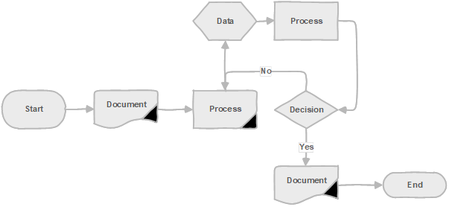
Figure 2: Example of a flowchart created in Microsoft Visio

Geographic maps
These visualisations allow you to display geographical data and analyse spatial relationships, which may help the audience understand patterns, trends, and distributions across geographic locations.
Using products like Power BI or Power Maps in Excel, you can plot data points on a map based on latitude and longitude coordinates or use built-in geographical hierarchies, such as countries, states, or postal codes, to display data at different levels of granularity.
Below are some key features and functionalities of maps that may help you decide which type is best to use:
- Point mapping: You can plot individual data points on a map based on their geographical coordinates – useful for displaying specific locations, such as customer addresses or business locations.
- Choropleth mapping: Choropleth maps use colour shading to represent data values for specific geographic regions. Each region has a colour corresponding to a specific data value, allowing you to visualise patterns across regions.
- Heat maps: Heat maps use colours to represent data density or intensity across a map. Areas with higher data density are shown with darker colours, while lower-density areas appear lighter. Heat maps are particularly useful for visualising spatial patterns in population density or product intensity.
- Drill-down and hierarchy: Maps drawn in Power BI will support hierarchical data allowing you to drill down into geographic detail. For example, you can start with a map of countries, then drill down to counties, and further drill down to postal code or city.
- Map layers: Power Maps in Excel allows you to overlay multiple map layers to display different datasets simultaneously. You can combine point maps, choropleth maps, and other map visualisations to view your data comprehensively.
Below is an example of a point map drawn in Power BI showing the number of learners who attend courses in training centres in the UK:
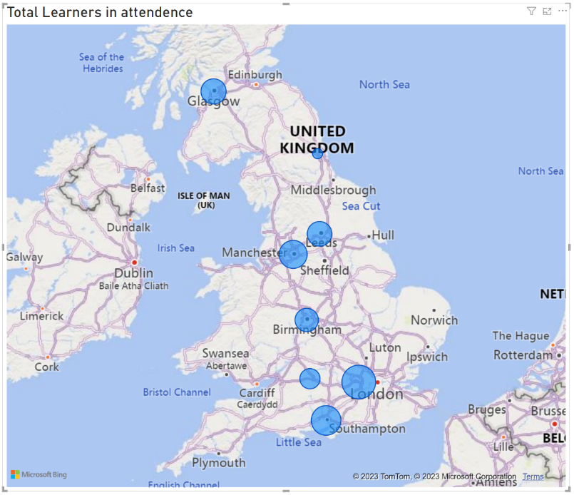
Figure 3: Example of a point map in Power BI

Infographics
The primary goal of an infographic is to simplify and condense information, making it easier for the audience to understand and retain the key message or insights. These visual representations combine text, graphics, and charts to convey information, usually as posters or social media content.
When creating an infographic, it is important to consider the target audience, the purpose, and the message you want to convey. Careful design choices, clarity of information, and a visually engaging layout are essential for creating an effective and impactful infographic.
Here are some key characteristics and benefits of infographics:
- Visual storytelling: Infographics use visual elements to tell a story and engage the audience.
- Data visualisation: Infographics effectively present data and statistics in a visual format.
- Simplification and clarity: Infographics condense information into concise and easily digestible formats.
- Visual hierarchy: Infographics use visual hierarchy to emphasise important information and guide the viewer’s attention.
- Branding and aesthetics: Infographics can be designed to align with a brand’s visual identity, incorporating colours, fonts, and logos.
- Shareability and virality: Infographics are highly shareable on social media platforms due to their visual appeal and ability to convey information succinctly.
Here is a real-world example of an infographic produced by ONS on their Twitter feed:
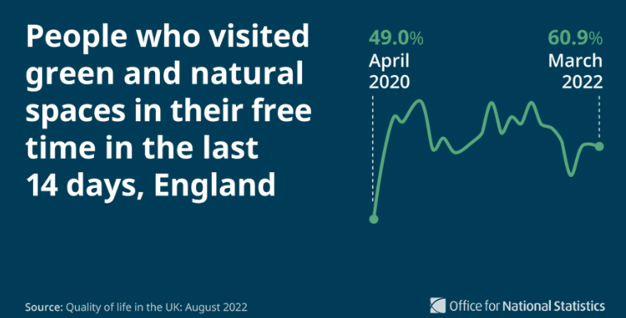
Figure 4: Example of a real-world infographic

Dashboards
Interactive visual displays provide an overview of key metrics, allowing the audience to monitor performance, track trends, and explore real-time data. They are typically larger and more interactive than an infographic, and due to the nature of the real-time data, they are usually held on-premises behind a security gateway.
Here are some key characteristics of dashboards:
- Data visuals: Dashboards use multiple visual elements, such as charts, graphs, and tables, to present data in an understandable format. These visualisations help the audience quickly interpret and comprehend complex datasets.
- Real-time or near real-time updates: Dashboards often provide real-time or near real-time data updates, allowing the audience to monitor the most current information at any given moment. Because of this feature, dashboards enable timely decision making and the ability to respond to changes or trends.
- Customisable and interactive: dashboards are typically customisable, allowing the audience to select the specific metrics and data points they want to monitor. They may also provide interactive features such as drill-down capabilities, filters, and dynamic controls, enabling the audience to explore the data in more detail and gain deeper insights.
- Aggregation of data from multiple sources: dashboards can integrate data from multiple sources, such as databases, spreadsheets, APIs, and online platforms, to provide a comprehensive view of the relevant information allowing the audience a more holistic view of their data.
- Key performance indicators (KPIs): dashboards often focus on displaying KPIs or metrics. KPIs are typically represented visually and updated in real-time to provide a snapshot of performance at a glance.
- Goal tracking and benchmarking: dashboards often include features to track progress towards specific goals or benchmarks, providing the audience with the insight to compare current performance against targets, historical data, or industry benchmarks – thus helping to identify areas for improvement.
- Accessibility and sharing: dashboards are designed to be accessible to many audiences. They can be shared easily to promote data transparency, collaboration, and informed decision making. Power BI, for example, has a Power BI Service platform for such a purpose.

Here is an example of a dashboard built to allow the stakeholders to compare and forecast unit sales:
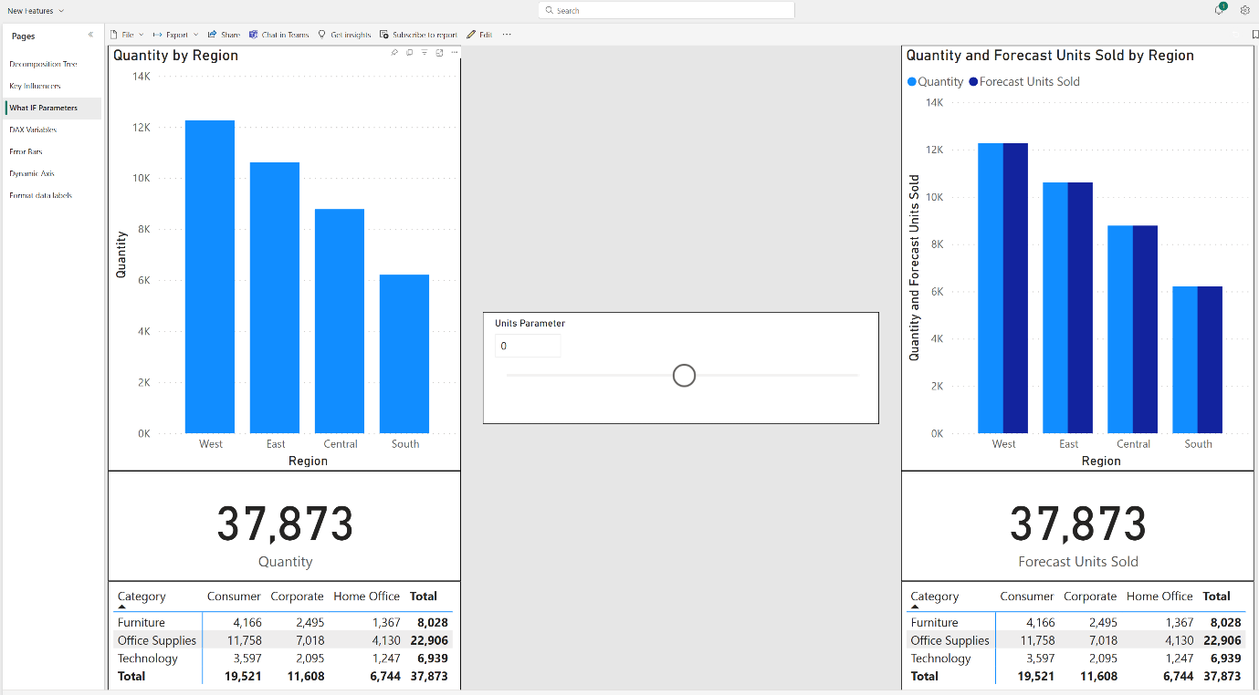
Figure 5: Example of a dashboard in Power BI

Visualisation types

Building tables and matrices
Tables and matrices are fundamental visuals commonly used to present information in a structured and organised manner, making them a good starting point for understanding and analysing large datasets.
Unlike other visualisations, tables display the data in a way closest to its original form, where values are stored as numbers or text rather than focusing on visual qualities.
Table and matrix visuals are usually used to present dense value structures. They are powerful for granular data examinations and can be used to identify value performance when combined with conditional formatting.
Although tables and matrices may appear to be the same element, they are both flat displays of rows and columns upon which various manipulations can be performed; there is one key difference.
A table is similar to an ordinary spreadsheet – a matrix aggregates and presents data in a crosstab or PivotTable format.

Before we discuss these two visuals in detail, let’s take a side-by-side look:
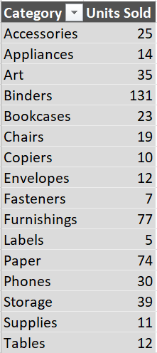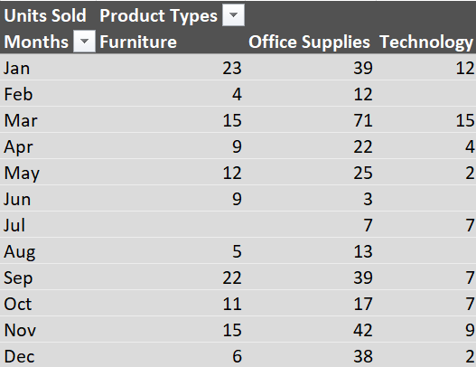
Figure 6: Examples of a table visual (left) and matrix visual (right)

Table visuals
This visualisation is a basic representation of data in rows and columns similar to a spreadsheet; they form the basis of data structure in products like Excel and Google Sheets.

What is a table?
A table is a type of data visualisation that presents information in a tabular format, resembling a spreadsheet or a database table. It is a straightforward way to display structured data, where each row represents a record or observation, and each column represents a specific attribute or variable.
Table visuals are commonly used when you need to present detailed information in a structured manner, allowing users to scan and compare values across different rows and columns easily. They are particularly useful for displaying textual data, categorical variables, or datasets with many columns.

Table benefits
There are several benefits of using tables to visualise data:
Data structure: tables provide an organised format for presenting data. They allow the report to represent complex information concisely and are easily understandable. Data can be arranged in rows and columns, making comparing and analysing different values easier.
Data comparison: tables are excellent for comparing data points side-by-side. Your audience can easily identify patterns, trends, and relationships between variables. Tables allow the report builder to perform calculations, such as aggregating data, calculating averages, or applying formulas to derive new stakeholder insights.
Efficient data lookup: tables are useful for quickly finding specific information. Scanning rows and columns allows your audience to locate and extract the required data without extensive searching, thus making tables highly efficient when referencing specific values or cross-referencing data from different sources. Building a table in Excel is perfect for lookup and reference functions such as XLOOKUP.
Data filtering and sorting: tables offer flexibility in filtering and sorting data. You can apply filters to display specific subsets of data based on criteria such as date ranges, categories, or numerical conditions. Sorting allows you to arrange data in ascending or descending order, helping you identify outliers or prioritise certain values. As well as being connected to the original data, table visuals in Power BI are internally connected to offer the audience a deeper data storytelling insight.
Visual clarity: when dealing with tabular data or presenting quantitative information, tables provide a clear and structured visual representation of data. They eliminate clutter, emphasise key data elements, and enhance readability and comprehension.
Customisation and formatting: depending on the product you’re using, a table visual can offer customisation options, allowing you to format and style them according to your audience’s needs. Adjustments to column widths, colour, style, highlighting specific cells or rows, and format numbers or dates can improve your intended audience’s readability and visual appeal.
Export data and sharing: tables are widely compatible and can be easily exported to different formats, such as CSV, Excel, or PDF. For example, in Microsoft Office, tables are structured using XML – this enables data to be shared with others or integrated into various software applications for further analysis or reporting. A table built using Excel can be easily transported and shared into PowerPoint or Word.
Audience accessibility: tables provide a structured layout that can be read by screen readers, making data accessible to individuals with different learning styles and visual impairments. Additionally, tables offer a convenient format for individuals who prefer to absorb information in a tabular form.
Helpful hint
Remember, tables should be designed with the audience in mind, making it easy for them to interpret and extract the desired information efficiently.
So before finalising the table, please review it to ensure the data is easily readable and understandable.
Consider how it will appear in different formats such as printed or digital and ensure it retains clarity.

Building a table in Excel
If you wish to build a table in Microsoft Excel, you can follow these step-by-step instructions:
- Launch Excel and open a new or existing workbook.
- Select the cell range you want to be included in the table – it should include headers and data but exclude any totals or calculations you might have.
- Select Insert > Table > or press Ctrl+T – Excel will automatically detect the range you selected.
- In the ‘Create Table’ dialog box:
  - Where is the data for your table?: ensure the range is correct, or manually adjust the range.
  - My table has headers: if your selected range includes headers, tick this option.
- With all relevant options set, select OK to convert the raw data into a table.
Excel will apply a default table style and name to your data. To customise the table:
- Use Design > Table Styles to change the appearance of the table.
- Use Design > Table Name to rename the table.
Your table is now ready! You can start entering or importing data into the table, and Excel will automatically expand the table range as needed.

Building a table in Power BI
Alternatively, if you wish to build a table in Power BI, you can follow these step-by-step instructions:
- Launch Power BI Desktop and open a new or existing report.
- Connect to your data source by selecting Home > Get Data.
- Select the appropriate data source type and follow the prompts to connect to your data.
- Once your data is loaded into Power BI, navigate to the page where you want to build your table or create a new page by selecting the + button at the bottom of the screen.
- In the ‘Visualisations’ pane on the right side of the screen, select on the Table icon – a blank table visual will be added to the report canvas.
- From the ‘Data’ pane on the right side of the screen, either:
  - Drag the desired fields into the ‘Values’ area of the table visual. Each field will become a column in your table.
  - Drag additional fields into the ‘Columns’ area of the ‘Visualisations’ pane to add more columns to the table.
- When the table has been created, it can be customised:
  - Format the table using the formatting options in the ‘Visualisations’ pane. You can change the font, text size, column width, and other visual aspects to suit your preferences.
  - You can apply conditional formatting to highlight specific values in the table. Right-click on a column header > Conditional Formatting > to define rules for formatting cells based on their values.
  - To apply sort or filtering to the table, you can use the options available in the table visual or the ‘Visualisations’ pane. For example, you can sort the table by a specific column by clicking on the column header and selecting the sorting options.
  - Adding measures or calculated columns can also apply additional calculations or transformations to the table.
Helpful hint
Measures allow you to calculate data using DAX (Data Analysis Expressions).

- Once the report has been completed, saving it will allow you to publish or share the Power BI report with others.

Matrix visuals

What is a matrix visual?
A matrix visual is an extension of the table visual, presenting data in a grid-like format. It is particularly useful for displaying aggregated or summarised data. The matrix visualisation organises data into rows and columns, just like a table, but it also includes additional dimensions for grouping or categorising the data.
The intersections of rows and columns display summarised values, often using colour or size encoding to represent the magnitude of the data. Matrix visuals are effective when your audience wants to explore the relationships between multiple variables or compare aggregated values across different dimensions.
Like a table, matrix visuals can be enhanced with additional features such as sorting, filtering, and formatting options to enhance data analysis and interpretation further. These visuals are commonly found in various data visualisation tools such as Power BI and Tableau and spreadsheet applications like Excel.
Matrix visuals are particularly useful when analysing multi-dimensional datasets and exploring relationships between variables. They provide a comprehensive data view, allowing the audience to compare and analyse aggregated values across dimensions. By visually representing the intersections of multiple variables, matrix visuals can help identify patterns, trends, and correlations that might not be apparent in a simple table format.

Below is an example of complex data represented first as a table and then as a matrix. As you can see, the period data summary is much clearer to see as a matrix.
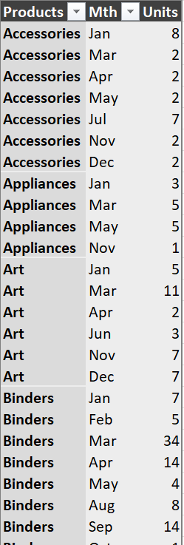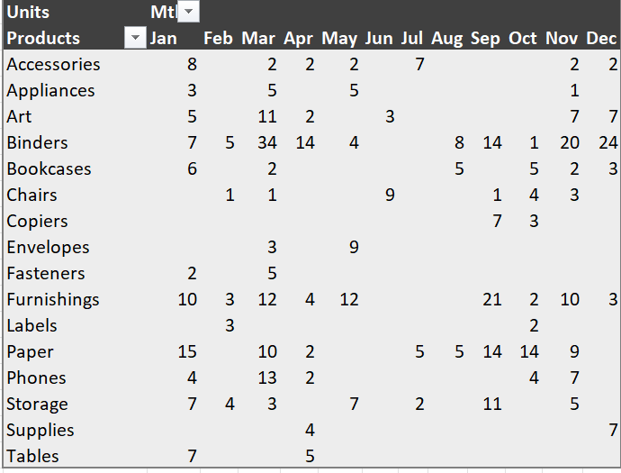
Figure 7: Examples of table (left) and matrix (right) visual

Matrices benefits
Some of the key benefits of matrix visuals are:
- Multi-dimensional analysis: Matrix visuals allow your audience to analyse data simultaneously across multiple dimensions. They can cross-tabulate data based on variables or attributes, such as periods, regions, products, or customer segments. Matrices may even help your audience uncover relationships and patterns that are not apparent when analysing data linearly.
- Summarisation and aggregation: Matrix visuals concisely summarise data by aggregating values based on various dimensions. They can calculate totals, averages, counts, and percentages or apply custom calculations. This summary enables your stakeholder/audience to gain insights into the overall trends and distributions of the data.
- Data comparison: Matrix visuals facilitate easy comparison of data across different dimensions. Organising data in rows and columns allows you to identify patterns, variances, and trends between variables. This comparison lets your audience understand the relationships between different factors and make informed decisions.

- Drill-down and hierarchical analysis: Matrix visuals, especially those built using Power BI, often support drill-down capabilities, enabling the stakeholder audience to explore data at different levels of granularity. They can expand or collapse rows and columns to view detailed or summarised information. This hierarchical analysis helps you navigate the data and uncover insights at different levels of detail.
- Flexible sorting and filtering: A matrix visual offers flexibility in sorting and filtering data like tables. You can sort rows or columns in ascending or descending order based on specific criteria. Filtering options allow you to focus on specific subsets of data by applying filters to one or more dimensions. This flexibility helps you narrow down your analysis and focus on relevant information.
- Conditional formatting: Matrix visuals often provide conditional formatting options to highlight specific values or patterns in the data. You can apply colour scales, data bars, or icon sets to visually emphasise high or low values, trends, or outliers. This formatting makes it easier to interpret and draw attention to important insights.
Helpful hint
Remember that the goal of a matrix table is to create a visually appealing and intuitive representation of the data, thus ensuring an efficient data exploration, comparison, and summarisation, whilst enabling the audience to derive meaningful insights from complex datasets.

Summary
In this topic, you have learned that table and matrix visuals are effective tools for presenting and organising data concisely and structured.
Tables display data in rows and columns, allowing easy comparison and analysis. They provide a clear overview of information and can accommodate various data types.
On the other hand, matrix visuals are used to represent relationships or correlations between multiple variables or entities. They are particularly useful in displaying complex data patterns and facilitating decision making processes.
Overall, tables and matrix visuals enhance data comprehension, extracting insights and communicating information more easily.

Graphs and charts
Sometimes your audience may prefer a pictorial representation of the data or need a quick overview or summary. In that case, graphs and charts are more likely the better choice of visual representation to aid in audience understanding and interpreting complex information.
Graphs present data points on a coordinate system, typically using lines or bars, to identify relationships, trends, or comparisons. They are ideal for displaying numerical data, such as statistical figures, measurements, or scientific data.
On the other hand, charts condense data into visual forms like pie charts, histograms, or scatter plots. These visual tools provide a clear overview of a dataset’s proportions, distributions, or patterns.
By presenting information concisely and intuitively, graphs and charts facilitate data analysis, decision making, and effective communication.

Graphs versus charts
The fundamental difference between a graph and a chart lies in their purpose and presentation.
A graph is a visual representation for displaying numerical data and analysing relationships.
In contrast, a chart encompasses a broader range of visual representations that can convey different types of information in a visual format typically used where time intelligence, progress or process is involved.
Visual | Reason
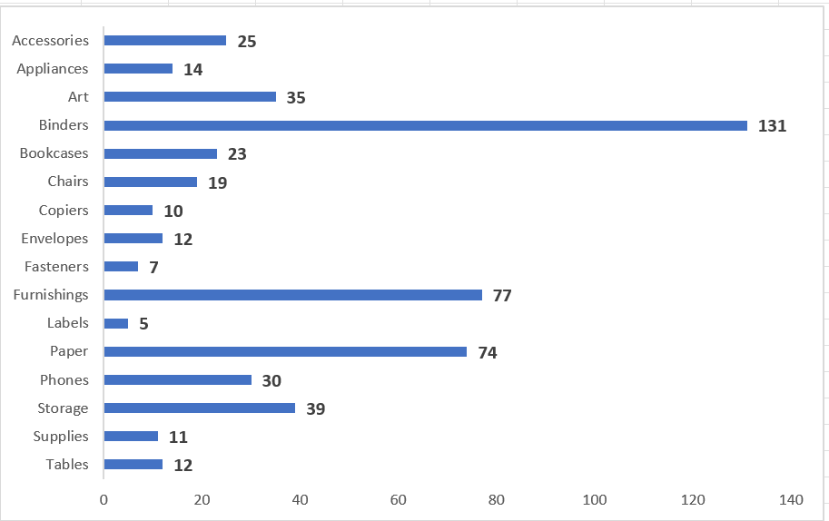 | A graph, often called a ‘graphical representation’ or ‘plot,’ is a visual tool to represent and analyse data relationships or trends.  Graphs typically consist of points or bars plotted against axes.  They are commonly used to display numerical data and show the relationship between variables, such as the data’s correlation, patterns, or trends.  Graphs are primarily used for data analysis and visualisation.
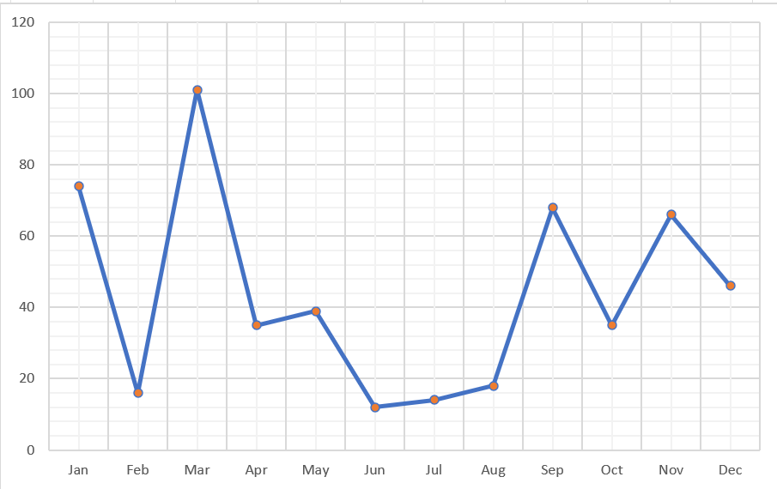 | A chart, also known as a ‘diagram,’ is a visual representation of data or information that uses progress or process formats to convey numerical, categorical, or qualitative information.  They can be plotted with a time-intelligent category axis like a line chart.

Common elements
Although graphs and charts are fundamentally different, they have common building blocks that every report author should know and, more importantly, decide whether the audience needs the elements.
By combining these building blocks effectively, you can create clear and informative graphs or charts that visually represent your data meaningfully.

Data
The data is the fundamental element of any graph or chart and can be in various formats, such as numbers, categories, or time series. Typically, products like Excel and Power BI will try to best fit the data into the visual.
For example, textual data is used as a label or title for an axis, and numerical data is plotted against the value axis with evenly distributed increments.

Axes
Graphs and charts usually have two axes: the x-axis and the y-axis. These axes provide the framework for positioning and scaling the data.
The x-axis represents the independent variable, known in various products as the category or horizontal axis. In contrast, the y-axis represents the dependent variable, known in various products as the value or vertical axis.

Scale
The scale determines the range and increments on the axes. It helps map the data accurately onto the graph or chart and can be linear or categorical, depending on the nature of the data.

Labels
These are essential for communicating the meaning of the graph or chart by providing information about the data being represented, the units of measurement, and any other relevant details.
Labels include titles for the graph or chart, axis labels, and data labels (if applicable).

Legends
Legends are used to explain the meaning of different elements in the graph or chart and are particularly useful when representing multiple data series or categories.
Legends help the audience understand the colours used to differentiate between various datasets. Data tools like Excel will automatically include a legend irrespective of whether the visuals need one.

Gridlines
Gridlines are horizontal and vertical lines that divide the graph or chart into smaller sections, assist in visually aligning the data points, and provide a reference for accurate interpretation.
They are particularly useful if the audience wants to extrapolate further or interpolate the data.

Colour palette
An appropriate colour palette makes your graph or chart visually appealing and easily interpretable. Colours can differentiate between data series, highlight essential information, or represent categories, i.e., they can focus the audience’s attention on the key points.

Chart type selection
Finally, based on the nature of your data and the purpose of your visualisation, you need to select the appropriate chart type.
Common types found in data tools like Excel include line graphs, bar charts, pie charts, scatter plots, and area charts.

Creating a chart in Excel
Here are the common steps for building graphs in Excel:
- Select your data – be sure to include the labels and all the data points you wish to represent.
- Select Insert > Chart – you will find different chart types such as column, line, or pie – and select the type that best suits your data.
After inserting the chart, it can be customised to your liking:
- Depending on your version of Excel, you will have either two (Chart Design and Layout) or three (Design, Layout, and Format) extra tabs on the Ribbon:
  - Design: use this tab to select different chart styles, change the layout, or switch between chart types.
  - Layout: adjust the chart elements such as titles, axis labels, legends, gridlines, and data labels.
  - Format: apply formatting options to change the appearance of your chart, including colours, fonts, borders, and more.
- Use the Add chart element button to include titles and labels – select a title to edit it.

Creating a chart in Power BI
- Alternatively, if you want to build a graph visual in Power BI, these are the fundamental steps you can follow:
- Once the data is imported, if needed, create a new page.
- In the ‘Visualisations’ pane, select the desired chart type to add an ‘empty’ chart to the page.
- Drag the required fields from the ‘Data’ pane into the appropriate field wells of the ‘Visualisations’ pane; for example, the data to be displayed might be added to the ‘Axis’ field well, and the data to be measured on the y-axis added to the ‘Values’ field well.
- When the chart has been created, it can be customised:
  - Format the chart using the formatting options in the ‘Visualisations’ pane. You can change the font, text size, column width, and other visual aspects to suit your preferences.
  - To apply sort or filtering to the chart, you can use the More Options icon in the visual header of the chart visual.
- More visuals can be added to the same or different report pages by repeating the steps if needed.

Summary
In this topic, you have learned that graphs and charts are visual representations of data that help convey information quickly and effectively. They condense complex datasets into concise and accessible formats, allowing the audience to immediately grasp key trends and patterns.
These visual tools come in various forms, such as line graphs, bar charts, pie charts, and scatter plots. Each type serves a specific purpose: showing trends over time, comparing categories, or illustrating relationships between variables.
Graphs and charts use building blocks like axes, labels, and legends to provide context and aid interpretation. They often use different colours, shapes, and sizes to differentiate data points and highlight important information.
By presenting data visually, graphs and charts enhance data analysis and decision making across multiple fields, including business, science, economics, and social sciences.
Graphs and charts are powerful tools that simplify complex data, enabling your stakeholder audience to understand and communicate information effectively.

Geographic plots or maps
Spatial plotting or geo-maps are becoming increasingly popular due to the introduction of advanced reporting and dashboarding tools like Power BI and Tableau – to the extent that they are available in Excel, albeit fundamentally.
In this final topic, we will look at how spatial plotting can be achieved on your report and explore the possibilities of building maps in reporting tools like Power BI and Excel.

Excel map tools
Firstly, let’s look at Microsoft Excel. Even though Excel is primarily a spreadsheet program, it does offer some basic mapping capabilities that can be used to create simple spatial maps.
Tool | Uses
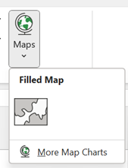 | A filled map chart is a type of data visualisation that represents data using a geographic map.  It allows you to colour-code different regions or countries based on the values or categories associated with them.  This chart type is particularly useful when you have geographical regions in your data, like countries/regions, counties or cities and want to compare data across different geographical areas.
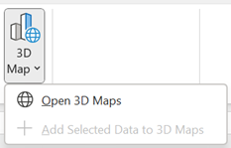 | These were initially introduced into Microsoft Excel 2016 as an add-in known as Power Maps.  As they became increasingly popular, they were developed into the 3D Maps tool – a powerful visualisation that allows users to create interactive 3D geographical and temporal data analysis directly onto a map.  From the point of view of the report builder, geographic data can be transformed into a visually compelling story that will enable your audience to gain insights and communicate information effectively.

Build a map chart in Excel
To create a filled map chart in Excel, you will need a dataset that includes geographic regions or countries and corresponding values.
Imagine you have created a table with three columns. The first column contains the names of the regions (Province as Excel knows it), the second column includes the relevant geography (in this example, we are using County), and the third column has the corresponding values you wish to display.
Helpful hint
Here you can see that the County field has been qualified with the Province field to ensure that Excel understands the locality of the geography.

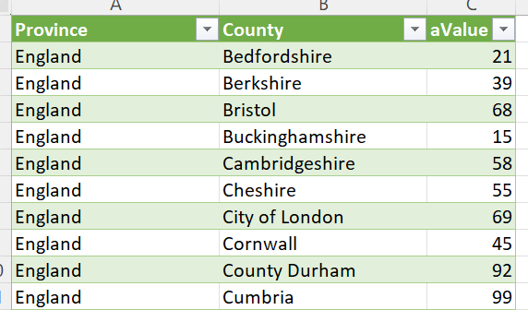
Figure 8: An example of raw geographic data
Helpful hint
Excel does not always understand geographic references, so you should use column labels that the product will recognise, such as Address, Place, City, Province, and County.
This disambiguation process will allow Excel to understand most geographic layers.

To create a filled map visual in Excel:
- Ensure the data is suitable for mapping (see above).
- If practical, convert the data into a table – this allows the Excel map to focus on the data and provide a dynamic connection – as the data table changes, the map will update.
- Select any cell in the table of data and select Insert > Maps > Filled Map.
- Once the map has been created, the ‘Chart Design’ and ‘Format’ tabs on the Ribbon can be used to customise it, like working with a regular chart.
In this example, the regional data seen earlier is now prominently displayed with a single colour scale to promote the idea of value size – the darker the shade, the larger the value.
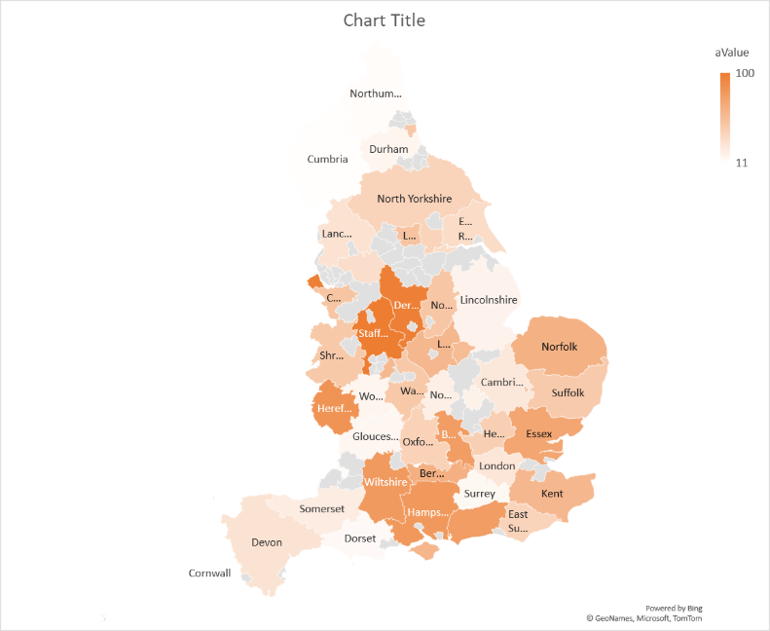
Figure 9: An example of a filled map visual
According to Microsoft, these types of spatial charts have limitations:
- Map charts can only plot high-level geographic details, so latitude/longitude and street address mapping are not supported.
- Map charts only support one-dimensional display, but you can use the 3D Map feature if you need multi-dimensional detail.
- Creating new maps or appending data to existing maps requires an online connection (to connect to the Bing Map service).
- Existing maps can be viewed without an online connection.
- There is a known issue where Map Charts, which use Geography Data Types, can sometimes map incorrectly – try to include extra fields, such as Province or Country, when plotting these until the problem is fixed.
This list was taken from Microsoft Support and was correct at time of writing.

Building a map in Power BI
Now that we have seen how to build a map in Excel, let’s look at a more powerful tool like Power BI.
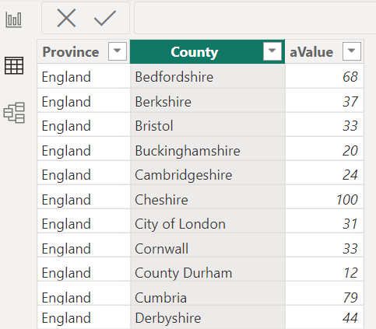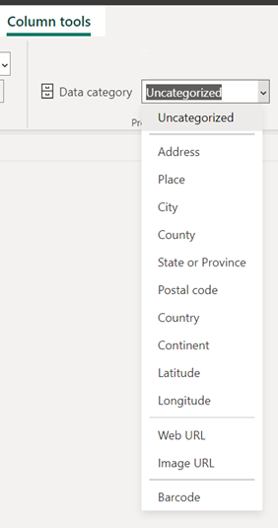
Figure 10: Example of data to be mapped in Power BI
Whilst there are more capabilities in Power BI, the process will start in the same way:
- Ensure the data is suitable for mapping (see above).
- In the Data View, select the column that will be mapped and click Column Tools > Data category to select the most appropriate spatial data.
- Create the visual, adding the spatial field(s) to the visual’s field wells as needed.
- With the map created, it can then be customised as with any other Power BVI visual.
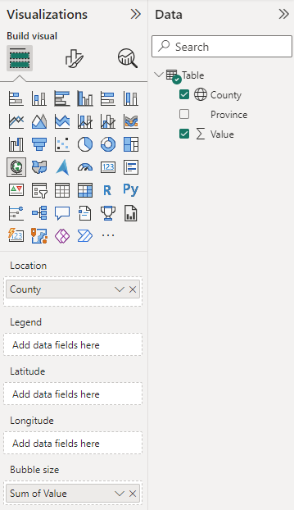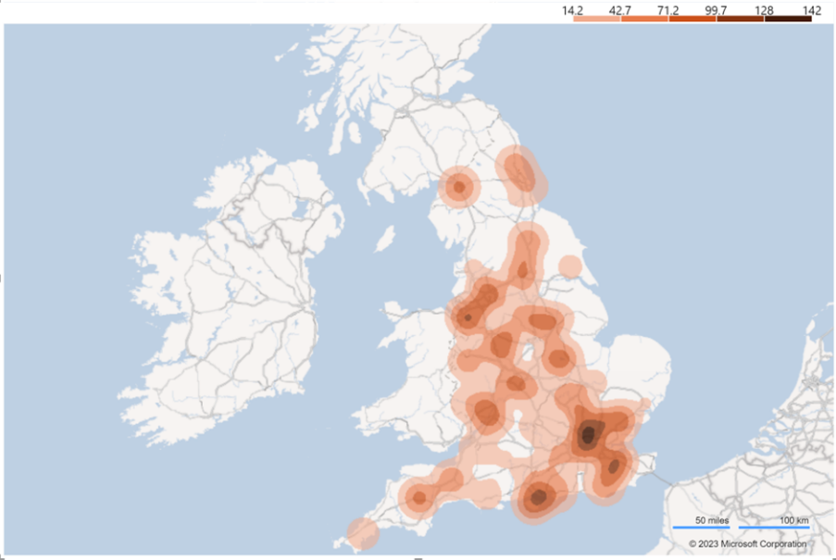
Figure 11: Working with spatial data in a Power BI visual
In this example, the regional data seen earlier is now shown with a single colour scale to promote the idea of value size – the darker the shade, the larger the value.

Summary
In this topic, you have learned that maps are visual representations of data plotted on a map, providing a spatial context to the presented information. They allow your audience to visualise and analyse data based on geographic locations.
Power BI and Excel provide mapping capabilities, allowing your audience to visualise and analyse geographic data effectively. However, Power BI offers more advanced features, interactive data exploration, and storytelling capabilities, making it a preferred choice for complex data analysis scenarios.
Maps are a powerful tool for visualising, exploring, and analysing data in a geospatial context, helping users gain insights and make informed decisions based on geographic patterns and relationships irrespective of the application used to create them.

Decluttering visuals
Decluttering is and how it aims to eliminate any distractions or noise hindering the audience’s ability to understand and interpret the data effectively.
Effective data visualisation is crucial for conveying information accurately and efficiently, so carefully considering the most relevant and essential information supporting the narrative and key insights graphs and charts can play a vital role in presenting complex data in a simplified and understandable manner.

What are the elements?
In this first topic, we will identify the various elements of graphs and charts that you may need to simplify and declutter.
Decluttered graphs and charts significantly improve comprehension by eliminating visual distractions and reducing cognitive load. A cluttered visualisation overwhelms the viewer, making it difficult to identify patterns, trends, or key information.
Removing unnecessary elements such as excessive gridlines, background patterns, or decorative elements shifts the focus to the essential data points, allowing the audience to grasp the message quickly.
Excessive data labels, complex legends, or crowded axes can confuse the audience and hinder comprehension, so in addition to decluttering, you may need to streamline the visual elements, such as clear labelling, consistent colour schemes, and appropriate font sizes, enabling your audience to interpret the information accurately.

Overview
Chart elements refer to the various components or parts that make up a chart or graph used to represent data visually. These elements are designed to help convey information effectively and aid in understanding the data being presented.
While the specific elements may vary depending on the type of chart or graph, some of the most common include:
Element | Example | Description
Title | 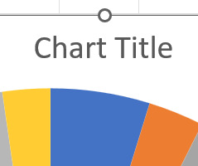 | A descriptive title that summarises the purpose or subject of the chart. Typically displayed at the top of the chart.
Axes | 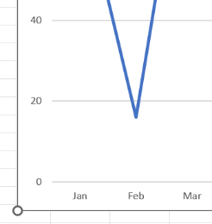 | The horizontal and vertical lines create a grid and establish reference points for plotting data.  The horizontal axis is typically called the x-axis (in the example plotted as a month), and the vertical axis is the y-axis (in the example plotted as a value).
Labels | 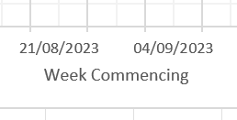 | Labels are used to identify and provide context for the data on the axes. They help interpret the scale and units used.  An example of the x-axis label is shown below.
Legend | 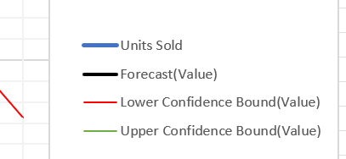 | Legends are used to explain the meaning of different data series or categories represented in the chart. Each series or category is typically assigned a unique colour, and the legend provides a key to understanding them.  Here is an example of a legend that explains each line on a forecast chart.
Data series | 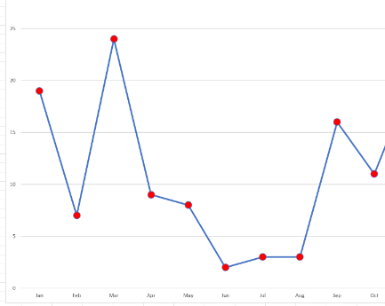 | The data points plotted on the chart are represented by bars, lines, points, or other visual markers. Each data series typically corresponds to a specific category or variable being measured.  Below is an example of a plotted line chart showing the data markers.
Gridlines | 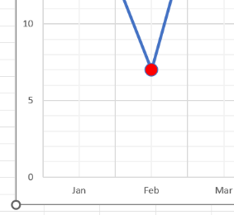 | Horizontal and vertical lines that extend from the axes and create a grid, helping to align and compare data points on the chart.  As you see in this sample, the gridlines have been activated.
Data labels |  | Numerical values or labels are attached to specific data points to provide precise information or aid interpretation. Here you see the data labels attached to the bar visual’s outside end.
Tooltips | 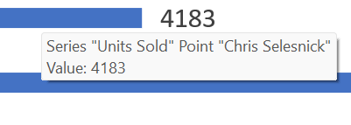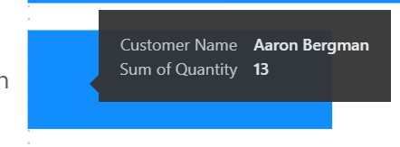 | Small text boxes appear when hovering over or interacting with individual data points, providing additional details or context.  In Excel, they show series, points, and values. Default tooltips in Power BI show X- and Y-data values.

Summary
Helpful hint
Remember, many applications will allow you to create chart types with additional elements specific to their design and purpose.

In this topic, you have seen that various chart elements convey information effectively and facilitate clear data communication. These elements, such as titles, labels, legends, and axes, enhance the visual representation of data, making it easier for the audience to interpret and understand the presented information.
Overall, the importance of chart elements lies in their ability to improve data comprehension, facilitate accurate interpretation, and engage the audience effectively.
By incorporating these elements thoughtfully, you can present information in a visually appealing and accessible manner, maximising the impact and value of the data being conveyed.

Why declutter?
Now that you have a better understanding of the elements needed to build a graph or chart and the importance they have in presenting clear stories to your audience, we can take these further and look at achieving clarity by understanding the concept of decluttering – removing unnecessary elements, simplifying designs, and optimising the visual representation.
This topic will explore why decluttering graphs and charts is essential, highlighting its benefits in comprehension, interpretation, and decision making.

Enhanced comprehension
The decluttering of graphs and charts will significantly improve comprehension by eliminating visual distractions and reducing cognitive load.
A cluttered visualisation overwhelms the viewer, making it difficult to identify patterns, trends, or key information. Removing unnecessary elements such as excessive gridlines, background patterns, or decorative elements shifts the focus to the essential data points, allowing the audience to grasp the message quickly.
Simplifying the design also aids in comprehension. Streamlining the visual elements, such as clear labelling, consistent colour schemes, and appropriate font sizes, enables the audience to interpret the information accurately.
Excessive data labels, complex legends, or crowded axes can confuse the audience and hinder comprehension. By decluttering, the graph or chart becomes more intuitive and user-friendly, enhancing its communicative power.
These two graphs present the same data – the left one is the original without any modifications – the right one has been decluttered.
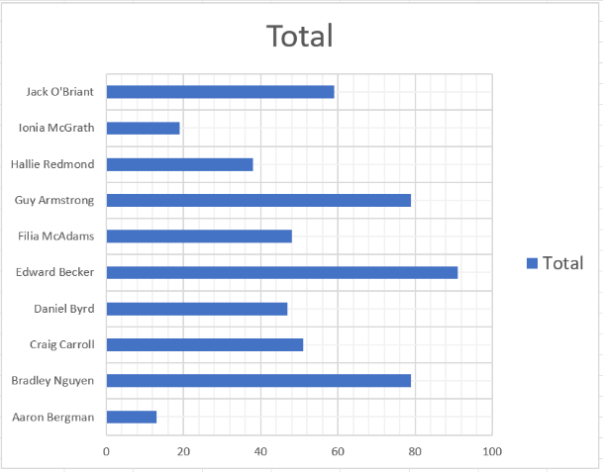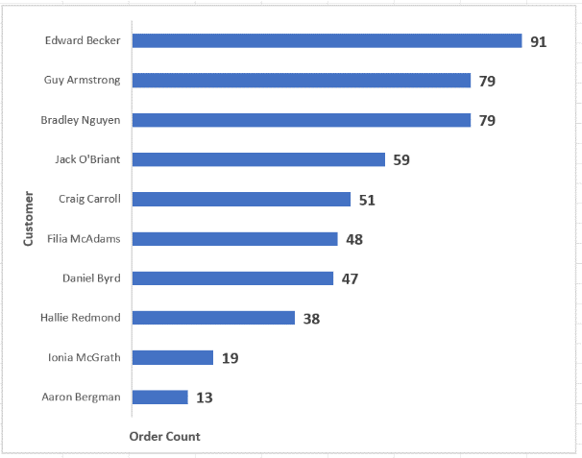
Figure 12: Cluttered and decluttered charts

Improved interpretation
Decluttering facilitates accurate interpretation by reducing ambiguity and emphasising key insights. When the visualisation is cluttered, the audience may struggle to distinguish between essential and secondary data points, leading to misinterpretations or incomplete understandings. Removing redundant information or non-essential elements helps highlight the main message and prevent confusion.
Strategic decluttering can also guide your audience towards the intended message. You can focus on specific data points, trends, or comparisons by carefully selecting which elements to emphasise or de-emphasise. This approach ensures that the audience focuses on the most critical aspects, making interpretations more accurate and aligned with the intended narrative.
Furthermore, decluttering enables effective storytelling through visualisations. You can construct a coherent narrative within the graph or chart by simplifying and organising the elements. By carefully arranging data, emphasising important findings, and aligning the visual hierarchy, complex information can be transformed into a compelling story that engages the audience and conveys the intended message.

In the example below, a scatter plot analysing the correlation between rainfall and the number of umbrellas sold has been created for the stakeholder. Unfortunately, the audience cannot interpret the data or interpolate the required answer for the question, ‘How many umbrellas would we sell at 3mm rainfall’?
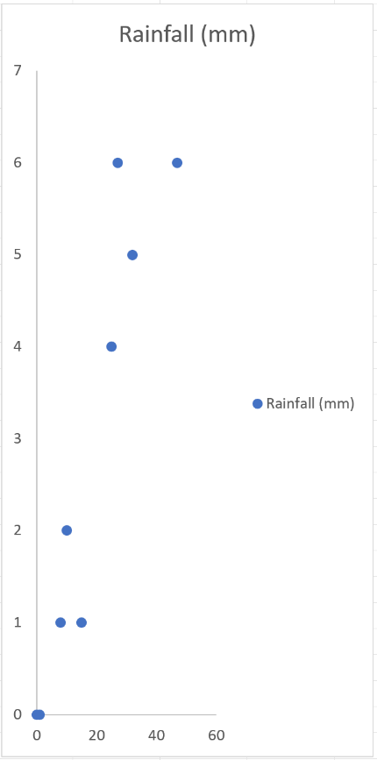 | 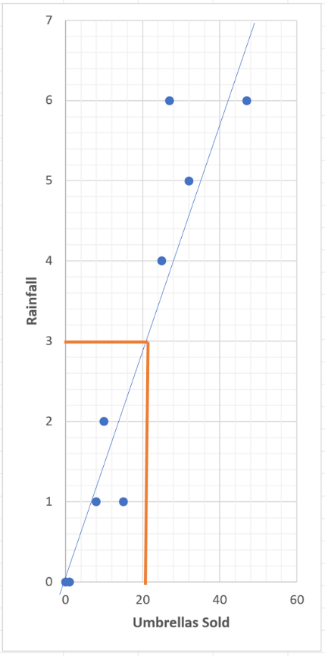
What can we do to improve the interpolation?  - Remove legend and title.  - Add axis labels.  - Add gridlines.  - Insert a line of best fit.  - Add interpolation lines to aid the scenario. | After decluttering and tidying the graph, you can see that the interpolation is easier to visualise for the stakeholder.

Optimised decision making
The decision-making process relies heavily on extracting relevant insights from data visualisations quickly. Decluttering is crucial in optimising this process by enabling stakeholders to make informed decisions based on accurate interpretations.
When data is cluttered, decision-makers may struggle to identify the most relevant data points or trends. Simplifying the visualisation and removing unnecessary details allows decision-makers to focus on the essential information. Clear, uncluttered graphs and charts enable faster and more accurate decision making, empowering stakeholders to extract insights efficiently and act accordingly.
Furthermore, decluttering contributes to effective data comparisons. Decluttered visualisations facilitate effortless comparisons between datasets by reducing visual noise and distractions. Decision makers can easily identify differences, similarities, and relationships, supporting them in identifying patterns, trends, or correlations that might otherwise go unnoticed.
In the example below, the stakeholder is keen to identify which salesperson best performs in the regions. The original table needs the column layers removed so the insight becomes clearer – the matrix visual results from this decluttering.
Original table | Decluttered matrix
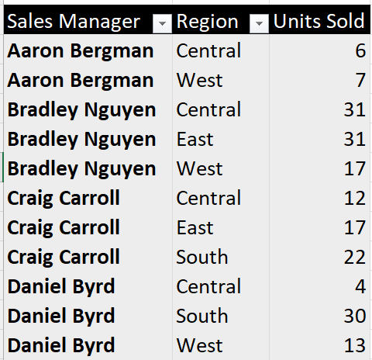 | 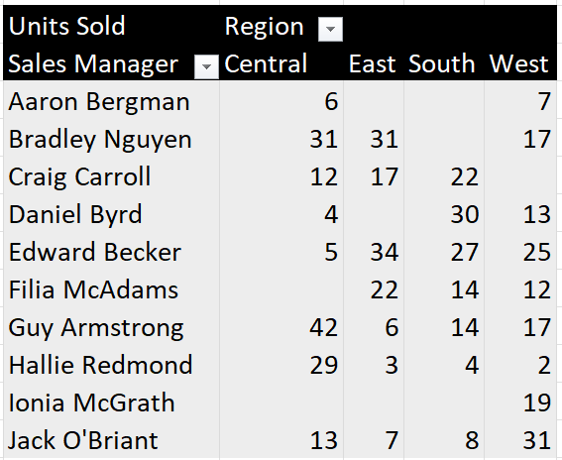
As you can see from the original table, the answer is hidden amongst the noise clutter. | By simplifying the table and converting it into a matrix, the story is starting to appear. (In the next topic, we will discuss using colour to focus attention).

How to remove distractions
When removing distractions from a graph or chart, the goal is to enhance the clarity and focus of the presented data. Here are some steps you can follow to achieve this:
- Identify the distractions: Carefully examine the graph or chart and identify any elements that might distract or confuse the viewer. Common distractions include excessive labels, gridlines, excessive data points, unnecessary colours, and decorative elements.
- Simplify the labels: Remove unnecessary labels or reduce the text used. Keep only the essential labels that provide clear and concise information. Consider using tooltips or annotations for additional details that can be displayed on demand.
- Remove excessive gridlines: Gridlines can clutter the graph and make it difficult to focus on the data. Remove any excessive or unnecessary gridlines or reduce their prominence using a lighter colour or thinner lines.
- Streamline data points: If your graph has too many data points, it can create visual noise and make it challenging to discern patterns or trends. Consider reducing the number of data points shown, especially if they do not add significant value to the visualisation. You can achieve this by using data aggregation or applying smoothing techniques like moving averages.
- Minimise decorative elements: Eliminate decorative elements that do not contribute to understanding the data. Items often deemed unnecessary include backgrounds, 3D effects, excessive shadows, or unnecessary textures. Keep the design clean and simple, focusing on the core data elements.
- Use a limited colour palette: Choose a colour palette that is visually pleasing and helps to convey the information effectively. Avoid using too many colours, which can lead to confusion and distraction. Stick to a limited number of colours with sufficient contrast and are easily differentiated.
Helpful hint
Avoid green and red/pink, as these can be difficult for colourblind users.
Neurodivergent stakeholders (ADHD or Autism) prefer muted, pastel hues and neutral tones.

- Highlight relevant information: emphasise the most critical data points or trends using visual cues such as colour, size, or annotations. Direct the audience to the key insights or messages you want to convey. We will look at this subject in more detail in the next module.
- Optimise the layout: adjust the layout of the graph or chart to ensure that the data is presented logically and organised. Group related elements together, align labels with their corresponding data points and ensure the overall composition is visually balanced.
- Test and iterate: after making the initial changes, test the revised graph with different stakeholders. Gather feedback and iterate based on their suggestions or observations. Continuously refine the visualisation until it effectively communicates the intended message without unnecessary distractions.
Following these steps, you can remove distractions and create a clear, focused graph or chart that effectively presents the data. Remember, simplicity and clarity are key to conveying information visually.

Focusing attention
In the vast ocean of information, you, the data storyteller, need to employ the concept of ‘focused attention’ to guide the audience towards the most relevant and impactful elements of a data story.
Identifying the key messages and insights that need to be conveyed is at the core of your empathy process when designing the storytelling approach accordingly.
By carefully highlighting the essential data points, you can effectively communicate insights, foster understanding, and make a lasting impact on your audience.

What are the key points of the story?
As you are now starting to realise, data visualisations are a powerful tool for presenting information in an appealing and accessible manner. However, without proper focus on key points, even the most well-designed visualisations can fail to deliver their intended message effectively.
Focused attention on key points is crucial to ensure that the audience grasps the main insights and takeaways from the data presented.
In this topic, we will explore the concept of focused attention on key points in data visualisation and understand its significance.

Core principles
Data visualisation aims to communicate complex information clearly and concisely. By representing data using charts, graphs, and other visual elements, patterns, trends, and relationships become more apparent, making it easier for the audience to understand the data’s underlying meaning.
However, with the abundance of information that can be visualised, there is a risk of overwhelming the audience with unnecessary details, distracting from the central message – this is where the concept of focused attention comes into play.
Focused attention involves carefully curating the visual elements to highlight the key points or main messages that must be conveyed. As the builder, you must identify the most critical insights and arrange and guide the audience’s attention towards them. Achieving focused attention involves several important considerations.
In this example, without a verbal clue (you telling the audience) that the focus is on ‘Which region has the lowest sales?’ the table and graph visuals are open to a variety of different interpretations by the audience, i.e., they may draw their conclusions which may be a great distance away from the actual focal point of the story being told.

However, by focusing on the key points (in this example, colour and narrative have been used), you can see that the audience’s attention has been drawn to the main story.
Original table | Original graph
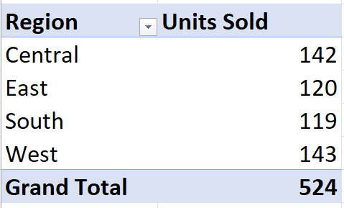 | 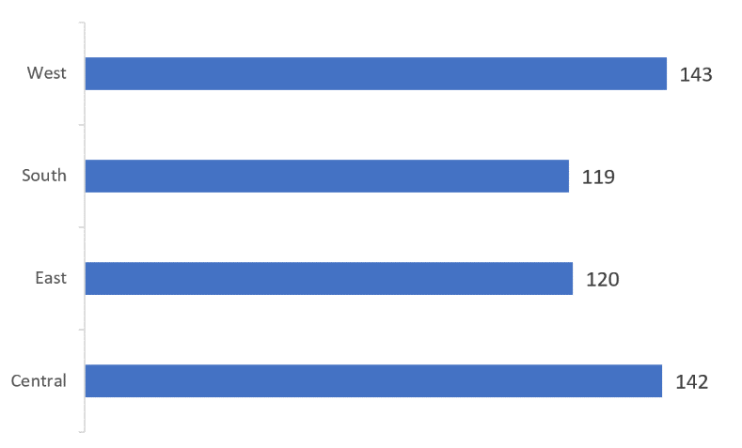
Focused table | Focused graph
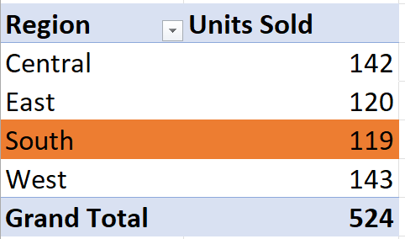 | 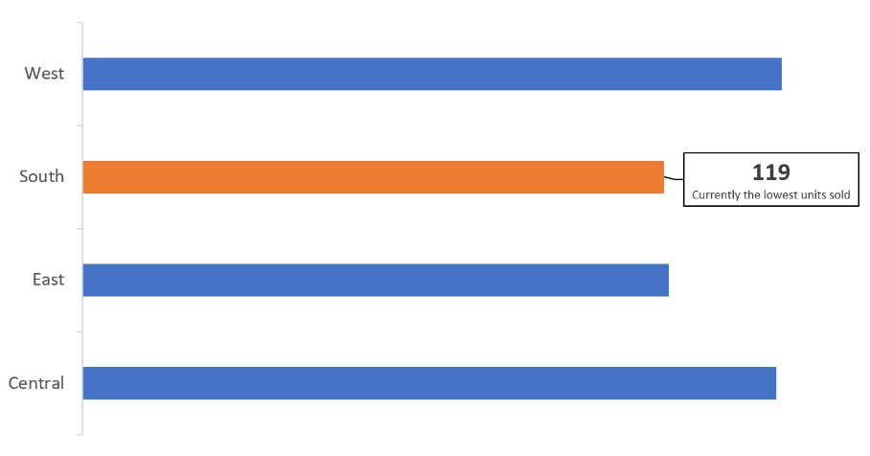

Considerations
Purpose: Understanding the purpose of the visualisation and the target audience is essential. Whether the goal is to inform, persuade, or entertain, knowing the audience’s background and knowledge level helps select the most relevant key points to emphasise. We will discuss the audience’s empathy in a later topic.
Clarity: Keep the visualisation simple and clutter-free. Remove any unnecessary elements that do not contribute directly to the main message. Clear labels, appropriate colours, and straightforward design choices enhance the visualisation’s effectiveness.
Data preprocessing: Clean, filter, and aggregate the data before visualisation. Raw data may contain noise and outliers that can distract from the key points. Preprocessing ensures that the data presented is relevant and supports the main insights.
Visual hierarchy: Arrange the visual elements to create a hierarchy that directs attention to the most critical information. Larger or bolder elements like titles or annotations can highlight key points.
Use of annotations: Annotations can be used strategically to highlight key data points, trends, or events. They provide context and aid in drawing attention to specific areas of interest.
Storytelling: Organise the visualisation into a coherent narrative. Guiding the audience through a story assists with understanding the key points logically, leading to better comprehension and retention of information.
Interactive features: Interactive visualisations allow users to explore the data themselves. However, a ‘self-service’ report overloaded with interactive features can distract from the primary message.
Consistency: Maintain consistency in design and formatting throughout the visualisation to avoid confusion. Consistent use of colour schemes and chart types helps viewers focus on the data rather than decoding visual elements.
Accessibility: Ensure the visualisation is accessible to all users, including those with visual impairments. Providing alternative text descriptions and considering colour contrast is essential for inclusivity.
Testing and iteration: Test the visualisation with a beta audience, gather feedback and then iteratively refine it to improve its focus on key points and overall effectiveness.
Focusing attention on key points is the cornerstone of effective data visualisation.
Data visualisers can enhance the audience’s understanding and decision-making processes by presenting the most critical insights clearly and concisely.
Through purposeful design and strategic choices, data visualisations become powerful tools for conveying complex information in an impactful way.
Ultimately making data-driven insights more accessible and actionable.

How to emphasise the key points
In the previous modules in this course, we understood the importance of audience empathy and how emphasising key points in a data story is crucial to ensure your audience understands and remembers the most important insights.
Now we can focus on the methods used to emphasise those points. For practical demonstrations, this topic will refer to one of the popular industry applications for producing visuals – Excel.

Simplify and focus
Firstly, we can start by simplifying the data and focusing on the most critical points – removing unnecessary details that might distract from the main message. Be clear about the story you want to tell and stick to it.
Demonstration activity – simplify and focus data
Here we have a data table in Excel, and as you can see, a large amount of information is currently being presented to the audience. Scenario: The executive audience wants to see the monthly units sold.
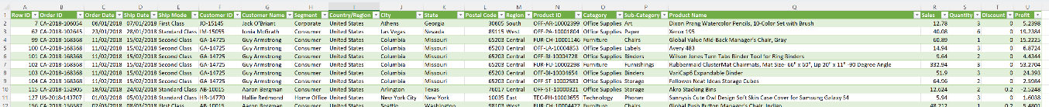
- The table in Excel is connected to a pivot cache – this is done using the Table Design ribbon and the ‘Summarise with PivotTable’ tool.

- Next, the Pivot Table can be created onto a new sheet in Excel.
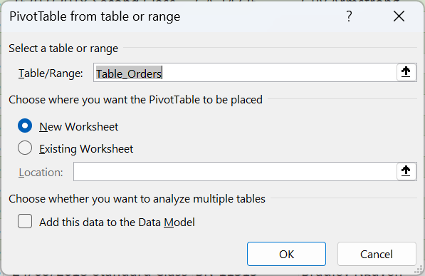

- The Order Date field can be dragged into the ROWS from the new Pivot Cache, and the Quantity field is dragged into the VALUES.
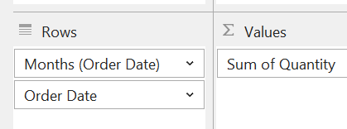
- The resulting table (shown below) can now be decluttered and formatted appropriately for the audience. Relabel the columns, remove the Grand Total, and flatten the data to show just months.
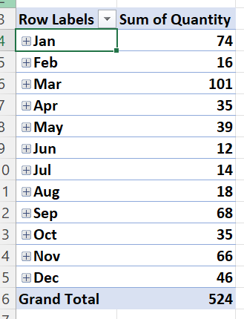
- After decluttering, the following table satisfies the scenario and shows the executive audience the monthly units sold. The finished product can be seen below.
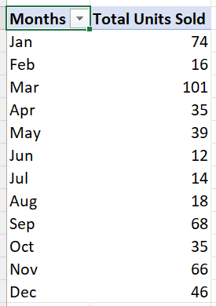

Visualise data
The story’s point may remain unclear even when the data is simplified and tabulated. Using graphical visualisations to make key points more evident and memorable may be the way forward for the report.
Developing well-designed charts, graphs, and infographics and choosing the right type of visualisation that best represents your data and supports your key messages can sometimes help communicate complex information in a digestible manner.
Demonstration activity – visualise the data
- If we use the table from the previous example, the intended audience may struggle to identify the insight for the scenario. The reason we need the monthly figures is so we can identify the highs and lows of the period.
- However, if we use the Insert ribbon in Excel, we can create a chart that identifies the changes over the 12 months – a Line Chart would be good for this.
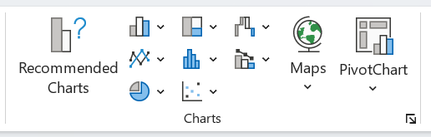
- The example below shows what this may look like as default when using the Excel application.
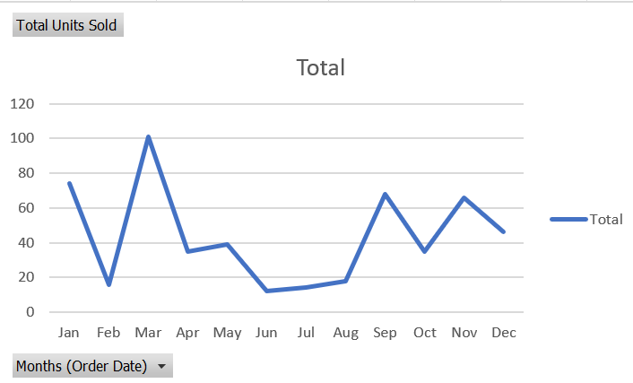
- In Module 2, we discussed the types of visuals, and in module 3, we discovered tools that will assist with decluttering. They can be applied at this stage to produce a visual that is both readable and appealing to the intended audience.

Colour highlight
A good way to draw attention to detail or the key point in a story is to use colour or emphasis. As the designer of the visual story, consider using colours, labels, or annotations to draw attention to the key points. Using bold or larger fonts in text often highlights important numbers or conclusions.
Demonstration activity – use colour and emphasis to highlight
- Your audience now wants to identify the monthly low points, and you have been given a target value to use. Scenario: to identify where the business is underperforming, you must show the months below the target of 20 units sold.
- Suppose you are using the table from the previous activity. In that case, you should be able to use colour to draw attention to the below target months by using an Excel feature called conditional formatting.
- Highlight the key data in the table and select the Conditional Formatting tool from the Home ribbon (conditional formatting is available in other data tools such as Power BI and Tableau).
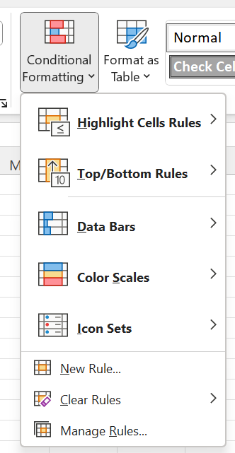
- Now you can select the New Rule option and develop a logical statement that will identify all the values that are less than (below) the target of 20.
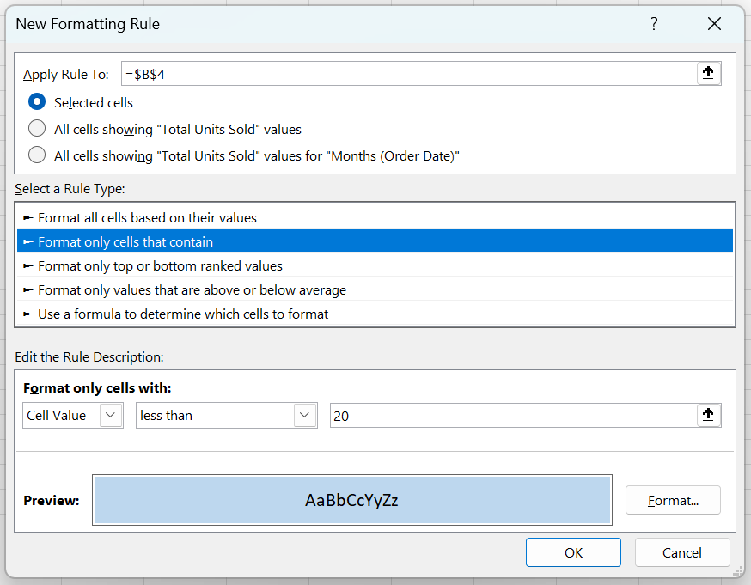
The colour you choose here will be specific to a corporate brand or guideline of accessibility. Remember that there may be a stakeholder who is Red/Green colour blind – so use appropriate colours for focus.
- A side-by-side comparison of the original table and the newly colour focussed table shows the huge difference a small amount of colour can do. Your audience can now easily identify where the business is underperforming.
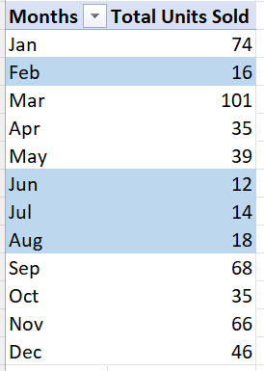

Annotations
These descriptive texts can provide additional context or insights into the key points. Annotations are a broad description of objects that can help reinforce the main message and make it stand out to the intended audience.
Examples include text labels, data callouts or arrows that provide context and highlight important points in the visualisation.
Demonstration activity – include annotations
- In the previous demonstration, you used colour to identify the low points of the data to the audience. Scenario: now you need to identify the lowest point and hypothesise why this may be.
- Suppose you are using the table from the previous activity. In that case, you should be able to create a bar graph visual showing the 12-month data.
- If you are using Excel as a product, you can create the bar graph from the Insert ribbon, charts panel where you can choose the type of bar graph you need. This demonstration uses a 2D Bar Graph.
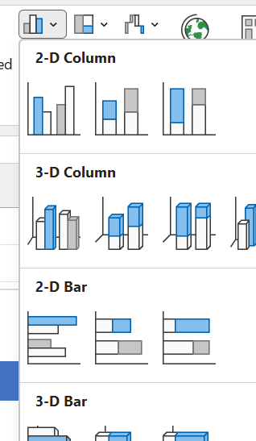
- Per your newfound knowledge from module 3, you may need to declutter the graph appropriately. Below is a screenshot of what the bar graph may look like after you have decluttered.
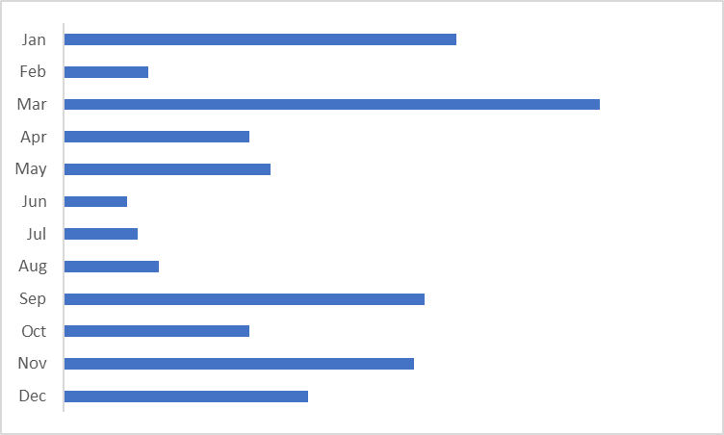
- If you have developed this visual in Excel, you can now add the data label for June. Adding labels to a single data point is achieved by using two single clicks – click one activates the bars and click two activates just the month of June.
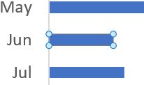
- Now that June has a focus, you can use the  ‘add element’ symbol and create a data label.
- The data label is a text block, so if you click inside the box it can be edited: the box can be resized, repositioned, and formatted appropriately.
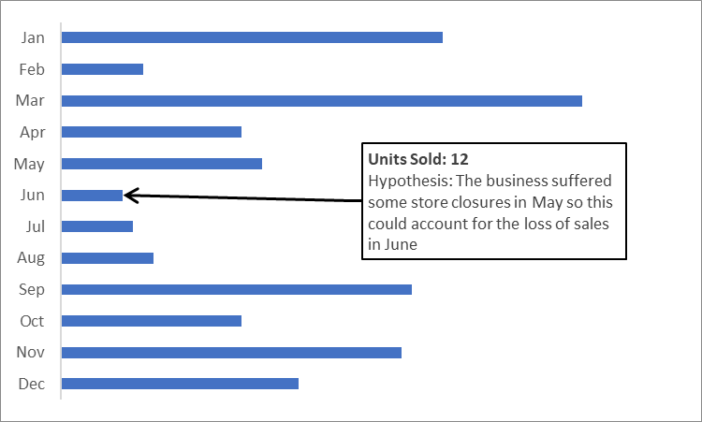
- In addition, some applications, such as Visio, have callouts or sidebars that can enhance diagrams by providing additional detail. As seen in the example below, these can be room plan measurements or database model properties.

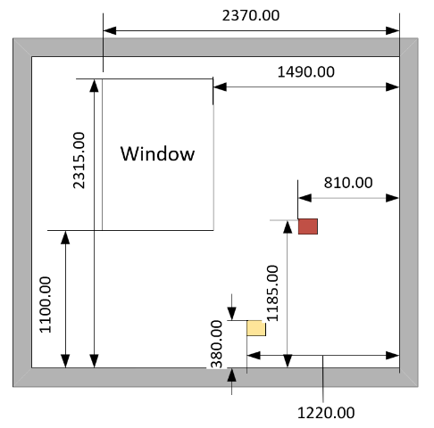 |  | .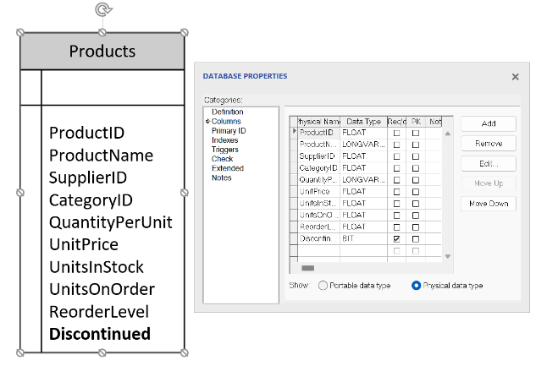
Remember that emphasising key points doesn’t mean oversimplifying or distorting the data.
It’s about presenting the most crucial information in a way that is accessible and memorable for your audience.
In summary, emphasising key points in a data story is crucial to effectively communicate the most important insights to the audience. To achieve this, you have seen in this module that simplification and focus are essential.
Using well-designed charts, graphs, and infographics to digest complex information will be more engaging for your audience, and the main message becomes clear and memorable – a better buy-in is achieved.

Module review
In this module, as the storyteller, we have seen how you can deliberately and strategically present key information to capture and maintain the audience’s concentration on the most critical insights.
We have also seen that you, the storyteller, can guide the audience’s attention to specific data points in data visualisations to highlight essential trends and patterns crucial in the business process by using colours, labels, and annotations.
And you have learned that graphs and charts are visual representations of data that help convey information quickly and effectively. They condense complex datasets into concise and accessible formats, allowing the audience to immediately grasp key trends and patterns.
This module was about:
- Understanding the types of visualisations.
- How to declutter the visuals.
- Focussing attention on the key points for the audience.

Review questions
- Why is simplifying complex data important in data storytelling?
  - A: To overwhelm the audience with information.
  - B: To make the data more difficult to understand.
  - C: To highlight only the critical insights and avoid distractions.
  - D: To impress the audience with the depth of the data.
- Fill in the blanks:
The matrix visualisation organises data into ____ and ____, just like a table, but it also includes additional dimensions for ____ or categorising the data.
- True or false? A large and varied colour palette is visually pleasing and helps convey the information effectively.

Review activity
- You can discuss this with your trainer or write down some ideas for the business.
- Your visuals – How do you declutter your visualisations? What type of focus may you need to use? What types of visualisations do you need to develop for your audience?

Module 7: Creating the story
Creating a compelling data narrative arc involves structuring data-driven content and is essential to communicate insights that captivate and inform the audience.
This concept borrows from traditional storytelling techniques, applying them to data to enhance engagement and comprehension.
The narrative arc typically comprises key stages: introduction, rising action, climax, falling action, and resolution.
In this module, using the knowledge gained so far, we will learn how to set the stage for what's to come once the data's relevance and context are established.

By the end of this module, you will be able to:
- understand the key stages of a data narrative arc.
- build a storyboard for the audience.

Data narrative arc – telling the story!
The data narrative arc is a storytelling framework applied to data-driven content to create a compelling and engaging narrative that helps audiences understand and connect with the presented information.
This concept typically requires you to build a storyboard which will visualise the key stages of the data narrative arc: Stage setting, rising action, climax, falling action, and resolution.
Stage |  | Description
 | Setting the stage | This introduction serves as the foundation of the data narrative arc. As the storyteller, you establish the presented data's context, relevance, and significance here.  This stage captures your audience's attention, provides background information to understand the subject, and often includes a hook or intriguing insight to pique your audience's curiosity.  It answers the questions: what is the data about? Why is it important?
 | Rising action | This stage is where you build tension and curiosity. As the storyteller, you must introduce data points, statistics, or trends that build upon the initial context.  This stage is similar to the rising action in traditional storytelling, where events and challenges escalate, creating tension and anticipation.  The data is presented in a way that keeps your audience engaged and curious about what might happen next.  You may use anecdotes, relatable examples, or real-world scenarios to create an emotional connection to the story and enable a stronger buy-in from your intended audience.
 | Climax | The pivotal point of the data narrative arc here is where the data's most important findings or turning points are revealed – the key insights.  At this moment, your audience's understanding is deepened, and the main message or takeaway of the data story becomes apparent.  Visualisations, charts, and graphs can be crucial in presenting complex data clearly and concisely during this stage.
 | Falling action | After the climax, the falling action stage delves into the implications and consequences of the revealed insights.  Here you explore the ‘what now?’ aspect of the data, explaining how the findings impact the larger context, industry, or problem being addressed.  This stage may involve discussing trends, potential scenarios, or future actions based on the data presented.  It helps your audience understand the broader significance of the insights and encourages critical thinking.
 | Resolution | The resolution stage of the data narrative arc offers a sense of closure and provides your audience with clear takeaways or a call to action.  At this stage, your audience comprehensively understands the data's implications and how it can be applied in real-world scenarios.  The resolution reinforces the importance of the data story, and it might include recommendations, decision making insights, or further exploration ideas.

Building the storyboard
Telling stories is an ancient and universal form of communication. It involves using a narrative structure to convey information, emotions, and ideas. Stories can capture attention, evoke emotions, make information memorable, and be fictional or based on real events. They are even told using various mediums, such as spoken word, written text, and visual art.
So why does a data story have to be any different? When combined, storytelling and data can create a powerful way to convey information, especially in contexts where data might otherwise be overwhelming or dry.
We can take the steps discussed in the previous section and build them into a visual, more appealing manner to engage the audience and better outline the journey.
Many experts in data storytelling often call this diagram the ‘storytelling mountain’ due to how the diagram is drawn.
Here is a rough outline of what the storytelling mountain might look like and how the stages of the narrative arc fit.










Setting the stage
Rising Action
Climax
Falling Action
Resolution

Reflection activity
It’s time for you to pause and think about the industry/business you work in, the data you are in contact with, the audience’s needs, and the type of data-driven questions they may ask.
Here are a few examples of story narratives. See if you can identify one or more stories you wish to use.

Navigating growth: unveiling the journey of sales performance
Let's consider a data narrative arc centred around sales:

Setting the stage
- An introduction to the company, its products/services, and its recent growth trajectory.
- It highlights the importance of understanding sales data to sustain and accelerate this growth.
- The audience learns about the context and the questions the data will address, such as, ‘what factors contribute to our sales growth?’
- The data sources and metrics used for measuring sales performance are explained in this phase. The audience learns how the data is collected and what it represents.
- The competitive landscape and market trends are also briefly outlined to provide context for the upcoming analysis.

Rising action
- The main findings are presented. The data reveals a steady increase in sales over the past year but with significant monthly fluctuations.
- This inconsistency raises questions about the underlying causes, prompting an investigation into the patterns and trends.
- Initial analysis suggests that certain months have consistently higher sales while others exhibit a downward trend.

Climax
- The climax occurs when the deeper analysis uncovers a correlation between higher sales months and the company's marketing campaigns.
- The data shows that months with well-timed and targeted marketing efforts consistently yield higher sales figures.
- This revelation is the turning point, highlighting the critical role of marketing strategies in driving sales success.

Falling action
- The narrative dives into the details of successful marketing campaigns.
- The data narrative explores how specific strategies, such as social media promotions and email campaigns, aligned with consumer behaviour patterns and market trends.
- It also discusses how customer feedback played a role in refining these strategies.

Resolution
- This conclusion emphasises the importance of data-driven decision making in sales and marketing efforts.
- It underlines the need for continuous monitoring, analysis, and adaptation based on real-time sales data.
- The data narrative closes by emphasising that the company's sustained growth hinges on its ability to translate data insights into actionable strategies.

Summary
Throughout this data narrative arc, the audience is taken on a journey that starts with an introduction to the sales environment, progresses through data analysis and insights, and concludes with actionable takeaways.
The narrative arc engages the audience, builds tension as insights are revealed, and ultimately offers a meaningful story about the company's sales performance and connection to marketing strategies.

Empowering engagement: unveiling the heartbeat of employee satisfaction
Let's explore a data narrative arc centred around employee engagement:
Setting the stage
- Introducing the company as a workplace that values its employees and their contributions.
- The significance of employee engagement and its impact on overall productivity and retention are highlighted.
- The audience learns about the data's purpose: to uncover insights into the factors influencing employee engagement.
- Introduces the methods for gathering employee engagement data, such as surveys and feedback sessions.
- Understanding the metrics used to measure engagement, including job satisfaction, work-life balance, and professional development opportunities.
- The importance of a positive work environment is established through examples of how it affects employee morale.
Rising action
- The central conflict emerges as the data analysis reveals a decline in employee engagement scores over the past year.
- Delve into specific areas of concern, such as increased turnover rates, reduced participation in company activities, and declining peer-to-peer recognition creating tension and raising questions about the decline's root causes.
Climax
- The narrative uncovers a connection between the decline in engagement and recent changes in the company's organizational structure.
- The data shows that employees affected by the restructuring exhibit lower engagement levels.
- This revelation marks a pivotal moment, illustrating changes in management's critical role in maintaining employee satisfaction.
Falling action
- The narrative explores the impact of open communication and transparency on engagement.
- The data reveals that teams with leaders who effectively communicated the reasons behind the changes experienced less decline in engagement.
- The narrative also showcases successful instances where team leaders provided opportunities for employee feedback and incorporated suggestions into the changes.
Resolution
- Underscores the company's commitment to employee well-being and engagement.
- It highlights the need for ongoing efforts to ensure employees feel valued and informed, especially during periods of change.
- The data narrative closes by emphasizing that a culture of transparency and active leadership engagement are key drivers of maintaining a motivated and loyal workforce.
Summary
Throughout this data narrative arc, the audience is taken on a journey that starts with understanding employee engagement, progresses through data analysis and insights, and concludes with actionable steps to improve engagement and maintain a positive workplace environment.
The narrative arc engages the audience, builds tension as insights are uncovered, and ultimately offers a meaningful story about the company's approach to fostering employee satisfaction and engagement.
Remember, a successful data narrative arc combines data-driven insights with compelling storytelling techniques to create a meaningful and engaging journey for your audience.
Adapt the structure to fit the specific data and audience you're addressing, and practice refining your narrative for maximum impact.

Module review
In this module, you have seen that by creating a data narrative arc that follows a trajectory from context establishment to insight dissemination, you can combine storytelling and data can engage your audience emotionally and intellectually, making your message more memorable and influential.
Whether you're presenting business metrics, scientific findings, or any other type of information, forging this approach can help you effectively communicate complex concepts and drive understanding to all your audience types.

This module was about:
- understanding the key stages of a data narrative arc.
- building a storyboard for your audience.

Review activity
You can discuss this with your trainer or write down some ideas for the business.
Your actions – What storyboards do you need to create? How are you going to foster an emotional connection?

