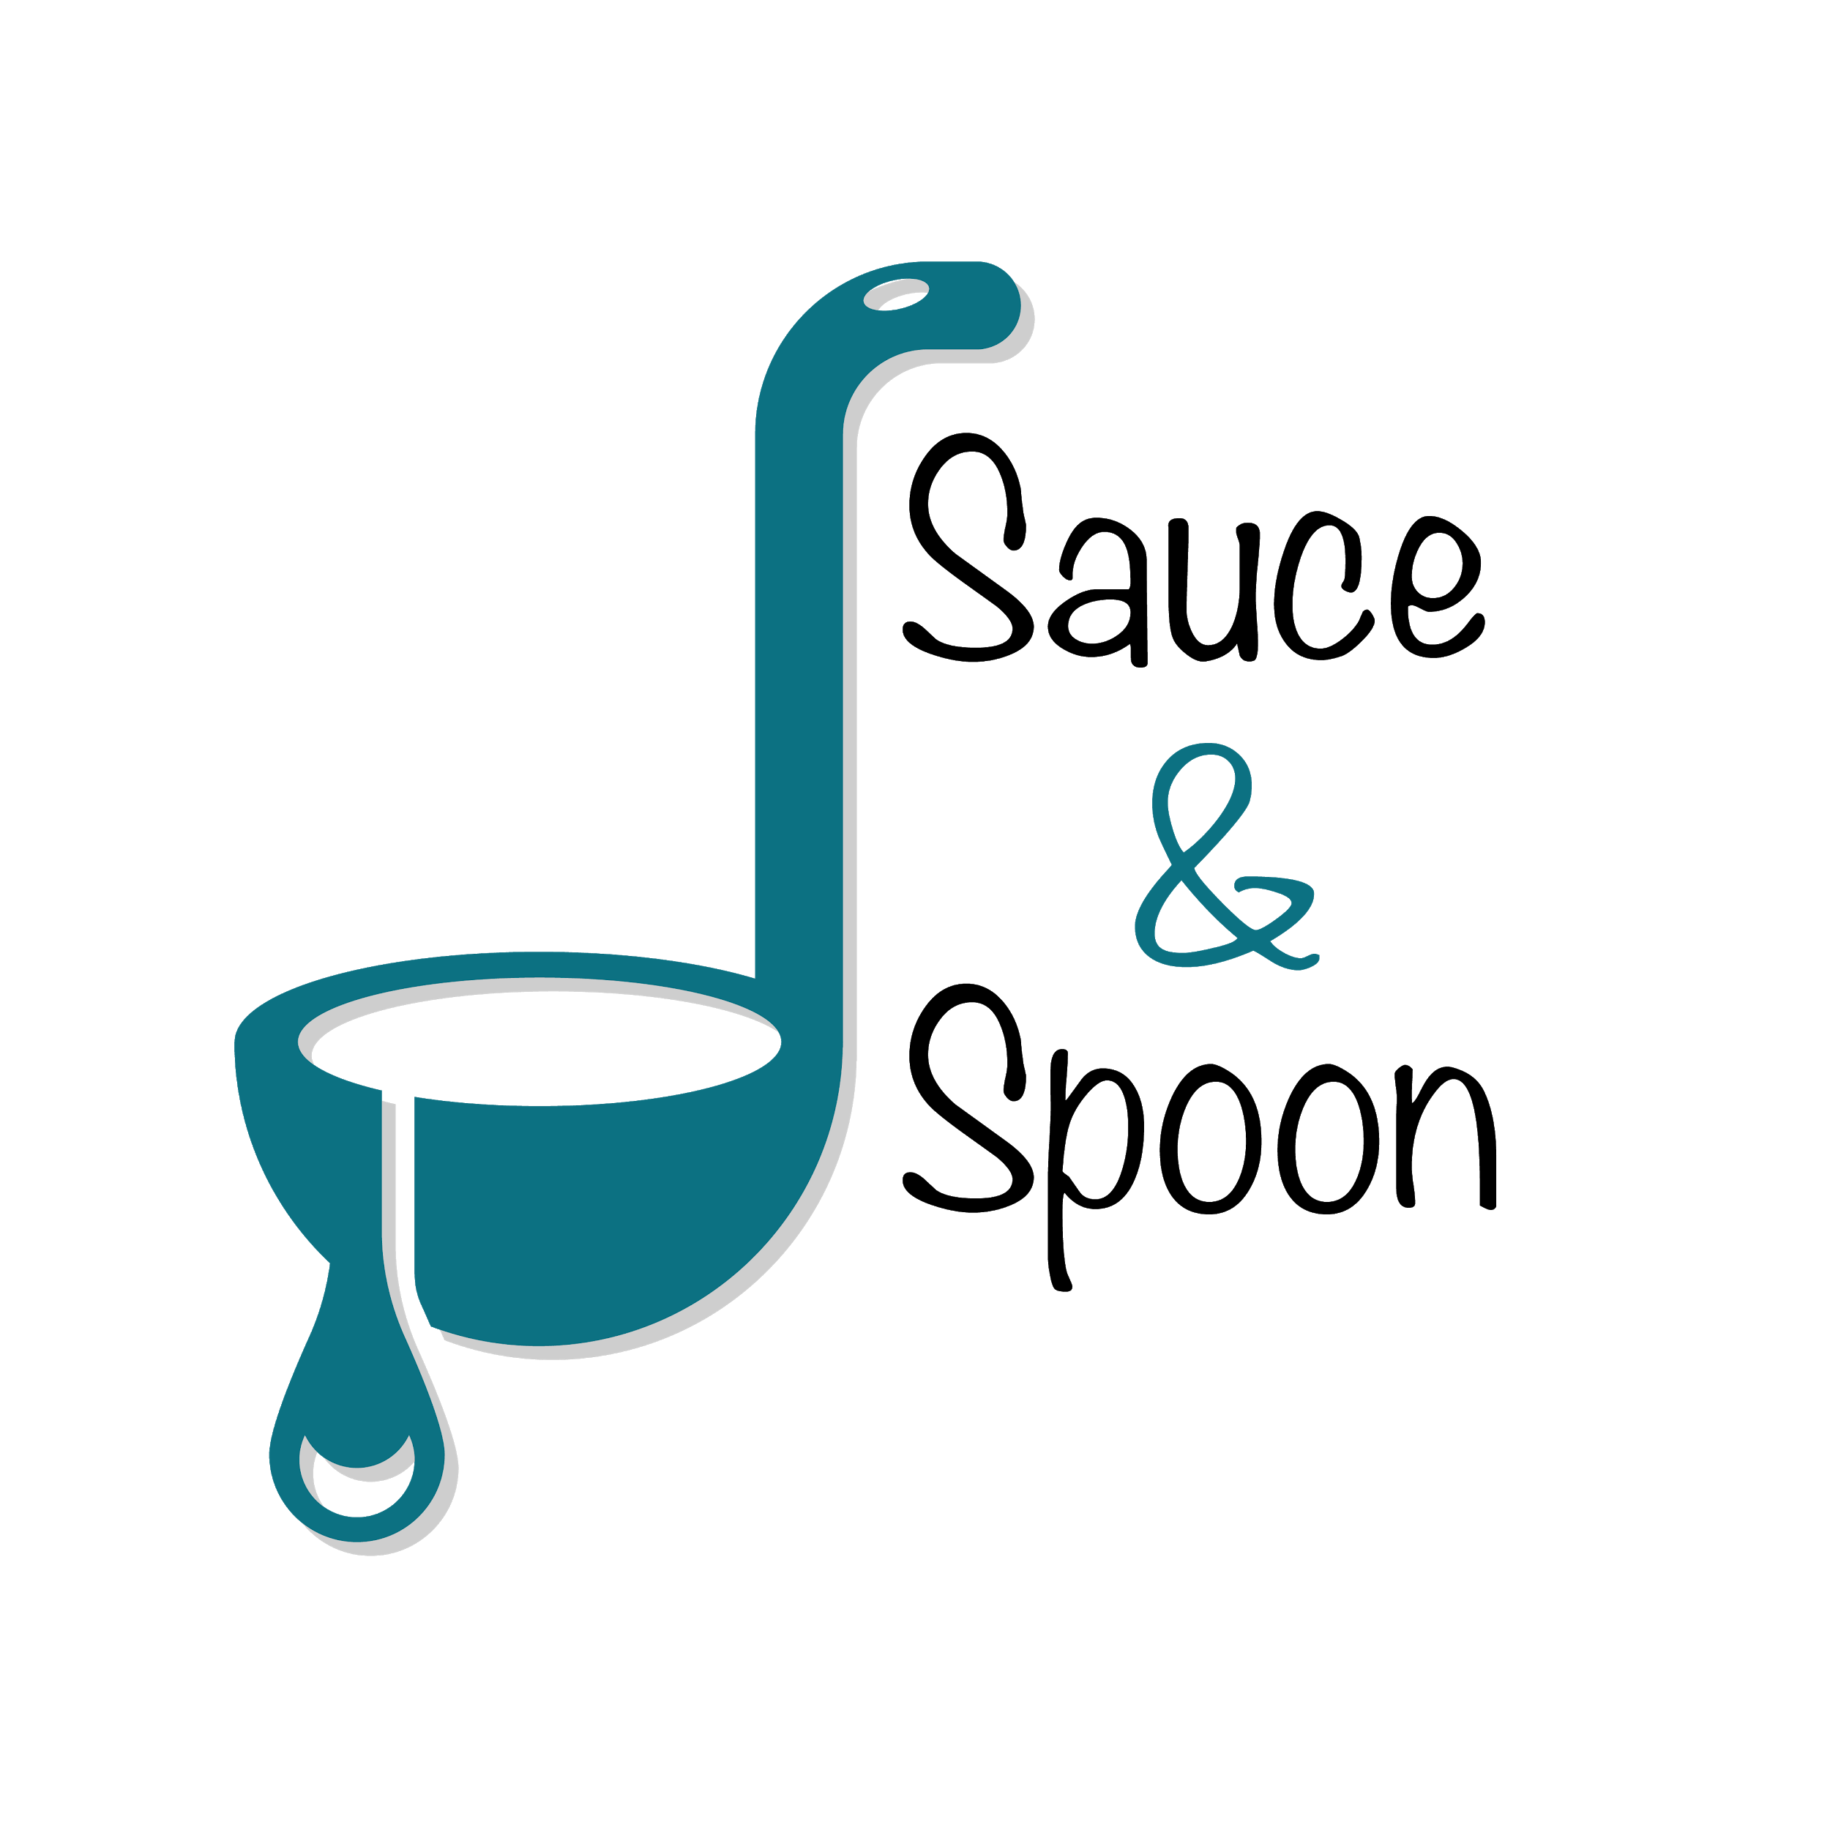

Project Charter: [Sauce & Spoon]

DATE: [31/12/23]

In order to aim for growth and expansion. Sauce and Spoon launch an pilot project by rolling out tableout menu tablets assist customers with quick, easy ordering options

while provide fresh food for working families of our community

**Project Summary**

* Improve table service efficiency by installing tablet menu since Q2
* Speed up service and more table turnover rates/reduce guest wait time
* Increase average check out total to $75 by sell more appetizer and beverages by the end of Q2
* Increase daily guest count by 10% by the end of Q2
* Decrease average turn time by approx. 30 min by the end of Q2
* Increase appetizer order overall by 15%(downtown 20% and North 10%)
* Reduce employee turnover rate and increase employee satisfaction

**Project Goals**

* Implement tabletop menu tablet on Downtown and North location
* Create training material and train staff on new tablet ordering system
* Tablet package with the menu item add-on feature and coupons
* Tablet software compatible with existing system
* Update website and menu design
* Partner with 5 new, local, and sustainable vendors each year on rotating basis
* Use only local vendors(250 miles radius) in all of our operations, support local business through sourcing and partnership

**Deliverables**

**In-Scope:**

* Tablet ordering system rollout
* New website and menu design
* Improve kitchen employee satisfaction metric
* Train staff with new system

**Out-of-Scope:**

* Implement new policy for food waste
* Hire more kitchen staff(BoH staff-back of house staff)

**Scope and Exclusion**

**Benefits:**

* Speed up service
* Increase sales by an estimated percent
* Provide restaurants with clear data points on customer ordering and an

integrated point-of-sale system to help guide decision-making in the future

* Improve employee royalty

**Costs:**

* Training Material - $10,000
* Hardware and Software Implementation - $30,000
* Maintenance - $5,000
* Update Website and Menu Design - $5,000
* Customization Fee - $550
* Total : $50,550

**Benefits & Costs**

* Misalignment about Payroll Reallocation - budget allocation which reduce FOH and increase BOH staff to support increase in order
* Revise Feature about Change in Policy Change - regard food waste and order return based on error
* Misalignment about Increase Appetizer Sale as a goal - since different location got different sale percentage on appetizer and beverage in total sales
* Misalignment about Goal - put decreasing in guest wait time and table turnover rate as separate goals

**Appendix:**