1. The project is hosted in <https://github.com/kwagilwajos/LockedMe.git>
2. This project is planned in one sprint, The tasked to be achieved are
3. Created the workflow of the application
4. Created a git repository
5. Development/coding
6. Tested the project on various kind of inputs
7. Pushed the code in GITHUB
8. Project Flow Chart

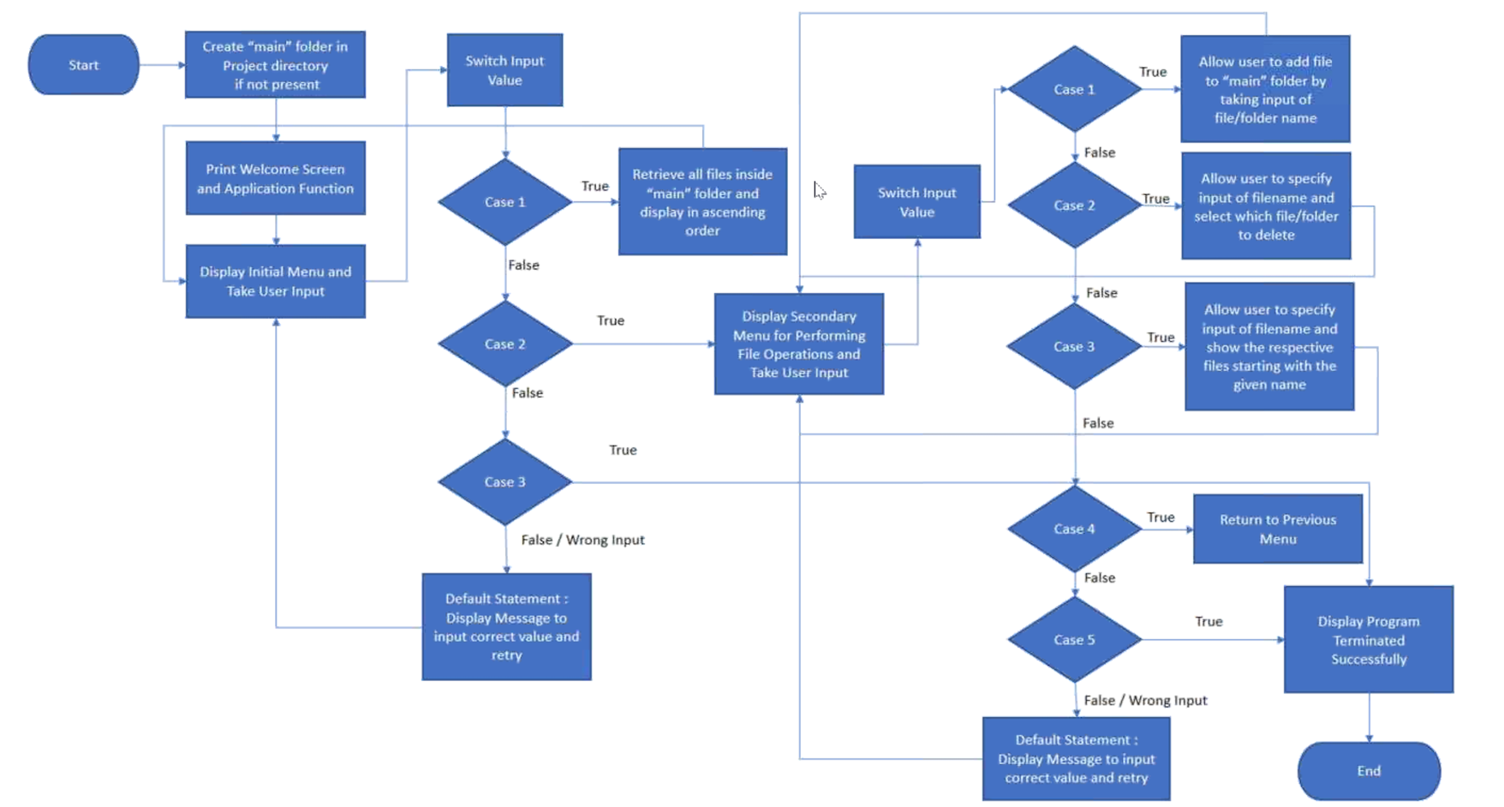

1. Java Concept used

File handling, Exception handling, Flow Control, Loop Control, Lambda Function and Functions.