**Inside Cover: Acknowledgements, Author names, Citation**

**PAGE 1 Foreword [RESERVE ONE PAGE]**

**Progress on the New York Declaration on Forests**

**An Assessment Framework and Initial Report**

**The New York Declaration on Forests (NYDF) was endorsed by more than 150 governments, companies and business associations, indigenous peoples’ and civil society organizations at the United Nations Climate Summit in September 2014**. Since then, the number of signatories has grown to more than 180. These signatories have committed to do their part to achieve the NYDF’s ten goals and follow its accompanying action agenda.[[1]](#endnote-1)

**The NYDF has roots in other processes, and its aims overlap with the Sustainable Development Goals and the new climate agreement expected to be adopted in December 2015 in Paris**. The NYDF builds on the Tropical Forest Alliance 2020 and other initiatives. Complementary processes include the 2011 Bonn Challenge to restore 150 million hectares of degraded land by 2020 and the Aichi Biodiversity Targets, which include at least halving the loss of all natural habitats. The NYDF goals are well aligned with discussions and agreements on forests that have emerged in international climate negotiations. Achieving NYDF goals could reduce the global emissions of greenhouse gases (GHG) by 4.5–8.8 billion metric tons every year.[[2]](#endnote-2)

**The NYDF comprises 10 goals** (Table 1)**. The first and overarching goal is to strive to end natural forest loss by 2030, with a 2020 milestone of a 50% reduction.** A number of the other goals are subsidiary to Goal 1, including halting deforestation from agricultural supply chains (Goal 2), reducing deforestation from other economic sectors (Goal 3), and supporting alternatives to deforestation driven by poverty and basic needs (Goal 4). Another goal calls for restoring 150 million hectares of degraded land by 2020 and an additional 200 million hectares by 2030 (Goal 5). A set of goals aim at improving the enabling environment to help signatories and other entities meet deforestation-related goals; they include establishing a strong international framework (Goals 6 and 7), better financing (Goals 8 and 9), and improved forest governance with more secure forest and land rights for local communities and indigenous peoples (Goal 10).

#### Table 1: The 10 NYDF goals to halt deforestation

|  |  |
| --- | --- |
| Goal |  |
| 1 | At least halve the rate of loss of natural forests globally by 2020 and strive to end natural forest loss by 2030 |
| 2 | Support and help meet the private-sector goal of eliminating deforestation from the production of agricultural commodities such as palm oil, soy, paper, and beef products by no later than 2020, recognizing that many companies have even more ambitious targets |
| 3 | Significantly reduce deforestation derived from other economic sectors by 2020 |
| 4 | Support alternatives to deforestation driven by basic needs (such as subsistence farming and reliance on fuel wood for energy) in ways that alleviate poverty and promote sustainable and equitable development |
| 5 | Restore 150 million hectares of degraded landscapes and forestlands by 2020 and significantly increase the rate of global restoration thereafter, which would restore at least an additional 200 million hectares by 2030 |
| 6 | Include ambitious, quantitative forest conservation and restoration targets for 2030 in the post-2015 global development framework, as part of new international sustainable development goals |
| 7 | Agree in 2015 to reduce emissions from deforestation and forest degradation as part of a post-2020 global climate agreement, in accordance with internationally agreed rules and consistent with the goal of not exceeding 2°C warming |
| 8 | Provide support for the development and implementation of strategies to reduce forest emissions |
| 9 | Reward countries and jurisdictions that, by taking action, reduce forest emissions —particularly through public policies to scale-up payments for verified emission reductions and private-sector sourcing of commodities |
| 10 | Strengthen forest governance, transparency, and the rule of law, while also empowering communities and recognizing the rights of indigenous peoples, especially those pertaining to their lands and resources |

The NYDF goals may be categorized according to the following typology:

* Quantitative output goals (1 and 5) provide numeric targets, and are timebound.
* Qualitative output goals (3 and 10) are directional, and may or may not be timebound.
* Support goals (2, 4, and 8) refer to inputs intended to help achieve the goals.
* Policy goals (6 and 7) refer to the inclusion of forest conservation, restoration, or emission reductions in international agreements.
* Reward goals (9) refer to results-based payments to countries and/or subnational jurisdictions.

**This report proposes a framework for assessing progress toward NYDF goals and summarizes the status of the ten goals on the one-year anniversary of the NYDF signing.** The NYDF is ambitious, and its signatories represent a powerful and diverse coalition. Nevertheless, while the NYDF is supported by an action agenda, it does not define a process or establish a forum to monitor progress toward achieving its goals. This report aims to address that gap.

**A number of indicators and proxies are proposed for measuring progress toward NYDF goals.**  The different types of NYDF goals present distinct challenges for monitoring progress. For example, where goals are framed quantitatively, data are often missing; where goals are framed qualitatively, it can be difficult to agree on appropriate metrics to measure progress. Indicators and monitoring will likely improve over time as data gaps are filled.

Detailed summaries of our assessments for each goal are available online at [www.forestdeclaration.org](http://www.forestdeclaration.org) and are referred to as supplementary materials throughout this report.

**Goal 1: At least halve the rate of loss of natural forests globally by 2020 and strive to end natural forest loss by 2030**

*Key messages:*

* *Globally, the annual loss of natural forest area appears to be declining, if forest regrowth is counted as offsetting forest clearing.*
* *At the same time, there is no sign that the annual rate at which natural forests are being cleared or harvested is slowing.*

The NYDF’s overarching goal, Goal 1, aims to end natural forest loss by 2030, with at least a 50% reduction by 2020 as a milestone toward its achievement. While natural forests clearly do not include monoculture tree plantations, Goal 1 does not specify whether the aim is to reduce and then end *gross* or *net* loss of natural forests. Thus we have selected separate proxy indicators to monitor each type of loss (see Box 1 for definitions):

**Indicator 1.** Annual *gross* forest/tree cover loss in hectares

**Indicator 2.** Annual *net* natural forest/tree cover change in hectares

We used data from Hansen et al. (2013, updated by Global Forest Watch) for Indicator 1 and data from the Food and Agriculture Organisation of the United Nations’ Global Forest Resources Assessment (FAO FRA; 2015) for Indicator 2. Each indicator uses a different method and both embody substantial uncertainties (see Data Gaps and Limitations section, below, and supplementary material for more detail).

* The Hansen et al. (2013) dataset uses satellite imagery at a 30 meter pixel resolution and measures areas with tree cover as a proxy for forest area, defined as all vegetation 5 meters or taller with a default canopy cover threshold of 25%. Global Forest Watch (GFW) illustrates the Hansen et al. 2013 dataset, with updated data for 2013 and 2014 using a 30% default canopy threshold (www.globalforestwatch.org).
* FAO FRA compiles data on forest area reported by countries every five years. Forests are defined based on national land use classifications, with a minimum threshold of 0.5 hectare of land area, trees over 5 meters and a 10% minimum canopy cover. The figures for net natural forest loss are reported by subtracting the total natural forest area of one reporting period from that of the previous reporting period.

Despite uncertainties and limitations, the two data sets show directional trends that can serve as proxies for monitoring. As improvements in these proxy measures as well as new measures emerge, they should be considered.

Box 1: Differentiating gross and net loss of natural forests

***Gross* loss of natural forest measures the magnitude of annual change, counting all tree cover or forest area lost, without regard to any regeneration or reforestation of natural forest**. Since 1988, this approach has been used by the Brazilian Space Agency (INPE) to monitor deforestation in the Brazilian Amazon. INPE’s analyses are widely recognized as credible and transparent. In this satellite-based approach, a pixel classified as forest in 1988 may be deforested only once, after which it is masked from future analysis, regardless of whether its conversion to “nonforest” is temporary or permanent. **Ending gross natural forest loss would mean that, from year-to-year, there would be no measurable clearing of natural forest area.**

***Net* loss of natural forests measures the difference in forest area between two points in time, averaged over the number of years between reporting periods.** The United Nations Food and Agriculture Organization’s Global Forest Resources Assessment (FAO FRA) monitors net changes in forest area every five years, based on tabular data that are self-reported by participating countries – using their own inventories, surveys, and maps. Recent data assembled and analyzed by FAO FRA allow separation of net natural forest loss from plantation forest data. **Ending net natural forest loss would mean that the measurable area of natural forest regeneration/reforestation is equal to or greater than the measurable area of gross natural forest loss over a specified time period.**

Beyond the data limitations described for the Goal 1 indicators, there are important trade-offs between targeting gross vs. net natural forest loss:

* **Gross forest loss treats loss as categorically distinct from regeneration/reforestation (noting that the latter is addressed in Goal 5), whereas net forest loss conflates the two.** For numerous purposes, and in most (but not all) cases, newly regenerating/reforesting areas are inferior to the forests that they offset under a net accounting approach. These purposes include:
  + Carbon storage, insofar as it can take 30 to 300 or more years for an area of regenerated or restored forest to accumulate the amount of carbon emitted to the atmosphere from the same area of lost natural forest, hence regeneration/restoration is unlikely to offset carbon emissions from natural forest loss – especially if the “new forest” subsequently experiences cycles of clearing and regrowth. **Zero net forest loss does not equal zero net forest emissions.**
  + Hydrological cycle functions may return more quickly than carbon storage, but it generally takes well over a decade of regrowth to regain the extent of water-pumping from ground to atmosphere that deep-rooted natural forests provide, hence the potential impact on rainfall may be important.
  + Biodiversity differs between older and younger forests with marked changes in plant species composition, and structure in the new forests offering different habitats that attract different types of wildlife.
* **Achieving zero natural forest loss could result in perverse outcomes for both gross and net accounting approaches, unless modifications or contingencies to the definition of “zero” are developed and applied:**
  + Because **zero gross natural forest loss means no clearing of any natural forest for any purpose**, strict adherence would translate (*inter alia*) to:
    - No construction of roads or other infrastructure in natural forest areas.
    - No clearing of natural forest (including secondary forest) for agriculture of any kind, even by small farmers and/or indigenous peoples.
    - Overmanagement of forests to prevent loss, including where disturbances (e.g., natural fires) are part of maintaining a healthy ecosystem.
  + **Because zero net natural forest loss conflates loss with reforestation/regeneration, this target could be successfully achieved at the same time as the world’s remaining primary/old-growth forests are completely replaced by regenerated forests.**

**Sources:**

Brown, S., and Zarin, D. (2013) What does net zero deforestation mean? *Science* (6160): 805-807. // Food and Agriculture Organization of the United Nations. (2015) Global forest resources assessment 2015: How are the world’s forests changing? Rome: FAO.

INPE website, accessed Oct 2015. Projeto Prodes: Monitoramento da floresta Amazonica Brasileira por satelite. http://www.obt.inpe.br/prodes/index.php.

**Figure 1** shows the data from both Hansen/GFW and FAO FRA over 15–20 years as well as the 2020 targets. The Hansen/GFW data shows an increase in *gross tree cover* loss (9%) between 2010 and 2014 compared with the preceding decade. In the figure, gross tree cover loss (red line) spikes in 2012, and trends downward in 2013 and 2014, but there is not significant progress toward halving gross annual loss by 2020 (*Indicator 1*). As for net natural forest loss (blue line), the FAO FRA data show a significant and continuous decline in net forest loss since the 2000-2005 reporting period (roughly a 25% decrease in the 2010-15 reporting period compared with the 2001-10 historical average). The rate of net natural forest loss may be on a trajectory for meeting the milestone of halving natural forest loss by 2020 (*Indicator 2*).

Recognizing the limitations of the data, we infer that, globally, these divergent results reflect an overall trend of increasing natural forest cover re-established on abandoned or degraded land even though regeneration and reforestation are not keeping up with the rate of gross forest cover loss.

#### Figure 1: Measures of gross (red) and net (blue) annual natural forest loss, 2000–15

Source: Hansen/Global Forest Watch (2015) provides proxy data for *gross* tree cover loss and United Nations Food and Agriculture Organisation’s Global Forest Resources Assessment (FAO FRA)

(2015) shows data for *net* natural forest loss. The Hansen/GFW data for a canopy cover of 30%, with the upper error bars representing 50% canopy cover and lower error bars representing estimates at 10% canopy cover. The FAO FRA data represent the net rate of natural forest loss, aggregated for the 140 countries that reported.

Data Gaps and Limitations

A major limitation of the Hansen data set is that it does not distinguish between natural forest and plantations, land-use designations, or types of forest disturbance (e.g., logging, fires, storms). Tree cover loss counts tree plantation rotations and shifting cultivations as well as natural disturbances, and does not distinguish them from anthropogenic natural forest conversion. GFW intends to delineate plantations for seven key tropical countries so they can be removed from this analysis.

FAO FRA data rely on self-reporting by countries, hence, the quality and methodology of the data varies. Challenges with the FAO FRA data include: incomplete global reporting (not all countries are accounted for), incomplete country reporting (all forests may not be accounted for), inaccurate reporting (tiers of accuracy vary), data that are not spatially explicit, and changing methods in different reporting periods. There is also a significant time lag between the collecting, reporting, and publication of FAO data.[[3]](#endnote-3)

**Goal 2: Support and help meet the private-sector goal of eliminating deforestation from the production of agricultural commodities such as palm oil, soy, paper, and beef products by no later than 2020, recognizing that many companies have even more ambitious targets**

*Key messages:*

* *Half the forests providing wood fiber for paper are under sustainability certified production. Certified sustainable palm oil has grown to 18% of the global market. Certified sustainable soy is only 2% of the global market. There is no data on beef products. For palm and soy, most certification is through sustainability offsets rather than on-site certification.*
* *The number of companies pledging to reduce deforestation has grown rapidly in recent years and for palm oil and wood fiber represents a large percentage of production. Overall it is still a small percentage of agricultural commodity market actors. Companies that endorsed the NYDF generally have better-than-average sustainability ratings.*

Goal 2 targets eliminating deforestation from the production of a defined set of agricultural commodities by 2020 and reflects a pledge by the Consumer Goods Forum, a private sector consortium.[[4]](#endnote-4) Agriculture causes about two-thirds of all deforestation in tropical countries, where commercial agriculture accounts for about 40% and subsistence agriculture accounts for about 33% of total tropical forest loss.[[5]](#endnote-5) Commercial tropical agriculture increasingly drives tropical forest loss because of growing demand for a small group of agricultural commodities including palm oil, soy, paper, and beef.[[6]](#endnote-6)

To assess progress on the private-sector goal of halting deforestation from agricultural commodities, we selected two proxy indicators. The first measures the market share of certified sustainable palm oil, soy, paper, and beef production. The second measures private companies’ and governments’ support for the production of low deforestation, or deforestation-free commodities.

**Indicator 1.** Market share of certified commodities (palm oil, soy, paper, beef)

**Indicator 2.** Companies’ and governments’ support for the production of low-deforestation, or deforestation-free commodities

These indicators are imperfect measures of progress toward meeting Goal 2 (see supplementary materials), but can help monitor the direction of progress.

*Indicator 1.* The market share of certified production varies across the commodities considered for this goal. Between 2008 and 2013, certified sustainable palm oil production increased from 0.6 million tons to 9.8 million tons, representing 18% of global palm oil production (Figure 2). However, a large proportion of sustainable production is currently certified through sustainability offsets,[[7]](#endnote-7) which means that forest may still be lost in production. Most production is still uncertified in major producing countries like Indonesia, Malaysia, and Thailand.[[8]](#endnote-8)

In contrast, the share of certified sustainable soybean production remained constant between 2008 and 2012 reaching a mere 2.1% of global soybean production by 2012. In the coming years, the Round Table on Responsible Soy expects a doubling in market share of certified soy among its members.[[9]](#endnote-9)

According to the International Council of Forest and Paper Associations half the total industry-managed forests supplying pulp for paper are under certification from the Forest Stewardship Council (FSC) or the Programme for the Endorsement of Forest Certification (PEFC).[[10]](#endnote-10) However, certification has plateaued with three-quarters of the certified forest areas located in North America and Western Europe. Bringing more industrial forest under certification will require the expansion of certification programs in developing countries.

There is no global certification standard on sustainably produced beef with market share information. This leaves a monitoring gap in one of the major deforestation risk commodities.

#### Figure 2: Global total and certified palm oil production, 2008-12

Production refers to the global production of palm oil. Certified Production (RSPO) refers to the production with a certification from the Roundtable on Sustainable Palm Oil.

Source: Climate Focus calculations based on data from the Roundtable on Sustainable Palm Oil (2015), and FAOSTAT for the global production data for palm oil.

*Indicator 2.* The number of pledges by corporations to reduce deforestation risk in their production, supply, and procurement of commodities has rapidly increased from the single digits in 2009 to the hundreds by September 2015, according to Forest Trends’ Supply-Change.org platform, which tracks corporate commitments (Figure 3).[[11]](#endnote-11) Although many large companies that play a significant role in these supply chains have made commitments, the percentage of companies in the major commodity supply chains that have made pledges remains low.

#### Figure 3: Number of companies making commitments to reduce deforestation, 2009-14

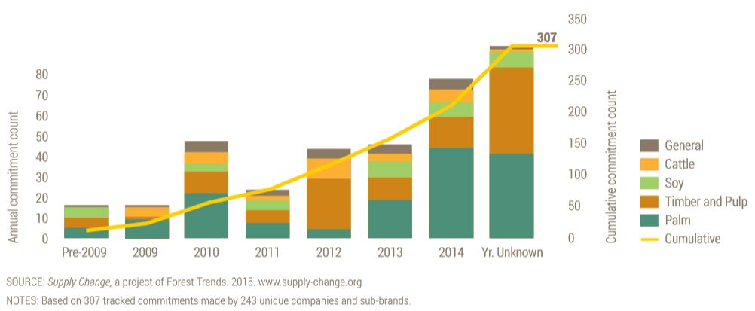

Source: Courtesy of Supply Change, a project of Forest Trends. 2015. www.supply-change.org

According to Forest 500,[[12]](#endnote-12) an initiative of the Global Canopy Programme, only 7% of companies identified as “powerbrokers” in these agricultural supply chains have zero or zero net deforestation commitments covering all agricultural commodities they produce or procure. Nevertheless, it is encouraging that a large proportion of companies identified by Forest 500 have commodity-specific production or procurement policies. A greater number of palm oil and timber companies have commodity-specific sustainability commitments than soy or cattle companies (Figure 3). Of the companies with commodity-specific commitments, those in the palm oil sector had the most comprehensive policies and scored highest in a system that measures the progress in meeting deforestation-related commitments.[[13]](#endnote-13)

The Sustainability Consortium[[14]](#endnote-14) develops key sustainability performance indicators used by Walmart and other companies to evaluate supplier performance on issues including commodity-specific deforestation commitments. Focused on product categories such as paper, beef, and seed oils, these indicators enable retailers and other users to track progress on product-level environmental and social impacts.

Although companies may source certified fiber and palm oil, less than 20% can report that their supply is 100% certified or 100% deforestation free. Additionally, only 20% of companies can report zero deforestation in their dairy and beef feed supply chain and the majority of companies have no data on deforestation for either feed or cattle.[[15]](#endnote-15) Availability of data and visibility into long supply chains is important in understanding how companies score on these indicators. Data availability may improve as systems are put in place for annual reporting.

Figure 4 shows key performance indicator (KPI) results on commodity-specific deforestation commitments by retailers as compiled by The Sustainability Consortium.

#### Figure 4 The Sustainability Consortium Key Performance Indicators scores (TSC KPI) from retail supplier surveys on certification and deforestation

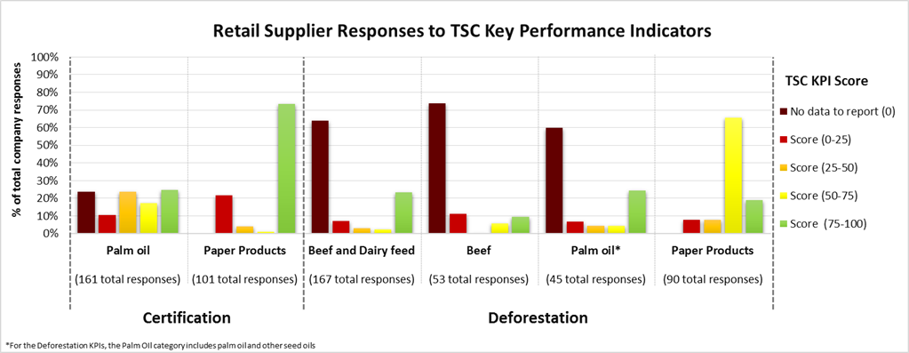

Source: Figure provided by The Sustainability Consortium based on personal communication. The KPIs evaluate the success of the companies in meeting their deforestation-related commitments. Soy-based feed is included in the Beef and Dairy Feed KPI. These scores are based on supply chain reporting conducted by companies.

Compared with companies from other sectors, financial institutions have made the least progress in supporting sustainable, low-deforestation, or deforestation-free commodity production. Less than 20% of major investors have developed forest safeguards or made commodity-specific pledges. However, a number of major banks have signed up to the Banking Environment Initiative and/or the Natural Capital Declaration suggesting that the risks associated with investing in companies involved in deforestation are beginning to be acknowledged.

As for governments, according to Forest 500, almost a quarter of the exporting and almost half of the importing countries have made public zero-deforestation commitments for one or more commodities.

Data Gaps and Limitations

There is no standardized way to measure sustainability of production across different commodities. Certification bodies apply various definitions and standards, and market data is often not publicly available. Beef production, one of the most important commodities driving forest loss, has no widely used international certification standards. Including deforestation as a sustainability indicator would improve ease of data collection and increase transparency.

**Goal 3: Significantly reduce deforestation derived from other economic sectors by 2020**

*Key messages:*

* *The most significant nonagricultural drivers of forest loss are infrastructure development, human settlements, and mining.*
* *Though some interventions can be highlighted, there is no coordinated effort to track effort to reduce the forest impact of these sectors.*

Goal 3 focuses on economic sectors other than agriculture. The most significant non-agricultural drivers of deforestation are infrastructure development, human settlements, and mining, while logging is the most important driver of forest degradation.[[16]](#endnote-16) Between 2000 and 2010, infrastructure (construction of roads, railroads, pipelines, hydroelectric dams) and human settlements (urban expansion) were each responsible for 10% of all tropical deforestation, while mining accounted for 7% of all tropical deforestation. During the same period, timber extraction and logging accounted for approximately 52% of all tropical forest degradation, making them the main drivers of total forest degradation (see Goal 10).

Unfortunately, few countries have disaggregated data that link deforestation spatially to particular drivers. The lack of such data prevents adequate measurement of aggregate deforestation from infrastructure, mining, and logging and makes it difficult to formulate indicators. Consequently, we do not define indicators to track progress toward Goal 3, but rather highlight public and private sector activities that address these drivers and thereby reduce pressure on forests. Public policies and private-sector-led initiatives show action that has been or can be taken to support this goal, though we cannot assess its effectiveness.

Table 2 summarizes public polices and private sector activities in infrastructure and mining that address economic drivers of deforestation. Additional measures are taken to control human settlements and infrastructure. The timber and logging sector is discussed in Goal 10 below.

#### Table 2: Public and private interventions addressing some economic drivers of deforestation

|  |  |  |
| --- | --- | --- |
| **Sector** | **Public Policies** | **Private Sector Activities** |
| **Infrastructure** | • Environmental Impact Assessment (EIA) and the Strategic Environmental Impact Assessment (SEA)  • Environmental, social, and legal safeguards  • Strengthened law enforcement and governance | *[Infrastructure is mainly in the realm of the public sector.]* |
| **Mining** | • Fines, control of illegal mining, strengthening the mining approval process and improving mining practices  • Integrated land-use planning  • Protected area laws  • Strengthened law enforcement and governance | • Initiatives that intend to reduce environmental and social impacts of mining through the promotion of responsible practices (e.g. Initiative for Responsible Mining Assurance (IRMA), Alliance for Responsible Mining (ARM)  • Commodity-specific sustainable commitments |

Enhanced regulation and oversight can better control these drivers and may reduce their impacts on forests. Examples of such approaches include:

* Regulation of activities and enforcement (e.g., Peru is starting to control gold mining by introducing fines for illegal mining, strengthening its mining approval process, and regulating mining practices;[[17]](#endnote-17) charcoal production in the Congo Basin is being regulated).
* Integrated land-use planning that reconciles mining development and forest conservation (e.g., infrastructure associated with the Mbalam-Nabeba iron project are developed in an integrated land use process that takes into account biodiversity and forest cover in Cameroon and the Republic of Congo).[[18]](#endnote-18)
* Designation of protected areas (e.g., heightened protection of ecosystems is included in the Constitution of Colombia).

Currently, no certification scheme sets standards for minimizing the impacts of mining on forests. However, the Initiative for Responsible Mining Assurance and the Alliance for Responsible Mining promote responsible mining practices that reduce environmental and social impacts.

Public finance institutions have environmental, social, and legal safeguards to ensure that their financing operations do not cause environmental and social damage. The World Bank’s safeguard policies, for example, require its lending to be accompanied by environmental and social risk assessments and risk-reduction plans. World Bank operational principles explicitly address forests: for example, no financing is allowed of projects that “would involve significant conversion or degradation of critical forest areas or related critical natural habitat,”[[19]](#endnote-19) or of “natural forest harvesting or plantation development that would involve any conversion or degradation of critical forest areas or related critical natural habitats.”[[20]](#endnote-20) In addition, social andenvironmental impact assessments are often mandated by law as well as by public and private institutions that finance infrastructure.

Data Gaps and Limitations

Data sources that link deforestation to particular economic sectors are largely missing or in need of improvement to become measurable indicators. Global mapped data showing mining and logging concessions over time (number, type, and area) would allow assessment of deforestation within and around concession areas.

**Goal 4: Support alternatives to deforestation driven by basic needs (such as subsistence farming and reliance on fuel wood for energy) in ways that alleviate poverty and promote sustainable and equitable development**

*Key messages:*

* *In the absence of data on interventions to tackle subsistence agriculture as a driver of forest loss, we focus solely on woodfuel interventions for which data is available.*
* *The global distribution of clean cookstoves is accelerating rapidly, almost doubling every year from 2008 to 2013. Global investments in clean cookstove distribution have also increased in recent years, peaking at US$260 million in 2014.*

Goal 4 promotes the reduction of forest loss by supporting economically sustainable alternatives to slash-and-burn farming and unsustainable harvesting of fuel wood from natural forests. Across tropical and subtropical countries in Africa, Asia, and America, small scale and subsistence agriculture are estimated to be responsible for about 33% of deforestation,[[21]](#endnote-21) with woodfuel and charcoal responsible for 27-34% of forest degradation.[[22]](#endnote-22) Small-scale agriculture remains a significant driver of deforestation in Africa.[[23]](#endnote-23) Approximately 275 million people live in woodfuel depleted “hotspots,” where harvesting to meet unsustainable demand is likely to cause deforestation.

There is no simple correlation between smallholder activities and forest loss; therefore, the relationship between poverty and forest loss is not linear (see supplementary materials). Poverty and low-yielding production practices can drive forest loss by increasing the land footprint required for subsistence, but not always, and traditional rotational cultivation is not necessarily bad for forests. Conversely, increasing wealth and returns on agricultural investment can drive forest loss by increasing the financial incentive and technological capacity to deforest. The focus of Goal 4 is not just avoiding forest loss associated with poverty, but also avoiding forest loss driven by unsustainable development pathways out of poverty.

No global datasets quantify government, corporate, or civil society support for alternatives to deforestation driven by basic needs; hence our ability to monitor progress toward achievement of this goal is currently inadequate. The only relevant metric identified is the growth in distribution of clean cookstoves that reduce woodfuel consumption. To monitor support for reducing the role of woodfuel harvesting as a driver of forest loss, we offer two proxy indicators:

**Indicator 1. Global distribution of clean cookstoves**

**Indicator 2. Financial support for woodfuel interventions**

In countries where woodfuel consumption is driving forest degradation, clean cookstove programs can reduce pressure on forests, as well as improve family health by reducing exposure to indoor smoke and pollution.

Woodfuel is any type of bioenergy derived directly or indirectly from trees and shrubs grown on forest or nonforest land,[[24]](#endnote-24) including firewood and charcoal. In many of the least developed countries, over 90% of households rely on woodfuel for cooking.[[25]](#endnote-25) In some countries, estimated GHG emissions from woodfuel consumption are equivalent to, or even greater than, reported emissions from deforestation.[[26]](#endnote-26)

*Indicator 1.* Figure 5 indicates a significant acceleration in the distribution of clean cookstoves globally. Analysis indicates that a large number of these cookstoves are distributed in countries where the link between woodfuel consumption and forest loss is well established (see supplementary materials). Our detailed analysis identifies countries where subsistence and smallholder activities correlate with high rates of forest loss, and includes case studies on specific interventions to reduce poverty among smallholder farmers while successfully protecting the forest.

#### Figure 5: Estimated distribution of cookstoves worldwide, 2006-13

Source: Climate Focus graphics based on data provided by Partnership for Clean Indoor Air (PCIA), and Global Alliance for Clean Cookstoves (2013).

*Indicator 2*. Finance for woodfuel interventions comes from official development assistance (ODA), carbon markets, other private investments, and other sources. While measuring total finance flows is not straightforward, several data sources indicate escalating sums. ODA directed to the woodfuel sector has increased from an annual average of US$3.6 million between 2006 and 2009, to US$47 million between 2010 and 2013. Ecosystem Marketplace data indicate a ramping up of the value of carbon market transactions for cookstove projects between 2011 and 2012, with a decline from 2013 to 2014.[[27]](#endnote-27) Cookstove project developers, however, have reported far higher investments. According to a Global Alliance for Clean Cookstoves market survey, cookstove project developers received US$ 273 million in 2014 (Global Alliance for Clean Cookstoves (GAC), Figure 6). This figure, which includes ODA and carbon market flows, is significantly higher than figures for previous years.

#### Figure 6: Finance for woodfuel interventions from multiple sources, 2002-14

ODA is official development assistance; GACC is the Global Alliance for Clean Cookstoves

Source: Climate Focus graphics based on unpublished data from Organisation of Economic Cooperation and Development’s Development Assistance Committee, the Global Alliance for Clean Cookstoves, and Ecosystem Marketplace.

Data Gaps and Limitations

OECD countries do not currently distinguish ODA flows to subsistence or smallholder agriculture from flows to the agricultural sector in general. Changing this would make it possible to track climate-relevant international public finance in this area.

**Goal 5: Restore 150 million hectares of degraded landscapes and forestlands by 2020 and significantly increase the rate of global restoration thereafter, which would restore at least an additional 200 million hectares by 2030**

*Key messages:*

* *Since 2011, countries, regions and organizations have committed to restore 62.6 million hectares of forest landscapes under the Bonn Challenge—approximately 42% of the 2020 restoration target.* *To meet the 2020 target, restoration pledges will need to be made at a greater rate to cover the remaining 90 million hectares.*
* *Parties to the United Nations Framework Convention on Climate Change have committed to restore, reforest, and/or afforest about 122 million hectares as part of their land-sector intended nationally determined contributions—approximately 41% of the 300-million-hectare 2030 restoration target.*

Goal 5 adopts the 2011 Bonn Challenge target of restoring 150 million hectares of forest by 2020,[[28]](#endnote-28) and extends it to restore an additional 200 million hectares by 2030. A methodology for tracking progress toward these goals by the International Union for the Conservation of Nature (IUCN) is expected to be released shortly making it possible to monitor implementation of Goal 5. In the meantime, we use restoration pledges made under the Bonn Challenge and the United Nations Framework Convention on Climate Change (UNFCCC) as imperfect proxies to signal progress. It is important to note that the UNFCCC pledges do not specify the type of land (degraded or other landscapes) being restored nor are the pledges all bound by the same timeframe.

**Indicator 1.** Forest restoration pledges under the Bonn Challenge, in hectares

**Indicator 2.** Afforestation, restoration, and reforestation pledges as part of the Intended Nationally Determined Contributions (INDCs) of Parties to the UNFCCC, in hectares

*Indicator 1.* Under the Bonn Challenge, forest landscape restoration is defined as “the long-term process of regaining ecological functionality and enhancing human well-being across deforested or degraded forest landscapes.”[[29]](#endnote-29) Current pledges include activities such as restoration of forest lands (including planted forests, natural regeneration, or silvicultural enhancement); restoration of agricultural lands (including agroforestry and improved fallows); and restoration of protective land and buffers (including mangrove restoration, watershed protection, and erosion control). IUCN and the World Resources Institute (WRI) have developed a Restoration Opportunities Assessment Methodology (ROAM), and are currently conducting country land assessments to help identify where restoration activities should take place.[[30]](#endnote-30)

The size of the Bonn Challenge commitments and the year they were made are shown in Figure 7. Since 2011, 14 countries, 3 subnational regions, and 2 organizations have committed to restore 62.6 million hectares of forest landscapes under the Bonn Challenge—equal to 41.7% of the 150-million-hectare 2020 restoration target. With projected announcements during the climate conference in Paris, it is expected that the total will increase to 83.8 million hectares of forest landscapes – equal to 55.8% of the target. While the number and size of commitments have increased over time, they have been clustered around major, multi-stakeholder agreements, primarily at the start of the Bonn Challenge in 2011 and the NYDF in 2014. Further commitments to the Bonn Challenge/NYDF process will need to be made at a faster rate to meet the restoration target by 2020.

#### Figure 7: Annual and cumulative commitments for hectares pledged for restoration under the Bonn Challenge relative to the target of 150 million hectares pledged by 2020

Source: Climate Focus analysis based on Bonn Challenge numbers from [www.bonnchallenge.org](http://www.bonnchallenge.org).

*Indicator 2.* Since early 2015, 68 parties to the UNFCCC have submitted INDCs containing land- sector targets. The total, forest restoration, reforestation, and afforestation pledges are estimated at 121.7 million hectares—equal to 41% of the 300-million-hectare 2030 restoration target. The specificity of forestation and restoration pledges vary significantly, with some having explicit hectare targets, regions, and timelines, and others providing a percentage-of-forest-cover goal for the country or targets conditional on support. Our rough estimate provides a glimpse of the potential restoration efforts underway, and shows a path for reaching the 2030 target.

Data Gaps and Limitations

Information on specific restoration activities and initiatives is currently spread across a number of databases, including those provided by the United Nations Environmental Programme World Conservation Monitoring Center and the Society for Ecological Restoration. Standardizing this information, and compiling global data, would make it possible to present global aggregates with greater confidence.

**Goal 6: Include ambitious, quantitative forest conservation and restoration targets for 2030 in the post-2015 global development framework, as part of new international sustainable development goals**

*Key messages:*

* *An ambitious and quantitative target for forest conservation has been adopted as part of the Sustainable Development Goals, namely to halt deforestation by 2020.*
* *However, no ambitious and quantitative target for forest restoration has been adopted.*

The Sustainable Development Goals (SDGs), adopted on September 25, 2015, replace and amend the Millennium Development Goals, which expire in 2015. Indicators to monitor implementation of the SDGs are under development by a United Nations inter-agency expert group. Meanwhile, we can assess the extent to which NYDF Goal 6 is reflected in the SDGs based on two indicators:

**Indicator 1**. Inclusion in the SDGs of an ambitious, quantitative 2030 target for forest conservation.

**Indicator 2.** Inclusion in the SDGs of an ambitious, quantitative 2030 target for forest restoration

SDG 15 aims to:

Protect, restore, and promote sustainable use of terrestrial ecosystems, sustainably manage forests, combat desertification, and halt and reverse land degradation and halt biodiversity loss.

Two of the nine targets under SDG 15 are relevant to the NYDF:

Target 15.1:

By 2020, ensure the conservation, restoration, and sustainable use of terrestrial and inland freshwater ecosystems and their services, in particular forests, wetlands, mountains, and drylands, in line with obligations under international agreements.

Target 15.2:

By 2020, promote the implementation of sustainable management of all types of forests, halt deforestation, restore degraded forests, and substantially increase afforestation and reforestation globally.

*Indicator 1*. Halting deforestation by 2020 is given in Target 15.2 as a forest conservation target. It is quantitative and would reduce global deforestation to zero by 2020. It is more ambitious than the NYDF Goal 1 target, which aims to halve deforestation in natural forests by 2020, and represents a significant increase in ambition from earlier SDG proposals to halt deforestation by 2030.

*Indicator 2.* In contrast, the SDG subtargets for restoring degraded forests and for “substantially” increasing reforestation are not quantitative targets. A placeholder for a quantifiable target (“increase reforestation by [x]%”) was in all iterations of the draft text from July 2014 to the final stage of the negotiations in July 2015, but was removed in the final stages of the SDG negotiations. The absence of quantifiable targets for forest restoration and reforestation signals a significant lack of ambition by the SDGs considering that other global targets (NYDF, Bonn Challenge, and Aichi Targets) all include quantifiable targets on forest restoration.

**Goal 7: Agree in 2015 to reduce emissions from deforestation and forest degradation as part of a post-2020 global climate agreement, in accordance with internationally agreed rules and consistent with the goal of not exceeding 2°C warming**

*Key messages:*

* *Although the contents of the post-2020 agreement to be reached in December 2015 are not known, it is unlikely that the main agreement will include more than a high-level reference to forests.*
* *Of the 122 countries that have submitted public outlines of their post-2020 mitigation contributions (INDCs), 40 have included specific actions on land use and forests, while 18 have excluded land use and forests.*

Goal 7 aims for the inclusion of forest-related mitigation measures in a post-2020 global climate agreement, the draft text of which is subject to intense negotiations but expected to be completed in Paris in December 2015. This agreement is expected to be high-level in nature, build on existing decisions of the UNFCCC, and be accompanied by bottom-up commitments of countries to domestic mitigation efforts (communicated through their INDCs).

Two indicators can assess whether and to what extent the Paris Agreement provides a framework that promotes reduction of emissions from deforestation and forest degradation (REDD+). An operational framework to support REDD+ is also being finalized.

**Indicator 1.** References to land use (including REDD+) in the Paris Agreement text

**Indicator 2.** References to land use (including REDD+) in submitted INDCs

*Indicator 1.*Throughout 2015, various versions of the negotiating text have included proposals for the inclusion of the land use sector, including in the preamble and in the context of accounting rules and market mechanisms. The structure and substance of the agreement are being intensely debated, and major changes can be expected in Paris. While the final text may contain high- level references to land use or the forest sector, Parties may settle the main implementation questions (e.g., principles of accounting for land-use emissions) in later decisions.

With respect to the operational framework for REDD+, the UNFCCC Subsidiary Body for Scientific and Technological Advice adopted three methodological decisions in 2015, essentially completing the REDD+ methodological framework.[[31]](#endnote-31) The Green Climate Fund board is however, still defining how it would make results-based payments for REDD+. It is not yet clear if Parties will formally recognize existing UNFCCC decisions in the text of the Paris Agreement, a move that would clarify the continuity and validity of these decisions.

*Indicator 2.* By October 2015, 122 countries had submitted INDCs and so, while more are likely to come and existing INDCs may be changed before a new international climate change agreement is reached, some initial assessment is possible. Forty Parties have specified some form of specific land-use activities within their INDCs, usually in addition to broader economy-wide targets. The content varies from specific emission-reduction targets to reducing deforestation, increasing forest cover, or increasing the share of protected areas. A large number of these INDCs do not specify an additional target, but rather state the proportion of their overall emission reductions that they intend to achieve through the land-use sector. Some 18 countries have specifically excluded the land-use and/or forest sectors from their targets.

**Goal 8: Provide support for the development and implementation of strategies to reduce forest emissions**

*Key messages:*

* *In the 12 years from 2002 to 2013, though varying significantly from year to year, bilateral ODA for reducing forest emissions in developing countries increased from an annual average of US$ 365 million during 2002-07 to US$744 million in 2008-13.*
* *There is not sufficient data to track public finance flows between developing countries, or domestic spending in developed and developing countries to reduce forest-related emissions, but indications are that it is increasing. Neither is there sufficient data to track private investment in strategies to reduce forest emissions but indications are that it is also increasing.*

We interpret NYDF Goal 8 to refer to the provision of financial and other support for efforts to reduce forest emissions through policies, laws, and government programs, or through private sector initiatives, efforts of local communities, indigenous peoples, ,or local projects. This broad interpretation of the goal reflects the diversity of signatories to the NYDF and the range of their capacities to deliver on this goal.

NYDF Goal 8 overlaps somewhat with several other NYDF goals. To avoid double counting we exclude here financial support for payments for verified emissions reductions (VER), which is covered by Goal 9.

Three proxy indicators can monitor Goal 8, recognizing some overlap with other goals:

**Indicator 1.** Amount of climate-relevant official development assistance for forests committed by OECD donor countries and disbursed either bilaterally or through multilateral institutions

**Indicator 2.** Domestic public spending in NYDF signatory countries on policies and measures that include an intent to reduce forest emissions

**Indicator 3.** Private support for strategies to reduce forest emissions

South-South cooperation in support of forest protection, contributions by indigenous peoples, and contributions by nongovernmental organizations (NGOs, are presented in more detail in the supplementary material.

*Indicator 1.* In 2013, the OECD’s Development Assistance Committee (OECD DAC) presented the first integrated picture of bilateral and multilateral commitments of climate relevant ODA,[[32]](#endnote-32) showing a total commitment of US$763.5 million (excluding results-based payments for REDD+). The majority of these funds (62%) came from bilateral sources, and the majority (also 62%) was reported as grants (Figure 9).

#### Figure 9: Total bilateral and multilateral ODA committed to the forestry sector for all developing countries with climate mitigation as a principal or significant objective, by channel and financial instrument, 2013

**Loan**

**Equity**

**Grant**

**Multilateral**

**Bilateral – mitigation significant**

**Bilateral – mitigation principle**

Note: Excludes REDD+ results based payments.

Source: Climate Focus calculations based on Organisation of Economic Cooperation and Development’s Development Assistance Committee dataset: Climate-related development finance in 2013.

In the 12 years from 2002 to 2013, though varying significantly from year to year, bilateral ODA for reducing forest emissions in developing countries increased from an annual average of US$ 365 million during 2002-07 to US$744 million in 2008-13 (Figure 8). Indications are that 2014 commitments were over US$1 billion, the strongest to date, though this has yet to be reported by OECD DAC.

#### Figure 8: Total bilateral ODA to reduce forest emissions committed to all developing countries, by whether climate mitigation was a principal objective or a significant objective, 2002-13

Source: Climate Focus calculations based on Organisation of Economic Cooperation and Development’s Development Assistance Committee dataset: Aid activities targeting global environmental objectives.

*Indicator 2.* No global data set reports relevant domestic public spending and data are patchy for developed and developing countries. Nonetheless, there is evidence of increased spending on forest management, for example, in the United States and Europe. In some developing countries, domestic public spending on forest conservation is equal to or greater than that received from international sources (see supplementary materials for details).

*Indicator 3.* Impact investments in forest conservation and the production of sustainable forest-related commodities, while still small, are also growing. Large investors, including major international banks and sovereign wealth funds, are developing sustainable investment policies that may reduce emissions from deforestation. These policies are still aspirational and their impact is difficult to assess. NGOs and indigenous peoples also make significant contributions toward strategies to reduce deforestation. It is difficult to distinguish whether NGOs are spending their own funds or passing through government funds, though this has been attempted in places. For example, it is estimated that between 2007 and 2013, four international NGOs contributed an estimated US$100 million toward reducing deforestation in the Amazon Basin (see supplementary materials for details).[[33]](#endnote-33)

Data Gaps and Limitations

Reliable data is available only for climate ODA commitments by OECD countries. It would increase transparency if OECD members would file complete disbursement data in DAC statistics, and if non-OECD countries would report on international financial assistance. There is no globally harmonized database that shows domestic public spending on forests to allows for an accurate assessment of own-country contributions to reducing forest loss. Nor is there adequate information on the scale or impact of private-sector and other investments for forests.

**Goal 9: Reward countries and jurisdictions that, by taking action, reduce forest emissions—particularly through public policies to scale-up payments for verified emission reductions and private-sector sourcing of commodities**

*Key messages:*

* *Between 2008 and 2014, over US$3 billion was committed, almost exclusively from international public sources, for performance-based REDD+ payments. Disbursements, at just over US$1 billion, have lagged behind commitments.*
* *The forest carbon market expanded rapidly to US$ 237 million in 2011, but growth has subsequently leveled off.*

Goal 9 encourages signatories to establish financial incentives that reward tropical forest countries and jurisdictions through payments, especially for verified emission reductions (VERs) from forests. Over the past decade, a range of approaches to making private and public payments for ecosystem services have been developed; this is one such effort in which it is assumed that forest emission reductions, measured against a baseline or reference level, will ultimately qualify for payment. A small but growing body of experience with payments for VERs is being developed as part of REDD+ result-based payment schemes, including Norway’s bilateral partnerships with Brazil, Indonesia, and Guyana, as well as the German REDD+ Early Movers Program. There is also private sector interest in rewarding VERs through carbon markets.

We propose two indicators to track progress on Goal 9:

**Indicator 1.** International payments for VERs disbursed through multilateral and bilateral funds and public programs

**Indicator 2.** The value of purchases of forest VERs through voluntary and compliance markets

*Indicator 1.* Between 2008 and 2014, a number of bilateral and multilateral results-based programs for reducing forest emissions were established, with over US$3 billion committed (Figure 10). These programs have been funded largely through Norway’s International Climate and Forests Initiative, although Germany, the United Kingdom, and other donor countries have also made significant contributions. Norway’s contribution to Brazil’s Amazon Fund is a preeminent example of performance-based payments for avoided deforestation.

Disbursements to payment for performance schemes, at just over US$1 billion, have generally lagged behind donors’ financial commitments. This is because forest countries have been engaging in a “readiness” process—building national strategies, developing monitoring systems, and so on—and are only recently starting to implement programs expected to reduce emissions from deforestation and forest degradation. Internal procedures and administrative requirements of donors and multilateral funds have also delayed disbursements.

#### Figure 10: Commitments to and disbursements from international payment- for- performance funds, 2014

Notes: NICFI is Norway’s International Climate Initiative, FCPF is the Forest Carbon Partnership Facility, KfW REM is the REDD Early Mover’s Program of Germany’s Kreditanstalt für Wiederaufbau.

Source: Graph by Climate Focus based on following data sources: NICFI commitments taken from Memorandi of Understanding with Brazil, Indonesia, Guyana, Peru Liberia. Commitments to FCPF Carbon Fund, BioCarbon Fund and REM programs were retrieved from respective fund websites. NICFI disbursements available from Amazon Fund website and Real-Time Evaluation of Norway’s International Climate and Forest Initiative. No disbursements recorded from FCPF Carbon Fund and BioCarbon Fund to date. REM disbursement data have been received from Forest Trends.

*Indicator 2.* Between 2005 and 2008, the value of the forest carbon market expanded steadily from US$8 million to US$32 million (Figure 11). The market then climbed rapidly over three years to US$ 237 million in 2011, representing an average annual growth of 90%. This was driven primarily by an increase in the size of the voluntary carbon market, which in 2011 represented 73% of the forest carbon market. However, in 2013 the value of the forest carbon market fell back to approximately US$150 million.[[34]](#endnote-34)

#### Figure 11: Value of the forest carbon market, 2005-13

Note: Excludes payments of the REDD Early Mover’s Program (REM), which are recorded under Indicator 1.

Source: Climate Focus calculations based on data provided by Forest Trends State of the Forest Carbon Market, 2014.

Greater market demand for forest VERs will require the integration of forest carbon credits into emissions trading systems, which will encourage entities covered under an emission trading system to purchase credits as offsets. However, market-based systems such as the Clean Development Mechanism and the European Emission Trading System have restricted the generation and use of forest carbon credits due to concerns over the permanence of emission reductions represented by forestry activities, and the potential for an oversupply of REDD+ credits to remove incentives for other offset projects. Though California’s Cap-and-Trade Program does not currently allow for the use of international forest offsets, this may change. Similarly the International Civil Aviation Association may provide opportunities for airlines to use forest VERs to offset airline emissions.

Data Gaps and Limitations

Most payment-for-performance programs focusing on forests and REDD+ have publicly accessible and up-to-date information on commitments and disbursements. However, this is not the case across all funds. Regular updates on commitment and disbursement levels by all payment-for-performance programs would help assess progress achieved under this goal.

**Goal 10: Strengthen forest governance, transparency, and the rule of law, while also empowering communities and recognizing the rights of indigenous peoples, especially those pertaining to their lands and resources**

*Key messages:*

* *Forest governance has improved modestly in recent years, coinciding with a significant expansion of bilateral and multilateral programs providing financial support to that end.*
* *Illegality remains high in the wood-based products market.*
* *Forest communities continue to live under the threat of violence, with killings related to land disputes continuing unabated.*
* *The proportion of forests over which indigenous people and local communities have recognized rights has increased by over one-third since 2002, though the rate of recognition has decreased in recent years.*

Goal 10 draws attention to the need for improving forest governance. Particular focus is given to transparency, rule of law, community empowerment, and indigenous peoples’ rights – especially their rights to land and resources. Given the complex nature of this goal, monitoring efforts are bound to be imperfect. For this assessment, we have chosen three proxy indicators for which some relevant data are available:

**Indicator 1.** Improvement of forest governance through strengthening institutions and policies

**Indicator 2.** Extension and strengthening the rule of law, as indicated by illegal logging as a percentage of total logging, the quantity of imports of timber with high risks of illegality, and the number of killings related to land disputes

**Indicator 3**. Recognition of indigenous peoples’ and local communities’ rights to land and forest resources.

*Indicator 1*. Many countries have made progress in strengthening institutions and policies related to forest governance. The governance frameworks across five timber-producing countries (Brazil, Cameroon, Ghana, Indonesia, and Malaysia), as measured Chatham House’s global policy index scores, experienced—on average—notable overall progress between 2008 and 2013 (Figure 12), though levels of improvement vary among countries.[[35]](#endnote-35) The strength of demand-side policy frameworks governing the timber trade across the seven consumer and processor countries (China, France, Japan, the Netherlands, United Kingdom, United States, and Vietnam) also increased (Figure 13).

#### Figure 12. Weighted average policy scores for five producer countries, by type of policy, 2008 and 2013

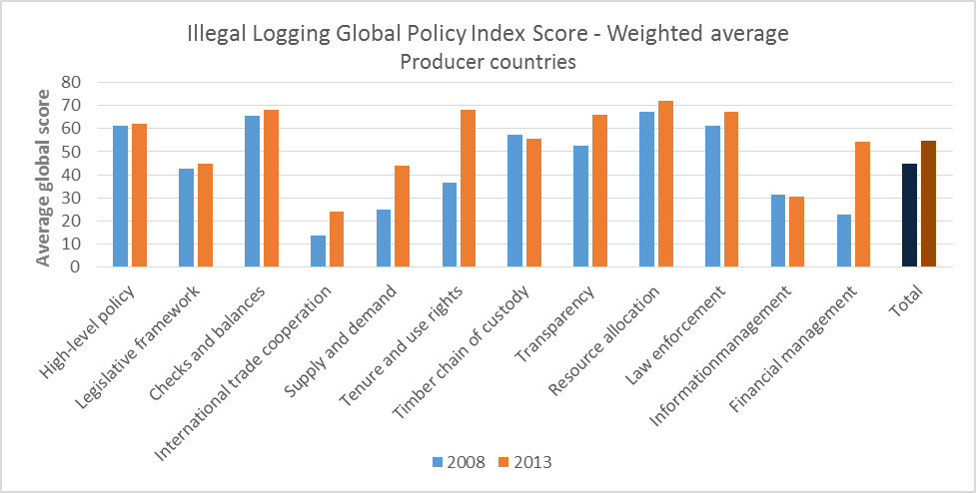

Note: The countries are Brazil, Cameroon, Ghana, Indonesia, and Malaysia. Scores are based on existence, quality and implementation of policies in relevant areas. For full description, see the supplementary material.

Source: Climate Focus calculations based on data provided by Chatham House.

#### Figure 13. Weighted average policy scores for seven consumer and processor countries, by type of policy, 2008 and 2013

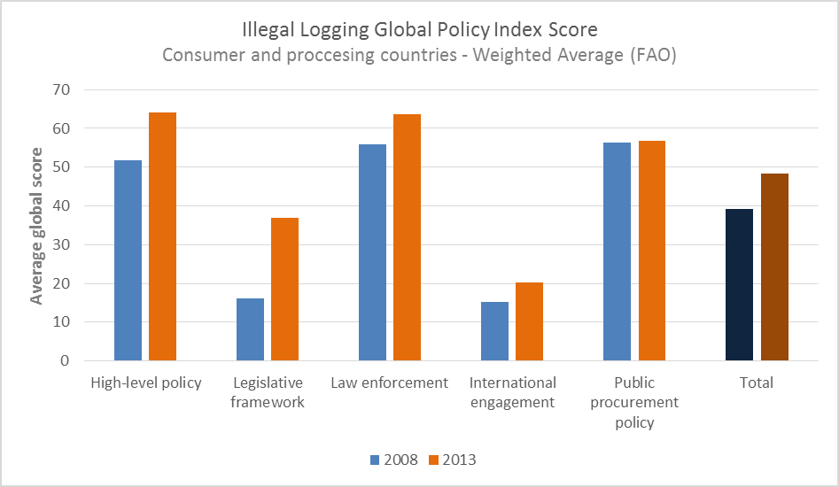

Note: The countries are China, France, Japan, the Netherlands, United Kingdom, United States, and Vietnam. Scores are based on existence, quality and implementation of policies in relevant areas. For full description, see the supplementary material.

Source: Climate Focus calculations based on data provided by Chatham House.[[36]](#endnote-36)

Average scores in producer countries have increased across all policy areas, with particular progress in policies that ensure greater matching of legal supply and demand, and that strengthen tenure and use rights and financial management regimes. Efforts toward international trade cooperation, while still nascent, have also improved, largely through the development of systems under the EU Forest Law Enforcement Governance and Trade (FLEGT) bilateral voluntary partnership agreements. In other areas, progress has been limited, and in several countries, some policy frameworks have weakened.

In consumer and processor countries, progress has also been made. The most notable gain has been in legislative frameworks, which reflect new and enhanced laws on timber legality across a number of developed countries and in Vietnam. In contrast, in China and Japan, legislation to address illegal imports remains largely absent. Other policy areas in demand-side countries generally showed incremental improvement, with international engagement remaining by far the lowest scoring policy area, which reflects limited international engagement on forest governance on the part of Asian consumer and processor countries.

Though it is not possible to accurately quantify international finance flowing toward forest governance and tenure, indicative evidence shows that, since 2002, the number of bilateral and multilateral programs that explicitly fund the improvement of forest governance and land rights has increased significantly. The emerging importance of REDD+ finance has further increased attention to governance and tenure issues. A substantial portion of finance dedicated to funding national REDD+ Readiness Preparation Programs – including US$360 million under the Readiness Fund of the Forest Carbon Partnership Facility and substantial co-financing from the UN-REDD Program and other donors – has been channelled toward governance, typically 16-20% of national readiness budgets. The Climate Investment Funds’ Forest Investment Program (FIP) has established a US$50 million dedicated grant mechanism for indigenous peoples and local communities to support their participation in the FIP, while an International Land and Forest Tenure Facility established by the Rights and Resources Initiative in 2015 aims at a budget of US$20-50 million per year for the next five years to provide financing for land rights, though at present it has only raised a fraction of this amount.

*Indicator 2*. According to Chatham House, the proportion of imports of wood-based products at high risk of illegality fluctuated less than 0.5% in the decade between 2003 and 2013 (Figure 14). It should be noted however that statistical measures of the rate of illegal logging and associated trade are inherently problematic precisely because it is illegal.

#### Figure 14. Wood-based product total imports and imports at a high risk of illegality of 10 importing countries, 2000-13

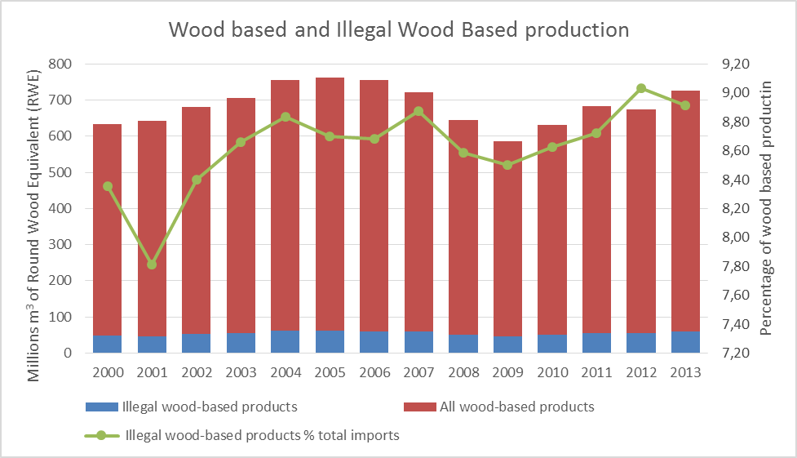

Note: The 10 importing countries are China, France, India, Japan, the Netherlands, Republic of Korea, Thailand, United Kingdom, United States of America and Vietnam

Source: Climate Focus calculation based on data provided by Chatham House.[[37]](#endnote-37)

Introducing greater control over the timber trade and banning the import of illegally harvested wood can reduce the level of imports associated with deforestation. The United States, the European Union, and Australia introduced import bans for illegal timber and timber products in 2008, 2010, and 2012 respectively. Revision of procurement rules by governments may also prevent tropical forest loss. According to a UN study, 56 countries had adopted laws on green public procurement by 2012.[[38]](#endnote-38)

As a direct index of forest governance, few metrics are more tangible than the incidence of violence related to conflicts over land and resources.[[39]](#endnote-39) From 2010 to 2014 at least 523 activists working on land/resource conflicts were murdered.[[40]](#endnote-40) There is no clear trend in the annual data, which very likely underreports the extent of the violence (see supplementary material for details).

*Indicator 3.* The share of total forests over which indigenous people and local communities have recognized rights increased 38% over 2002-13. The vast majority of forest lands where rights are recognized for indigenous peoples and local communities are in low- and middle-income countries, where such rights exist over more than 30% of forest land. While this share has increased from 21% in 2002, the rate of recognition has slowed dramatically since 2008, with less than half the area granted new rights recognition in 2008-13 compared with 2002-08.

Figure 15 compares the percentage of land area in four ownership categories identified by the Rights and Resources Initiative in the 40 countries for which data is available for 2002 and 2013.[[41]](#endnote-41) It shows in the second and third columns that, although the proportion of total forests over which indigenous peoples and local communities have recognized rights (either designation or ownership) remains small at 15.5%, it has increased by a third over 2002-13.

#### Figure 15: Global change in forest land tenure, 2002-13

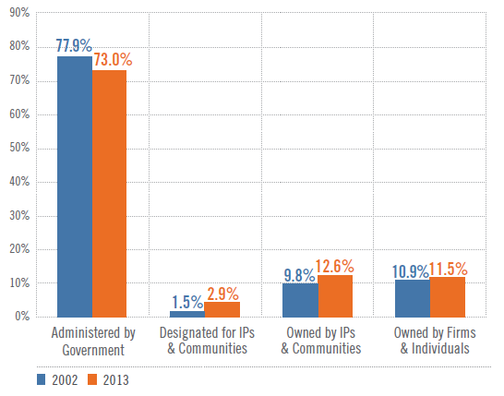

Note: IP is indigenous peoples.

Source: Rights and Resources Initiative (2014).

Recent years have also seen some progress in initiatives to support recognition of the land rights of local communities. REDD+ financing and safeguards processes have emphasized community rights and helped to strengthen them in places. Donors such as USAID have dedicated substantial financing to strengthening tenure recognition, while an International Land and Forest Tenure Facility established by the Rights and Resources Initiative in 2015. In addition, 2015 saw the launch of LandMark, an interactive global platform that provides maps and other critical information on lands that are collectively held and used by indigenous peoples and local communities, helping to increase the visibility of customary tenure arrangements, and thus protect land rights.[[42]](#endnote-42)

Data Gaps and Limitations

The assessments of forest sector governance include relatively few countries and thus provide only a partial picture of global progress. Expanding these assessments to more countries would enable a more complete assessment. There is as yet little research on the extent of forest land over which ownership is contested by indigenous peoples and local communities or for which they have sought formal titling. Understanding these areas of dispute would help to put the data on recognition of land and forest rights in context and enable a better assessment of how much more needs to be done. The LandMark initiative discussed above may help to address this gap.

**Summary of Assessment**

***Goal 1. At least halve the rate of loss of natural forests globally by 2020 and strive to end natural forest loss by 2030***

The combined efforts of public and private actors in past years have led to a slowing of the rate of net forest area loss. But at the same time, natural forests continue to be cut down at an alarming rate. More must be done to achieve the overarching goal of the NYDF to end natural forest loss by 2030, with at least a 50% reduction by 2020 as a milestone toward its achievement.

***Goal 2. Support and help meet the private-sector goal of eliminating deforestation from the production of agricultural commodities such as palm oil, soy, paper, and beef products by no later than 2020, recognizing that many companies have even more ambitious targets***

The increasing relevance of commercial agriculture as a main driver of tropical forest loss is closely linked to the growing demand for a relatively small group of agricultural commodities including palm oil, soy, paper (wood pulp), and beef products. Recent data show that palm oil certification jumped from 3 to 18 percent of the market between 2008 and 2013. During the same period, the market share for certified soy and paper remained stable, at 2 percent and 50 percent, respectively.

***Goal 3. Significantly reduce deforestation derived from other economic sectors by 2020***

While global data tracking deforestation linked to other economic sectors (infrastructure, human settlements, mining, timber) are lacking, there are numerous efforts to reduce deforestation associated with economic sectors (e.g., mining, infrastructure) other than commercial agriculture. These include a mix of supply- and demand-side measures, including establishing protected areas, law enforcement, environmental and social impact assessment requirements, and investment safeguards.

***Goal 4. Support alternatives to deforestation driven by basic needs (such as subsistence farming and reliance on fuel wood for energy) in ways that alleviate poverty and promote sustainable and equitable development***

There is no simple correlation between smallholder activities and forest loss, and the relationship between poverty and forest loss is not linear. Still, it is estimated that across tropical and subtropical countries in Africa, Asia, and America, small-scale and subsistence agriculture is responsible for approximately 30% of deforestation, with woodfuel and charcoal responsible for approximately 25% of forest degradation. In countries where woodfuel consumption is driving forest degradation, clean cookstove programs can help reduce pressure on forests, as well as improve people’s health by reducing exposure to indoor smoke and pollution. The distribution of clean cookstoves has increased significantly over the past years, and constitutes the principal area of measurable progress related to addressing deforestation driven by basic human needs.

***Goal 5. Restore 150 million hectares of degraded landscapes and forestlands by 2020 and significantly increase the rate of global restoration thereafter, which would restore at least an additional 200 million hectares by 2030***

This goal adopts the 2011 Bonn Challenge target of restoring 150 million hectares of forest by 2020, and extends it to restore an additional 200 million hectares by 2030. Since 2011, nine countries, two subnational regions, and one multinational region have pledged to restore 59.6 million hectares of forests. The INDCs of Parties that committed to afforestation, reforestation and restoration in their mitigation commitments cover about 122 million hectares.

While there has been clear progress, further commitments to the Bonn Challenge/NYDF process are needed, and must be implemented at a faster rate, to meet the remaining 60% of the restoration target by 2020.

***Goal 6. Include ambitious, quantitative forest conservation and restoration targets for 2030 in the post-2015 global development framework, as part of new international sustainable development goals***

Clear progress has been made in anchoring the commitment to reduce deforestation in the Sustainable Development Goals (SDGs), but the corresponding commitment on restoration is weak. In September 2015, the United Nations agreed as part of the SDGs to “[b]y 2020, promote the implementation of sustainable management of all types of forests, halt deforestation, restore degraded forests, and substantially increase afforestation and reforestation globally.”

***Goal 7. Agree in 2015 to reduce emissions from deforestation and forest degradation as part of a post-2020 global climate agreement, in accordance with internationally agreed rules and consistent with the goal of not exceeding 2°C warming***

Whether and how this agreement to reduce deforestation will be reflected in a new international climate agreement to be adopted in December 2015 in Paris remains to be seen. Some progress by countries is notable: of the 122 countries with mitigation pledges, 40 have included specific actions on forests and land use.

***Goal 8. Provide support for the development and implementation of strategies to reduce forest emissions***

Commitments of financial support to reduce deforestation are also increasing, although disbursements remain slow. From 2002 to 2013, though varying significantly from year to year, bilateral ODA for reducing forest emissions in developing countries increased from an annual average of US$365 million during 2002–07 to US$744 million in 2008–13. Though not yet captured in OECD reported figures, indications are that 2014 commitments are over US$1 billion, the highest to date.

***Goal 9. Reward countries and jurisdictions that, by taking action, reduce forest emissions —particularly through public policies to scale-up payments for verified emission reductions and private-sector sourcing of commodities***

Experience with payments for emission reductions is growing as part of result-based-payment schemes that increase incentives for reduced deforestation exists, including Norway’s bilateral partnerships with Brazil, Indonesia, and Guyana, as well as the German REDD+ Early Movers Program. Private sector interest in rewarding emission reductions through carbon markets also exists.

Between 2008 and 2014, over US$3 billion in public finance was pledged for results-based finance for forest emission reductions and roughly US$1 billion was disbursed. During the same period, the market for forest carbon grew from US$32 million to US$150 million, peaking at US$237 million in 2011.

***Goal 10. Strengthen forest governance, transparency and the rule of law, while also empowering communities and recognizing the rights of indigenous peoples, especially those pertaining to their lands and resources***

A number of countries have made progress in strengthening institutions and policies related to forest governance, which is essential to protecting forests and livelihoods. Particular progress has been achieved in policies to ensure greater matching of legal supply and demand of forest products, to strengthen tenure and use rights of forest land, and to set up financial management regimes. The share of total forests over which indigenous people and local communities have recognized rights increased 38% over 2002-13. The rate of recognition has, however, slowed dramatically since 2008.

**Conclusions**

**One year after the adoption of the NYDF is too soon to assess on-the ground progress made by signatories working toward the goals**. In the past year, however, many important new initiatives have been launched, pledges have been made, and programs started. It will take months, perhaps years before these initiatives translate into measurable progress. They are important first steps toward achieving the NYDF goals.

**Since the signing of the NYDF in September 2014, a number of early achievements have emerged.** Most notable was the inclusion in the final text of the Sustainable Development Goals an ambitious target to halt deforestation by 2020. Also noteworthy has been national government pledges to the Bonn Challenge to restore nearly 40 million hectares of forest, tripling the previous pledge. In terms of forest finance, early indications are that 2014 commitments of ODA to reduce emissions from the forest sector were the largest to date, though they have yet to be officially reported. Finance for clean, efficient cookstoves, in particular, has accelerated at a dramatic rate. Large private-sector actors continue to make sustainability pledges, with one-third of all pledges to reduce or eliminate deforestation from supply chains made since 2014.

**Action has been taken across all sectors and geographies.** Governments work toward strengthening forest governance and supporting REDD+ strategies. An increasing number of private-sector actors are promoting sustainability across their supply chains, and civil society works across all goals in support of governments and private actors. Action has been seen among developed as well as developing countries and across all continents.

**Important data is missing.** To assess progress towards the NYDF goals over time, it is essential that data gaps are filled. For some goals data are almost completely missing (Goals 3 and 4) while other goals have important data gaps (Goals 8, 9, and 10) or data with significant limitations (Goals 1 and 2). We encourage all signatories of the NYDF to work toward improving the availability and quality of data.

**We conclude that, across the diverse set of goals, data are mostly trending in the right direction.** Yet, more needs to be done, and progress will need to accelerate if the timebound targets are to be met.

**Endnotes**

1. See United Nations Climate Summit. (2014). Section 1, New York Declaration on Forests, available at <http://www.un.org/climatechange/summit/wp-content/uploads/sites/2/2014/07/New-York-Declaration-on-Forest-%E2%80%93-Action-Statement-and-Action-Plan.pdf> [↑](#endnote-ref-1)
2. Ibid. [↑](#endnote-ref-2)
3. MacDicken (2015). [↑](#endnote-ref-3)
4. See Consumer Goods Forum, Board of Directors, Resolution on Deforestation, November 2010, available at <http://www.theconsumergoodsforum.com/sustainability-strategic-focus/sustainability-resolutions/deforestation-resolution> [↑](#endnote-ref-4)
5. Hosonuma (2012). There are significant regional differences. In Latin America commercial agriculture is responsible for about 70% of deforestation. [↑](#endnote-ref-5)
6. Boucher et al. (2011). [↑](#endnote-ref-6)
7. Under this approach, companies purchase credits issued for sustainable production (e.g., by GreenPalm) representing a quantity of sustainably produced palm oil, which companies can report as offsetting the unsustainable element in their own supply chains. The revenue from credit sales is used to fund sustainable production. [↑](#endnote-ref-7)
8. Potts et al. (2014). [↑](#endnote-ref-8)
9. Round Table on Responsible Soy (2015). [↑](#endnote-ref-9)
10. The International Council of Forests and Paper Association (ICFPA) calculations are based on the data provided by seven ICFPA member associations: AF&PA (United States), CEPI (Europe), CORMA (Chile), FPAC (Canada), Ibá (Brazil), JPA (Japan) and PAMSA (South Africa), representing 24 countries with a forest certified area of 302 million hectares. [↑](#endnote-ref-10)
11. The Supply Change project is an initiative that provides information on the extent of commodity-specific commitments made by governments, companies, investors, and civil society. The project is in the early stages of development and so far only provides information on the number of commodity-specific commitments made by businesses. http://www.supply-change.org. [↑](#endnote-ref-11)
12. The Forest 500 identifies, assesses, and tracks the key powerbrokers that together can virtually eradicate deforestation from forest risk commodity supply chains. The initiative ranks companies, investors, and jurisdictions based on the policies they have in place to reduce or remove deforestation from their supply chains. Powerbrokers are selected based on two broad criteria: (1) risk of being linked to tropical deforestation through involvement in or potential exposure to forest risk commodity supply chains; and (2) influence within the political economy of tropical deforestation, whether in terms of supply chain sustainability, agricultural development or tropical forest conservation.  [↑](#endnote-ref-12)
13. Rautner, Lawrence, Bregman, & Leggett (2015). [↑](#endnote-ref-13)
14. The Sustainability Consortium (TSC) is a multi-stakeholder, science-based, global organization dedicated to improving the sustainability of consumer products while representing nearly 100 members from some if the world’s largest consumer goods manufacturing companies, civil society organizations, retailers, and universities. TSC brings their stakeholders together to work collaboratively to create sustainability-related tools for over 117 product categories across diverse sectors. [↑](#endnote-ref-14)
15. The Sustainability Consortium. Personal communication Sept-Nov 2015 on data, and organization information accessed from the website: www.sustainabilityconsortium.org [↑](#endnote-ref-15)
16. Hosonuma et al. (2012). [↑](#endnote-ref-16)
17. Swenson, Carter, Domec, & Delgado (2011). [↑](#endnote-ref-17)
18. Hund & Megevand (2013). [↑](#endnote-ref-18)
19. World Bank, Safeguard Policy, Natural Habitats, Operational Principle 2. [↑](#endnote-ref-19)
20. World Bank, Safeguard Policy, Natural Habitats, Operational Principle 3. [↑](#endnote-ref-20)
21. Hosonuma et al. (2012). [↑](#endnote-ref-21)
22. Bailis, Drigo, Ghilardi, & Masera (2015). [↑](#endnote-ref-22)
23. Rudel, De Fries, Asner, & Laurance (2009). [↑](#endnote-ref-23)
24. FAO (2004), Unified bioenergy terminology, Rome, December. [↑](#endnote-ref-24)
25. Rehfuess (2006). [↑](#endnote-ref-25)
26. Parker, Keenlyside, Galt, Haupt, & Varns (2015). [↑](#endnote-ref-26)
27. Ecosystem Marketplace (2015). [↑](#endnote-ref-27)
28. www.bonnchallenge.org [↑](#endnote-ref-28)
29. Definition according to the Global Partnership on Forest and Landscape Restoration (<http://www.forestlandscaperestoration.org/forest-landscape-restoration>, accessed 10 November 2015). [↑](#endnote-ref-29)
30. IUCN and WRI (2014). [↑](#endnote-ref-30)
31. These relate to (1) the need for further guidance on ensuring transparency, consistency, comprehensiveness and effectiveness when informing how all the safeguards referred to in appendix I to decision 1/CP.16 are being addressed and respected (decision 12/CP.17, paragraph 6); (2) the development of methodological guidance on nonmarket-based approaches to support the implementation of the activities referred to in decision 1/CP.16, paragraph 70 (REDD-plus) (decision 1/CP.18, paragraph 39); and (3) the consideration of methodological issues related to noncarbon benefits resulting from the implementation of activities relating to REDD-plus (decision 1/CP.18, paragraph 40). [↑](#endnote-ref-31)
32. OECD DAC dataset: Climate-Related Development Finance, project level data for 2013, available at <http://www.oecd.org/dac/stats/climate-change.htm> [↑](#endnote-ref-32)
33. De la Mata, & Riega Campos (2014). [↑](#endnote-ref-33)
34. Goldstein, Gonzalez, & Peters-Stanley (2015). [↑](#endnote-ref-34)
35. Hoare (2015). [↑](#endnote-ref-35)
36. Chatham House (2015). [↑](#endnote-ref-36)
37. Ibid. [↑](#endnote-ref-37)
38. UNEP (2013). [↑](#endnote-ref-38)
39. See Durán, Bray, Velázquez, & Larrazábal (2011) and FAO (2012). [↑](#endnote-ref-39)
40. Global Witness (2014). [↑](#endnote-ref-40)
41. Rights and Resources Initiative (2014).

    The LandMark platform is an initiative of the World Resources Institute and the Rights and Resources Initiative, launched on behalf of a consortium of civil society, indigenous and community organizations ([www.landmark.org](http://www.landmark.org)).

    **References**

    Global Alliance for Clean Cookstoves. (2013). *Results report: Sharing progress on the path to adoption of cleaner cooking solutions*, Washington D.C.

    Bailis, R., Drigo, R., Ghilardi, A., & Masera, O. (2015). The carbon footprint of traditional woodfuels. *Nature Climate Change,* 5, 266–272.

    Boucher D., Elias, P., Lininger, K., May-Tobin, C., Roquemore, S., & Saxon, E. (2011). *The root of the problem: What’s driving tropical deforestation today*. Cambridge, Massachusetts: Union of Concerned Scientists.

    Brown, S., and Zarin, D. (2013). What does net zero deforestation mean? *Science*, 312 (6160), 805-807.

    De la Mata, G., & Riega Campos, S. (2014). *An analysis of international conservation funding in the Amazon*. Commissioned by the Betty and Gordon Moore Foundation. Retrieved from https://www.moore.org/docs/default-source/Environmental-Conservation/Andes-Amazon-Initiative/amazon-intl-conservation-funding-analysis\_2014.pdf?sfvrsn=2

    Chatham House. (2015). *Illegal logging and related trade: Indicators of the global response.* Retrieved from <http://indicators.chathamhouse.org/>.

    Durán, E., Bray, D.B., Velázquez, A., & Larrazábal, A. (2011). Multi-scale forest governance, deforestation, and violence in two regions of Guerrero, Mexico. *World Development*, 39 (4), 611–619.

    Ecosystem Marketplace. (2015). *Ahead of the Curve, State of the Voluntary Carbon Markets 2015.* Washington DC: Forest Trends. Retrieved from <http://forest-trends.org/releases/uploads/SOVCM2015_FullReport.pdf>

    FAO (Food and Agriculture Organization of the United Nations. (2012). *Voluntary guidelines on the responsible governance of tenure of land, fisheries and forests in the context of national food security*. Rome.

    FAO (Food and Agriculture Organisation of the United Nations). (2015). *Global forest resources assessment 2015: How are the world’s forests changing?* Rome.

    Global Witness. (2014). *Deadly environment:* *The dramatic rise in killings of environmental and land defenders.* London.

    Goldstein, G., Gonzalez, G., Peters-Stanley, M. (2015). *Turning over a new leaf: State of the forest carbon markets 2014*. Washington DC: Forest Trends Ecosystem Marketplace.

    Hansen, M. C., et al. (2015). Hansen/UMD/Google/USGS/NASA tree cover loss and gain area. University of Maryland, Google, U.S. Geological Survey, and National Aeronautics and Space Administration. Retrieved from Global Forest Watch, August 12, 2015 at [www.globalforestwatch.org](http://www.globalforestwatch.org/" \t "_blank).

    Hoare, A. (2015). *Tackling illegal logging and the related trade: What progress and where next?* (Chatham House Report). London: Chatham House.

    Hosonuma, N. et al., (2012). An assessment of deforestation and forest degradation drivers in developing countries. *Environmental Research Letters,* 7(4), 044009, 1-12

    Hund, K. & Megevand, C. (2013). *Deforestation trends in the Congo Basin: Reconciling economic growth and forest protection. (Working Paper 4).* Washington, DC: World Bank.

    INPE [website], accessed Oct 2015. Projeto Prodes: Monitoramento da floresta Amazonica Brasileira por satelite. http://www.obt.inpe.br/prodes/index.php.

    International Union for Conservation and Nature and World Resources Institute. (2014). *A guide to the restoration opportunities assessment methodology (ROAM): Assessing forest landscape restoration opportunities at the national or sub-national level.* (Working Paper: Road-test edition). Gland, Switzerland.

    MacDicken, K. (2015). Global resources assessment 2015: What, why and how? *Forest Ecology and Management,* 352, 3-8.

    Organisation for Economic Cooperation and Development, *Development Assistance Committee database—Aid activities targeting global environmental objectives*

    Organisation for Economic Cooperation and Development, *Development Assistance Committee database—Climate-related development finance in 2013*

    Parker, C., Keenlyside, P, Galt, H., Haupt, F., & Varns, T. (2015). *Linkages between cookstoves and REDD+, Climate Focus. A Report for the Alliance of Clean Cookstoves*, Washington, DC.

    Potts, J., Lynch, M., Wilkings, A., Huppé, G., Cunningham, & M., Voora, V. (2014). *The state of sustainability initiatives review: Standards and the green economy.*  London, International Institute for Sustainable Development (IISD) and Winnipeg, International Institute for Environment and Development. Retrieved from <https://www.iisd.org/pdf/2014/ssi_2014.pdf>.

    Round Table on Responsible Soy. (2015). *Demand for responsible soy increases by 50 % in 2014*. Retrieved from: http://www.responsiblesoy.org/en/demand-increases-50-in-2014/

    Rehfuess, E. (2006). *Fuel for life: Household energy and life*. Geneva: World Health Organization.

    Rudel, T. K., De Fries, R., Asner, G. P., & Laurance, W. F. (2009). Changing drivers of deforestation and new opportunities for conservation. *Conservation Biology*, 23, 1396–1405.

    Swenson, J.J., Carter, C.E. Domec, J-C, & Delgado, C.I. (2011). Gold mining in the Peruvian Amazon: Global prices, deforestation, and mercury imports. *PLoS ONE,* 6(4).

    Rautner, M., Lawrence, L., Bregman, T., & Leggett, M. (2015). *The forest 500*. Oxford: Global Canopy Programme.

    Rights and Resources Initiative. (2014). *What future for reform? Progress and slowdown in forest tenure reform since 2002*, Washington DC: Author. Retrieved from http://www.rightsandresources.org/publication/view/what-future-for-reform/

    The Sustainability Consortium (2015). Personal communication Sept-Nov 2015 on data, and organization information accessed from the website: www.sustainabilityconsortium.org

    United Nations Environment Program (UNEP). (2013). *Sustainable public procurement: A global review*. Nairobi.

    [↑](#endnote-ref-41)
42. [↑](#endnote-ref-42)