I love writing novels, but I always adhere to the principle of writing a “realistic” novel, even if the novel genre is fantastical in nature. That is, to say, I always wish to present real-world problems in my novels. Therefore, I always pay attention to world problems in order to get a better sense of the world, regardless of its genre. As I read more and more, I came across one realization: many problems in this world, big to small, stem from economic problems. Country relations are affected by economics – discussed in macroeconomics and international economics to be exact. Household decisions too – by factors discussed in microeconomics. Economics is everywhere around the world. This realization skyrocketed my interest in economics and how it manifests in the world around us, thus propelling me towards studying economics. Furthermore, most of my potential career paths, such as business, is also closely related to economics, which further makes economics the right choice for me.



To pursue knowledge and understanding in this major, I have tried to apply my economic knowledge on real world examples on in-depth researches. For example, I have researched into and analyzed the economics behind the NEV subsidy policy of China to promote environmental sustainability using the case of Beijing, and have learnt that the policy had, to an adequate extent, pushed the city of Beijing towards environmental sustainability through influencing consumer incentives positively. I have also researched on other world issues such as COVID-19 healthcare in specific countries, such as Singapore, and the current inflation happening in countries around the world, such as Britain, through the lens of both microeconomic and macroeconomic concepts respectively. While these topics seem very specific, it is meant to be so as I understand that economics is always changing and what is relevant in the past may not be so in the present, thus my research is mostly focused on presently prevalent issues.



As a student, I have good time management skills due to the ability to focus easily and finish the tasks on hand efficiently, and as a result, I also have a good ability to cope with pressure, especially those from deadlines and studies. As a learner of economics, I find it easy to understand the logic behind economic concepts, and also applying it to real world situations, which I did multiple times for my aforementioned researches.

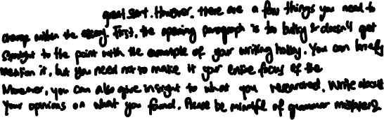

I would like to run an international trade business in the future, and economics will help prepare me well for doing international trade. NUS/HKU are some of the best schools for economics in the world, thus I believe it can prepare me well.

