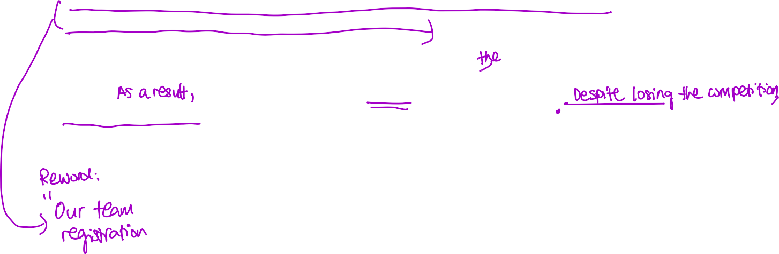3rd draft:

Success has been around me since I was young as I saw all my family members succeed. I have always taken inspiration from my mother as she grew a business by herself and was able to support us as children. During elementary school, I had an insatiable want for knowledge of the business industry and I had the opportunity to see this firsthand. I saw my mother coordinating with her staff members and also delegating tasks yet still being able to handle money, it was like I was starstruck. She made everything seem so easy and simple that I felt that this was something that I wanted to pursue in life as I tried other activities like selling in school and handling money it made me realize that I wanted to pursue Business Management as my major.

Not knowing how to learn more about business management I searched for summer programs to develop my business skills. I found the PassionXplorer work experience program about a business where we had to help a restaurant called Devon uplift the customer intake. One of the key takeaways that I had during the program was how to forecast prices for a restaurant for example counting the cost of goods sold, expenses, profit margin, and revenue. We were able to place what we learned into the restaurant itself where we were able to see how the profit margin affects the price of the menu and understood how that affects the quality of the product as well.

Business management needs analytical skills as well as how to problem solve in the work environment, through the PassionXplorer program we analyzed the data on the revenue of the restaurant with an increased cost or added expenses and how much an investment is going to help the business or not.

In terms of the business industry, it contains very broad subjects and I have been wanting to try out being in the world of marketing. I had the opportunity to do an internship with Skitchen as a marketing intern. Learning about the world of Digital Marketing and how to enhance the webpage, focusing more on topics like SEO and SEM. Wanting to grow more in my knowledge of the world of Digital Marketing, I joined several online courses like Revou and Sydney Romantics. Applying the knowledge I learned from the course to my internship, I broke down the problem that we had and found the AIDA formula which was perfect for the website as it grew from 15 clicks per day to 180 clicks in a week. I learned how to apply knowledge to real- life situations which are important in the business industry as sometimes we are faced with difficult situations that we need to solve.

Being a business manager we need to understand how to be able to lead and organize a team where work can be done to the maximum capacity. I had the opportunity to develop this skill when joining the INCEPTION business competition. We were consisting of 3 members of the team and I organized the time of our meetings as well as prepared the registration forms. I had to coordinate and delegate our tasks since we had different time zones as well as be able to understand them personally to how we would be able to work efficiently. As a leader of the team, I understood how to effectively work with different types of people and how to address them. We were able to complete our work in time before the deadline though we had lost the competition I gained many new insights on how to delegate tasks, work with other people, and how effectively communicate with other people which are compelling skills needed in business management.



Business Management has always been a widespread degree that unites different people together and where them are able to work together effectively. The United Kingdom has always been a place that contains the most culture as you can see different cultures and races. This is what draws me into taking Business Management in the United Kingdom. Business management is about being able to lead different individuals being able to create mutual understanding to grow ideas producing an efficient workflow. The opportunity to be able to work with people who have different backgrounds is crucial for growing our communication skills in working

in a business environment. The business world is always growing and therefore I would love to grow together with it.  

