PROMPT:

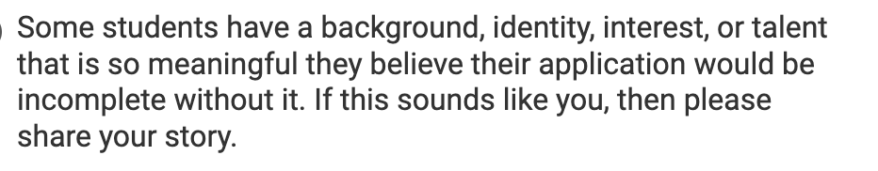

“Two lines guys, one for boys, one for girls.” Ms.Inno said, guiding my second grade class to Church which was conveniently adjacent to the Catholic school I attended. I remember looking around and seeing what was

“Who here has a small mouth?”, Li Laoshi asked our second grade class in Mandarin as a few of my friends raised their hands. We were learning about body parts and facial features, but as much as she tried to convince me that we were all different, I looked around and strongly disagreed; as according to my 7 year-old knowledge, everyone I knew spent their Sundays at church, ate bakmi and dimsum after, and attended Kumon. We were Chinese-Indonesians. Being Chinese-Indonesian, and on top of that, Catholic, is not a duality. In fact, ironically it makes you neither Chinese, nor Indonesian. Most of us don’t speak Mandarin on a daily basis, but when Chinese New Year Eve comes along, we always leave one side of the fish untouched. Being of both cultures ironically did not make us feel accepted by one or another, the only people we could confide in was our own. That was what my parents felt in the Indonesian riots of 1998, when most of our people were massacred. And that was also what my grandparents felt when they had to change our Chinese surname, “Zhou” to a more stealthy, less Chinese name, “Tjokroardi” in the hopes of avoiding any conflict. They taught me that diversity is a source of fear.

So, I do not blame them for placing me and my siblings in the super homogenous community we live in. A suburban town, a Catholic school, where everyone, young or old looked the same, prayed the same way, lived in similar houses. For 15 years of my life, I lived thinking that everyone in Indonesia lived the way I did. To say that I did not know better would be a lie. I did, but what can a naive 15-year-old do when someone says one thing, but she herself has never seen or experienced much else?

Then the COVID-19 virus came to Indonesia, and guess who they had to blame. It indeed did not help with feeling accepted, but in ways I could never have imagined at the time, it changed my life. When we first started online learning, I began to explore the internet, and like everyone else at the time, our lives began to thrive with it (after all it was our only source of socialising). I started to explore more issues around the world, either socio-economic, environmental, or human rights issues. These were things the people in my neighbourhood had no clue about. That was when I began my journey with We The Genesis. Although I have to admit, the passion and goal we had at the time was shallow at best; to us, a start was better than nothing.

As We The Genesis grew, so did I. I had never known that there were children living by mountains of landfills in Bantargebang (a city only 2 hours away from mine), until I went there. I had only found out that there were students my age in public schools being bullied for money by their seniors, or physically beat up– when I spoke to a member of my organisation who experienced it. These were not things I could have experienced at my school or my city. In fact, I would have never believed that these were happening in my country, because the Indonesia I know had turned out to be very different from the one they knew.

So, when people ask me why I started fighting for social justice, my answer will never be because I read books or because I read the news. I did not start advocating for climate action after reading news of floods in Jakarta; I started advocating for it after meeting people who lost families and homes. It was not because of the news that I started advocating for the sexual violence bill in Indonesia, but because of the girls I met that were being told by society and the law that it is their fault. Now, diversity to me is a close friend, and great teacher. Every person different from me has taught me something new about the world, about their lives. Now, I am no longer afraid of diversity; because they taught me that diversity is a source of change.