Q:1) what is 2+2 =?

Desc: description here

A:) 4

B:) 5

C:) 6

D:) 3

Correct: A

Q:2) what is 2+6 =?

Desc:

A:) 4

B:) 8

C:) 6

D:) Eight

Correct: B,D

Q:3) Who is in the picture?

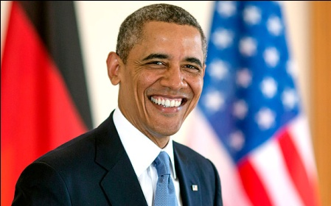

Desc:

A:) Osama

B:) Obama

C:) Arvind

D:) Anil

Correct: B