Didactic PCB V1.0 user guide

Contents
1.0 Power and start-up 2
2.0 IO 2
2.1 SysCtrl 3.3V IO 2
2.2 Didactic 1.8V IO 3
2.3 PMOD 3
3.0 Power monitor MCU 3
3.1 Virtual COM port 4
3.2 Commands 4
3.3 Programming 5

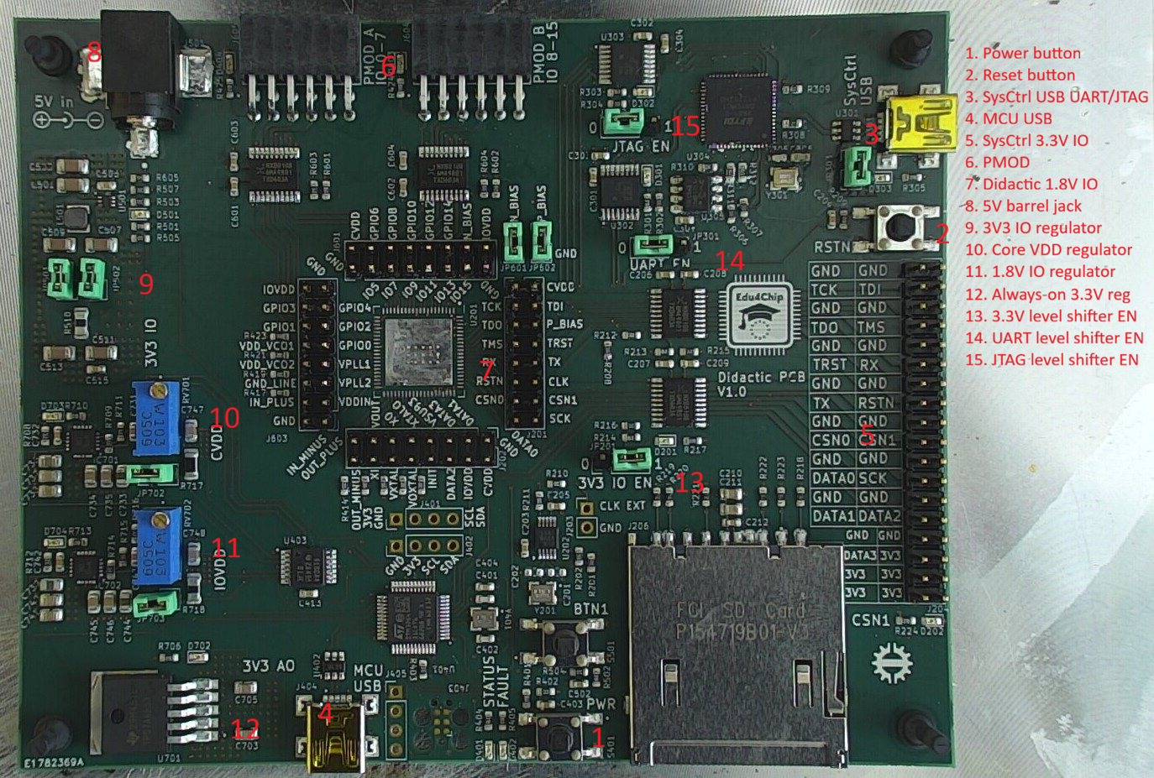
Figure 1. Didactic PCB

Power and start-up
The Didactic PCB requires external 5V source to function. The 5V can be inserted from a 5.5 mm x 2.1 mm barrel jack or from the SysCtrl Mini-USB port. Only one of these methods should be used at once. If barrel jack is used and the SysCtrl Mini-USB ports are used at the same time, then JP303 should be opened to disconnect the 5V power from the Mini-USB port.
After 5V power has been provided to the board, an LED (D303) near the SysCtrl Mini-USB port should be lit to indicate that power is being provided. LED (D702) should also be lit to indicate that always-on 3.3 V is being regulated. Finally, the Status LED (D401) should slowly blink to indicate that the microcontroller on the board is ready, and the rest of the board can be powered by pressing the PWR button (S401). After pressing the Power button, the microcontroller will enable 3.3V IO, 1.8V IO and 0.9V Core power rails and start the clock generator and finally release the reset for the Didactic chip. Successful start-up is indicated by the STATUS LED being lit and not blinking. An LED near each power rail’s source will also be lit to indicate that the power rails are enabled. All STATUS LED patterns are shown in table 1.
LED pattern | Pattern meaning
Slowly blinking | Board is powered, but Didactic power is off
Rapid blinking | Didactic power is on, but fault monitoring is disabled
Fully on | Didactic is powered
Table 1. STATUS LED patterns
The power rails are always monitored for failure. The power rails will fail if their voltage differs too much from the set amount or if too much current is being drawn from them. All power rails are immediately powered down if a failure is noticed in any of the power rails. Failure is indicated by blinking the Fault LED (D402). The failed power rail is indicated by the blinking pattern of the Fault LED (table 2). After power rail failure, the board can be repowered by pressing the PWR button.
Blink amount | Failed power rail
1 | Core
2 | IO
3 | 3.3V IO
Table 2. Fault LED blinking patterns
If needed, the power regulators can be disconnected from the power rails by removing the jumpers near them (JP703, JP702, JP501 and JP502). This may be needed at the first bring-up process for each PCB as the power rail voltages may be set incorrectly. If the Didactic chip is assembled on the PCB before bring-up, the power regulators must be disconnected and adjusted.
Voltage of the IO and Core voltage rails can be adjusted using trimmers RV702 and RV701.

2.0 IO

2.1 SysCtrl 3.3V IO
All SysCtrl IOs are level shifted to 3.3V and available on header J204. The signals are level shifted using bidirectional auto direction sensing level shifters. The level shifters must be enabled using the 3V3 IO EN jumper. Because of a design mistake, the level shifters are enabled when the jumper is set to 0 and disabled when the jumper is set to 1. LED D201 near the jumper will indicate when the level shifters are enabled. Level shifted SPI signals are also connected to an SD card socket.
JTAG and UART signals are also level shifted using separate unidirectional level shifters and connected to FT2232HQ USB converter. These level shifters can be enabled with UART EN (JP301) and JTAG EN (JP302) jumpers. Pinout for the FT2232HQ is shown in table 3.
FT2232HQ pin | Net
ADBUS0 | TCK
ADBUS1 | TDI
ADBUS2 | TDO
ADBUS3 | TMS
BDBUS0 | TX (Didactic RX)
BDBUS1 | RX (Didactic TX)
Table 3. FT2232HQ pinout

2.2 Didactic 1.8V IO
All of Didactic 1.8V IO is directly accessible on pin headers J201, J202, J601 and J603. All analog pins 32-50 of Didactic are connected to ground using 0-ohm resistors. N BIAS and P BIAS are connected to ground using JP601 and JP602 jumpers.

2.3 PMOD
GPIO signals 0-15 of the Didactic are connected to two PMOD (PMOD A and PMODB) connectors and level shifted to 3.3V using bidirectional auto direction sensing level shifters. These level sifters are always enabled. PMOD connect IO signal pinouts are shown in table 4.
PMOD A |  | PMOD B
Didactic | PMOD | Didactic | PMOD
GPIO0 | IO1 | GPIO8 | IO1
GPIO1 | IO2 | GPIO9 | IO2
GPIO2 | IO3 | GPIO10 | IO3
GPIO3 | IO4 | GPIO11 | IO4
GPIO4 | IO5 | GPIO12 | IO5
GPIO5 | IO6 | GPIO13 | IO6
GPIO6 | IO7 | GPIO14 | IO7
GPIO7 | IO8 | GPIO15 | IO8
Table 4. PMOD pinout

3.0 Power monitor MCU
Microcontroller on the board is used to monitor and sequence the power rails and control the clock generator. The Didactic can be started by pressing the PWR button or the start-up process can be controlled using the microcontrollers virtual COM port. The COM port can be accessed by connecting a Mini-USB cable to the MCU USB port.

3.1 Virtual COM port
Any virtual terminal software can be used to connect to Virtual COM port. Baud rate can also be freely chosen.
The microcontroller will continuously print the voltage and current of all the power rails. The virtual terminal window should be made big enough so that a full line of text can fit without line changes. Commands can be typed into the virtual terminal, and all commands must be ended by pressing enter. Pressing enter will also always reprint the command list
Virtual terminal view is shown in figure 2. Configuration for all power rails is shown at the bottom of the terminal and the bottom most line is updated three times a second and it shows the current voltage and power consumption of the power rails.
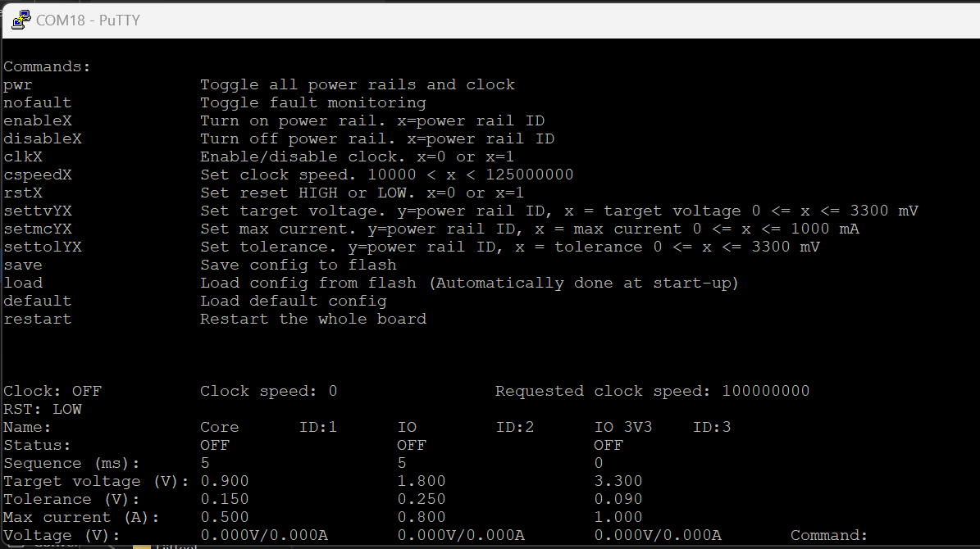
Figure 2. Power management MCU virtual terminal view

3.2 Commands
Power rails and the clock can be controlled by writing commands to the virtual terminal. All supported commands are shown in table 5.

Command | Parameters | Explanation
pwr |  | Turns on/off all the power rails and clock. Same as pressing the PWR button
nofault |  | Disables/enables fault checking for all power rails. Status LED will blink quickly when power is enabled and fault checking is disabled
enableX | X = power rail ID | Enabled power rail¹
disableX | X = power rail ID | Disable power rail¹
clkX | X = 0 or X = 1 | Enabled or disable clock. 1 = enable
cspeed | 10000 < X < 125000000 | Set requested clock speed. clk1 command must be sent after this command to enable clock with requested speed
rstX | X = 0 or X = 1 | Set Didactic reset LOW or HIGH, LOW = reset
settvYX | Y = power rail ID, 0 mV <= X <= 3300 mV | Set power rail’s target voltage
setmcYX | Y = power rail ID, 0 mA <= X <= 1000 mA | Set power rail’s maximum current
settolYX | Y = power rail ID, 0 mV <= X <= 3300 mV | Set power rail’s tolerance to voltage difference between target and actual voltage
save |  | Save current config to Flash
load |  | Load config from flash
default |  | Load default config
restart |  | Shutdown all power rails and restart the MCU
Table 5. Power management MCU commands
1. IO and Core power rails source their power from 3.3V IO power rails, so they cannot be powered before 3.3V IO power rails. IO and Core can be enabled before 3.3V IO power rails but they will be powered only after 3.3V IO has been powered.

3.3 Programming
The microcontroller can be programmed using SWD interface. This can be done using 4-pin pin header (J405) or 6-pin TC2030 Tag-Connect cable.

