Windows11
vagrant ssh
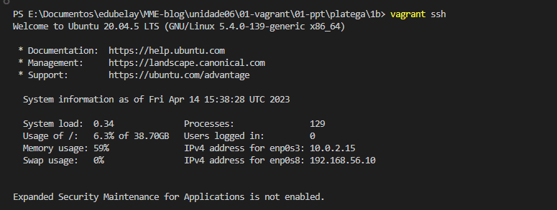
ip addr show | grep inet
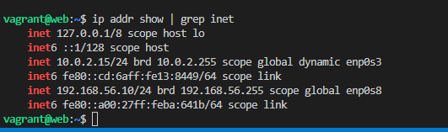

ss --tcp --listening
