Technologies and Frameworks

The project makes use of following technologies

C++ REST SDK (Casablanca)

A library for cloud-based client-server communication in native C++ code using a modern asynchronous C++ API design for high performance.

PARALLEL PATTERNS LIBRARY (PPL)

For developing concurrent applications with a layer of abstraction between your application code and the underlying threading mechanism.

MySQL C++ CONNECTOR

For interfacing and communicating with the MySQL relational database server.

The project makes use of C++14 features

The project is built on the foundation of the new C++14 language features and makes heavy use of the new standard library and language constructs like auto, functors and lambdas.

Client-Server Architecture Design

High level overview of flow control between Client and Server

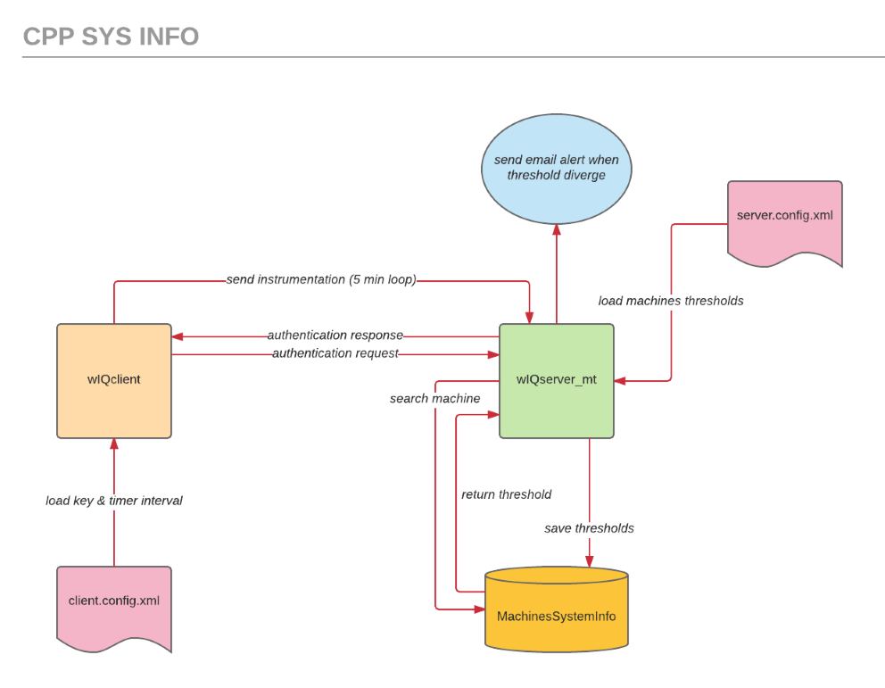
CLIENT

The client application starts its life cycle by loading information from the ‘client.config.xml’ file.

After parsing and retrieving <KEY> and timer <INTERVAL> information from the XML file it attempts to connect to the server. If the connection fails the client process exits, otherwise the client sends it’s KEY to be authenticated.

On a successful authentication the client begins a 5 minute loop interval sending instrumentation data to the server.

The communication between client and server is performed using the REpresentational State Transfer (REST) protocol.

SERVER

The server application starts its life cycle by loading all client machines registered in the ‘server.config.xml’ file.

After loading and parsing the XML data from the config file the server attempts to connect to the database. If the connection fails the server process exits otherwise it connects to the database and adds the new retrieved machines or updates the existing ones.

After successfully handling the contents of the ‘server.config.xml’ file the server begins listening for clients sending instrumentation data.

When the instrumentation data arrives the server searches the database looking for the machine that sent the data. It performs the database lookup using the machine KEY supplied in conjunction with the instrumentation data.

The server retrieves the thresholds values of the identified machine from the database, compare those values with the received ones and trigger an email alert when the data diverge.

Components and Code Implementation

Description and break down of client and server class design

PROJECT wIQclient CLASS DIAGRAM

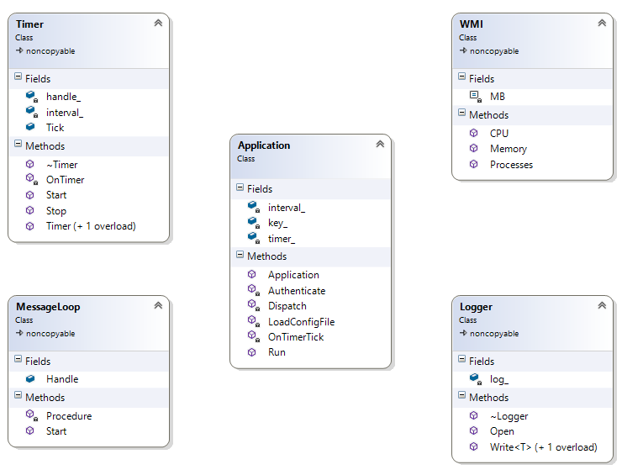

Application Class

This class is the client application starting point and it is instantiated at main. The instantiated object calls its Run member function to start the client life cycle.

The LoadConfigFile member function attempts to load the data contained in the ‘client.config.xml’ file. It parses the file to retrieve the client machine ID and the interval for the timer.

The Authenticate member function will try to connect to the server and authenticate the client. When the authentication fails the application terminates.

The OnTimerTick member function is responsible for retrieving the machine instrumentation data. It is called by the timer_ data member at each timer interval.

The Dispatch member function sends the gathered instrumentation data to the server.

Timer Class

This class implements a timer that calls Application.OnTimerTick and loops for the interval defined in its interval_ data member.

WMI Class

This class is responsible for collecting instrumentation data. Its public interface is composed of 3 member functions CPU, Memory and Processes that convey the instrumentation data.

Logger Class

This class is responsible for logging application flow and errors to the standard console output and to the application log file ‘wIQclient.log’.

PROJECT wIQserver_mt CLASS DIAGRAM

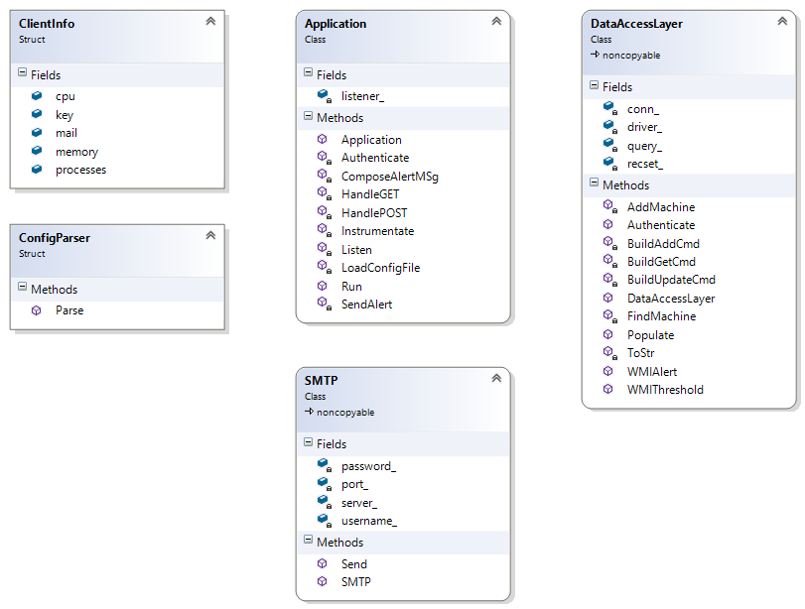

Application Class

This class is the server application starting point and it is instantiated at main. The instantiated object calls its Run member function to start the server life cycle.

The LoadConfigFile member function attempts to load the data contained in the ‘server.config.xml’ file. It invokes the ConfigParser::Parse static member function to parse the XML and retrieve the client machines thresholds. It instantiates a DataAccessLayer object and calls Populate to fill the database with the retrieved data.

The Listen member function listens for client request such as authentication and instrumentation and dispatch those request to HandleGET or HandlePOST.

The Authenticate member function will authenticate the client searching for the client key at the database. It instantiates a DataAccessLayer object and calls FindMachine to perform the search.

The Instrumentate member function process the instrumentation data received from the client at the Application.HandlePOST member function. It instantiates a DataAccessLayer object and calls WMIThreshold to retrieve the thresholds for this client. When the data diverge SendAlert is called.

DataAccessLayer Class

This class is responsible for interfacing with the database to perform data related tasks such as searches, updates and insertions on behalf of the Application class.

The member functions BuildAddCmd, BuildGetCmd and BuildUpdateCmd support the DataAccessLayer class by composing the SQL commands necessary to perform CRUD operations at the database level.

The Authenticate member function searches for the client machine calling the FindMachine member function. It returns true when the client machine is found in the database.

The AddMachine member function adds the client machine to the database. If the machine already exists in the database it updates its data to reflect possible changes in the ‘server.config.xml’

The FindMachine member function performs a database search for the requested client machine using its KEY info as the search condition.

The WMIAlert member function is called by Application.SendAlert to register the client machine together with the divergent threshold data. This will enable database searches for machines out of threshold scope.

The WMIThreshold member function retrieves the threshold data for a give client machine.

ClientInfo Class

This class is a metadata wrapper around the database table entity responsible for holding client info and threshold data.

ConfigParser Class

This class is responsible for parsing the XML file ‘server.config.xml’ and storing the parsed data in a collection of ClientInfo elements.

SMTP Class

This is a wrapper class around a 3rd party class used to send SMTP emails.

